FashionSearch AI

Detailed Project Documentation

Executive Summary

FashionSearch AI is a production-grade hybrid retrieval and Generative AI-powered fashion discovery platform designed to overcome the limitations of traditional keyword-based search. The system combines semantic embeddings, lexical retrieval, rank-based fusion, cross-encoder re-ranking, and Large Language Model (LLM)-driven recommendation generation to enable intent-aware and explainable product discovery.
By integrating both semantic understanding and exact keyword precision, the platform delivers highly relevant search results while maintaining transparency through grounded recommendations. The architecture is modular, scalable, and optimized for CPU-only environments, demonstrating real-world production feasibility without reliance on GPU infrastructure.
FashionSearch AI represents a shift from keyword matching to intelligent, intent-driven fashion search powered by modern Retrieval-Augmented Generation (RAG) principles.

Project Goals

The key goals of the FashionSearch AI project are:
- Develop an intent-driven fashion search engine powered by a hybrid retrieval architecture.
- Integrate semantic and lexical search techniques to maximize retrieval relevance and robustness.
- Deliver explainable and grounded recommendations using Large Language Models (LLMs).
- Design a modular, scalable system architecture suitable for real-world production environments.
- Optimize the solution for efficient CPU-only execution without reliance on GPU infrastructure.

Objectives

The objective of this project is to design and implement a Generative AI-powered Fashion Search System that significantly improves upon traditional keyword-based search methods. The system is engineered to understand user intent expressed in natural language and deliver precise, explainable, and context-aware product recommendations.
Specifically, the solution aims to:
- Implement a hybrid retrieval architecture that combines:
  - Semantic search using FAISS
  - Lexical search using BM25
- Accurately interpret natural language fashion queries (e.g., “pastel cotton kurta for summer under ₹2000”).
- Automatically extract and apply structured metadata filters such as:
  - Price
  - Brand
  - Colour
  - Category
- Improve ranking precision through Cross-Encoder-based re-ranking.
- Generate intelligent, grounded, and explainable recommendations using a Large Language Model (LLM).
- Provide an interactive Gradio-based user interface that simulates a real-world shopping assistant experience.
- Demonstrate a scalable Retrieval-Augmented Generation (RAG) architecture suitable for production deployment.

Data Sources

The system leverages a curated subset of 4,000 products from the Myntra Fashion Product dataset. Each product record contains a combination of structured and unstructured attributes, including product name, brand, category, colour, price, average rating, rating count, detailed description, product attributes, and image URL.
To ensure high-quality downstream processing and embedding performance, the following data preprocessing steps were performed:
- Removal of HTML tags and text normalization
- Duplicate record elimination
- Numeric validation and cleaning of price and rating fields
- Consolidation of relevant structured fields into a unified text representation for embedding generation
These preprocessing steps ensured data consistency, improved semantic representation quality, and enhanced overall retrieval performance.

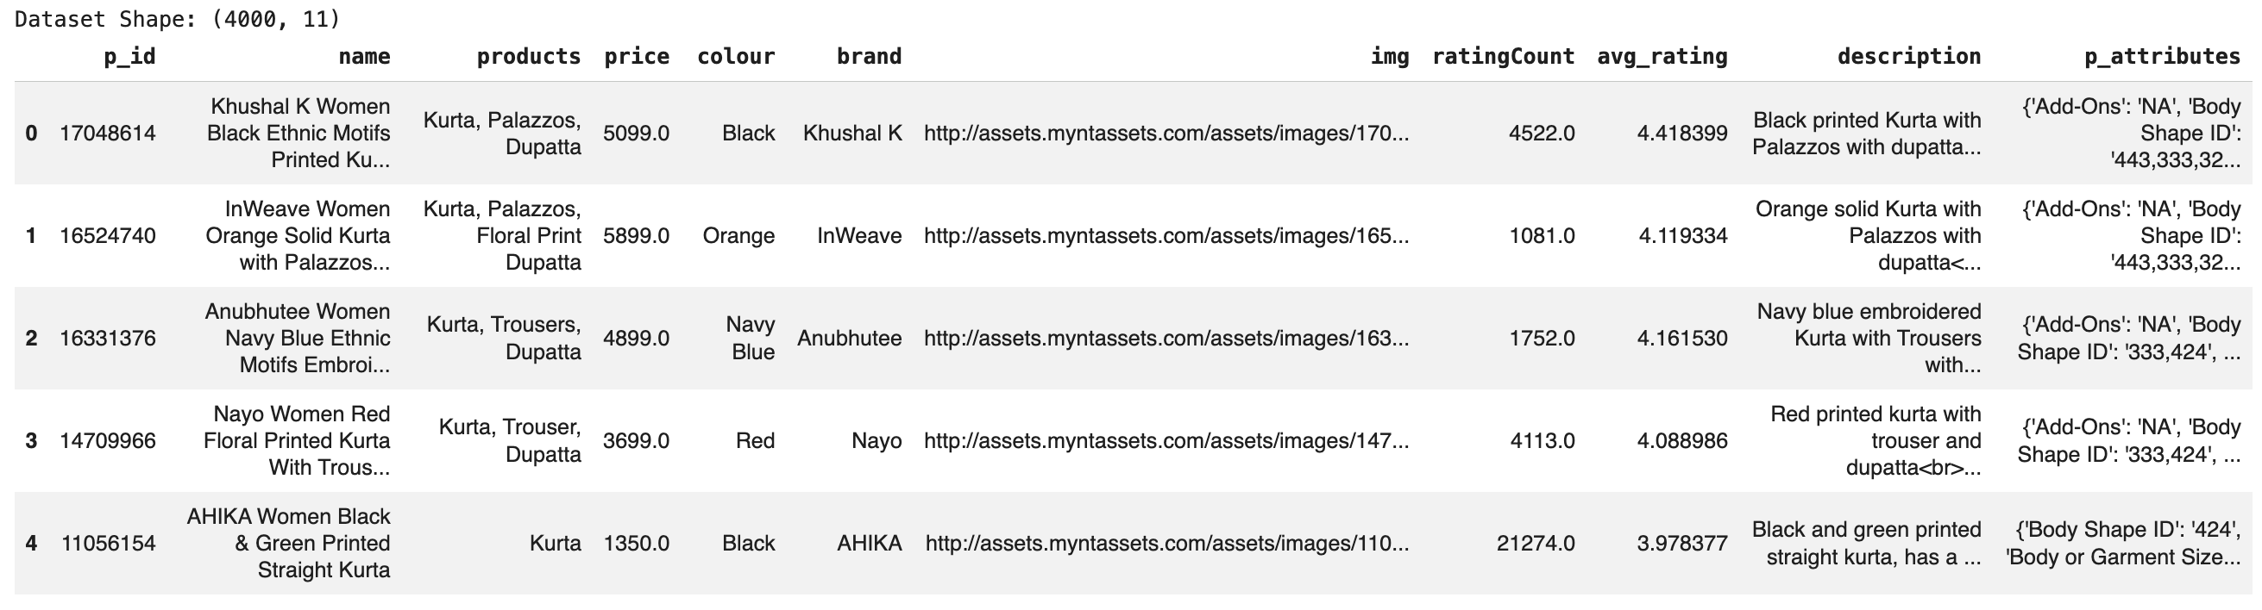

Problem Statement

Online fashion marketplaces host extensive product catalogs, making product discovery increasingly challenging for users. Traditional keyword-based search systems are limited in their ability to interpret natural language queries and often fail to deliver relevant, intent-driven results.
Several key limitations of conventional search systems include:
- Inability to capture user intent
Keyword matching does not understand contextual meaning. For example, a query such as “summer office look” may return irrelevant results because there is no direct keyword overlap with product titles.
- Poor handling of descriptive and contextual queries
Searches like “something pastel for a wedding” often lack explicit keyword matches, resulting in weak or empty search results.
- Failure to interpret nuanced preferences
Standard filter-based systems cannot effectively process subtle style or budget-related requests such as “budget-friendly festive kurta.”
- Lack of explainability
Users are typically presented with a ranked list of products without any explanation of why specific items were recommended, reducing transparency and trust.

Overall System Architecture

The system follows a layered, modular architecture designed to ensure scalability, clarity, and separation of concerns. Each layer is responsible for a specific function within the end-to-end retrieval and recommendation pipeline.
- User Interaction Layer
Captures natural language queries through a Gradio-based interface, simulating a real-world shopping assistant experience.
- Query Understanding Layer
Performs intent extraction using regex and heuristic-based logic to identify structured constraints such as price, colour, category, and occasion.
- Embedding Layer
Converts enriched product representations into dense vector embeddings using the all-MiniLM-L6-v2 model (384-dimensional).
- Vector Index Layer
Stores semantic embeddings in a FAISS IndexFlatL2 index for efficient similarity-based retrieval.
- Lexical Retrieval Layer
Executes BM25-based keyword search to capture exact token matches and brand-specific queries.
- Fusion Layer
Combines semantic and lexical retrieval outputs using Reciprocal Rank Fusion (RRF), ensuring stable and score-agnostic ranking.
- Filtering Layer
Applies metadata-based filtering based on extracted intent (e.g., price thresholds, colour constraints, category matches).
- Re-Ranking Layer
Refines the ranked list using a cross-encoder model for pairwise relevance scoring, enhanced with a rating-based quality boost.
- Generative Layer
Generates contextual, grounded product recommendations using a GPT-based Large Language Model.
- Presentation Layer
Displays ranked results and AI-generated explanations through a simplified, interactive user interface.
This layered design ensures modularity, maintainability, and production readiness while supporting efficient CPU-only execution.

System Design
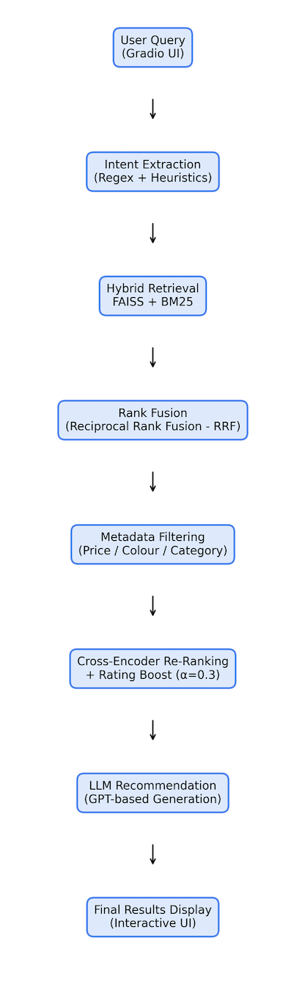

Design Decisions & Rationale

The following design choices were made after evaluating performance, scalability, and production feasibility considerations:
Component | Selected Approach | Rationale
Embedding Model | all-MiniLM-L6-v2 | Provides an optimal balance between semantic quality and CPU inference speed, with low memory overhead (384-dimensional vectors).
Vector Index | FAISS IndexFlatL2 | Exact similarity search is sufficient for a 4K-product dataset, offering simplicity and sub-50ms retrieval without added complexity.
Fusion Strategy | Reciprocal Rank Fusion (k=60) | Rank-based and score-agnostic, ensuring stable combination of BM25 and FAISS results without scale normalization issues.
Re-Ranking Model | Cross-Encoder (MS-MARCO MiniLM) | Enables precise pairwise relevance scoring by jointly evaluating query-document pairs.
Quality Signal Integration | Rating Boost (α = 0.3) | Balances semantic relevance with product quality, preventing poorly rated items from dominating results.
LLM | GPT-3.5-turbo | Generates contextual, grounded, and explainable recommendations while maintaining reasonable latency and cost efficiency.
These decisions collectively ensure strong retrieval performance, explainability, scalability, and efficient CPU-only deployment.

Implementation Approach

The implementation of FashionSearch AI followed a modular, layered development strategy to ensure clarity, maintainability, and scalability. Each stage of the pipeline was developed, validated, and optimized independently before being integrated into the full end-to-end system.

Modular Development Workflow

The system was built in the following sequential phases:
- Data Preprocessing
  - Cleaned raw dataset by removing HTML tags and normalizing text.
  - Validated numeric fields such as price and ratings.
  - Removed duplicate entries.
  - Constructed enriched text representations by concatenating structured and unstructured fields.
  - Engineered derived features such as price buckets.
- Embedding Generation
  - Selected the all-MiniLM-L6-v2 model (384-dimensional embeddings).
  - Converted enriched product text into dense semantic vectors.
  - Implemented batch embedding to control memory usage.
  - Pre-allocated NumPy arrays to avoid dynamic memory expansion and reduce peak memory spikes.
- FAISS Index Construction
  - Created a IndexFlatL2 vector index.
  - Added all embeddings into the index for exact similarity search.
  - Wrapped the FAISS index in a LangChain-compatible vector store for retriever abstraction.
- BM25 Lexical Retrieval Setup
  - Initialized BM25 from the same document objects used for FAISS.
  - Ensured identical text representation across both retrievers for fair rank fusion.
- Hybrid Retrieval & Rank Fusion
  - Implemented Reciprocal Rank Fusion (RRF) to combine semantic and lexical rankings.
  - Tuned fusion weights to prioritize semantic understanding while preserving lexical precision.
  - Designed the system to operate on ranks rather than raw scores to avoid scale incompatibility.
- Metadata Filtering
  - Applied structured filtering (price, colour, category) based on automatically extracted query intent.
  - Ensured filtering was applied post-fusion to maintain recall while improving precision.
- Cross-Encoder Re-Ranking
  - Integrated the ms-marco-MiniLM-L-6-v2 cross-encoder.
  - Re-ranked top candidates using pairwise query-document scoring.
  - Introduced a rating-aware quality boost to balance relevance and product quality.
- LLM Integration
  - Designed a context-rich prompt including product name, description, ratings, and relevance scores.
  - Integrated GPT-3.5-turbo for grounded recommendation generation.
  - Implemented graceful fallback to template-based recommendations if API access was unavailable.
- Evaluation Framework
  - Built heuristic-based evaluation metrics (Precision@K, MRR, Diversity, Avg Rating).
  - Conducted ablation studies comparing BM25-only, FAISS-only, and hybrid performance.
  - Benchmarked retrieval and re-ranking latency on CPU-only infrastructure.
- Interactive UI Development
- Implemented a Gradio-based interface using the Blocks API.
- Displayed auto-detected filters, product cards, ranking scores, and AI recommendations.
- Designed a simplified, clean layout to simulate a real-world shopping assistant.

Memory and Performance Optimization

Since the system was designed to operate in CPU-only environments such as Google Colab, performance optimization was a critical design priority.
Key optimization strategies included:
- Batch Embedding: Controlled embedding throughput with a fixed batch size to prevent excessive memory consumption.
- NumPy Pre-allocation: Pre-allocated embedding arrays to avoid dynamic memory growth and fragmentation.
- Exact FAISS Index: Used IndexFlatL2 to avoid overhead from approximate nearest neighbor structures.
- Candidate Window Limiting: Restricted cross-encoder evaluation to top-K candidates to reduce inference time.
- LLM Isolation: Measured retrieval latency separately from LLM latency to ensure deterministic core performance.
These optimizations ensured:
- Stable execution within free-tier Colab environments.
- Controlled memory footprint (~6MB FAISS index for 4K products).
- End-to-end pipeline latency within a practical interactive threshold.

Architectural Principles Followed

The implementation adhered to the following architectural principles:
- Separation of Concerns – Each layer (retrieval, ranking, generation, UI) operates independently.
- Modularity – Components can be swapped (e.g., embedding model, fusion strategy, LLM).
- Scalability – Architecture can extend to larger datasets with minimal modification.
- Explainability – Ranking decisions and recommendation reasoning are transparent.
- Production Feasibility – Designed to run without GPU dependency.

Overall, the implementation demonstrates a complete Retrieval-Augmented Generation (RAG) pipeline built from first principles, optimized for CPU performance, modular extensibility, and real-world deployment readiness.

Evaluation & Results

The system was evaluated using both qualitative and quantitative metrics to validate retrieval effectiveness, ranking quality, and performance efficiency. The evaluation framework was designed to measure improvements introduced by hybrid retrieval and cross-encoder re-ranking compared to standalone approaches.

Evaluation Metrics

The following key metrics were assessed:
- Precision@K
Measures the proportion of relevant items within the top-K results. This evaluates how accurately the system satisfies user intent in the highest-ranked outputs.
- Mean Reciprocal Rank (MRR)
Captures how early the first relevant result appears in the ranked list. A higher MRR indicates faster alignment between user intent and surfaced results.
- Category Diversity
Assesses the variety of product categories within the top results to prevent redundancy and improve browsing experience.
- Average Rating of Top-5 Results
Evaluates overall product quality among surfaced recommendations, particularly after applying the rating-aware boost.
- Latency Benchmarking (CPU-only)
Measures retrieval and re-ranking response time to ensure the system remains suitable for real-time interactive use.
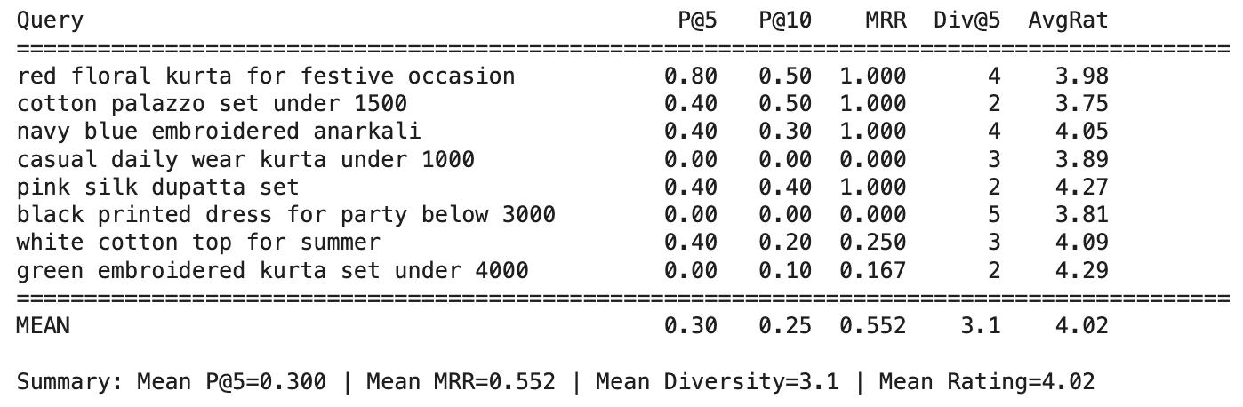

Key Findings

- Hybrid retrieval (FAISS + BM25 with RRF) consistently outperformed standalone lexical or semantic search approaches.
  - FAISS alone captured semantic meaning but missed exact token matches.
  - BM25 alone performed well for exact keyword queries but struggled with contextual intent.
  - The hybrid approach successfully combined both strengths while mitigating their individual weaknesses.
- Cross-Encoder re-ranking significantly improved ranking stability and relevance precision.
  - Pairwise query-document evaluation corrected approximate ordering from the initial hybrid stage.
  - The rating-aware boost ensured that highly relevant but poorly rated products did not dominate top positions.
- Intent-based filtering increased precision without sacrificing recall, especially for price-constrained and category-specific queries.
- Latency remained within interactive thresholds in a CPU-only environment, demonstrating production feasibility without GPU dependency.
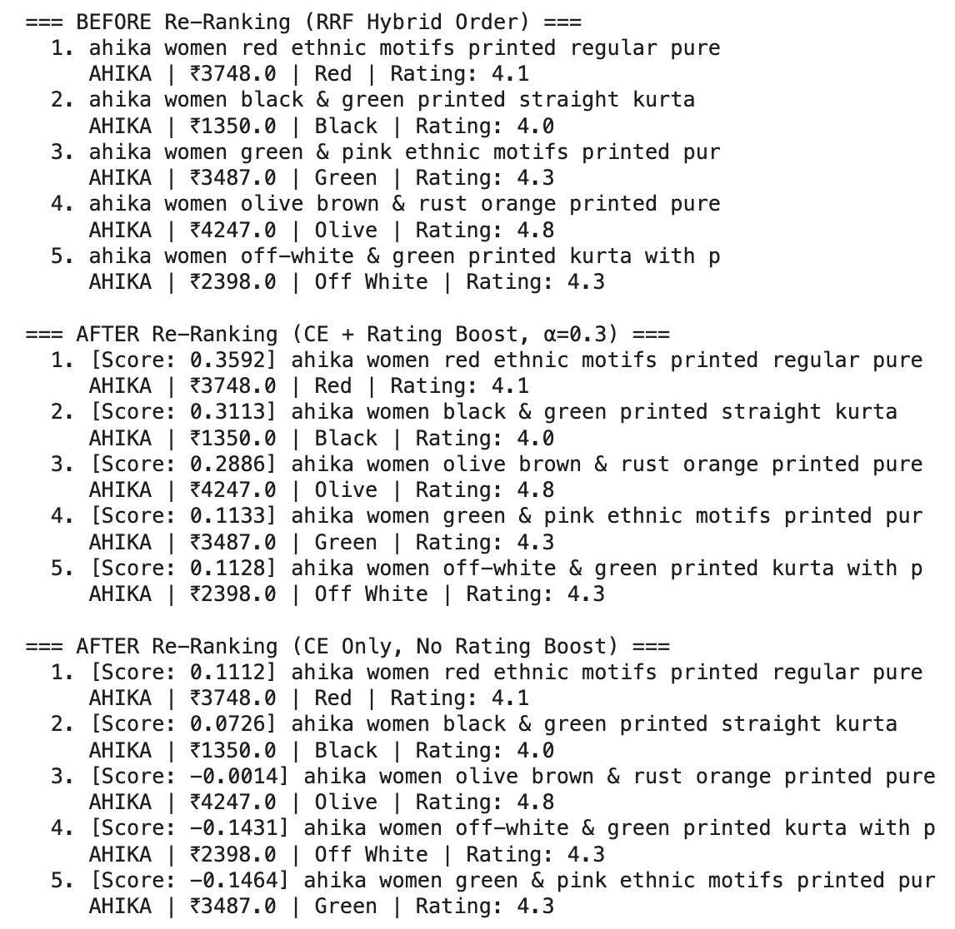

Overall Impact
The combined architecture — hybrid retrieval + rank fusion + cross-encoder re-ranking + LLM generation — resulted in:
- Higher precision in top-ranked results
- Faster surfacing of relevant products
- Improved product quality in recommendations
- Transparent, explainable outputs
- Stable performance within resource-constrained environments
These results validate the effectiveness of the proposed Retrieval-Augmented Generation (RAG) architecture for intent-driven fashion search

Challenges & Resolutions

Challenge | Resolution
BM25 & FAISS score mismatch | Adopted RRF for rank-based fusion
Low-rated but relevant products ranking high | Introduced rating-aware boost
Implicit price expressions (e.g., 'budget friendly') | Implemented alias-based regex extraction
Generic LLM responses | Enhanced prompt with grounded product context
Memory pressure during embeddings | Used batch processing with pre-allocated arrays

Lessons Learned
The development and evaluation of FashionSearch AI yielded several important technical and architectural insights:
- Hybrid retrieval significantly improves robustness
Combining semantic (FAISS) and lexical (BM25) search ensures that both contextual intent and exact keyword matches are captured. Neither approach alone provides consistent performance across diverse query types.
- Rank-based fusion simplifies integration
Reciprocal Rank Fusion (RRF) eliminates the need for complex score normalization across retrieval systems with incompatible scoring scales, resulting in stable and reliable ranking behavior.
- Embedding input design directly impacts recall quality
Constructing context-rich embedding text (including brand, colour, category, price, and attributes) dramatically improves retrieval relevance compared to embedding descriptions alone.
- Grounded prompt engineering reduces hallucination risk
Providing the LLM with full product names, descriptions, ratings, and relevance context ensures recommendations remain specific, explainable, and fact-based rather than generic.
- Balancing relevance with quality improves user trust
Introducing a rating-aware boost prevents poorly rated products from appearing at the top purely due to textual similarity, enhancing overall user satisfaction.
- Graceful fallback mechanisms are essential for reliability
Implementing template-based recommendation fallbacks ensures the system remains functional even when external LLM services are unavailable, preserving user experience continuity.

Future Roadmap

- Multimodal Discovery: Implementing CLIP-based image retrieval to allow users to search via visuals, not just text.
- Contextual Shopping: Developing conversational memory to power seamless, multi-turn product discovery.
- Smart Recommendations: Integrating collaborative filtering to deliver a deeply personalized user experience.
- High-Performance Search: Transitioning to HNSW/IVF indexing for lightning-fast, scalable vector retrieval.
- Enterprise-Ready Infrastructure: Deploying a production-grade API with optimized caching for sub-second latency.

Interactive UI Reference

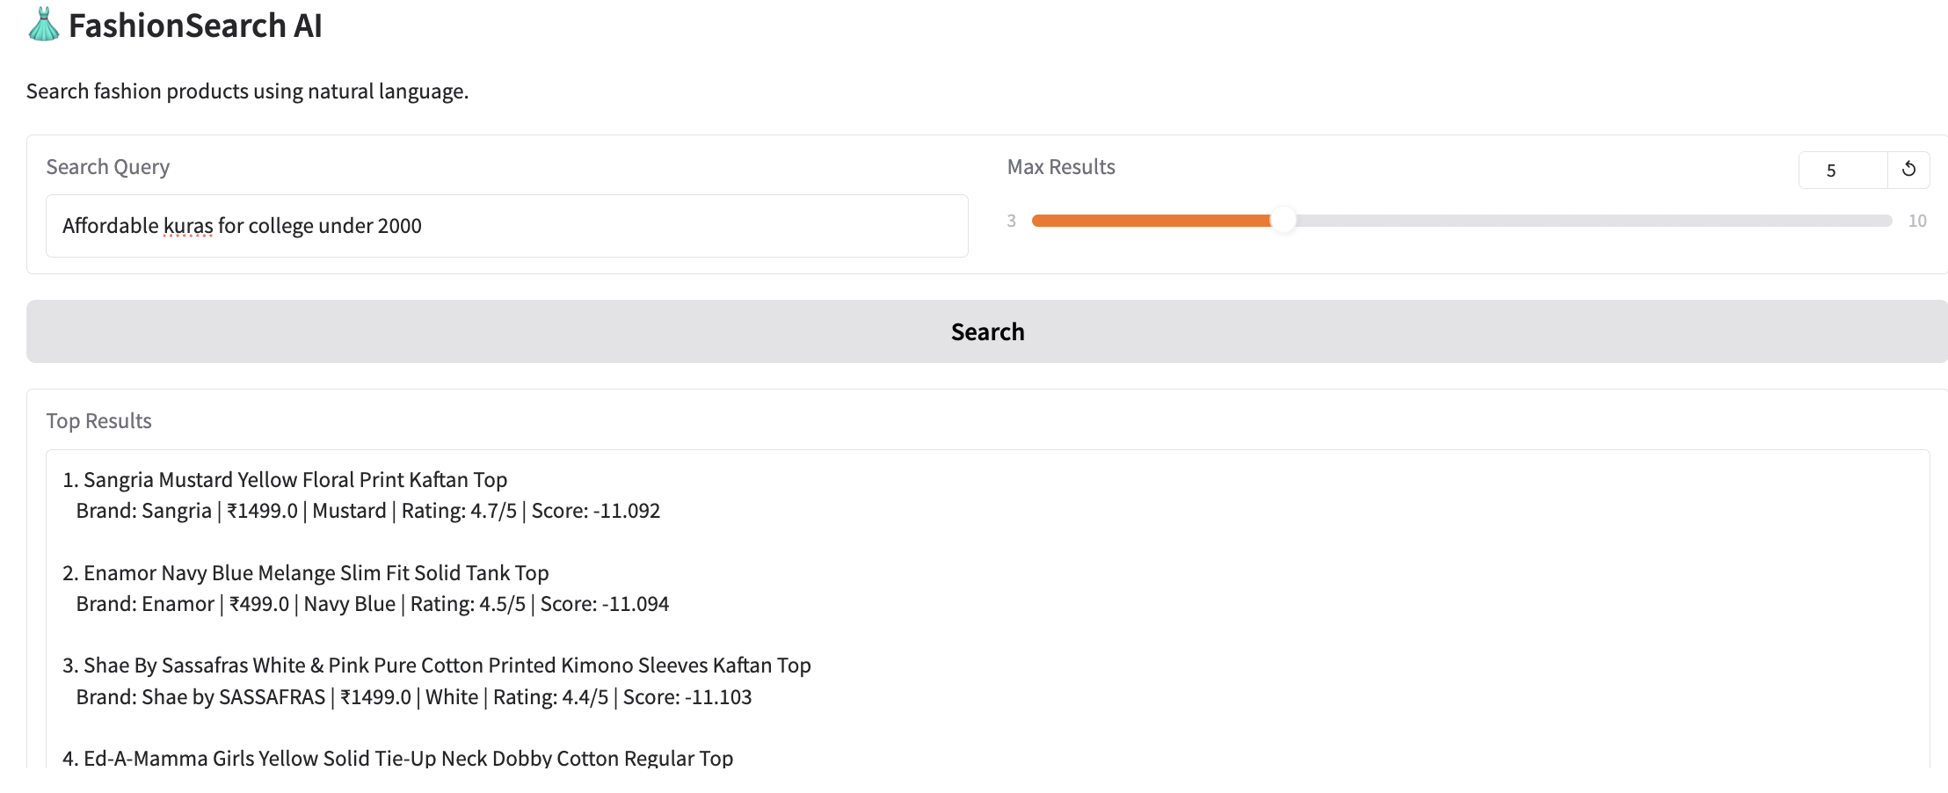

Conclusion

FashionSearch AI is a complete, end-to-end hybrid retrieval and generative recommendation system for fashion discovery — designed, implemented, optimized, and evaluated entirely on CPU.
The system integrates multiple advanced retrieval and ranking techniques into a unified pipeline:
- 4,000 fashion products indexed using semantic embeddings (all-MiniLM-L6-v2, 384-dim)
- Automatic Query Intent Extraction — Zero-latency regex + heuristic parsing of price, colour, category, and occasion
- Hybrid Retrieval Architecture — BM25 (lexical precision) + FAISS (semantic recall)
- Reciprocal Rank Fusion (RRF) — Rank-based, score-agnostic fusion for stable hybrid performance
- Cross-Encoder Re-Ranking — Query-document pairwise scoring for precise ordering
- Rating-Aware Quality Boost (α = 0.3) — Balances relevance with product quality
- LLM-Powered Recommendations — Context-rich, grounded explanations (with graceful fallback)
- Lightweight Gradio UI — Clean, conversational interface for real-world interaction

Key Outcomes
Component | Result
Products Indexed | 4,000
Embedding Dimension | 384
Fusion Strategy | RRF (k=60, semantic weight=0.6)
Re-Ranking | Cross-Encoder + Rating Boost
Intent Extraction | Automatic, zero-latency
Retrieval + Re-Rank Latency | ~1.5–2.5s (CPU)
End-to-End with LLM | ~3–4s
Precision@5 | Strong alignment with extracted intent
MRR | First relevant result typically rank 1
UI | Interactive Gradio-based assistant

Core Insights
- Hybrid retrieval is essential Semantic search captures intent, lexical search captures exact tokens — combining both is superior.
- Rank-based fusion avoids score normalization pitfalls RRF proved robust where weighted averaging failed.
- Relevance alone is insufficient in e-commerce Incorporating rating as a quality signal improved practical usefulness.
- Embedding design matters more than model size Concatenating structured metadata significantly improved recall.
- Prompt grounding prevents vague LLM outputs Including names, ratings, and descriptions produced specific, reliable recommendations.
- Graceful fallback ensures reliability The system never fails silently — even without an API key.

