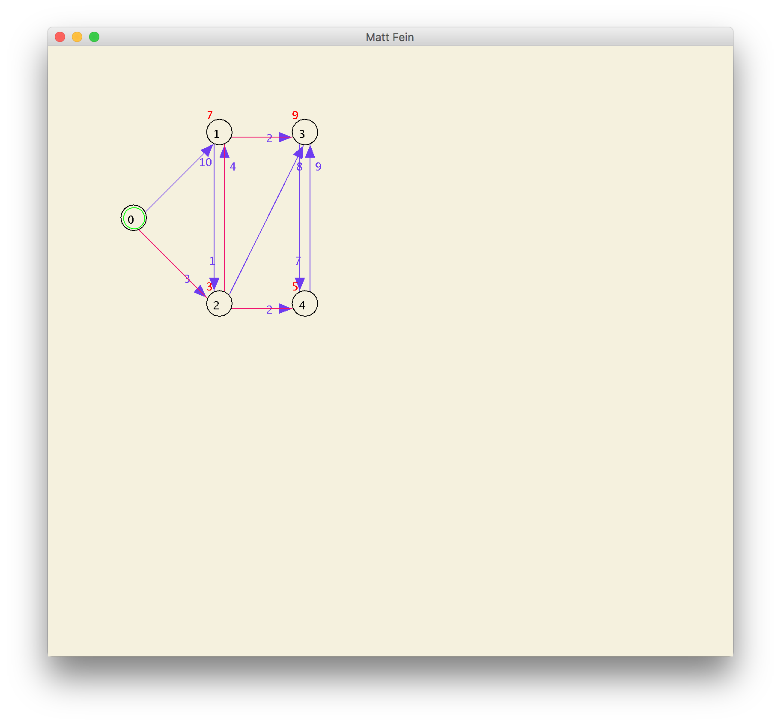Graph.dat for Bellman Ford

Graph.dat Dijkstra

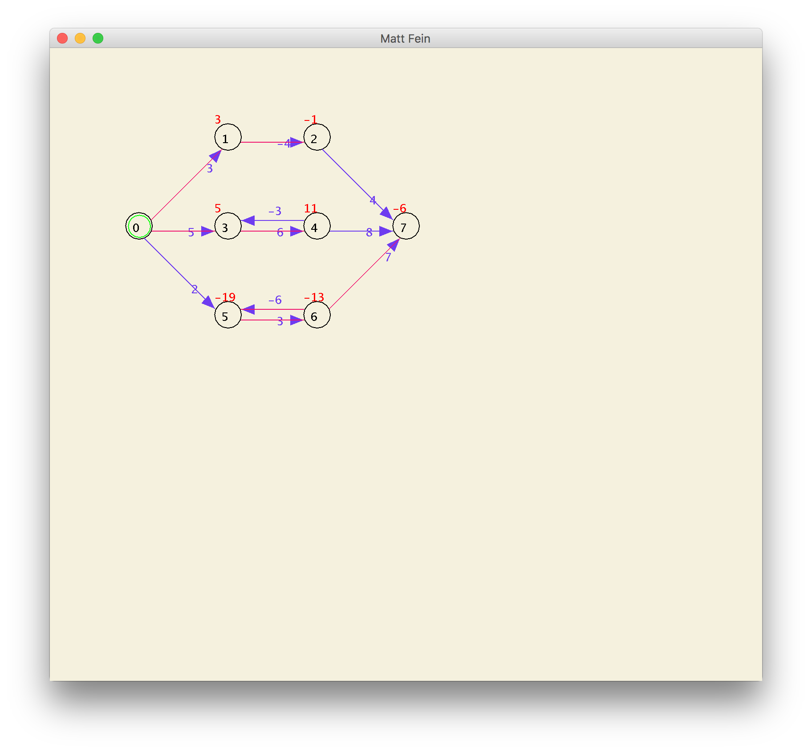Negative cycle for Bellman Ford

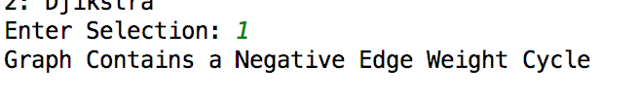

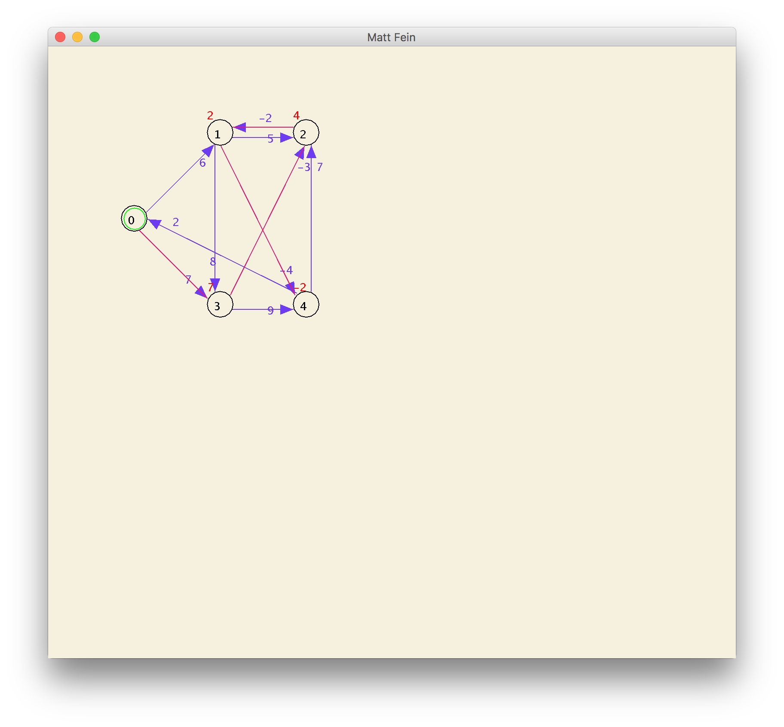

GraphNeg for Bellman

The project does not run for Dijkstra on a negative cycle

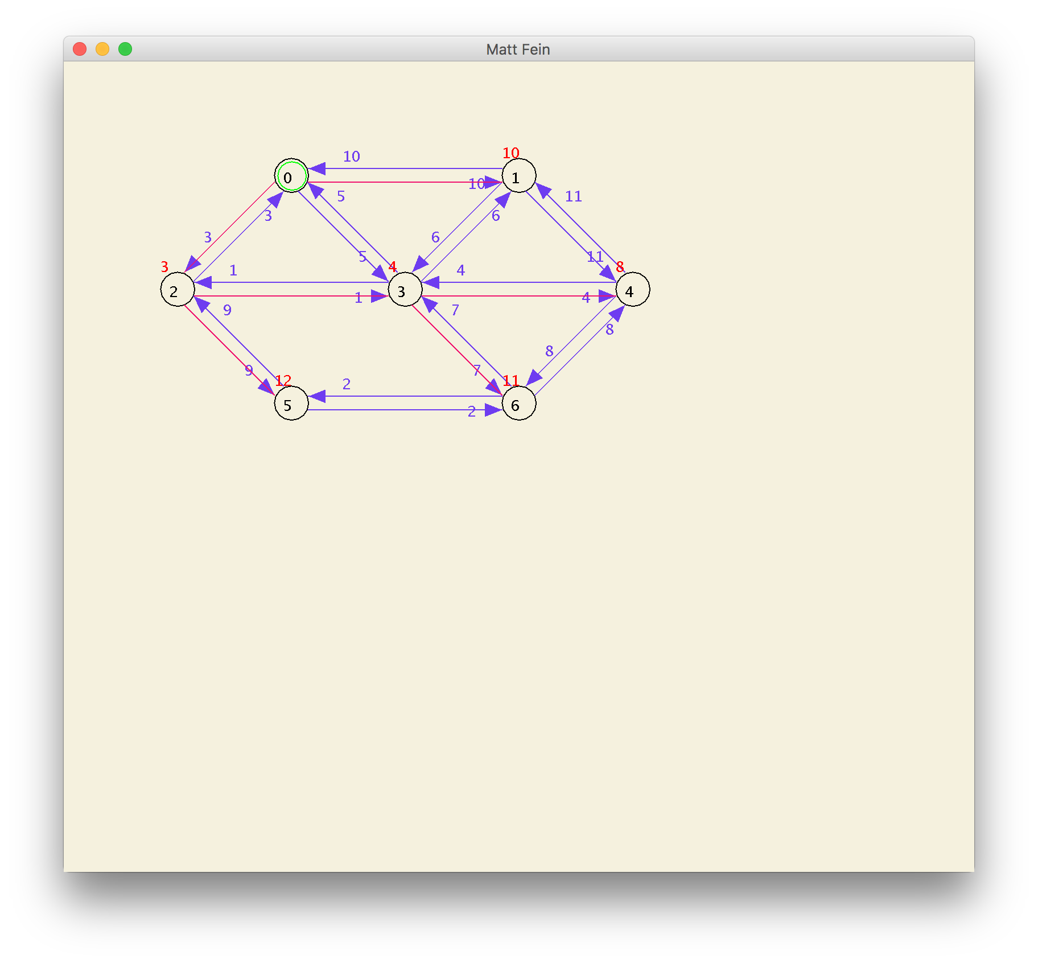Undirected Graph for DijkstraUndirected Graph for Bellman Ford

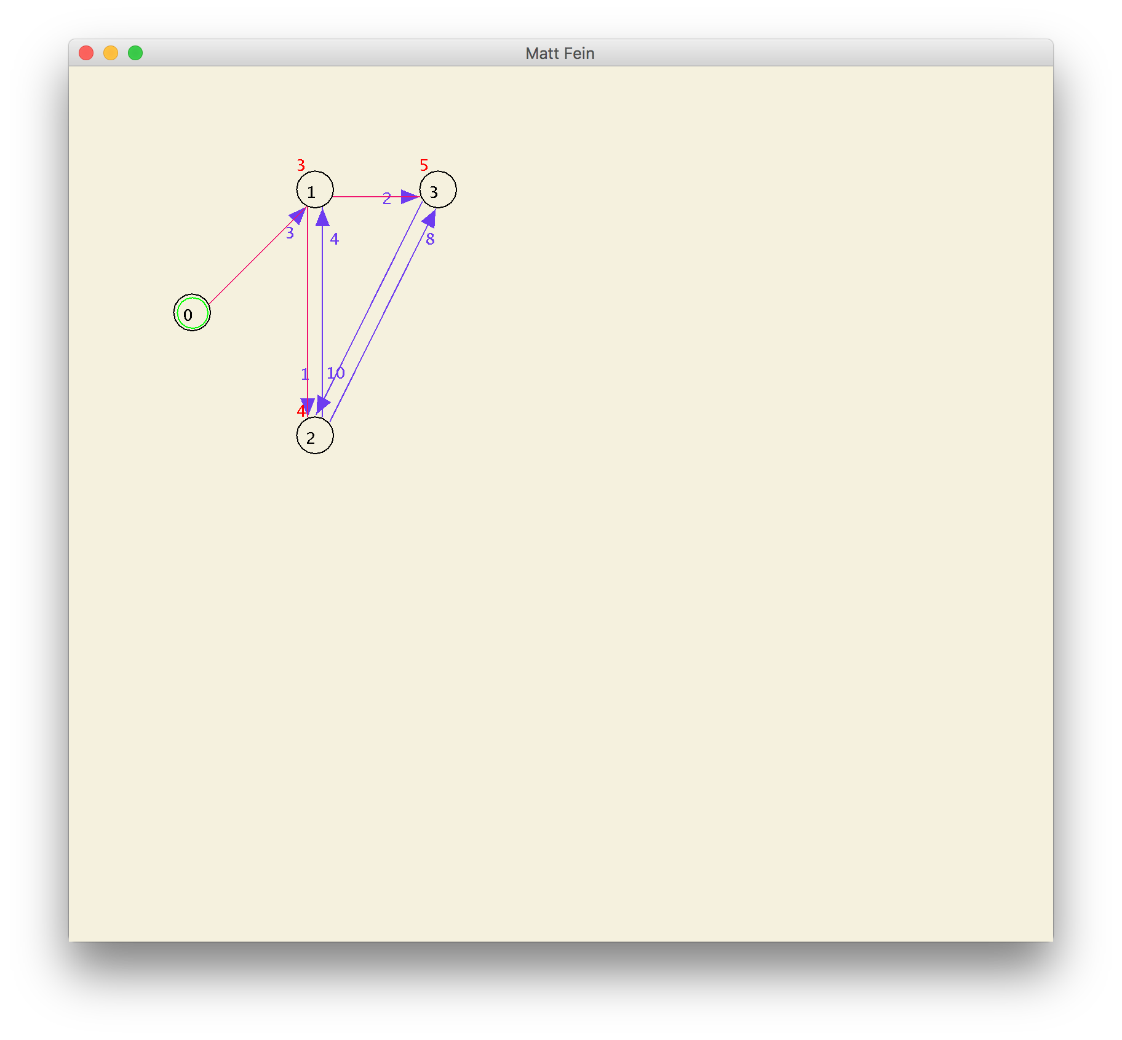

Custom Graph for Bellman Ford



Custom Graph for Dijkstra