Questions : What is the bandwidth of the bike ? How does the bandwidth of the balancing control loop impact the response of the bike to disturbances ? How does including the inertia of the front wheel in the bike model influence the bandwidth of the balancing control loop ?

Plan :

* Write equations for the balancing control loop in steady-state. Compute the gains from disturbances to true steering angle. Is a D or I term needed/should be avoided ?
* Confirm in simulation.

Conclusion : The equation giving the true steering angle as a function of reference roll, reference steering angle and steering angle disturbance does not contain the PID transfer function, therefore the choice of PID gains has no impact during steady-state.

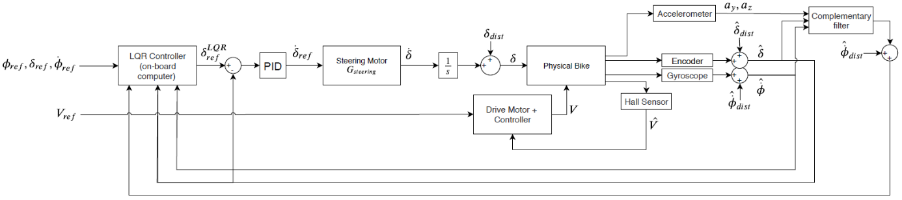

Figure - Block diagram of the balancing control loop

The bandwidth of the bike (from true steering angle $δ$ to true roll $ϕ$) is 0.5Hz.

The three reference inputs to the system (roll reference $ϕ_{ref}$, roll rate reference ${\dot{ϕ}}_{ref}$, steering angle reference $δ_{ref}$) have similar effect on the system down to a gain as the LQR controller operates a linear combination of these signals. The measured roll perturbation ${\hat{ϕ}}_{dist}$ acts in the same way to a change in references. Therefore, the bandwidth of the system will be presented only for ${\hat{ϕ}}_{dist}$ as it will have the same value for the three references.

Even though bandwidths are identical, Bode plots from perturbations on roll/roll rate/steering angle to true roll/roll rate/steering angle are not identical to Bode plots from reference roll/roll rate/steering angle to true roll/roll rate/steering angle.

We compare the bandwidth of the system for 3 different LQR controller :

* ‘slow’ LQR : $Q_{slow}=\left[\begin{matrix}10 & -9 \\ -9 & 10\end{matrix}\right]$
* ‘medium LQR : $Q_{medium}=\left[\begin{matrix}10 & -3 \\ -3 & 1\end{matrix}\right]$
* ‘fast’ LQR : $Q_{fast}=\left[\begin{matrix}100 & -9 \\ -9 & 1\end{matrix}\right]$

Figure 2 shows the bandwidth of the system for various input-output combinations. In this table, bandwidth related to the ‘slow’ LQR will be written in blue color, yellow color for the ‘medium’ LQR and red for the ‘fast’ LQR.

|  |  |  |  |  |  |  |
| --- | --- | --- | --- | --- | --- | --- |
| From  To | Measured Roll Perturbation $${\hat{ϕ}}_{dist}$$ | | Measured Roll Rate Perturbation $${\hat{\dot{ϕ}}}_{dist}$$ | | Measured Steering Angle Perturbation $${\hat{δ}}_{dist}$$ | |
| True Roll $$ϕ$$ | 0.155  0.515  2.845 |  | 0.130  0.217  0.238 |  | 0.118  0.195  0.226 |  |
| True Roll Rate $$\dot{ϕ}$$ | Inf  Inf  Inf |  | Inf  Inf  Inf |  | 25.754  26.698  34.359 |  |
| True Steering Angle $$δ$$ | 0.173  10.684  23.853 |  | 0.138  0.271  0.327 |  | 0.124  0.227  0.288 |  |

Figure - Bandwidth of the balancing control loop for various input-output combinations.