Objective : Linear analysis of PD controller on SISO bike model from steering rate to roll rate.

* Considering the continuous time transfer functions of the bike and the PD controller as in Figure 1, the closed-loop is stable for $K_{P}$ large enough and any value of $K_{D}$. This is validated by simulations.
* When changing the PD to discrete time, the closed-loop is unstable for any non-zero value of $K_{D}$. The closed-loop is stable for $K_{D}=0$.

Questions :

* The model in Figure 1 does not include the dynamics of the steering motor which are included in the simulation, how does the steering motor influence the stability of the closed-loop ?
  + Removing the steering motor block in Simulink leads to a stable closed-loop with discrete time PD controller.
* What changes can be made to the controller to ensure stability of the closed-loop ?

-1

Bike

$$G_{bike}$$

$$\dot{ϕ}$$

PD Controller

Figure - Block diagram of the bike with PD controller closed-loop

|  |  |  |
| --- | --- | --- |
|  | PD continuous time | PD discrete time |
| Steering motor dynamics included | Stable | Unstable |
| Steering motor dynamics excluded | Stable | Stable |

Open loop block diagram :

Bike

$$G_{bike}$$

Steering motor

$$G_{steering}$$

$$\dot{ϕ}$$

$$\dot{δ}$$

Bike model :

$$mh^{2}\ddot{ϕ}\left(t\right)-mghϕ\left(t\right)=I_{front}\ddot{δ}\left(t\right)+\frac{mahV}{b}\dot{δ}\left(t\right)+\frac{mhV^{2}}{b}δ\left(t\right)$$

$$G_{bike}\left(s\right)=\frac{ϕ(s)}{δ(s)}=\frac{\dot{ϕ}(s)}{\dot{δ}(s)}=\frac{\frac{I_{front}b}{mh}s^{2}+aVs+V^{2}}{bhs^{2}-bg}$$

where $I_{front}=0.2741 kg.m^{2}$ is the inertia of the front wheel, fork and handlebar of the bike

Steering motor model :

$$G_{steering}\left(s\right)=\frac{253.4}{s+245.9}$$

Open loop analysis : The closed-loop with unit feedback is stable.

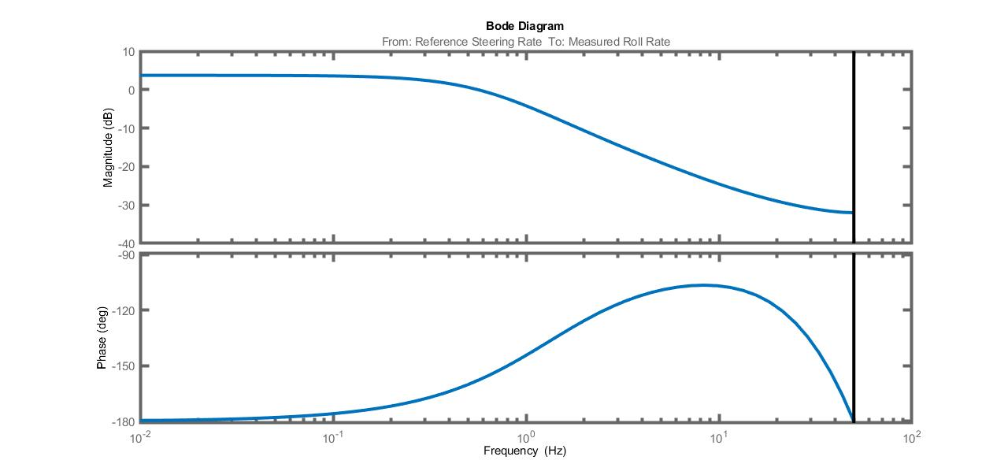

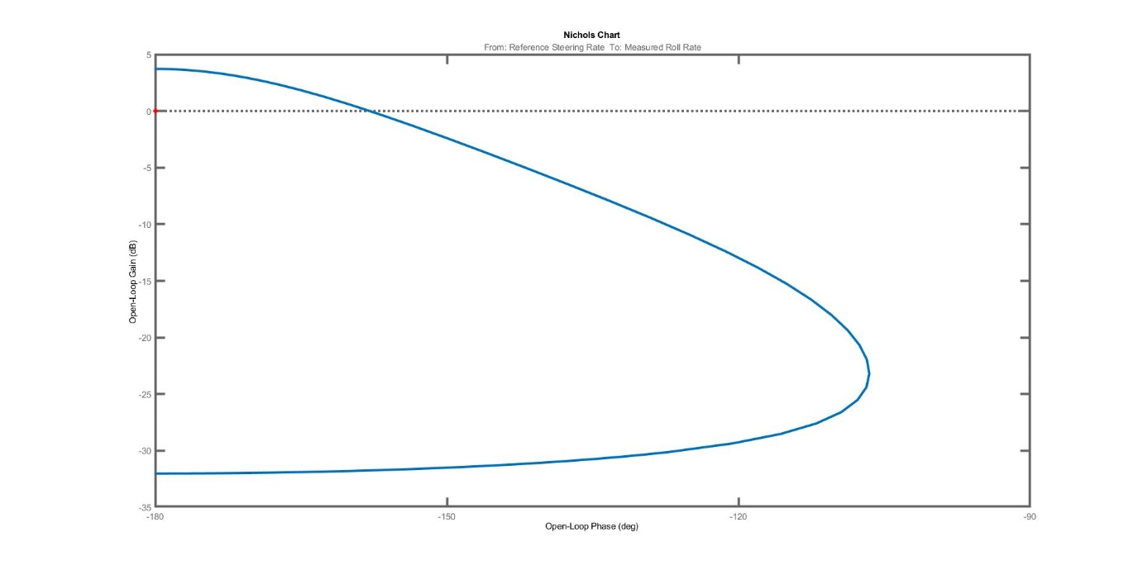

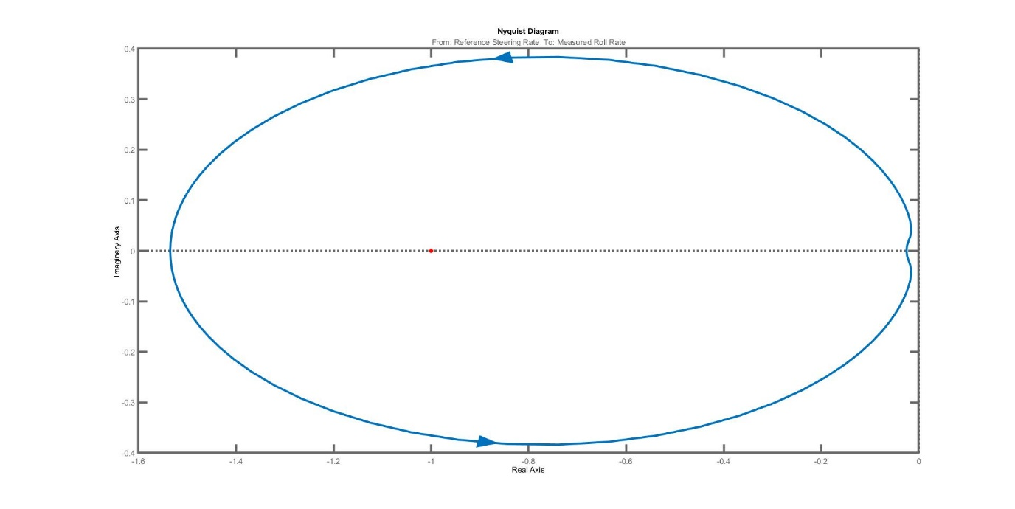

Closed loop block diagram :

-1

Bike

$$G_{bike}$$

Steering Motor

$$G_{steering}$$

$$\dot{ϕ}$$

PD Controller

PD controller :

$$PD\left(s\right)=K_{P}+K_{D}s$$

Closed loop equation in Laplace domain :

$$\left(1+PD\left(s\right) G_{steering}\left(s\right) G_{bike}\left(s\right)\right)\dot{ϕ}(s)=0$$

$$\frac{\left(bhs^{2}-bg\right)\left(s+245.9\right)+253.4\left(\frac{I_{front}b}{mh}s^{2}+aVs+V^{2}\right)\left(K_{P}+K_{D}s\right)}{\left(bhs^{2}-bg\right)\left(s+245.9\right)}=0$$

$$\left(bhs^{3}+245.9bhs^{2}-bgs-245.9bg\right)+\left(253.4\frac{I_{front}b}{mh}K_{P}s^{2}+253.4aVK_{P}s+253.4V^{2}K_{P}\right)+\left(253.4\frac{I_{front}b}{mh}K_{D}s^{3}+253.4aVK_{D}s+253.4V^{2}K_{D}\right)$$

$$\left(\right)s^{3}$$

The closed loop is stable iif $\left(1+PD\left(s\right) G_{steering}\left(s\right) G_{bike}\left(s\right)\right)$ has zeros with negative real part. For $V=4 m/s$, this is true for $K_{P}≥0.7$ and any positive value of $K_{D}$.