Current issues with the real bike

# Oscillations in the steering angle

The steering angle presents oscillations for LQR controllers with 0.2Hz or 0.7Hz bandwidth. Figure 1 shows the reference and obtained steering angle on the real bike as well as the steering angle obtained in simulation using the same reference. The oscillations are between 2 and 3Hz, varying for each test.

The dynamics of the steering motor are slower on the bike than in simulation as the red curve for steering angle on the real bike is always late with respect to the reference and simulated steering angles. Using cross-correlation we can estimated the following lags :

* Lag between reference and experimental steering angle : 0.35s (35 time steps)
* Lag between reference and simulated steering angle : 0.3s (3 time steps)
* Lag between reference and experimental steering rate : 0.01s (1 time step)
* Lag between reference and simulated steering rate : 0.01s (1 time step)

The 0.01s lag between refrence and experimental or simulated steering rate is due to the response time of the steering motor’s transfer function and is therefore not a delay in the system.

The 0.01s lag between refrence and simulated steering angle is due to the response time of the steering motor’s transfer function and the integrator from steering rate to steering angle and is therefore not a delay in the system. The lag between reference and experimental steering angle is larger and could indicate a delay in the real bike.

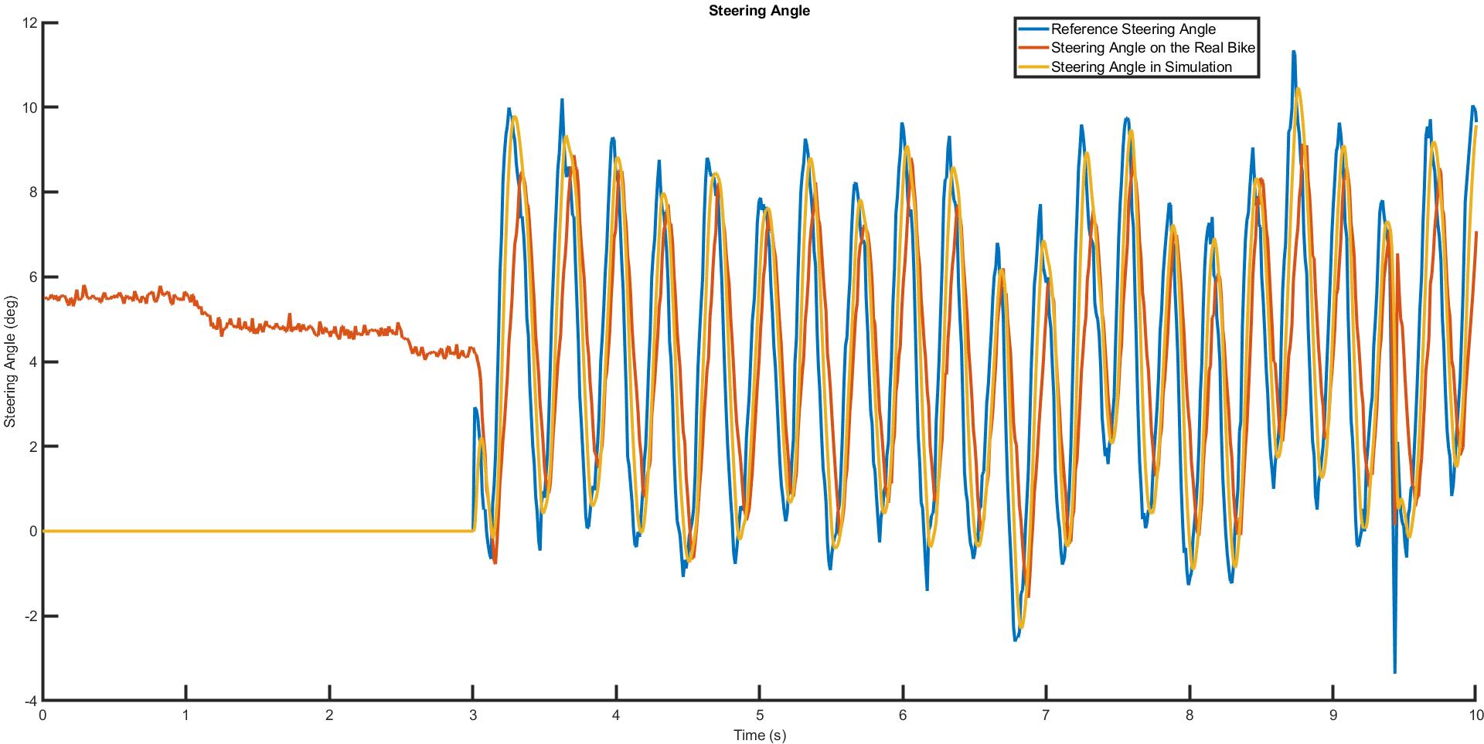

Figure - Oscillations in the steering angle

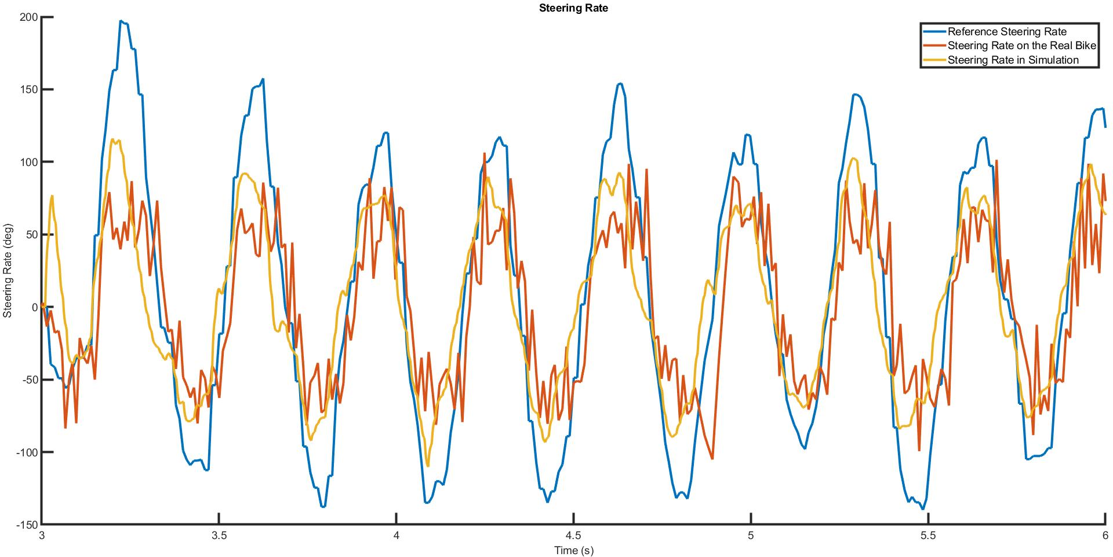

Figure - Steering Rate