The title

Meritxell Feliu Ribas1

1 Rutgers University

Author note

Complete departmental affiliations for each author (note the indentation, if you start a new paragraph). Enter author note here.

Correspondence concerning this article should be addressed to Meritxell Feliu Ribas, Postal address. E-mail: [mfeliuribas@spanport.rutgers.edu](mailto:mfeliuribas@spanport.rutgers.edu)

Abstract

Enter abstract here (note the indentation, if you start a new paragraph).

*Keywords:* keywords

*Word count:* X

The title

# Load libraries

library("papaja")  
r_refs("r-references.bib")  
library("tidyverse")  
library("ds4ling")  
library(here)

# Load data

attitude_raw <- read.csv(here("data_raw","attitude_data.csv"))

# Visualize data

head(attitude_raw)

## id age edu proficiency warmth_friendly  
## 1 007857_heritage_male 27 college 20 4  
## 2 009704_heritage_male 25 college 20 3  
## 3 003531_heritage_female 22 higher 22 4  
## 4 002170_heritage_female 28 college 21 4  
## 5 002865_heritage_male 26 college 34 4  
## 6 007280_heritage_male 23 hs 14 3  
## warmth_likeable warmth_helpful competence_intelligent competence_successful  
## 1 4 3 2 2  
## 2 3 3 1 1  
## 3 3 2 3 1  
## 4 3 2 1 2  
## 5 4 3 2 1  
## 6 4 2 1 2  
## competence_ambitious  
## 1 2  
## 2 2  
## 3 2  
## 4 4  
## 5 1  
## 6 1

glimpse(attitude_raw)

## Rows: 40  
## Columns: 10  
## $ id <chr> "007857_heritage_male", "009704_heritage_male",…  
## $ age <int> 27, 25, 22, 28, 26, 23, 19, 29, 32, 18, 23, 26,…  
## $ edu <chr> "college", "college", "higher", "college", "col…  
## $ proficiency <int> 20, 20, 22, 21, 34, 14, 23, 26, 15, 27, 26, 26,…  
## $ warmth_friendly <int> 4, 3, 4, 4, 4, 3, 4, 4, 3, 3, 3, 2, 3, 2, 4, 4,…  
## $ warmth_likeable <int> 4, 3, 3, 3, 4, 4, 3, 4, 2, 3, 4, 3, 3, 3, 3, 4,…  
## $ warmth_helpful <int> 3, 3, 2, 2, 3, 2, 3, 4, 3, 3, 3, 3, 1, 4, 3, 3,…  
## $ competence_intelligent <int> 2, 1, 3, 1, 2, 1, 1, 1, 4, 1, 2, 4, 2, 2, 2, 2,…  
## $ competence_successful <int> 2, 1, 1, 2, 1, 2, 3, 3, 2, 1, 1, 3, 4, 2, 1, 2,…  
## $ competence_ambitious <int> 2, 2, 2, 4, 1, 1, 1, 2, 1, 2, 1, 1, 4, 1, 1, 1,…

summary(attitude_raw)

## id age edu proficiency   
## Length:40 Min. :18.00 Length:40 Min. :13.00   
## Class :character 1st Qu.:22.75 Class :character 1st Qu.:21.00   
## Mode :character Median :26.50 Mode :character Median :26.00   
## Mean :25.90 Mean :26.55   
## 3rd Qu.:28.25 3rd Qu.:31.25   
## Max. :35.00 Max. :44.00   
## warmth_friendly warmth_likeable warmth_helpful competence_intelligent  
## Min. :2.00 Min. :2.00 Min. :1.00 Min. :1.000   
## 1st Qu.:3.00 1st Qu.:3.00 1st Qu.:3.00 1st Qu.:2.000   
## Median :4.00 Median :3.00 Median :3.00 Median :3.000   
## Mean :3.45 Mean :3.25 Mean :3.00 Mean :2.525   
## 3rd Qu.:4.00 3rd Qu.:4.00 3rd Qu.:3.25 3rd Qu.:3.000   
## Max. :4.00 Max. :4.00 Max. :4.00 Max. :4.000   
## competence_successful competence_ambitious  
## Min. :1.000 Min. :1.0   
## 1st Qu.:2.000 1st Qu.:1.0   
## Median :3.000 Median :2.5   
## Mean :2.575 Mean :2.5   
## 3rd Qu.:4.000 3rd Qu.:4.0   
## Max. :4.000 Max. :4.0

# Tidy data

attitude_tidy <- attitude_raw %>%  
 separate(  
 col = id,  
 into = c("id", "group", "gender"),  
 sep = "_"  
 ) %>%  
 write_csv(here("data_tidy", "attitude_tidy.csv"))

# Create variables

## rowws_df [40 × 14] (S3: rowwise_df/tbl_df/tbl/data.frame)  
## $ id : chr [1:40] "007857" "009704" "003531" "002170" ...  
## $ group : chr [1:40] "heritage" "heritage" "heritage" "heritage" ...  
## $ gender : chr [1:40] "male" "male" "female" "female" ...  
## $ age : int [1:40] 27 25 22 28 26 23 19 29 32 18 ...  
## $ edu : chr [1:40] "college" "college" "higher" "college" ...  
## $ proficiency : int [1:40] 20 20 22 21 34 14 23 26 15 27 ...  
## $ warmth_friendly : int [1:40] 4 3 4 4 4 3 4 4 3 3 ...  
## $ warmth_likeable : int [1:40] 4 3 3 3 4 4 3 4 2 3 ...  
## $ warmth_helpful : int [1:40] 3 3 2 2 3 2 3 4 3 3 ...  
## $ competence_intelligent: int [1:40] 2 1 3 1 2 1 1 1 4 1 ...  
## $ competence_successful : int [1:40] 2 1 1 2 1 2 3 3 2 1 ...  
## $ competence_ambitious : int [1:40] 2 2 2 4 1 1 1 2 1 2 ...  
## $ warmth_total : num [1:40] 3.67 3 3 3 3.67 ...  
## $ competence_total : num [1:40] 2 1.33 2 2.33 1.33 ...  
## - attr(*, "groups")= tibble [40 × 1] (S3: tbl_df/tbl/data.frame)  
## ..$ .rows: list<int> [1:40]   
## .. ..$ : int 1  
## .. ..$ : int 2  
## .. ..$ : int 3  
## .. ..$ : int 4  
## .. ..$ : int 5  
## .. ..$ : int 6  
## .. ..$ : int 7  
## .. ..$ : int 8  
## .. ..$ : int 9  
## .. ..$ : int 10  
## .. ..$ : int 11  
## .. ..$ : int 12  
## .. ..$ : int 13  
## .. ..$ : int 14  
## .. ..$ : int 15  
## .. ..$ : int 16  
## .. ..$ : int 17  
## .. ..$ : int 18  
## .. ..$ : int 19  
## .. ..$ : int 20  
## .. ..$ : int 21  
## .. ..$ : int 22  
## .. ..$ : int 23  
## .. ..$ : int 24  
## .. ..$ : int 25  
## .. ..$ : int 26  
## .. ..$ : int 27  
## .. ..$ : int 28  
## .. ..$ : int 29  
## .. ..$ : int 30  
## .. ..$ : int 31  
## .. ..$ : int 32  
## .. ..$ : int 33  
## .. ..$ : int 34  
## .. ..$ : int 35  
## .. ..$ : int 36  
## .. ..$ : int 37  
## .. ..$ : int 38  
## .. ..$ : int 39  
## .. ..$ : int 40  
## .. ..@ ptype: int(0)

# Descriptive Stats

attitude_final %>%  
 group_by(group) %>%   
 summarize(  
 mean_proficiency = mean(proficiency),  
 median_proficiency = median(proficiency),  
 sd_proficiency = sd(proficiency),  
 min_proficiency = min(proficiency),  
 max_proficiency = max(proficiency),  
 ) %>%  
 knitr::kable(  
 caption = "Descriptive Stats for Proficiency by Group.",  
 col.names = c("Group", "Mean", "Median", "Sd", "Min", "Max")  
 )

Table 1: Descriptive Stats for Proficiency by Group.

| Group | Mean | Median | Sd | Min | Max |
| --- | --- | --- | --- | --- | --- |
| heritage | 21.55 | 21 | 5.306153 | 13 | 34 |
| monolingual | 31.55 | 31 | 5.306153 | 23 | 44 |

attitude_final %>%  
 group_by(group, edu) %>%   
 summarize(  
 mean_proficiency = mean(proficiency),  
 median_proficiency = median(proficiency),  
 sd_proficiency = sd(proficiency),  
 min_proficiency = min(proficiency),  
 max_proficiency = max(proficiency),  
 ) %>%  
 knitr::kable(  
 caption = "Descriptive Stats for Proficiency by Group and Education.",  
 col.names = c("Group", "Education", "Mean", "Median", "Sd", "Min", "Max")  
 )

Table 2: Descriptive Stats for Proficiency by Group and Education.

| Group | Education | Mean | Median | Sd | Min | Max |
| --- | --- | --- | --- | --- | --- | --- |
| heritage | college | 21.41667 | 20.5 | 5.212892 | 15 | 34 |
| heritage | higher | 25.00000 | 26.0 | 2.645751 | 22 | 27 |
| heritage | hs | 19.80000 | 19.0 | 6.534524 | 13 | 27 |
| monolingual | college | 31.41667 | 30.5 | 5.212892 | 25 | 44 |
| monolingual | higher | 35.00000 | 36.0 | 2.645751 | 32 | 37 |
| monolingual | hs | 29.80000 | 29.0 | 6.534524 | 23 | 37 |

attitude_final %>%  
 group_by(group) %>%   
 summarize(  
 mean_warmth_total = mean(warmth_total),  
 median_warmth_total = median(warmth_total),  
 sd_warmth_total = sd(warmth_total),  
 min_warmth_total = min(warmth_total),  
 max_warmth_total = max(warmth_total),  
 ) %>%  
 knitr::kable(  
 caption = "Descriptive Stats for Warmth by Group.",  
 col.names = c("Group", "Mean", "Median", "Sd", "Min", "Max")  
 )

Table 3: Descriptive Stats for Warmth by Group.

| Group | Mean | Median | Sd | Min | Max |
| --- | --- | --- | --- | --- | --- |
| heritage | 3.233333 | 3.166667 | 0.4472136 | 2.333333 | 4 |
| monolingual | 3.233333 | 3.166667 | 0.4472136 | 2.333333 | 4 |

attitude_final %>%  
 group_by(group, edu) %>%   
 summarize(  
 mean_warmth_total = mean(warmth_total),  
 median_warmth_total = median(warmth_total),  
 sd_warmth_total = sd(warmth_total),  
 min_warmth_total = min(warmth_total),  
 max_warmth_total = max(warmth_total),  
 ) %>%  
 knitr::kable(  
 caption = "Descriptive Stats for Warmth by Group and Education.",  
 col.names = c("Group", "Education", "Mean", "Median", "Sd", "Min", "Max")  
 )

Table 4: Descriptive Stats for Warmth by Group and Education.

| Group | Education | Mean | Median | Sd | Min | Max |
| --- | --- | --- | --- | --- | --- | --- |
| heritage | college | 3.305556 | 3.333333 | 0.4371241 | 2.666667 | 4.000000 |
| heritage | higher | 3.333333 | 3.000000 | 0.5773503 | 3.000000 | 4.000000 |
| heritage | hs | 3.000000 | 3.000000 | 0.4082483 | 2.333333 | 3.333333 |
| monolingual | college | 3.305556 | 3.333333 | 0.4371241 | 2.666667 | 4.000000 |
| monolingual | higher | 3.333333 | 3.000000 | 0.5773503 | 3.000000 | 4.000000 |
| monolingual | hs | 3.000000 | 3.000000 | 0.4082483 | 2.333333 | 3.333333 |

attitude_final %>%  
 group_by(group) %>%   
 summarize(  
 mean_competence_total = mean(competence_total),  
 median_competence_total = median(competence_total),  
 sd_competence_total = sd(competence_total),  
 min_competence_total = min(competence_total),  
 max_competence_total = max(competence_total),  
 ) %>%  
 knitr::kable(  
 caption = "Descriptive Stats for Competence by Group.",  
 col.names = c("Group", "Mean", "Median", "Sd", "Min", "Max")  
 )

Table 5: Descriptive Stats for Competence by Group.

| Group | Mean | Median | Sd | Min | Max |
| --- | --- | --- | --- | --- | --- |
| heritage | 1.833333 | 1.666667 | 0.5567239 | 1.333333 | 3.333333 |
| monolingual | 3.233333 | 3.500000 | 0.5629912 | 1.666667 | 3.666667 |

attitude_final %>%  
 group_by(group, edu) %>%   
 summarize(  
 mean_competence_total = mean(competence_total),  
 median_competence_total = median(competence_total),  
 sd_competence_total = sd(competence_total),  
 min_competence_total = min(competence_total),  
 max_competence_total = max(competence_total),  
 ) %>%  
 knitr::kable(  
 caption = "Descriptive Stats for Competence by Group and Education.",  
 col.names = c("Group", "Education", "Mean", "Median", "Sd", "Min", "Max")  
 )

Table 6: Descriptive Stats for Competence by Group and Education.

| Group | Education | Mean | Median | Sd | Min | Max |
| --- | --- | --- | --- | --- | --- | --- |
| heritage | college | 1.805556 | 1.666667 | 0.4596515 | 1.333333 | 2.666667 |
| heritage | higher | 1.777778 | 2.000000 | 0.3849002 | 1.333333 | 2.000000 |
| heritage | hs | 1.933333 | 1.333333 | 0.8944272 | 1.333333 | 3.333333 |
| monolingual | college | 3.277778 | 3.500000 | 0.4889348 | 2.333333 | 3.666667 |
| monolingual | higher | 3.222222 | 3.000000 | 0.3849002 | 3.000000 | 3.666667 |
| monolingual | hs | 3.133333 | 3.666667 | 0.8692270 | 1.666667 | 3.666667 |

# Plots

attitude_final %>%   
 ggplot() +   
 aes(x = group, y = warmth_total) +   
 geom_boxplot() +  
 labs(x = "Group", y = "Warmth",  
 title = "Warmth by Group")

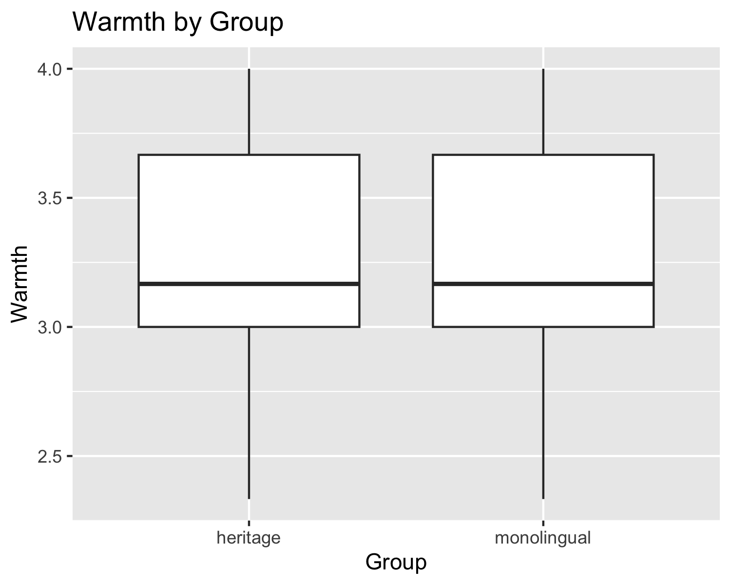 # No hay diferencias entre grupos en cuanto a la percepción del castellano en # términos de warmth.

attitude_final %>%   
 ggplot() +   
 aes(x = group, y = competence_total) +   
 geom_boxplot() +  
 labs(x = "Group", y = "Competence",  
 title = "Competence by Group")

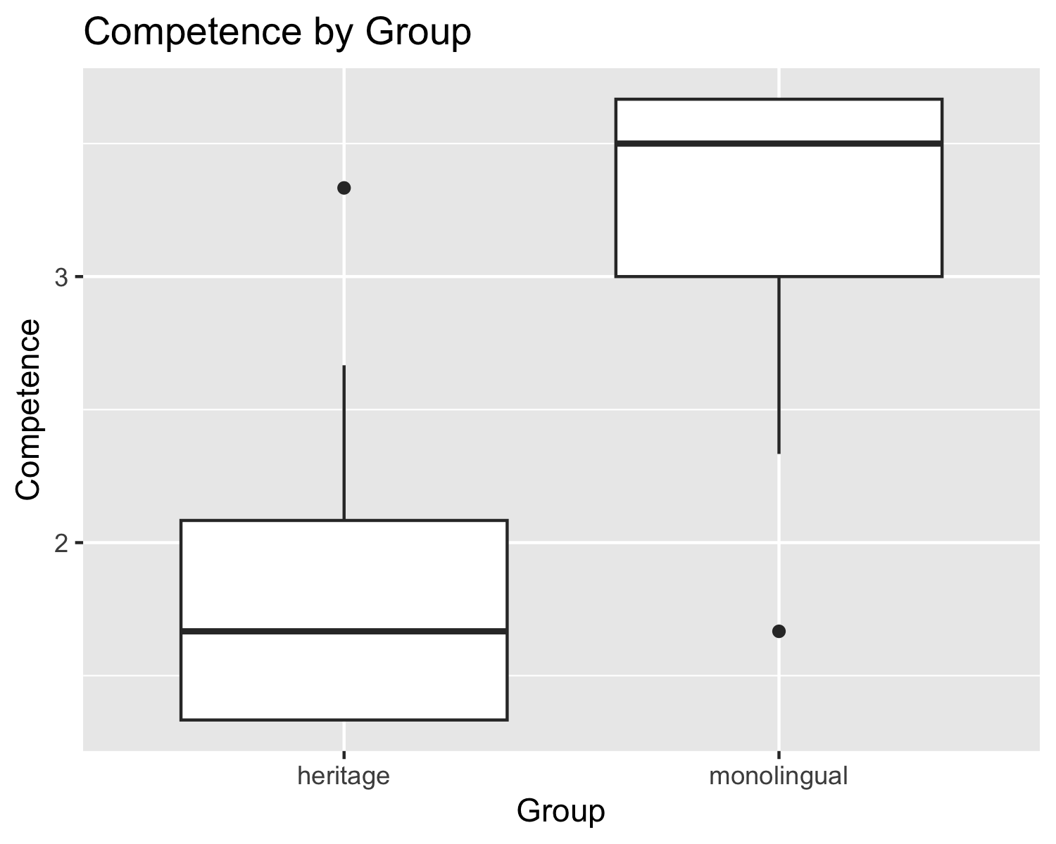 # Hay diferencias entre grupos en cuanto a la percepción del castellano en # términos de competence. Los monolingües valoran más positivamente esta # variedad que los hablantes de herencia en cuanto a inteligencia, éxito y # ambición.

attitude_final %>%   
 ggplot() +   
 aes(x = group, y = warmth_total) +   
 facet_grid(. ~ edu) +  
 geom_boxplot() +  
 labs(x = "Education", y = "Warmth",  
 title = "Warmth by Education and Group")

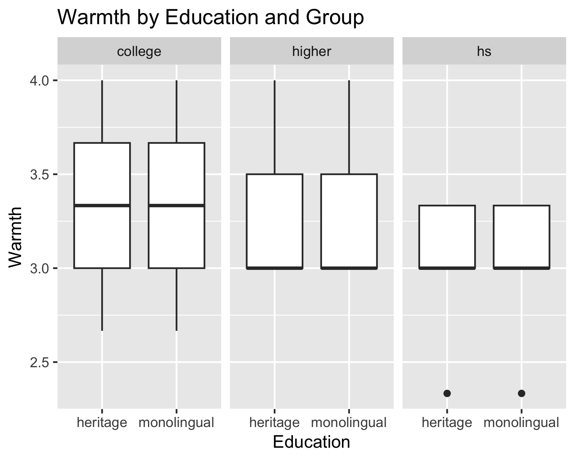

attitude_final %>%   
 ggplot() +   
 aes(x = group, y = warmth_total) +   
 facet_grid(. ~ edu) +  
 geom_point() +  
 labs(x = "Education", y = "Warmth",  
 title = "Warmth by Education and Group")

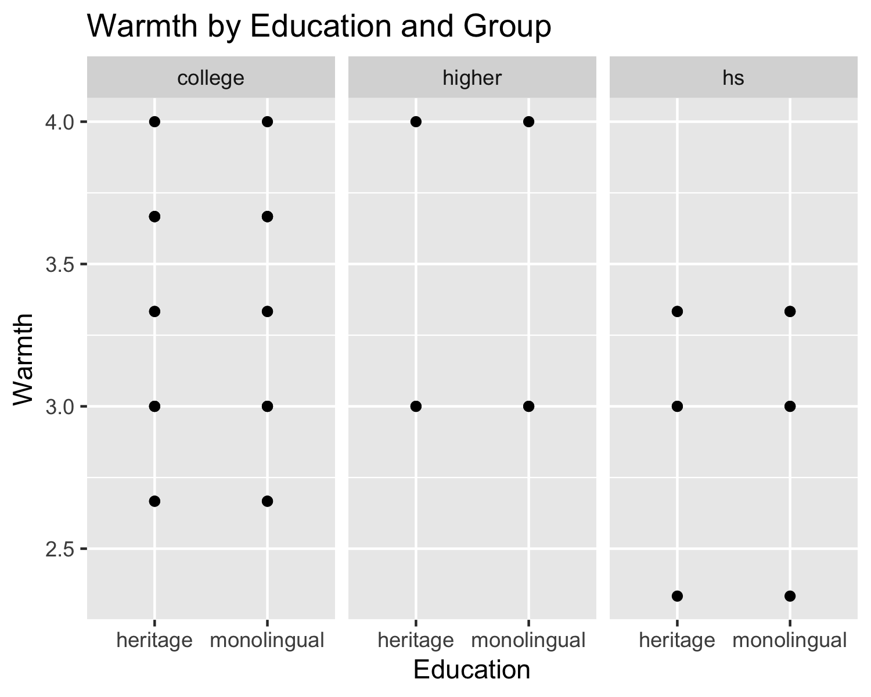 # El descriptive stats ya nos aporta esta info, pero el plot es más visual. # No hay diferencias entre grupos en cuanto a la percepción del castellano # en términos de warmth. Sin embargo, vemos que hay bastante variabilidad de # opiniones en los participantes que han hecho una carrera en comparación con # los que solo han estudiado en el instituto.

attitude_final %>%   
 ggplot() +   
 aes(x = proficiency, y = warmth_total, color = group) +   
 geom_point() +  
 geom_smooth() +  
 labs(x = "Proficiency", y = "Warmth",  
 title = "Warmth by Proficiency and Group")

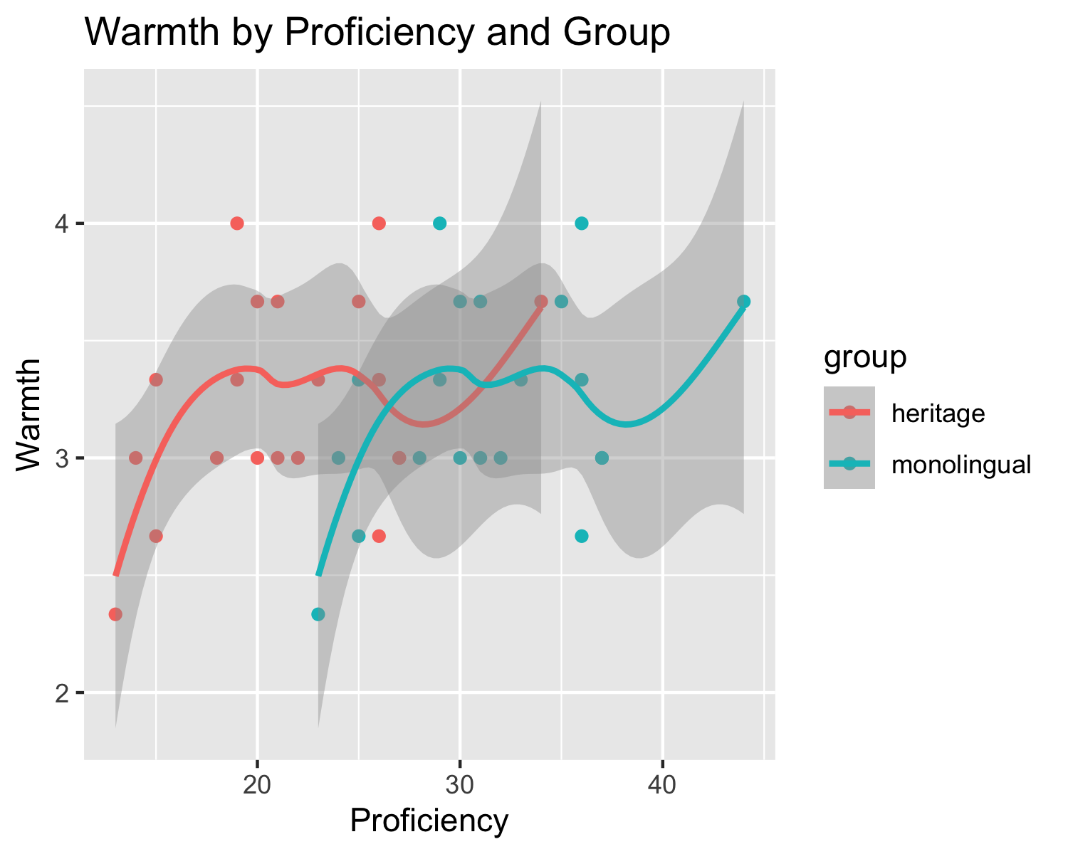 # Otra vez, la tendencia entre grupos es parecida, aunque aquí vemos que los # monolingües tienen, en general, más proficiencia en español. No obstante, los # puntos de datos están muy dispersos y no siguen la línea, por lo que podríamos # pensar (es probable) que no hay una correlación entre proficiency y percepción # en términos de warmth. Esto se deberá # analizar en el modelo.

attitude_final %>%   
 ggplot() +   
 aes(x = group, y = competence_total) +   
 facet_grid(. ~ edu) +  
 geom_boxplot() +  
 labs(x = "Education", y = "Competence",  
 title = "Competence by Education and Group")

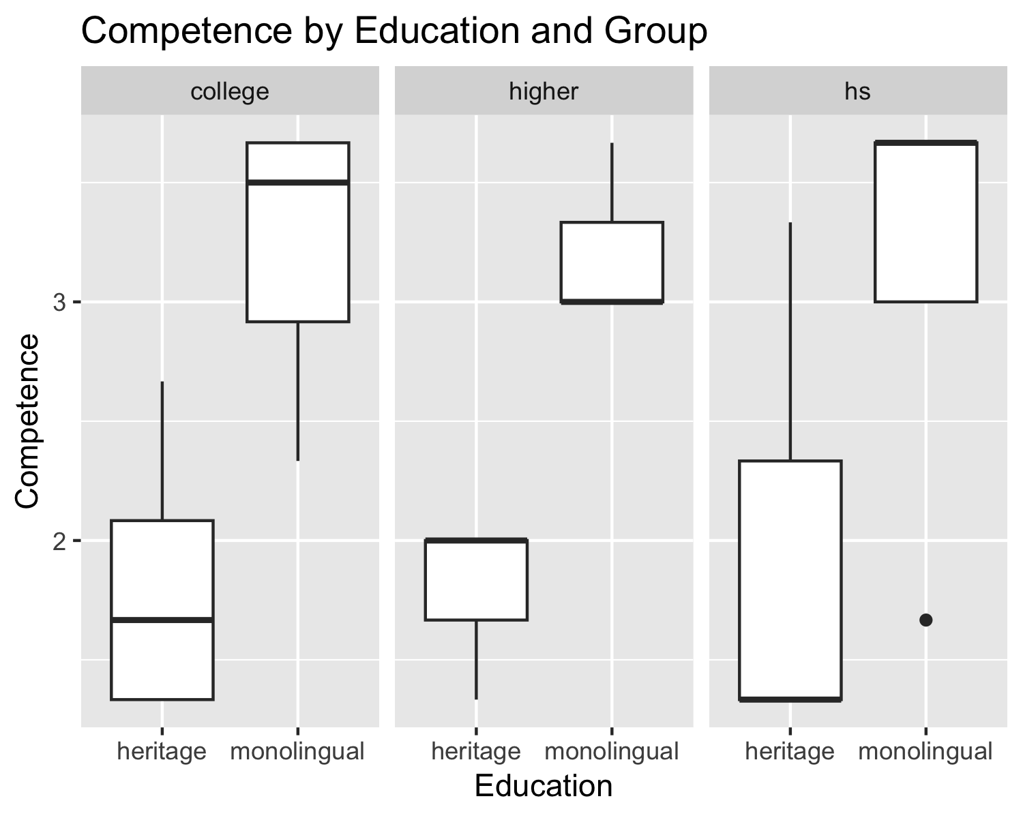 # Los monolingües valoran más positivamente el castellano en términos de # competence comparado con los hablantes de herencia, por lo que hay una # diferencia entre grupos. El modelo nos va a decir si esta diferencia es # significativa o no. Asimismo, y como ha pasado con warmth pero en niveles # opuestos, vemos que hay bastante variabilidad de opiniones en los # participantes que solo han estudiado en el instituto comparado con los que # han hecho un máster o un doctorado, que tienen opiniones más parecidas.

attitude_final %>%   
 ggplot() +   
 aes(x = proficiency, y = competence_total, color = group) +   
 geom_point() +  
 geom_smooth() +  
 labs(x = "Proficiency", y = "Competence",  
 title = "Competence by Proficiency and Group")

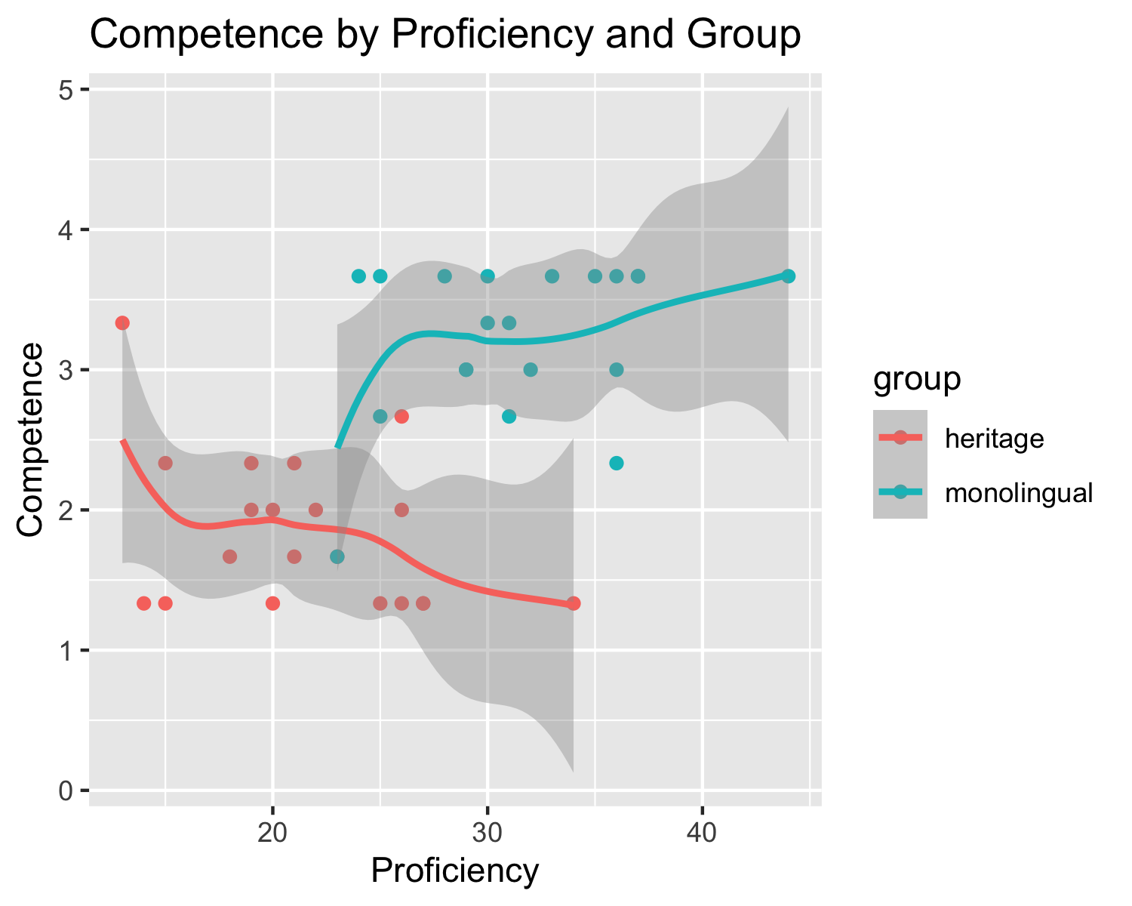 # Parece que hay una tendencia opuesta entre grupos. En los monolingües, cuanto # más proficiencia en español, se valora más positivamente la propia variedad # en términos de competence (correlación positiva). En el caso de los hablantes # de herencia, esta tendencia es contraria (correlación negativa). Es posible # que proficiency no tenga ningún efecto sobre competence. Esto se tiene que # mirar en nuestro modelo.

attitude_final %>%   
 ggplot() +   
 aes(x = edu, y = competence_total) +   
 geom_boxplot() +  
 labs(x = "Education", y = "Competence",  
 title = "Competence by Education")

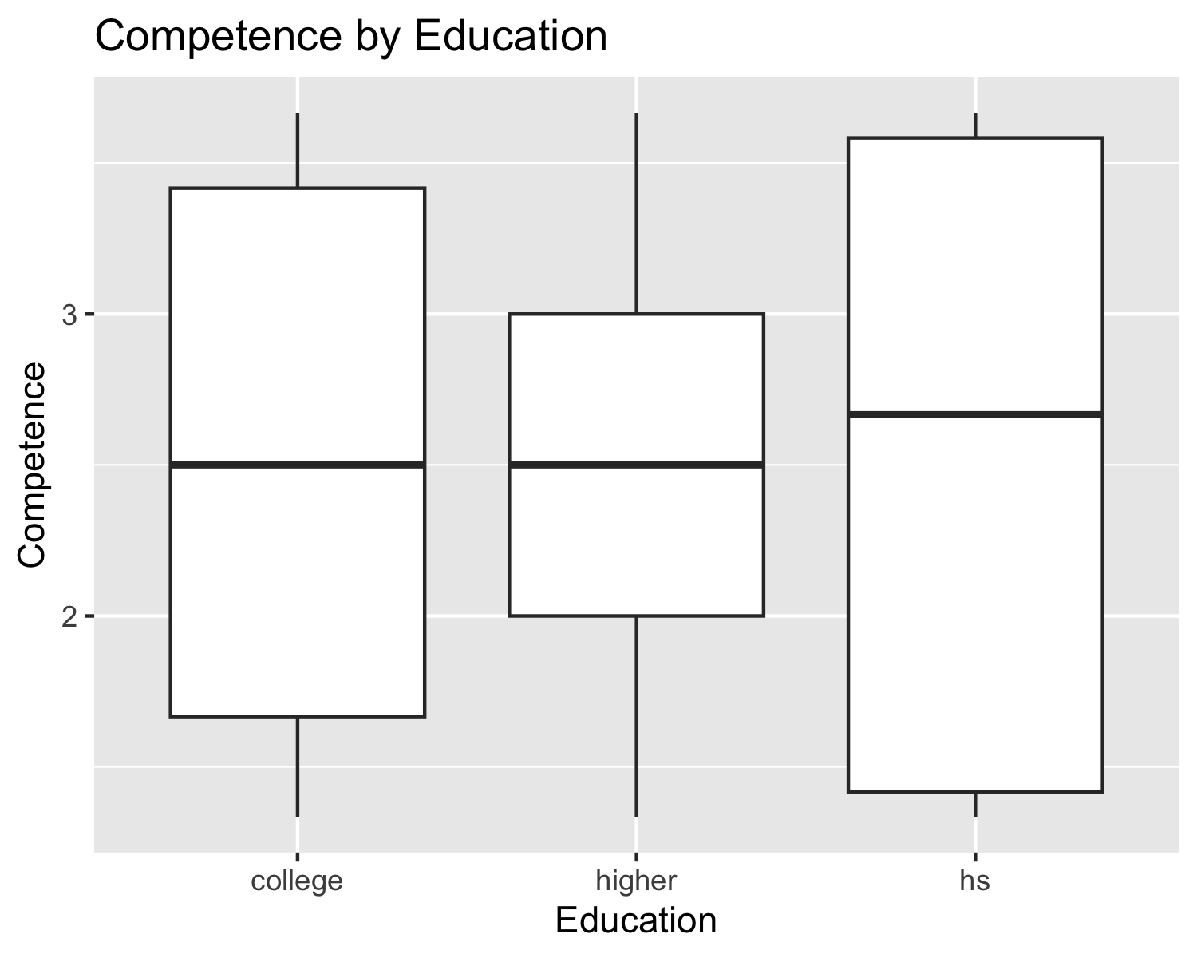 # Parece que hay diferencias en la valoración de la propia variedad en términos # de competence en función del nivel educativo.

attitude_final %>%   
 ggplot() +   
 aes(x = proficiency, y = competence_total) +   
 geom_point() +  
 geom_smooth() +  
 labs(x = "Proficiency", y = "Competence",  
 title = "Competence by Proficiency")

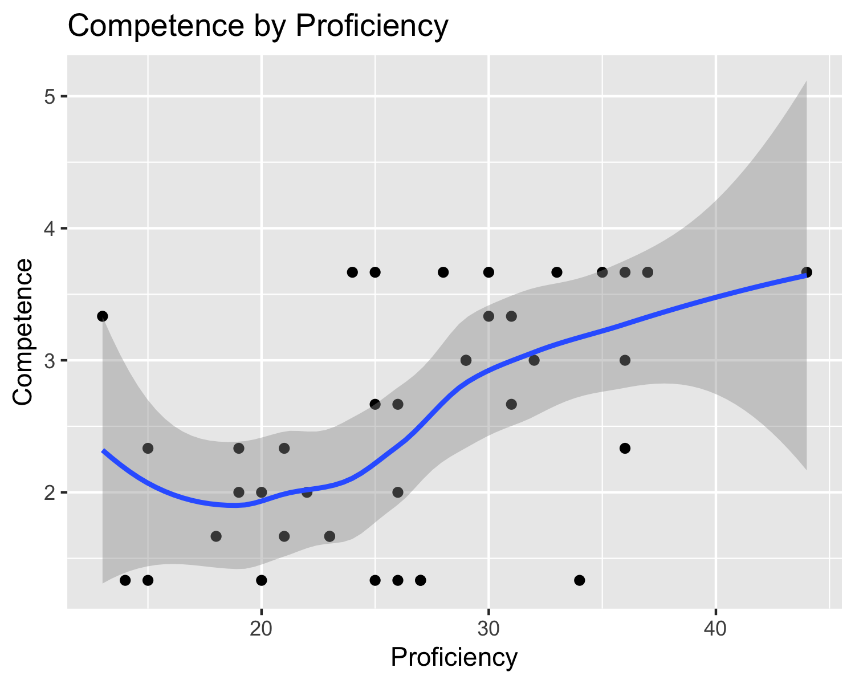 # Parece que, cuanta más proficiencia, hay cierta tendencia a valorar más # positivamente a la propia variedad en términos de competence.

attitude_final %>%   
 ggplot() +   
 aes(x = edu, y = warmth_total) +   
 geom_boxplot() +  
 labs(x = "Education", y = "Warmth",  
 title = "Warmth by Education")

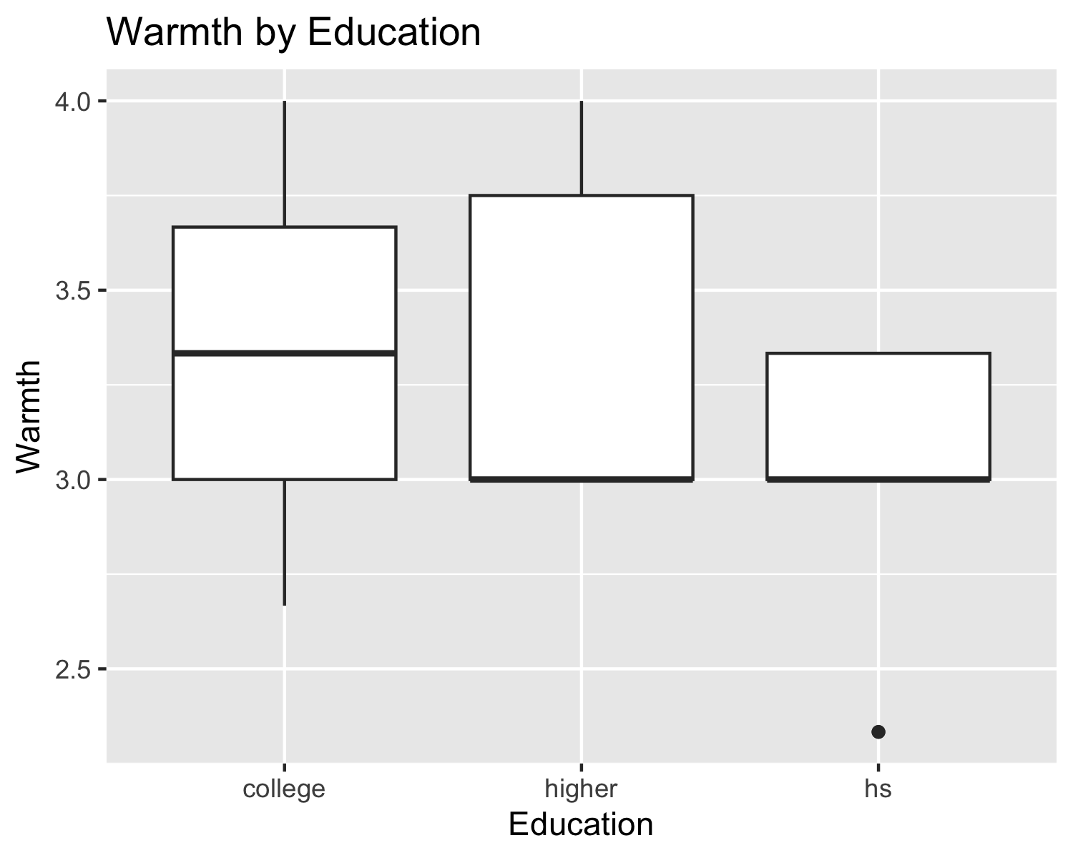 # Parece que hay diferencias en la valoración de la propia variedad en términos # de warmth en función del nivel educativo, pero es menor que en competence.

attitude_final %>%   
 ggplot() +   
 aes(x = proficiency, y = warmth_total) +   
 geom_point() +  
 geom_smooth() +  
 labs(x = "Proficiency", y = "Warmth",  
 title = "Warmth by Proficiency")

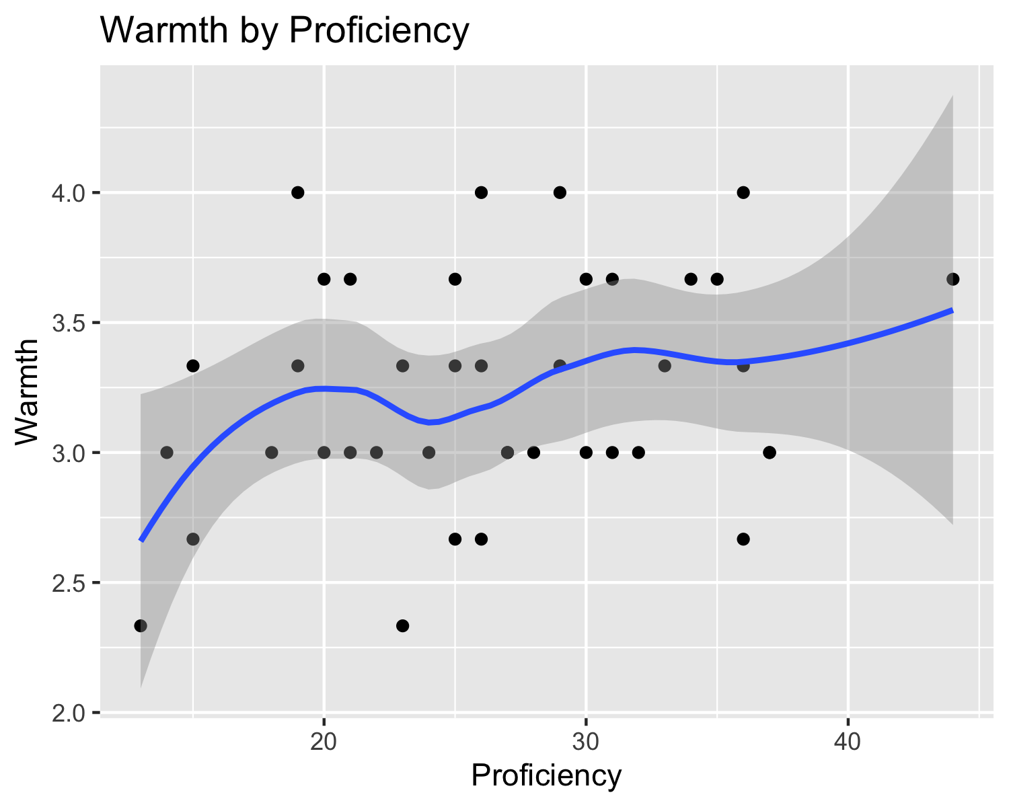 # Parece que proficiency no afecta a cómo se valora la propia variedad en # términos de warmth.

# ¿Qué hemos observado hasta ahora?

# 1. Parece que no hay diferencias entre grupos en cuanto a la percepción del

# castellano en términos de warmth, pero sí de competence. El modelo nos va a

# decir si esta diferencia de percepción del castellano en términos de

# competence es significativa.

# 2. Es posible que proficiency no afecte a la percepción del castellano, pero

# se debe mirar en el modelo.

# 3. Puede ser que el nivel educativo afecte a la percepción del castellano.

# Asimismo, hay bastante variabilidad individual entre niveles educativos. Esto

# se debe mirar en el modelo.

# 4. El modelo nos dirá si la pertenencia de grupo, la proficiencia en español

# y el nivel educativo tienen algún impacto en la percepción del castellano en

# términos de warmth y competence.

# Analysis

# Models (warmth)

# Main effects testing (warmth)

## Analysis of Variance Table  
##   
## Model 1: warmth_total ~ 1  
## Model 2: warmth_total ~ group  
## Model 3: warmth_total ~ group + proficiency  
## Model 4: warmth_total ~ group + proficiency + edu  
## Res.Df RSS Df Sum of Sq F Pr(>F)   
## 1 39 7.6000   
## 2 38 7.6000 1 0.00000 0.0000 1.0000   
## 3 37 6.5904 1 1.00964 5.7742 0.0217 *  
## 4 35 6.1199 2 0.47043 1.3452 0.2736   
## ---  
## Signif. codes: 0 '***' 0.001 '**' 0.01 '*' 0.05 '.' 0.1 ' ' 1

## Analysis of Variance Table  
##   
## Model 1: warmth_total ~ 1  
## Model 2: warmth_total ~ group  
## Model 3: warmth_total ~ group + proficiency  
## Model 4: warmth_total ~ group + proficiency + group:proficiency  
## Res.Df RSS Df Sum of Sq F Pr(>F)   
## 1 39 7.6000   
## 2 38 7.6000 1 0.0000 0.0000 1.00000   
## 3 37 6.5904 1 1.0096 5.5152 0.02446 *  
## 4 36 6.5904 1 0.0000 0.0000 1.00000   
## ---  
## Signif. codes: 0 '***' 0.001 '**' 0.01 '*' 0.05 '.' 0.1 ' ' 1

# Summary and assumptions of the best model (warmth)

##   
## Call:  
## lm(formula = warmth_total ~ group + proficiency, data = attitude_final)  
##   
## Residuals:  
## Min 1Q Median 3Q Max   
## -0.70337 -0.27673 -0.01905 0.30775 0.84500   
##   
## Coefficients:  
## Estimate Std. Error t value Pr(>|t|)   
## (Intercept) 2.57133 0.29363 8.757 1.5e-10 ***  
## groupmonolingual -0.30719 0.18563 -1.655 0.1064   
## proficiency 0.03072 0.01290 2.381 0.0225 *   
## ---  
## Signif. codes: 0 '***' 0.001 '**' 0.01 '*' 0.05 '.' 0.1 ' ' 1  
##   
## Residual standard error: 0.422 on 37 degrees of freedom  
## Multiple R-squared: 0.1328, Adjusted R-squared: 0.08597   
## F-statistic: 2.834 on 2 and 37 DF, p-value: 0.07158

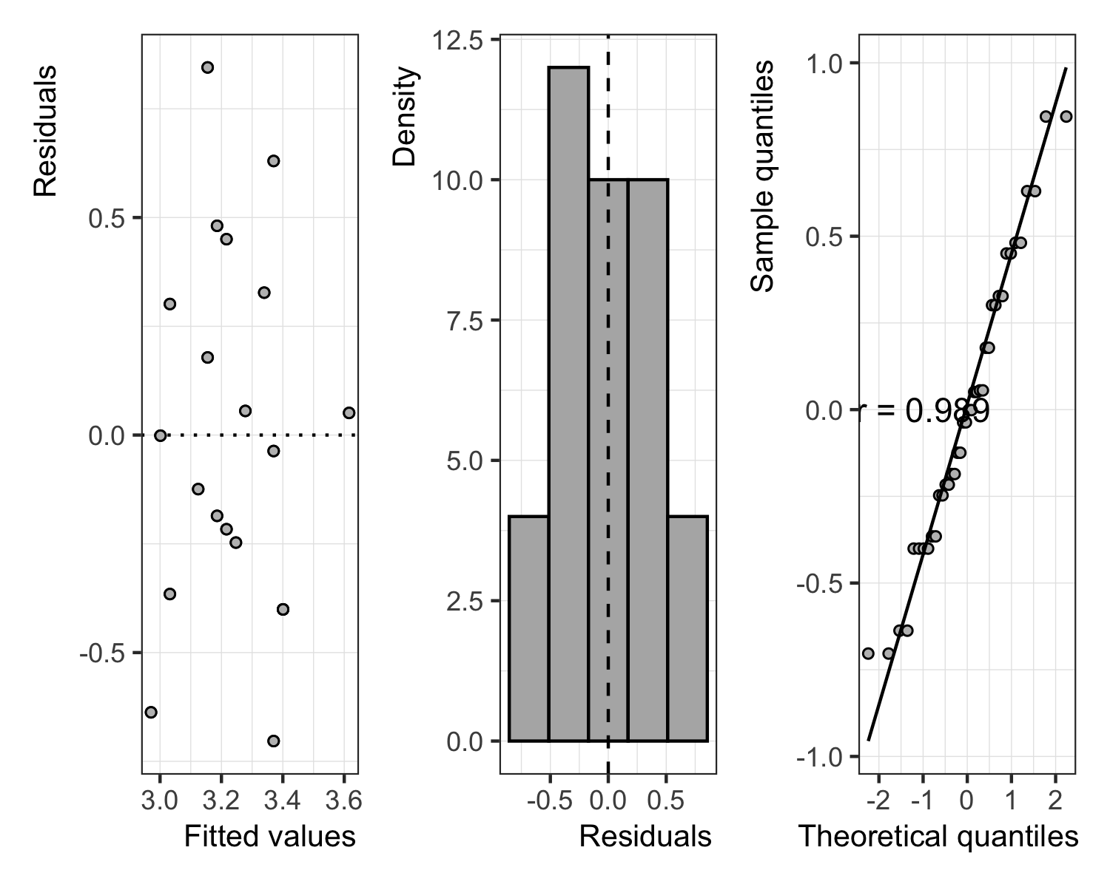

##   
## Call:  
## lm(formula = warmth_total ~ group + proficiency + edu, data = attitude_final)  
##   
## Residuals:  
## Min 1Q Median 3Q Max   
## -0.76654 -0.27306 -0.00284 0.28489 0.76175   
##   
## Coefficients:  
## Estimate Std. Error t value Pr(>|t|)   
## (Intercept) 2.70907 0.30750 8.810 2.09e-10 ***  
## groupmonolingual -0.27851 0.18857 -1.477 0.1486   
## proficiency 0.02785 0.01344 2.072 0.0457 *   
## eduhigher -0.07202 0.19685 -0.366 0.7167   
## eduhs -0.26053 0.15888 -1.640 0.1100   
## ---  
## Signif. codes: 0 '***' 0.001 '**' 0.01 '*' 0.05 '.' 0.1 ' ' 1  
##   
## Residual standard error: 0.4182 on 35 degrees of freedom  
## Multiple R-squared: 0.1947, Adjusted R-squared: 0.1027   
## F-statistic: 2.116 on 4 and 35 DF, p-value: 0.09956

# Models (competence)

# Main effects testing (competence)

## Analysis of Variance Table  
##   
## Model 1: competence_total ~ 1  
## Model 2: competence_total ~ group  
## Model 3: competence_total ~ group + proficiency  
## Model 4: competence_total ~ group + proficiency + edu  
## Res.Df RSS Df Sum of Sq F Pr(>F)   
## 1 39 31.511   
## 2 38 11.911 1 19.6000 57.6427 6.683e-09 ***  
## 3 37 11.907 1 0.0040 0.0117 0.9143   
## 4 35 11.901 2 0.0062 0.0092 0.9909   
## ---  
## Signif. codes: 0 '***' 0.001 '**' 0.01 '*' 0.05 '.' 0.1 ' ' 1

# Summary and assumptions of the best model (competence)

##   
## Call:  
## lm(formula = competence_total ~ group, data = attitude_final)  
##   
## Residuals:  
## Min 1Q Median 3Q Max   
## -1.5667 -0.5000 0.1000 0.4333 1.5000   
##   
## Coefficients:  
## Estimate Std. Error t value Pr(>|t|)   
## (Intercept) 1.8333 0.1252 14.644 < 2e-16 ***  
## groupmonolingual 1.4000 0.1770 7.908 1.51e-09 ***  
## ---  
## Signif. codes: 0 '***' 0.001 '**' 0.01 '*' 0.05 '.' 0.1 ' ' 1  
##   
## Residual standard error: 0.5599 on 38 degrees of freedom  
## Multiple R-squared: 0.622, Adjusted R-squared: 0.6121   
## F-statistic: 62.53 on 1 and 38 DF, p-value: 1.507e-09

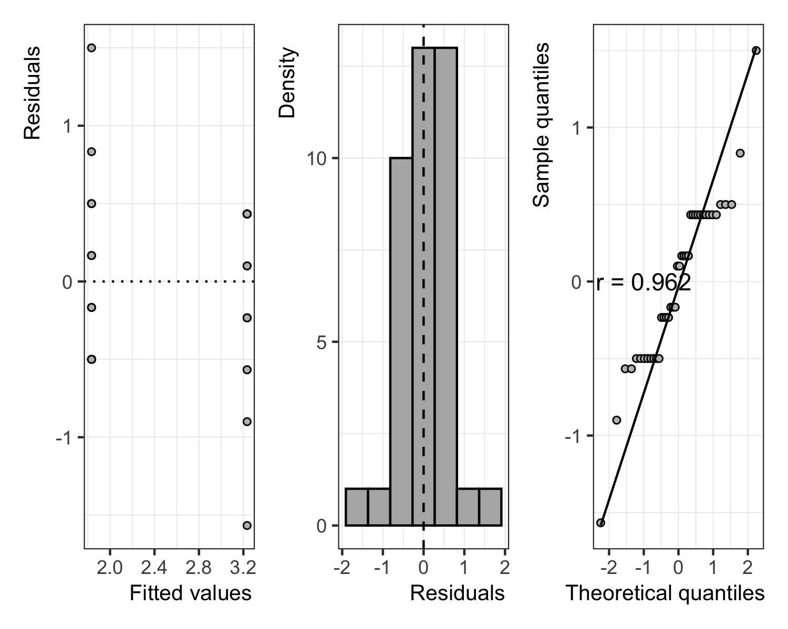

# Methods

We report how we determined our sample size, all data exclusions (if any), all manipulations, and all measures in the study.

## Participants

## Material

## Procedure

## Data analysis

We used R (Version 4.2.2; R Core Team, 2022) and the R-packages *dplyr* (Version 1.1.0; Wickham, François, Henry, Müller, & Vaughan, 2023), *ds4ling* (Version 0.7; Casillas, 2023), *forcats* (Version 1.0.0; Wickham, 2023), *ggplot2* (Version 3.4.0; Wickham, 2016), *here* (Version 1.0.1; Müller, 2020), *kableExtra* (Version 1.3.4; Zhu, 2021), *papaja* (Version 0.1.1; Aust & Barth, 2022), *purrr* (Version 1.0.1; Wickham & Henry, 2023), *readr* (Version 2.1.3; Wickham, Hester, & Bryan, 2022), *stringr* (Version 1.5.0; Wickham, 2022), *tibble* (Version 3.2.1; Müller & Wickham, 2023), *tidyr* (Version 1.3.0; Wickham, Vaughan, & Girlich, 2023), *tidyverse* (Version 1.3.2; Wickham et al., 2019), and *tinylabels* (Version 0.2.3; Barth, 2022) for all our analyses.

# Results

# Discussion

# References

Aust, F., & Barth, M. (2022). *papaja: Prepare reproducible APA journal articles with R Markdown*. Retrieved from <https://github.com/crsh/papaja>

Barth, M. (2022). *tinylabels: Lightweight variable labels*. Retrieved from <https://cran.r-project.org/package=tinylabels>

Casillas, J. (2023). *ds4ling: Datasets and functions developed for SPAN589: Data science for linguists*. Retrieved from <https://github.com/jvcasillas/ds4ling>

Müller, K. (2020). *Here: A simpler way to find your files*. Retrieved from <https://CRAN.R-project.org/package=here>

Müller, K., & Wickham, H. (2023). *Tibble: Simple data frames*. Retrieved from <https://CRAN.R-project.org/package=tibble>

R Core Team. (2022). *R: A language and environment for statistical computing*. Vienna, Austria: R Foundation for Statistical Computing. Retrieved from <https://www.R-project.org/>

Wickham, H. (2016). *ggplot2: Elegant graphics for data analysis*. Springer-Verlag New York. Retrieved from <https://ggplot2.tidyverse.org>

Wickham, H. (2022). *Stringr: Simple, consistent wrappers for common string operations*. Retrieved from <https://CRAN.R-project.org/package=stringr>

Wickham, H. (2023). *Forcats: Tools for working with categorical variables (factors)*. Retrieved from <https://CRAN.R-project.org/package=forcats>

Wickham, H., Averick, M., Bryan, J., Chang, W., McGowan, L. D., François, R., … Yutani, H. (2019). Welcome to the tidyverse. *Journal of Open Source Software*, *4*(43), 1686. <https://doi.org/10.21105/joss.01686>

Wickham, H., François, R., Henry, L., Müller, K., & Vaughan, D. (2023). *Dplyr: A grammar of data manipulation*. Retrieved from <https://CRAN.R-project.org/package=dplyr>

Wickham, H., & Henry, L. (2023). *Purrr: Functional programming tools*. Retrieved from <https://CRAN.R-project.org/package=purrr>

Wickham, H., Hester, J., & Bryan, J. (2022). *Readr: Read rectangular text data*. Retrieved from <https://CRAN.R-project.org/package=readr>

Wickham, H., Vaughan, D., & Girlich, M. (2023). *Tidyr: Tidy messy data*. Retrieved from <https://CRAN.R-project.org/package=tidyr>

Zhu, H. (2021). *kableExtra: Construct complex table with ’kable’ and pipe syntax*. Retrieved from <https://CRAN.R-project.org/package=kableExtra>