Seeburger AS2 Spoke Polling Installation V3.0.2

Following document includes Seeburger Spoke (AS2) requirements, installation, and configuration information.

1 Hardware Requirements: 2
2 Software Requirements: 2
3 Install Seeburger Spoke: 3
3.1 Start Spoke: 11
4 Spoke configuration: 12
4.1 Configurations to receive files from HP: 12
4.1.1 File Handling Action: 12
4.1.2 AS2 Controller: 13
4.2 Configurations to send files to HP: 14
4.2.1 AS2 Transfer Action: 14
4.2.2 BIS 6 Polling 18
4.2.3 File Controller: 22
5 Provide information to HP 23
6 Testing: 23
7 Message Tracking: 24

Hardware Requirements:

Parameter | Requirement/Recommendation
CPU | Min. 2 GHz recommended.  For high performance, a fast CPU should be used.
RAM | At least 256MB of available memory is required by Spoke Unit for proper operation.  The processing of files with a size between 1 MB and 50 MB requires in between 256 MB and 1GB additional memory, depending on the size and count of the processed files.
free HDD drive space | 200 MB for installation + additional (individual) "working area".  Since the client component stores further data on the hard disk for the trace process as well as the recovery mode, there are further memory requirements during processing. The required size depends on the data rate and the data volume.
Web Access | A permanent Internet connection and fixed IP address is required

Software Requirements:

Parameter | Requirement/Recommendation
Operating system | Microsoft Windows 2000 and above Operating systems
Java | SUN Java Runtime Environment version 1.4.2

Install Seeburger Spoke:

Click the link named “Spoke Polling Installation” on the download web page to begin downloading the installation package.

When prompted, select Save (DO NOT CLICK ON “OPEN”) and specify the location of a temporary directory on your local drive in which to download the installation package zip file (Spoke3.0.2Q2_Polling_Setup.zip).

After saving the zip file, extract (unzip) its contents.

Execute the file “install_win32.exe”:

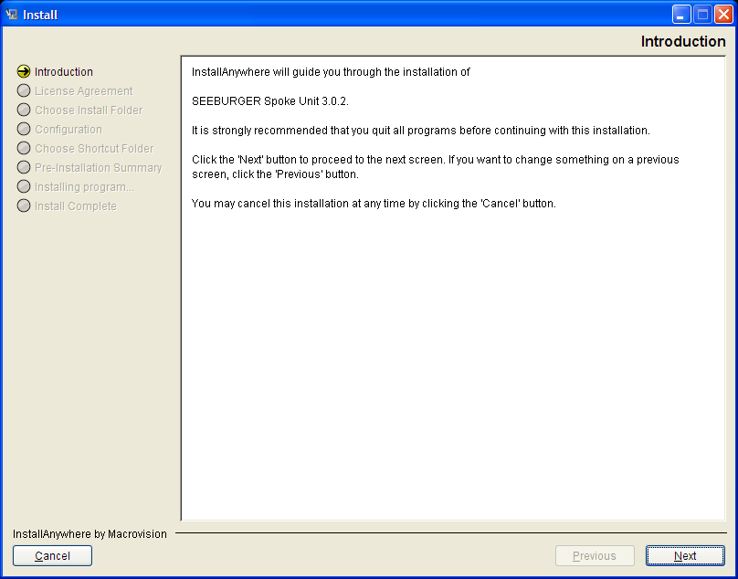
Click on “Next”
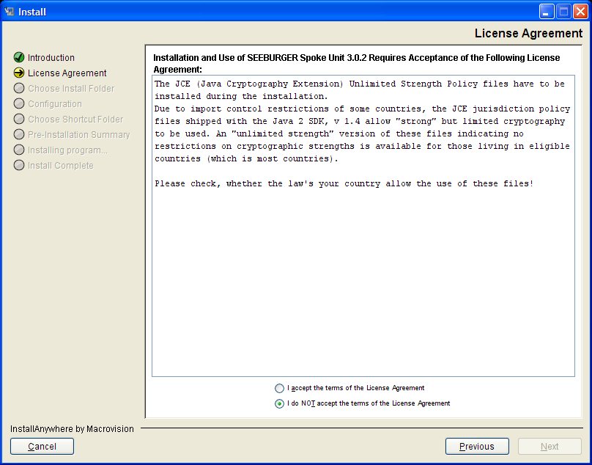
Choose “accept” option and click on “Next”
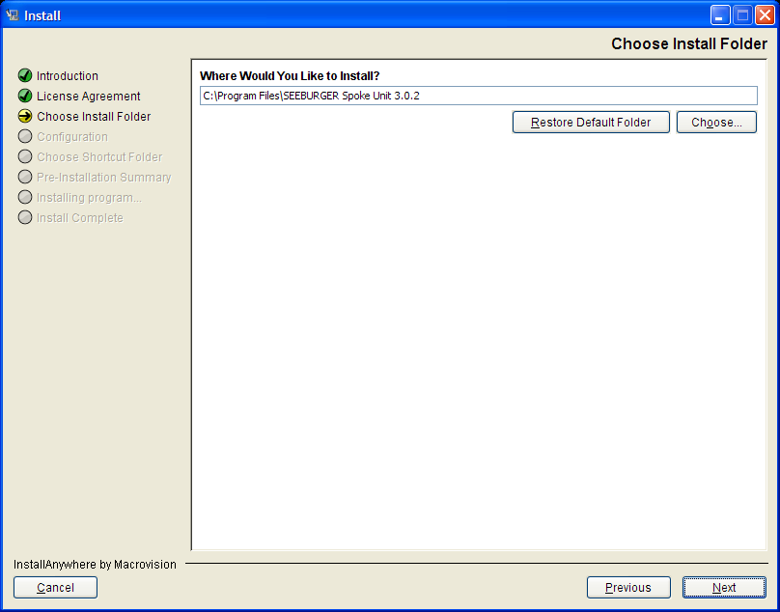
Keep default value and click on “Next”
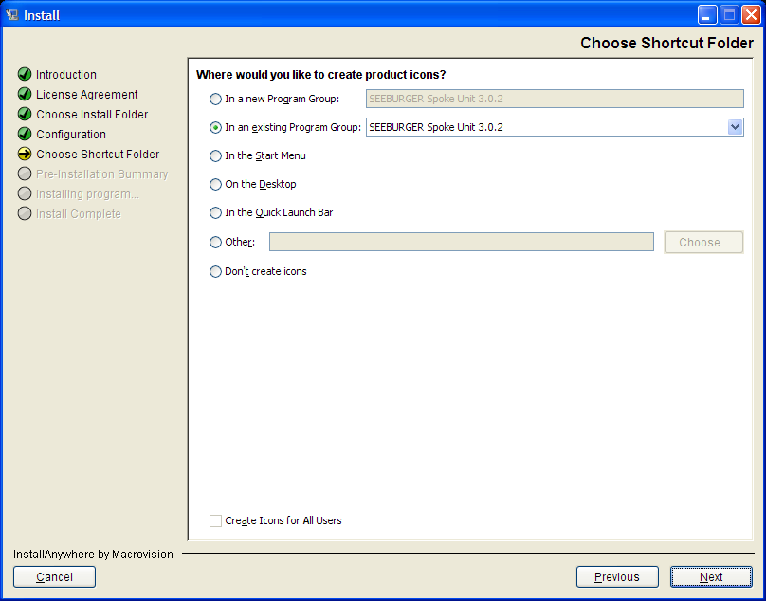
Keep default value and click on “Next”
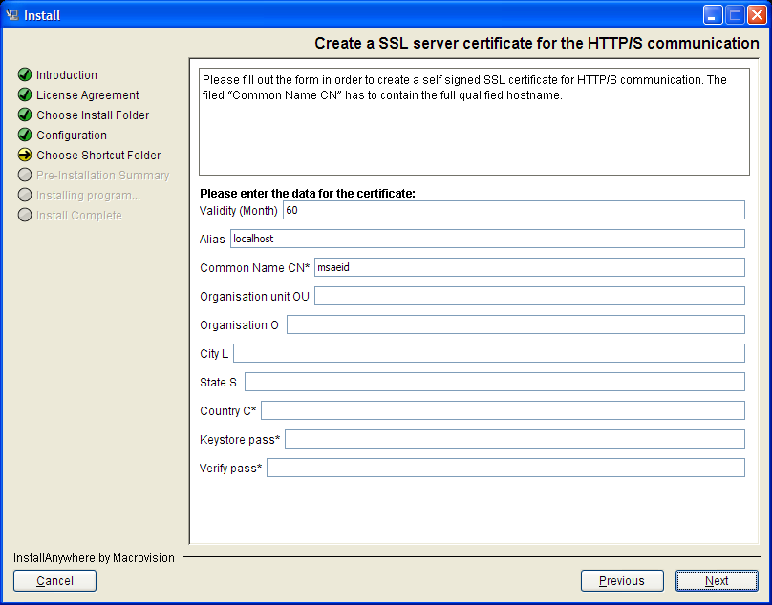
Enter following information:
Validity = 60 Months
Alias = Keep as “localhost”
Common Name CN = Partner company name
Organization unit OU = Partner organization name (optional)
Organization O = Partner company name (Optional)
City L = Partner city name
State S = Partner state name
County C = Partner 2 character country code
Keystore pass = Private key password.
Password criteria:
1 – At least twelve character long. Should not be a word in dictionary.
2 – Must include 3 of 4 character types: Upper case, lower case, number, symbol
Verify pass = Enter above password
Click on “Next”
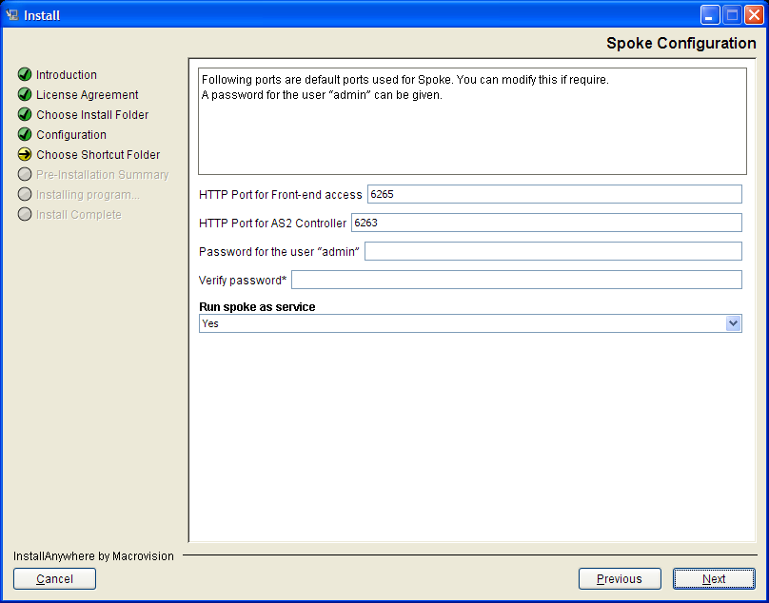
HTTP Port for Front-end access = Port value for partner webserver
HTTP Port for AS2 Controller = Port value for AS2 controller
Password criteria:
1 – At least twelve character long. Should not be a word in dictionary.
2 – Must include 3 of 4 character types: Upper case, lower case, number, symbol
Select “Yes” for Spoke service
Click on “Next”
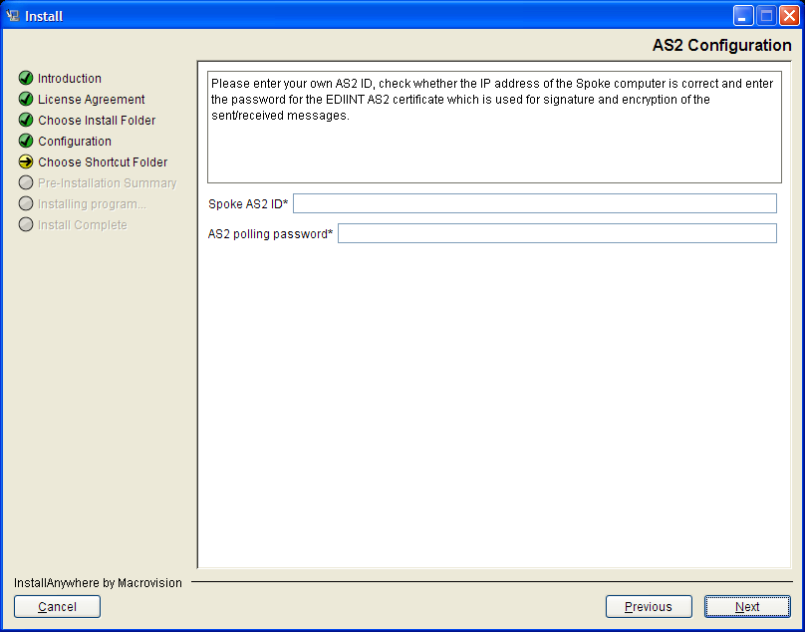
AS2 ID should have following format:
HPSPOKE_YYY...
Where Y= 17 Chars for the Partner Name and all upper case
Password criteria:
1 – At least twelve character long. Should not be a word in dictionary.
2 – Must include 3 of 4 character types: Upper case, lower case, number, symbol

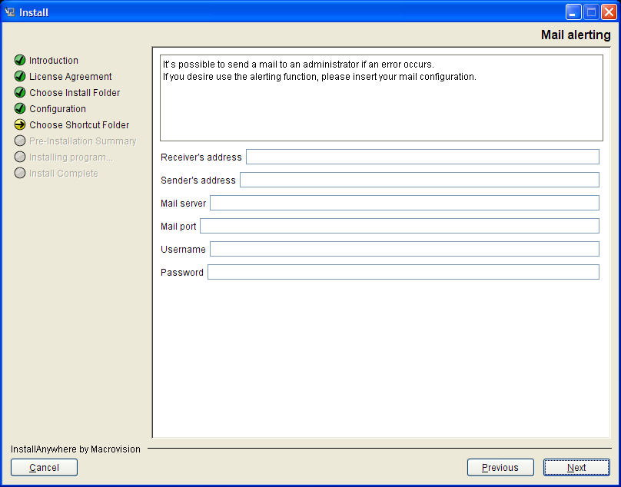
For administrator mail alerting, please include information requested. This is optional.

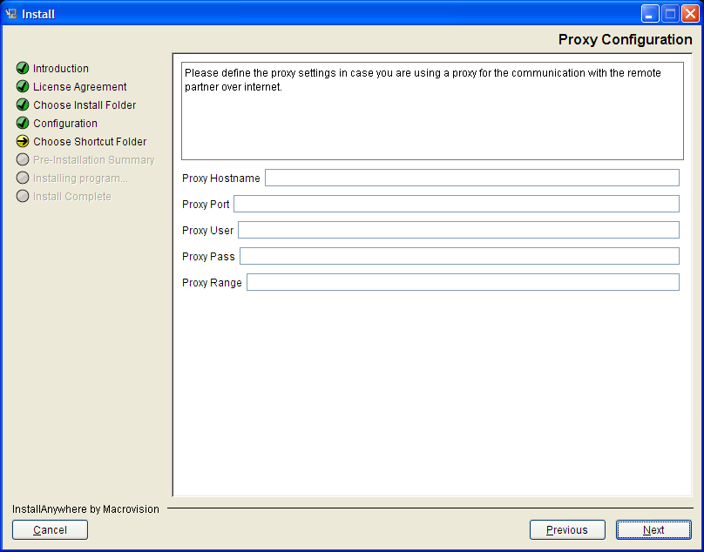
If proxy server is used to communicate with remote partner over internet, then include that information. This is optional.

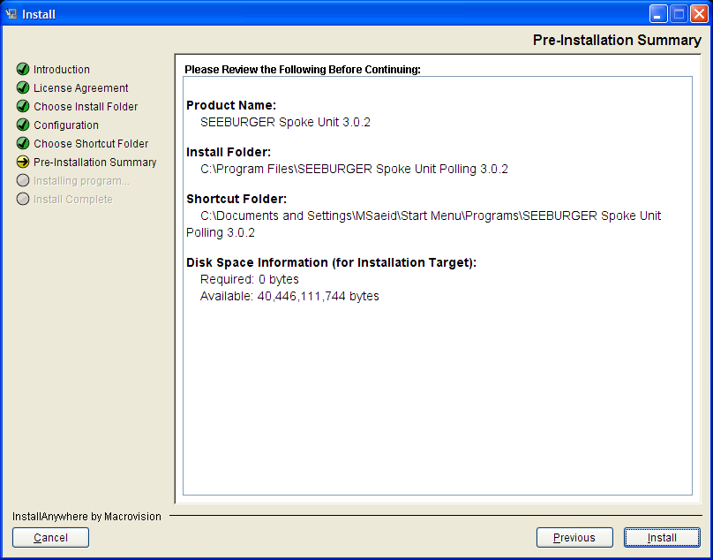
Click on “Install”
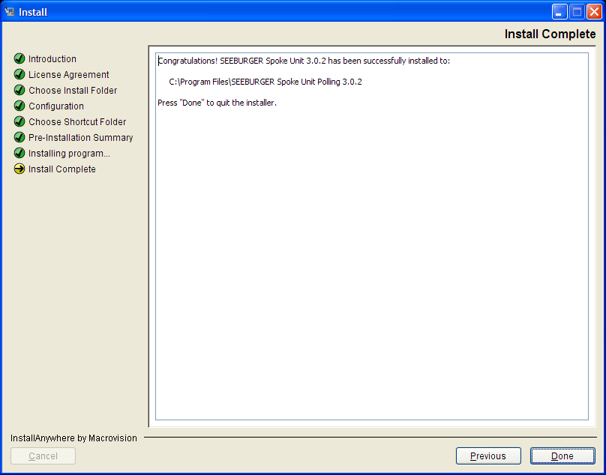
Click on “Done”.

Start Spoke:
Important Notice: If Spoke is already running as a service, The Spoke Console below shouldn’t be manually started, as the service is already available. The Web Administration should be accessed directly through http://localhost:6265/index.jsp and not through the Web Administration button below.

To manually start Spoke go to Start → All Program → SEEBURGER Spoke Unit 3.0.2 → SEEBURGER Spoke Unit 3.0.2.
This will start the Spoke Console:

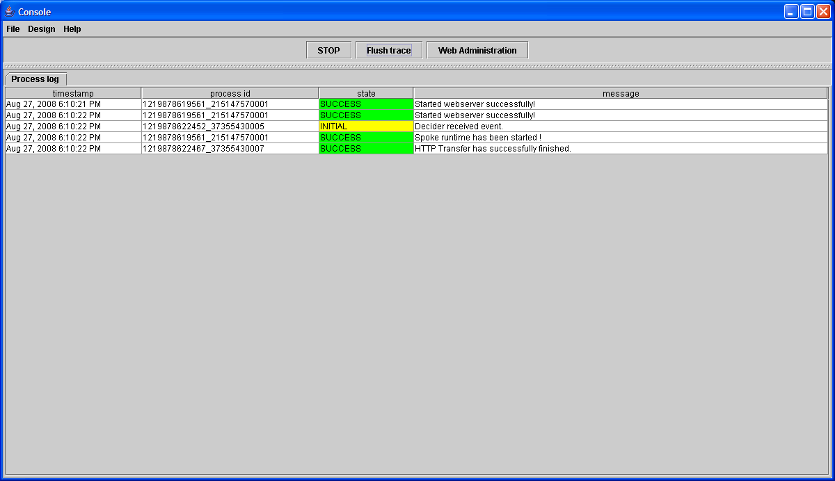

Click on “Web Administration”.

The initial login is with the User: admin and password.
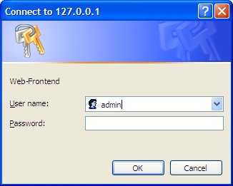

Spoke configuration:
Modules configured for receiving files from HP:
- Actions Section – File handling
- Controller Section – AS2 Controller
Modules configured for sending files to HP:
- Actions Section – AS2 Transfer
- Controller Section – File Controller

Configurations to receive files from HP:

File Handling Action:
In the Actions section, the “File handling’ module moves inbound files received from HP to proper directory based on file content type (edi-x12, edifact, xml, octet-stream).

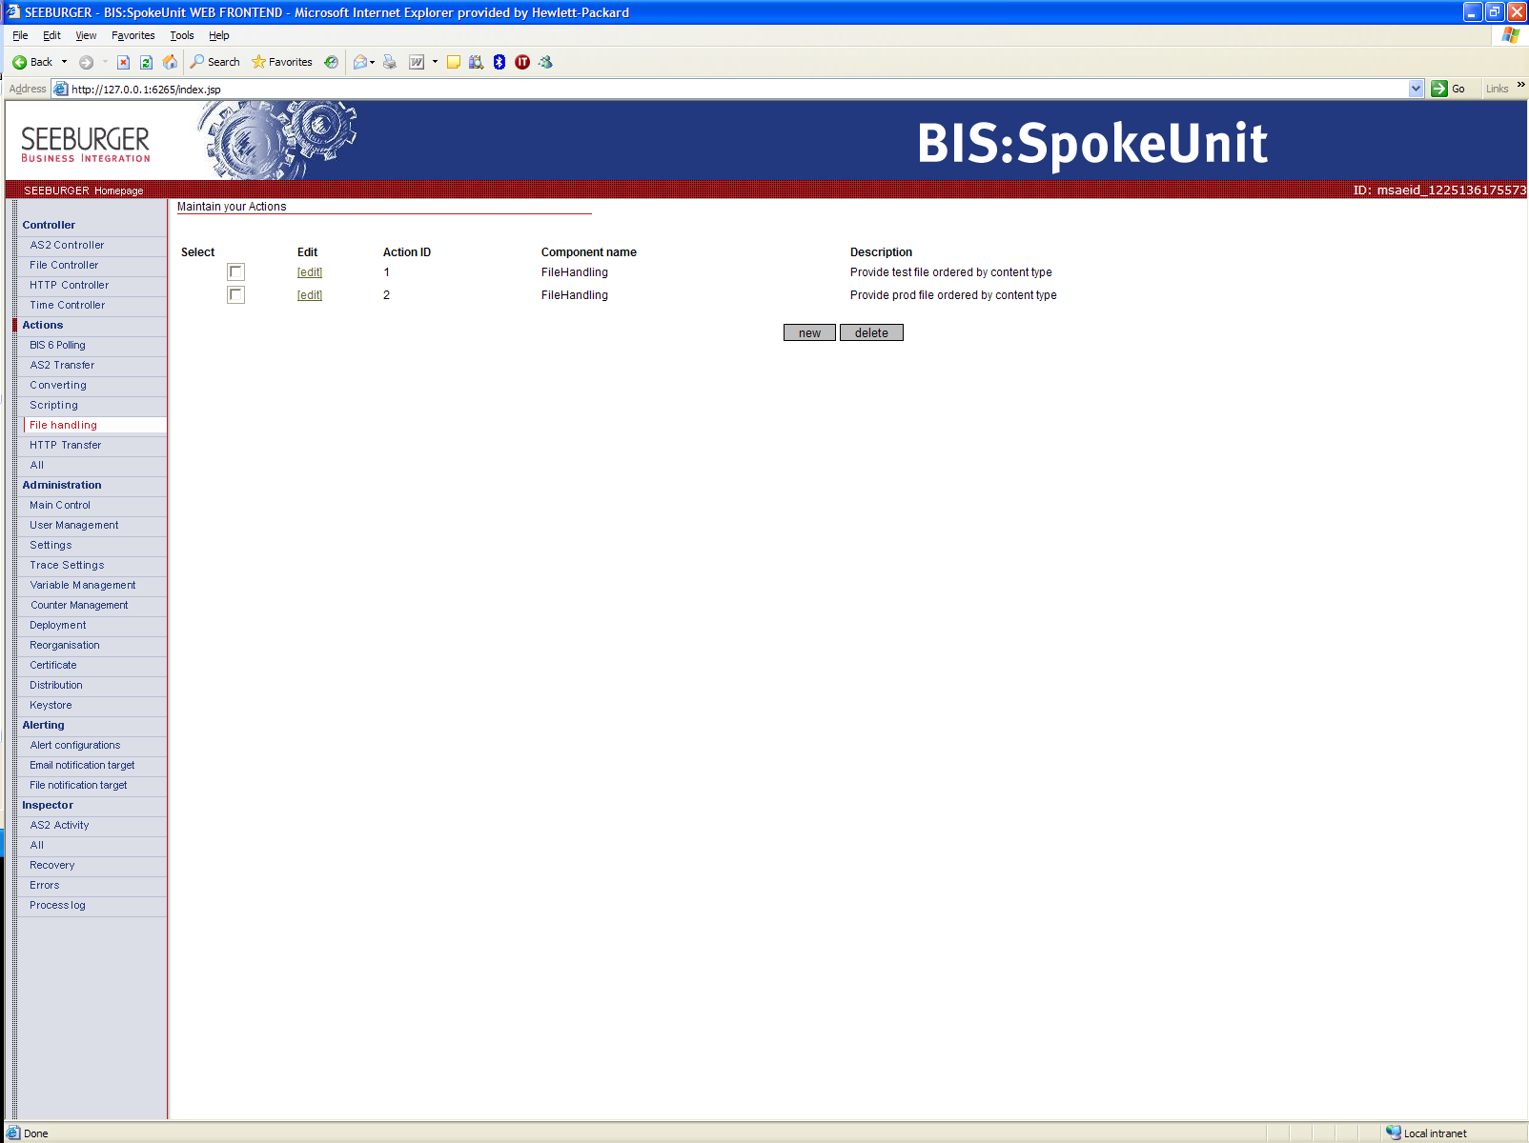

AS2 Controller:
In the Controller section, the “AS2 controller” module uses following values for compliant checking and matching a given “AS2 Controller” configuration to its corresponding configuration in “File handling”:
Own ID
Partner ID
Subject
Message type
On match (Link to Action ID)

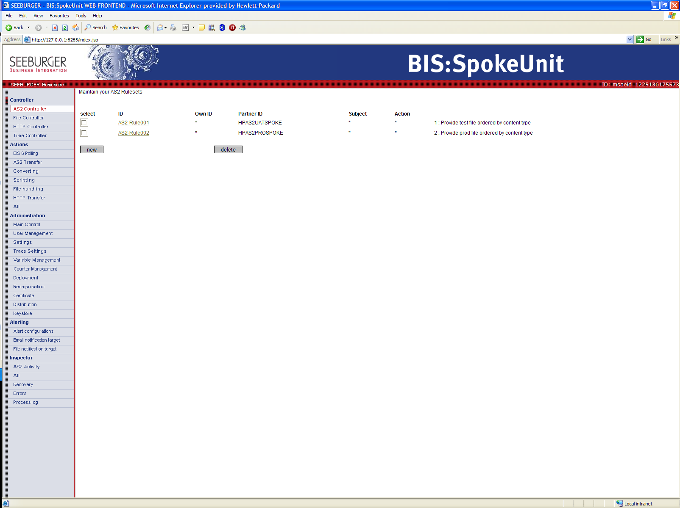

Configurations to send files to HP:

AS2 Transfer Action:
In the Actions section, the “AS2 Transfer” module is used to send messages over the EDIINT AS2 protocol.
Verify installation information in this module. Sample shows below is for content type = “edi-x12”.
- AS2 Tab – Verify “Own AS2 ID” content
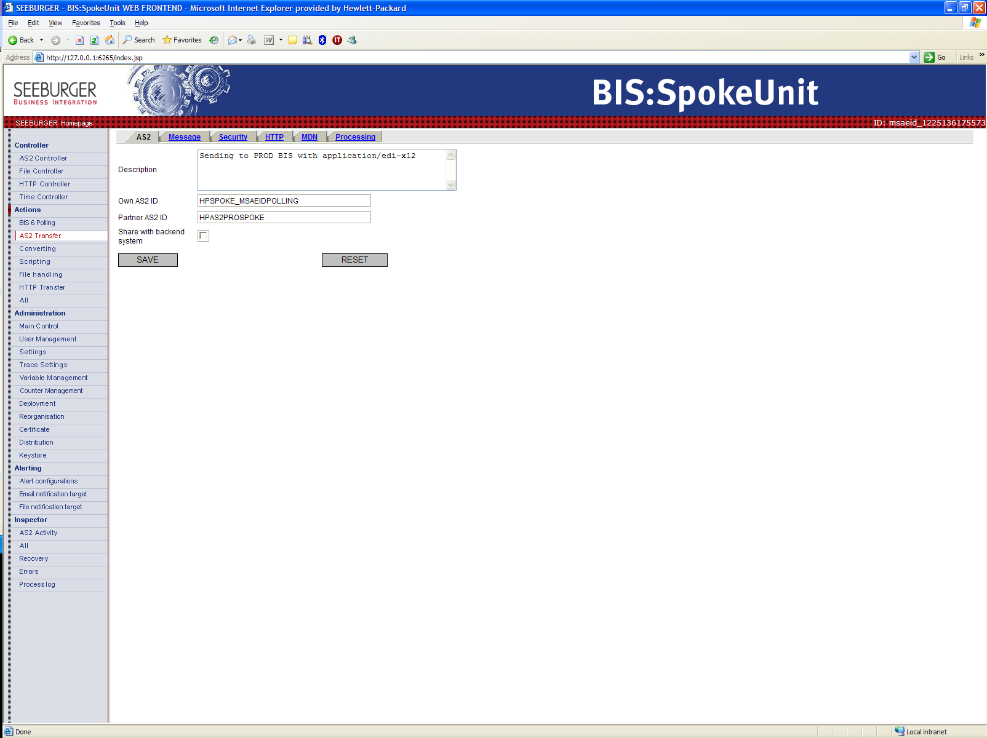
- Message Tab
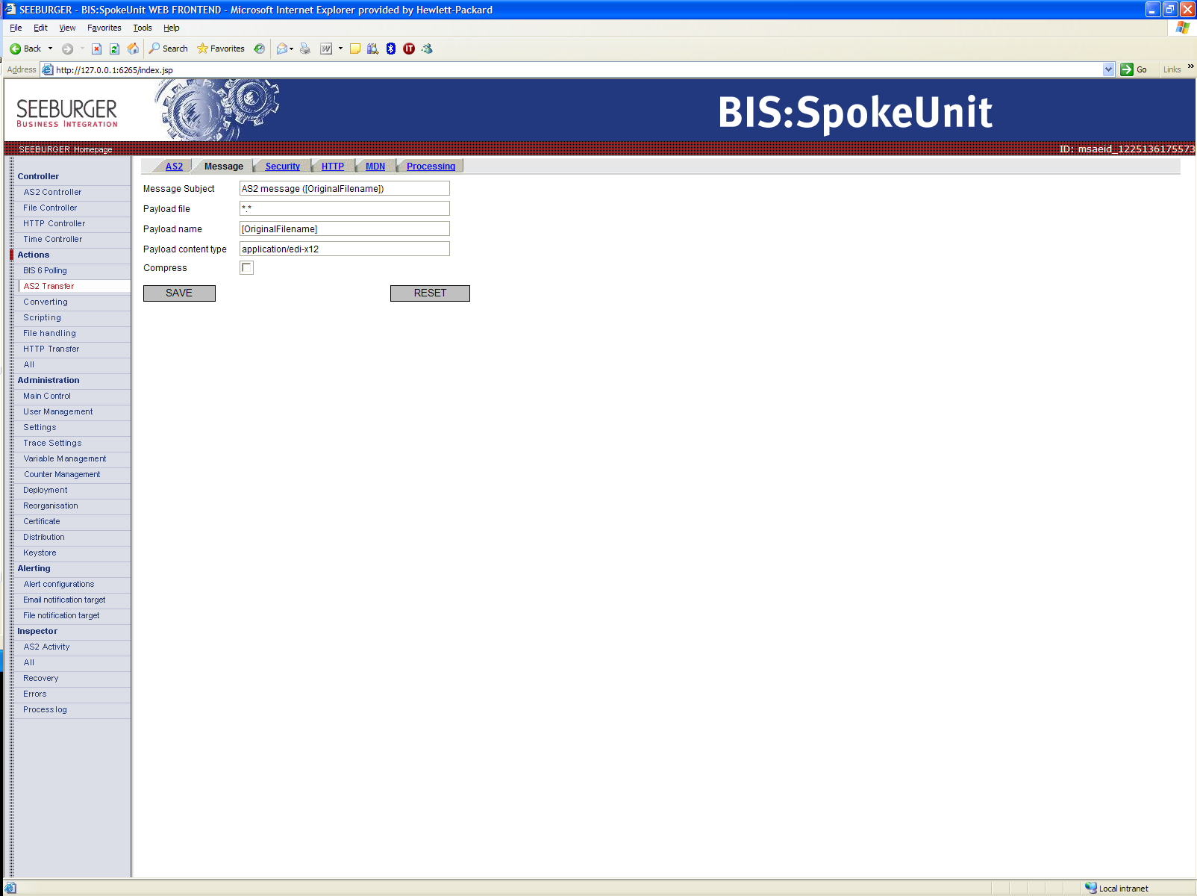
- Security Tab – Verify certificate information
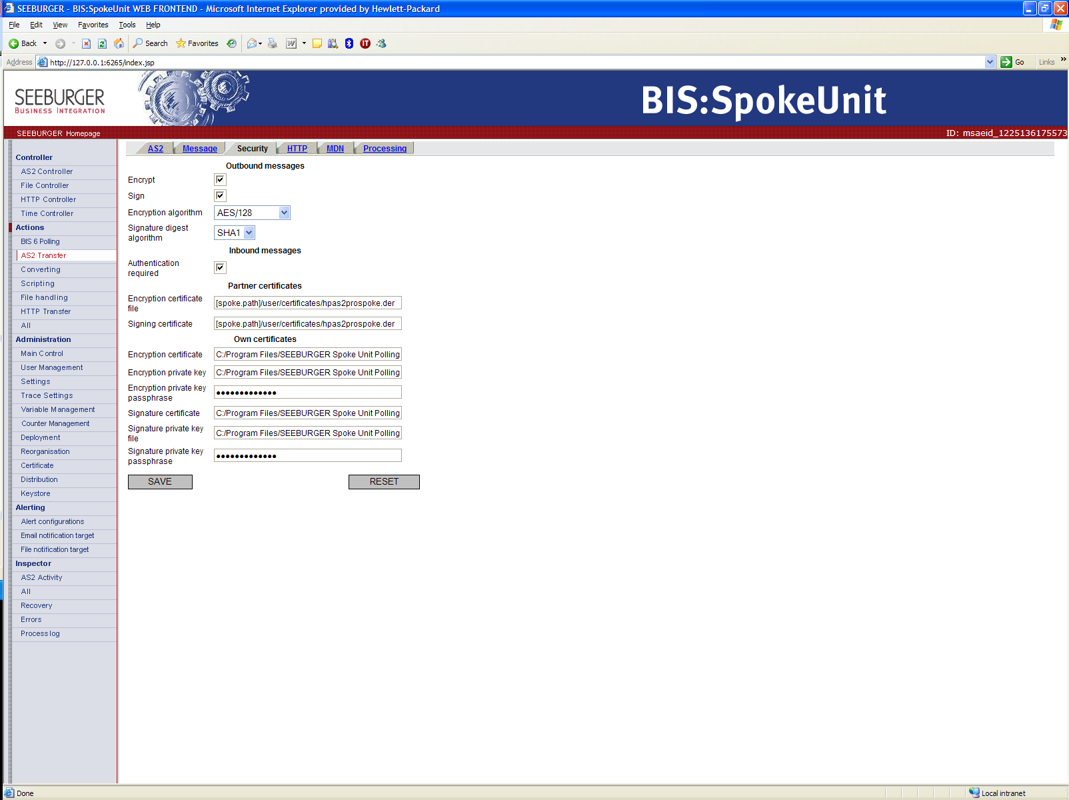

- HTTP Tab – Verify HP UAT or production URL.
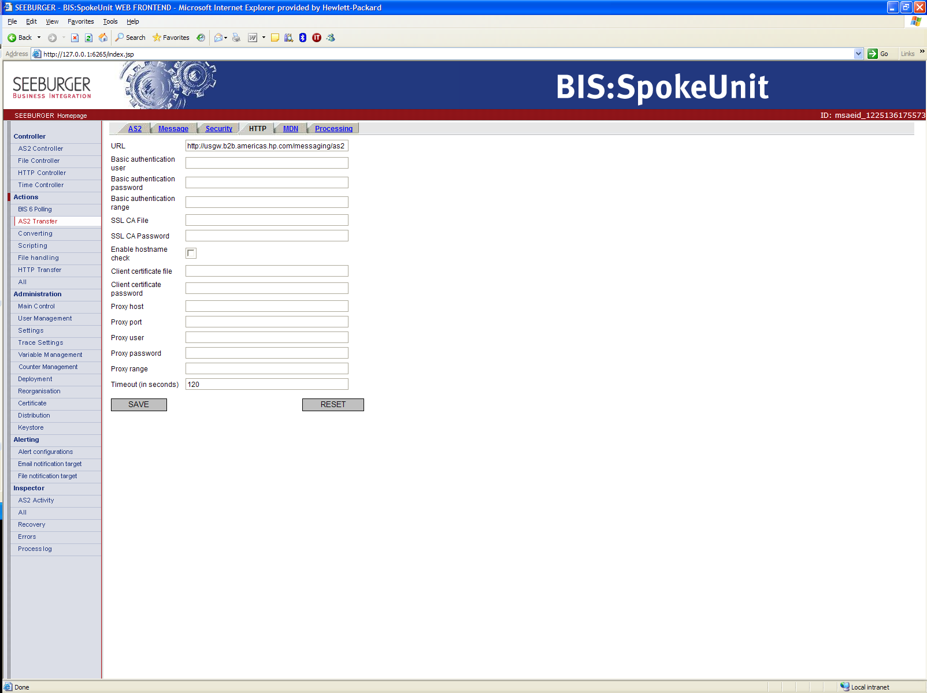
- MDN Tab
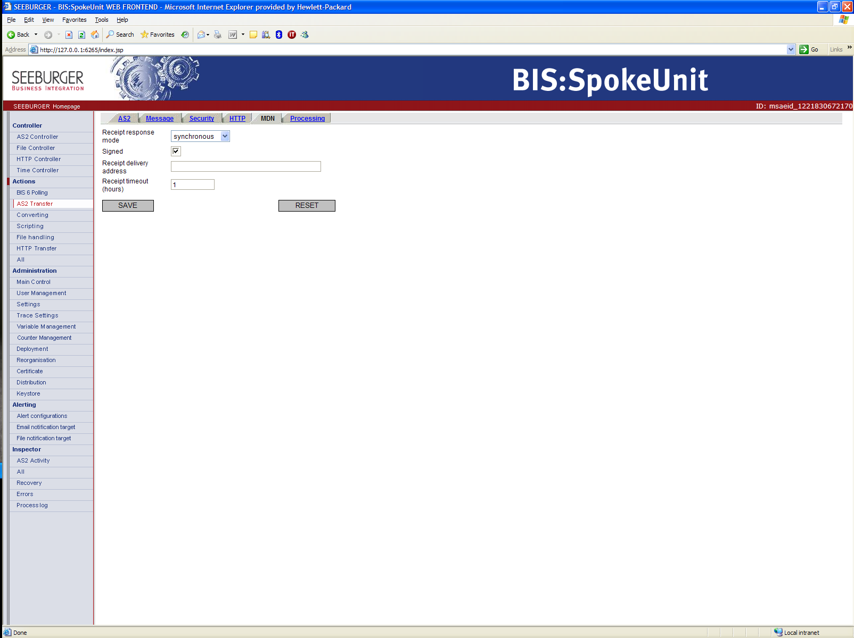

- Processing Tab
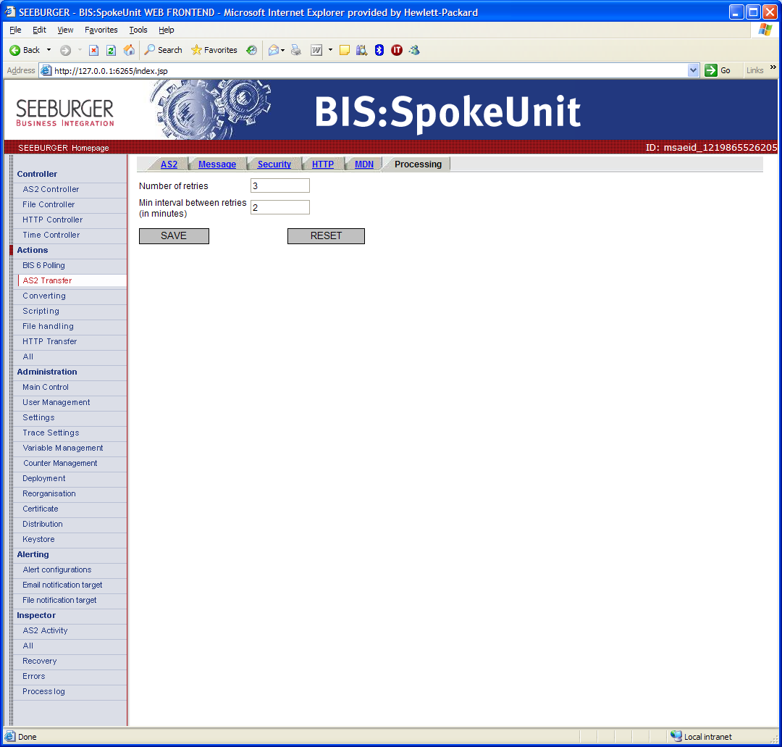

BIS 6 Polling
In the Action section, “BIS 6 Polling” is used to poll files from HP server.
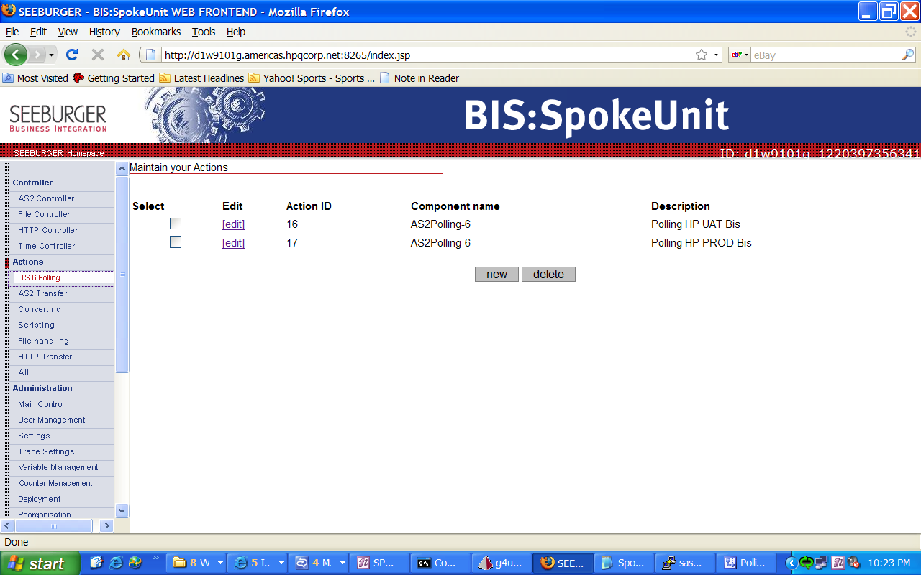

1) AS2 Tab
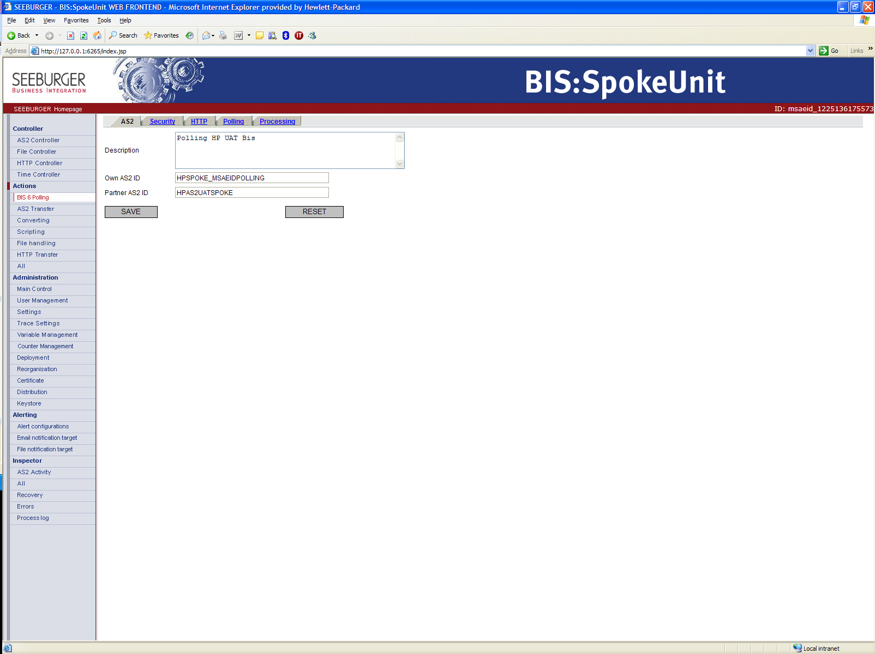
2) Security Tab
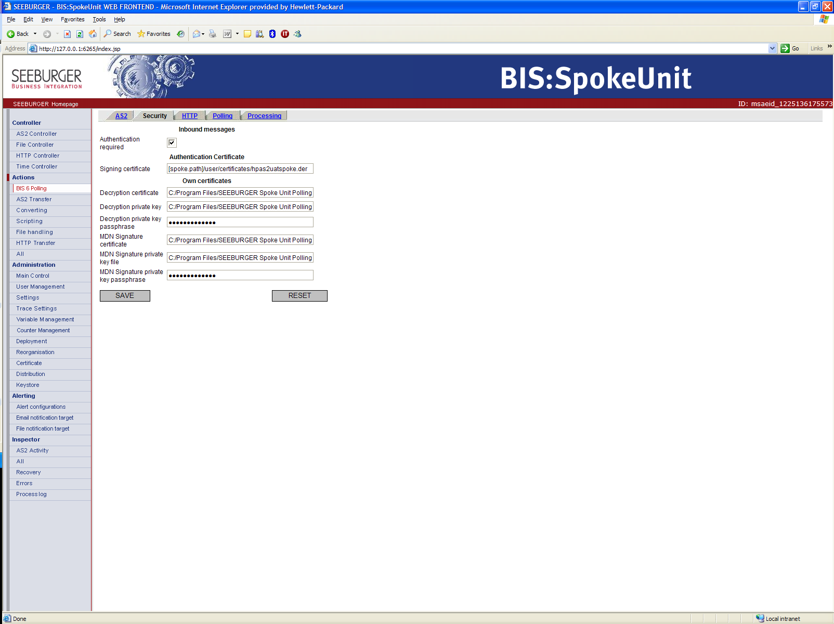
3) HTTP Tab
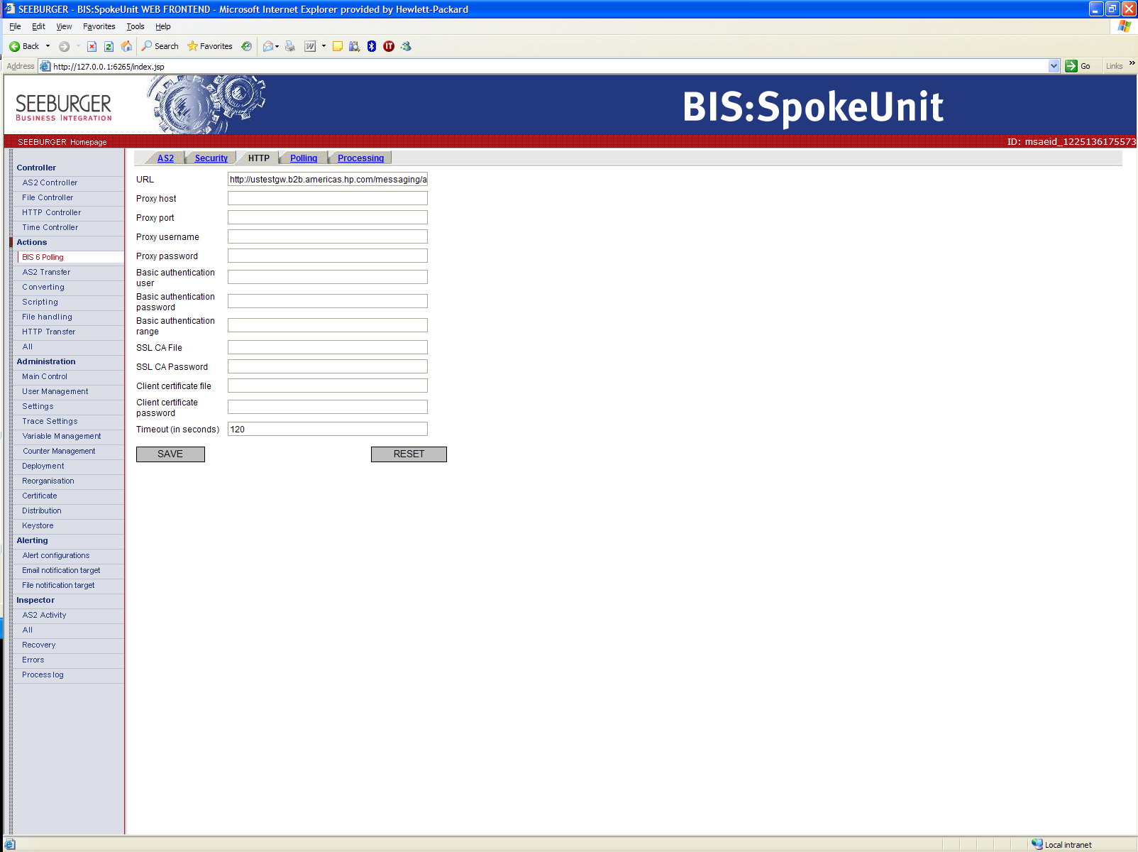

4) Polling Tab
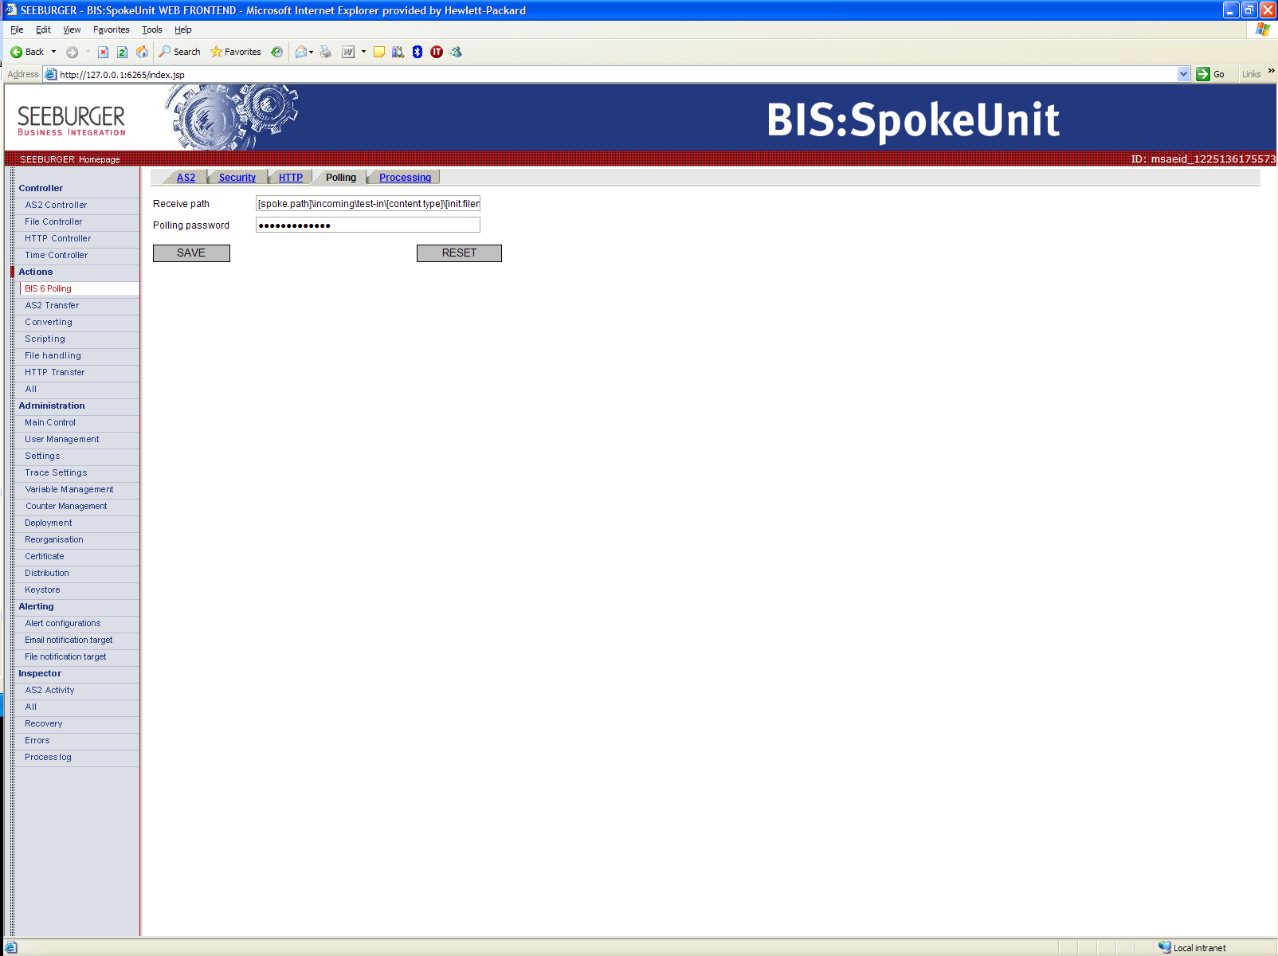
Password criteria:
1 – At least twelve character long. Should not be a word in dictionary.
2 – Must include 3 of 4 character types: Upper case, lower case, number, symbol

5) Processing Tab
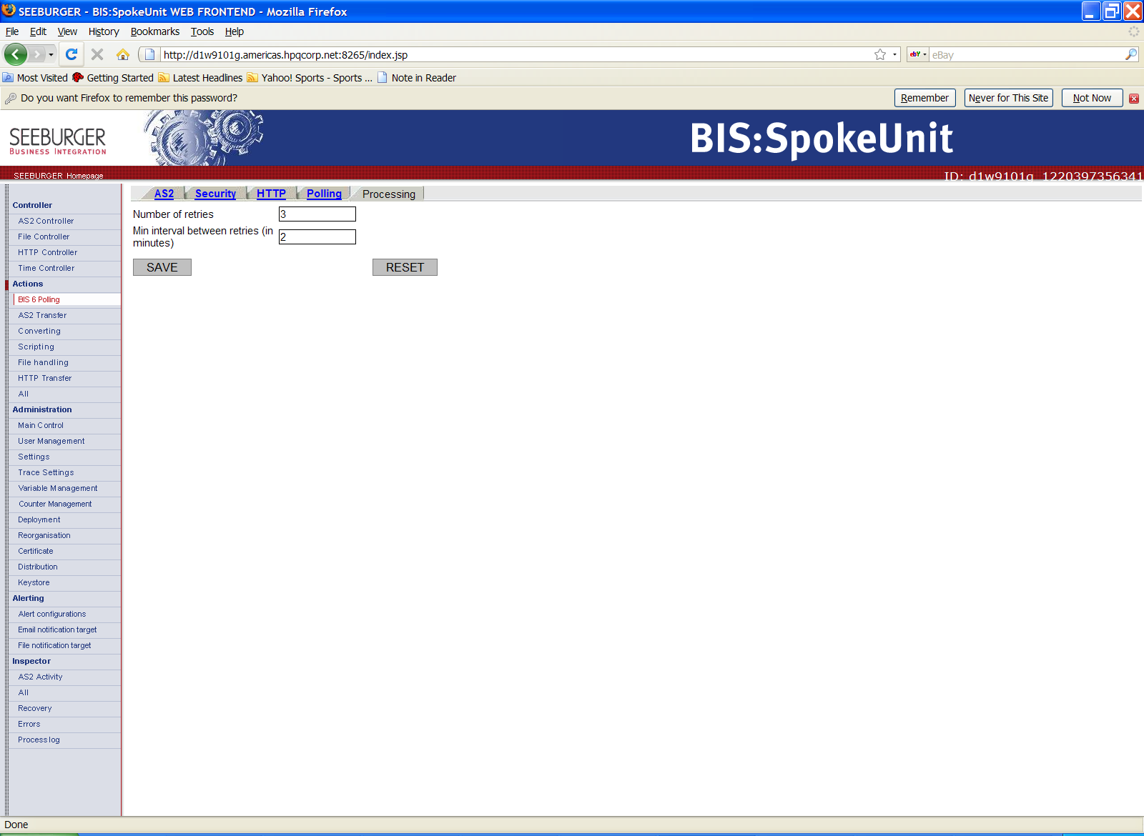

File Controller:
In the Controller section, “File Controller” module is used to specify action that needs to take place for a given controller configuration.

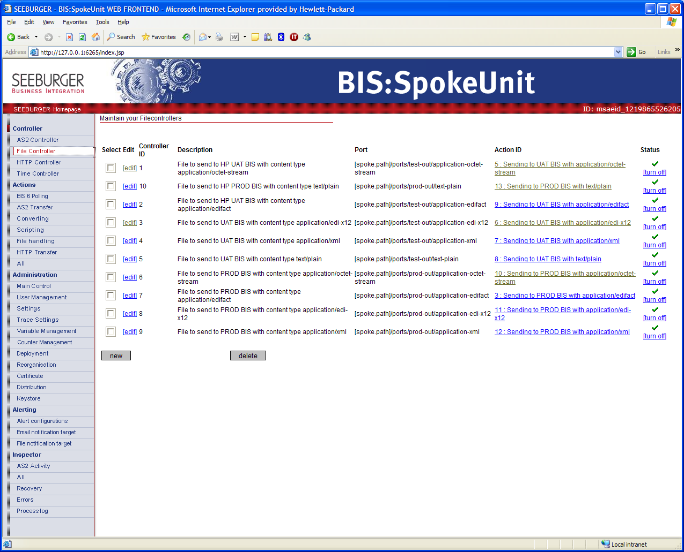
Sample file controller for “edi-x12”
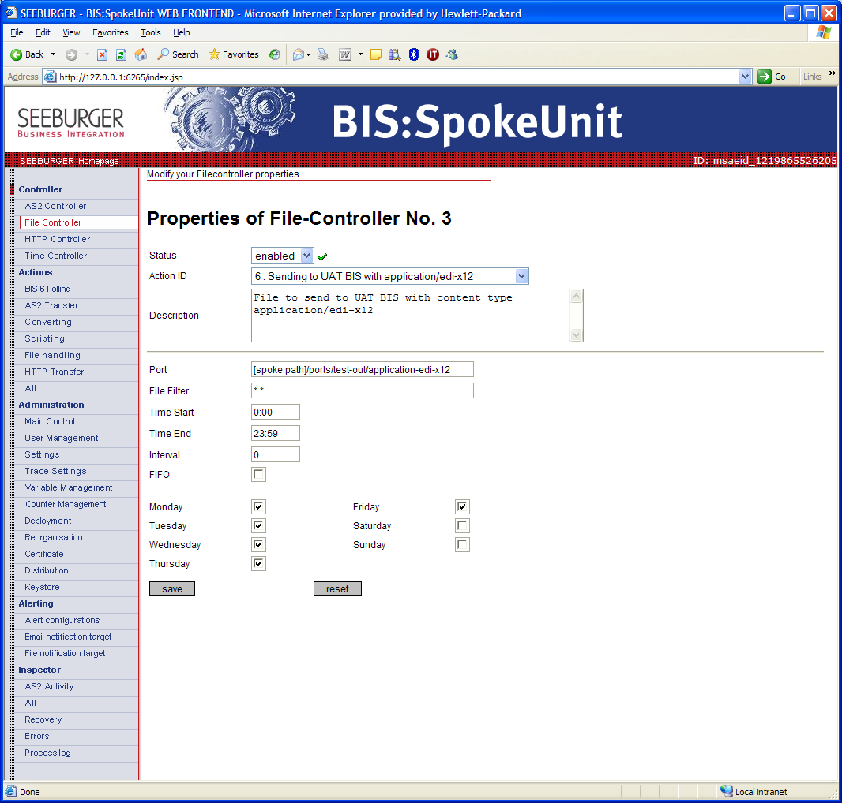

Provide information to HP
Email following information to the HP analyst you are working with:

- Partner certificate <Installation-Directory>\user\certificates\certfile.cer
- Partner AS2 ID
- Partner contact – Two contact or PDL is required for Spoke installation
- Polling password

Testing:
Outbound file processing:
For outbound test file from partner to HP, drop a test file into directory “C:\[installation directory]\ports\test-out\ octet-stream” or any other file content type listed in “test-out” directory. File should be picked up and delivered to HP.
Note: If there is a problem with a given test file, that file can be located in directory “C:\ [installation directory]\ports\test-out\ octet-stream\work” or “work” directory in any other three file content type listed in “test-out” directory.

Inbound file processing:
For inbound test file from HP to partner, look into one of the directories (depending on file content type) located in “C:\[installation directory]\incoming\test-in\content type”.

Message Tracking:
In order to be able to track messages, click on “AS2 Activity” located under “Inspector” section.
