Library Management System – Semester Project Report
Course | Introduction to Information and Communication Technology Lab
Instructor | Zulqarnain Arshad
Semester | Fall 2026
Student | Muhammed Fatih Erkan (01-136262-054)
GitHub link | https://github.com/mferkan2023-png/library-management-system

1. Introduction
In this project I made a Library Management System. It is a console program written in C++ and it saves all data in an SQLite database. The user can add, view, update, delete and search books and members. The user can also issue a book to a member and mark it as returned. My database has 3500 records in total (2000 books, 500 members and 1000 loans).

Why I chose a library
I chose a library because everybody knows how a library works, so it was easy for me to plan the tables. A library also has a lot of data. There are many books, many members and many loans, so it is a good example for a database project. In the real world, a small library can use a system like this to know which books are in the library and who has which book.

2. Tools I used and why

Database: SQLite
I used SQLite for the database. I chose it for these reasons:
- It does not need a server. The whole database is one file (library.db), so it is easy to copy and share with the teacher.
- It is free and open source.
- It works very well with C++. I only add two files (sqlite3.c and sqlite3.h) to my project and it works. With MySQL I would need to install a server and a connector library.
- It supports normal SQL, primary keys, foreign keys and indexes, so I can still show all the important database ideas.
The weak side of SQLite is that it is not good for many users at the same time. For a small library with one computer this is not a problem.

Programming language: C++
I wrote the interface in C++ with a console menu. I chose C++ because I learned it in my programming courses, so I feel comfortable with it. C++ programs are also very fast, and this is good for my speed test. SQLite itself is written in C, so I can call its functions directly from C++ without any extra library.
I used Visual Studio as my IDE because it is easy to build and debug programs with it on Windows. I made a console menu and not a graphic interface, because I wanted to spend my time on the database part, which is the main topic of the project.

3. Diagrams

ERD (Entity Relationship Diagram)
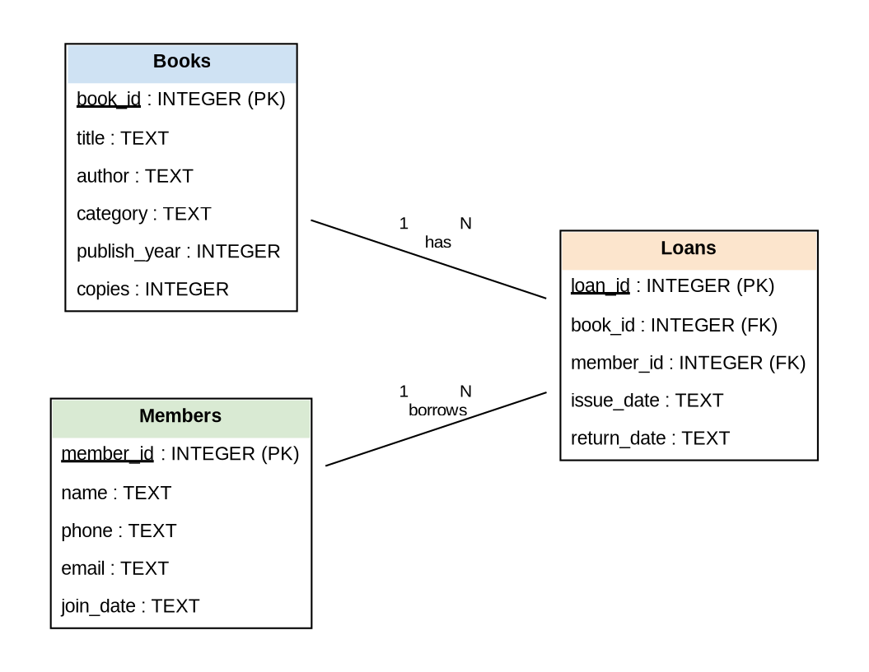
ERD of the library database
The ERD has three entities. Books and Members both have a one-to-many (1:N) relationship with Loans. One book can be borrowed many times, and one member can borrow many books. Loans is the table in the middle that keeps book_id and member_id as foreign keys.

Class diagram
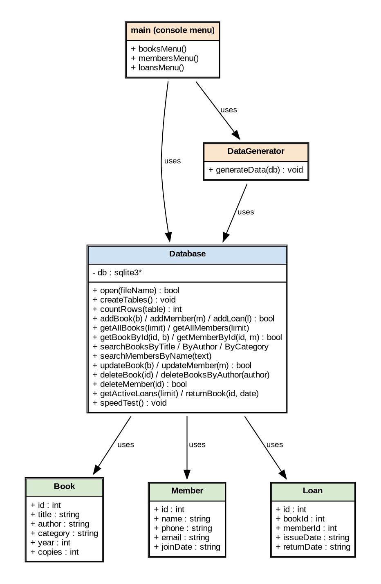
Class diagram of the program
The Book, Member and Loan classes only hold data, one object for one row. The Database class has all the SQL code. The main menu and the DataGenerator use the Database class, but they never write SQL themselves. In this way, if I want to change the database later, I only need to change one class.

4. Database design and creation
My database has three tables: Books, Members and Loans. The Loans table connects the other two tables. One book can be in many loans, and one member can have many loans.
Table | Columns | Keys | Records
Books | book_id, title, author, category, publish_year, copies | book_id is the primary key | 2000
Members | member_id, name, phone, email, join_date | member_id is the primary key | 500
Loans | loan_id, book_id, member_id, issue_date, return_date | loan_id is the primary key; book_id and member_id are foreign keys | 1000
Total |  |  | 3500
If return_date is empty (NULL), it means the member still has the book.

How the database is created
The program creates the database by itself. When it starts, it opens the file library.db. If the file is not there, SQLite makes a new one. Then the function createTables() runs CREATE TABLE IF NOT EXISTS for all three tables. It also makes an index on the author column of the Books table:
CREATE INDEX IF NOT EXISTS idx_books_author ON Books(author);
I use this index later in the speed test.

How I got more than 2000 records
Typing 2000 records by hand was not possible, so I wrote a small data generator (DataGenerator.cpp). It makes book titles by mixing words from lists, for example “The Silent River” or “The Lost Storm Returns”. In the same way it makes author names, member names, phone numbers, e-mails and dates. I used a fixed random seed, so the program makes the same data every time.
Without a transaction, SQLite saves every insert to the disk one by one, and this is very slow. So I put all inserts inside one transaction (BEGIN and COMMIT). In this way all 3500 records are added in less than one second.

5. How the system works
The program has a main menu with six options:
=================================
LIBRARY MANAGEMENT SYSTEM
=================================
1. Books
2. Members
3. Loans (issue / return)
4. Generate sample data (2000+ records)
5. Search speed test
6. Show number of records
0. Exit
The table below shows which operations the system can do.
Operation | Books | Members | Loans
Insert | Add book form | Add member form | Issue a book
Read | View first N books | View first N members | View books not returned
Update | Change any field | Change name, phone, email | Return a book
Search | By ID, title, author, category | By ID, name
Delete | By ID, or all books of one author | By ID

Insert
The user fills a simple form in the console. For example, for a new book the program asks for the title, author, category, year and number of copies. Then it saves the book with an INSERT query.

Search and read
The user can search a book by ID, by part of the title, by author or by category. For members the user can search by ID or by part of the name. The results are shown in a table on the screen.

Update
The user enters the ID of the record. The program first shows the old data. Then it asks for the new values. If the user presses Enter without typing, the old value stays.

Delete
Delete uses the same search queries. The user can delete one book by its ID, or delete all books of one author. Before deleting, the program shows the records and asks “Are you sure? (y/n)”. When a book or member is deleted, its loans are deleted too, so the Loans table does not keep wrong IDs.

Safety of the queries
I used prepared statements (sqlite3_prepare_v2 with ? marks) for all queries with user input. I do not put the user’s text directly inside the SQL string. This protects the database from SQL injection and also from errors when a title has a ’ character in it.

6. Which search query is the fastest?
Search by ID was the fastest query in my test. It took about 4 microseconds, and the LIKE search on the title took about 215 microseconds, so it was more than 50 times faster.

How I tested
I added a “Search speed test” option to the menu (option 5). It runs four different search queries on the Books table (2000 rows). Every query runs 1000 times with different values, and the program shows the average time. I measured the time with the chrono library of C++. The program also prints the query plan from SQLite (EXPLAIN QUERY PLAN), so I can see how SQLite finds the rows.

Results
No. | Search query | Average time | Query plan
1 | By ID: WHERE book_id = ? | 3.93 µs | SEARCH using INTEGER PRIMARY KEY
2 | By author: WHERE author = ? | 7.55 µs | SEARCH using INDEX idx_books_author
3 | By category: WHERE category = ? | 159.58 µs | SCAN Books
4 | By title: WHERE title LIKE '%word%' | 214.94 µs | SCAN Books
(µs = microsecond, one millionth of a second. The times change a little on every run and on every computer, but the order stays the same.)

Why is search by ID the fastest?
1. ID search. book_id is the INTEGER PRIMARY KEY. In SQLite this column is the rowid, and the table is stored as a B-tree sorted by it. So SQLite does not read the whole table. It goes down the tree in a few steps and finds the row directly. With 2000 rows, this takes only about 11 steps (because 2^11 = 2048).
2. Author search. The author column has an index. An index is like the index at the end of a book: it is a sorted list of authors and the rowid of each book. SQLite finds the author in the index and then jumps to the rows. This is also very fast, but a bit slower than ID search, because SQLite needs two look-ups (first the index, then the table).
3. Category search. There is no index on category, so the plan says SCAN. SQLite must read all 2000 rows and check each one. Also, every category has about 200 books, so the program has to read and copy many results.
4. Title search with LIKE. This is the slowest one. The pattern starts with %, so even an index cannot help, because SQLite does not know where the word starts. It reads all 2000 rows and compares the text of every title, and text comparison takes more time than comparing numbers.

What I learned
The most important thing is not the size of the table but whether SQLite can use an index or must SCAN the whole table. My table is small, so all queries feel fast to the user. But with 2 million rows, the SCAN queries would become 1000 times slower, while ID search would still take only a few microseconds. So it is a good idea to search by primary key when possible, and to add an index on columns that are searched often.

7. Problems and solutions
Problem | Solution
Adding 2000+ records one by one is very slow | All inserts are inside one transaction
When a book is deleted, its old loans stay in the Loans table | The program deletes the loans of that book first
The user can type text where a number is needed, and the program can crash | The readInt() function checks the input and asks again
A title with a ’ character can break an SQL string | I use prepared statements with ? marks

8. Conclusion
I made a working Library Management System with C++ and SQLite. It can insert, read, update, delete and search records, and it has 3500 records in three related tables. I drew an ERD and a class diagram before writing the code, and this helped me a lot while writing the queries.
From the speed test I learned that search by primary key is the fastest, and an index makes a big difference. In the future I can add a graphic interface, a login for the library staff, and a fine for late returns.

9. References
- SQLite Documentation – https://www.sqlite.org/docs.html
- SQLite Query Planner – https://www.sqlite.org/queryplanner.html
- SQLite C/C++ Interface – https://www.sqlite.org/cintro.html
- EXPLAIN QUERY PLAN – https://www.sqlite.org/eqp.html
- C++ chrono library – https://en.cppreference.com/w/cpp/chrono

