EMERGENCIAS

**LINKS INTERNET**

COPEL: **43-3403-0000 | 43-3403-1189 |43-9916-4246 | 0800-601-1576**

[noc@redenetworks.com.br](mailto:noc@redenetworks.com.br) [julio@redenetworks.com.br](mailto:julio@redenetworks.com.br)

OI: 0800-031-0800

Circuito DDR:0514681

Circuito IPConect: 0763186

Consultora: Soraia : 41-8516-7353 | 41-9681-3240

**AR**

Suporte AR: 11-41938885 Vitor: 11-77016818 Alessandro 11-2619-0377

**Central Server**

0800-701-1993 | 11-4063-6549

**Mastertech**

Suporte: 3083-6533 – Amaro ou Junior

**SIMPRESS**

*Service Desk : (11) 2103-9753 / 3616-9753*

**Sixtech**

41-3015-2535 Contato Sérgio

E-mail: sergio@sixtech.com.br

Como trocar link na VPN?

* Trocar cabo direto na VPN
* Substituir IP na VPN
* Esperar DynDNS atualizar

Como trocar link do Firewall?

1)Acessar 192.168.0.1 porta 3224

2)editar o arquivo /etc/network/interfaces

3) substituir **iface eth0 inet static**

4) /etc/init.d/networking restart

**IP COPEL**

**IP:189.36.131.217 --> Firewall Principal**

**IP:189.36.131.218 --> VPN Backup**

**IP:189.36.131.219 a 221 --> LIVRE**

**MASK: 255.255.255.248**

**GTW: 189.36.131.222**

**BROAD: 189.36.131.223**

**REDE: 189.36.131.216/29**

**DNS1:189.36.129.2**

**DNS2: 189.36.129.1**

**IP OI**

**IP:189.11.37.26 --> Firewall Backup**

**IP:189.11.37.27 --> VPN Principal**

**IP:189.11.37.28 a 30 --> LIVRE**

**MASK: 255.255.255.248**

**GTW: 189.11.37.25**

**BROAD: 189.11.37.31**

**REDE: 189.11.37.24**

**DNS1:201.10.120.2**

**DNS2:201.10.128.3**

**Wireless**

**brasildb413299**

**jj92ww – 192.168.0.254**

**420gr0wroom 253**

**diagnosticosdobrasil.com.br**

**user:diagn1br**

**senha: 420Weeds**

**Servidor Sênior 192.168.0.12**

**Admin**

**420@fog**

**Banco de dados**

**User: SA**

**Senha: sênior@123**

**Server 01**

**#LaPlace@07# -p 3224**

**Interfaces**

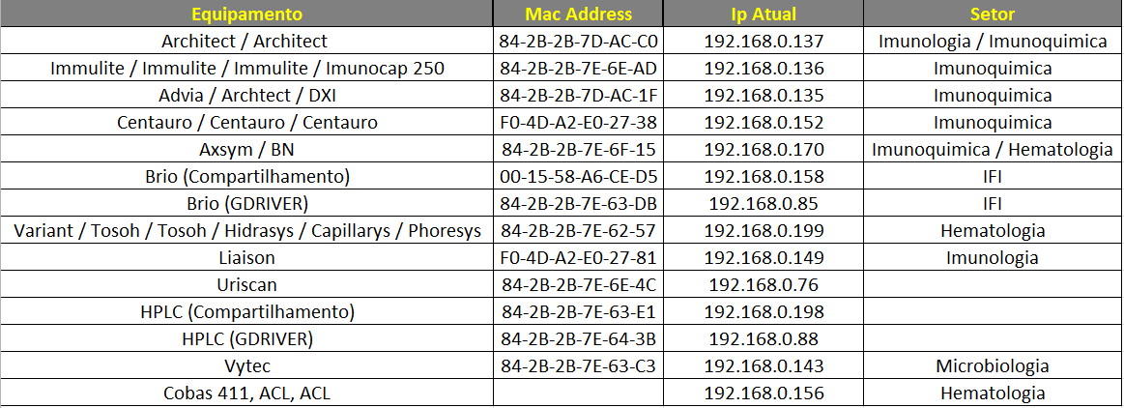

|  |  |  |  |
| --- | --- | --- | --- |
| **Equipamento** | **Mac Address** | **Ip Atual** | **Setor** |
| Architect / Architect / Architect | 84-2B-2B-7D-AC-C0 | 192.168.0.137 | Imunologia / Imunoquimica |
| Immulite / Immulite / Immulite / Imunocap 250 | 84-2B-2B-7E-6E-AD | 192.168.0.136 | Imunoquimica |
| Advia / Archtect / DXI | 84-2B-2B-7D-AC-1F | 192.168.0.135 | Imunoquimica |
| Centauro / Centauro / Centauro | F0-4D-A2-E0-27-38 | 192.168.0.152 | Imunoquimica |
| BN / Vitros | 84-2B-2B-7E-6F-15 | 192.168.0.174 | Imunoquimica / Hematologia |
| Brio (Compartilhamento) | 00-15-58-A6-CE-D5 | 192.168.0.158 | IFI |
| Brio (GDRIVER) | 84-2B-2B-7E-63-DB | 192.168.0.85 | IFI |
| Variant / Tosoh / Tosoh / Hidrasys / Capillarys / Phoresys / Capillarys2 | 84-2B-2B-7E-62-57 | 192.168.0.190 | Hematologia |
| Liaison / Liason / Architect | F0-4D-A2-E0-27-81 | 192.168.0.149 | Imunologia |
| Uriscan | 84-2B-2B-7E-6E-4C | 192.168.0.76 |  |
| HPLC (Compartilhamento) | 84-2B-2B-7E-63-E1 | 192.168.0.198 | Cromatografia |
| HPLC (GDRIVER) | 84-2B-2B-7E-64-3B | 192.168.0.88 | Cromatografia |
| Vytec | 84-2B-2B-7E-63-C3 | 192.168.0.143 | Microbiologia |
| Cobas 411 / Axsym | 84-2B-2B-7E-6E-D1 | 192.168.0.156 | Imunologia / Hematologia |
| ACL, ACL | 84-2B-2B-7E-63-41 | 192.168.0.174 | Hematologia |
| DXI | 84-2B-2B-7E-5D-56 | 192.168.0.176 | Imunoquimica |

COBAS 411 DRIVER ELEC_MYSQL

HIDRASYS(SEBIA) – 192.168.0.68

CAPILLARYS – 192.168.0.190

Archtect (em frente neonatal) – 192.168.0.135

Archtect(em frente escada) – 192.168.0.137

Variant II -192.168.0.180

Tosoh-Hidrasys-Capillarys-Phoresys -> Gdriver está na máquina com IP 192.168.0.199.

Vitros – 192.168.0.170

Server Clarity

192.168.0.250

user: clarity

senha:ctvoicer

iniciar o Clarity Server e Clarity CSTA