

**MARMARA UNIVERSITY**

**FACULTY OF ENGINEERING**

**COMPUTER ENGINEERING DEPARTMENT**

**CSE1142 TERM PROJECT**

150116034-Enes GARIP 150116022-Muhammed F. EROGLU

CSE1142:Computer Programming II, Spring 2018

Date Submitted: May 20, 2018

**PROBLEM DEFINITION**

In this project, we developed a great game in the puzzle category. The game is simple and easy to learn but after every level the game become harder and needs lots of scamming skills.

In game, there are lines connected to the filled circles. The aim is drag all the lines without intersect any lines.If two lines overlap each other, that level is start again.It continues when all the lines drag to the filled circles. If all the line dragged correctly than the game continue to the next level.

**IMPLEMENTATION DETAILS**

* **Difficulties**
* Collisions: In every level we have to check wheter there is a collision or not.In order to do that we need to check the start-end points of the lines or semicircles that have possibility to collide each other. So we check that problem with if statements.
* Disconnectors: In some levels there are disconnectors. They disconnects or connects two lines and it turns also.We need to check if disconnector not disconnect the two lines which we want to move.
* Transitions between levels: We need to move next level when the previous level is completed. We checked if the previous level is completed successfully by using buttons. When level is completed Event buttonclicked occurs in background and clicking invisible btNext button. In main method this event handled and moving to next level.
* **Additional Specification**
* We warned the user if the collision occurs by text like”Collision Occured.Please try again .”. Also we added the again button to give user another chance to repeat the level.
* We added a reward at the end of the game. If the user plays the game correctly he or she will reach the reward.

|  |
| --- |
| Project |
|  |
| +main(String[] args):void  +start(Stage PrimaryStage):void |

|  |
| --- |
| Level1 |
| btNext:Button  allelements:ArrayList<Node> |
| level1():  +level1(): void  FadeAway(ArrayList<Node> node): void  GetBack(ArrayList<Node> node): void  GetBack2(ArrayList<Node> node) :void |

|  |
| --- |
| Level2 |
| btNext:Button  btPrev:Button  allelements:ArrayList<Node> |
| Level2():  +Level2(): void  FadeAway(ArrayList<Node> node): void  GetBack(ArrayList<Node> node): void  GetBack2(ArrayList<Node> node) :void |

|  |
| --- |
| Level3 |
| btNext:Button  btPrev:Button  allelements:ArrayList<Node> |
| Level3():  +Level3(): void  FadeAway(ArrayList<Node> node): void  GetBack(ArrayList<Node> node): void  GetBack2(ArrayList<Node> node) :void |

|  |
| --- |
| Level4 |
| btNext:Button  btPrev:Button  allelements:ArrayList<Node> |
| Level4():  +Level4(): void  FadeAway(ArrayList<Node> node): void  GetBack(ArrayList<Node> node): void  GetBack2(ArrayList<Node> node) :void |

|  |
| --- |
| Level5 |
| btPrev:Button  allelements:ArrayList<Node> |
| Level5():  +Level5(): void  FadeAway(ArrayList<Node> node): void  GetBack(ArrayList<Node> node): void  GetBack2(ArrayList<Node> node) :void |

|  |
| --- |
| HorizontalLineWithCircle |
| leftline:Line  rightline:Line  semicircle:Arc  smallline:Line |
| HorizontalLineWithCircle(xcoordinate: int, ycoordinate: int, left: int, right: int) |

|  |
| --- |
| VerticalLineWithCircle |
| topline:Line  bottomline:Line  semicircle:Arc  smallline:Line |
| VerticalLineWithCircle(xcoordinate: int, ycoordinate: int, bottom: int, top: int) |

|  |
| --- |
| Disconnector |
| circle:Circle  line:Line |
| Disconnector(centerx:int,centery int) |

**TEST CASES**

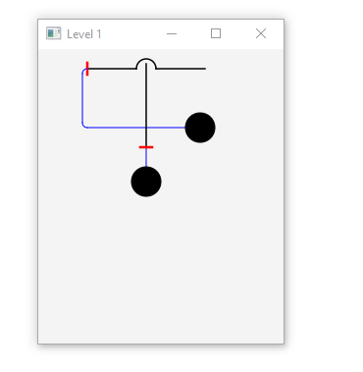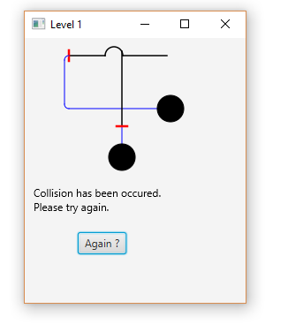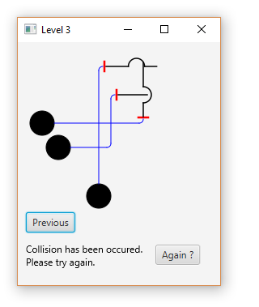

If user clicks the filled circle on the right than there is a collision and the user must click the again button.

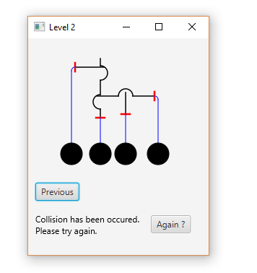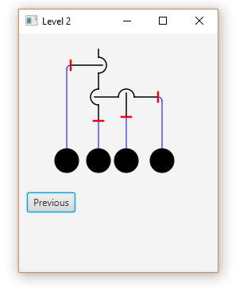

That level is a little bit complex than level1.If the user does not click all the circles correctly than there is a collision.

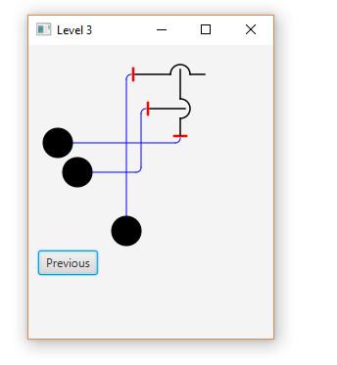

That level is looks similar with level2 but the user should be ready for collisions.

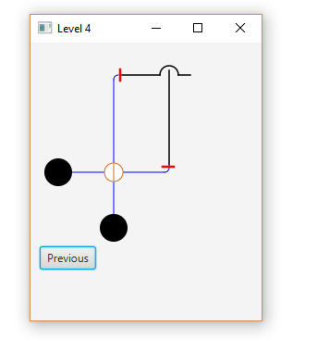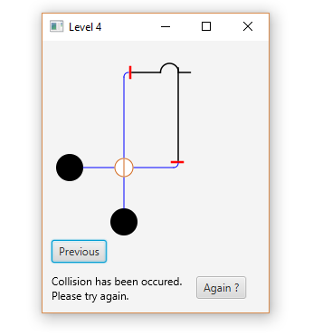

In that level, there is a disconnector. The user should consider that situation.

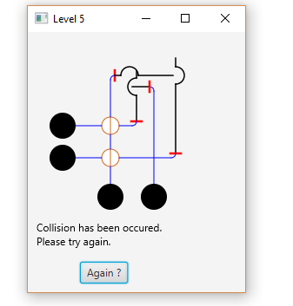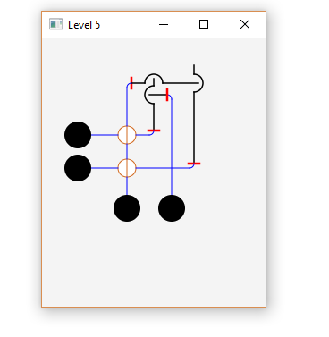

In level5, there are two disconnectors and lots of lines. At this point, the user think more carefully.

Level5 is the last level of the game so if the user play level5 correctly than a new scene can be visible and in that scene there is a congrats gif as an award.