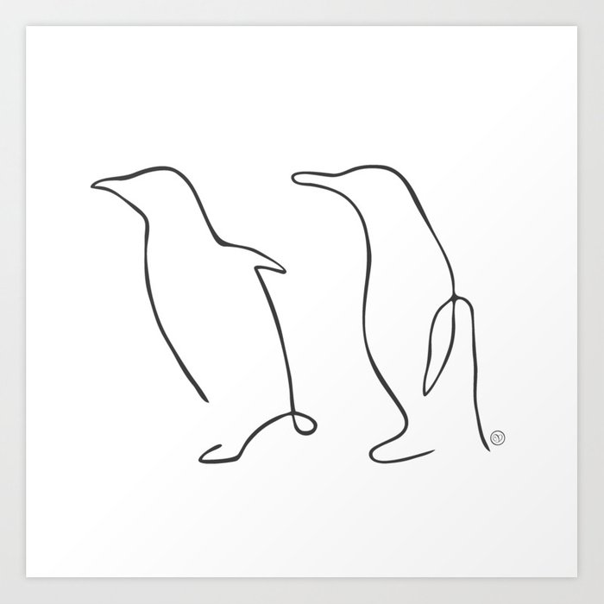

**Family Information**

|  |  |  |  |  |  |
| --- | --- | --- | --- | --- | --- |
| First name | Last name | Age | Hobbies | Likes pets? | Information that is correct |
| {%tr for PYitem in PYpersonal_info%} | | | | | |
| {{ PYitem[‘First name’] }} | {{ PYitem[‘Last name'] }} | {{ PYitem[‘Age’] }} | {{ PYitem[‘Hobbies’] }} | {{ PYitem[‘Do you like pets?’] }} | {%p if PYitem[‘PYanswers’].any_true() %}  {{ PYitem[‘PYanswers’].true_values()}}  {%p else %}  *All information incorrect*.  {%p endif %} |
| {%tr endfor %} | | | | | |