**Your Project Title**



Matthew Ferrett

18681724

18681724@students.lincoln.ac.uk

School of Computer Science

College of Science

University of Lincoln

Submitted in partial fulfilment of the requirements for the

Degree of BSc(Hons) Computer Science

*Supervisor:* Dr. Your Supervisor

April 2022

**Acknowledgements**

Firstly, I want to thank somebody, and somebody else. Here is another thing.

**Abstract**

Here is the abstract for this project report.

**Table of Contents**

Introduction 1

1.1 Some notes 1

1.2 Testing some mathematics 1

1.3 Undergraduate Project Report 1

1.4 Referencing 1

1.4.1 Ludography 2

Literature Review 3

2.1 Background 3

2.2 Related Literature 3

Methodology 4

3.1 Project Management 5

3.2 Software Development 5

3.3 Toolsets and Machine Environments 5

3.4 Research Methods 6

Design, Development and Evaluation 7

4.1 Software Development Projects 7

4.2 Research Projects 8

Conclusions 9

Reflective Analysis 10

References 11

**List of Figures**

3.1 A picture of the Brayford from Google Images. . . . . . . . . . . . . . 5

**List of Tables**

1. Here is a table. . . . . . . . . . . . 5

**Chapter 1**

# Introduction

## 1.1 Some notes

The final report for this project will demonstrate in full, the process that I have undertaken to research, plan, build and test the final artefact that I am presenting.

My project is to be used as an additive to the already expansive research area of image processing and artificial intelligence. The problem my artefact is attempting to solve is one of a real-world issue, through personal experience in child-care I have witnessed first-hand the large amount of stress workers go through on a day-to-day basis. To add onto this stress, I watched my co-workers struggle to sort through a large dataset of images and manually obfuscate children whom their parent’s wish to remain anonymous, whilst attempting be stay in-control of the classroom.

To summarise this problem into a problem question I have asked myself these questions; “What software development artefact can I create to solve this problem?” And, “Following my own research into current relevant literature, what algorithm can I use to solve the problem.”

## 1.2 Testing some mathematics

Here are two equations using the equation editor (1, 2):

${\left(x+a\right)}^{n}=\sum_{k=0}^{n}{\left({n \atop k}\right)x^{k}a^{n-k}}$ (1)

$f\left(x\right)=a_{0}+\sum_{n=1}^{∞}{\left(a_{n}\cos{\frac{nπx}{L}}+b_{n}\sin{\frac{nπx}{L}}\right)}$ (2)

And here is some text with some nice inline maths, (*x,y*) wow *γ* so cool *ρ*.

## 1.3 Undergraduate Project Report

Currently, this template is set up for use with undergraduate project reports. However, the template can be modified fairly easily to conform to, for example, an MComp project report.

## 1.4 Referencing

It is worth noting that the standard for referencing is Harvard.

### 1.4.1 Ludography

There is an optional ludography for Games Computing students. To cite games, you can cite like any other reference with Harvard styling.

**Chapter 2**

# Literature Review

## 2.1 Background

The literature review is an essential requirement of any academic project. A comprehensive review of the literature will provide background to the project. This section establishes what you intended to do and shows the reader that what you have done is the result of academic study, rather than an unfounded whim. This section can use the literature review submitted as part of the Interim Report. If you want to add to it, you can, but it is not directly assessed again.

## 2.2 Related Literature

As above. If you are undertaking an external project, you should also describe the client and outline the nature of their work or business and explain how the artefact will address the client’s needs.

**Chapter 3**

# Methodology

Here is a sentence, and you can see a nice picture in Figure 1.

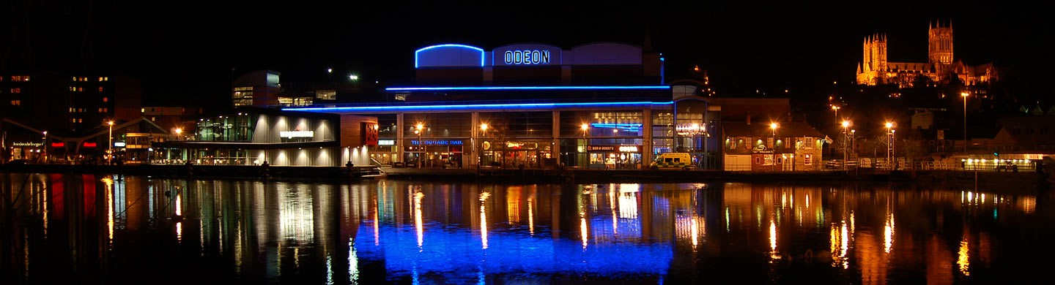

Figure 1: A picture of the Brayford from Google Images.

A table showing some data is displayed here (Table 1). This doesn’t have to be a table, it could be in the form of a chart or some other form of data representation.

|  |  |  |
| --- | --- | --- |
| **First name** | **Last name** | **Age** |
| Bob | Bobbington | 24 |
| Beth | Wavies | 49 |
| Joe | Bloggs | 37 |
| Billy | Bob | 10 |

Table 1: Here is a table.

This section will cover a number of aspects of your project where appropriate. **Not all projects will require every section though**. The key thing is that you demonstrate critical awareness of all of the processes that you have employed in your work and that for all sections needed in your report you are presenting a justification for the methods you adopted and not just presenting a list of methods.

## 3.1 Project Management

Some awareness of project management should be demonstrated in all projects. This section should outline the nature of your project and the specific characteristics that need to be considered in determining what project management methodology you should use. You should identify the specific demands of your project in terms of project management and support your rationale for the selection of a methodology with appropriate and recent academic references. Questions which may be relevant here are:

1. What are the guiding principles and processes in managing your project?
2. What project management methods may be useful for this project?
3. How can you exploit their advantages for your project and mitigate their drawbacks?

## 3.2 Software Development

There should be a methodological analysis of software development approaches used in your project. It is important to note that what is NOT required here is a pedestrian account of popular software development methodologies or a simplistic review of their strengths and weaknesses.

Where relevant, you should give serious thought to the proper design of research and requirements capture approaches. This may include surveys, questionnaires and interviews.

## 3.3 Toolsets and Machine Environments

Toolsets refer to both software development and to project management, so the coverage should address both. This section will outline the tools for software development and project management process; it will make appropriate comparisons between tools available and argue for the most appropriate selection based on metrics, possibly a matrix diagram and other criteria. DO NOT justify the grounds for using specific toolsets and environments simply because you know them well or have developed skills already.

## 3.4 Research Methods

You should investigate the types of research methods necessary to validly answer the research questions that your project addresses. You should cite relevant sources to justify your choices.

**Chapter 4**

# Design, Development and Evaluation

This section of the report will vary significantly in both structure and content, depending on the type of project you are undertaking. For example, a Games design project may include a Game Design Document. However, it must be noted that if your project contains significant software development work, this should be presented in the structure expected of a formal development report. If your project involves an experimental evaluation – especially if that evaluation involved human participants – you are expected to write this work up in the format expected in Section 4.2.

## 4.1 Software Development Projects

Include this section if you are undertaking a software development project. You should discuss:

1. Requirements elicitation, gathering, collection and analysis
2. Design
3. Building and programming
4. Testing
5. Operation

## 4.2 Research Projects

If your project includes primary research components it is expected that you present this work in a manner appropriate to a scientific report:

1. Participant recruitment
2. Evidence that ethical procedures have been followed
3. Study design (short summary of research methods section) – including hypotheses/research question as appropriate
4. A detailed description of the procedure
5. Results of experiment
6. Analysis of results. Consider the results of your work with respect to both your own specific hypotheses/research question and wider context identified in your literature review.

**Chapter 5**

# Conclusions

The results from this project indicate that ...

**Chapter 6**

# Reflective Analysis

The project went well ...

# References

Aad, Georges et al. (2012). ‘Observation of a new particle in the search for the Standard Model Higgs boson with the ATLAS detector at the LHC’. In: *Physics Letters B* 716.1, pp. 1–29 (cit. on p. 2).

Chatrchyan, Serguei et al. (2012). ‘Observation of a new boson at a mass of 125 GeV with the CMS experiment at the LHC’. In: *Physics Letters B* 716.1, pp. 30–61 (cit. on p. 2).