**Matt Fertakos, worked w/ Heather**

**Q1**:

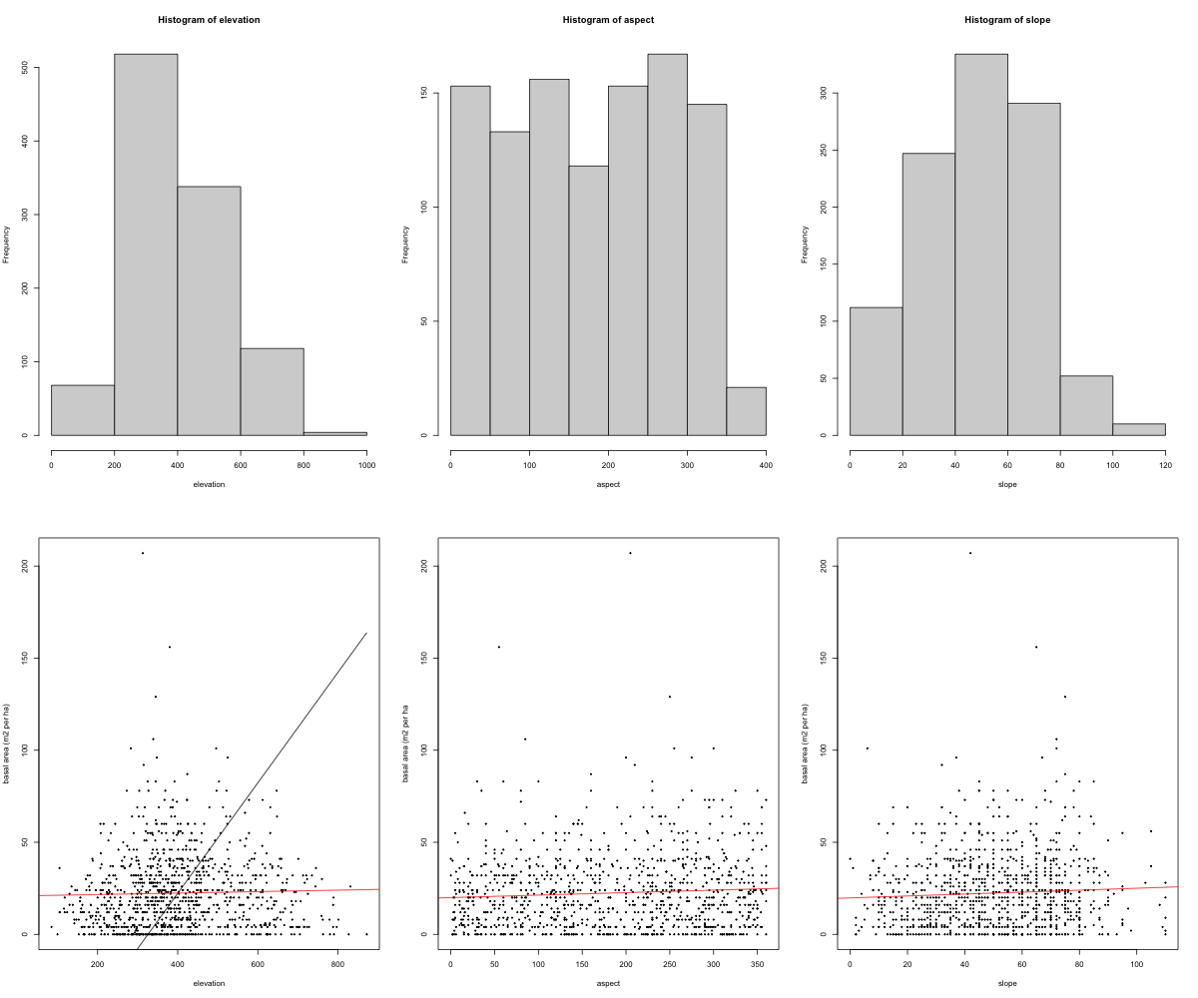

**Q2**: The elevation histogram shows that very low elevation sites are not frequent in the dataset, but that changes for sampling sites in the middle of the range of elevations, which is where the frequency of data peaks. Sampling sites at the highest elevations are then not as frequent. The data is not spread evenly across sampling sites at varying elevations (x-axis), which can be seen in the overrepresentation of sampling from sites in the middle range of possible elevations.

**Q3**: % slope (aka rise/run x 100). 45˚ is considered 100%.

**Q4**: The histogram of slopes at sample sites show most slopes were at a moderate % slope (20% to 80%). Very few sites were very steep (above 45˚/100%), and few were flat (closer to 0%). The data in this histogram is not evenly spread across the x axis, as most study sites were moderately steep while the other two extremes were not as represented in the dataset. Most sites are not flat, but also not extremely steep, so there is not a great mixture of steepness.

**Q5**: Aspect is the direction a surface faces in degrees on a compass. The directions on a compass range from 0˚C to 360˚C, which is reflected in the x-axis of the histogram.

**Q6**: Aspect measurement at sampling sites are evenly distributed across the range of possible aspect values (0-360˚C, x-axis). This means that there were about the same number of sampling sites across all compass directions (except a significant decrease for north west facing sites). This decrease may only be due to only 10 degrees actually existing (350- 360) on the last bar.

**Q7**: included in Q1 figure

**Q8**:

1. Elevation: Looking visually at the distribution of the points it appears to be a positive linear association between elevation and basal area. When I plotted my own visually estimated line of fit (in black) it does not appear to fit the trend of the data correctly because the points are spread far from the line. When I plot the actual line of best fit (in red), it is easy to see there is no notable association between elevation and basal area based on the linear model fit to the scatter plot. The linear model is almost flat, meaning there is no trend in basal area as elevation increases. This means the relationship is linear. As a result, my linear model is a good fit because the points are mostly evenly distributed around the line, but my own line of fit I plotted is not.
2. Slope: There is no notable association between slope and basal area based on the linear model fit to the scatter plot. The linear model is almost flat, meaning there is likely no trend in basal area as slope increases. This means the relationship is linear. As a result, my linear model is a good fit because the points are mostly evenly distributed around the line.
3. Aspect: There is no notable association between aspect and basal area based on the linear model fit to the scatter plot. The linear model is almost flat, meaning there is no trend in basal area as aspect changes. This means the relationship is linear. As a result, my linear model is a good fit because the points are mostly evenly distributed around the line.

*note: I used the abline() and lm() functions to help me create an accurate linear model that fit the data, but I also used the line_point_slope function initially to try to fit a line visually.