**Matt Fertakos** w/ help from John

**Question 1**

boxplot(formula = body_mass_g ~ sex*species,data=penguins,ylab="body mass (g)",names=c("female \n Adelie","male \n Adelie","female \n Chinstrap","male \n Chinstrap","female \n Gentoo","male \n Gentoo"),las=2,xlab="",main="boxplot of body mass as explained by sex and species")

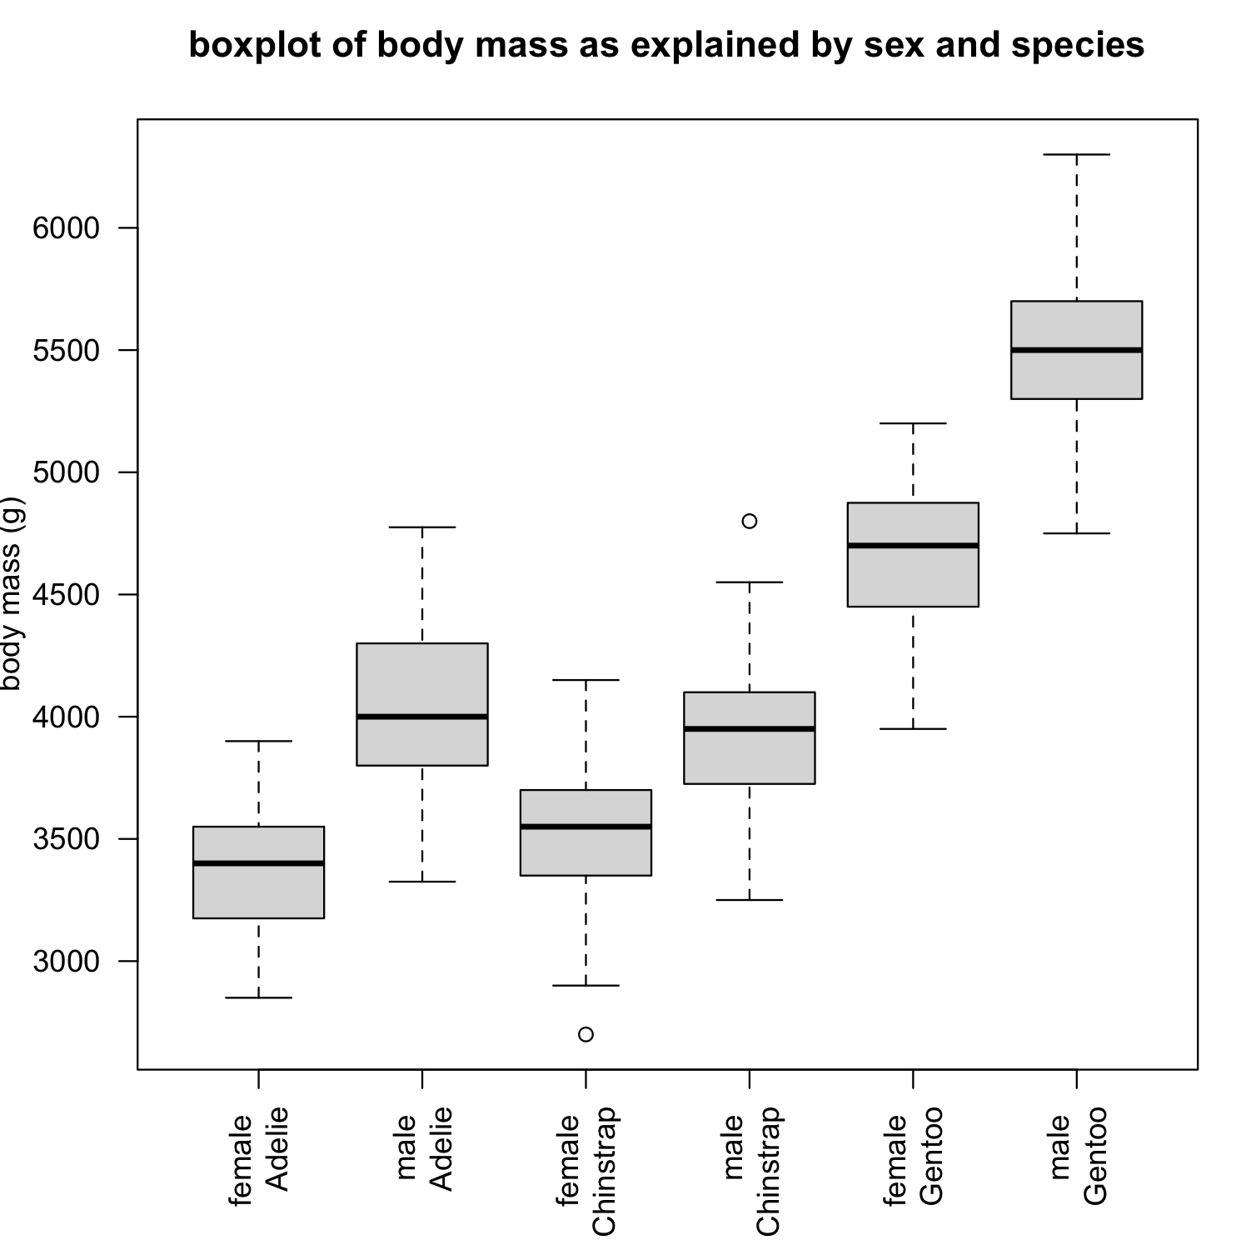

**Question 2**

Based on the boxplots, I think that male Gentoo penguins are significantly heavier than female Gentoos, while the other two species are not significantly different. I believe this because of the distance between the median weights of male and female Gentoos are far apart, and the minimum male weight is still higher than the median female weight.

**Question 3**

I think adding sex to the model of species will improve the fit. If you compare the boxplot created with only species and the one created with species and sex as predictors, you can see that the ranges of variation are different between levels in the plot with sex and species, while in the plot of just species the variation seems the same. This means sex added more information to the model because the range of variation changed.

**Question 4**

fit_both = lm(body_mass_g ~ sex*species, data = penguins)

**Question 5**

The base case is female*Adelie (Adelie females)

**Question 6**

The intercept and speciesChinstrap.

**Question 7**

3368.84+(1)158.37=3527.21g

**Question 8**

aggregate(body_mass_g ~ sex*species, data = penguins,

FUN = "mean",na.rm=TRUE)

=3527.206g