**Worked with Mandy, Heather, Tim, John and Jahiya**

**Q1**

Basal area is the total amount of cross sectional area of each tree per unit in a designated area. It is measured by taking the cross sectional area of each tree at breast height in a given area, summing these values together and placed into a proportion of total area.

**Q2**

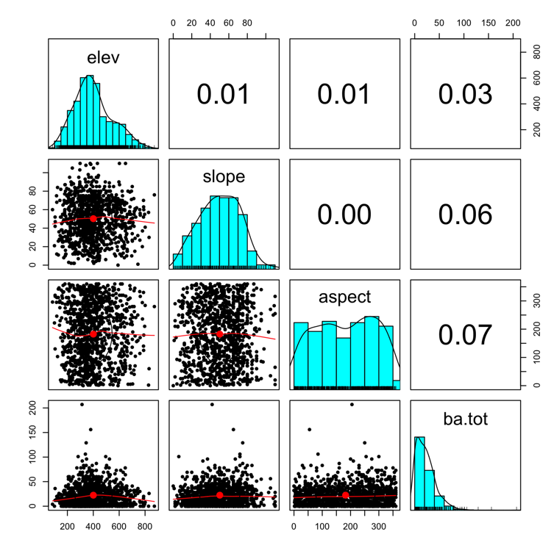

**Q3**

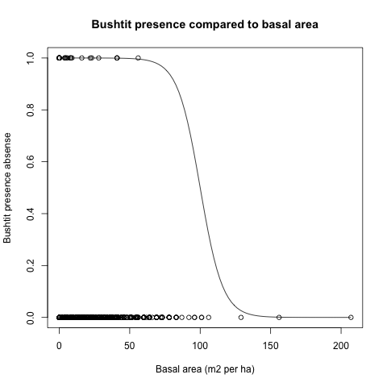

**Q4** The bushtit has greater presence at a lower basal areas. There are no presences above ~75 meters squared per hectare in the plot. This means in a one hectare area, less coverage (total cross-sectional area) by trees leads to an increase in bushtit presence. Bushtits prefer areas of low tree coverage. The logistic model is an okay fit visually because it matches the relationship that bushtits are more present at areas of lower basal area which quickly decreases at areas of higher basal area.

**Q5**

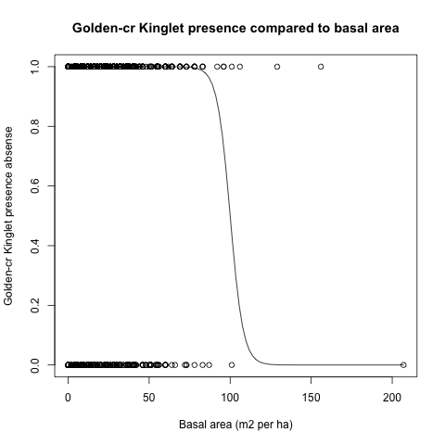

**Q6** The Golden-cr Kinglet has presences up to a basal area of 100 meters squared per hectare in the plot. This means that as basal area (tree coverage) increases, Golden-cr Kinglet presence decreases. The Golden-cr Kinglet prefers areas with low to mid amounts of tree coverage. The logistic model is an okay fit of the data because it shows a drop off near the midpoint which matches my interpretation of the data that Golden-cr Kinglets prefer areas of low to mid coverage as measured by basal area.

**Q7** 181 Gray Jays

**Q8** sum(dat_all$GRJA)

**Q9** 110 Gray Jays sites

**Q10**

as.numeric(dat_all$GRJA>0)->GRJAamounts

length(GRJAamounts[which(GRJAamounts=='1')])

Or instead of length function

sum(GRJAamounts)