**Matt Fertakos** – worked w/ Bonnie

**Question 1**

rm(list = ls())

rope<-read.csv(here("data","rope.csv"))

class(rope$rope.type)

rope$rope.type<-as.factor(rope$rope.type)

levels(rope$rope.type)

n_obs = length(rope$blade)

n_groups = length(levels(rope$rope.type))

ss_tot = sum((rope$p.cut-mean(rope$p.cut))^2)

df_tot = n_obs-1

#png(filename=here("eco_634_2021","lab_10_Q2.png"),width=1500,height=1600,units="px",res=180)

par(mfrow=c(1,2))

boxplot(rope$p.cut,xlab="all ropes",ylab="percent rope cut", main="percent rope cut by all ropes")

boxplot(rope$p.cut~rope$rope.type,xlab="rope type",ylab = "percent rope type",main="percent rope cut by rope type")

dev.off()

resid_function = function(x){

x-mean(x)

}

agg_resids = aggregate(

x = rope$p.cut,

by = list(rope$rope.type),

FUN = resid_function)

sumsqresid_function = function(x){

sum((x-mean(x))^2)

}

agg_sq_resids = aggregate(

x = rope$p.cut,

by = list(rope$rope.type),

FUN = sumsqresid_function)

ss_within = sum(agg_sq_resids$x) #4.875

df_within = n_obs-n_groups

ss_among = ss_tot - ss_within #0.472

df_among =

ms_within = ss_within / (n_obs - n_groups) #0.0424

ms_among = ss_among / (n_groups - 1) #0.0946

#dividing by degrees of freedom accounts for sample size and allows for a better comparison

f_ratio = ms_among/ms_within

f_pval = pf(f_ratio,n_groups - 1,n_obs - n_groups,lower.tail=FALSE)

#0.0558

**Question 2**

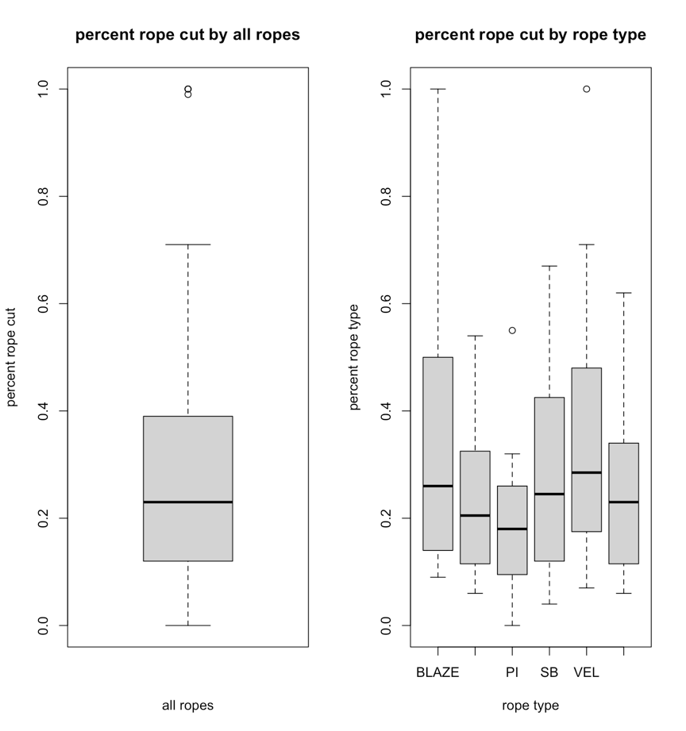

No, I do not think there are equal variances between groups. This is because the size of the boxes, which represents the spread of most of the data from the mean, varies between groups.

**Question 3**

bartlett.test(p.cut~rope.type,data=rope)

p=0.00143 (not homogeneous)

**Question 4**

An ANOVA-type analysis is not appropriate for the raw data because it breaks the homogeneity assumption of group 1 models (general linear models). Both my graphical analysis and the significant p-value from the Bartlett test reject homogeneity in the raw data. We could consider doing data transformations to fit the required assumptions of a general linear model like ANOVA.

**Question 5**

“BLAZE”

**Question 6**

It is the estimate of the intercept: 0.36714

**Question 7**

0.36714 + 0(-0.13014)+0(-0.18014)+0(-0.09514)+0(-0.01714)+1(-0.10164) = 0.2655