Question 1

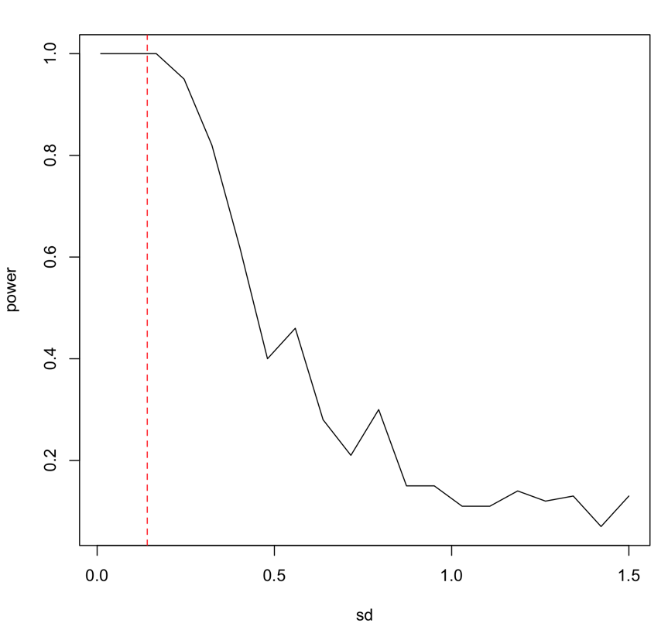

n_sds=20

Question 2

Statistical power is the probability of correctly rejecting the null hypothesis. As dispersion increases, which is also known as the standard deviation, the variation in your possible results also increases. With more variation it is more difficult to correctly reject the null because with repeated sampling you are more likely to get significantly different results.

Question 3

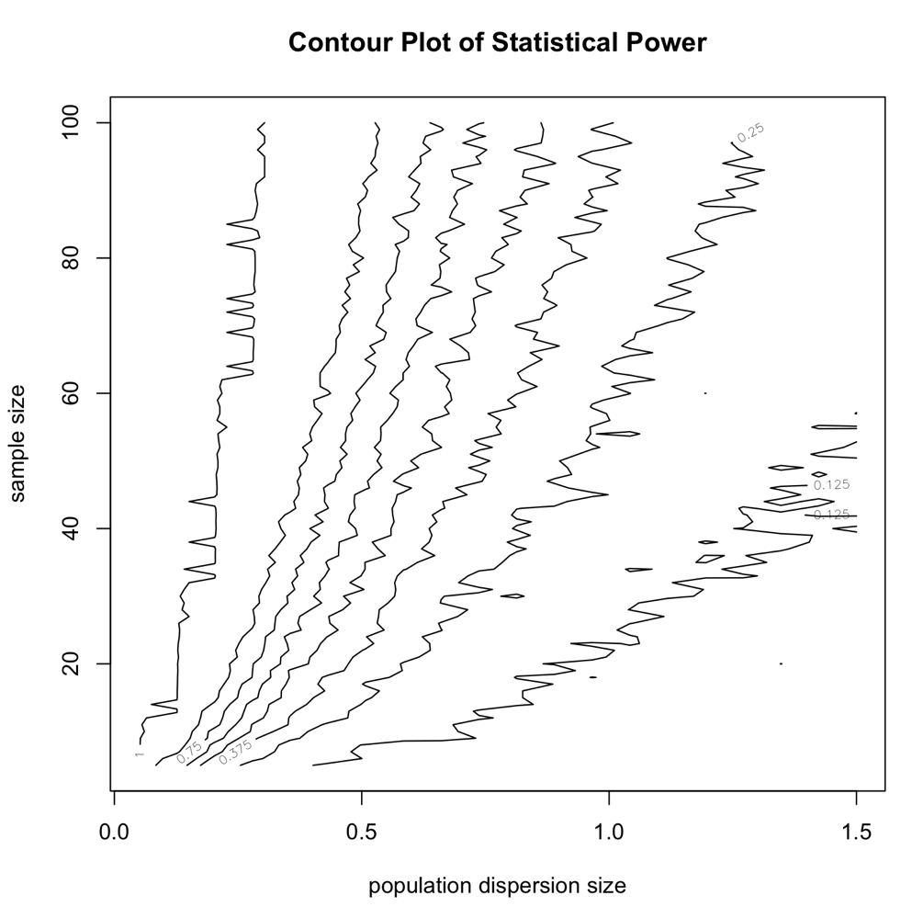

Question 4

Question 5

Htlm file in documents

Question 6