Matt Fertakos

Worked with Bonnie

Q1:

exp_fun = function(x, a, b)

{

return(a* exp(-b*x))

}

Q2:

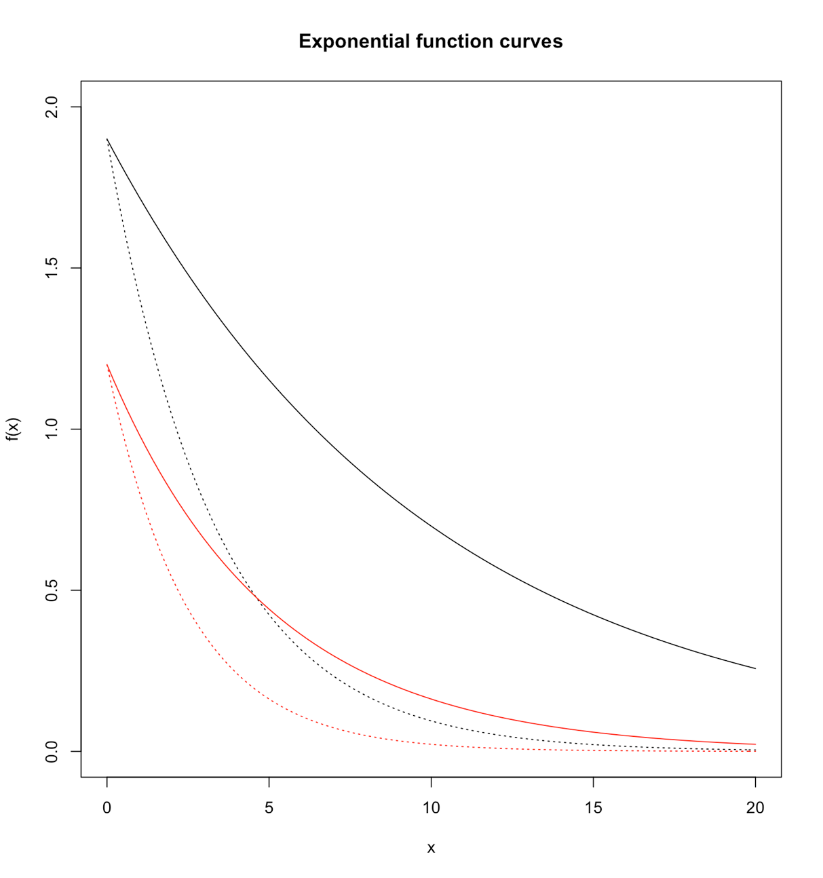

Q3: When a decreases the curve appears to shift lower on the y-axis. An increase in a would shift the curve higher on the y-axis. Changing a does not appear to change the slope of the curve.

Q4: When the value of b increases the steepness of the curve shifts left along the x-axis. A decrease in b would decrease the steepness of the curve and shift it further right along the x-axis. The slope of the curve is affected by b.

Q5:

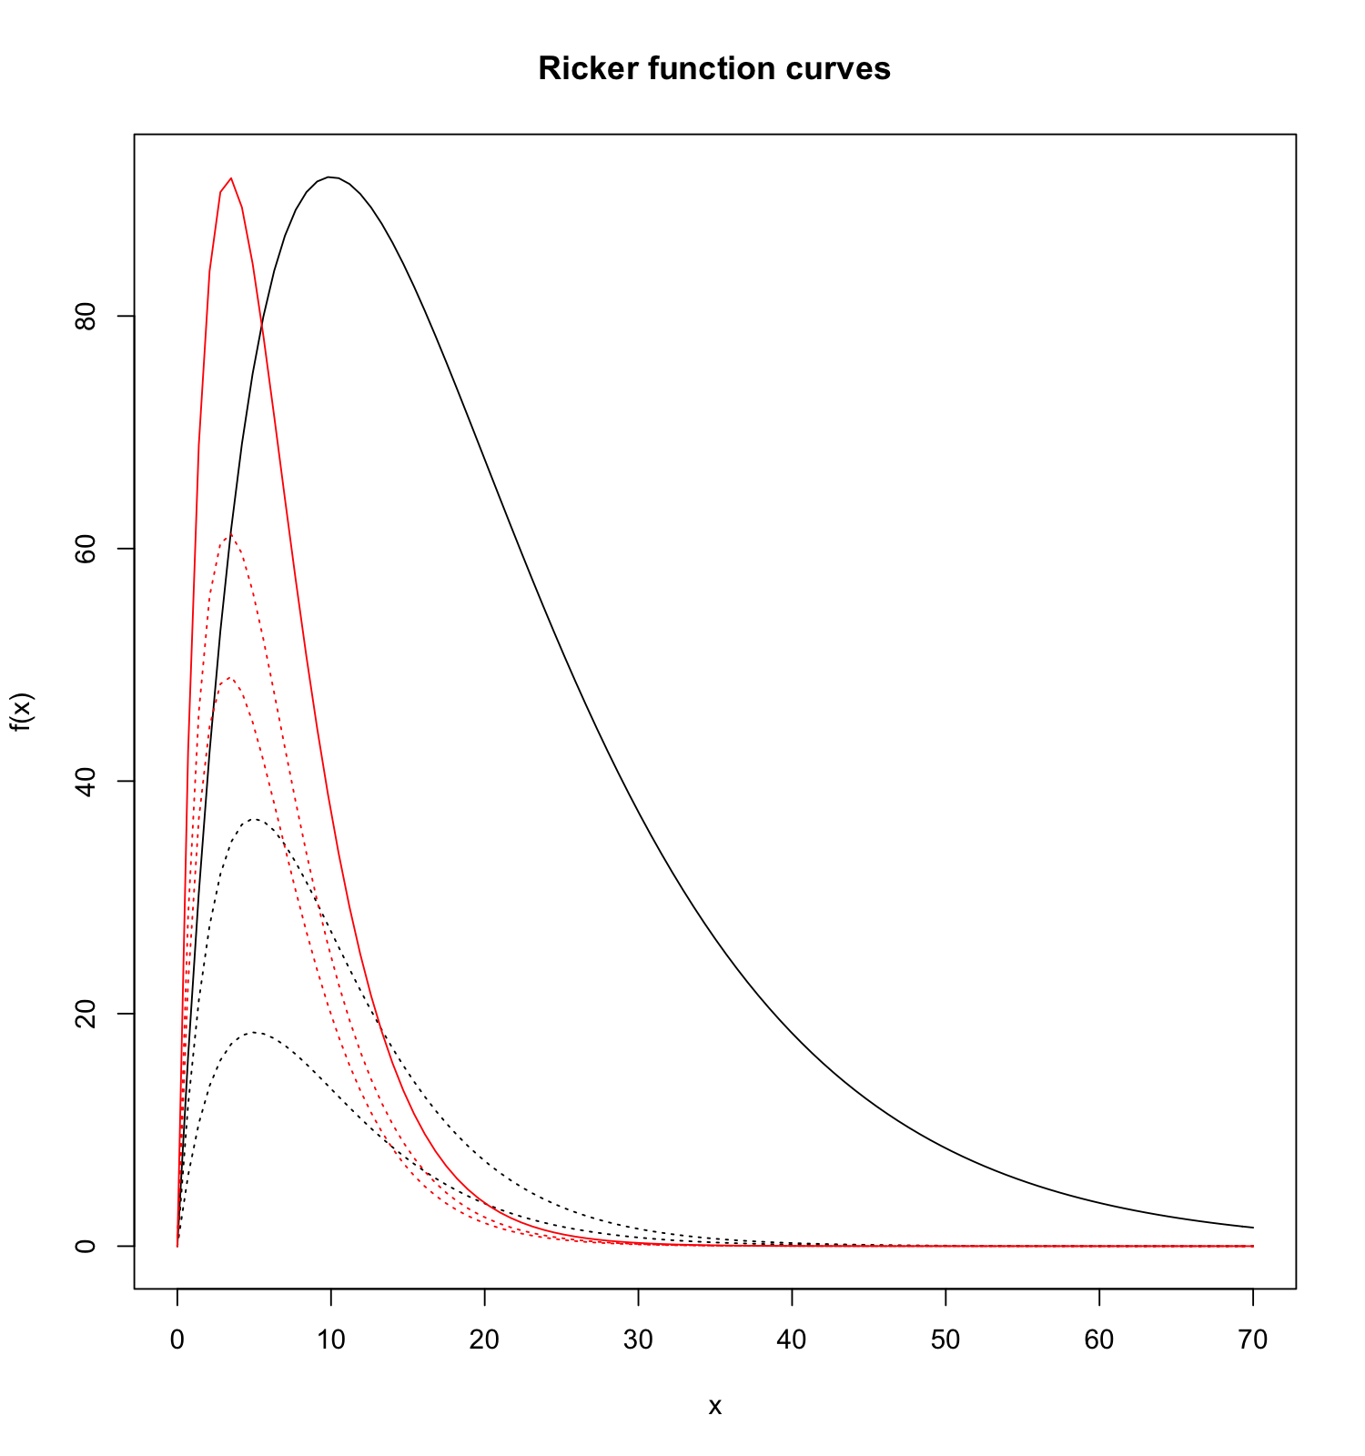

Q6: As a increases, the initial slope of the curve increases. This is clear in the three red curves, where the red solid line has a very steep slope with a =75, and the shorter red dotted line has a flatter slop with a =40. Increases a appears to increase the height, but we know from the documentation that both a and b contribute to height.

Q7: As b increases, the x value of the peak’s location shifts to the left. This is clear in the three black lines in which the two dotted lines’ peaks are further to the left with b=0.2 than the solid line with b=0.1. We also know b contributes to the curves height because where the curve peaks (b) in combination with the initial slope (a) limits the height.

Q8: The slope value is -0.00035, the x-intercept is 700, and the y-intercept is 0.3. The slope value was created to make steepness of the line fit through and be as close to as many points as possible. It was made negative because it appears that as distance class increases the dispersal rate decreases. The x and y intercept values were determined to shift the line along the x axis, and y axis so it crosses and is close to as many points as possible.

Q9: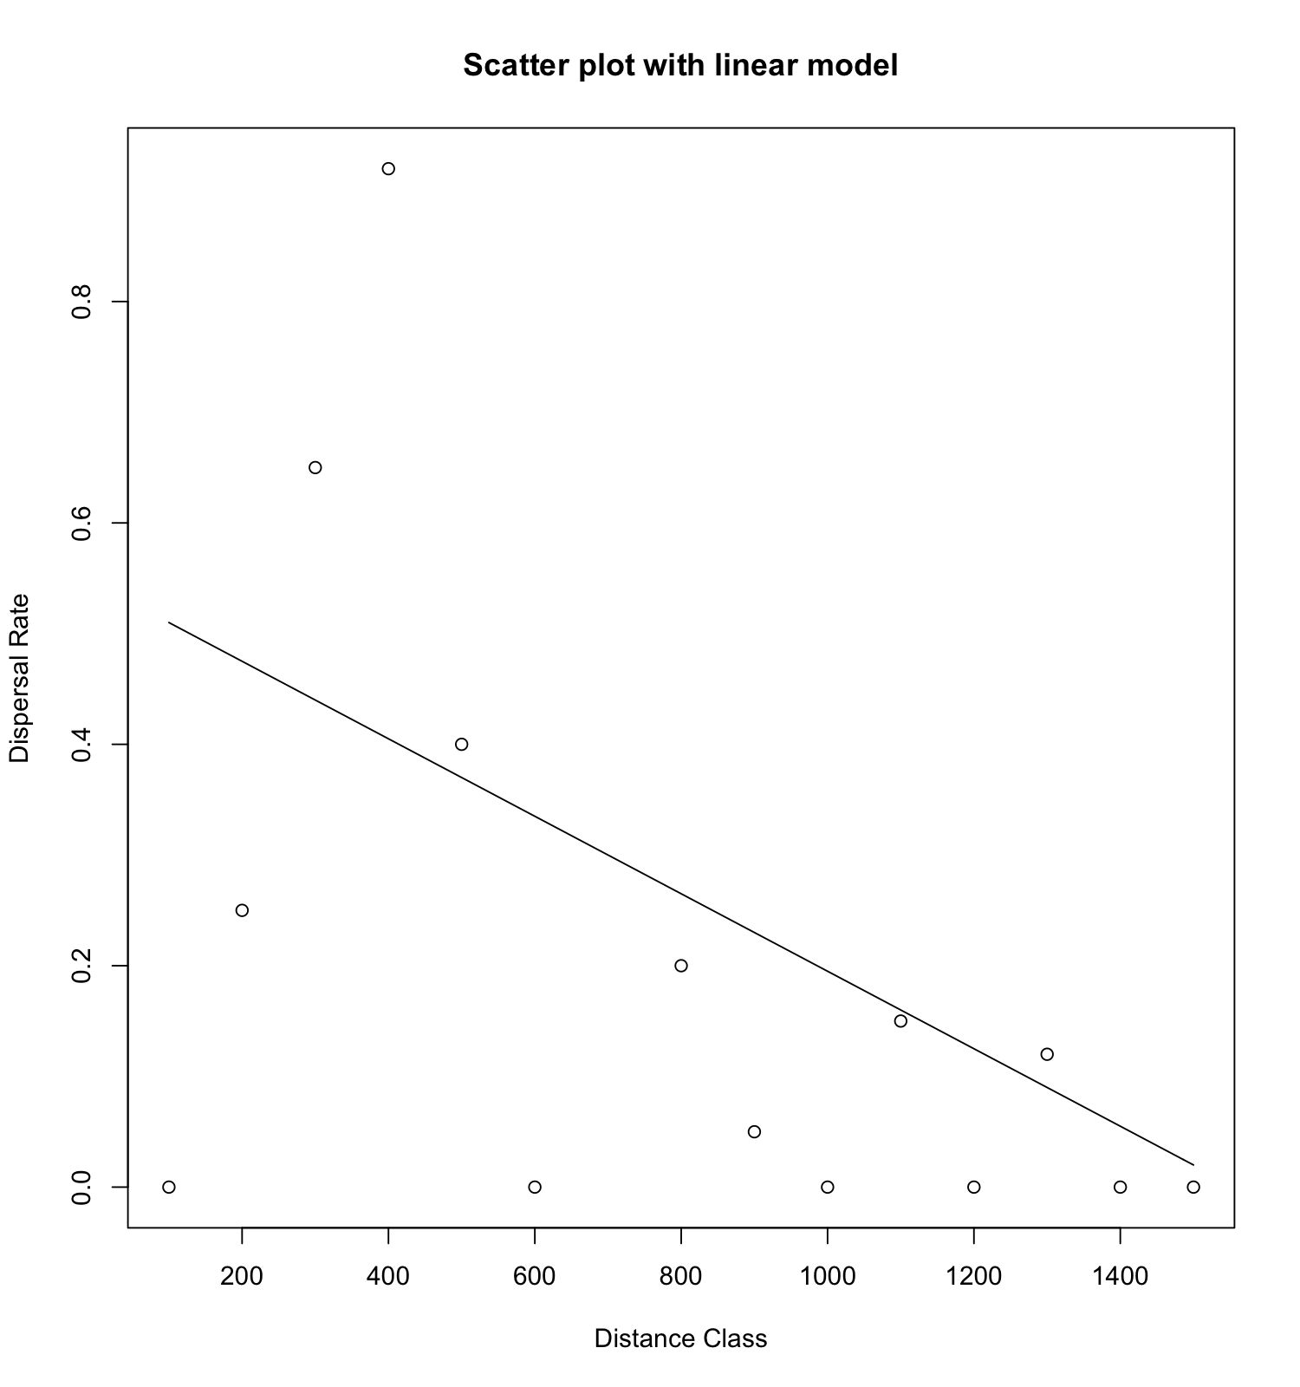

Q10: In my exponential model a = 75, and b= 0.015. The a value was selected by testing random numbers, until the curve appeared to be at an appropriate place on the y-axis. The b value was selected by testing random numbers until an appropriate steepness and placement of the curve along the x-axis was found for the data points. My overall aim was to create an exponential curve that was close to as many points as possible, and I did this by changing the a and b values.

Q11:

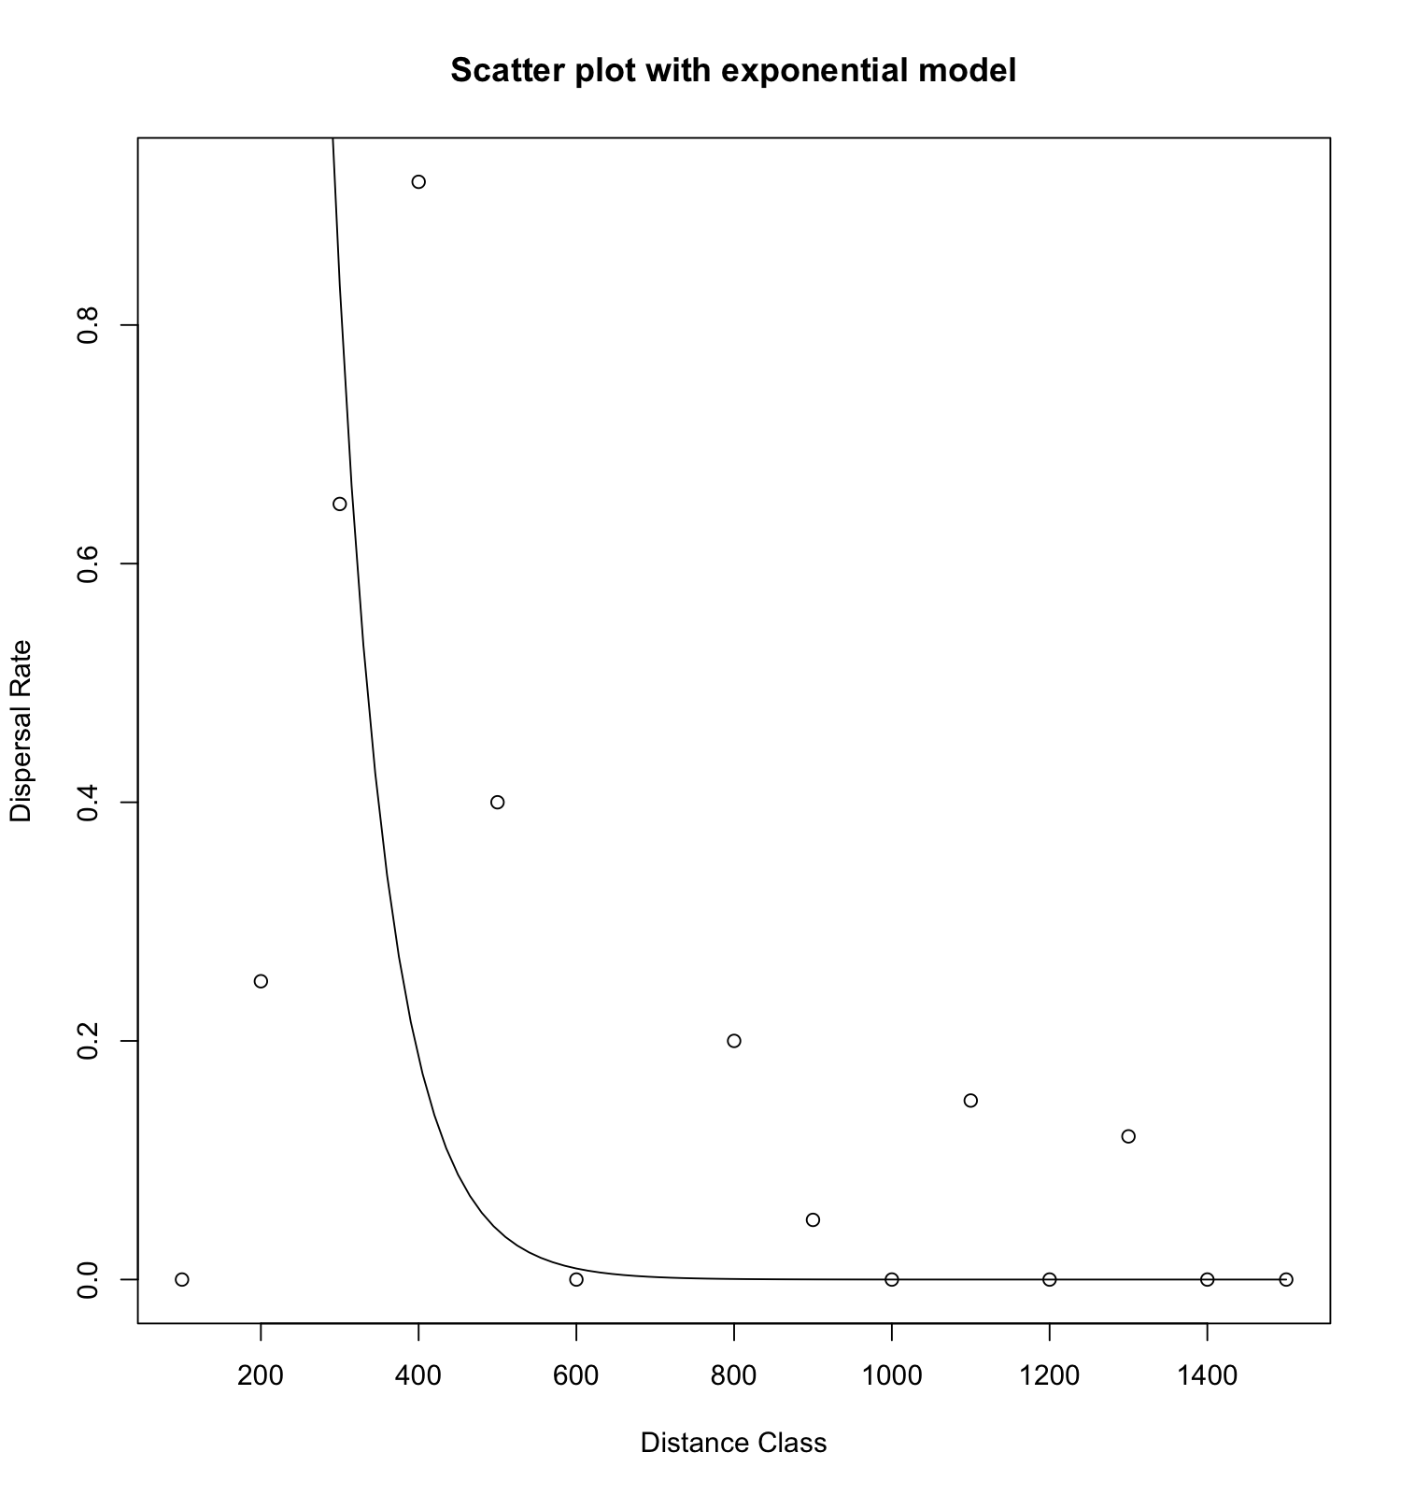

Q12: In my Ricker model a =0.01, and b=0.004. We worked with another student and tweaked the values we found that created a curve we could actually see to fit the scatterplot. We knew the a value controlled the initial slope of the curve, so I decreased that until it was as close to as many points as possible. We also knew b changes where on the x-axis the peak is, so I decreased that to move to further to the right. My overall aim was to make the model as close to the data points as possible and reflect that as distance class increases, dispersal rate decreases after an initial major increase in dispersal rate that peaks around 100.

Q13:

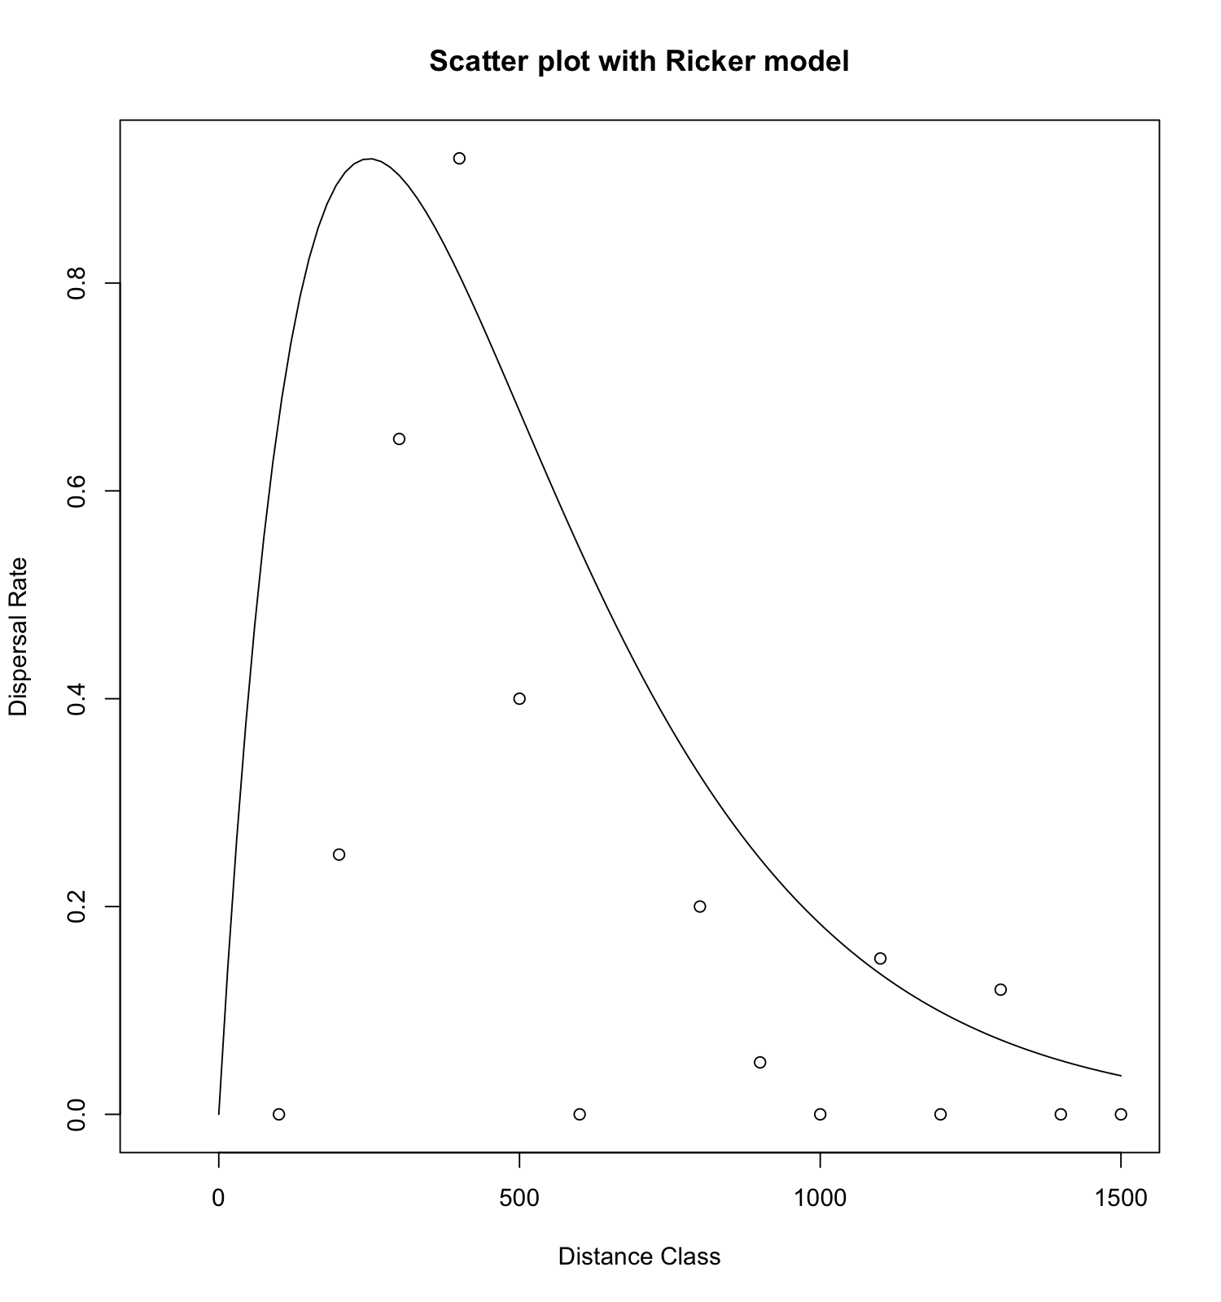

Q14:

guess_x=700

guess_y=0.3

guess_slope=-0.00035

dat_dist$linpred<-line_point_slope(dat_dist$dist.class,guess_x,guess_y,guess_slope)

dat_dist$resids_linear<-dat_dist$disp.rate.ftb-dat_dist$linpred

dat_dist$exppred<-exp_fun(dat_dist$dist.class,75,0.015)

dat_dist$resids_exp<-dat_dist$disp.rate.ftb-dat_dist$exppred

dat_dist$rickpred<-ricker_fun(dat_dist$dist.class,0.010,0.004)

dat_dist$resids_ricker<-dat_dist$disp.rate.ftb-dat_dist$rickpred

Q15:

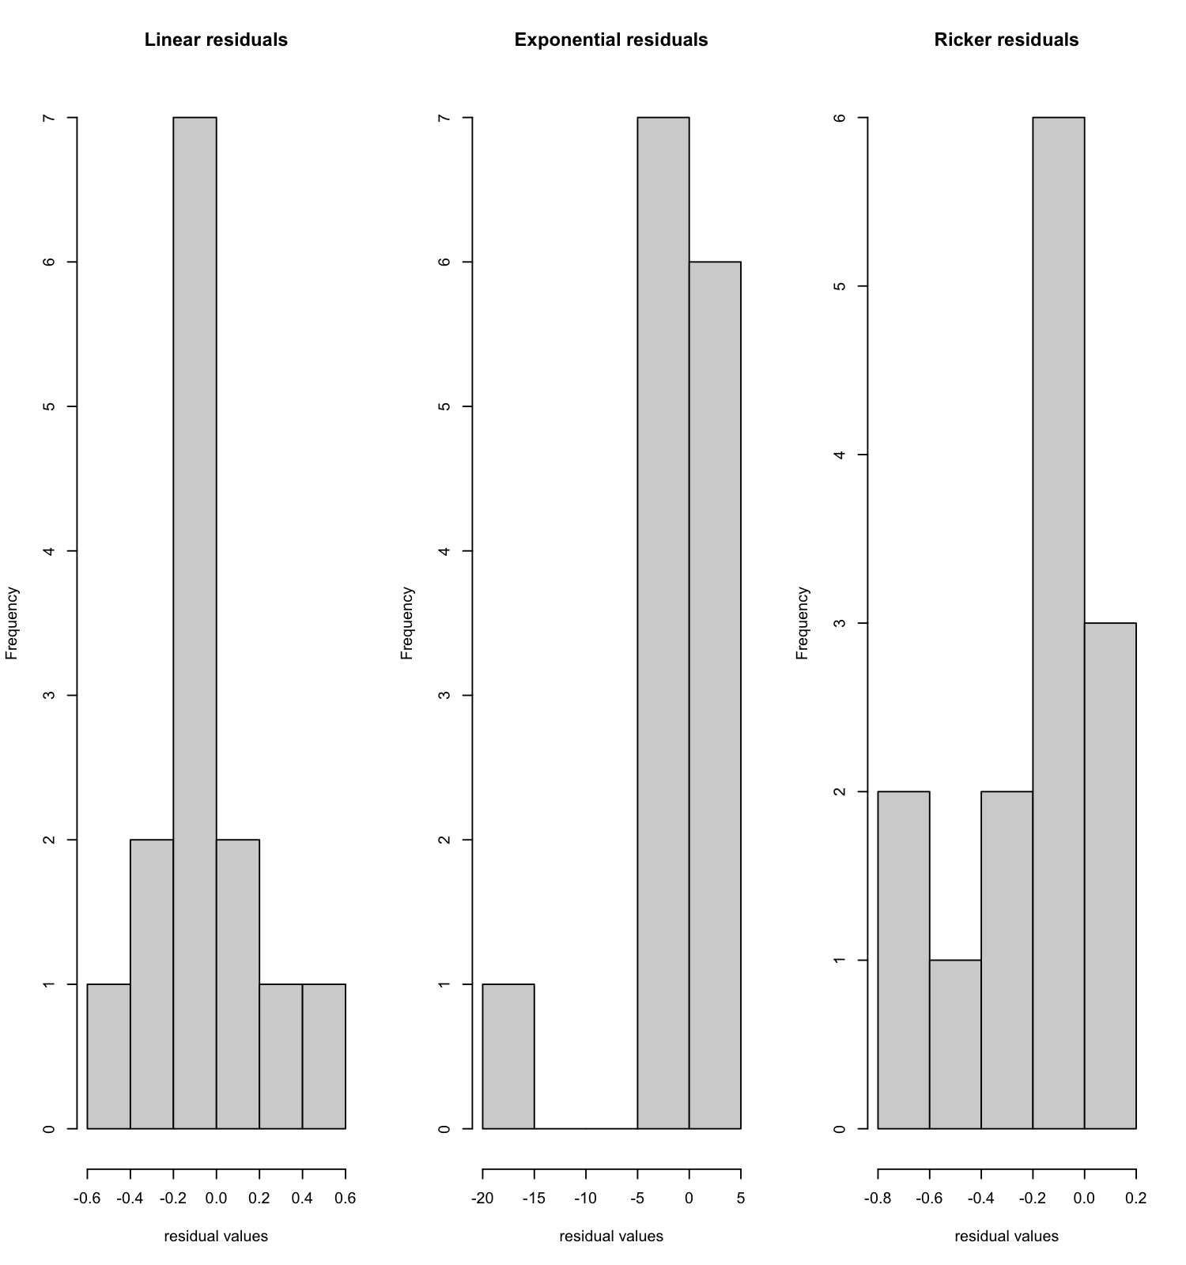

The exponential residuals show an outlier due to the first point that is initially very far from the exponential function. It will have a much farther residual from zero than the other points in relation to the exponential fit. This could be remedied by changing the alpha value to bring the exponential fit closer to this point. This outcome displays how histograms are a good way to evaluate the fit you made on a scatterplot of points.