Matt Fertakos w/ input from Mandy, Bonnie, and John

Q1:

dbinom(3,4,0.75)

0.421875

Q2:

pbinom(3,4,0.75)

0.6835937

Q3:

1-pbinom(3,5,0.75)

0.6328125

Q4:

pnorm(1.2,mean=2,sd=2)

0.3445783

Q5:

1-pnorm(1.2,mean=2,sd=2)

0.6554217

Q6:

pnorm(3.2,mean=2,sd=2)-pnorm(1.2,mean=2,sd=2)

0.3811686

Q7:

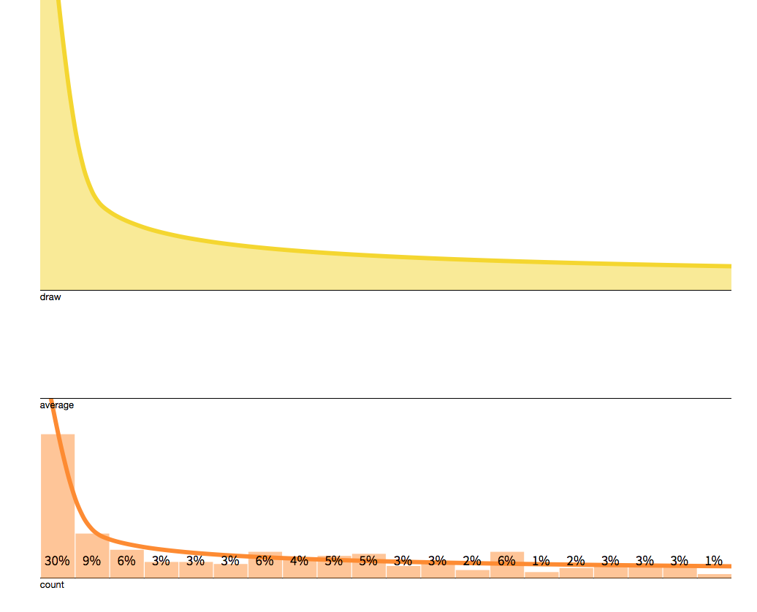

The histogram becomes more skewed to the left and resembles the curve above it. It does not resemble a normal distribution.

Q8:

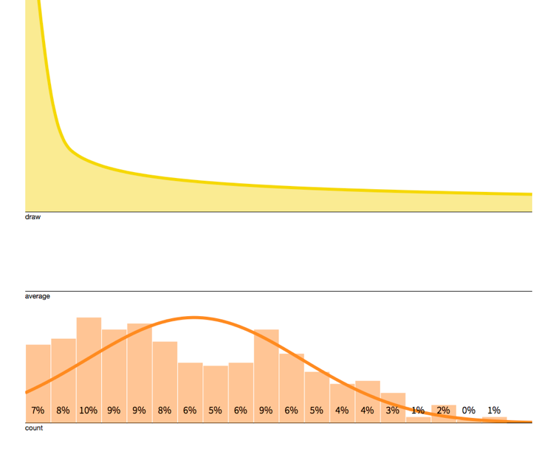

The histogram becomes more normal. It no longer looks like the draw curve above it.

Q9:

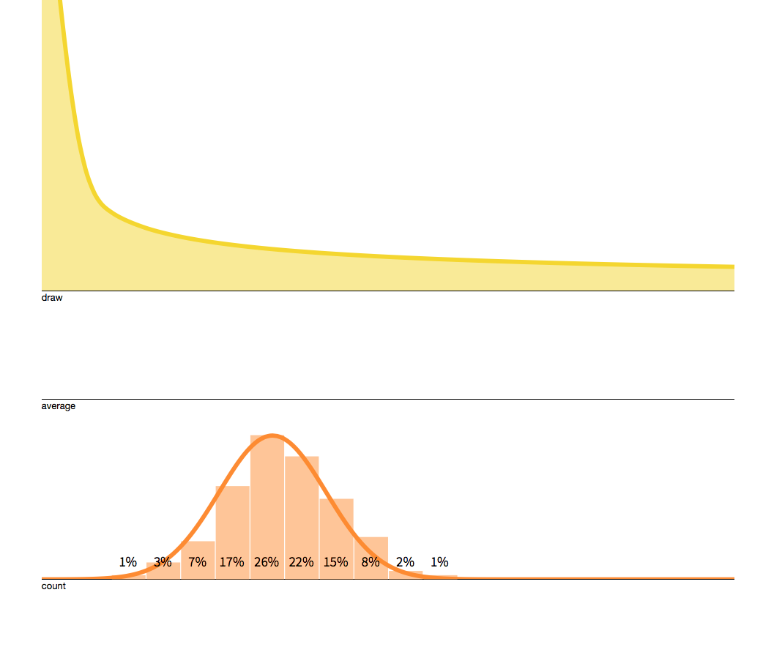

The histogram is normally distributed almost immediately.

Q10:

Increasing the sample size from 1 to 2 increases the total number of draws to 100 (50 draws x2 sample size) and therefore increases the breadth of sampling. Because there is more sampling occurring, it is easier to see trends in the data and therefore view where the sample mean is. In the formula for the central limit theorem, the sample size (n) is in the denominator, so increasing it decreases the z-score, which represents the amount of spread in the sample distribution.

Q11:

The sample size (n) and the sample standard deviation (which is influenced by the population standard deviation).

Q12:

25^3

15625 words

Q13:

B x 251

This is done to add 1 to the exponent of B which adds 1 position to the end of the book.