Matt Fertakos w/ input from Bonnie

**Question 1:**

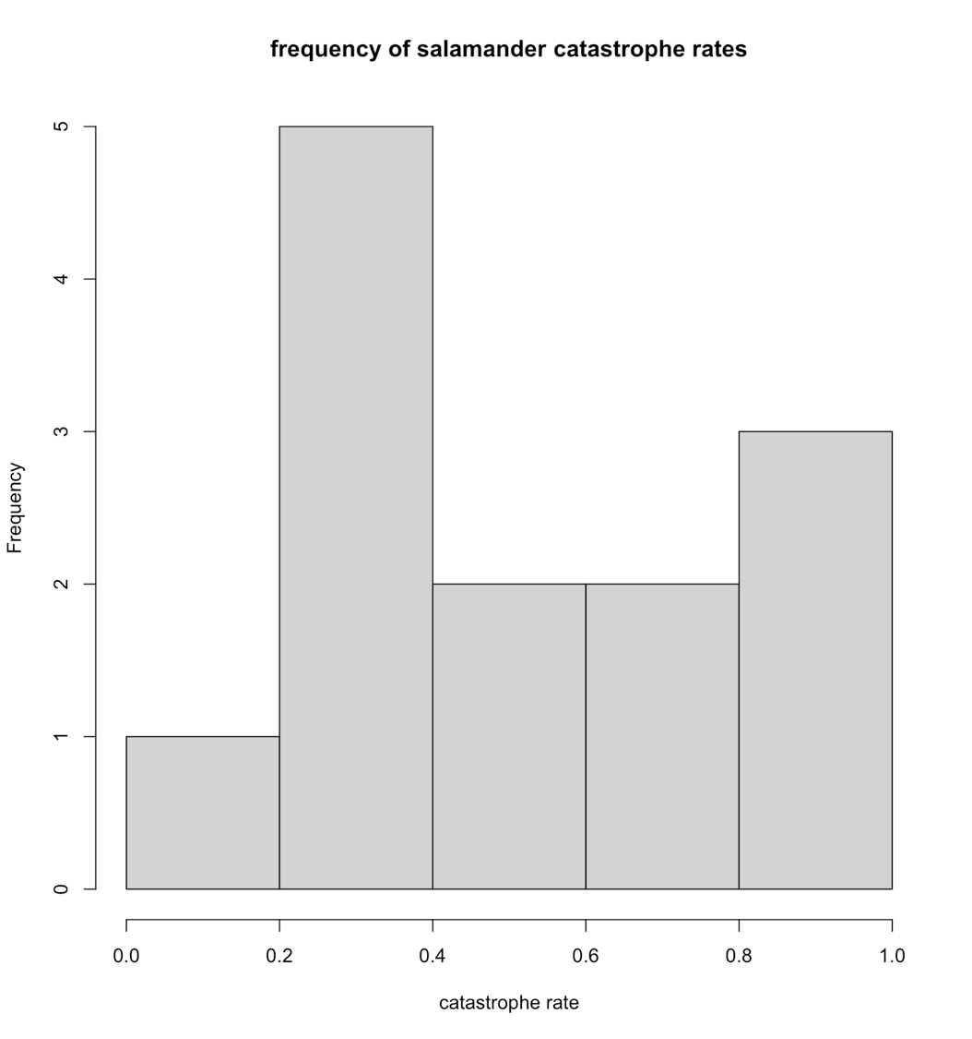

**Question 2:**

shapiro.test(catrate$cat.rate)

p=0.041

**Question 3:**

The null hypothesis of a Shapiro test is that the distribution is normal.

**Question 4:**

There is strong evidence (p=0.041) that the null hypothesis that the distribution is normal is not supported. Therefore, there is strong evidence the distribution is not normally distributed.

**Question 5:**

t.test(x=catrate$cat.rate,mu=2/7)

p=0.01193 shows that the null is not supported.

**Question 6:**

The null hypothesis is that the mean observed catastrophic rate and the mean expected rate from the pond late-filling rate are equal.

**Question 7:**

This is a two-tailed test

**Question 8:**

p=0.01193 is equivalent to the false positive rate that 1% of the time we will observe a catastrophic rate that is in fact NOT different from the pond late-filling rate.

**Question 9:**

CI: 0.3526 to 0.7261 - It does not include 0.

**Question 10:**

p=0.01193 means the alternative hypothesis that the observed rate is greater than the expected is supported, and consequently provides strong evidence to reject the null hypothesis.

**Question 11:**

wilcox.test(catrate$cat.rate, mu = 2 / 7)

**Question 12:**

The Wilcoxon test gives a p value of 0.006, which is much smaller than the p value obtained from the t-test (0.01054).

**Question 13:**

The p-value of 0.006 from the Wilcoxon rank sum test provides strong evidence to reject the null that the distribution that the observed and expected rates are the same.

**Question 14:**

The p-values from the t-test and the Wilcoxon rank sum test both reject the null that the observed catastrophic rate is the same as the expected catastrophic rate. The Wilcoxon rank sum test provides stronger evidence to reject the null, though, because the p value from this test is much smaller, and is therefore a smaller false positive rate.

**Question 15:**

Both tests work for small sample sizes, but the Wilcoxon rank sums test is for datasets that are not normally distributed. Because the catastrophic salamander dataset appears non-normal when plotted as a histogram, the Wilcoxon rank sums test is better. This is verified by a Shapiro test which has a p value of 0.041, meaning the alternative hypothesis that they are non-normally distributed is supported.

**Question 16:**

dat_adelie = subset(penguin_dat, species == "Adelie")

dat_chinstrap = subset(penguin_dat, species == "Chinstrap")

shapiro.test(dat_adelie$flipper_length_mm)

shapiro.test(dat_chinstrap$flipper_length_mm)

**Question 17:**

The p value of 0.72 from the Shapiro test of the flipper length of Adelie penguins supports the null hypothesis that they are normal. Furthermore, the p value of 0.81 from the Shaprio test of the flipper length of Chinstrap penguins supports the null hypothesis that they are normal.

**Question 18:**

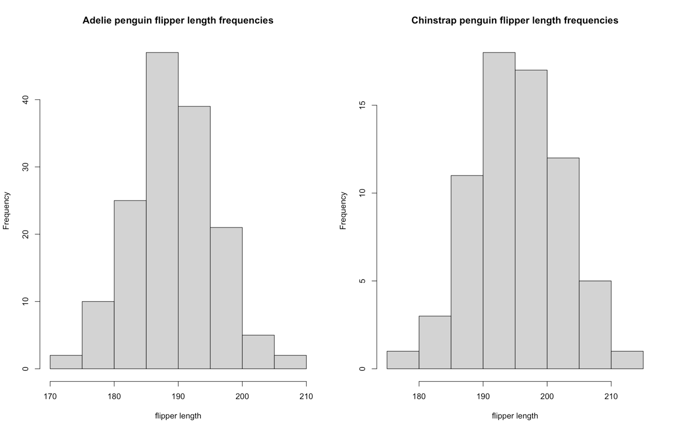

**Question 19:**

The alternative hypothesis is that the average flipper length of Adelie penguins are larger OR smaller than the average flipper length of Chinstrap penguins.

**Question 20:**

t.test(penguin_dat$flipper_length_mm ~ penguin_dat$species)