**Only visible for the authorized users (see About page)**

Select a Country

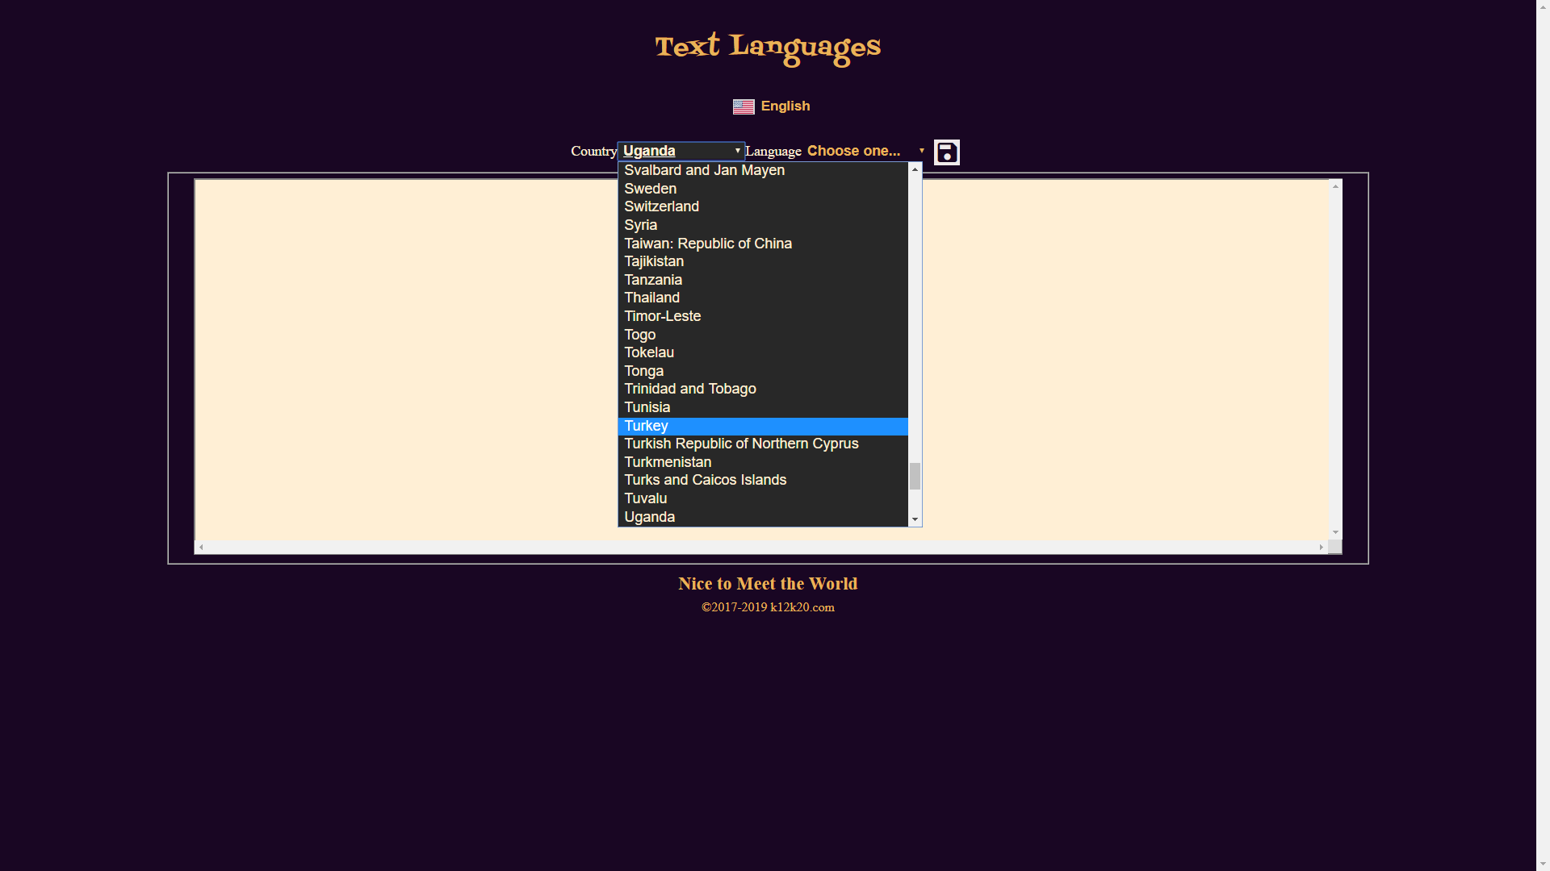

Select a Language for this Country

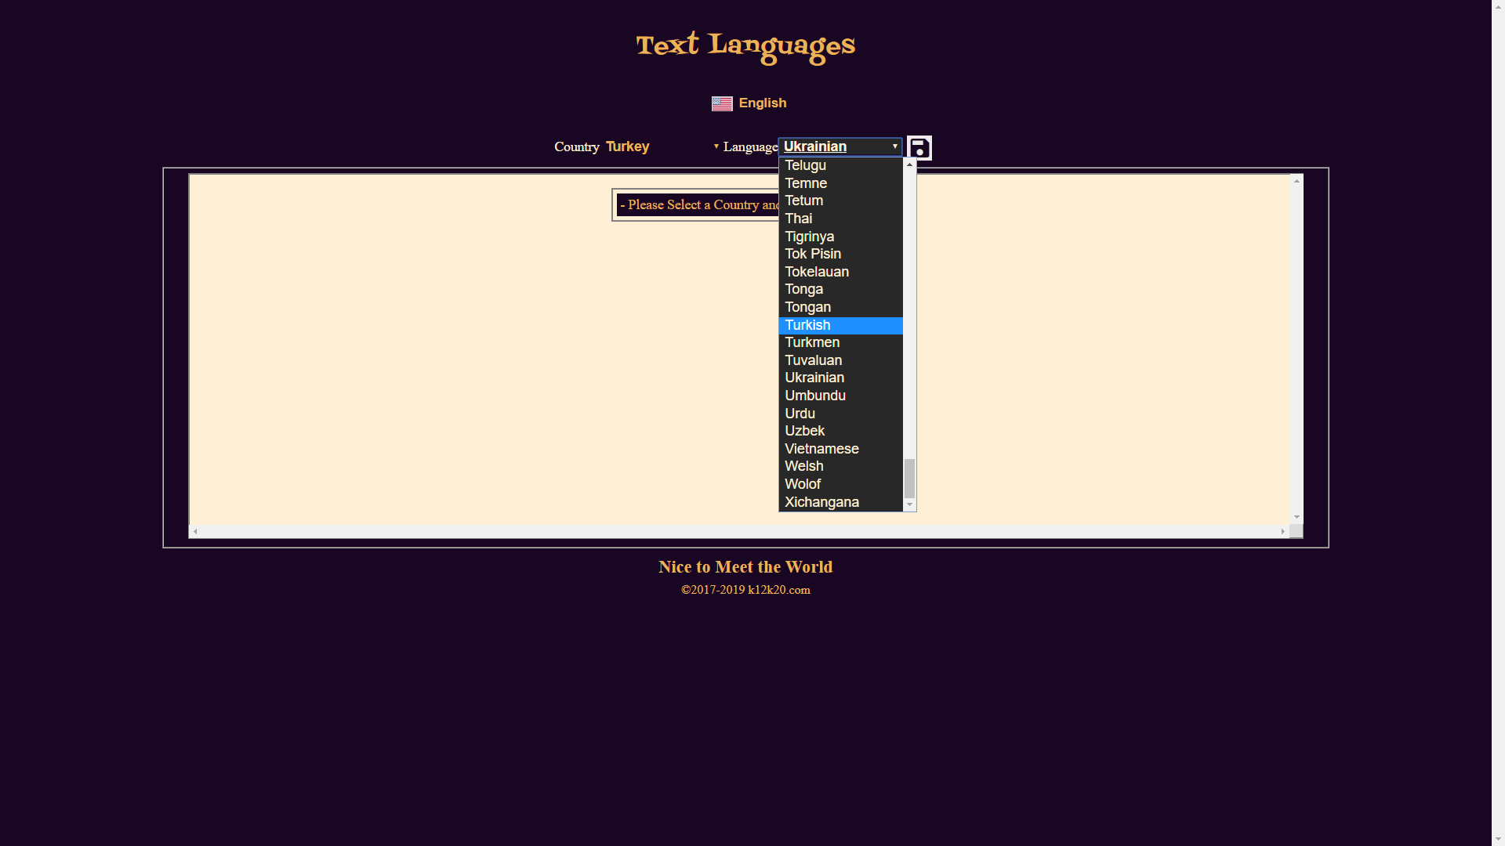

Translate each English word/text into the chosen Language

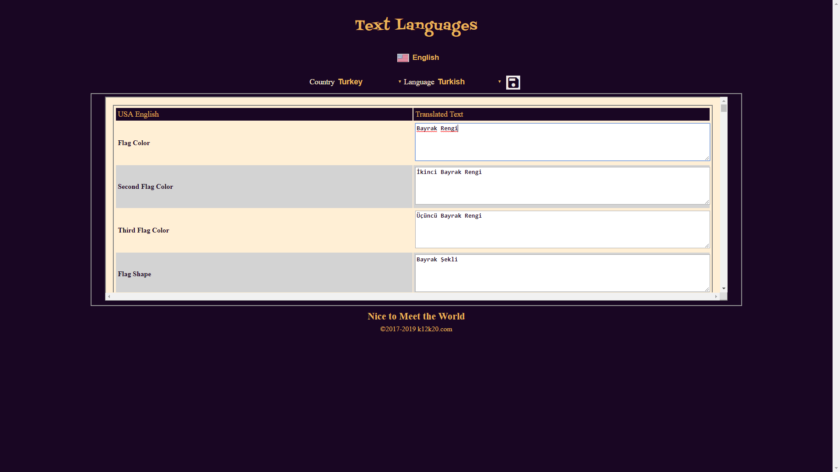

Keep entering to the end and select the Save button (diskette icon) on the top to register the new Application Text Language