**k12k20.com starts the application**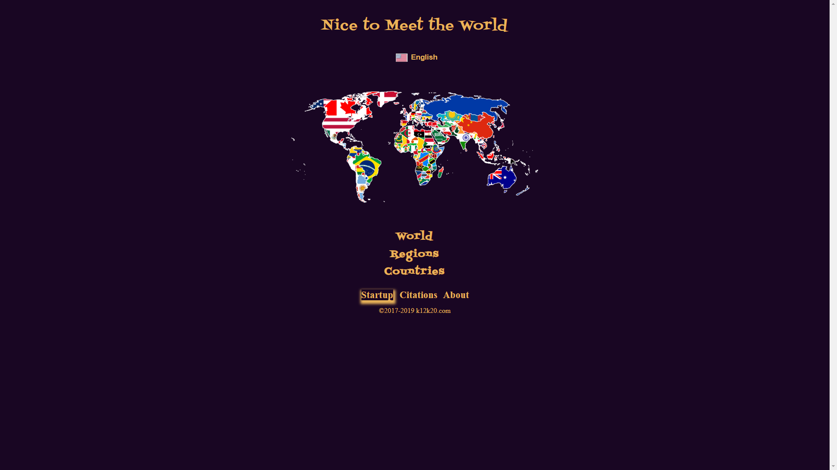

**To start the application with “World” or “Regions” or “Countries” click on “Startup” option**

**Here a Region can be selected** 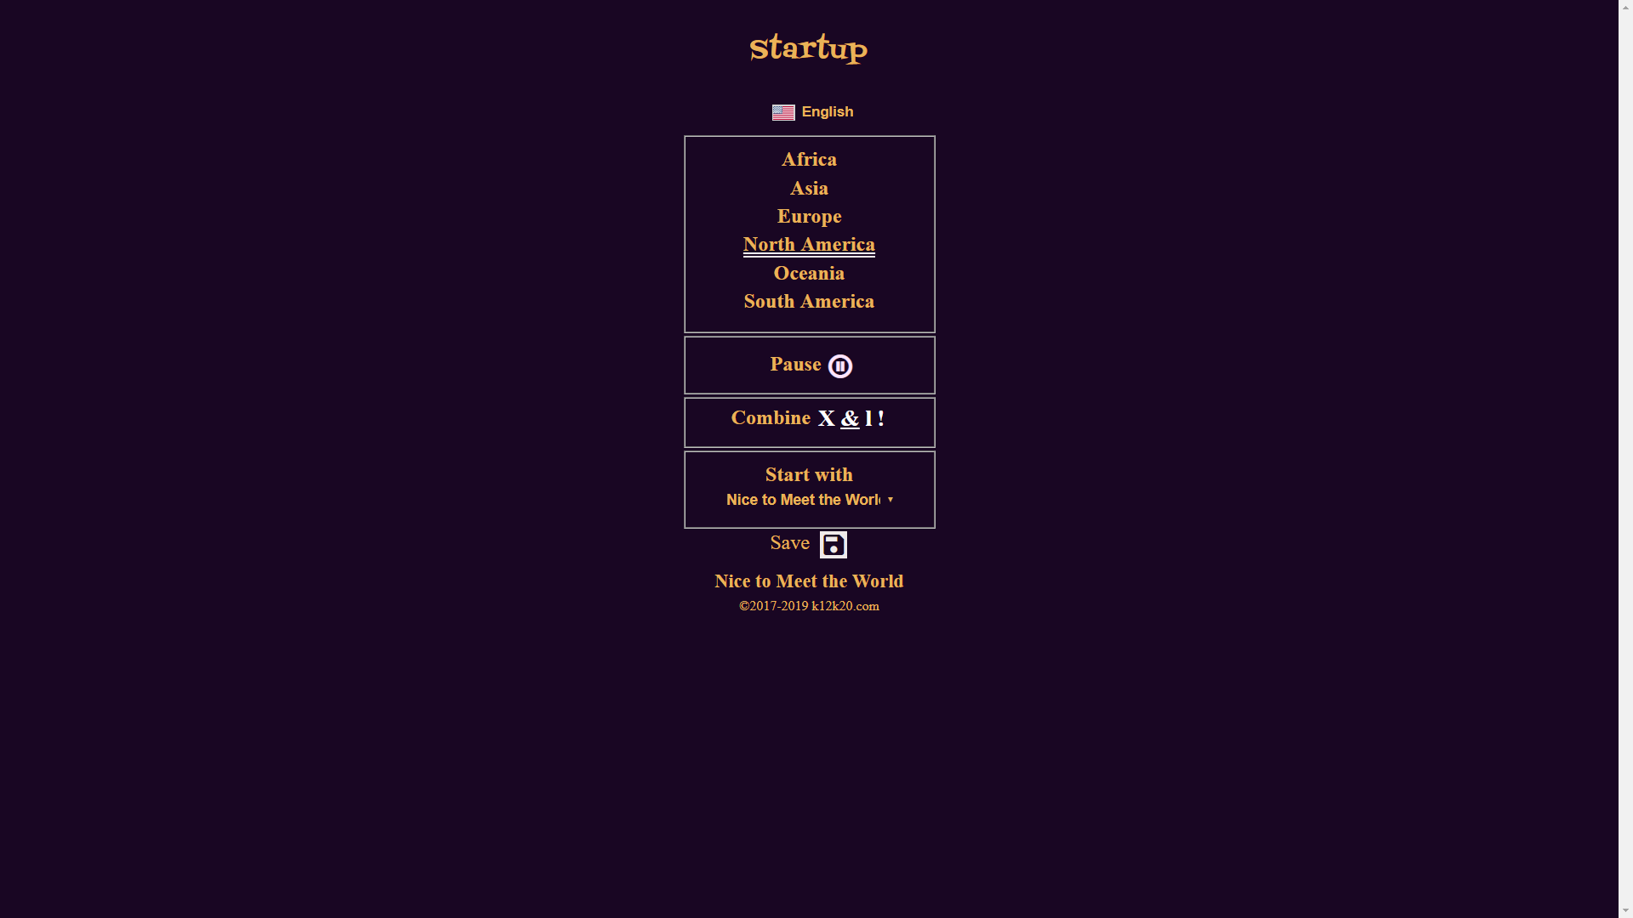

**Here the Audio can be paused/played at the start**

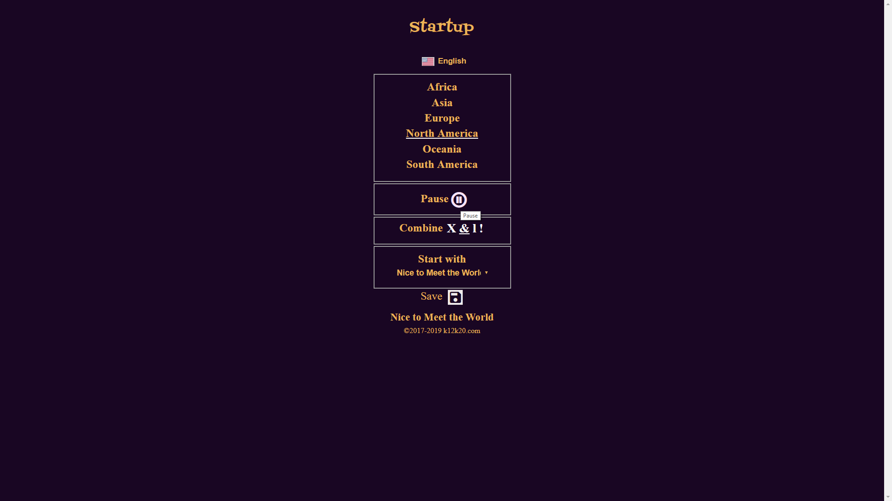

**Here the Combination Search Flag can be selected: &=”And”, |=”Or”, X=”None” plus !=”Reverse”**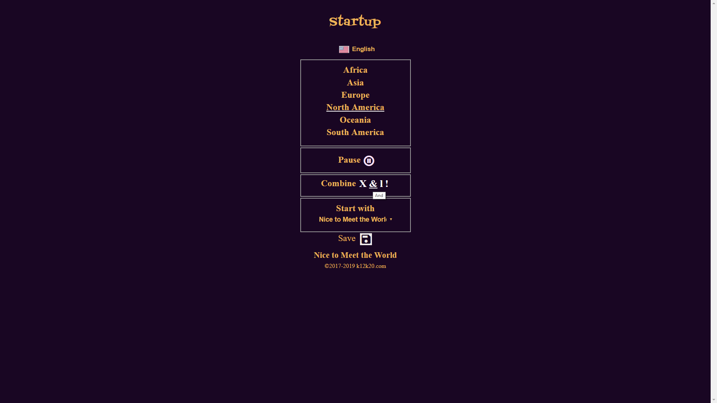

**And finally, here we can select which application page to start with**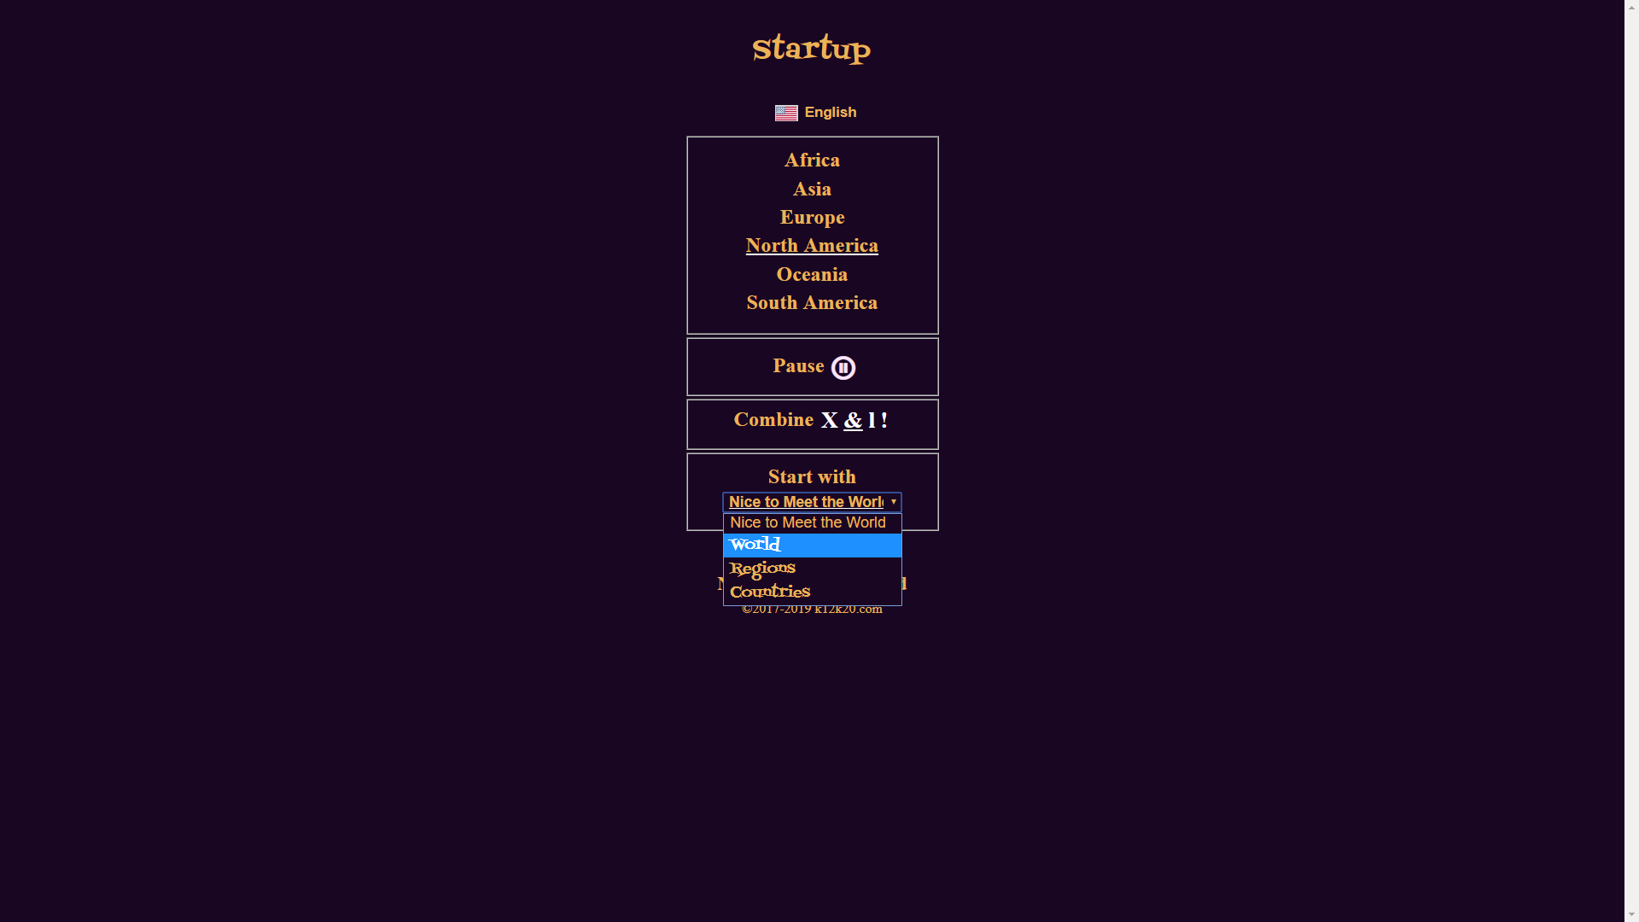

**Click on the Save Icon will save the entered values**

**And the application starts with the entered values**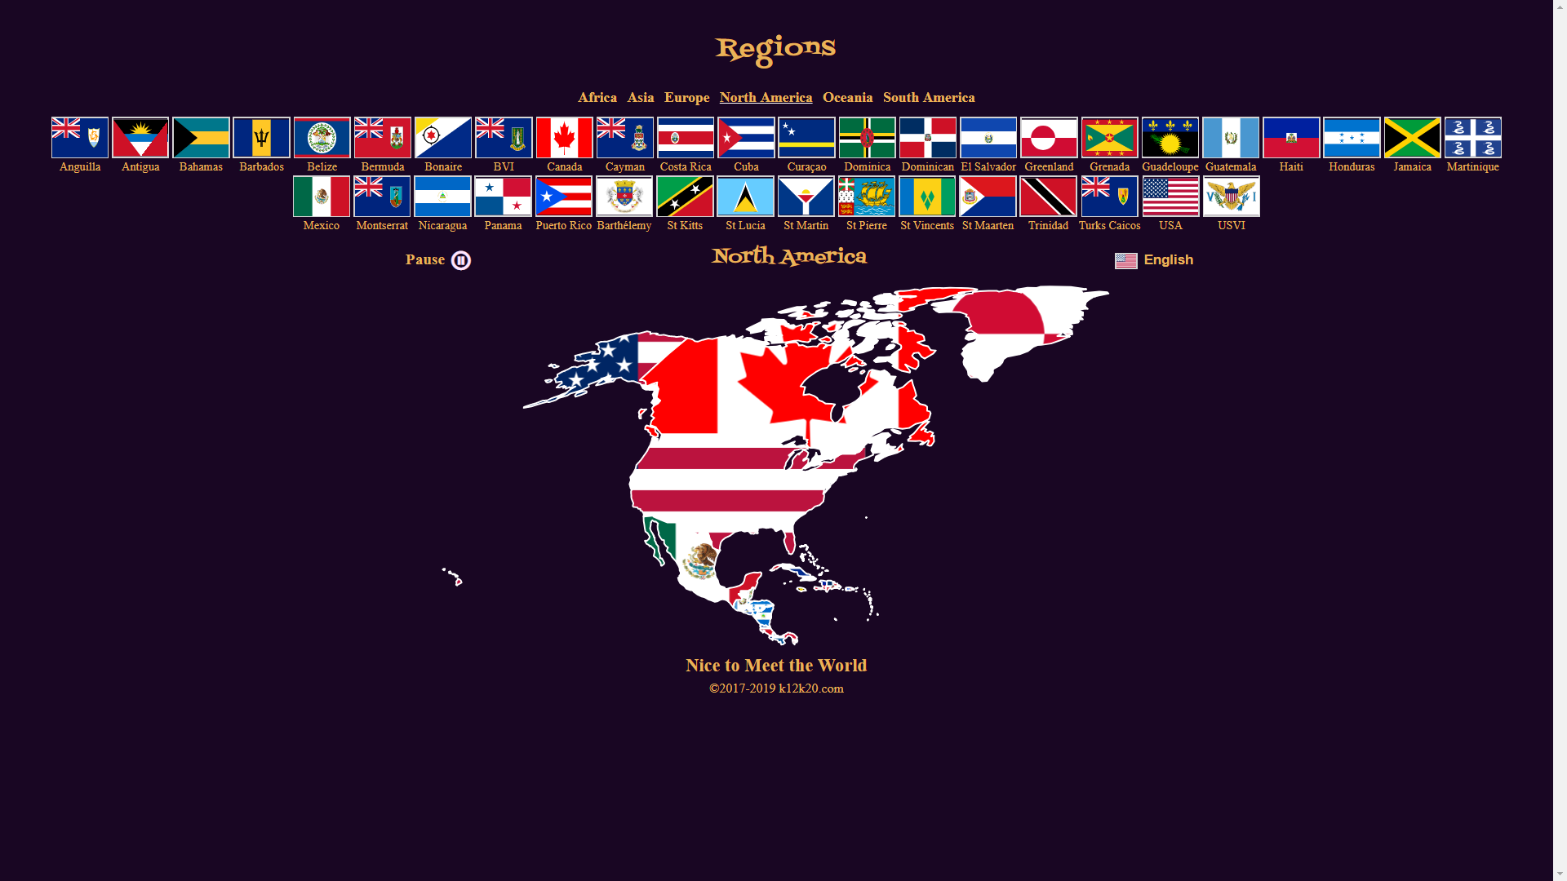

**Or to start an application, click on any button**

**World**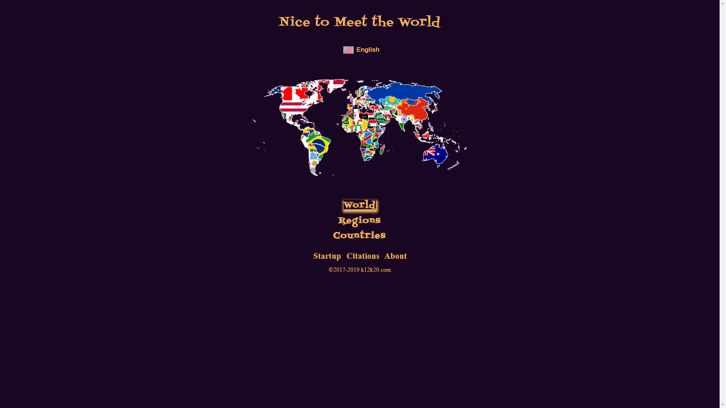

**Starts the World View**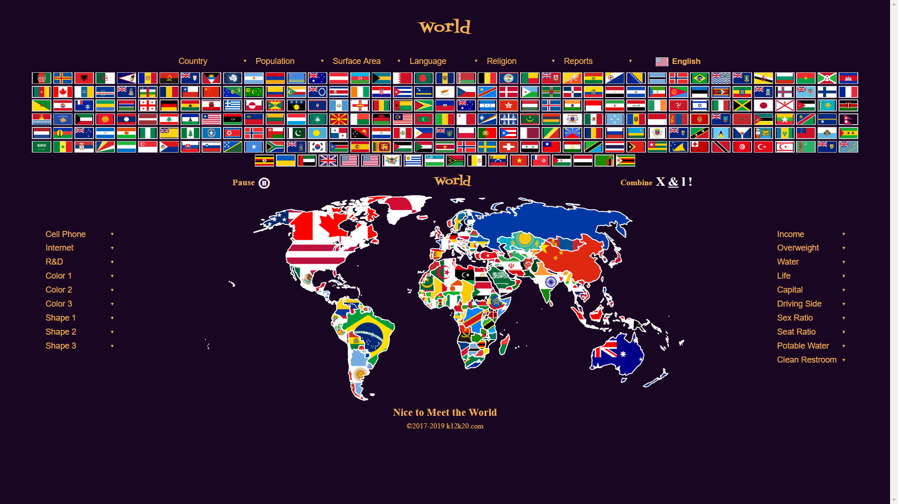

**Countries**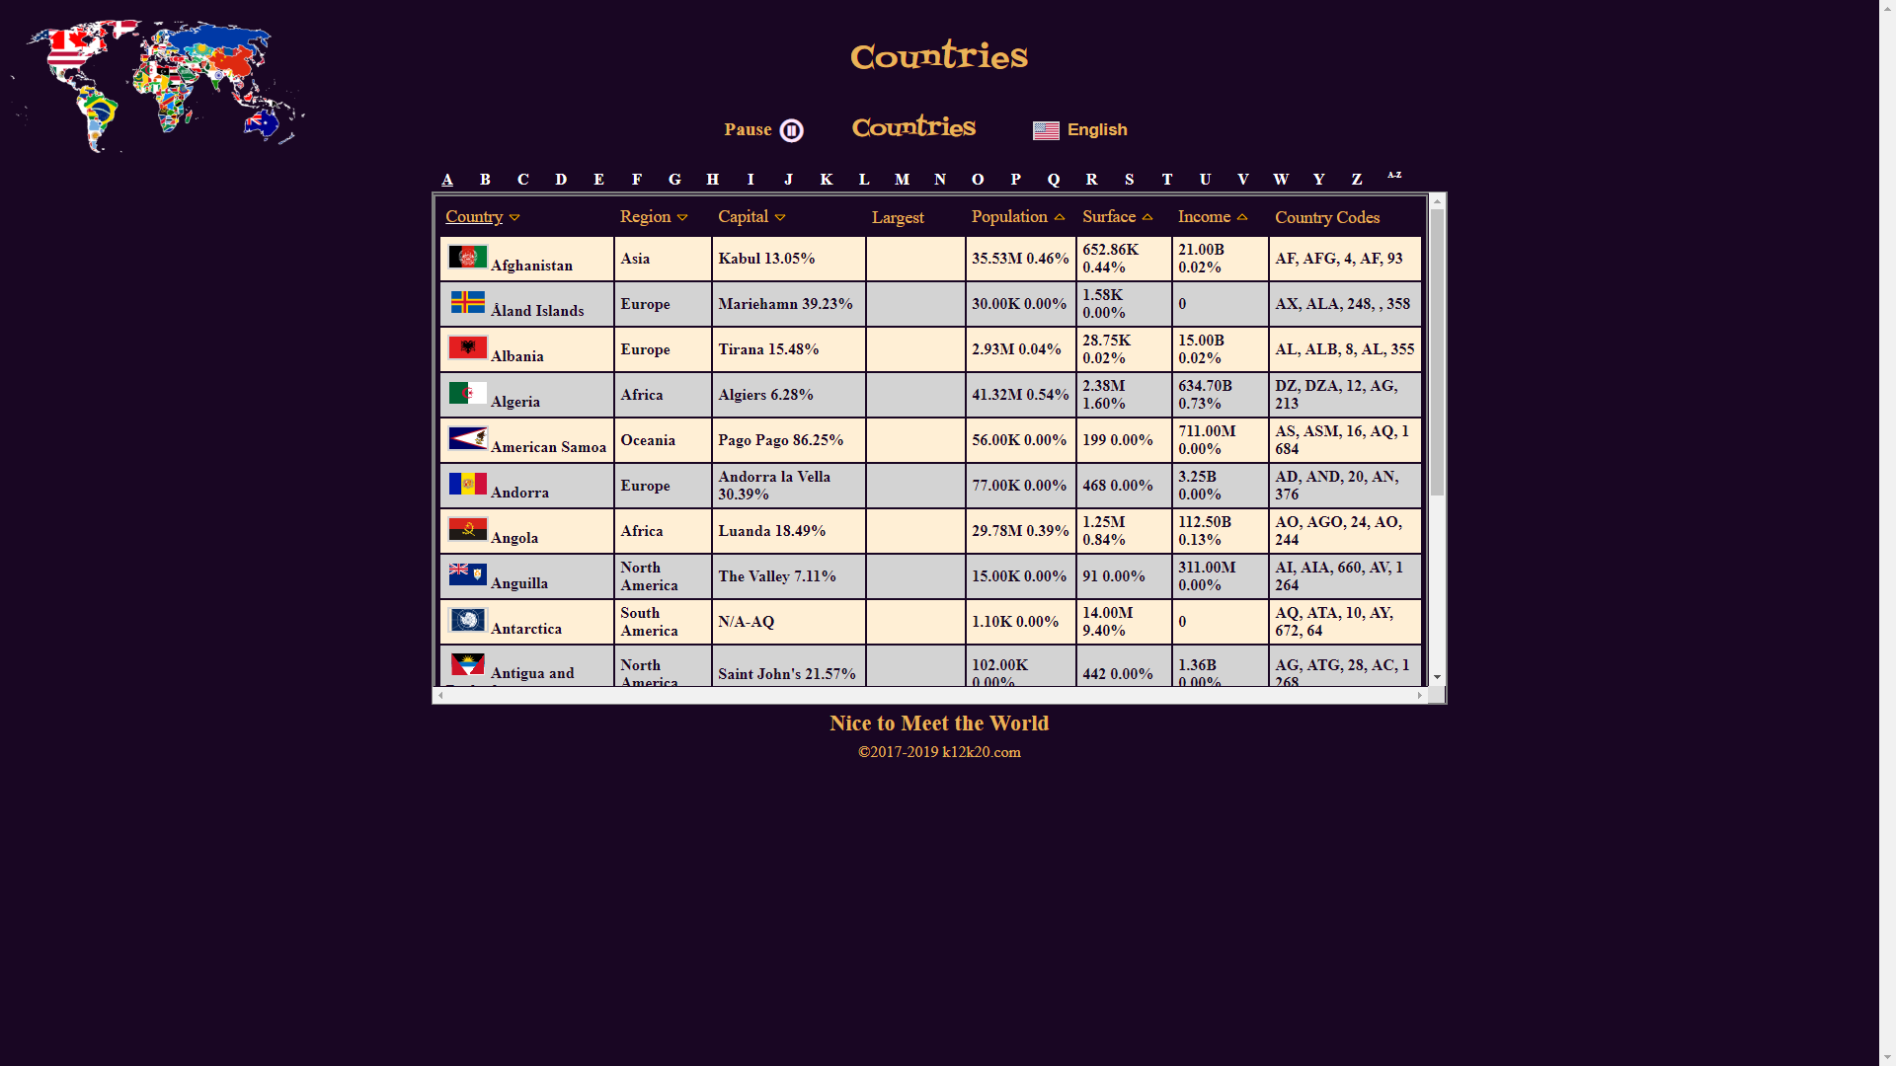

**After entering the “Start With” value, only the “Nice to Meet the World” can change the value**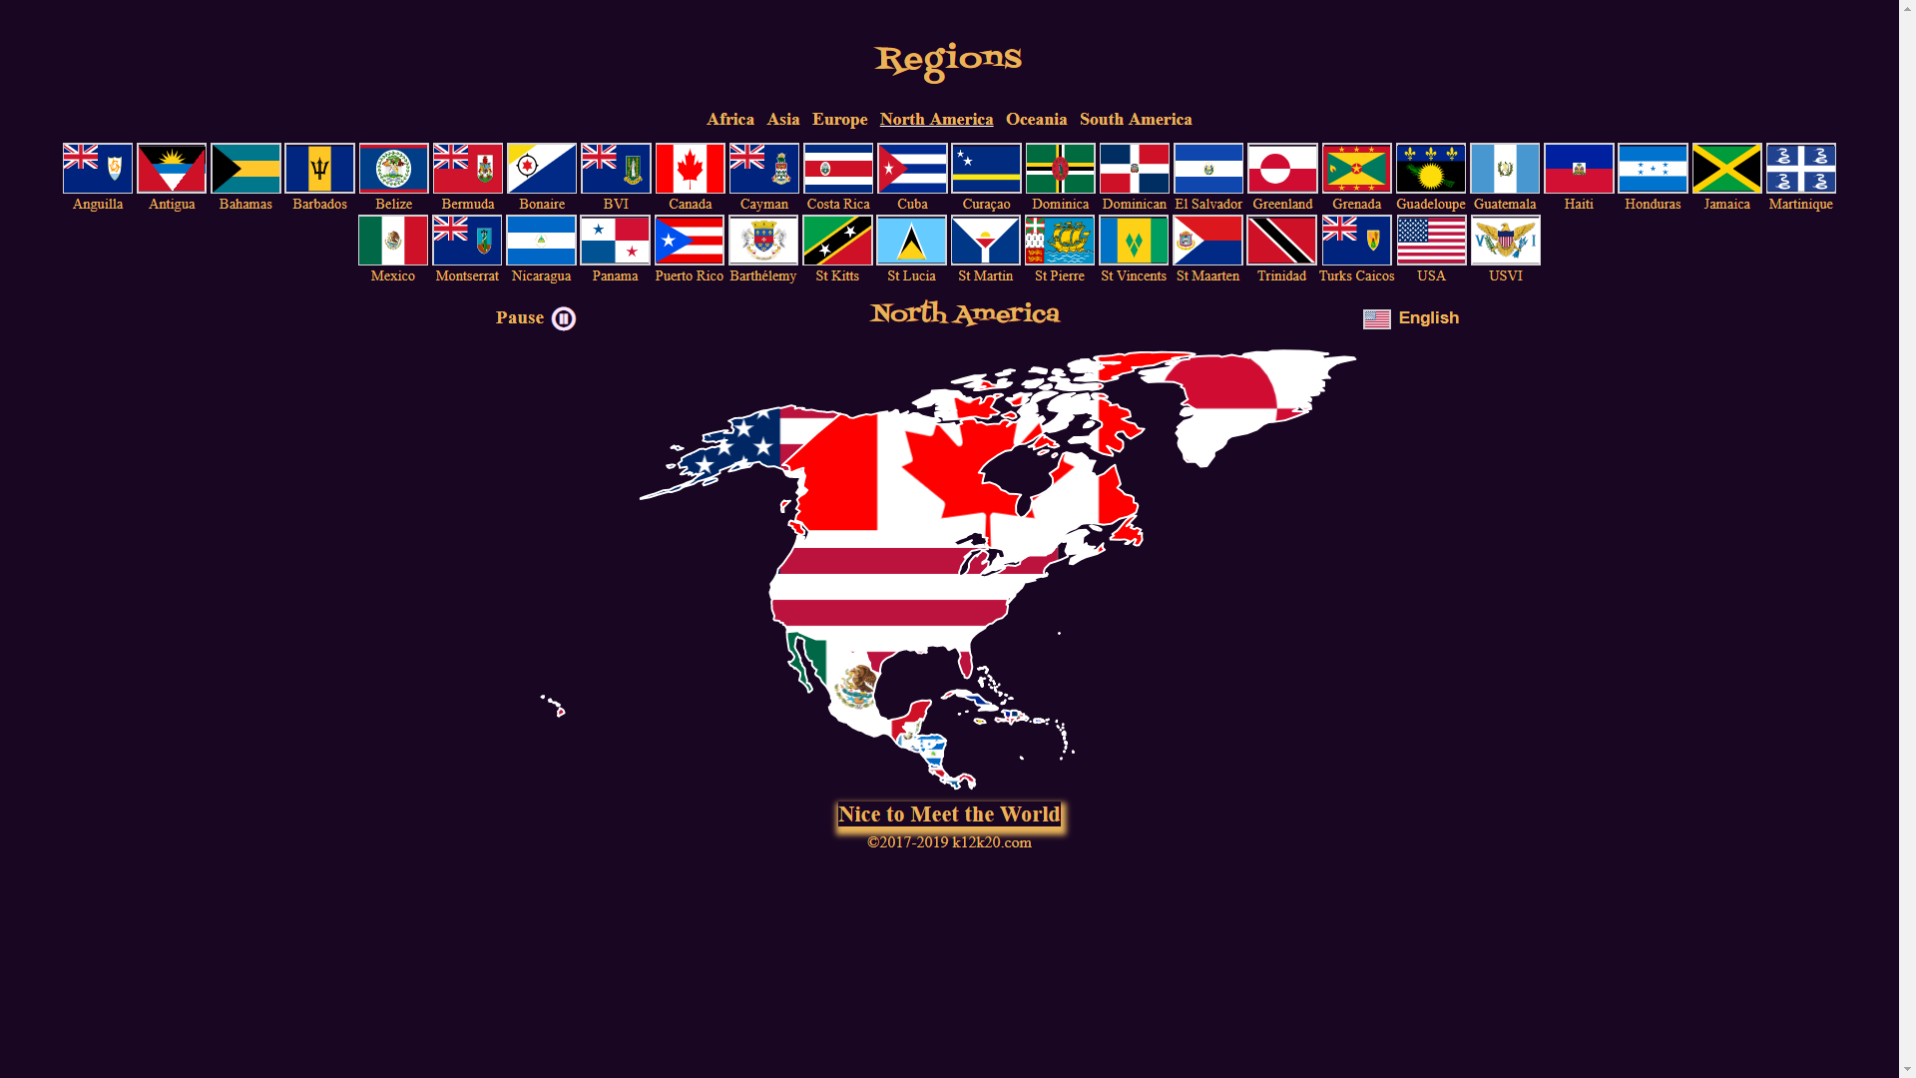

**Which starts from the very first page above**