**WIP**: Click on [Data Languages](http://eworldsurfing.com/dataLanguages) (http://eworldsurfing.com:8080/world-dashboard/)

Select a Country

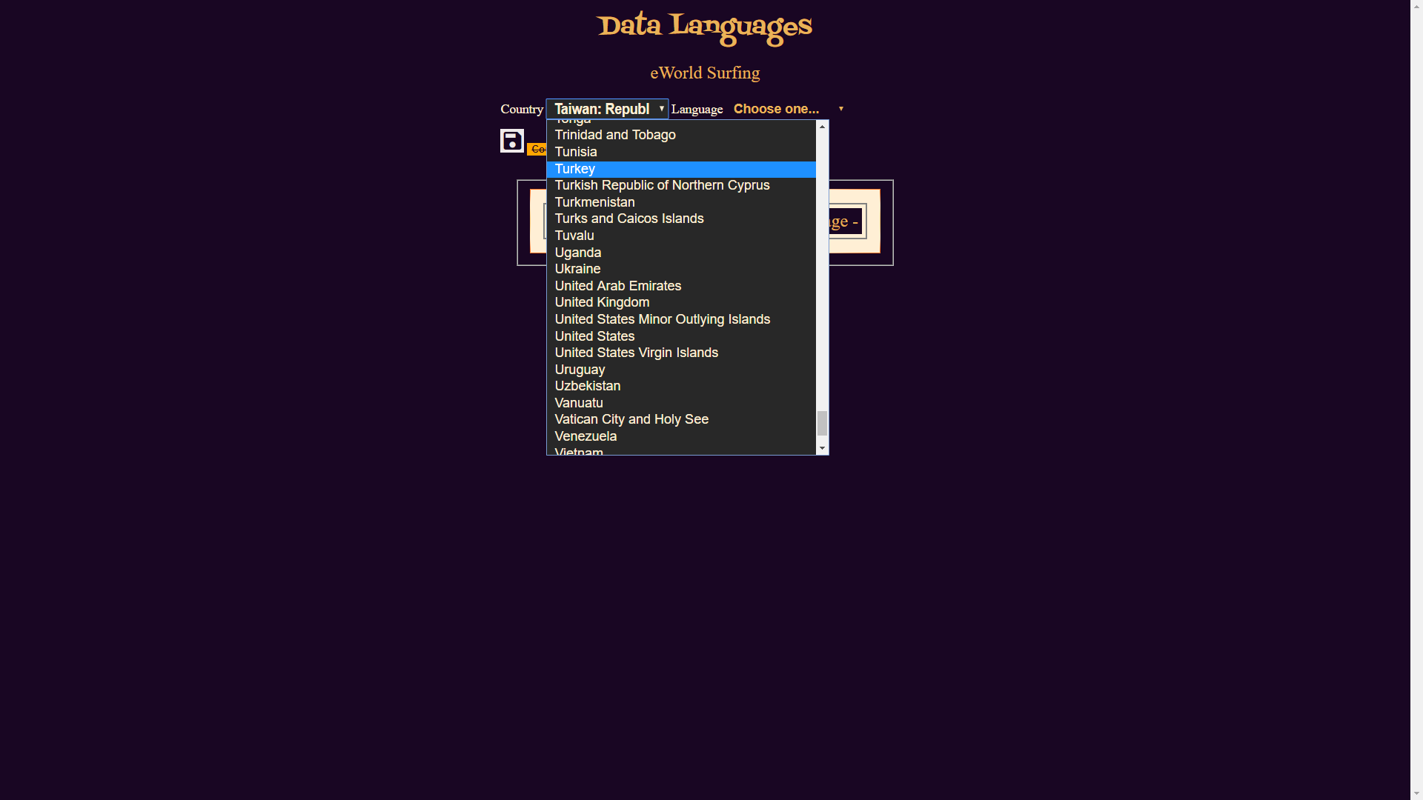

Select a Language

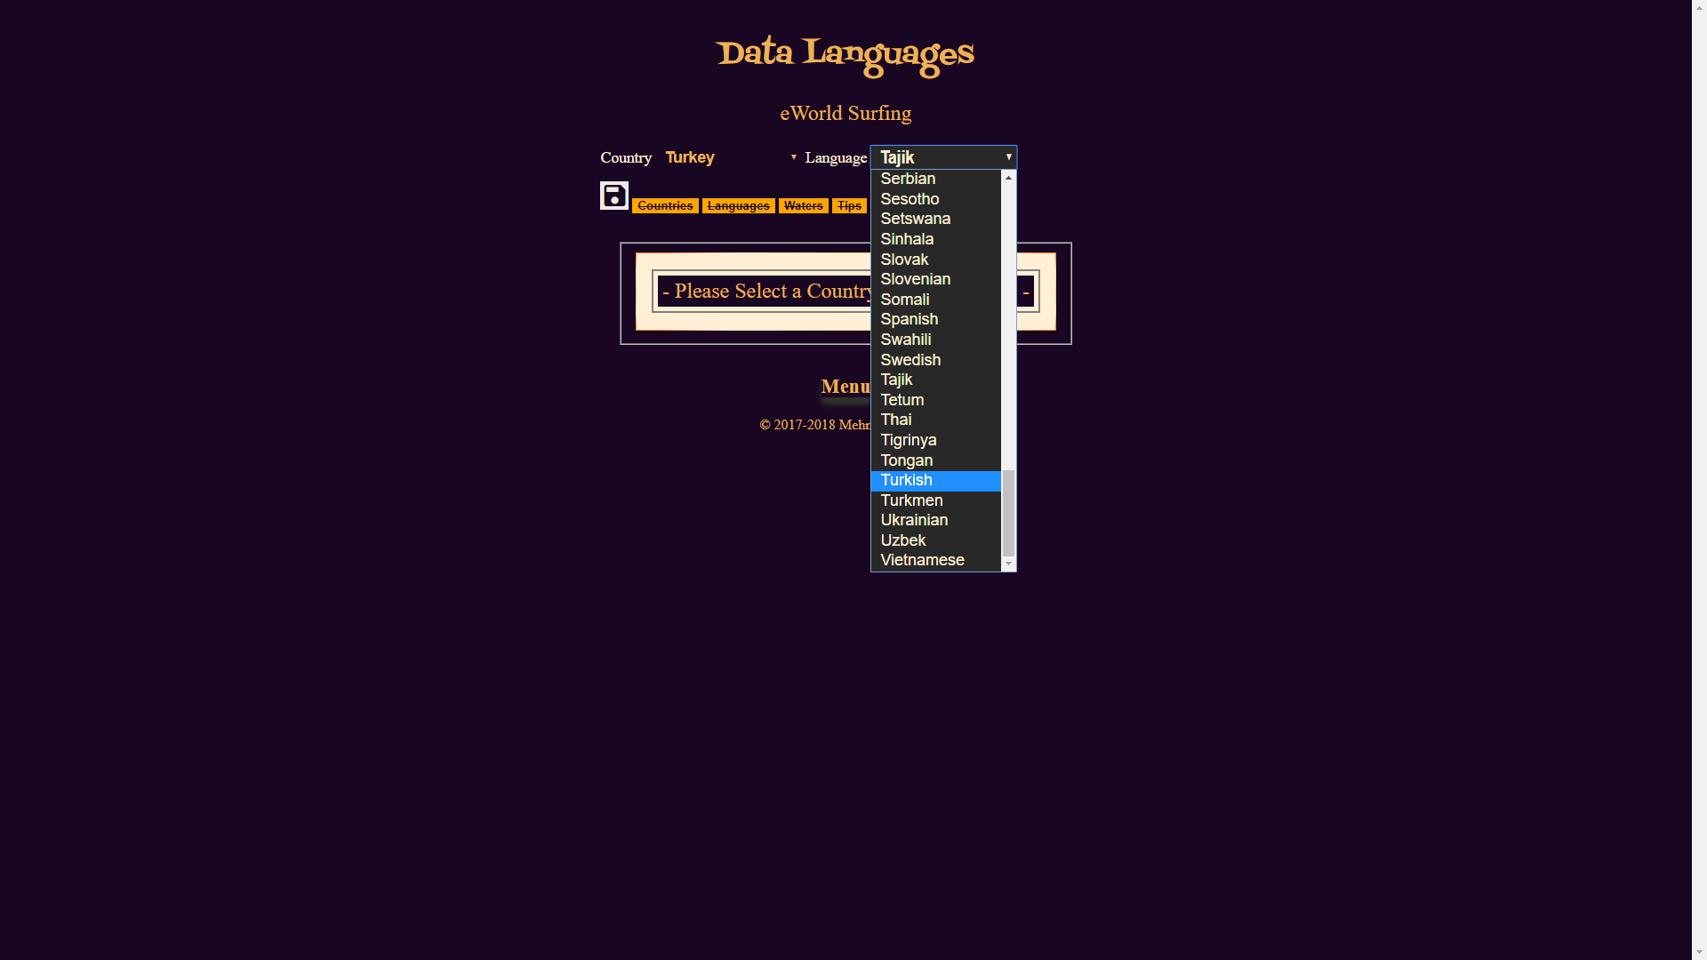

Enter the selected Language text for each English counterpart

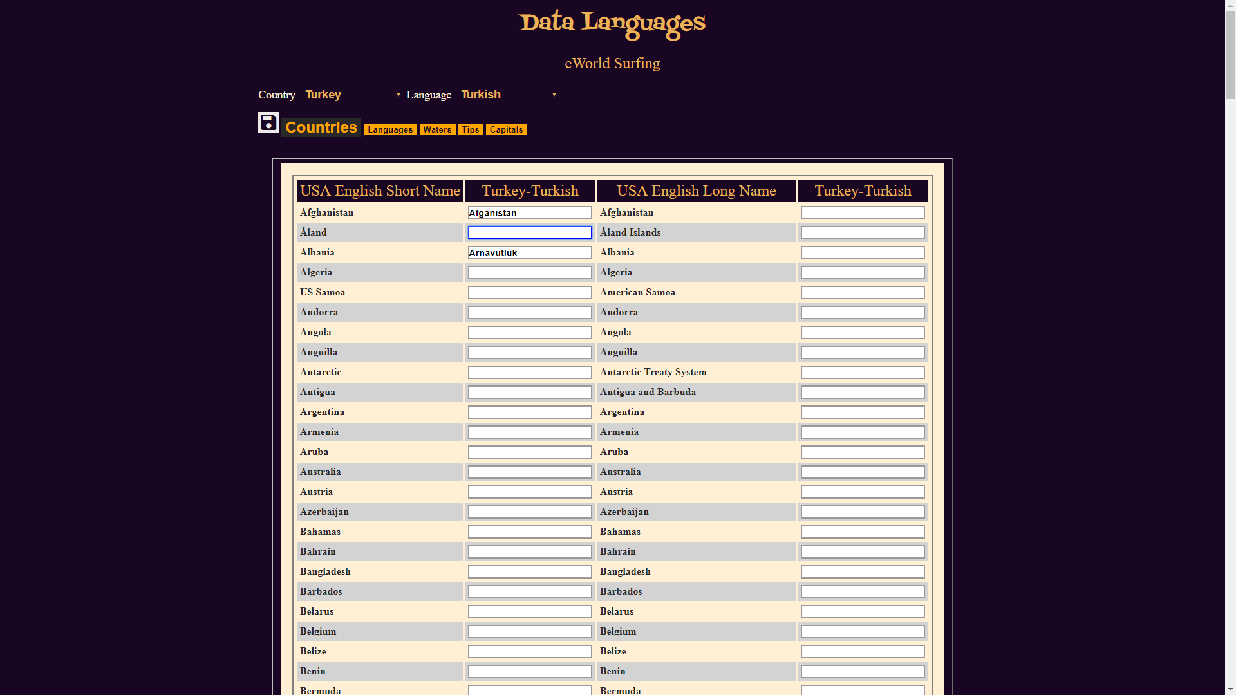

Keep entering to the end and select the Save button (diskette icon) on the top to register the new Application Data Language