Click on [Text Languages](http://eworldsurfing.com/textLanguages) (http://eworldsurfing.com:8080/world-dashboard/)

Select a Country

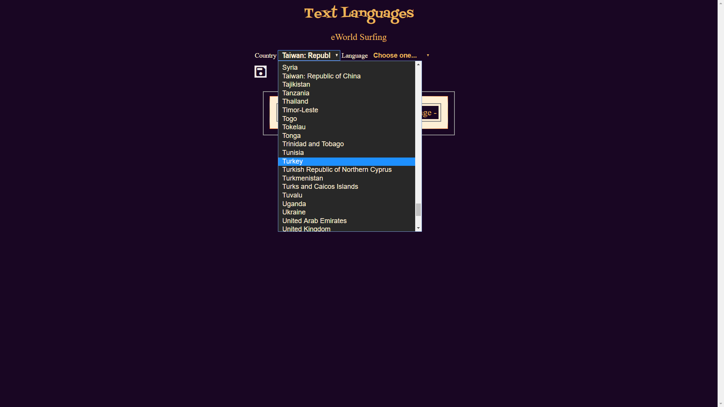

Select a Language

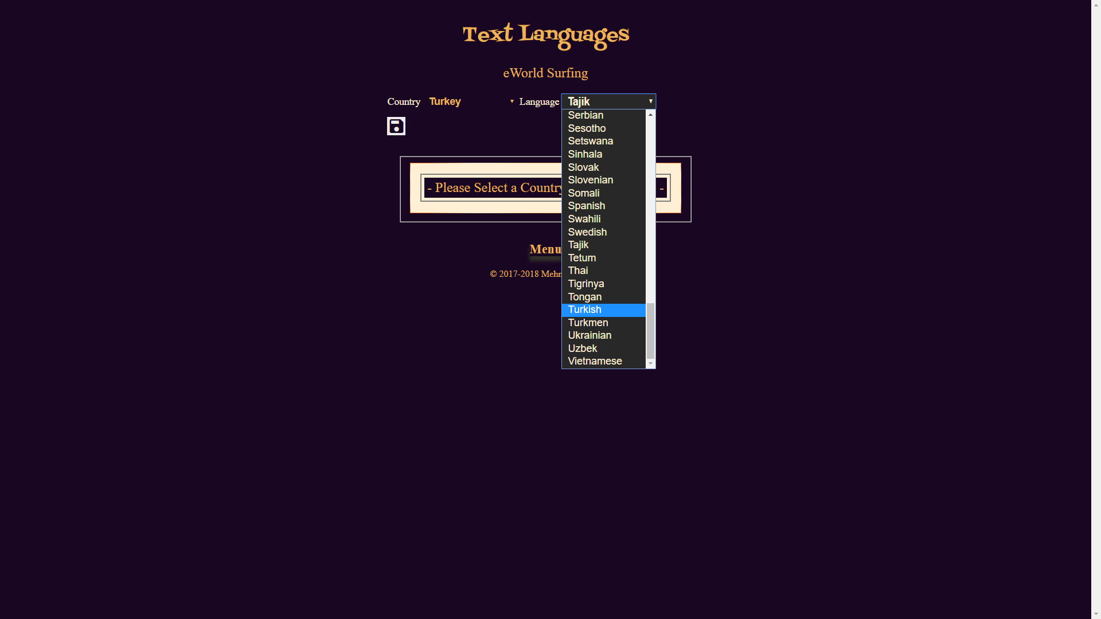Enter the selected Language text for each English counterpart

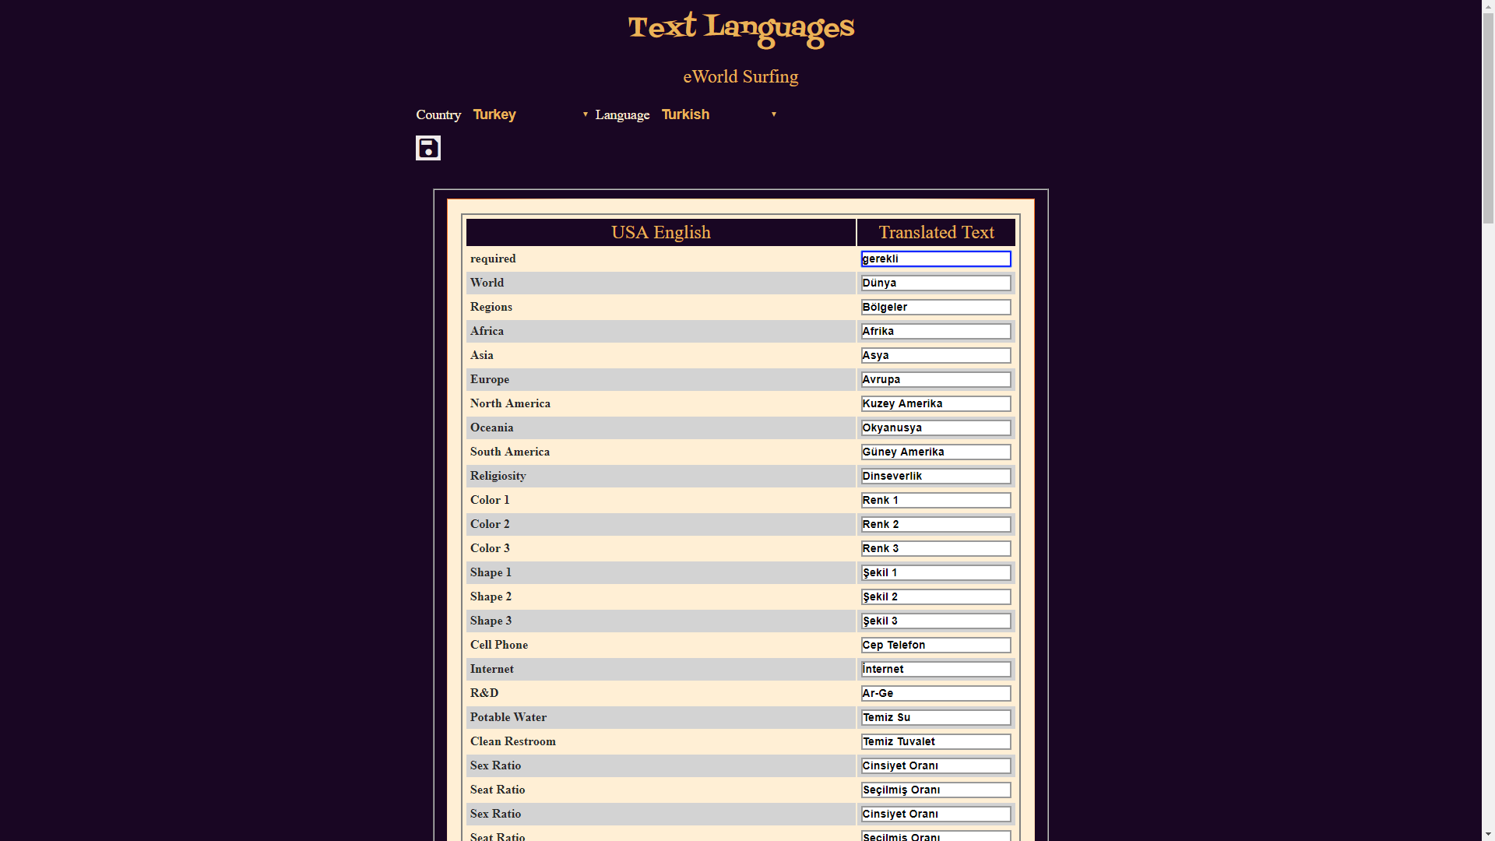

Keep entering to the end and select the Save button (diskette icon) on the top to register the new Application Text Language