**Web Technologies Usage**

**Client Site**

**iPhone-iPad**

**XAMPP on Windows 10**

**LAMPP on Ubuntu Desktop**

**Laravel/PHP/Eloquent/MariaDB/Apache**

**Spring MVC/Java**

**Eclipse IDE to code in Java**

**Atom to code in PHP/JS/CSS/HTML**

**Server Site**

**Centos Linux 7 Server**

**MariaDB SQL Server**

**Apache Web Server**

**Tomcat Java Servlet Container**

**iRedMail Mail Server**

**Git and GitHub is integrated with the development**

**(CSCI E-15 heritage)**

Atom, XAMPP Control Panel, Cmder and PuTTY (Windows)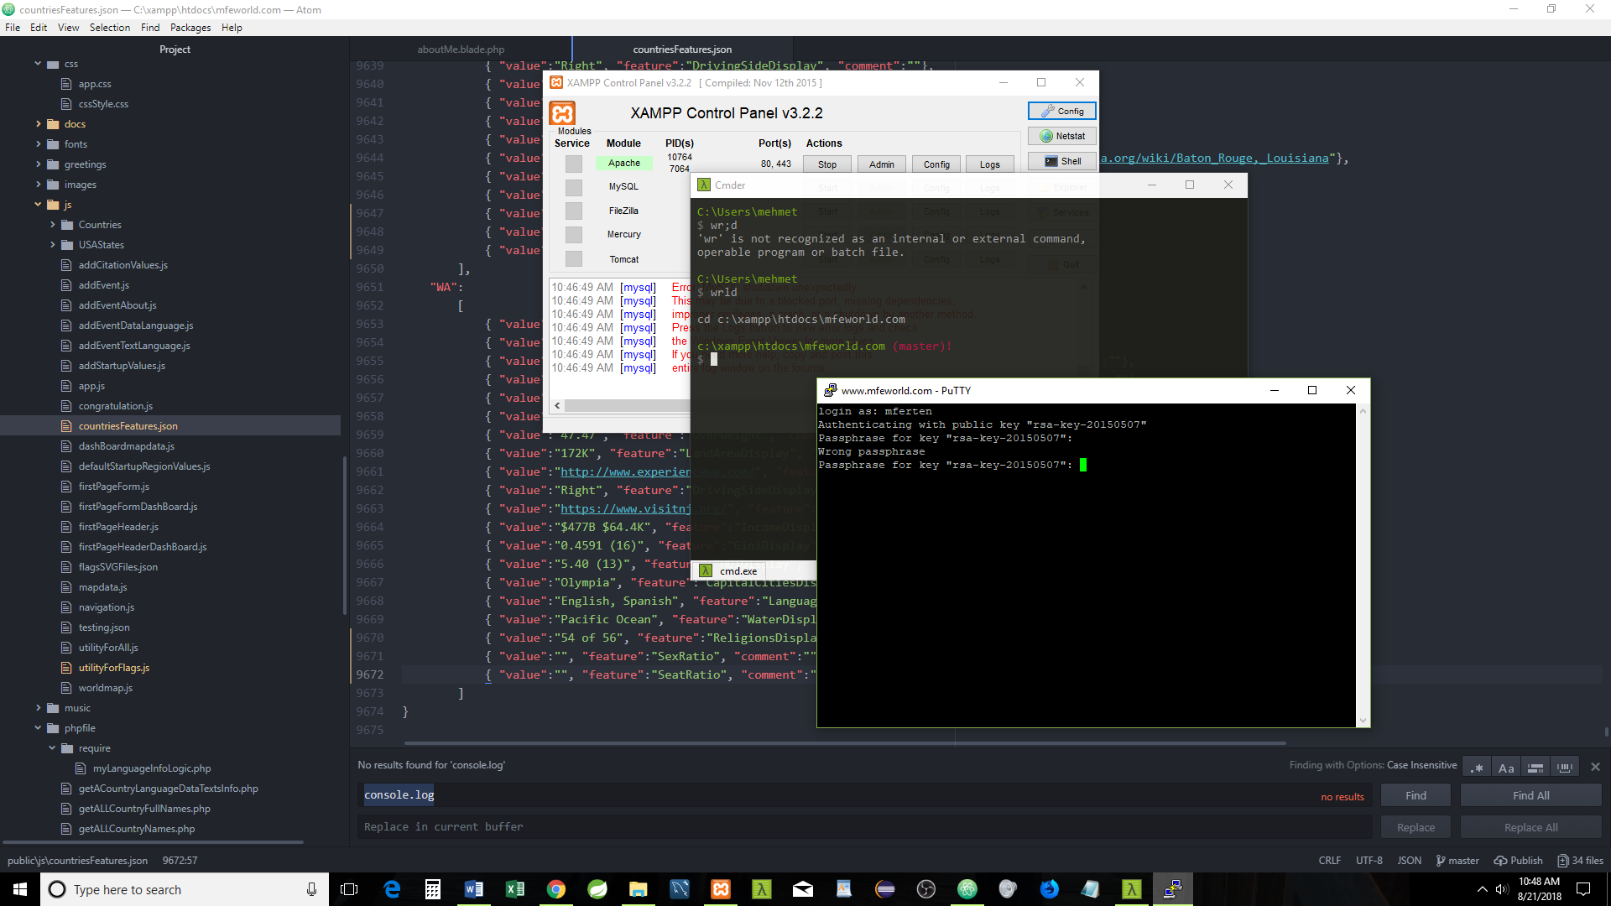

**Firefox Developer Edition and**

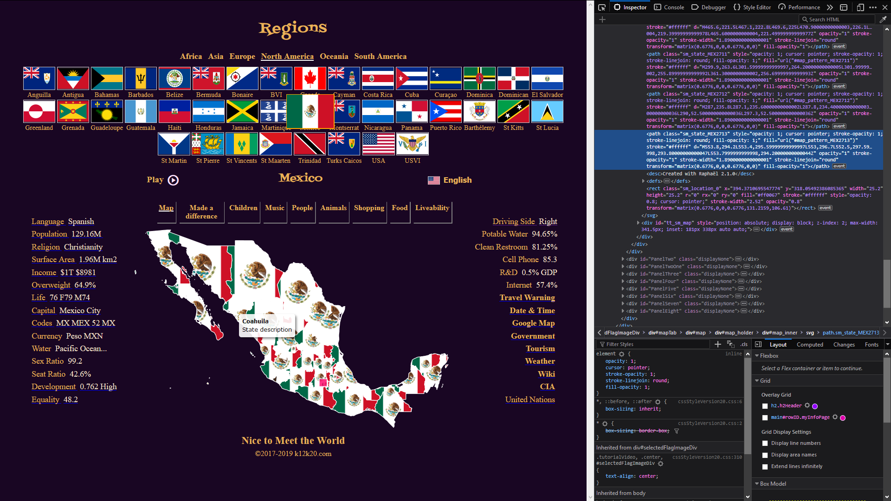

**Google Chrome are in use** 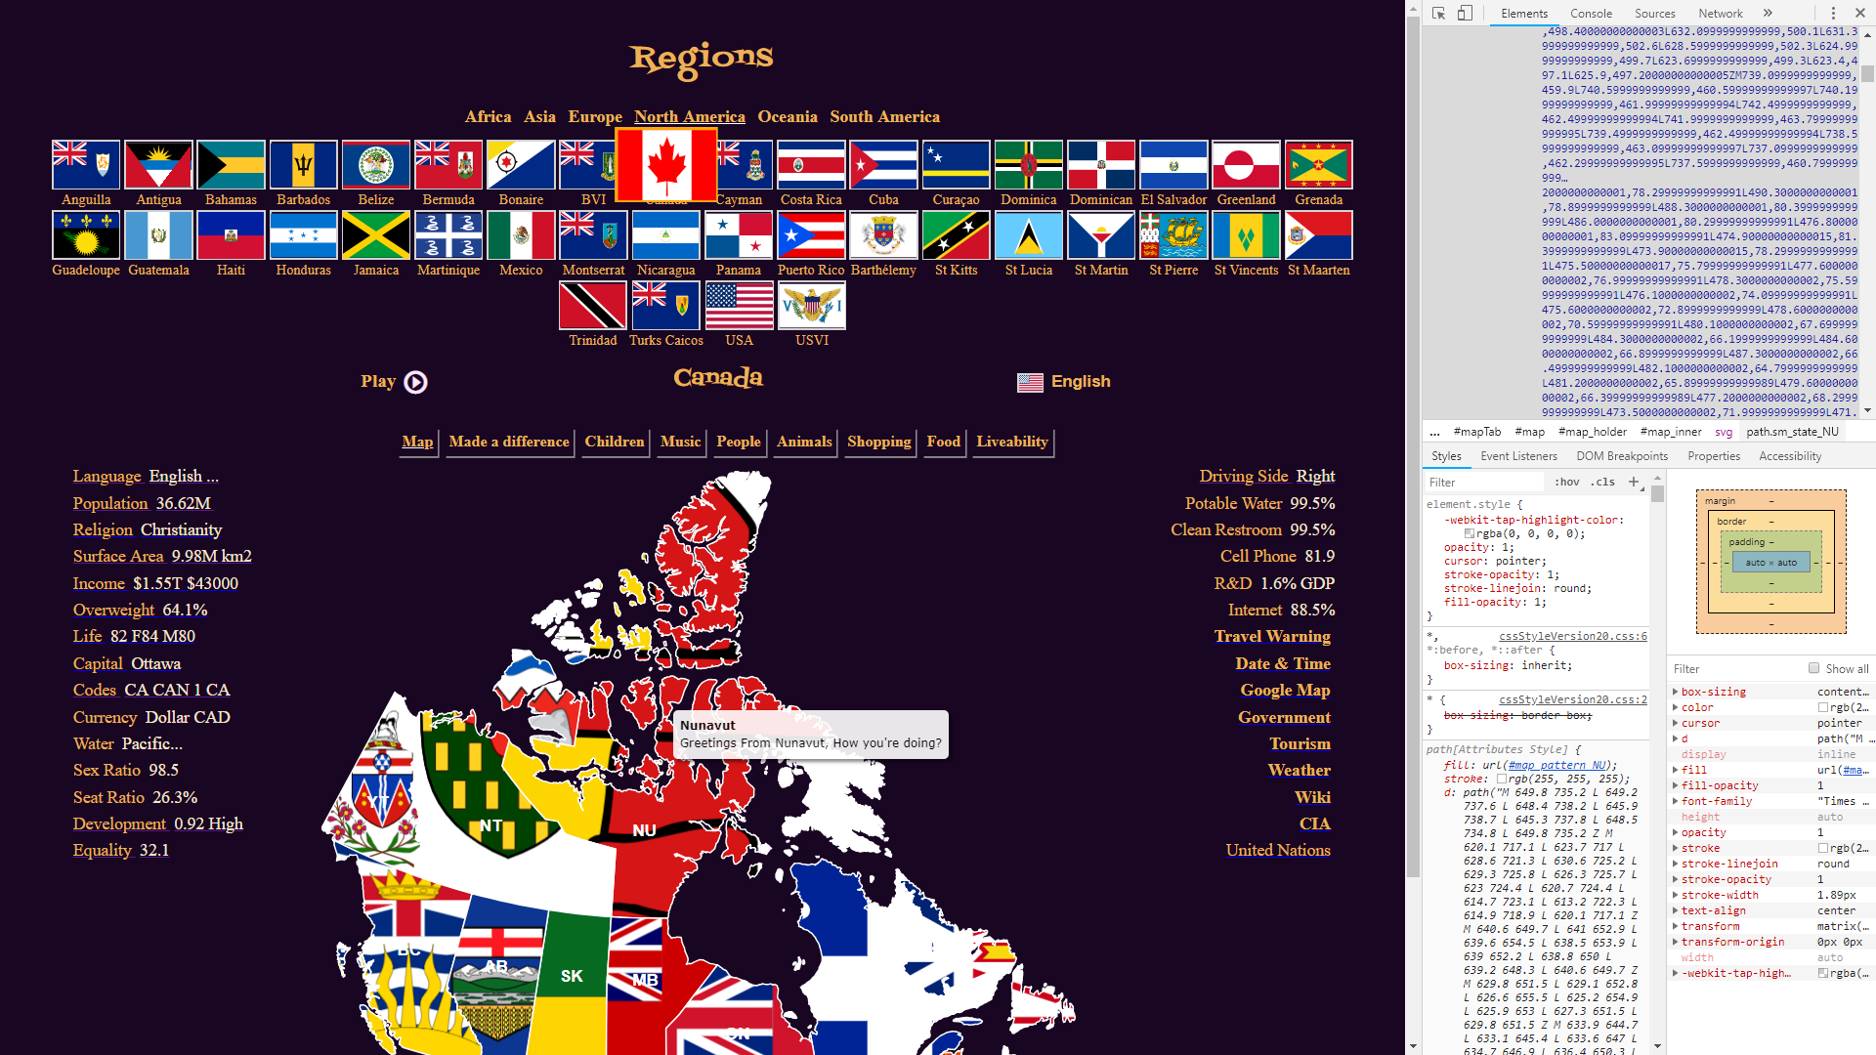

**The browsers help to code the responsive design interactively**

**Chrome**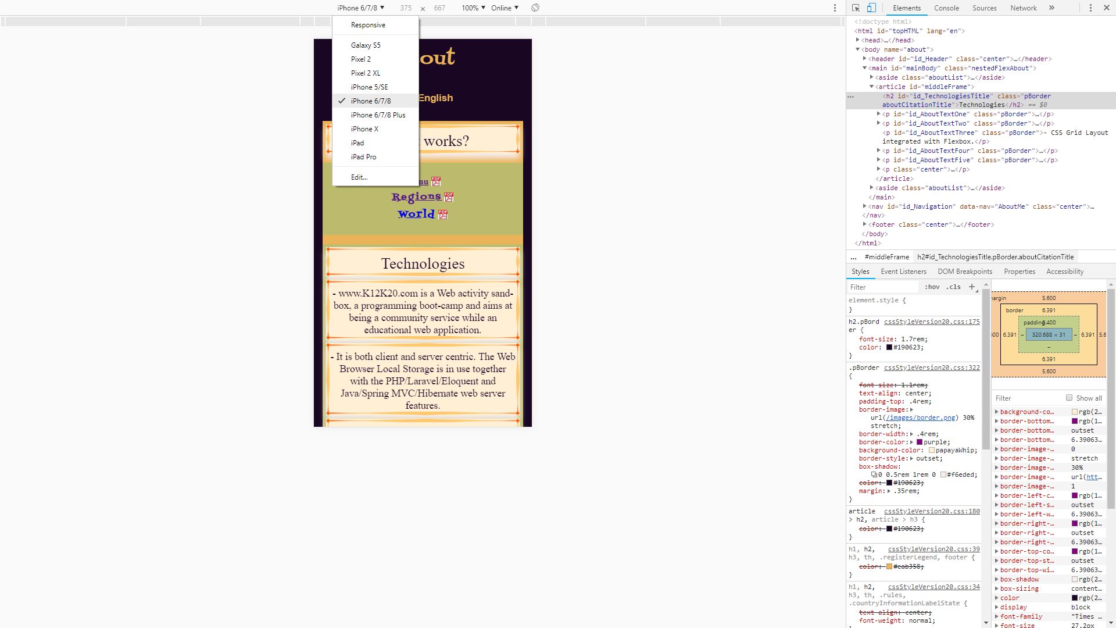

**Firefox Developer**

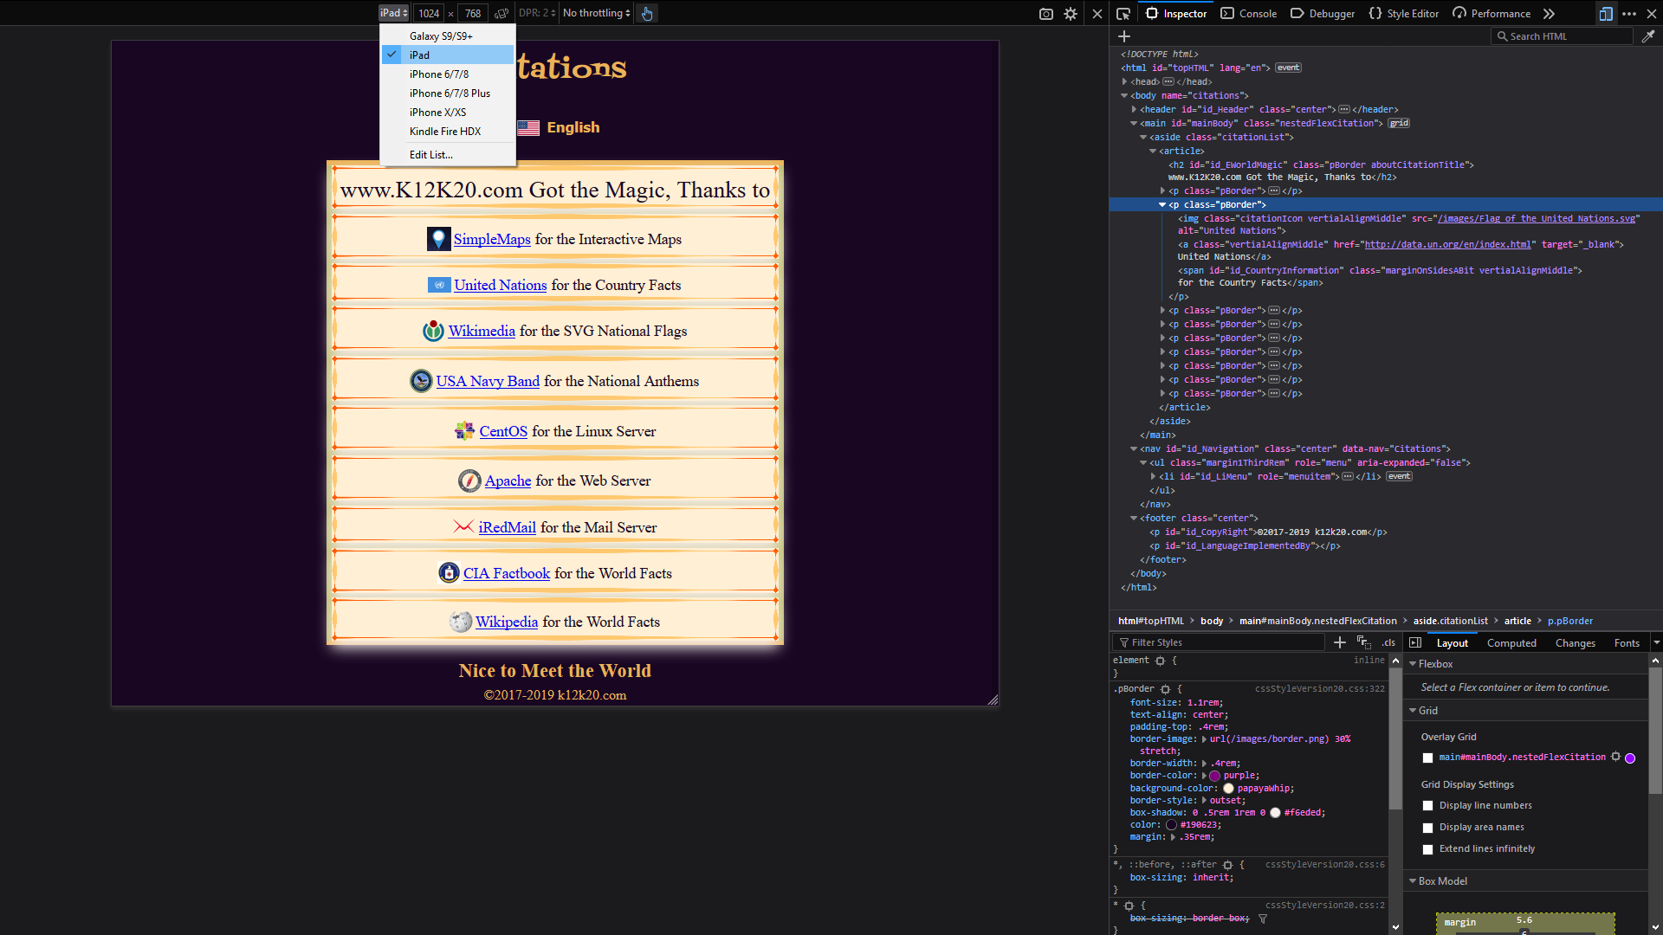

**Client Site Browser Local Storage is in use**

**Chrome**

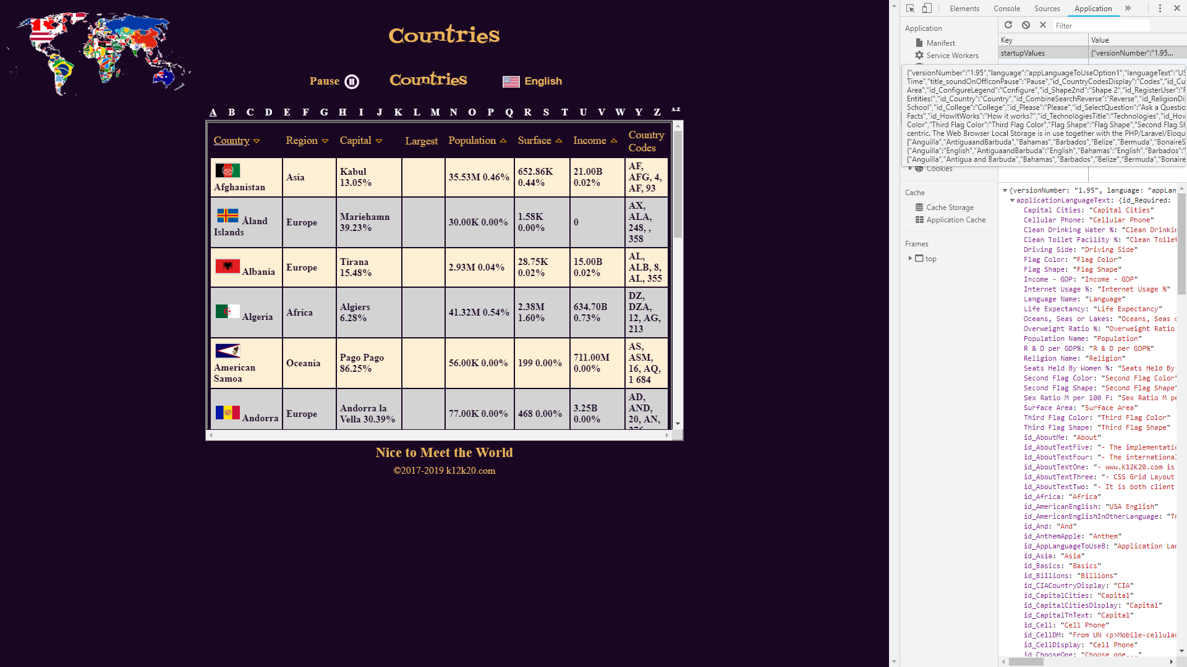

**Firefox Developer Edition**

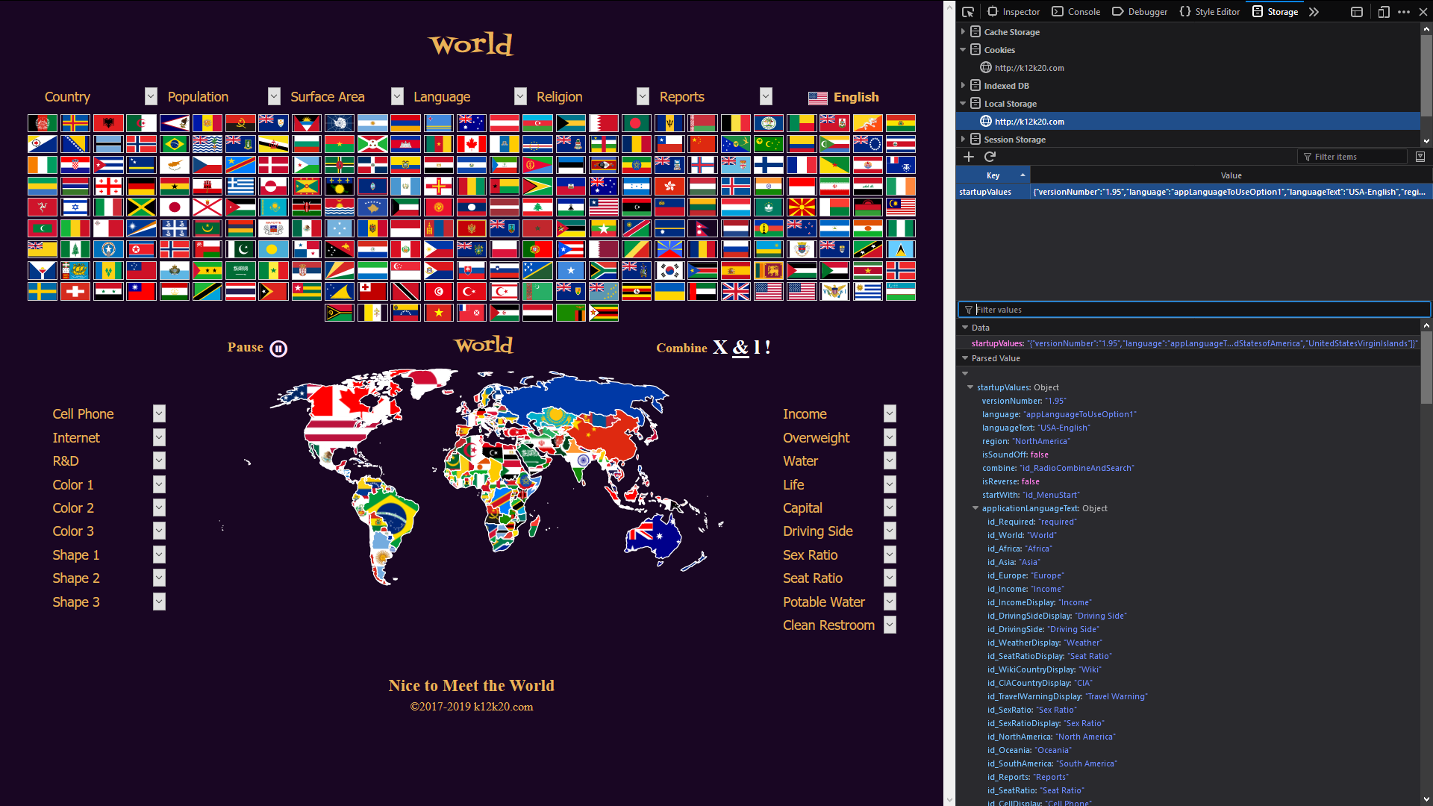

Spring MVC – Java/Eclipse and Tomcat will be used as a “Data and Logic” center

It will be available for the application if needed.

Tomcat/Spring MVC Java will be utilized as pure server operation: Data retrieval and data-processing (application logic) only

There will be no Java Web activities beyond the AJAX calls.

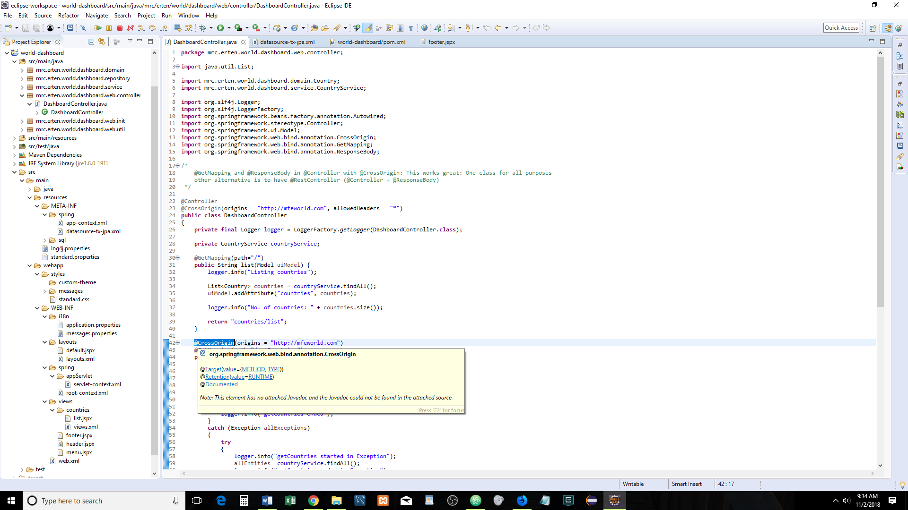

Spring MVC will handle the AJAX calls which manages Cross-origin resource sharing (CORS) very effectively and easily.

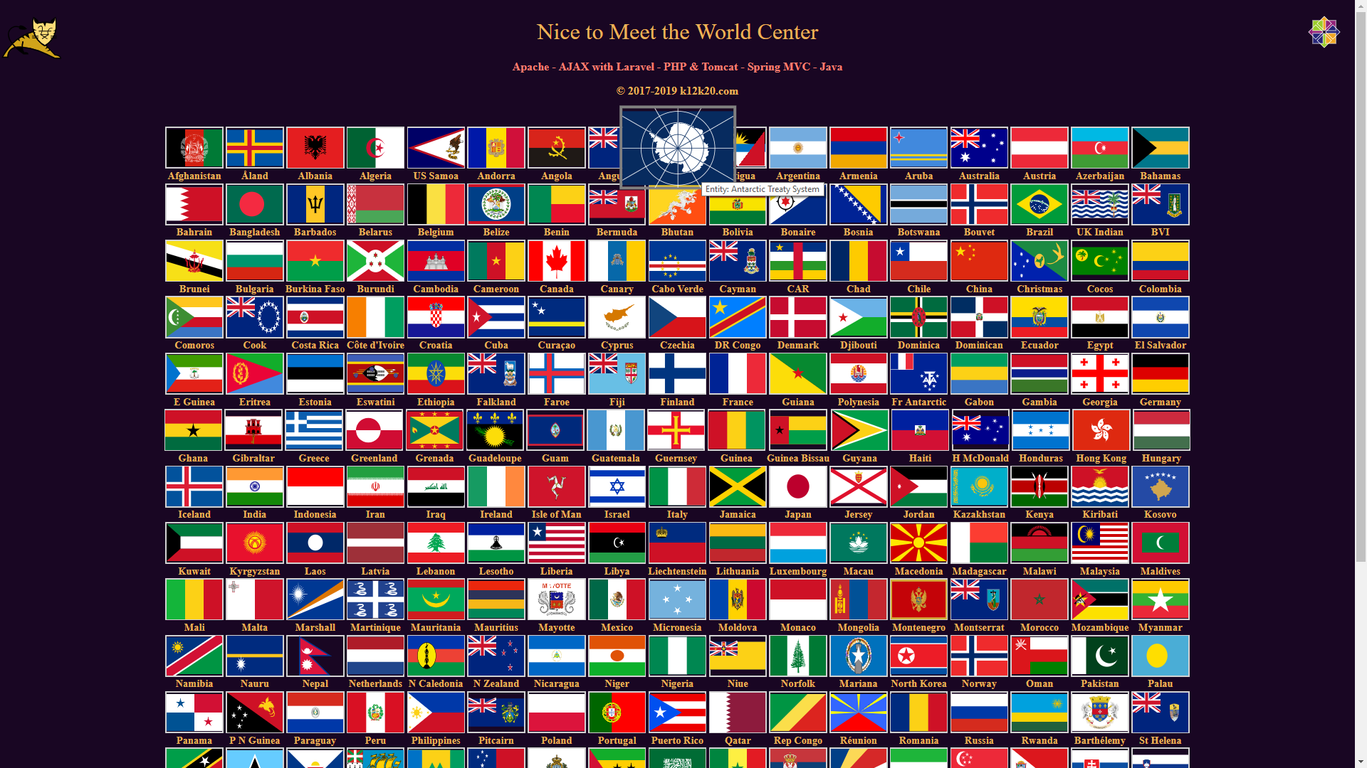Apache Tomcat handles the Web and Ajax activities for Spring MVC-Java Server environment

