**eWorldSurfing.com starts the application**

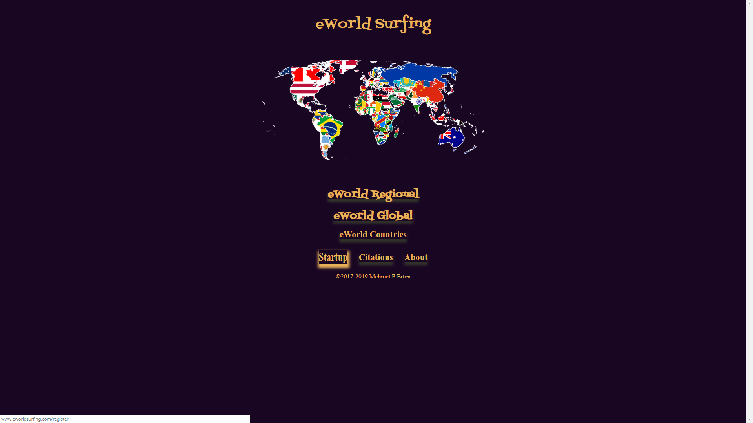**To start the application with “eWorld Surfing” or “eWorld Searching” or “eWorld Countries” click on “Startup” option**

**Here an Application Text Language can be selected**

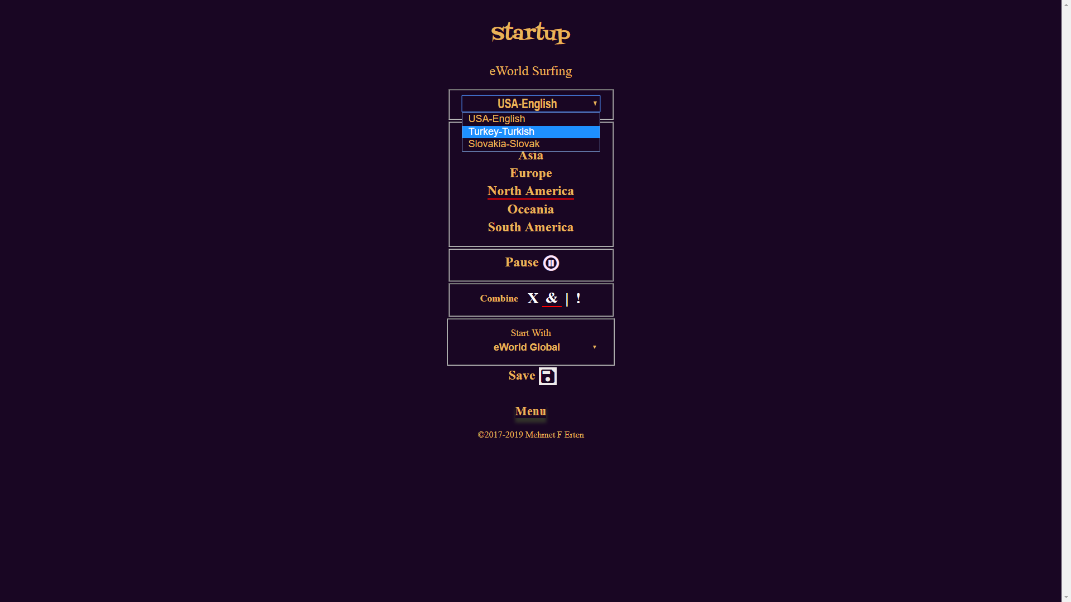

**Here a Region can be selected**

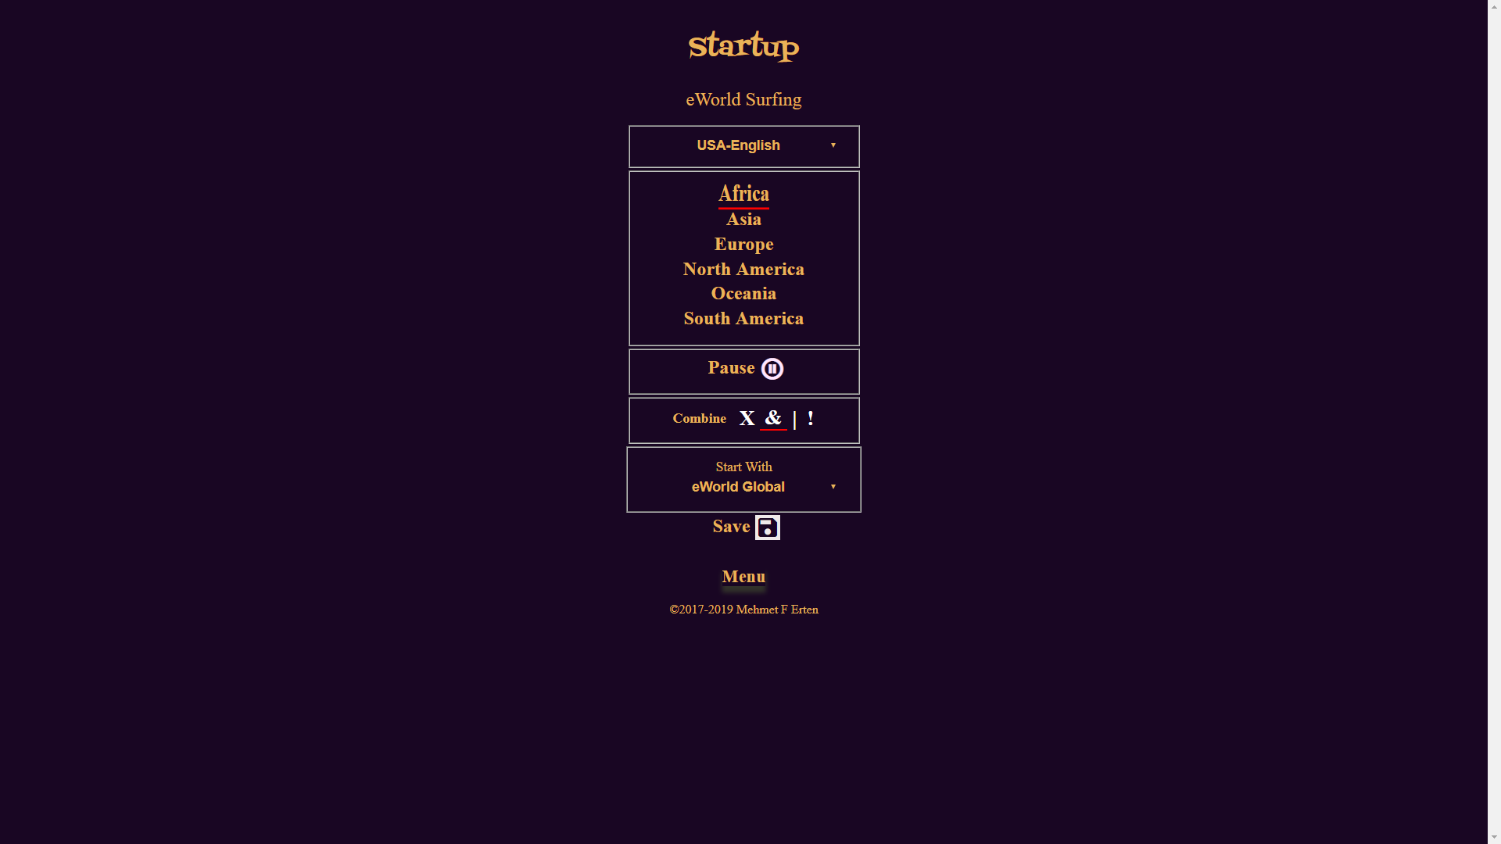

**Here the Audio can be paused/played at the start**

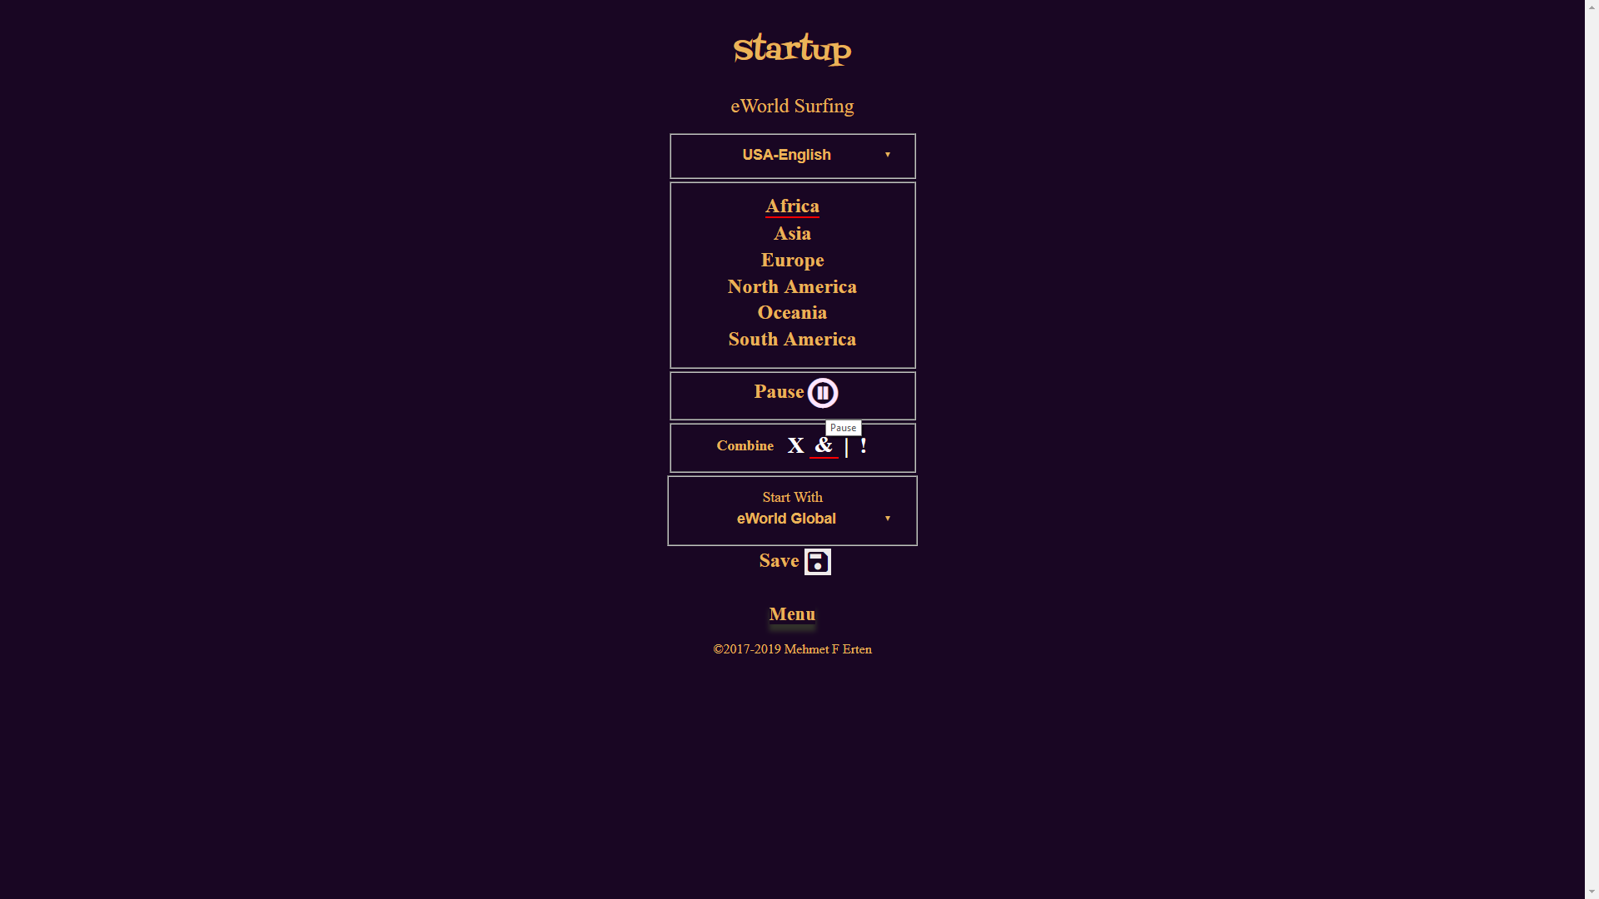

**Here the Combination Search Flag can be selected: &=”And”, |=”Or”, X=”None” plus !=”Reverse”**

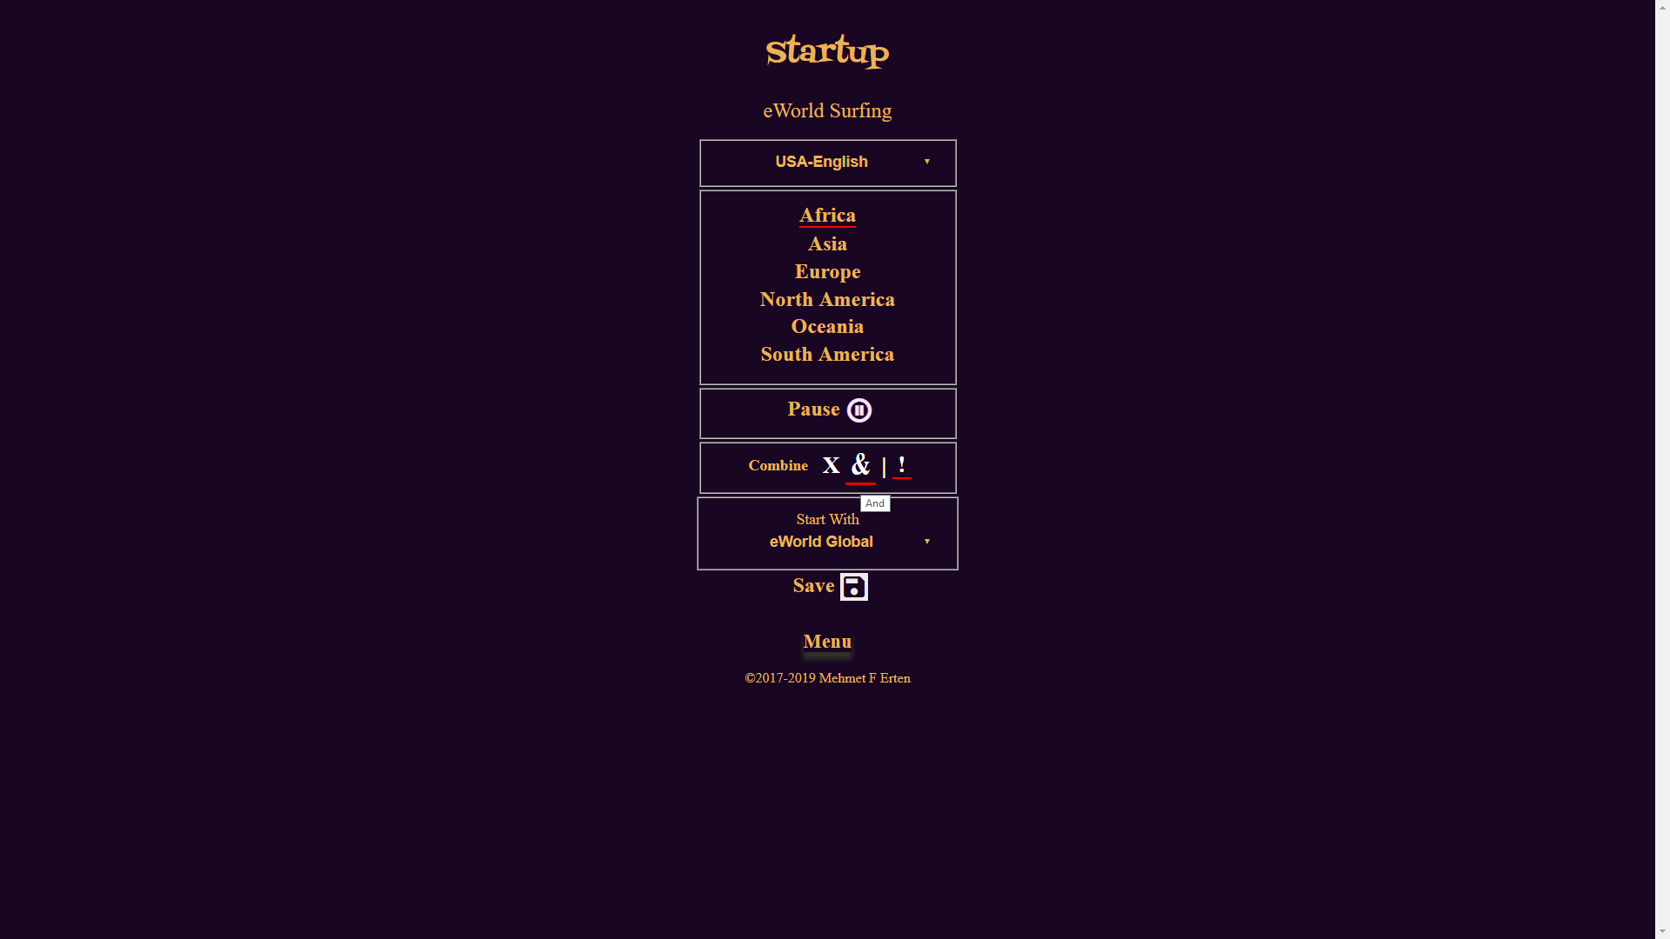

**And finally, here we can select which application page to start with**

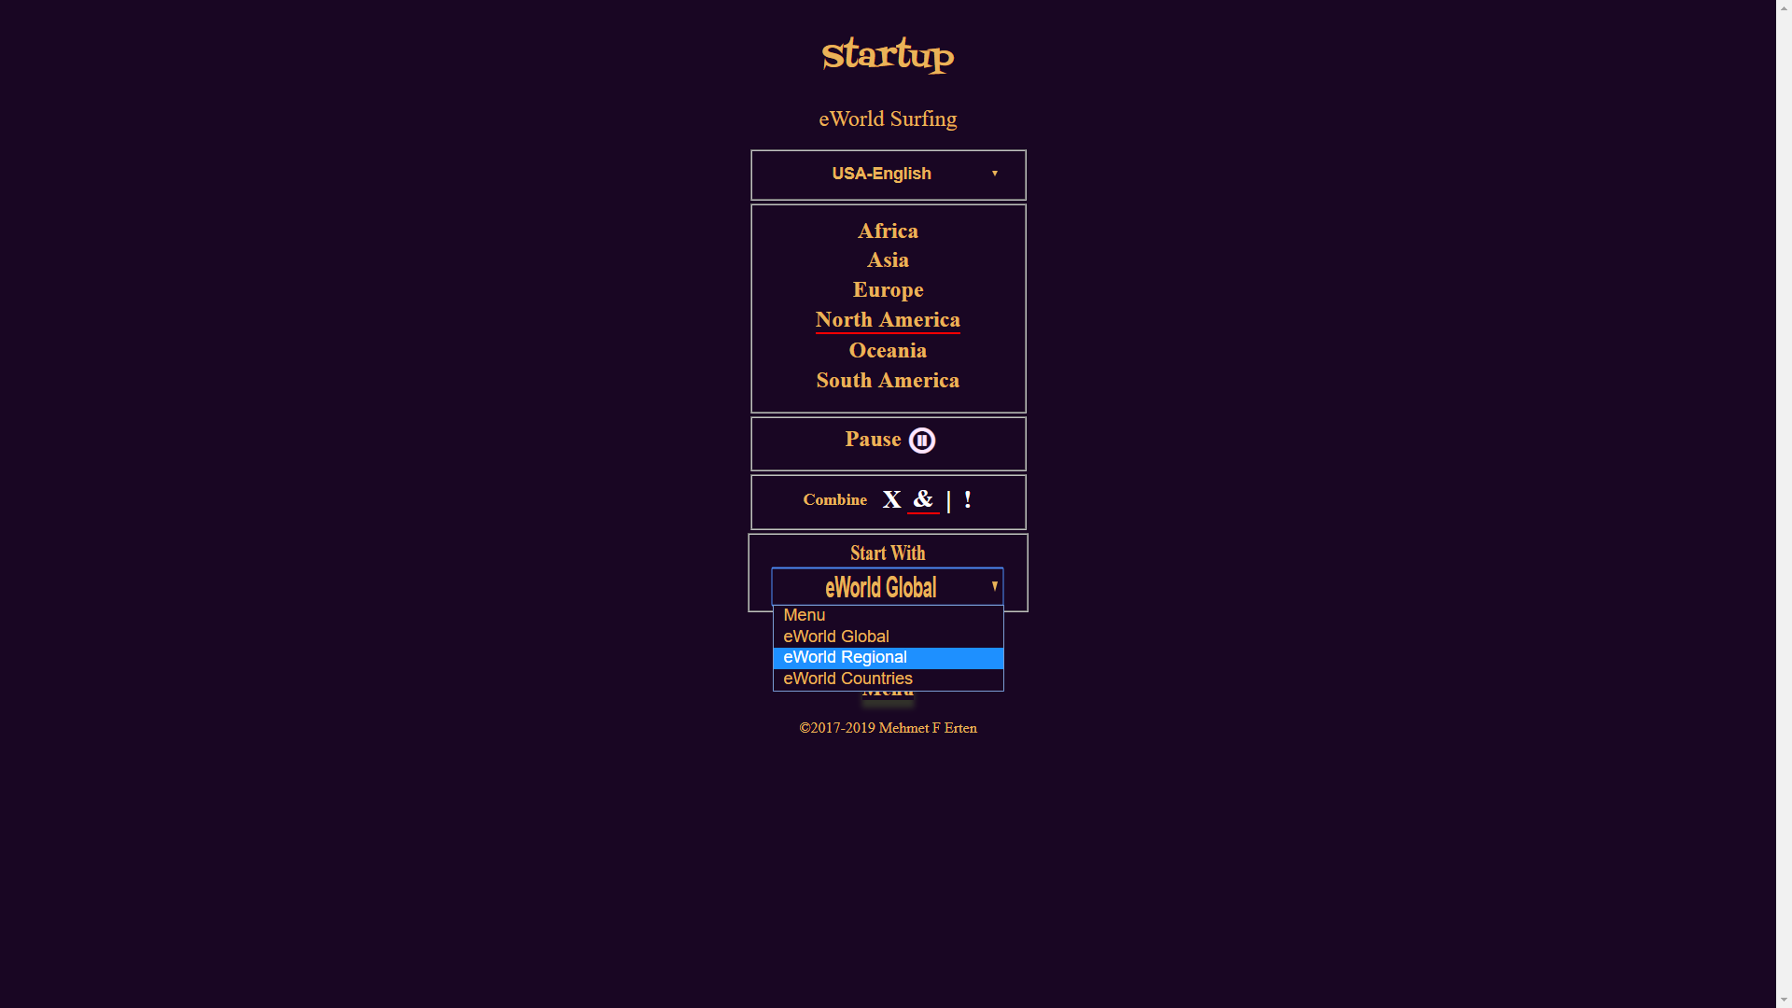

**Click on the Save Icon will save the entered values**

**And the application starts with the entered values**

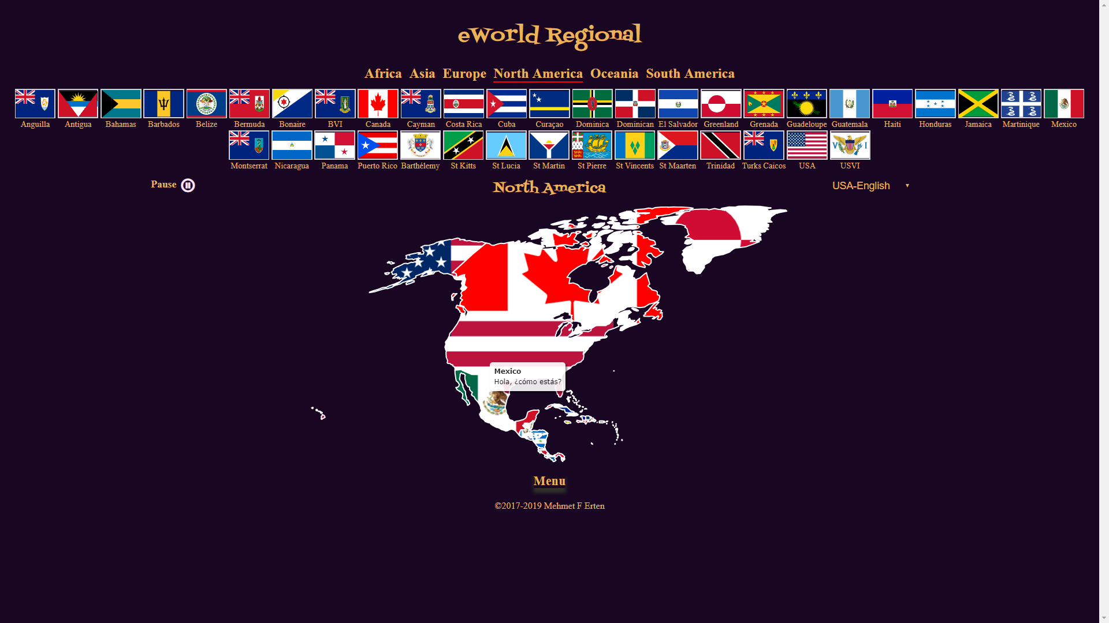

**Or to start an application, click on any button**

**eWorld Regional**

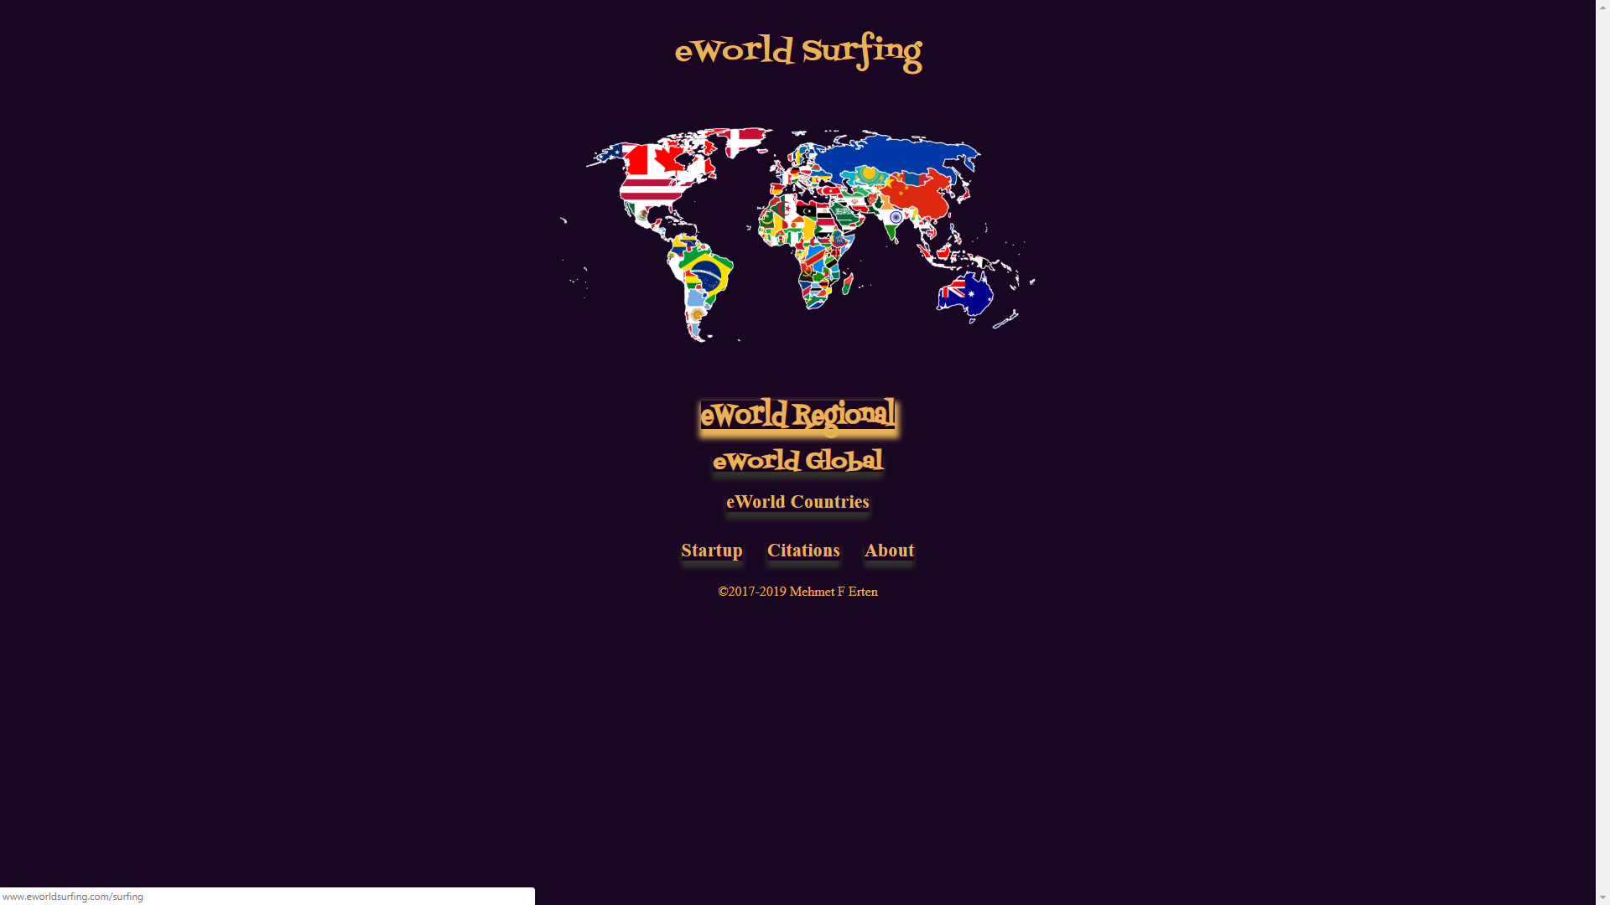

**Starts eWorld Regional**

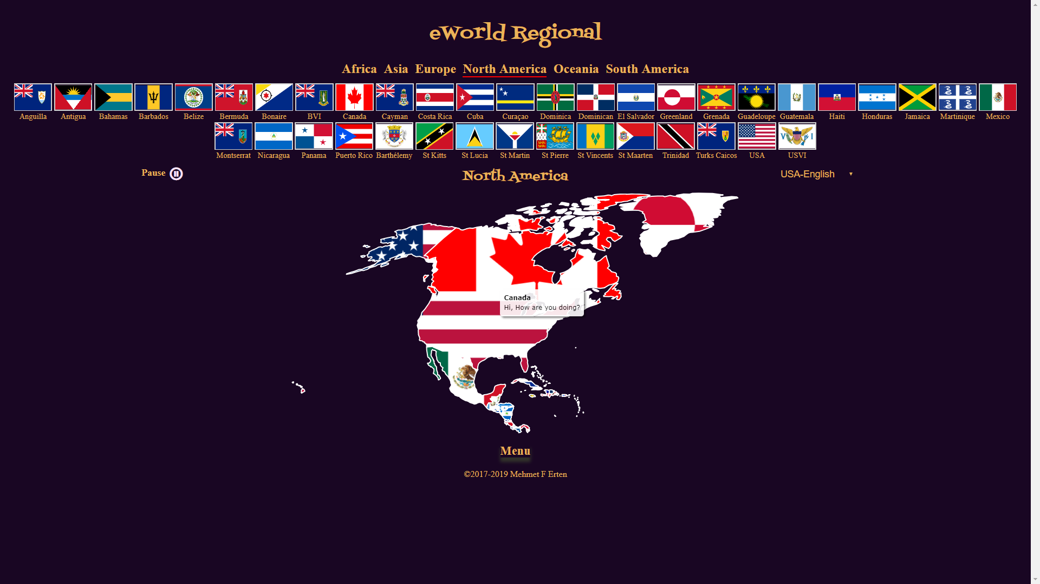

**eWorld Global**

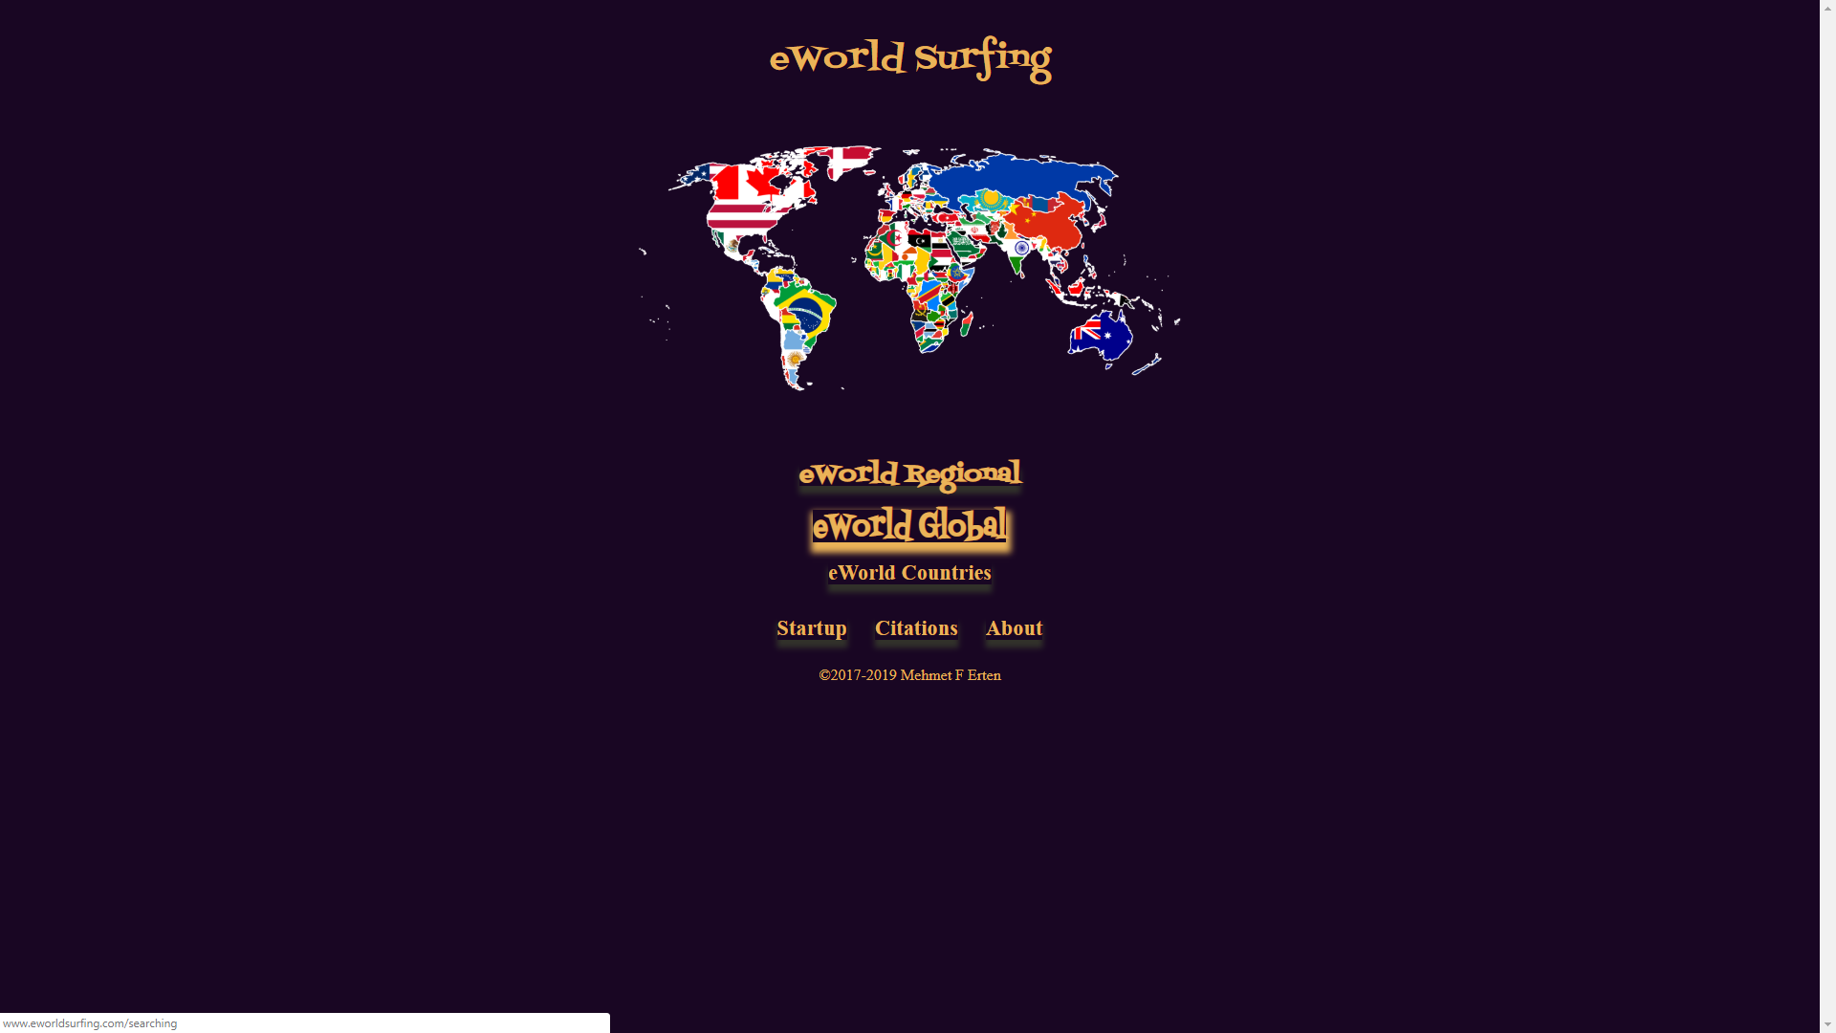

**Starts eWorld Global**

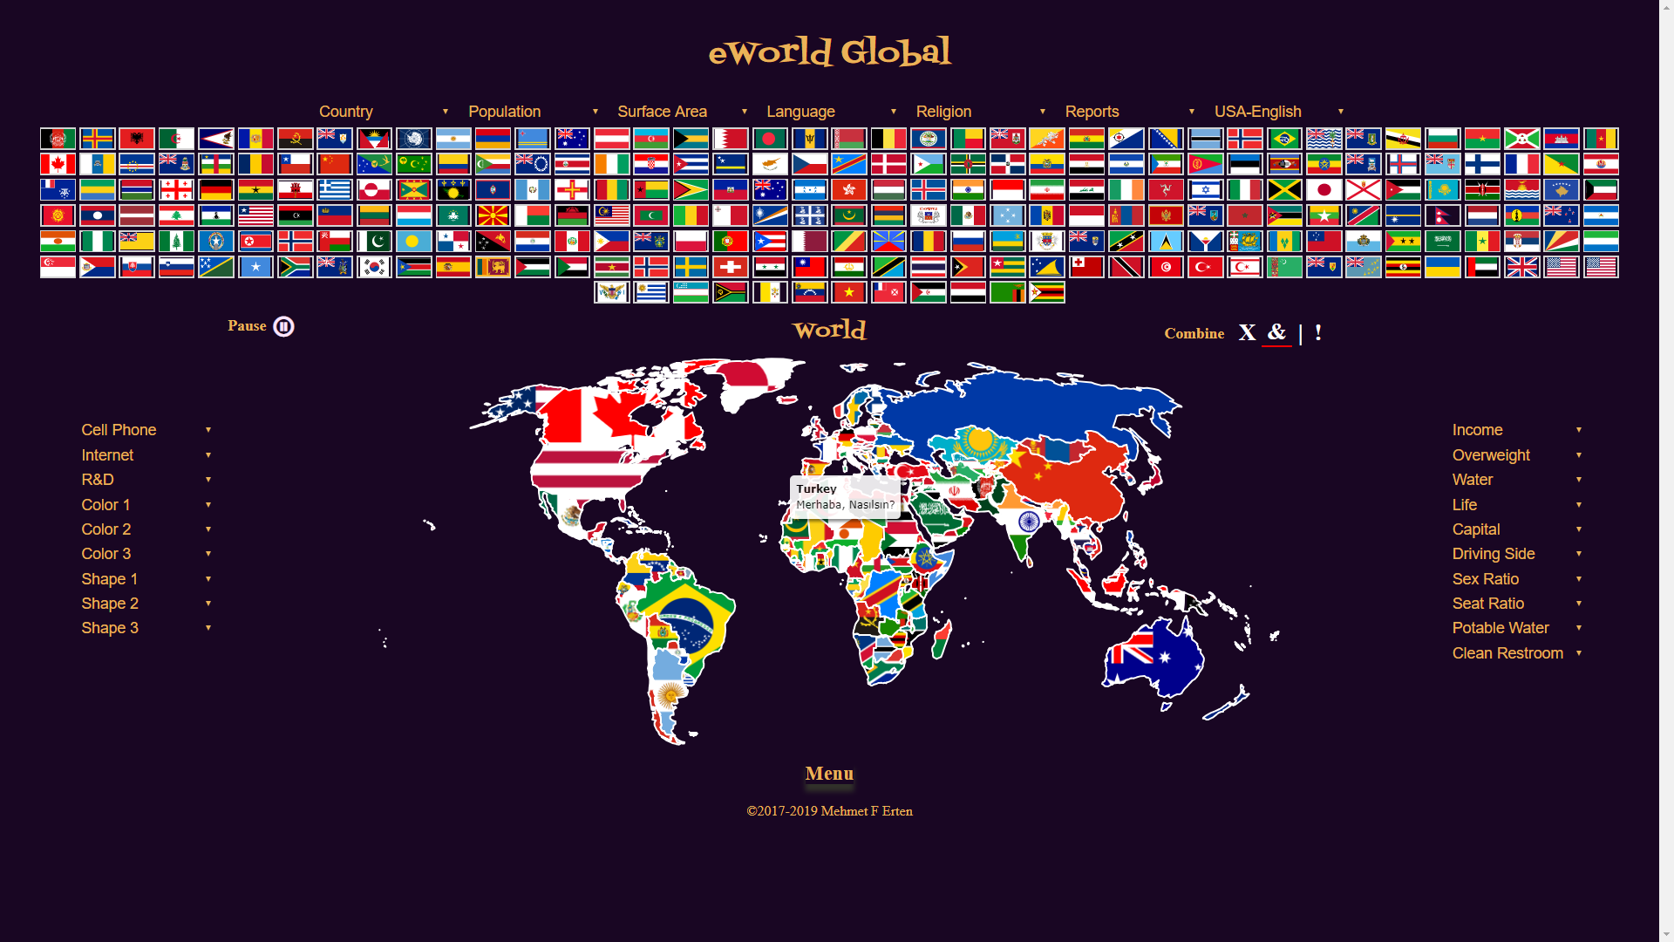

**eWorld Countries**

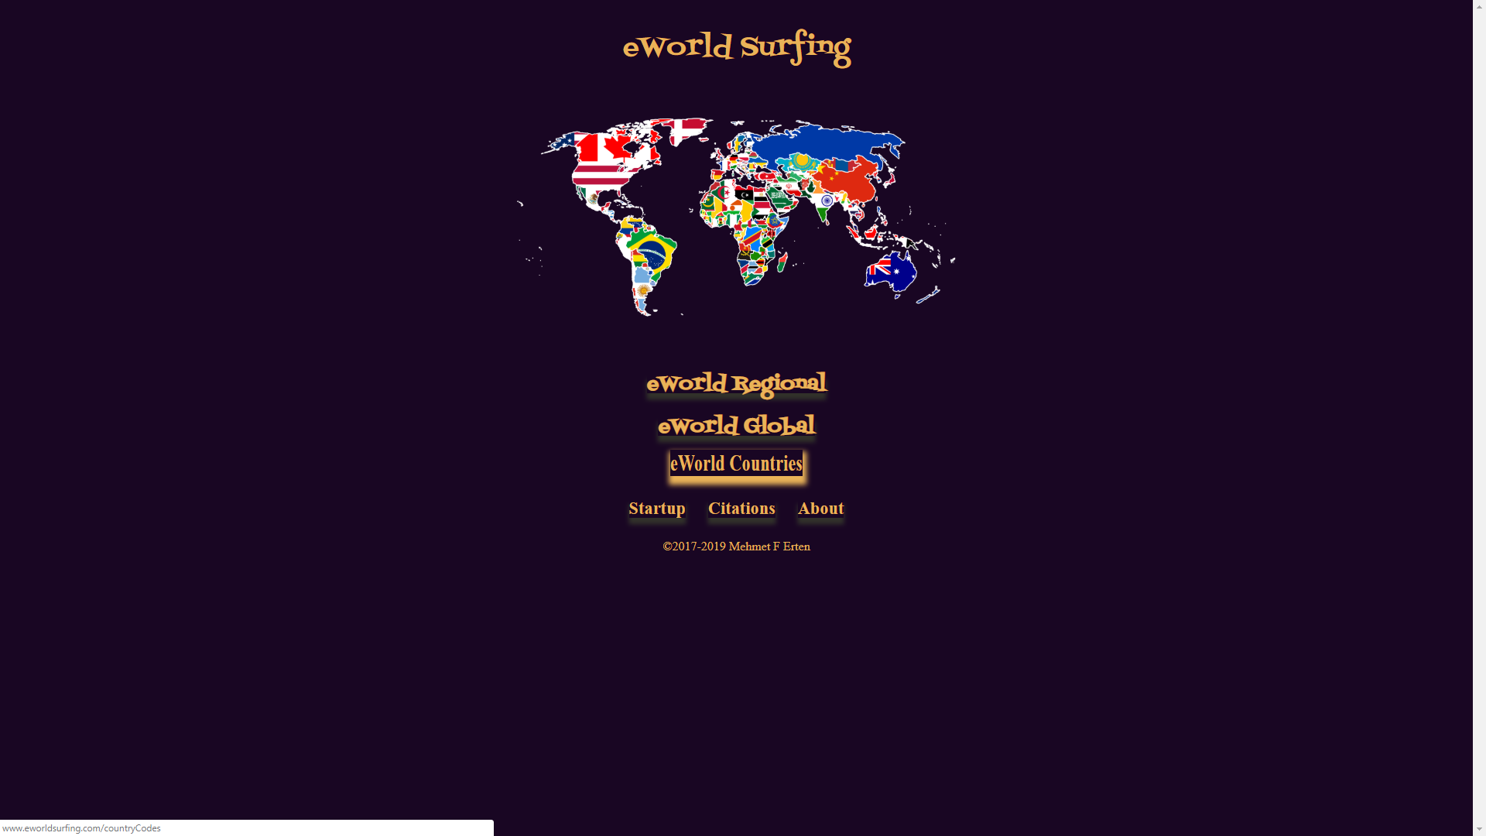

**Starts eWorld Countries**

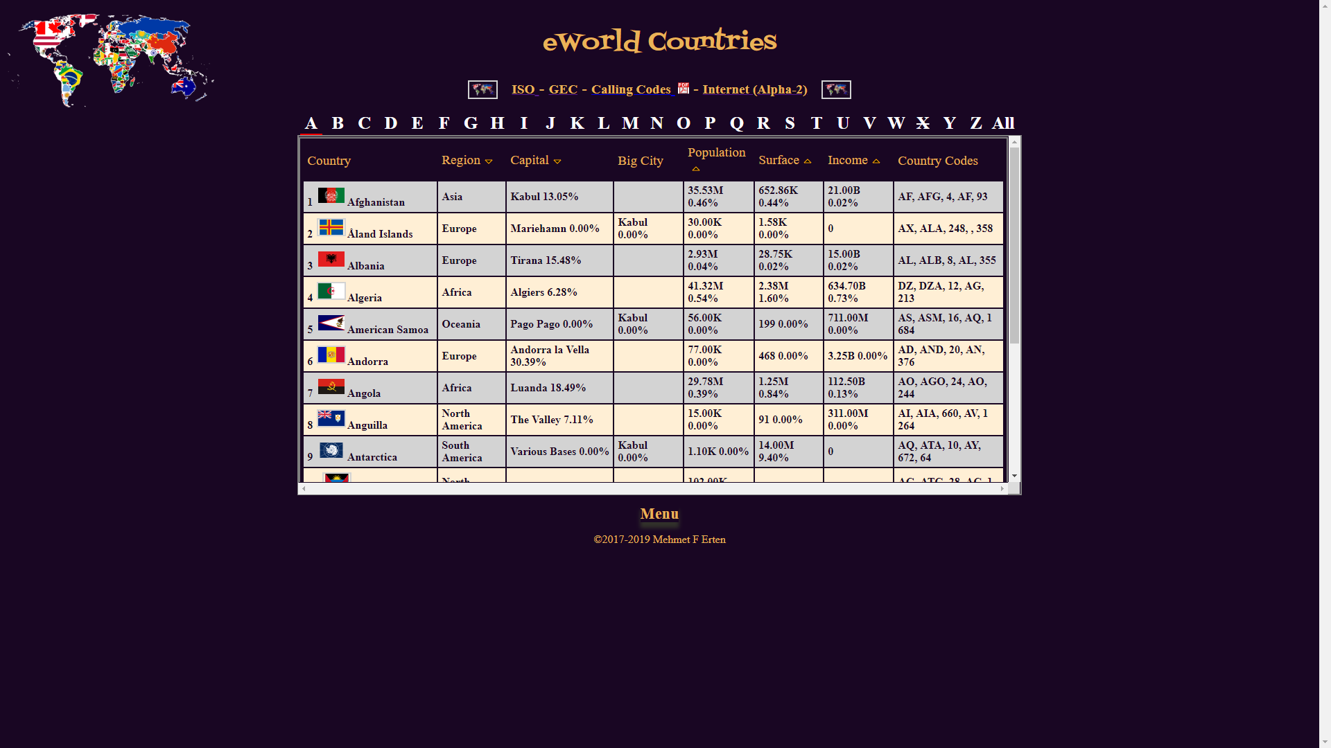

**After entering the “Start With” value, only the “Menu” can change the value**



**Which starts from the very first page above**