**Internationalization** (**i18n**)

Application Text Language

Application Data Language

**While using the Application, selecting an Application Language**

will Change the Domain from k12k20.com to k12k20tr.com or to k12k20sk.com …

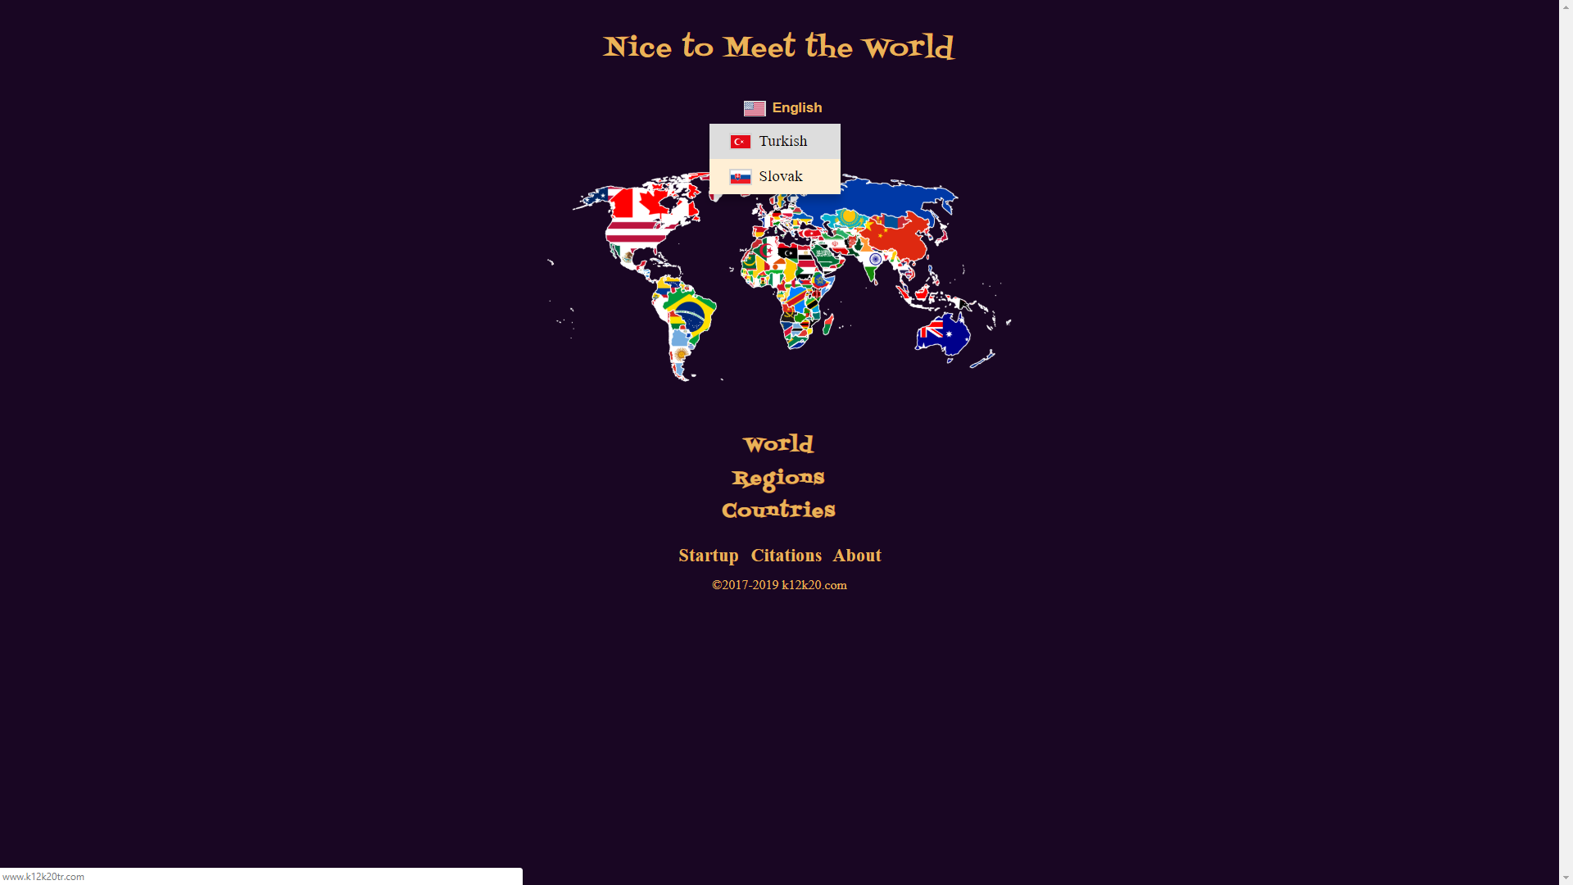

“Nice to Meet the World” now is in Turkish ([www.k12k20tr.com](http://www.k12k20tr.com))

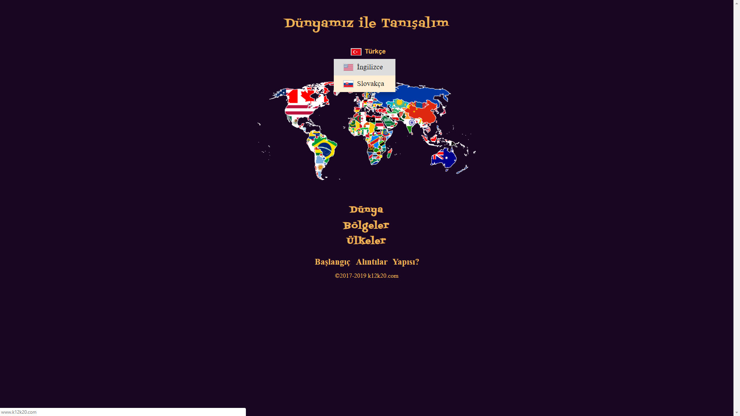

“Nice to Meet the World” now is in Slovak ([www.k12k20sk.com](http://www.k12k20sk.com))

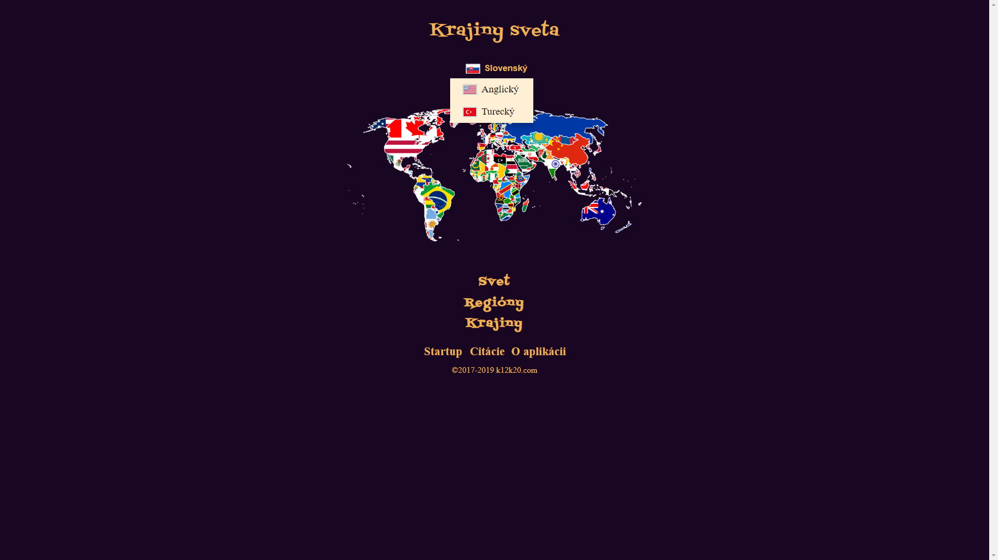

**Only Authorized Users can define a new Application Language**

**As seen on the Application Text and Application Data Language PDF files on About page**