

Programmer’s Guide
v 1.0
Table of Contents
1 XCase overview - MVC 5
1.1 Example: Rename a Class 5
2 Model 6
2.1 Introduction 6
2.2 Two levels of abstraction 7
2.3 The model interface 7
2.4 The top-level hierarchy 8
2.4.1 Element 8
2.4.2 NamedElement 9
2.4.3 TypedElement 9
2.5 Special interfaces 9
2.6 PIM Constructs 9
2.6.1 Class & PIM Class 10
2.6.2 Stereotypes – definition and usage 11
2.7 PSM Constructs 13
2.7.1 PSMElement 13
2.7.2 PSMSuperordinateComponent 13
2.7.3 PSMSubordinateComponent 13
2.7.4 PSMAssociationChild 13
2.7.5 IHasPSMAttributes 14
2.7.6 PSM Class & PSM Structural representative 14
2.7.7 PSM Attribute 15
2.7.8 PSM Attribute Container 15
2.7.9 PSM Content Choice / Content Container 15
2.7.10 PSM Association 15
2.7.11 PSM Class Union 15
2.7.12 Nesting Join 15
2.8 XSem Stereotypes 15
2.9 Linking between the PIM and PSM levels 16
2.10 How to add a new construct to the model 17
2.11 Mapping of the model to the UML constructs 17
3 XCase drawing framework 19
3.1 Canvas control – XCaseCanvas 20
3.2 Objects 22
3.2.1 DragThumb 22
3.2.2 ResizeThumb 23
3.2.3 IConnectable, ConnectableDragThumb 24
3.2.4 Templates of elements 24
3.3 Lines 25
3.3.1 XCaseJunction 25
3.3.2 XCasePrimitiveJunction 26
4 Representing elements of diagrams 27
4.1 XCaseCanvas 27
4.2 Representing elements 28
4.2.1 Sequence of actions performed when new element is added into a diagram 28
4.3 Binding Model properties to View 29
5 TreeLayout 31
5.1 Used Algorithm 31
5.1.1 Layouting of a Forest 31
5.1.2 Layouting of a Single Tree 31
5.2 TreeLayout Class 31
6 Controllers 32
6.1 Element Controllers 32
6.1.1 Example 32
6.2 CommandControllers 32
6.2.1 Diagram Controller 32
6.2.2 Model Controller 32
6.2.3 View Controller 32
6.3 Commands 32
6.3.1 Commands overview 32
6.4 Command stacks 33
6.5 More complex commands 33
6.6 HOW-TO create a command 34
6.7 Command factories 35
7 Setup 36
8 GUI - DockingLibrary 37
8.1 DockManager 37
8.1.1 Pane 37
8.1.2 ManagedContent 38
8.2 Changes to Original Library 38
9 GUI – Windows 39
9.1 Main window 39
9.1.1 Docking & Managing Diagrams 39
9.1.2 Main toolbar 39
9.2 Navigator window 39
9.2.1 Model Administration 39
9.2.2 Interaction with Other Windows 39
9.3 Project window 40
9.3.1 Overview 40
9.3.2 Interaction with Other Windows 40
9.4 Properties window 40
10 Storing and loading of XCase projects 42
10.1 Serializator 42
10.1.1 Serialization order 43
10.1.2 Example 44
10.2 XML Deserializator 45
10.2.1 Restoration Order 45
10.3 XmlVocabulary 46
11 Translation of PSM diagrams into XML schemas 47
11.1 Description of PSM diagram 47
11.2 Translation infrastructure 49
11.3 Part 3 Translation to XML Schema language 50
11.3.1 Basic translation principles 51
11.3.2 Translation of attributes and content 52
11.3.3 Translation of structural representatives 56
11.3.4 Translations of generalizations 59
11.3.5 Translation of simple types 61
11.4 Limitations of XML Schema translation 62
11.4.1 Mixed content 62
11.4.2 Attributes under choice constructions 63
11.4.3 Specialized classes without element labels 65
11.4.4 Non-deterministic diagrams 68
11.4.5 Not package-aware 69
11.4.6 Multiplicity of attributes is discarded 69
References 70
- XCase overview - MVC
XCase is based on Model-View-Controller (MVC) architecture.
- Model stores all the data managed by XCase and raises events when the data is changed (which can be done only through Controllers or loading data from a file)
- View binds to Model's events and displays the current state in GUI. This binding is unilateral; View cannot directly access/change the model.
- Controllers provide methods for changing the model, which can be used by view and GUI (when processing user input), but doesn't change the View directly.
  - Example: Rename a Class
- User clicks on the Rename context menu item of a Class, types in a new name and presses Enter
- View checks whether the new name is different from the old one. If it is, it replaces the new name with the old one (because the new name will be set here in a different way and we want to see if everything works OK)
- View calls the Controller with the rename request
- Controller creates a Rename command, initializes it with the Model class and executes it
- The Rename command sets the Name property of the Model class and stores the old name for Undo
- The Model class detects the change to its Name property and invokes the PropertyChanged event
- The View representation of this class receives an update via Binding and updates the text box containing the class name.

- Model
  - Introduction
This component is responsible for storing the semantics of the modeled data. It does not hold any information for a particular visualization of the model. But to support binding of the view, it defines a set of so-called view helpers that contain the basic data needed for any visualization (coordinates or dimensions). There will be a more detailed description of the view helpers later in the text.

The main purpose of the model is to provide an easy-to-use implementation of the UML and XSem models to the higher levels of the software (especially view and controller). The UML model constructs are restricted to those needed for UML class diagrams and even there we omitted some structures. The UML model is very general and XCase does not need more than a rather small specialized part of it. Therefore, we did not implement too general constructions as for example Classifier or RedefinableElement. The XSem model will be described in details later in this text but in this place let’s say that it is entirely represented in the UML language by use of the UML classes and stereotypes.

As the base of our implementation of the UML model we took an existing open-source library called nUML [1] written by Rodolfo Campero. The nUML library is a nearly complete implementation of the UML 2.0 specification and supports import / export from / to XMI language which is a standard format for metadata exchange between different software tools. Despite this, it is still just a bunch of classes without any automatic ownership or objects relations management. Thus, we created a complete set of adapter classes that enrich the library objects by the mentioned relations management and several other capabilities that will be described in the following sections.

The whole Model component is divided into two parts: public interfaces and internal implementation classes. The interfaces use multiple inheritance, since UML also makes use of it in its definition. Internal classes are not visible to other layers. They implement the public interfaces and sometimes extend it by other methods and properties needed mostly for the automatic relations management and for the exposition of the adapted nUML element. The name of the implementation class is the same as the name of the interface but is preceded by an underscore (e.g. Class -> _Class).

To support binding with other layers all model constructs implements the INotifyPropertyChanged interface and so raise a PropertyChanged event whenever any property has changed. Also all the collections in the model are instances of the ObservableCollection class defined in the System.Collections.ObjectModel namespace that raises a CollectionChanged event on every interesting collection action (add / remove / move / replace item).

  - Two levels of abstraction
When dealing with the model, probably the most problematic part is to clearly distinguish between the metamodel and model levels. Every class defined in the Model library is a part of the metamodel and their instances participate to represent the user model. This distinction is very important especially when working with stereotypes and the type system.

A Stereotype is a metaclass describing any stereotype the user can create (or we have created for representing XSem). It defines collections for describing attributes of the stereotype and so on. An instance of this class is one concrete stereotype. The collections are filled with the Property instances defining the real attributes that the stereotype have, its name is set etc. So far, it was easy. When we want to apply a stereotype to a concrete model element a new metaclass comes to the scene: a StereotypeInstance. It is a distinct interface describing any applied stereotype. It has an attribute of type Stereotype referencing the instantiated stereotype (an instance of the Stereotype class) and defines a collection for storing the values of the attributes of the stereotype. Its instance describes one concrete instance of a given stereotype. The collection is filled with the instances of InstantiatedProperty class that specifies the concrete values of the stereotype attributes.

An analogue situation is in the type system. It is easy to yield to the temptation to use the types existing only in the metamodel with the model attributes et versa. The DataType interface is a common base class to all the data types used in the model. The Property.Type attribute has the DataType reference type. And the concrete type of a Property instance is an instance of the DataType class. Thus, for example, if you want to model an attribute that can reference any construct in the user model, you cannot give it the Element type, since it is a metamodel type. Instead you have to define a new class inherited from DataType called for example Object (or Element if you want) and set the Type reference of the modeled attribute to its instance. (Note: We have already created a primitive type called object intended for this purpose, but it was a good example).
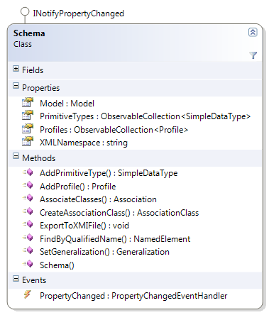
  - The model interface
To use the model classes you need to create at least one instance of the Schema class. This object represents the whole modeled domain including the platform-specific models. New Schema is created with an empty Model instance called “User model” that is used for the user data and another prefilled Model instance with the name “UML” containing the UML metaclasses to be used for stereotypes (described in more details later in the text).
The UML model is protected but is inserted as a default metamodel reference to each new profile.
The Schema methods are the only way to create new associations, generalizations and association classes in the user model. Also it is the unique owner of all the profiles since they are not a part of the user model.
New schema is created without any profiles or primitive types but XCase uses a project template file to initiate these collections by the XSem profile and the primitive types used in xml modeling.
  - The top-level hierarchy

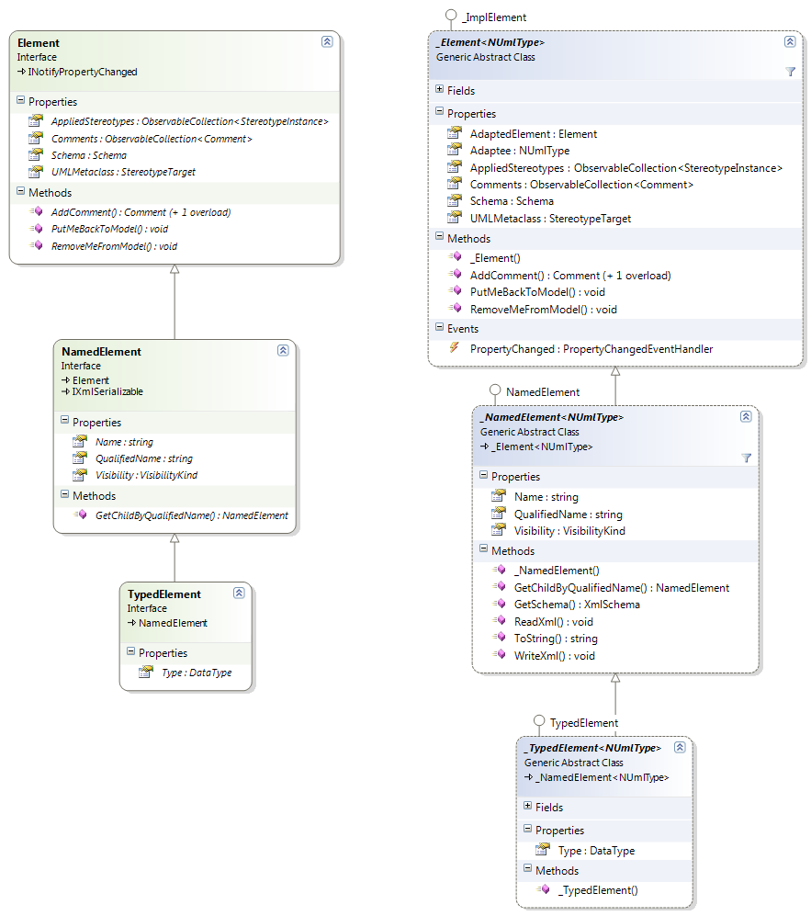
Figure 1 Top-level hierarchy : Interface & Implementation
    - Element
The topmost interface in the model object hierarchy is the Element and all the used UML and XSem constructs inherit directly or indirectly from this interface. It corresponds to the Element construct described in the UML specification but it is enriched by several new properties. One is the AppliedStereotypes collection that presents an effective way to find all the stereotypes applied to this particular element. This is not possible in the pure UML where the stereotypes have to be found by traversing the extensions instances present in the model.
The second one is the pair of RemoveMeFromModel / PutMeBackToModel methods that are responsible for correct removal of the element from the model and its return to the model when user undoes the operation that removed it. On the contrary the OwnedElement and Owner attributes defined in UML are not exposed since the ownership of the elements is solved type-safely between the classes that are concerned.

The implementation class is called _Element and extends the Element interface by the Adaptee property exposing the adapted nUML element. This class is generic and the type parameter is the adapted nUML element type. The type-safety of this property is ensured by the type constraints construction of the C# language.
    - NamedElement
A direct child of the Element interface is the NamedElement interface. It is a common base interface of all the constructs that have a name. It extends the Element by three properties: Name representing a name of the model element relative to its namespace (package). QualifiedName representing a name including all the names of the namespaces (packages) on the path from the owner package to the root of the model. The last property is Visibility defining the access rights to the element. The interface also provides a method to search for a subordinate element by its qualified name.
NamedElement inherits also from the System.Xml.Serialization.IXmlSerializable interface to support the serialization / deserialization of the model to an xml file.
    - TypedElement
The last interface described in this section is the TypedElement. It is a named element that has a type. The type is an instance of a DataType interface as described in the chapter 2.2.
  - Special interfaces
There is a set of 5 special interfaces defined in the model to ease the use of the model components:
- IAssociationSource – Identifies an element that can be a source of an association
(i.e. an association can start in this element)
- IAssociationTarget – Idenitifies an element that can be a target of an association
(i.e. an association can end in this element)
- IHasAttributes – Identifies an element that can contain attributes (Property instances)
- It defines an attributes collection and the methods for adding a new attribute
- IHasOperations – Identifies an element that can contain operations (Operation instances)
- It defines an operations collection and the methods for adding a new operation
- IHasPSMAttributes – Identifies an element that can contain PSM attributes (PSMAttribute instances)
- It defines a PSM attributes collection and the methods for adding a new attribute
  - PIM Constructs
The Platform Independent Model is realized by an UML class diagram model. Therefore, most of the PIM constructs have direct equivalents in the UML specification. Therefore, we will describe only the most important ones. Some of them are extended by new properties mostly to support linking between the PIM and derived PSM constructs. There is a dedicated section describing them.

No component can be created on its own without an owner. When a new project is created, automatically two Model instances are created. One is empty and is intended for the user model and the second, invisible to the user, contains the definition of UML metaclasses that can be extended by the stereotypes. There is also one profile created containing the XSem stereotypes definitions. Any new user component can be created uniquely by calling an appropriate Add method on the existing model element that will contain it. For example, to add a new class into the model you have to use the AddClass method on an existing package that will contain the new class.

Each component has a reference to its owner that is set automatically when the component is inserted to the owner’s collection. This reference is read-only for other layers of the software.
    - Class & PIM Class
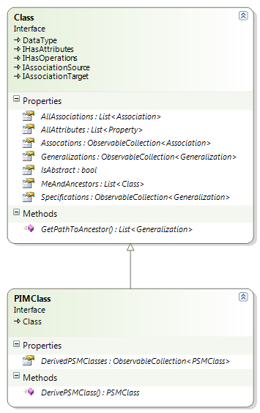
Figure 2 - Class & PIM Class
The Class interface corresponds to the UML Class structure. It is a data type that can have attributes, operations and can participate in the associations. The original construct is enriched by the following properties
- MeAndAncestors – Collection containing this class and all its ancestors (classes that this class inherits directly or indirectly from)
- Associations – Contains all the associations that include this class
- AllAssociations – Contains the content of the Associations collection and of the Associations collections of all the ancestors.
- AllAttributes – Contains the content of the attributes collection of this class and of all the ancestors of this class.
- Generalizations / Specifications – Present an effective way to identify all the generalizations that go to or from this class.
All the collections concerning the inheritance are virtual and their content is built on each access, so frequent reading of this property can result in a loss of performance.

The PIM class is a simple extension of the UML class allowing the user to create a new PSM class representing this one and track all the PSM classes that were derived from this class. The content of the DerivedPSMClasses is managed automatically. When a derived PSM class is correctly removed from the model (via RemoveMeFromModel call) it removes a reference to itself from this collection and puts it back if the PutMeBackToModel method is called.
    - Stereotypes – definition and usage
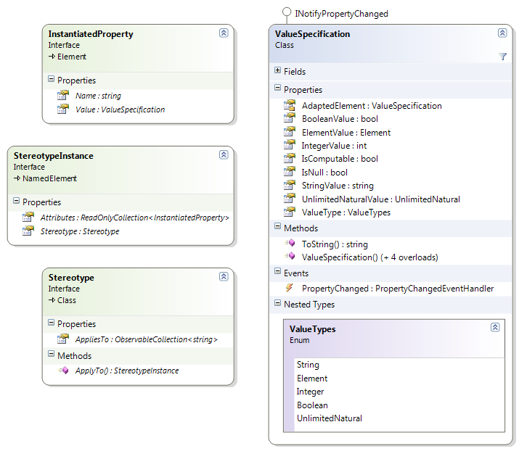
Figure 3 - Stereotypes - most important structures
Stereotypes are special kinds of classes defining how an existing metaclass can be extended. Therefore, an instance of a stereotype is always related to an instance of its related metaclass (or metaclasses since stereotypes can be sometimes applied to more than one element types). Since the stereotypes are special classes, they are also stored in a special type of package called a profile. However, the profiles are very similar to standard packages except that they can reference one or more metamodels. A metamodel is a standard UML model that contains standard UML classes. But the names of the classes correspond to the metaclasses existing in the used model.

To make it more clear we take an example of the UML model. It contains many familiar metaclasses: Class, Association, Property, etc. The XSem profile in XCase that contains definition of the stereotypes used to represent XSem structures references an instance of the Model interface that has the name “UML” and contains instances of the Class interface having the Name attribute set to “Class”, “Association”, “Property”, etc.
When we apply a stereotype to some model element, we extend its definition by the attributes of the stereotype. Before continuing, let’s look to an example of the stereotype usage:

In XCase PSM classes of the XSem model are represented as standard UML classes having the XSem.PSMClass stereotype. Note that both the PSM class and the UML class are metaclasses and user is working with their instances. The definition of the UML class is described in the previous section, the PSMClass stereotype contains attributes as RepresentedClass referencing the PIM class that is represented by a concrete PSM class or Components collection that contains all the PSM components subordinate to the PSM class. The PSMClass stereotype can be applied to the instances of the UML class which is (in UML) represented by an instance of the Extension metaclass that relates the stereotype and a class in the UML metamodel corresponding to the UML class. Thus, factually a new metaclass (let’s call it a PSM Class) is created that integrates the definition of both the UML class and the PSMClass stereotype. When the stereotype is applied to an existing UML class instance, its definition is extended and corresponds to the PSM Class metaclass. Thus, the user gains access to all the attributes defined by the PSMClass stereotype and can see / set their values.

Now from the programmer’s point of view. The stereotypes are described by the instances of the Stereotype interface. As you can see on the figure above, it inherits from the Class interface. Thus, its definition is the same as the definition of a standard UML class. It is extended by a collection called AppliesTo that contains the names of all the metaclasses that can be extended by this stereotype. The collection contains strings instead of the references to the concrete metaclasses to support the visualization and the serializator that does not serialize the UML metamodel. When a reference is needed a search by the metaclass name is performed in the metamodels referenced by the owner profile. The extensions mechanism mentioned in the previous paragraph is hidden from the other layers of the project and is represented only inside the nUML library.

The Stereotype interface also defines a method called ApplyTo that takes a reference to an existing element instance. When this method is called it first checks if the element metaclass can be extended by this stereotype and if yes a new instance of the StereotypeInstance is created and inserted to the element AppliedStereotypes collection. This is analogous to the object oriented programming. You have a class that describes generally the attributes of some entity and you instantiate it to create an object that represents one concrete instance of the entity. The Stereotype instance is a description of the attributes of the stereotype. For example in case of the XSem.PSMStereotype you know that this stereotype has an attribute called RepresentedClass and its type is a reference to a PIMClass instance. But to have a reference to a concrete PIM class you have to instantiate the stereotype and this is what the StereotypeInstance is for.

The StereotypeInstance instance contains instances of the InstantiatedProperty interface that defines the value of the attribute. A value is represented by an instance of the ValueSpecification interface.

If you want to create your own stereotype, proceed by the following scheme:
- Create a new profile or use an existing one. Profiles are accessible via the Schema.Profiles collection, to create a new one call Schema.AddProfile.
- Create a new Stereotype by calling the Profile.AddStereotype method.
- Set the name of the stereotype and define its attributes by calling Stereotype.AddAttribute method and setting the attributes of the created Property instances appropriately.
- Add the names of the metaclasses that can be extended by the new stereotype to its AppliesTo collection (all the extensions are created automatically)
- After that you can simply apply the stereotype using its ApplyTo method

  - PSM Constructs
In this section we list the structures defined in the XSem model used in XCase for the Platform-specific model and some important auxiliary constructs. In contrast to the PIM structures that can be a part of multiple diagrams but exist only once in the model, the existence of every PSM component is connected to the existence of the diagram that it is part of. And no PSM component can be drawn on more than one diagram.
    - PSMElement
PSMElement interface is the base interface of all the PSM components. It is inherited from the NamedElement interface and extends it by the Diagram property that references the PSM diagram that the component is part of.
    - PSMSuperordinateComponent
This is a common base interface of PSM components that can contain other PSM components. It defines a Components collection that is an ordered list of the subordinate PSM components and a method called AddComponent which adds a new component to the end (or to the specified position) in the components. This method accepts a reference to a factory that creates instances of the concrete PSMSubordinateComponent interface child.
    - PSMSubordinateComponent
This is a common base interface of PSM components that can make a part of some superordinate component content (components collection). Note that a PSM component can be both superordinate and subordinate at the same time. This is a case of for example PSM content choice structure that can exist only in the content of some other PSM component but contains other PSM components on its own.
    - PSMAssociationChild
This is a common base interface of PSM components that can appear at the child end of a PSM association.
    - IHasPSMAttributes
This is a common interface of PSM components that can contain PSM attributes. Beside the PSMAttributes collection and the methods to add new attributes, it defines a property called RepresentedClass that references the PIM class containing the attributes that are represented by the owned PSM attributes.
    - PSM Class & PSM Structural representative
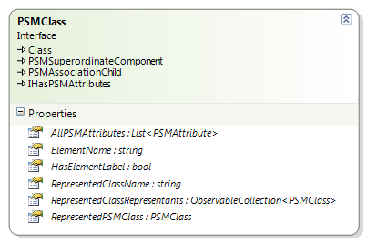
Figure 4 - PSM Class definition
The PSM class inherits from the Class interface. Thus, it has all the functionality of the standard UML class, which is especially useful for modeling the inheritance. It can appear at the end of the PSM association and can contain subordinate PSM components. It has a collection of PSM attributes that contains the same items as the Attributes collection inherited from the Class. The content of both collections is synchronized automatically and you cannot insert an attribute instance that does not implement the PSMAttribute interface to the attributes collection (an attempt to do this, results in an ArgumentException).

A PSM Class instance can be turned to a PSM Structural Representative instance by setting the RepresentedPSMClass attribute to a valid reference. In the background this results in a replacement of the PSMClass stereotype by a PSMStructuralRepresentative stereotype. Contrarily, a representative can be turned to a PSM class by setting the RepresentedPSMClass property to a null value.

The AllPSMAttributes collection includes the attributes from the PSMAttributes collection of this class and all the subordinate attribute containers (owned directly in the components or indirectly through another subordinate component). This collection is virtual and its content is built on each access to the property.
    - PSM Attribute
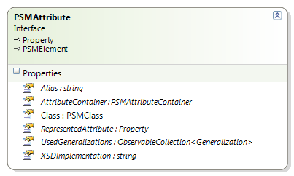
Figure 5 - PSM Attribute definition
A PSM attribute is a standard UML property extended by a reference to the represented PIM attribute, Alias attribute that defines the name of this attribute in the generated XML schema and XSDImplementation that contains the implementation of the type of this attribute in the generated schema.
    - PSM Attribute Container
An attribute container can contain some of the attributes of its superordinate PSM class. It is a subordinate component and has PSM attributes.
    - PSM Content Choice / Content Container
These two components are superordinate and subordinate at the same time. They can only exist in the Components collection of some PSM component but typically contains other PSM components.
    - PSM Association
A PSM association has exactly two ends, a parent and a child end. It is a subordinate component and so it is a part of the parent’s content (content of the PSM component on the parent end). The semantics of the association is defined by one or more nesting joins. If the association contains more than one nesting join, the semantics is defined as their union.
    - PSM Class Union
A class union is a PSM association child and so can appear at the child end of a PSM association. It defines a Components collection that can contain any association child, so by now a PSM Class or another class union.
    - Nesting Join
Nesting join defines the semantics of a PSM association. It is formed mostly by instances of PIMPath interface which defines a path through associations in the platform-independent model. It is an ordered list of steps described by a PIMClass in which the step starts and a PIMClass in which the step ends and an Association used to get from the start to the end.
  - XSem Stereotypes
As we already mentioned earlier in this text, all the XSem structures are expressed in the standard UML language using the stereotypes. There is an “XSem” profile created upon the project creation that contains all the stereotypes needed for the representation of the XSem constructions.

We present their list in this section:
- PSMClass (applies to Class)
RepresentedClass (object, 1..1) – Reference to the represented PIM class
ElementName (string, 1..1) – Element label assigned to the PSM class
Components (object, 0..*) – Ordered collection of references to subordinate PSM components
- PSMAttribute (applies to Property)
RepresentedAttribute (object, 1..1) – Reference to the represented PIM attribute
Alias (string, 1..1) - Alias of the PSM attribute
- PSMAttributeContainer (applies to Class)
Parent (object, 1..1) – Reference to the component that contains this container
- PSMClassUnion (applies to Class)
Components (object, 0..*) – Ordered collection of references to PSM components in the union
- PSMContentContainer (applies to Class)
Parent (object, 1..1) – Reference to the PSM component that owns this container
Components (object, 0..*) – Ordered collection of references to the subordinate PSM components
ElementLabel (string, 1..1) - Name of the modeled XML element
- PSMContentChoice (applies to Class)
Parent (object, 1..1) – Reference to the PSM component that owns this choice
Components (object, 0..*) – Ordered collection of references to the subordinate PSM components
- PSMAssociation (applies to Association)
NestingJoin (object, 1..*) – Collection of nesting joins defining the semantics of the association
- PSMStructuralRepresentative (applies to Class)
RepresentedClass (object, 1..1) – Reference to the represented PIM class
RepresentedPSMClass (object, 1..1) – Reference to the represented PSM class
ElementName (string, 1..1) - element label assigned to the representative
Components (object, 0..*) – Ordered collection of references to the subordinate PSM components
All the XSem stereotypes as well as the XSem profile are defined in the project template file.
  - Linking between the PIM and PSM levels
The model is responsible for keeping the platform-independent model and related platform-specific models consistent. Therefore, the constructs from the models are related from both sides by the references and collections. These references are in most cases handled automatically, but there are several cases in which the model does not have enough information to do this and the outer layers have to manage the binding themselves.

PIM Class has a collection containing all the PSM classes that were derived from it and every PSM class has a reference to the PIM class that it was derived from. This linking is handled automatically. Changes of some PIM class properties are propagated automatically to the derived PSM classes (for now the Package property). Other can be easily added in the implementation of the _PSMClass.OnRepresentedClassChanged event handler.

PIM Attribute has a collection of all the PSM attributes that represent it and PSM attributes have reference to the represented PIM attribute. This linking is handled automatically.
For a case when the PSM attribute in a class or container represents a PIM attribute that is not owned by the represented PIM class but by some of its ancestors, the PSM Attribute has a collection of all the generalizations (in PIM) that lead from the represented class to the class containing the represented attribute. Accordingly the generalization has a collection of all the PSM attributes that reference it. This linking is also handled automatically.

PIM Association has a collection of all the nesting joins that reference it. This linking is handled automatically.

For case when a PSM association contains a reference to a PIM association that is not directly in the Associations collection of the PIM class represented by the PSM class on the parent end, but in some of its ancestors, the PSM association defines the collection referencing all the generalizations (in PIM) that lead from the parent represented class to this ancestor. Likewise, a generalization has a collection of all the PSM associations that reference it. The filling of these two collections is left for to the outer layers since the model cannot simply get the necessary information. The rest of the management (when some of the PSM associations is removed from or put back to the model) is automatic.
  - How to add a new construct to the model
When creating a new structure for use in the model, the most problematic part is its representation in the UML. If you need to represent a structure outside the UML definition you have to create a stereotype that will add the requested functionality. The procedure to create a new stereotype is described in the section about the stereotypes.

The new structure should be divided into a public interface and an internal implementation class and should inherit directly or indirectly from the Element interface. Constraint the type parameter of the Element interface to the real nUML type.

In the constructor of the new element create the adapted nUML object using the appropriate NUml.Uml2.Create class method. Bind the properties of your structure to the corresponding properties of the adapted nUML element. For every writable property raise the PropertyChanged event when the property value changes, so that the visualization can reflect the change. For collections use the ObservableCollection type defined in the System.Collections.ObjectModel.
Override the PutMeBackToModel / RemoveMeFromModel methods.
  - Mapping of the model to the UML constructs
Most of the UML constructs in the model have direct mapping to the structures with the same name defined in the UML specification, so we will omit them and will list only the items that differ either by name or by their properties from their UML equivalents. We will certainly list here all the PSM constructions.

Sometimes we have chosen a different name than given in the UML specification, because the original name described a more general structure or because our name seemed clearer to us. Not all the properties have mapping to the UML model. As for example the PIMClass.DerivedPSMClasses collection. This collection is restored automatically when the project is loaded and presents only redundant information for the model added to find the derived classes effectively. Without this collection we are still able to identify all the derived classes of the specified one but the algorithm is more time complex. This is the case of many collections used to track dependencies between elements in the model (especially between PIM and PSM).
- Adapter name: DataType → Adapted construct Type
- InstantiatedProperty → Slot
- PIMClass → Class
- PSMAssociation → Association with the XSem.PSMAssociation stereotype
- PSMAttribute → Property with the XSem.PSMAttribute stereotype
- PSMAttributeContainer → Class with the XSem.PSMAttributeContainer stereotype
- PSMClass → Class with the XSem.PSMClass stereotype
- PSMClassUnion → Class with the XSem.PSMClassUnion stereotype
- PSMContentContainer → Class with the XSem.PSMContentContainer stereotype
- PSMContentChoice → Class with the XSem.PSMContentChoice stereotype
- SimpleDataType → PrimitiveType
- StereotypeInstance → InstanceSpecification

- XCase drawing framework
We chose Windows Presentation Foundation for implementation of graphical user interface and drawing both the UML class diagrams and XSEM diagrams. This part covers some of the basic building blocks that we created for drawing diagrams and are part of View.dll assembly, the visual part of the View component of Model-View-Controller pattern (updates of View according to changes in Model are described in 1.1. Diagrams basically consist of objects (usually rectangular) and lines between these objects. The example diagram on Figure 6 shows both objects and lines.

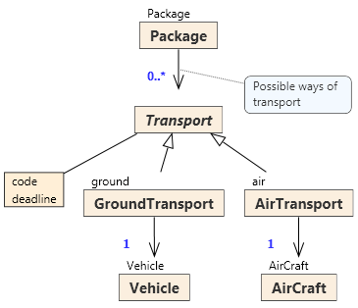
Figure 6 - Example diagram
Examples of objects are classes and attribute container and comment, all arrows (associations and generalizations), the component connector between class Transport and the attribute container and line attaching comment to association between classes Package and Transport are examples of lines. Endpoints of all lines (in red circles) are objects again (and can be dragged by mouse). The example diagram is a PSM diagram where all layouting is performed automatically, but in PIM diagrams, most of objects can be freely dragged on the canvas (including endpoints of lines that can be dragged around the borders of connected object) and lines can be broken to polylines.
All diagrams are created using class XCaseCanvas.
  - Canvas control – XCaseCanvas
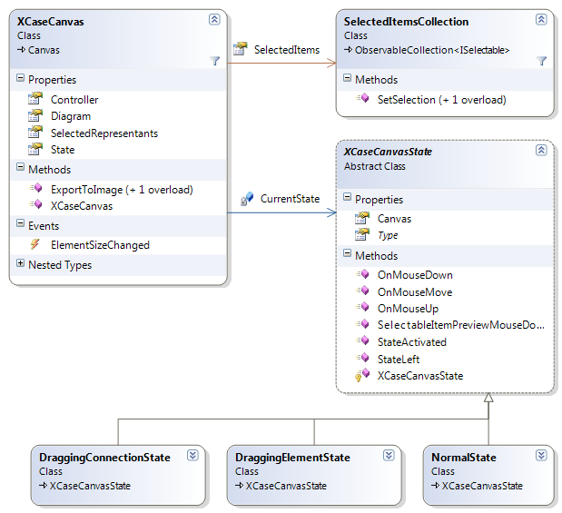
Figure 7

Canvas control is a counterpart of Diagram in View component of Model-View-Component pattern and is responsible for drawing diagrams. It also receives user input from mouse and keyboard. It is responsible for creating representations of elements added to the displayed diagram and removing the representations when the elements are removed from diagram. This part of XCaseCanvas functionality is covered in detail in the chapter 4.

Class SelectedItemsCollection stores items selected on the diagram, its method SetSelection deletes the current selection and adds items passed as arguments to new selection. This class is used as SelectedItems property. The property SelectedRepresentants acts as a filter above SelectedItems and returns only items of type IModelElementRepresentant. See the chapter 4.
XCaseCanvas uses State design pattern [2] to manage mouse input correctly. Canvas can be in three states and in each state mouse events are handled differently. Abstract class XCaseCanvasState declares empty operations that are overridden in derived classes. State is changed by assigning desired value to State property.
NormalState is the initial state of XCaseCanvas. In this state elements can be selected via mouse and selected elements of type DragThumb (this class is described in its own section).
DraggingElementState must be entered explicitly. In this state a new element is dragged onto canvas (in XCase this state is used when a new class or new comment is dragged from toolbar or navigator window). Canvas returns into NormalState immediately after the dragged element is dropped on canvas.
DraggingConnectionState must also be entered explicitly. In this state user can dragged connections between elements implementing IConnectable. The user can start dragging by clicking an element and continue by dragging the connection to another element. When the connection is dropped, event handler that processes the event is called and user can start dragging another element. This state is not left automatically (user can drag as many lines as he wants) and must be left explicitly.

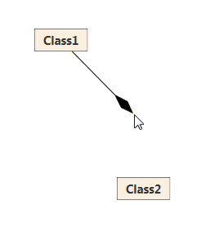
Figure 8 - XCaseCanvas in DraggingConnectionState

  - Objects
We created a set of several WPF classes to draw objects on diagram. Each of these objects encapsulates certain functionality. They don’t have a visual appearance – this is where we rely on WPF styles and templates. To add visual appearance to a derived class, template is assigned to each class.
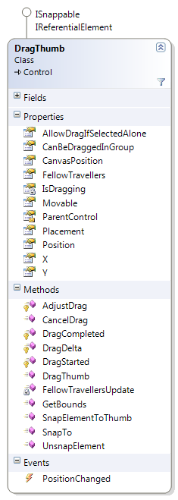
    - DragThumb
DragThumb is a class that can be dragged on the diagram via mouse. It is tightly related to MoveElementCommand, which wraps the dragging action. DragThumb is an ancestor of virtually all the elements in the diagram. It does not have visual representation itself – this is left to derived classes and their templates.
Properties Placement, X, Y, Position, and CanvasPosition and event PositionChanged are all related to position of the object on canvas.
Position returns values of X and Y as Point.
CanvasPosition property is point with coordinates of the object on canvas. The value returned by the property depends on values of X and Y and also on value of Placement. Placement property describes the way how CanvasPosition is computed from X and Y. DragThumb can be placed absolutely on canvas or relatively to another element (snapped to another element – using methods SnapTo or SnapElementToThumb). When element is snapped to another element, it moves with that element when that element is moved. This way it is for example achieved that comments attached to another objects move along with those objects. Another option is to set Placement to EPlacement.AbsoluteSubCanvas - then Position is relative in coordinates of ParentControl and CanvasPosition is then equal to ParentControl.CanvasPosition + this.Position. EPlacement.ParentAutoPos – with this value the computation of CanvasPosition is the same as with EPlacement.AbsoluteSubCanvas, but besides that, ParentControl is responsible of moving the control. This setting is used for automatically adjusting positions of EndPoints of lines when the connected object is moved. Event PositionChanged is invoked every time DragThumb is moved.
By setting value of DragThumb.Movable to false, dragging of DragThumb is disabled (this is used for DrugThumbs on PSM diagrams, where objects and lines are positioned automatically. Property AllowDragIfSelectedAlone returns whether the object can be dragged when it is the only object selected. Property CanBeDraggedInGroup returns true if the object can be dragged when more objects are selected.
Methods DragStarted, DragDelta and DragCompleted are handling the dragging itself. They are called depending on mouse input. DragDelta changes the values of X and Y and thus moves the element on the canvas. DragCompleted aggregates all the changes done in DragDelta and issues MoveElementCommand. This command actually does not move the object (because it only puts the object on the same position where it was before the command was executed), but the command is pushed into undo stack and thanks to that the dragging can be undone/redone (see chapters 6.3 and 6.4 for description of undo).
All the methods DragStarted, DragDelta and DragCompleted are protected virtual and can be overridden by derived classes.
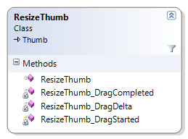
    - ResizeThumb
ResizeThumb is a small class that handles resizing of another element (and is related to ResizeElementCommand). Again, it lacks any visual representation. ResizeDecoratorTemplate is a control template made of ResizeThumbs and it can be applied to virtually any Control and can be used to resize the control via drag and drop.
At run time, ResizeDecoratorTemplate is shown on those elements that are selected at the time. The template allows resizing the selected element. ResizeDecoratorTemplate is defined in ControlTemplates.xaml. To allow resizing for an object, declare control with ResizeDecoratorTemplate. This is the declaration taken from XCaseCommentTemplate:
<Grid x:Class="XCase.View.Controls.XCaseCommentTemplate">
<Control Name="ResizeDecorator"
Visibility="Collapsed"
Template="{StaticResource ResizeDecoratorTemplate}"/>
</Grid>
Normally, the ResizeDecoratorTemplate is collapsed. When the Visibility of ResizeDecorator is changed to Visible (usually when the control is selected), border-like control that allows resizing is shown:
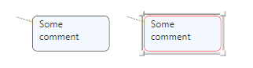
Figure 9 - Displayed ResizeDecoratorTemplate

    - IConnectable, ConnectableDragThumb
IConnectable is an interface required for objects that should be connected by lines, ConnectableDragThumb its basic implementation. IConnectable basically requires the element to be able to create end points for lines.
ConnectableDragThumb derives from DragThumb. Its two main abilities – dragging via mouse (derived from DragThumb) and connecting together make ConnectableDragThumb a suitable base class for most diagram elements. ResizeDecoratorTemplate is often used for resizing subclasses of ConnectableDragThumb.
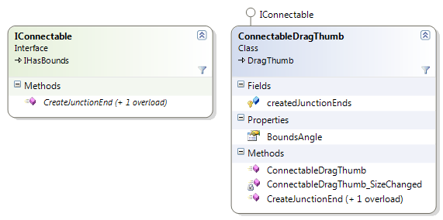
Figure 10

The key method of IConnectable is CreateJunctionEnd that creates new JunctionPoint and places it on the border of the control. Later, line can be attached to this point. References to created points are stored in createdJunctionEnds.
    - Templates of elements
As written earlier, most of the diagram elements derive from ConnectableDrugThumb. Usually each element has some template that contains its visual representation; the class itself contains only logic above the visual representation. The template is usually registered as a static resource and is loaded when the element is created (in the constructor).
This example shows how XCaseCommentaryTemplate is assigned to XCaseComment – class that represent comments on diagrams:
public XCaseComment(XCaseCanvas xCaseCanvas)
: base(xCaseCanvas)
{
#region Commentary Template Init
Template = (ControlTemplate)Application.Current.Resources["XCaseCommentaryTemplate"];
ApplyTemplate();
…
The template class can reference the elements in the template (using WPF Template.FindName call, that returns a control from a template by its name).
  - Lines
Two objects contained in View.dll assembly contain sufficient functionality for displaying all lines on diagrams. These objects are XCaseJunction and XCasePrimitiveJunction.
    - XCaseJunction
XCaseJunction is can draw a line between two objects. It can be a direct line or can be broken to a polyline. Elements connected by XCaseJunctions must implement IConnectable interface. Each point on a junction is a separate control (JunctionPoint) that can be dragged on the diagram. XCaseJunction is drawn as a polyline connecting the points.
On the example below, four junctions are used – first is the junction between Class1 and Class2, with two inner points created by BreakLine calls. Other three junctions connect classes 3-5 to association diamond.
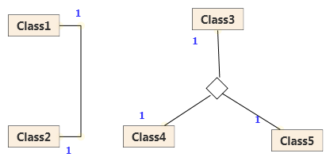
Figure 11 - Examples of XCaseJunction usaje

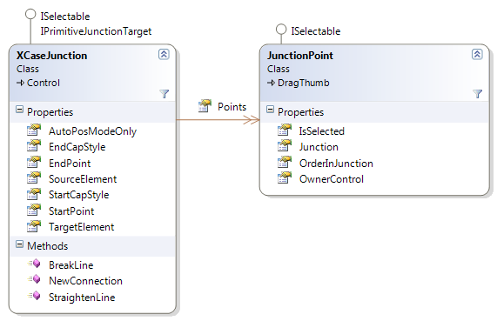
Figure 12
Points collection stores the JunctionPoints that the line consists of. More points can be added via BreakLine call and deleted via StraightenLine call. NewConnection call is an initializing method that connects two connectable elements.
Property AutoPosModeOnly is set to false by default, but when set to true, the junction will always have only two points – StartPoint and EndPoint and both will be positioned automatically. This setting is used on PSM Diagrams, where all positioning is done automatically.
Styles EndCapStyle and StartCapStyle control the figure that is drawn at the beginning and end of the line. Several styles are provided (diamonds, arrows, and triangles).
Property OwnerControl of JunctionPoint contains the reference to the control that created the point (see IConnectable.CreateJunctionEnd).
    - XCasePrimitiveJunction
XCasePrimitiveJunction is a much simpler control than XCaseJunction that is used to connect elements to other junctions (but can be used to connect an element to any object implementing IPrimitiveJunctionTarget). It is always drawn as a straight line, not polyline. It is used for example to connect comments and associations.
- Representing elements of diagrams
XCase uses Model-View-Controller design pattern. When diagram elements are created in the UML model, event mechanism notifies View about the changes. It is up to the View to reflect the changes in user interface and show the elements on the diagram.
  - XCaseCanvas
XCaseCanvas is the class that represents one diagram in user interface. When new diagram is opened, XCaseCanvas is empty. It listens to the events in Diagram class (ElementAdded and ElementRemoved). When an element is added XCaseCanvas creates its representation.
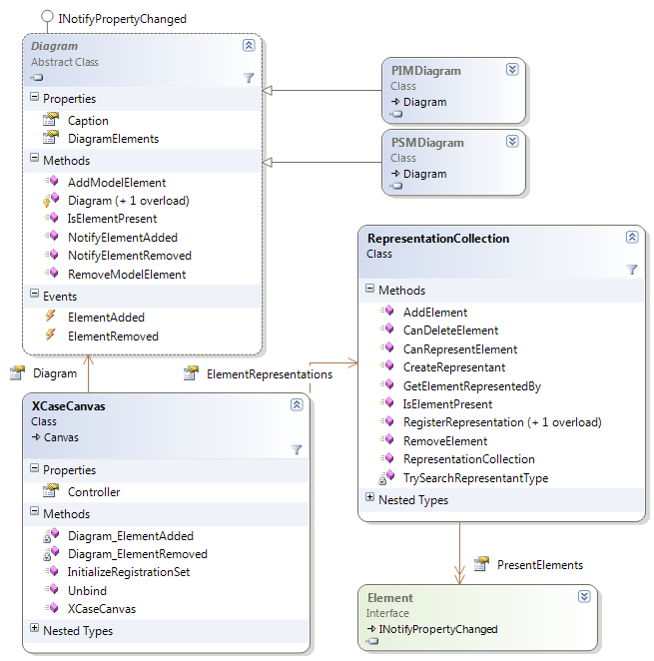
Figure 13
  - Representing elements
Part of XCaseCanvas’ initialization is initialization of the ElementRepresentations collection.
ElementRepresentations is a collection of entries of type RepresentantRegistration. For each element that is part of the Model and should be represented in View a RepresentantRegistration entry must be added into the collection. The entry consist of
- ModelElementType – type of the registered diagram element in Model (subclass of Element)
- RepresentantType – type that should represent the element in View (usually WPF control) implementing IModelElementRepresentant interface
- ControllerType – type of the controller for the element
- ViewHelperType – type of the view helper used for the element
This is an example of RepresentantRegistration entry for PIM_Association:
new RepresentantRegistration(
typeof(Model.PIMClass), // model element type
typeof(View.Controls.PIM_Class), // representant type
typeof(Controller.ClassController), // controller type
typeof(Model.ClassViewHelper),..) // view helper type
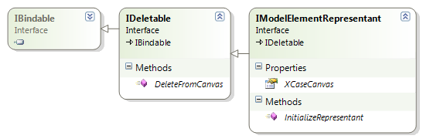
Figure 14
Visual representations of elements must implement IModelElementRepresentant interface. Since View uses WPF for drawing, visual representation of an element is usually composed of one or more WPF controls (for example: representation of an Association is made of points of the association, line that goes through the points and set of labels). The WPF controls that the representation composes of should be added to XCaseCanvas in the implementation of method InitializeRepresentant. The same controls that were added in InitializeRepresentant should be removed in DeleteFromCanvas method.
    - Sequence of actions performed when new element is added into a diagram
When new element is added into a diagram, ElementAdded event is invoked on Diagram class. This event fires the Diagram_ElementAdded event handler in XCaseCanvas. XCaseCanvas then uses its ElementRepresentations to instantiate the element. RepresentationCollection looks up the entry for the type of the element and if it founds one, it can create new representant element, controller and view helper. Then InitializeRepresentant method is called on the representant and created controller and view helper are passed as arguments.
If the XCase model were to be extended by new elements, the representant type must be created (if any of the existing ones cannot be used). Probably new controller will also be created and maybe a new view helper. Then these four types need to be added as a RepresentantRegistration entry into the ElementRepresentations collection.
Currently there are two sets of RepresentantRegistrations used in XCase – one for PSM Diagrams and one for PIM Diagrams; both are defined as static sets in MainWindow class and the entry for the new element would be probably added into one of these).
  - Binding Model properties to View
Very often it is desired to update some properties of model element’s representant when properties of represented element change (e.g. when Class’ Name property is changed via RenameElementCommand, PIM_Class’ ElementName property should be updated to contain the same value). Copying value of model element property into representant property can be easily achieved via set of metadata attributes XCase supports and thanks to property change notifications coming from the model elements (model elements implement INotifyPropertyChange, collections of elements implement INotifyCollectionChange).
Binding infrastructure expects that each model element representant will have two properties – one referring to represented model element and one to the element’s ViewHelper. Declarative attribute markup is used to declare these two properties
This section deserves an example – comment example was chosen because it is quite simple, but can demonstrate most of the binding features.
This is part of XCaseCommentary code declaring ViewHelper and model element references:
public class XCaseCommentary: IModelElementRepresentant
{
[ModelElement]
public Comment ModelComment { get… }

[ViewHelperElement]
public CommentViewHelper ViewHelper { get… }
}
ModelElement attribute is used in ModelComment property declaration – this property will be used by the binding infrastructure as a source of model binding. ViewHelperElement property is used to declare source of view binding in a similar way.
Another pair of attribute is used to declare binding between pair of properties itself:
[ModelPropertyMapping("Body")]
public string CommentText …
The declaration above says that each update of ModelComment.Body will update property CommentText.
ViewPropertyMapping attribute can be declared in the same way as ModelPropertyMapping attribute.
There is also an equivalent way to define the mappings – use the attributes on classes instead of properties, following declaration is equivalent to the declaration above:
[ModelPropertyMapping("Body", "CommentText")]
public class XCaseCommentary
{
…
public string CommentText …
}
This second way of declaring the mappings is useful when a property is declared in a base class but mapping is defined in derived class (thus there is no place to declare an attribute in the derived class without overriding the property). For example this is how X and Y properties of base class DragThumb (that is a base class to ConnectableDragThumb) are bound to ViewHelper properties; X and Y are not overridden in XCaseCommentary:
[ViewHelperPropertyMapping("X", "X")]
[ViewHelperPropertyMapping("Y", "Y")]
public class XCaseCommentary : ConnectableDragThumb,
IModelElementRepresentant
This was the declarative part. The process of binding on a certain object must be explicitly started at runtime by calling method StartBindings (extension method of IBindable interface – it doesn’t have to be implemented by model element representants, only XCase.UMLController interface must be imported).
CloseBindings method suspends binding for the object.
Good time to call StartBindings is at the end of InitializeRepresentant method (from IModelRepresentant interface), good time to call CloseBindings is at the end of DeleteFromCanvas method (from IDeletable).
Note: C# compiler requires this qualifier when calling StartBindings and CloseBindings. These methods must be called using this qualifier: this.StartBindings() resp. this.CloseBindings(). Both methods also provide overrides that start/closes only model bindings or only view bindings.
Internally, copying values from Model to View uses reflection to identify the properties with assigned mapping attributes. TypeBindingData class does this job.
- TreeLayout
The purpose of this static class is to ensure layouting in case of PSM diagrams. In contrast to PIM diagrams, these have strictly tree structure in which also order of children of an element is important. For this reason, user’s positioning is disabled and automatic layouting is performed.
  - Used Algorithm
    - Layouting of a Forest
When a PSM diagram contains several roots and so its elements form a forest instead of a single tree, these trees are layouted side by side from left to right, separated by a gap of fixed width.
    - Layouting of a Single Tree
The root of the tree gets the information of desired top and left coordinates of the entire tree. From height of the root and size of fixed gap between next levels of the tree, situation of the top of the root’s children is computed. Then layouting of the first child is called recursively, returning real width of the child’s subtree (if this subtree consists only of this node, width of this node is returned). This width is used to compute situation of the left of the second child (by adding size of fixed horizontal gap to the width), then this child can be layouted. Other children are layouted analogically. Now we know the width of the entire subtree and we can layout the root to the center.
  - TreeLayout Class
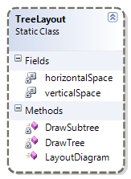

Figure 15 - TreeLayout class
- active – Indicates whether layouting is active now
- horizontalSpace – Size of fixed gap between neighboring nodes on the same level
- verticalSpace – Size of fixed gap between neighboring levels of a tree
- LayoutDiagram() – Performs complete layout of given diagram
- DrawTree() – Draws given element and all its children
- DrawSubtree() – Draws all children of given element
- SwitchOff() – Suppresses layouting
- SwitchOn() – Activates layouting
- Controllers
Controller as in MVC in our case consists of two parts. Controllers and Commands. Controllers also consist of two parts, ElementControllers and CommandControllers.
  - Element Controllers
Classes providing methods for changing the model (or ViewHelpers) using Commands, each PIM and PSM element has its own controller providing means to rename, add/remove attributes, operations etc. Used mainly by view elements, so they do not create Commands on their own.
    - Example
PSM_ClassController Controls PSMClass Model element is used by PSM_Class View element. Provides methods such as DeriveNewRootPSMClass, AddClassSpecialization, GroupBy, AddChildren, ManageAttributes etc., which are usually wrappers for Commands creation.
  - CommandControllers
    - Diagram Controller
There is one for each diagram, stores diagram-specific settings like Diagram (model class representing a Diagram), and provides diagram-specific methods like NewAssociation, NewGeneralization etc., which are usually also wrappers for commands creation and initialization.
    - Model Controller
One per project (we support only one project so far), stores the undo stack and the redo stack, provides model-specific methods like IsElementUsedInDiagrams, HasElementPSMDependencies, CreateSimpleType etc.
    - View Controller
Provides methods for moving and resizing view elements, which are usually also wrappers for commands like MoveElement, ResizeElement, BreakLine etc.
  - Commands
XCase’s commands are small objects that are typically created in response to some user action (typically toolbar click or menu selection) and somehow alter the UML model and diagrams built upon the model.
    - Commands overview
The key methods of each command are Execute and UnExecute. Execute performs some operations, UnExecute reverts the changes done by Execute. When creating a new command, one usually does not have to override Execute or UnExecute, because they are implemented as Template methods (design pattern) that rely on CommandOperation and UndoOperation.
CommandOperation should perform the task itself, Execute serves as a kind of wrapper of CommandOperation that integrates the task into the MVC infrastructure. Relation between UnExecute and UndoOperation is analogical. There is also a RedoOperation which you will need to override in case that CommandOperation cannot be used by Redo. Choose proper base class for the new command (typically it would be DiagramCommandBase, ModelCommandBase or MacroCommand) to achieve desired integration into the program. Turn to overriding of Execute and UnExecute only when solving some uncommon scenario.
Base class of all commands is abstract CommandBase that contains some basic fields and abstract methods CommandOperation, UndoOperation, RedoOperation and CanExecute and also a default implementation of Execute method (that calls CommandOperation) and UnExecute (that calls UndoOperation). Inheriting classes have to implement these methods:
- CommandOperation – this method should perform the actual effective function of the command (e.g. add an element to a diagram, add attribute to a class)
- UndoOperation – should revert all changes done by CommandOperation
- CanExecute – should return true if command can be executed – when it is properly initialized and all relevant objects are in a state that permits execution of the command
Beside CanExecute there is another method that can be used to validate commands – marking properties of the command with MandatoryArgument and CommandResult attributes.
  - Command stacks
To support undo and redo operations, XCase works with stacks of commands. When a command is executed, it is pushed to the undo stack. When user wants to undo the last command, the command is popped from the undo stack, its operation is reverted and the command is pushed to the redo stack. When user wants to redo last undone command, the command is popped from the redo stack and executed and pushed again to the undo stack. Thanks to command stacks, XCase support undo/redo with unlimited depth.
Pair of stacks (undo and redo stack) exists only in one instance. All commands are pushed to these stacks. Both DiagramController's and ModelController's getUndoStack and getRedoStack methods return these stacks.
There are two actual commands that follow the two previous scenarious – UndoCommand and RedoCommand. They are executed when user wants to undo or redo his action.
  - More complex commands
StackedCommandBase is the next class in commands hierarchy. Again, it is an abstract class, but its Execute and UnExecute method work with command stacks. When created, reference to stacks is passed in the constructor (undo/redo stacks are part of ModelController object which is the constructor’s parameter). When executed, command is pushed to command stack, when unexecuted, the command is pushed to the redo stack. Here the template methods Execute and UnExecute work with command stacks. StackedCommandBase implements IStackedCommand interface that can also be used to work with stacked commands.
DiagramCommandBase is again an abstract class – subclass of StackedCommandBase and parent of all commands that alter diagrams.
ModelCommandBase is another abstract subclass of StackedCommandBase and parent of all commands that alter the model.
When deciding whether to implement the new command as a diagram command or model command, look at the action the command does from the user point of view. Does the action alter only one diagram or the model under all the diagrams?
Diagram commands typically work with Diagram object and its DiagramElements collection (when adding an element to the diagram or removing an element from diagram). Another type of diagram command is ViewCommand. ViewCommands alter visualization of an element on the particular diagram (its position, size etc.) – this is done by changing a certain ViewHelper.
Model commands typically alter properties of some model element (Class, Association etc.).
MacroCommand is a special kind of command that is composed of other commands. Using MacroCommand, more complex action can be executed as a single command.
When deciding whether to join commands into one MacroCommand, look again from the user point of view. When user selects “undo”, should be the whole action reverted or should it be taken back step by step? The first scenario speaks for MacroCommand, the second for separate commands.

  - HOW-TO create a command
- Create a new class in the Controller.Commands folder or one of its subfolders (depends on what the command does)
- You may want to change the namespace to XCase.Controller.Commands if you do not want to include another namespace into the place where you use your new command
- Decide whether the command you are creating, involves only one diagram or the whole model and choose DiagramCommandBase or ModelCommandBase as the ancestor of your new command accordingly
- Decide the complexity of your command. If it is a command, which could utilize another commands, create new basic operations as separate commands and then group them into one MacroCommand<ModelController> or MacroCommand<DiagramController> along with the existing commands you would like to use using MacroCommand.Commands collection in a command preparation method of the newly created MacroCommand, like Set() or InitializeCommand() (it is up to you how you name this method, it is not standardized), which will be called by the user of your command (ElementController, PropertiesWindow, MainMenuCommand etc.) after command creation and before command execution.
- In the constructor of your command, set the Description property to a text description of what your command does. Store the description in the CommandDescription.resx file in the Commands folder.
- Create a Factory for your command. Look at another command of the same type (DiagramCommandBase or ModelCommandBase). The factories are all the same except names.
- If your command does not support Undo, you can set the undoable property to false in the constructor. This will cause that this command will not be placed on the UndoStack after execution.
- Override the CanExecute, CommandOperation and UndoOperation methods of the CommandBase.
- If you are returning false in CanExecute or OperationResult.Failed in UndoOperation, do not forget to fill the ErrorDescription property with an item from the CommandError.resx file.
- You may need to override RedoOperation also, if your command cannot use CommandOperation as RedoOperation. (When you are creating a new object, you don't want to create another one when Redoing, you want to return the already created one from CommandOperation)
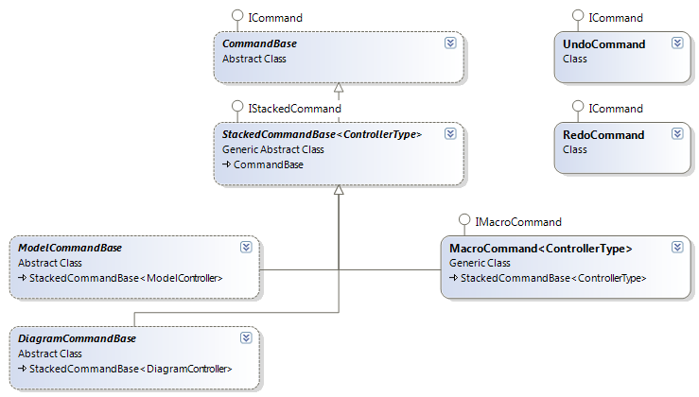
Figure 16
  - Command factories
Command factories are used as the only way of creating instances of standard Commands in Controller.
HOW-TO create a factory is included in HOW-TO create a command in Commands.

- Setup
XCase Setup is realized as a standard Visual Studio 2008 Setup Project. It automatically detects dependencies; there are no manually added dialogs.
Prerequisites set:
- Windows Installer 3.1
- .NET Framework 3.5 SP1
There is a manually added icon, which is used as a desktop icon and a Start Menu icon. For some reason, the setup project doesn't allow to use the icon set to the XCase.exe file.
The Setup is set to create a Desktop Icon and the Start Menu Icons.
Also, the default banner is overridden with our own:


When run, the setup detects presence of the prerequisites and downloads them from the Microsoft's website as needed.

- GUI - DockingLibrary
DockingLibrary is an external library [3] for managing dockable windows used in the XCase editor (Navigator, Project, Properties) and also for managing multiple diagrams at once in a TabControl. Its goal is to acquire a way of working with dockable panels very similar to Visual Studio.
The fundamental classes of this library are DockManager, Pane and ManagedContent.
  - DockManager
DockManager is responsible for managing the main window layout. It is a user control which can be easily embedded into a window using just several lines of code.
    - Pane
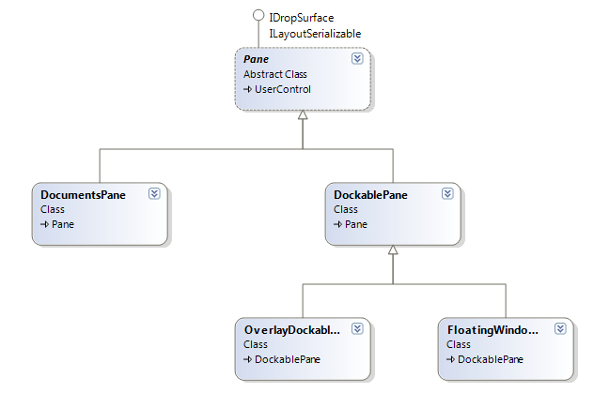
Figure 17 - Pane

Pane represents the window area which a) can be docked to a border (DockablePane), b) contains documents in the main part of the window (Documents Pane).

    - ManagedContent
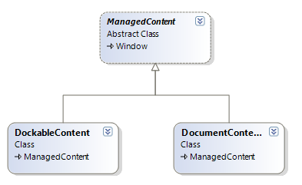
Figure 18 - ManagedContent

The content of Panes is compound of ManagedContent. DockableContent is contained in DockablePane and all dockable windows have to inherit from this class (in our case, these windows are NavigatorWindow, ProjectsWindow and PropertiesWindow). Analogically, DocumentContent is contained in DocumentsPane and all document windows have to inherit from it (PanelWindow in our case).
  - Changes to Original Library
We made several changes to this library. The majority of them are just subtle cosmetic changes, two changes which are of major importance are
- DocumentsPane.ActivateTab(TabItem item) method – allows a user to easily activate chosen tab
- DockManager.ActiveTabChanged event – invoked when an active tab in DocumentsPane is changed

- GUI – Windows
  - Main window
Main window ensures proper displaying of dockable windows (Navigator, Project, Properties) and all diagram tabs as well as interaction among them.
    - Docking & Managing Diagrams
The management of dockable windows is achieved by using DockingLibrary – Main window incorporates DockManager and after loading registers Navigator, Project and Properties as dockable windows of DockManager. Main window also handles opening/closing/changing of diagrams and notifications to other windows about it.
When DockManager invokes event ActiveTabChanged, Main window reacts to it by finding a diagram associated with now active tab and invokes event ActiveDiagramChanged. This event is handled by method OnActiveDiagramChanged(…). Handling of this event is required for proper synchronization amongst active diagram, Navigator, Properties and also the main toolbar.
    - Main toolbar
Main toolbar consists of several groups of buttons for controlling project, displayed dockable windows and, above all, editing diagrams. The selection of displayed groups depends on the type of active diagram, the possibility of clicking on particular buttons depends on the state of particular active diagram (e.g. logically, Undo is disabled on newly created diagram). That is the reason why main toolbar visualization has to be adjusted after each occurrence of ActiveDiagramChanged event.
  - Navigator window
Navigator window enables structuring of model classes into packages and their easy control. Using Navigator is also the only way to administer classes which are not present in any diagram at the moment.
    - Model Administration
When a project is loaded, Navigator is bound to it using the method BindToProject(…). This ensures that model’s collection Classes is used as items source of TreeViewItem modelClasses and collection NestedPackages is used as items source of TreeViewItem nestedPackages. Proper displaying of all classes, attributes, packages (and their recursively nested packages) is handled by DataTemplates packageTemplate and classTemplate.
Editing/adding/removing of these elements is possible via context menus of particular elements. These context menus are also defined in DataTemplates mentioned above.
    - Interaction with Other Windows
When a class is selected in Navigator, Navigator invokes event NavigatorSelectedClass (which includes class reference). Main window reacts to this event by selecting referred class on canvas, if the class is visualized in active diagram, and displaying this class in Properties.
On the other side, Navigator reacts to selecting a class on canvas (event XCaseCanvas.SelectedItems.CollectionChanged). As a reaction to the event, class selected on canvas is also selected in Navigator.
  - Project window
Project window enables projects’ diagrams visualization and administration.
    - Overview
When a project is loaded, Project window is bound to it using the method BindToProject(…). DataTemplate projectTemplate then ensures visualization of the project and memberTemplate handles visualization of particular diagrams. These templates also contain definitions of context menus of project and diagrams and assign event handler for handling double click on a diagram. Renaming of project and adding/renaming/removing diagrams is then administered through these context menus.
    - Interaction with Other Windows
Project window invokes DiagramDClick event after double click on a diagram. In reaction to this event, Main window opens a tab with selected diagram (if not open so far) and gives it focus.
Event DiagramRemove is invoked after removing a diagram through context menu. Main window reacts to it to ensure closing a tab containing this diagram visualization.
Event DiagramRename is invoked after renaming a diagram through context menu. Invoking this event enables Main window to change the header of appropriate tab accordingly to the new diagram caption.
  - Properties window
Properties window displays properties of a PIM or PSM element selected on the canvas or a PIM class selected in the Navigator window. If no or more elements are selected, Properties window does not display anything.

There are several independent XCaseGridBase components in the Properties window, each for one type of visual element. Only one is visible at time.

public abstract class XCaseGridBase : UserControl
{
abstract public void UpdateContent();
//…
}
In the following table there is a list of all elements that can be displayed in the Properties window together with the grid used for their displaying. All the listed grids can be found in Gui\Windows\Properties

PIM Element | XCaseGridBase grid used
PIM Class | PIMClassGrid
Association class | AssociationClassGrid
PIM Association | AssociationGrid
Comments | CommentGrid
PSM Element | XCaseGridBase grid used
PSM Class | PSMClassGrid
PSM Association | PSMAssociationGrid
PSM Attribute Container | AttributeContainerGrid
Content container | ContentContainerGrid
Comment | CommentGrid

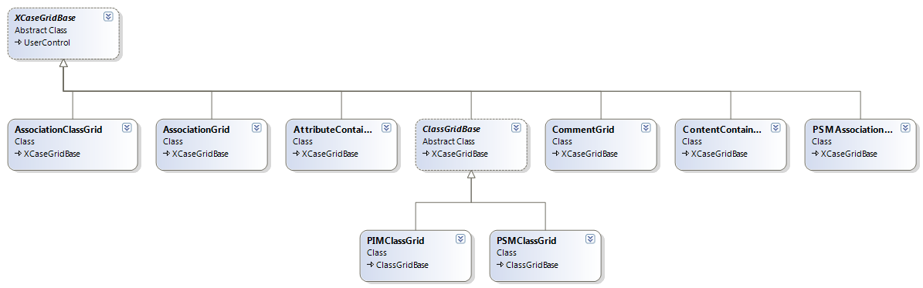
Figure 19

When a selected element on the canvas is changed (user selects something else), SelectionChanged is invoked. According to what has been selected, one of these methods is called and the appropriate specialized grid becomes visible.

private void DisplaySelectedPIMClass(XCaseViewBase c)
private void DisplaySelectedPSMClass(XCaseViewBase c)
private void DisplaySelectedComment(XCaseComment c)
private void DisplaySelectedAssociation(XCaseAssociation a)
private void DisplaySelectedAssociationClass(XCaseAssociationClass c)
private void DisplaySelectedPSMContentContainer(PSM_ContentContainer c)
private void DisplaySelectedPSMAssociation(PSM_Association p)
private void DisplayAttributeContainer(PSM_AttributeContainer c)

When user selects a PIM class in the Navigator window DisplayModelClass(Class c) method is called. In this case, just model properties of the class are displayed in the Properties window, not appearance properties.

When selection is being changed, the content of the previously displayed XCaseGridBase component is updated (UpdateContent) to ensure that all unsaved changes are saved. Then, new XCaseGridBase component is displayed in the Properties window (Display is called on the appropriate specialized grid).

- Storing and loading of XCase projects
  - Serializator
XMLSerializator class provides an interface for serialization of the entire XCase project to a single XML file. We call this file with serialized XCase project ‘XCase XML file’ and use our own suffix *.XCase for it. Class XmlVoc is used as a vocabulary of XML element and attribute names while serializing the XCase project.

Public interface:

public class XmlSerializator
{
// project = XCase project to serialize
public XmlSerializator(Project project);

// filename = Name of output XCase XML file with serialized project
// Returns true if serialization was successful, false otherwise
public bool SerilizeTo(string filename);
}

XCase XML file hence contains full information about one XCase project and such project can be later completely restored from its XCase XML file by using XMLDeserializator class.

XCase XML file
The structure of XCase XML files is precisely described by XCaseSchema.xsd (Description provided in W3C XML Schema language). The overall structure of XCase XML file looks as the following:

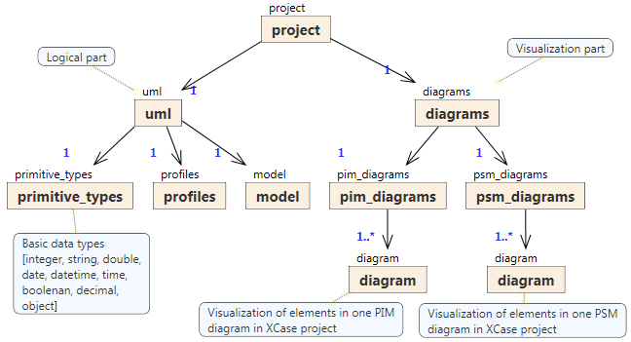
Figure 20

    - Serialization order

First, UML (metamodel+model) is serialized and then all the diagrams. This approach ensures that the logical part of the project (UML metamodel + model) and the visualization (diagrams) are completely separated in the XCase XML file.

Serialization order of the most important UML and diagrams parts is the following:

UML part
1] Data types (basic embedded data types: integer, string, date …)
2] Profiles
3] Model
3.1] PIM classes
  - Their derived PSM classes
    - Their nested components (can be recursive):
      - PSM Association
      - PSM Attribute Container
      - PSM Content Choice
      - PSM Content Container
      - PSM Class Union
3.2] PIM association classes
  - Their derived PSM classes
    - Their nested components (can be recursive) – the same as listed above

3.3] PIM associations (all types: simple associations, aggregations, compositions)
3.4] PIM generalizations

Diagrams part
1] PIM diagrams with their visual elements:
- Class (PIM class)
- Association class
- Association
- Comment
- Generalization

2] PSM diagrams with their visual elements
- Class (PSM class)
- PSM association
- Comment
- PSM attribute container
- PSM content container
- PSM content choice
- PSM class union

ID Table
During serialization, each serialized element gets its unique ID. This is then serialized as ID XML attribute and determines the serialized element. All elements with assigned ID attribute are being stored in HashTable idTable during serialization.

HashTable idTable; //[Key = Element; Value = ID]

References are then handled via ID/REF mechanism.

In the XCase XML file, elements referring to other elements use attribute with keyword containing ref. If there is an element with @ref = n somewhere in XCase XML file, it refers to an element with @id = n
    - Example
In the UML part there is a PSM class with @id = 43.
<xc:psm_class id="43" name="Class1">
…
</xc:psm_class>
In diagrams part there is the visualization for this class, which is expressed by @ref = 43.
<xc:class ref="43" methods_collapsed="False" properties_collapsed="False" element_label_collapsed="False" element_label_aligned_right="False"> <xc:appearance> … </xc:appearance>
…
</xc:class>

  - XML Deserializator
XMLDeserializator class provides an interface for restoration of then entire XCase project (UML model + visualization) from XCase XML file. Class XmlVoc is used as a vocabulary of XML element and attribute names while restoring the XCase project.

Public interface:

public class XmlDeserializator
{
public XmlDeserializator();

public static bool ValidateXML(System.IO.Stream input, ref String message);
public static bool ValidateXML(string file, ref String message);

// file = Valid XCase XML file
// window = window where to restore the visualization diagrams
public void RestoreProject(string file, MainWindow window);

// input = Valid streamed XCase XML
// window = window where to restore the visualization diagrams
public void RestoreProject(System.IO.Stream input, MainWindow window);
}

Validation
Before starting the restoration itself it is recommended to check the validity of the input XCase XML file by calling ValidateXML method.
It returns true if the passed XML is a valid XCase XML file. False is returned otherwise.

ID Table
While reading XCase XML file, all restored elements are added to idTable along with their IDs. This ensures correct restoration of references between elements. References between elements are provides via @id/@ref attributes in the XCase XML file.

HashTable idTable; // [Key = ID; Value = Element]
    - Restoration Order
First, primitive types and profiles are restored. Then there are two phases: PIM and PSM. In PIM phase, all PIM diagrams with all their PIM elements are restored;, in PSM phase, all PSM diagrams with all their PSM elements. A PIM or a PSM element is always restored together with its visualization.

1] Primitive Types
2] Profiles
3] PIM elements
3.1] Comments in PIM diagrams
3.2] Datatypes
3.3] Packages (recursive) – PIM elements
3.4] PIM classes
3.5] Association classes
3.5] PIM Associations
3.6] PIM Generalizations
4] PSM elements
4.1] Derived PSM classes and their components (recursive)
4.2] PSM Generalizations
4.3] PSM Associations
  - XmlVocabulary
Class XmlVoc serves as a collection of static strings used as XML element and attribute names in XCase XML file. These static strings are used during serialization as well as during deserialization instead of writing the XML element names right into the source code.

Class XmlVoc offers all element and attribute names defined in XCaseSchema.xsd as well as some XPath queries constructed from these names.
- Translation of PSM diagrams into XML schemas
XCase PSM diagram describe a given type of XML documents on the conceptual level. For practical reasons, we need to translate it to an XML schema that describes the type on the logical level. For this, we can apply an XML schema language like XML Schema [4] or RELAX NG [5].
  - Description of PSM diagram
PSM diagram contains mainly PSMClasses connected by PSMAssociations – these are main semantic elements and are representations of Classes and Associations in PIM diagrams. In addition it contains other elements that describe structure of the XML document and are not referencing any PIM elements. Those are PSMClassUnion, PSMAttributeContainer, PSMContentContainer and PSMContentChoice.
PSMContentContainer, PSMContentChoice and PSMClass all implement interface PSMSuperordinateComponent which means that they can have other classes implementing PSMSubordinateComponent interface among their components (PSMSubordinateComponent.Components collection). PSMClassUnions can have only PSMClasses among their components (PSMClassUnion.Components collection). PSMAssociation always starts in a PSMSuperordinateComponent and leads to PSMAssociationChild, which is either PSMClass or PSMClassUnion (see Figure 2).
PSMDiagram is basically a forest of trees composed of these elements where following elements act as nodes:
- PSMClass,
- PSMContentChoice,
- PSMAttributeContainer,
- PSMContentContainer
- PSMClassUnion
and following as edges:
- PSMAssociation
- lines connecting PSMSuperordinateComponent to its components
- lines connecting PSMClassUnion to its components
- (specializations also act as edges, they will be described later).

Roots of the forest are always PSMClasses and they are stored in the Roots collection of PSMDiagram (see Figure1).
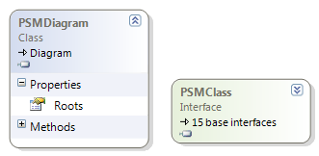
Figure 21 - PSMDiagram and its roots

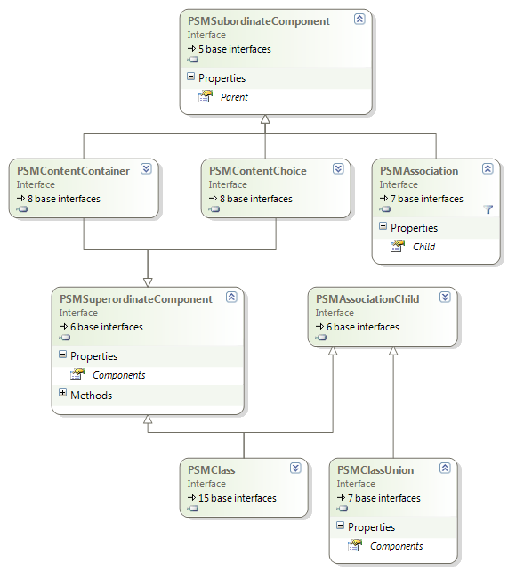
Figure 22 - Basic elements in PSM diagram
  - Translation infrastructure
Abstract class DiagramTranslator is meant to be parent class of all the classes that translate PSM diagram to a XML schema. One derived class – XmlSchemaTranslator is currently provided in XCase. XmlSchemaTranslator translates PSM Diagram to a XML schema in XML Schema language [4]. The translation is based on the algorithm described in [6].

There may be constructions that are valid in PSM diagrams (that describe a set of XML documents), but they cannot be expressed by the concrete translator (see Part 4 for a list of these constructions related to translation to XML Schema language). Errors and warnings caused by the constructions in PSM diagrams that cannot be expressed by the concrete translator should be kept in the TranslationLog class.
DiagramTranslator has a set of Translate{..} methods that all have empty default implementation (except for TranslateSubordinateComponent that continues the translation by calling more specific Translate{..} method and TranslateSpecializations that continues by calling TranslateSpecialization for each specialization. Other methods have empty bodies and it is up to the derived classes to override the body if needed. Also the order in which the methods are called is up to the derived classes. Each derived class must override abstract Translate method, which returns the result of the translation.

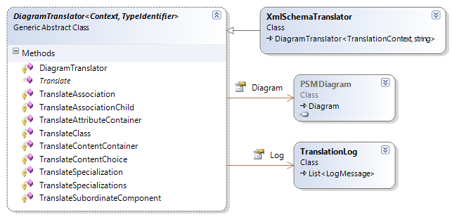
Figure 23 - Translators

  - Part 3 Translation to XML Schema language
XmlSchemaTranslator is a subclass of DiagramTranslator that translates PSM Diagram into a XML schema in XML Schema language. XmlSchemaTranslator and classes supporting the translation to XML Schema reside in namespace XCase.Translation.XmlSchema.
XmlSchemaWriter is a wrapper of standard .NET class XmlWriter that makes writing declarations of XML Schema language more convenient. XmlSchemaWriters are created by WriterFactory class. SimpleTypesWriter is a XmlSchemaWriter that can write definitions of simple types (definitions already written are kept in DeclaredTypes property).

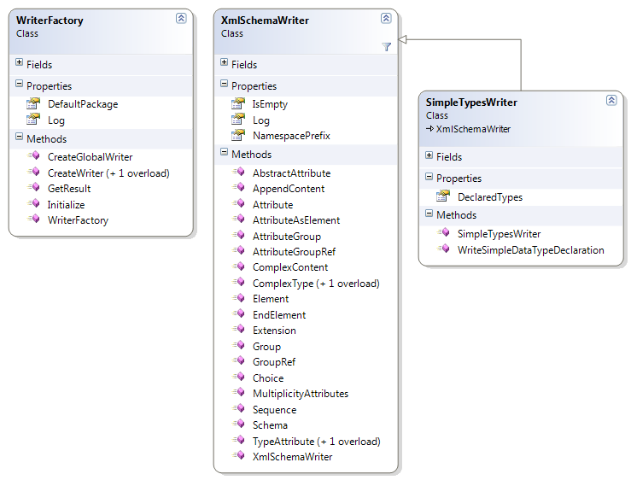
Figure 24 - Translation writers

Each time a new global declaration (complex type, group, attribute group) is needed, WriterFactory.CreateGlobalWriter is called and returned writer can be used to write the declaration. Contents of all writers created by these calls are concatenated when WriterFactory.GetResult is called (this method returns result of the whole translation). For temporary writers, CreateWriter method can be called (writers returned by this call are not considered in GetResult).

    - Basic translation principles
The algorithm [6] works as follows:
Classes with defined element labels are translated to global xs:complexType definitions. Classes from roots also add global xs:element definition. Classes without element labels are translated into model groups and attribute groups. Associations are translated into element declarations referencing complex types if child of the association is translated into a complex type. If it is translated into groups, references to the groups are propagated to the complex type above. (Note: xml document declaration and xml schema starting declaration will be omitted in the examples).
The algorithm creates a new global declaration or each root class and continues with translation of the contents of the root class and then proceeds recursively. All XmlSchemaTranslator.Translate{..} methods have a parameter of type TranslationContext. This is a class that contains references to three XmlSchemaWriters:
- TreeDeclarations – this is the “current writer” where the element is being translated
- ComposedAttributes – this writer is used when references to attribute groups are propagated to a complex type above (see section Translation of a class section (2))
- ComposedContent – this writer is used when references to groups are propagated to a complex type above (see section Translation of a class section (2))
Assume class U with Attributes A₁, .., A_{m} and components C₁, ... C_{n}. Type of each Ai is usually a SimpleDataType (translated to built in XML Schema data type or to a restriction of another SimpleDataType), but other data types can be used in Class (see Part 3.5 – Translation of simple types). Each C_{i} is an association, attribute container, content container, or content choice. In PSM Diagram Class U models a sequence of XML elements and set of XML attributes. The XML elements are modeled by the content of U and XML attributes by the attributes of U. The components of U are translated to a xs:sequence declaration
<xs:sequence>
XSC₁ ... XSC_{n}
</xs:sequence>
where XSC_{i} denotes the translation of C_{i} (the translation is described later in this section). The xs:sequence is denoted XS^{E}_{U} .
The attributes of U are translated to a sequence
XSA₁ ...XSA_{m}
where XSA_{i} denotes the translation of A_{i} (the translation is described later in this section). The sequence is denoted XS^{A}_{U} .
U gets assigned an automatically generated unique name for the purposes of the translation. Names are generated by the class NamingSupport (this class ensures that created complex types gets assigned distinct names even when names of the PSM Classes behind them are identical, which is valid in PSM Diagrams). The assigned name is composed of the name of the type T represented by U and sequence number for the nodes representing T in the PSM Diagram. Name generated by NamingSupport for the class U will be denoted TN_{U} in this text.
If there is an association leading from U to V and V does not have an element label, the XML attributes modeled by V are propagated to U. Therefore, XS^{A}_{U} must be extended with declarations of such XML attributes. The only exceptions are the child nodes of U contained in a content container. In that case the XML attributes are propagated to the XML element modeled by the content container (because content containers are also translated into xs:complexType declaration).
As we show in a moment, the declarations of the XML attributes modeled by classes without element labels are included in the resulting XML schema in a form of attribute groups (i.e. xs:attributeGroup construct) named TN_{V}-a. Therefore, for each child V of U without an element label and not contained in a content container, XS^{A}_{U} is extended with
<xs:attributeGroup ref="TN_{V}-a" />
    - Translation of attributes and content
In the following list we describe how U is translated to an XML schema representation. (1) describes the translation in case U has an element label. (2) describes the translation in case U does not have an element label. (3) covers specifics of abstract classes.

Class with an element label
If U has an element label lU, the sequence of XML elements and set of XML attributes modeled by U is enclosed in an XML element named lU. To describe the content of the XML element lU we use a complex type (i.e. xs:complexType construct) composed of XS^{E}_{U} and XS^{A}_{U} . Therefore, XS^{E}_{U} and XS^{A}_{U} are included in the resulting XML schema in a form of a global complex type definition
<xs:complexType name="TN_{U}">
XS^{E}_{U}
XS^{A}_{U}
</xs:complexType>
Moreover, if U is a member of the Roots collection of the PSM Diagram then it models root XML elements named lU with the content described by the complex type TN_{U}. In that case a global element declaration
<xs:element name="lU" type="TN_{U}" />
is added to the resulting XML schema. If U is not among roots, it is an inner node in the tree. In that case either a) there exists an association going to the class U and then the declaration for lU XML elements is created in the scope of the translation of the edge going to U as we show later or b) U is among components of class union and then the element declaration will be created in the scope of the class union.
Method XmlSchemaTranslator.TranslateClassWithLabel writes the complex type declaration described above.

Class without an element label
If U does not have an element label, the sequence of XML elements and set of XML attributes modeled by U is not enclosed in an XML element. The attributes of U model a set of XML attributes that is a subset of XML attributes modeled by the parent of U (if there is any). Similarly, the content of U models a sequence of XML elements that is a part of the sequence of XML elements modeled by the parent of U. Therefore, we cannot include XS^{E}_{U} and XS^{A}_{U} in the XML schema in the form of a complex type definition, as in the previous case, because xs:complexType construction can describe only the whole content of XML elements but not a part. Instead, we use model groups (i.e. xs:group construction) and attribute groups (i.e. xs:attributeGroup construction) to include XS^{E}_{U} and XS^{A}_{U} in the XML schema representation as follows
<xs:group name="TN_{U}-c ">
XS^{E}_{U}
</xs:group>
<xs:attributeGroup name="TN_{U}-a">
XS^{A}_{U}
</xs:attributeGroup>
with the name composed of TN_{U} followed by the string "-c" or "-a", respectively. Instead of xs:element declarations, that are created in the case (1), reference to group TN_{U}-c and attribute group TN_{U}-a is propagated to the first ancestor in PSM Diagram tree that is translated to a complex type (this can be either class with an element label or content container).
Note: there is a departure from the rule that says that class with an element label is translated without using groups. It refers to a situation concerning structural representatives and is described in the section devoted to structural representatives [see Part 11.3.3].
Note: translation of xs:attributeGroup is different when the class being translated is under a content choice or class union and the reference to the created group should be propagated to a complex type above the choice resp. class union. This rule is described in section (7) devoted to class unions.
Method XmlSchemaTranslator.TranslateClassContentToGroups writes the group declarations described above.

Abstract classes
Class can be marked abstract in a PSM Diagram (by setting the property IsAbstract to true). This is taken into account in translation. Abstract classes are covered in more detail in Part 3.4 describing translations of specialization. In short – if the class is translated into a xs:complexType declaration, attribute abstract=”true” is used for the complex type. xs:element declarations are not created for abstract class (with some exceptions described in Part 3.4). When the class is translated into groups, references to the groups are not propagated into containing complex type (again with the same exceptions).
Translation of a class is executed in method XmlSchemaTranslator.TranslateClass, which calls either XmlSchemaTranslator.TranslateClassWithLabel when the class has an element label or method XmlSchemaTranslator.TranslateClassContentToGroups when the class has not an element label.
Translation of class attributes and contents
In the following list, we describe how the attributes and content of U are translated. The content of U is composed of associations going to classes or class unions, content choices, attribute containers and content containers. The following list describes the translation of all these constructs. (4) is related to the attributes of U. The other items are related to the content of U.

Attribute of a class
A simple attribute A with alias NA and type domA of U is translated to an attribute declaration
<xs:attribute name="NA" type="domA" />
Attributes can have their multiplicity properties Lower and Upper defined. But declaring multiplicity of attributes in XML documents is restricted to use=”optional” and use=”required” definitions. Thus, if Lower is set to 0 and Upper to 1 A is translated as follows:
<xs:attribute name="NA" type="domA" use="optional" />
If both Lower and Upper are set to 1 A is translated into:
<xs:attribute name="NA" type="domA" use="required" />
When either Lower or Upper values are greater than 1 a warning is put into translation log (because the same attributes cannot occur more than once in an element declaration in XML documents).
When both Lower and Upper are set to 0, the attribute is not translated.
Attributes can also have their Default property specified. If Default property of A is set to “value” then A is translated as follows:
<xs:attribute name="NA" type="domA" default="value" />
It is up to the user to set correct default values to generate a valid schema, XCase does not check the default value (it can be set to an arbitrary string) and it is always translated as is.
When both Default value and multiplicity are specified and multiplicity is set to "required", the use attribute is omitted and A is translated into:
<xs:attribute name="NA" type="domA" default="value" />
because use="required" and default="value" would not make sense (and is forbidden in XML Schema).
Note: there is a departure from the rules for multiplicity and that is when the attribute is under content choice or class union but should be propagated to a class or content container above the content choice resp. class union. This exception is described in Part 4.2 – Attributes under choice constructions.
XmlSchemaTranslator.TranslateAttributesIncludingRepresentative method translates attributes of a class as described above. It also appends attribute group references for attributes propagated from classes beneath the translated class.

Attribute container
An attribute container that is composed of attributes A₁ ... A_{k} among the components of U is translated to a sequence
XSA1 ...XSAk
where XSA_{i} is the following element declaration translated from the simple attribute A_{i} with alias NA_{i} and type domA_{i}:
<xs:element name="NA_{i}" type=" domA_{i} " />
Rules for translation of Default property are similar as for attributes in classes. If Ai has multiplicity properties Lower set to L_{i} and Upper to U_{i}, they are translated using minOccurs and maxOccurs declarations:

<xs:element name="NA_{i}" type="domA_{i}"
minOccurs="L_{i}" maxOccurs="U_{i}"/>
When Upper is set to value UnlimitedNatural.Infinity, it is translated into maxOccurs="unbounded" declaration.
XmlSchemaWriter.TranslateAttributeContainer writes element declarations of all the attributes in the attribute container.

Association going to a class
Let E be an association going from U to class V where m and n are values assigned to cardinality properties Lower and Upper of the association. U can be another class, content choice, content container or class union.
- If V has an element label lV , E is translated to an element declaration
<xs:element name="lV " type="TN_{V}"
minOccurs="m" maxOccurs="n" />
TN_{V} is the name of the global complex type to which class V is translated.
- If V does not have not an element label, E is translated to a model group reference
<xs:group ref="TN_{V} -c"
minOccurs="m" maxOccurs="n" />
the model group reference is propagated to a nearest complex type above V using TranslationContext.ComposedContent writer. The group declaration is written when class V is translated.
XmlSchemaWriter.TranslateAssociationChild(V) calls TranslateClass(V) and after V is translated, it writes the element declaration when V has an element label. When V does not have an element label, the group reference is written during the translation of components of V using TranslationContext.ComposedContent writer.

Association going to a class union
Let E be an association going from U to a class union with components V₁, ..., V_{n}. It is translated to a xs:choice content model
<xs:choice minOccurs="m" maxOccurs="n">
XS^{E}_{V1} ... XS^{E}_{Vn}
</xs:choice>
where m and n are values assigned to cardinality properties Lower and Upper of the association E and XS^{E}_{Vi} is an element declaration
<xs:element name="lV_{i}" type="TN_{Vi}" />
if V_{i} has an element label lV_{i} , or a model group reference
<xs:group ref="TN_{Vi}-c" />
if V_{i} does not have an element label.
XmlSchemaTranslator.TranslateAssociationChild writes translation of a class union and calls TranslateAssociationChild for each of the components V₁, ..., V_{n}.
Both class union and content choice enter “choice context”. Specifics of the translation when in choice context are described in Part 4.2 – Attributes under choice constructions.

Content container
Let C be a content container with a name lC among components of U. It is translated to an element declaration
<xs:element name="lC">
<xs:complexType>
XS^{E}_{C}
XS^{A}_{C}
</xs:complexType>
</xs:element>
XS^{E}_{C} is the translation of the content of C. The translation of the content of C is performed in the same way as a content of a class, i.e. it is a xs:sequence containing translations of the components from the content of C as described by (5) - (9). XS^{A}_{C} is a set of references to attribute groups translated from the child nodes of U that are contained in C and do not have an element label.
XmlSchemaWriter.TranslateContentContainer writes translation of the content container. This method creates new TranslationContext which is passed to the translation of the Components. Using this new context, all propagated attribute group references and group references are included in the translation of the content container.

Content choice
A content choice with components C₁... C_{n} is translated to a xs:choice content model
<xs:choice>
XS_{C1} ... XS_{Cn}
</xs:choice>
where XS_{Ci} is the translation of C_{i} as described by (5)-(9).
XmlSchemaTranslator.TranslateContentChoice writes translation of the content choice. If there are any classes without element labels among the components of the content choice or beneath them (but not beneath en element that is translated to a complex type), references to groups and attribute groups are written in the TranslationContext.ComposedContent and TranslationContext.ComposedAttributes writers (so the references are passed to the first element translated to a complex type above the content container).
Both class union and content choice enter “choice context”. Specifics of the translation when in choice context are described in Part 11.4.2 – Attributes under choice constructions.
    - Translation of structural representatives
PSM Diagrams allow structural representative construct. Let there be PSMClass U and its PSMClass.RepresentedPSMClass property is assigned a reference to another class V. Now U has all the attributes and content of V and also can have some content of its own. The whole structural representative concept is meant to allow several PSM Classes representing one PIM Class without repeating the whole definitions of their contents types. This concept is also very beneficial when defining recursive structures in XML documents.
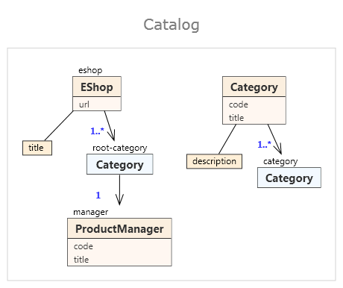
Figure 25 - Structural representatives used to defined recursive structure

Concept of structural representatives could be translated via several methods. XmlSchemaTranslator uses attribute groups and model groups which is more flexible than for example using xs:extension context (with attribute groups and model groups it is possible to propagate content and attributes to a complex type above, like it was described in Part 3.2). Let U be a structural representative of V. If V does not have an element label, it is translated according to Part 11.3.2 (2) to a model and attribute group. If it is does have an element label, it should be translated into a complex type according to section 11.3.2 (1). Because for the translation of a structural representative we need the represented class to be translated into model and attribute group, the pattern for translating V must be modified a little bit – so if V is a class with an element label and it is being referenced from a structural representative, it is not translated into this definition:
<xs:complexType name="TN_{V}">
XS^{E}_{V}
XS^{A}_{V}
</xs:complexType>
But rather to
<xs:complexType name="TN_{V}">
<xs:sequence>
<xs:group ref="TN_{V}-c" />
</xs:sequence>
<xs:attributeGroup ref="TN_{V}-a" />
</xs:complexType>
<xs:group name="TN_{V}-c">
XS^{E}_{V}
</xs:group>
<xs:attributeGroup name="TN_{V}-a">
XS^{A}_{V}
</xs:attributeGroup>

where XS^{E}_{V} and XS^{A}_{V} denote the translations of the content and attributes of V_{i}, respectively. With the algorithm altered like that it is ensured that V is translated into a model group and attribute group no matter whether V has an element label or not.
The altered translation of a PSMClass without label to groups is performed by XmlSchemaTranslator.TranslateClassWithLabelAsGroups method.
U itself is translated as follows. The content C₁, .., C_{n} of U extends the content of V. It is therefore translated to a xs:sequence content model
<xs:sequence>
<xs:group ref="TN_{V}-c">
XS_{C1} ... XS_{Cn}
</xs:sequence>
where XS_{Ci} denotes the translation of C_{i}. The xs:sequence is denoted XS^{E}_{U} . The attributes A₁, ..., A_{m} of U extend the propagated attributes of V₁, ..., V_{k} and are translated to the sequence
<xs:attributeGroup ref="TN_{V}-a">
XS_{A1} ... XS_{Am}
where XS_{Ai} denotes the translation of A_{i}. The sequence is denoted XS^{A}_{U} . For each child V of U without an element label and not contained in a content container, XS^{A}_{U} is extended with the reference to the attribute group translated from V (if there is any).
The rest of the translation of U is the same as in the case of classes that are not structural representatives. This is described in Part 11.3.2 (1) and (2). It means that if U has an element label then XS^{A}_{U} and XS^{E}_{U} are included in the resulting XML Schema as a global complex type definition. Otherwise they are included as a model and attribute group.
Methods XmlSchemaTranslator.TranslateComponentsIncludingRepresentative resp. XmlSchemaTranslator.TranslateAttributesIncludingRepresentative are both “structural representative aware” and thus if class being translated is a structural representative then if the represented class was not already translated, it is translated immediately, and then the contents resp. attributes of the translated class are translated into the sequences described above.
    - Translations of generalizations
PIM Diagrams allow defining generalizations and PSM Diagrams allow bringing these generalizations into the PSM level. XML Schema language has adequate constructions to allow translations of these relationships into XML Schema. There are two approaches used that follow the principles described in Part 11.3.2 (1) and (2).
Let U be a node specialized by nodes V₁, ..., V_{n}. V₁, ..., V_{n} are translated as follows.

U has an element label lU.
U is translated to a complex type definition TN_{U} as described in Part 11.3.2 (1). Moreover, if U is abstract, the complex type definition has set the parameter abstract to true. Each V_{i} is translated to a complex type definition
<xs:complexType name="TN_{Vi}">
<xs:complexContent>
<xs:extension base="TN_{U}">
XS^{E}_{Vi}
XS^{A}_{Vi}
</xs:extension>
</xs:complexContent>
</xs:complexType>
where XS^{E}_{Vi} denotes the translation of the content of V_{i} and XS^{A}_{Vi} denotes the translation of the attributes of V_{i} as described in Part 11.3.2. The complex type TN_{Vi} extends TN_{U} which corresponds to the semantics of the specialization of class U by class V_{i}.

U does not have an element label.
U is not translated to a complex type definition but to model group TN_{U}-c and attribute group TN_{U}-a as described in Part 11.3.2 (2). Therefore, we cannot use the xs:extension construction (it can be applied only on complex types). Model and attribute groups are used again.
If V_{i} does not have an element label as well, it is translated to a model group and attribute group
<xs:group name="TN_{Vi}-c ">
<xs:sequence>
<xs:group ref="TN_{U}-c" />
XS^{E}_{Vi}
</xs:sequence>
</xs:group>
<xs:attributeGroup name="TN_{Vi}-a">
<xs:attributeGroup ref="TN_{U}-a" />
XS^{A}_{Vi}
</xs:attributeGroup>
If V_{i} has an element label lV_{i} , it is translated to a global complex type definition
<xs:complexType name="TNV_{i}">
<xs:sequence>
<xs:group name="TN_{U}-c" />
XS^{E}_{Vi}
</xs:sequence>
<xs:attributeGroup name="TN_{U}-a" />
XS^{A}_{Vi}
</xs:complexType>
To fully express the semantics of specializations, generalized classes must be substitutable by the specialized classes. This comes up in these occasions
- Global elements – in section Part 11.3.2 (1) it was stated that each class from PSM Diagram’s Roots collection that is not abstract and that has an element label adds a global element declaration. For classes that specialize root this has to be extended.
- Element declarations that are a result of association being translated.
- References to groups that are propagated from a general class without an element label.

Substitutions of roots
If U is a root with type name TN_{U} and element label lU. If U is not an abstract class, then
<xs:element name="lU" type=" TN_{U}" />
global declaration is written. To satisfy substitutability, the same element declaration is created even when there is some non-abstract class C whose ancestor is U (not necessarily parent) and C has not an element label and there are no classes with element label between C and U in the inheritance hierarchy.
This condition can be checked using extension method PSMClass.CanBeDeclaredAsElement() defined in namespace XCase.Translation.XmlSchema.
Let U be a node specialized by nodes V₁, ..., V_{n}. If V_{i} is a specialization of U and V_{i} is not abstract and has an element label lV_{i} which is different from lUi a global element declaration:
<xs:element name="lV_{i}" type="TN_{Vi}" />
is written. The complex type TN_{Vi} is declared because V_{i} has the element label. If U has an element label lU, a global element declaration
Because of (10), each V_{i} is translated to a complex type definition TN_{Vi} extending TN_{U} using xs:extension construct. Because of the semantics of xs:extension, the element lU with the type TN_{U} can also have a type inherited from TN_{U}. Therefore, the element declaration lU does not represent only the node U in the resulting XML schema but each V_{i} that does not have its own element label and therefore inherits lU from U.

Substitutions in associations and class unions
If U is not a root and there is an association E going from a class U₀ to U, E must be translated in a different way then we described in Part 11.3.2 (6) and (7). Instead the element declaration created by (6), the xs:choice content model
<xs:choice minOccurs="m" maxOccurs="n">
XS_{E} XS_{E(V1)} ... XS_{E(Vk)}
</xs:choice>
is created where (m; n) is the cardinality of U₀ in E. If U does not have an element label and is abstract, XS_{E} is empty. Otherwise, XS_{E} is the result of the translation of E according to (5). If V_{i} has an element label lV_{i} , XS_{E(Vi)} is an element declaration
<xs:element name="lV_{i}" type=" TN_{Vi}" />
Otherwise, XS_{E(Vi)} is a model group reference
<xs:group ref="TN_{Vi}-c" />
These substitutions apply recursively (if V_{i} is specialized by W, substitutions for W is translated in a similar way as for V_{i}).
If V_{i} was translated to model group TN_{Vi}-c, the referenced is placed inside the choice declaration. But if there also is an attribute group TN_{Vi}-a, there is not a convenient place where to put this reference. Thus TN_{Vi}-a is not referenced during translation of U (reasons for this are given in Part 11.4.3 – Specialized classes without element labels).
Translation of a class union (described in Part 11.3.2 (7)) is modified in a similar way as translation of association.
Method XmlSchemaTranslator.TranslateSubstitutions, which is called for each specialized class, tests conditions mentioned above and translates substitutions for each specialized class (recursively).
    - Translation of simple types
XCase allows the user to define custom types on the PIM level. Type of an attribute on PIM level is propagated to PSM level. XML Schema language provides constructions to define custom attribute types and these have to be used for translation of a PSM Diagram into a XML schema. XCase supports deriving new simple types by restriction of built-in XML Schema data types and other already defined simple types. The rules for the restriction are entered by user into the property SimpleDataType.DefaultXSDImplementation. The translation algorithm considers string value of SimpleDataType.DefaultXSDImplementation to generate a simple type declaration.
Following properties of SimpleDataType are taken into account when generating the declaration:

- Name – for naming the type
- Parent – to use as the restriction base
- DefaultXSDImplementation – the actual restriction
Following declaration is generated for simple data type with values of Name, Parent and DefaultXSDImplementation equal to “STName”, “STParent”, “STXSD”:
<xs:simpleType name="STName">
<xs:restriction base="xs:STParent">
STXSD
</xs:restriction>
</xs:simpleType>
The value of DefaultXSDImplementation is pasted into declaration as is (only xml well-formedness is checked).
  - Limitations of XML Schema translation
PSM Diagram describes certain set of XML documents. Constructions of XML Schema language are not always sufficient enough to cover all possible constructions available in PSM Diagrams. On the other hand, there are some constructions provided by XML Schema language that cannot be achieved by PSM Diagrams. This section is devoted to these incompatibilities.
    - Mixed content
It is possible to define complex types with mixed content in XML Schema language. Mixed content is useful for “document oriented” XML documents (like XHTML pages) but less useful for documents describing data and since XCase is oriented to data modeling, mixed content is not supported

    - Attributes under choice constructions
XML Schema language does not allow any kind of “choice between attributes”. Attribute declarations are not allowed in xs:choice declarations and the only instrument to control occurrence of attributes in XML Schema are use=”optional” and use=”required” attributes.
Consider following XML Diagram:
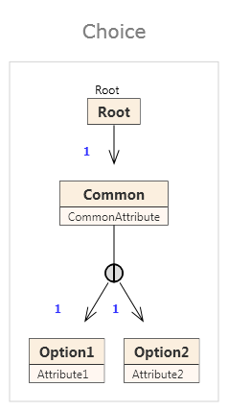
Figure 26 - Choice

XML documents modeled by this diagram will look like this:
<Root>
<Common CommonAttribute=”...” Attribute1=”... />
</Root>
or this:
<Root>
<Common CommonAttribute=”...” Attribute2=”... />
</Root>
However, such a construction cannot be expressed by XML Schema language, but could be expressed in other languages describing structure of XML documents (i.e. Schematron [7]). Basic translation algorithm described in Part 11.3.2 disturbs the semantic meaning of the diagram – according to Part 11.3.2 this diagram would be translated to following schema:

<xs:complexType name="Root">
<xs:attributeGroup ref="Common-a" />
</xs:complexType>

<xs:attributeGroup name="Common-a">
<xs:attribute name="CommonAttribute"
type="xs:string" use="required" />
<xs:attributeGroup ref="Option1 " />
<xs:attributeGroup ref="Option2 " />
</xs:attributeGroup>

<xs:attributeGroup name="Option1 ">
<xs:attribute name="Attribute1"
type="xs:string" use="required" />
</xs:attributeGroup>

<xs:attributeGroup name="Option2 ">
<xs:attribute name="Attribute2"
type="xs:string" use="required" />
</xs:attributeGroup>
This is very different from the semantic meaning of the diagram, because all the three attributes in element Root are now required. The better solution is to declare only CommonAttribute as required and Attribute1 and Attribute2 as optional. This would not prevent the situation where all the three attributes are defined in Root element or only CommonAttribute is defined, but at least all documents valid according to the desired descriptions are valid according to the description in XML Schema. The additional check against using both attributes at once would have to be performed by other means [7].
The translation described in Part 11.3.2 is therefore changed to support the correct declarations. XML Schema does not support use=”optional” and use=”required” on attribute groups, only on attributes. This obstacle leads to introducing “opt-groups” that are created each time an attribute group needs to be referenced from a choice context. Translation is in choice context (see fields inChoice and choiceCounter in XmlSchemaTranslator) if it is translating elements between content choice or class union (that are translated to xs:choice) and nearest content container or class with element label (that are translated to a xs:complexType).
If the translation is in choice context, attributes in classes without element labels are translated into opt-groups. The diagram above will be translated into following schema:
<xs:complexType name="Root">
<xs:attributeGroup ref="Common-a" />
</xs:complexType>

<xs:attributeGroup name="Common-a">
<xs:attribute name="CommonAttribute"
type="xs:string" use="required" />
<xs:attributeGroup ref="Option1-a-opt" />
<xs:attributeGroup ref="Option2-a-opt" />
</xs:attributeGroup>

<xs:attributeGroup name="Option1-a-opt">
<xs:attribute name="Attribute1"
type="xs:string" use="optional" />
</xs:attributeGroup>

<xs:attributeGroup name="Option2-a-opt">
<xs:attribute name="Attribute2"
type="xs:string" use="optional" />
</xs:attributeGroup>

The drawback of opt-groups is that in some diagrams there have to be created both versions of an attribute group – standard version and opt-group differencing only in the use declarations.
When the attribute group is translated, only the version that is currently needed is written (opt or normal) by the method XmlSchemaTranslator.TranslateAttributesIncludingRepresentative. If the attribute group needs to be referenced as the other version, it is translated by calling XmlSchemaTranslator.TranslateAttributeGroupsAgain. The versions already created are tracked in ClassTranslationData.AttributeGroupUsage field (that can have values None, Optional, Normal and Both). Also a warning is written to Log when an opt-group is translated, because this is only a work-around that does not ensure perfect semantic correctness of the XML document being validated.
    - Specialized classes without element labels
PSM Diagrams allow declaring both general and specific classes without an element label. In that case both classes are translated into model and attribute groups (xs:complexType and xs:extension are not used here). Trouble comes when there is an edge going to the general class and attribute group of the specific class is not empty, because having an association going to a general class should allow the general class to be substituted by specialized class. The situation is a bit similar to the situation described in previous section, but is a bit trickier.
Consider following diagram:
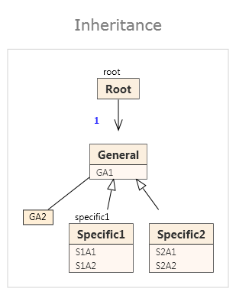
Figure 27 - Inheritance problem
The diagram contains classes General and Specific2 that have no element labels. They are translated into groups and groups belonging to Specific2 reference the groups belonging to General. General should be always substitutable by Specific2. The diagram describes XML documents that look like:
<root GA1=”...”>
<GA2>...</GA2 >
</root>
or
<root GA1=”...”>
<GA2>...</GA2 >
<specific S1A1=”...” S1A2=”...”/>
</root>
or
<root GA1=”...” S2A1=”...” S2A2=”...”>
<GA2>...</GA2>
</root>
But such a set of XML documents can hardly be expressed in XML Schema. One problem is that the first and third options are again choosing between two possible ways of declaration of attributes. This is similar to the problem described in Part 11.4.2 but trying to solve it again by creating opt-groups fails, because complex type root would result in following translation:
<xs:complexType name="Root">
<xs:sequence>
<xs:choice>
<xs:group ref="General-c" />
<xs:element name="specific1" type="Specific1" />
<xs:group ref="Specific2-c" />
</xs:choice>
</xs:sequence>
<xs:attributeGroup ref="General-a-opt" />
<xs:attributeGroup ref="Specific2-a-opt" />
</xs:complexType>
...
<xs:attributeGroup name="General-a-opt">
<xs:attribute name="GA1" type="xs:string" use="optional" />
</xs:attributeGroup>

<xs:attributeGroup name="Specific2-a-opt">
<xs:attributeGroup ref="General-a-opt" />
<xs:attribute name="S2A1" type="xs:string" use="optional" />
<xs:attribute name="S2A2" type="xs:string" use="optional" />
</xs:attributeGroup>
and there are many problems with this translation:
- there is no check whether Specific2-c and Specific1-a-opt are used together in the document
- attributes in General-a-opt and Specific1-a-opt can be declared both ore none of them can be declared (this is similar to translation with choice context)
- attributes in General-a-opt are not only included in Root element but also in element specific1, because they are part of the content of Specific1 type
- attribute GA1 is in both groups – in General-a-opt, because it is declared there, and in Specifc2-a-opt because it references General-a-opt. The schema above is thus not only semantically inaccurate, but even invalid.
To overcome the last issue the groups created from specialized classes would have to not reference the groups from general classes (in schema above <xs:attributeGroup ref="General-a-opt" /> would be omitted from Specific2-a-opt. Then the schema above would be valid (although the first two problems would still remain) and would described a superset of XML Documents that were described by the PSM Diagram.
But there are new issues coming from this workaround. The Specific2-a-opt is now not a superset of General-a-opt, they are distinct set of attributes in fact. If Specific2-a-opt were referenced from some other class in the diagram via the structural representative construct described in Part 11.3.3, the attributes from General would not be included in the representative’s translation which is again semantically incorrect. The groups would have to be translated again using the original algorithm where the general groups are referenced from specific groups. And it mustn’t be forgotten that the class can be referenced from a structural representative in two ways – from choice context or normally.
In the end there could be up to three translations of each attribute group (and since attribute groups can be nested and each of the nested groups would have to be translated in these three ways, the resulting schema would be extremely unclear).
That is why the attribute groups belonging to specialized classes are not referenced from translations of general classes, moreover situation can be simply solved by assigning an element label to the specialized class or moving the attributes of the specialized class into an attribute container (so that they are translated into xs:elements). If there is such a construction in the diagram, warning is written in Log.
    - Non-deterministic diagrams
It is possible to assign the same element labels to two associations going from one class like in the following diagram:
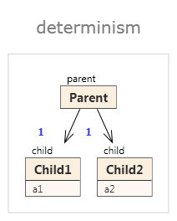
Figure 28 - Determinism
The diagram describes XML documents looking like:
<parent>
<child a1=”...” />
<child a2=”...” />
</parent>
But XML Schema language does not allow declaring two elements of the same name and different type in the same scope. Such a content is in general nondeterministic (the example above is deterministic, but when the multiplicities of associations are changed for example to 1..3 and aliases of both the attributes were the same, it would truly be nondeterministic).
XCase translation algorithm does not solve the problem and the solution is left up to the user – he is given an error when he tries to validate the generated XML Schema.
Nondeterministic schema can occur in more structures (for example when there is some content declared in two model groups and when the groups are both referenced in a complex type, the result is nondeterministic).
Another similar problem occurs when there are two attributes with the same name defined in different attribute groups or types and referenced together in a type or attribute group. This problem is also ignored by the translation and the user must change his diagram to get a valid schema as a result.
    - Not package-aware
The translation algorithm does not consider packages and the whole schema is placed in one namespace common for the project. Creating XML namespaces according to package hierarchy cannot be used, because PSM Diagram can contain classes from several packages and the translated schema has to declare the derived types – and one schema cannot declare elements in multiple packages.
    - Multiplicity of attributes is discarded
As described in Part 11.3.2 (4), XML Documents cannot contain multiple instances of the same attribute in one elements, therefore only 0..0, 0..1 and 1..1 multiplicity specifications can be considered by the translation. Attributes can be moved to an attribute container, where their multiplicity can be fully expressed using minOccurs and maxOccurs attributes of element declaration.

References

[1] nUML project page on sourceforge.net
http://numl.sourceforge.net

[2] State design pattern.
E. Gamma, R. Helm, R. Johnson, J. M. Vlissides: Design Patterns: Elements of Reusable Object-Oriented Software.

[3] Original DockingLibrary webpage - http://www.codeproject.com/KB/WPF/WPFdockinglib.aspx

[4] W3C, XML Schema Part 0: Primer Second Edition, October 2004,
http://www.w3.org/TR/xmlschema-0/

[5] Relax NG, a schema language for XML.
www.relaxng.org/

[6] M. Necasky: Conceptual Modeling for XML. Ph.D. thesis.
Faculty of Mathematics and Physics, Charles University, Prague. May 2008.
http://www.necasky.net/thesis.pdf

[7] Schematron, a rule-based validation language.
http://www.schematron.com/

