5 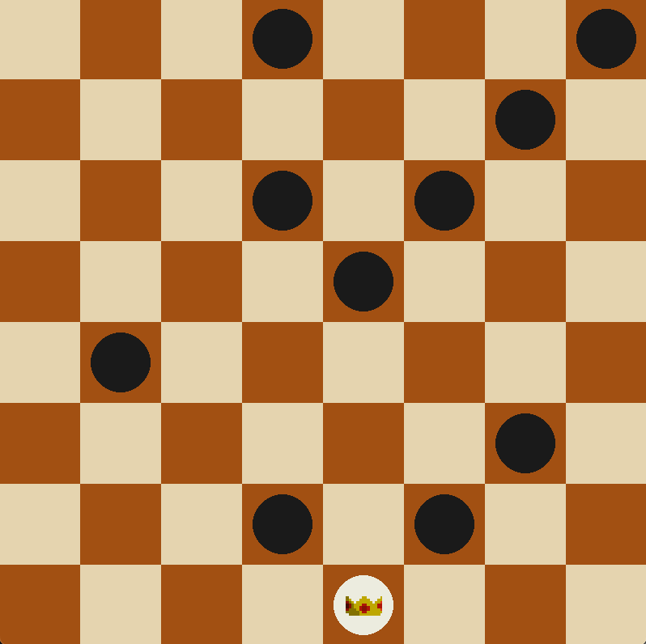 6 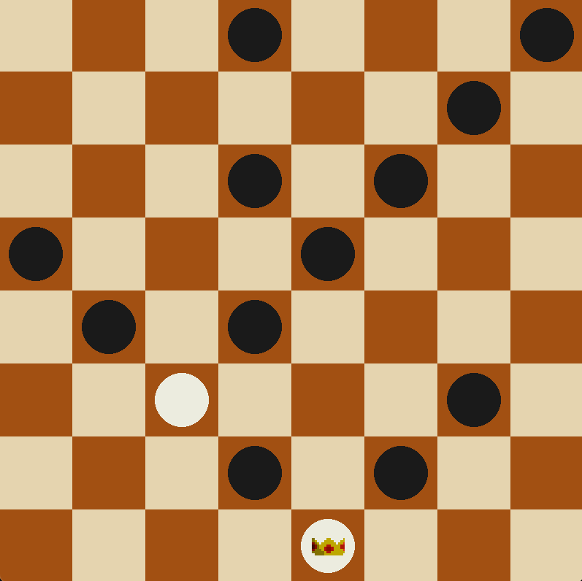

12 