**Sentiment Analysis on Roe v. Wade using Social Media Data**

**Introduction**

Social media in the current era has evolved from just a means to communicate with other people to a platform for political and apolitical people alike to voice their opinions on various subject matters. With this project we intend to study a recent political event through the lens of social media and find patterns in users’ opinions. In June 2022, the US Supreme Court overturned the historical Roe v. Wade case [1], opening the possibility of individual states across the country enforcing state-wide bans on abortion. This, in turn, brought the topic of abortion to the center of public interest nationwide and stimulated widespread discussion through offline and online channels. Our goal remains to analyze the sentiment around a politically charged topic based off of discussions on social media where we will be focused on stances on abortion within the United States during the past six months. Health systems, social scientists, clinicians, and charitable organizations geared towards supporting women are especially interested in understanding the sentiment around this historic overturningasunderstanding the trend and consensus would help them in developing better response plans, guiding women through complex pregnancies' and identifying underrepresented populations to provide better support to them [2].

**Problem Definition**

A lot of earlier work has been done on the sentiment analysis of twitter data on abortion but on a smaller scale and have been more focused on the sentiment analysis aspect. In this project, we aim to improve the model to work for large-scale data and also improve the sentiment analysis implementation to aid in developing better visualizations to examine the varying responses to the abortion ban and the spatial distribution of sentiment in the different states of the USA.

**Literature Survey**

Over the entire project, we reviewed more than 20 different peer-reviewed literature (including books and articles). In recent years, social media has increasingly become a tool used to express ideas in a public online forum. Several studies thus far have tried to use these platforms to extrapolate stances on politically charged issues. As an example, Budiharto et al. [14] perform Twitter sentiment analysis on hashtags relevant to elections in Indonesia to predict the results of presidential elections being held in the country. They find that their predictions align with conclusions arrived at by survey institutes, showing that this method of prediction can yield promising results. We wanted to use a similar technique in our project. Moreover, google trends revealed that the term “abortion” spiked in search frequency in the United States in May and June of 2022, with the latter spike aligning with the Supreme Court Decision. Thus, we consider abortion to be a topic of high public interest in the current national political climate. Earlier efforts have performed sentiment analysis on tweets relating to abortion [15], but on a seemingly small scale, and more focused on labelling the tweets depending on whether they were pro-life, pro-choice, or neutral. There are several examples of experimental paradigms that have used sentiment analysis techniques on Twitter data. As an example, Kaur et al [16] used NRC Lexicon-based emotion detection to classify responses into one of several categories, a method developed by Kiritchenko et al [17]. This sets a precedent for the possibility of successfully using existing analysis methods on a dataset extracted from Twitter specifically for the purpose of emotional response detection and classification. Furthermore, summarizing social media texts is challenging as the data is noisy, ungrammatical and opinion filled. Abridging well-founded documents have already been done extensively [7,8], but they don’t capture sentiments or opinions. Recent work on visualizing opinions on social media has focused on exploring reactions to large-scale events [13]. However, real-time reactions require a different method to visualize changing sentiments [10].

**Proposed Method**

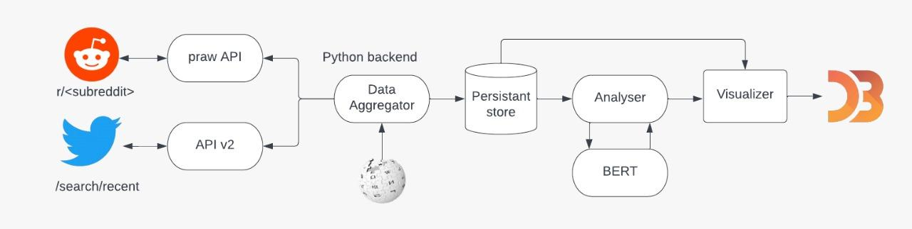

**Figure 1: Workflow of our Model**

**Data Collection:**

The data that we’re working with is text data that voice the opinions and thoughts of users across social media platforms. We are using this as our data as we believe that this will give us a view into the general public’s stance on the overturning of Roe v. Wade. The data obtained is not time-dependent however we have scraped tweets/posts made between the beginning of the semester till now and due to the changes the Twitter API underwent, we have been scraping tweets on a weekly basis recently.

Twitter Data Collection - For the process of tweet data collection, we began with scraping tweets from Twitter using their Developer API. To identify tweets that would be relevant to the topic of abortion rights, we made a list of hashtags that cover both ends of the spectrum of opinions on abortion rights like #Prolife, #AbortionIsAWomansRight, #RoeOverturned, #Prochoice, #WomensReproductiveRights, #AbortionIsMurder, etc. We made use of the *Tweepy* library in Python where for each tweet, the following data was collected: Username, description, location, following, followers, total tweets, retweet count, text, hashtags. Each group member received Twitter Developer access and pulled close to 100k tweets.

Reddit Data Collection - When scraping data from Reddit, it was important to collect data from subreddits closely related to the issue being analyzed. Some subreddits chosen were r/prochoice, r/prolife, r/abortion, r/abortiondebate, r/uspolitics, r/roevwade2022, etc. Reddit scraping was seamless with the *praw* library, which is considered to be a Python Reddit API Wrapper*.* A total of 50k posts were obtained where the title and body of each post was stored.

**Sentiment Analysis:**

For sentiment analysis, we used a variation of the BERT model known as DistilBERT. BERT stands for Bidirectional Encoder Representations and is an NLP model which bidirectionally analyzes text to generate embedded vector representations for a wide range of settings, ranging from sentence prediction to answering questions and, most useful to our goal, sentiment analysis [3]. We decided to implement DistilBERT as it’s better than other state of the art BERT models for a variety of reasons. DistilBERT is a smaller, cheaper, lighter and faster version of BERT. It has 40% less parameters than bert-base-uncased, runs 60% faster while preserving over 95% of BERT’s performances as measured on the GLUE language understanding benchmark [22].

A BERT model was ideal for our implementation of sentiment analysis model as it is pre-trained. In our case, we intended to classify the sentiment of tweets and Reddit posts made on the topic of abortion. However, we did not have a pre-labelled data set and for this reason, and thus, we required a model that had already been trained on a large corpus. DistilBERT was perfect for our use-case as it’s been trained on data sources such as Wikipedia and the Toronto Book Corpus (same as BERT) which are both extensive and exhaustive corpora.

To implement the DistilBERT model, we leveraged the python packages of tensorFlow and transformers. The transformers package has an in-built function called pipeline() which allows us to select any specific pretrained model that has been fine tuned for sentiment analysis. By applying this function on our retrieved tweets, we are returned back a sentiment score and sentiment label for each tweet. The sentiment score exists in a range of 0 to 1 and the sentiment labels are either “Positive”or “Negative”. We then made the scores of negative labels as negative which gave us the sentiment score range from -1 to 1. While most analyses tend to limit their labels to negative and positive, we decided to define a new approach where we have outlined our own labels depending on DistilBERT’s polarity output: strongly negative, mildly negative, neutral, mildly positive, and strongly positive.

| **LABEL** | **RANGE OF SCORES** |
| --- | --- |
| Strongly Negative | -1 to -0.75 |
| Negative | -0.75 to -0.25 |
| Neutral | -0.25 to 0.25 |
| Positive | 0.25 to 0.75 |
| Strongly Positive | 0.75 to 1 |

**Table 1: List of sentiment scores range and their corresponding label**

Using our own labels, we can now gather more granular insight into the sentiment towards the abortion ban through the visualizations we’ve developed.

**Visualization/User Interface:**

The visualizations created aid in deriving insights into questions one may have when trying to understand the varying sentiment towards the polarizing issue of abortion rights. We generated three visualizations for this purpose, with each one having its own unique takeaway for the reader. These visualizations have been created using d3.js and they are hosted on a web browser. The user can interact with them on localhost.

Visualization #1 - After looking at the current state-visualizations on sentiment data [7,8, 10, 13], and based on our learnings in class, we used D3 choropleths for visualizing the Pro-choice and Pro-life sentiment for each US state [21]. The tweets retrieved have been grouped based on the state from which they were made and an average sentiment score was calculated on a state level. The user can interact with the visualization by hovering their cursor over a state which will provide them a brief summary containing the state name, sentiment score and sentiment label.

Intuitive benefits: This visualization allows the user to gather an isolated view of the aggregated public sentiment towards pro-abortion and anti-abortion topics. The separate maps for Pro-choice and Pro-life give the user an opportunity to clearly view the contrast between statewide opinion on the abortion ban from either ends of the spectrum. With this visualization, we can explore the aspect of our problem statement where we intend to observe the varying responses to the overturning of Roe v. Wade in the country.

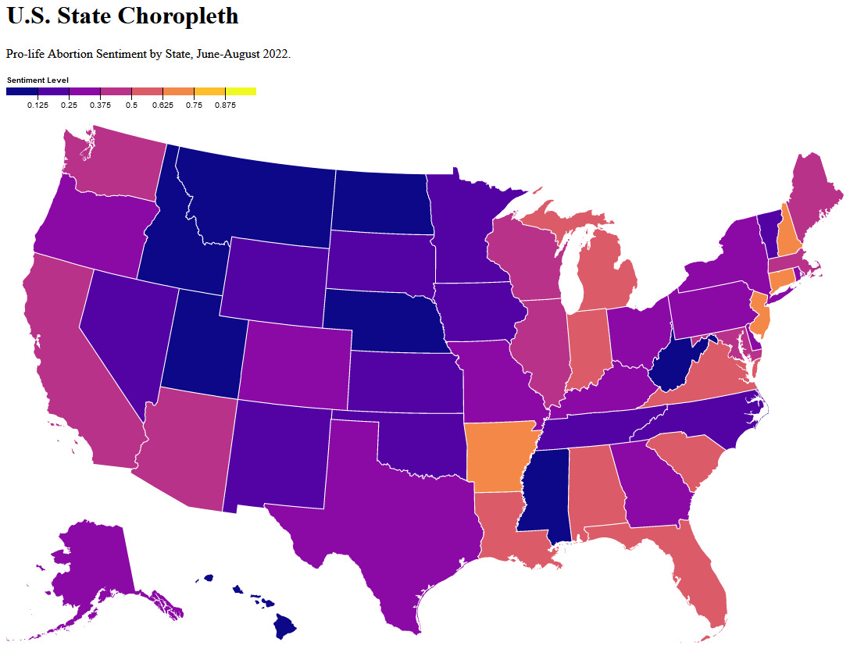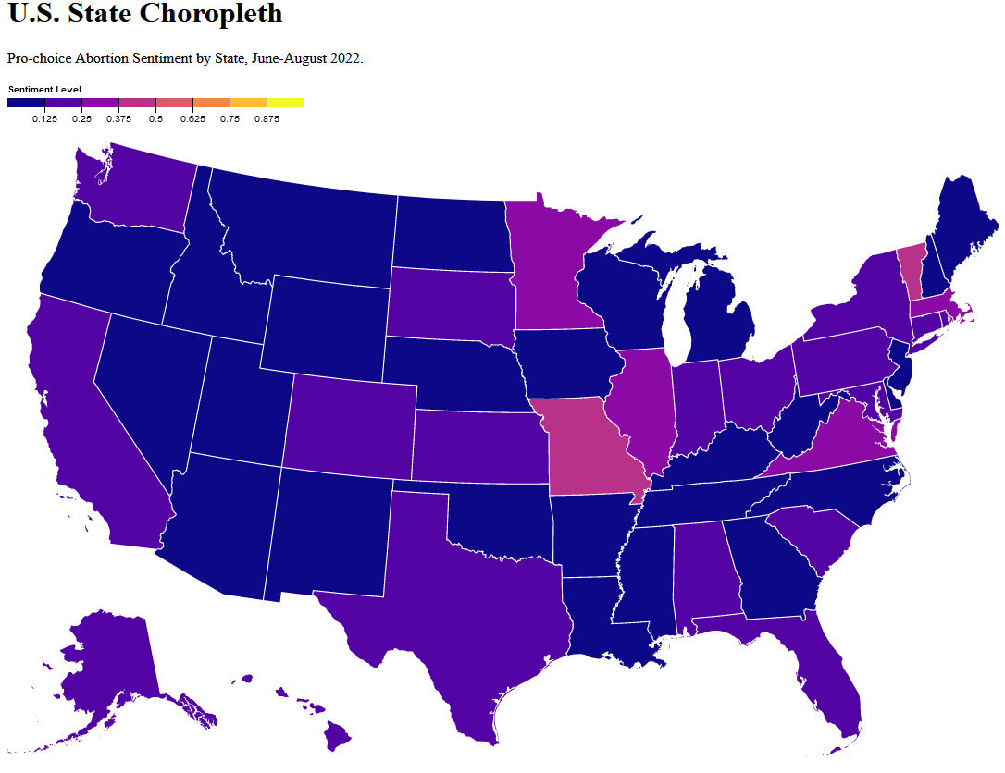

**Figure 2: US Choropleth Map for Pro-life Figure 3: US Choropleth Map for Pro-choice**

Visualization #2 - As abortion is a highly political topic, especially as seen during the overturning of Roe v. Wade, we have made bar charts using d3 to compare average sentiment for pro and anti abortion tweets for each state and each political party that holds the majority in that state. The user may select either stance (either Pro-Choice or Pro-Life) and the corresponding bar chart pops up. On the x-axis, the states in which the respective political holds a majority are given and on the y-axis, the average sentiment score across all Pro-choice or Pro-life hashtags are given. We have grouped the list of hashtags into pro-abortion/anti-abortion hashtags and have accordingly calculated the sentiment scores for this visual:

| **Pro choice** | **Pro life** |
| --- | --- |
| #prochoice, #Abortion, #Abortionban, #AbortionIsHealthcare, #Abortionrights, #AbortionRightsAreHumanRights, #Safeabortion, #Women, #WomensReporoductiveRights, #Womensrights | #AbortionIsMurder, #banabortion, #CatholicTwitter, #ChristianTwitter, #EndAbortion, #Life, #prolife, #Stilllife, #Stopkillingbabies, #UnbornLivesMatter |

**Table 2: List of Different Hashtags used for Web Scraping**

Intuitive benefits: This visualization draws the connection between politics and the topic of abortions in this country. A user may easily access and potentially find relationships between the aggregated public sentiment towards abortion and the general political leanings in the state.

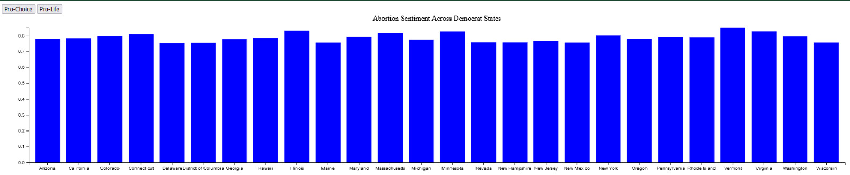**Figure 4: Bar Chart of Pro-Choice Abortion Sentiment Across Democrat States**

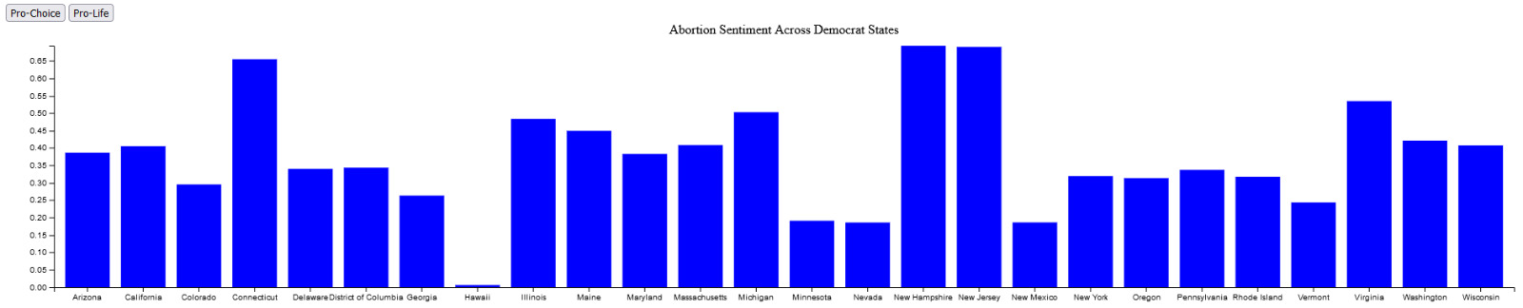**Figure 5: Bar Chart of Pro-Life Abortion Sentiment Across Democrat States**

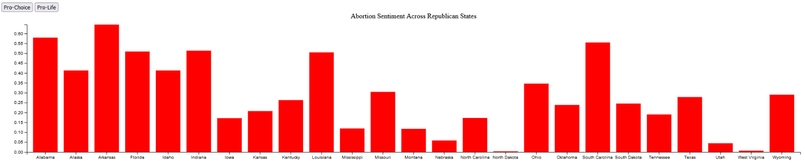 **Figure 6: Bar Chart of Pro-Choice Abortion Sentiment Across Republican States**

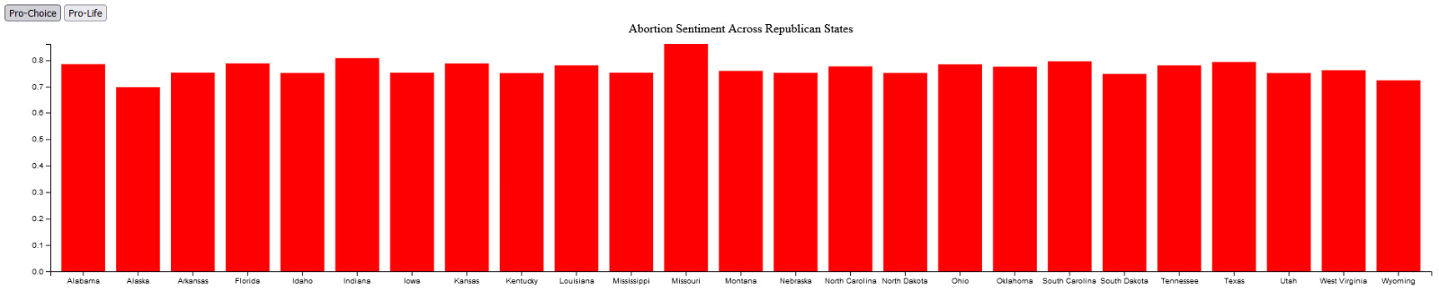 **Figure 7: Bar Chart of Pro-Life Abortion Sentiment Across Republican States**

Visualization #3 - We’ve used a bubble chart for the purpose of comparing cross-platform sentiments. In our graph the x-axis corresponds to the average sentiment score when tweets/posts have been grouped on the basis of hashtags and the corresponding subreddit. For example, the average sentiment score has been calculated for #Prochoice and r/prochoice. For the y-axis, we’ve plotted the number of tweets made with a specific hashtag or the number of posts made on the subreddit. Each bubble corresponds to a single hashtag/subreddit and the user can interact with the visualization by hovering their cursor over the bubble to view the hashtag that it’s representing.

Intuitive benefits: With this visualization, the user will be able to immediately draw a comparison between platforms with respect to the intensity of their sentiment towards each subtopic under the Pro-choice and Pro-life umbrellas. In addition, by comparing sentiments across another major social media platform, we have expanded our analysis and have not limited ourselves to any bias that may appear from just using Twitter. We can support our original problem statement with a diversified set of opinions that allows us to draw better conclusions regarding the general public sentiment surrounding this topic.

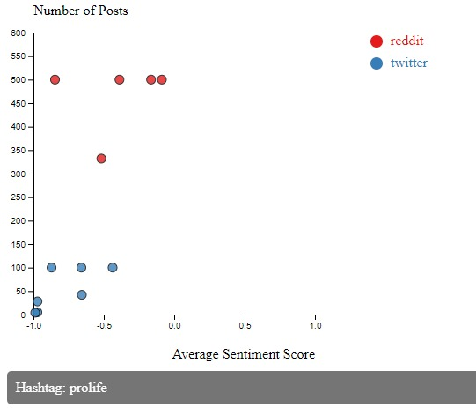 **Figure 8: Bubble Chart to Compare Cross Platform Sentiments for Reddit and Twitter Data on Pro-life**

**Experiments/Evaluation**

Evaluation of the approach can be split into two parts: evaluation of the model and the visualizations we created to draw meaningful conclusions from the data.

**Model Validation:**

As our dataset is unlabeled, we needed a pretrained model. Out of all the pretrained models, BERT is one of the best as it takes into account the context of the sentences, understands the ambiguity in the text, and is pre-trained on a large text corpus. To validate the model, we created a testbed that consists of a subset of tweets from our main data set of tweets. We manually assigned one of five labels to each entry in our testbed and then trained the test data on the same model to ensure that we are getting sufficient accuracy on test data.

**User Interface Evaluation:**

We began this process by confirming that we have sufficient data for all states and that there was enough data per state so that we don’t mislabel it. For visualization 2, the evaluation was more convoluted. We first needed base labels for each state to categorize them into a liberal/conservative state. The subsequent steps involved were to juxtapose results for Republican or Democratic and see if the results for visualization 1 are consistent with this one. Furthermore, we also evaluated our visualizations and their interfaces through the responses of students’ using an anonymous survey. Scalability effects were evaluated from the users’ experiencing both prolife and prochoice hashtags datasets. We collected feedback for all visualizations to ensure that our project is feature-rich. For example, some users came back with the suggestion that we should show pertinent information when hovering the cursor like the most prominent hashtags in each state. We incorporated this suggestion and improved our visualizations accordingly.

**Experiments Description:**

Before designing the experiments, we’ve created a list of questions that we hope to answer through experimentation -

1. What is the spatial distribution of pro-abortion and anti-abortion sentiments in the country following the overturning of Roe v. Wade?
2. Can we observe any alignment between the disposition of the leading political party in the state and the general sentiment of the public?
3. As Reddit is completely anonymized, does anonymity lead to viewing more unfiltered and potentially extreme opinions online as compared to Twitter?

Question 1: We began with selecting one hashtag which was #Prolife, determined the average state-level sentiment and created the choropleth. However, for those states that showed more negative sentiment towards this topic, this raised a crucial question - “A state having positive sentiment towards the pro-abortion topic may be a flawed conclusion as the mean sentiment score is very sensitive to outliers. The state could potentially have a positive sentiment towards the anti-abortion topic as more users may be tweeting with #Prolife. How do we observe this?”. To answer this question, we experimented by developing a new choropleth for the #Prochoice hashtag to observe results that are not biased by the conclusions from the previous choropleth.

Question 2: In our visualization, the user can select between Democratic and Republican. With this feature, we experimented with the relationship between the political party and the sentiment scores on pro-abortion and anti-abortion topics. The bar graph allows for us to see the general trend in how high/low the sentiment scores are. In addition, we are only viewing states where the political party won through a democratic election which further supports us in answering the question we’ve posed. By varying the topic and political party, we could draw conclusions about the potential relationship between the political party and the general sentiment of the public.

Question 3: With the third visualization, our experiment to observe if anonymity influenced the sentiment towards a topic depended on first observing the distribution of average sentiment vs number of tweets for each hashtag on Twitter and then observing the distribution of average sentiment vs number of posts for Reddit in each subreddit. Once we had drawn some insights from these plots, we combined them to form the third visualization. With this visual, we could directly compare across similar hashtags and subreddits and answer our question.

**Observations:**

We successfully analyzed the Twitter dataset to visualize how states express their opinions about this issue. Our visualizations confirmed the political partisanship and consensus in almost all the states on this issue have a strong correlation hence confirming the fidelity of data as well as visualization. The cross-platform sentiment analysis delineated how different social media mediums are given the depth of anonymity offered on these platforms. Reddit opinions inclined a lot toward the extreme ends of the opinion spectrum compared to Twitter.

The state political stances and abortion related opinions received the most positive feedback on its ability to distinguish state's sentiment scores. In addition, the comparison chart between Reddit and Twitter also received a good response as many users echoed the sentiment that the results align with what they’ve observed on these sites, personally. We also heard some clamor for the lack of descriptions for what ‘sentiment scores’ meant. The state choropleth and hashtags scatterplot received a very positive feedback on its ability to explain each state’s sentiment score through hashtags.

**Conclusions and Discussion**

Through the sentiment analysis and visualization, we conclude that certain states have very strong positive and negative views towards the abortion ban. States like Arkansas show strong support for the abortion ban while states like Vermont seem to oppose it. We also note that there appears to be a strong relationship between the public consensus and political leanings in a certain state. Finally, through cross-platform comparison, we conclude that anonymity may contribute to voicing less-filtered, more extreme opinions online.

In the method we’ve proposed, we recognize certain limitations. When handling large-scale, real data, it becomes more difficult to accurately capture sentiment with the presence of spelling/grammar mistakes, broken HTML, etc. Another crucial limitation one may face is that using Twitter as a platform to voice opinions may be more popular in certain states and less in others. Sentiment analysis may give us a view into one state’s majority opinion however it may not be the case for others.

The interactive tool we’ve developed could be used in the future to support any health systems or charitable organizations, for example. Sufficient insight could be derived from this analysis which can then be used to better support women through their medical journeys any complications that may arise.

Furthermore, In this project, all team members have contributed a similar amount of effort. The work was divided equally and each member delivered completely on their responsibility.

**References:**

[1] Sherman Mike June 24, 2022 Supreme Court overturns Roe v. Wade; states can ban abortion AP<https://apnews.com/article/abortion-supreme-court-decision-854f60302f21c2c35129e58cf8d8a7b0>

[2] Arey, Whitney Lerma, Klaira Beasley, Anitra Harper, Lorie Moayedi, Ghazaleh White, Kari A Preview of the Dangerous Future of Abortion Bans — Texas Senate Bill 8 2022/06/22 New England Journal of Medicine 10.1056/NEJMp2207423<https://www.nejm.org/doi/full/10.1056/NEJMp2207423>

[3] Devlin, Jacob, et al. "Bert: Pre-training of deep bidirectional transformers for language understanding." *arXiv preprint arXiv:1810.04805* (2018).

[4] Xu, Hu, et al. "BERT post-training for review reading comprehension and aspect-based sentiment analysis." *arXiv preprint arXiv:1904.02232* (2019).

[5] Sousa, Matheus Gomes, et al. "BERT for stock market sentiment analysis." *2019 IEEE 31st International Conference on Tools with Artificial Intelligence (ICTAI)*. IEEE, 2019.

[6] Singh, Mrityunjay, Amit Kumar Jakhar, and Shivam Pandey. "Sentiment analysis on the impact of coronavirus in social life using the BERT model." *Social Network Analysis and Mining* 11.1 (2021): 1-11.

[7] Nenkova A., McKeown K. Automatic summarization. 2011

[8] Juan-Manuel Torres-Moreno. Automatic Text Summarization. 2015

[9] Matei Zaharia, Mosharaf Chowdhury, Tathagata Das, Ankur Dave, Justin Ma, Murphy McCauley, Michael J. Franklin, Scott Shenker, and Ion Stoica. 2012. Resilient distributed datasets: a fault-tolerant abstraction for in-memory cluster computing. In Proceedings of the 9th USENIX conference on Networked Systems Design and Implementation (NSDI'12). USENIX Association, USA, 2.

[10] Marcus, Adam; Bernstein, Michael S.; Badar, Osama; Karger, David R.; Madden, Samuel R.; Miller, Robert C. TwitInfo: Aggregating and Visualizing Microblogs for Event Exploration

[11] Chris Richardson Microservices Patterns With examples in Java, ISBN 9781617294549

[12] Matei Zaharia, Reynold S. Xin, Patrick Wendell, Tathagata Das, Michael Armbrust, Ankur Dave, Xiangrui Meng, Josh Rosen, Shivaram Venkataraman, Michael J. Franklin, Ali Ghodsi, Joseph Gonzalez, Scott Shenker, and Ion Stoica. 2016. Apache Spark: a unified engine for big data processing. Commun. ACM 59, 11 (November 2016), 56–65. https://doi.org/10.1145/2934664

[13]Diakopoulos N., Naaman M., Kivran-Swaine F. Diamonds in the rough: social media visual analytics for journalistic inquiry.

[14] Budiharto, W., Meiliana, M. Prediction and analysis of Indonesia Presidential election from Twitter using sentiment analysis. J Big Data 5, 51 (2018).<https://doi.org/10.1186/s40537-018-0164-1>

[15] Bradley Webb June 28, 2022 Analysis of the Abortion / Roe v. Wade Dataset

<https://www.surgehq.ai/blog/dataset-of-roe-v-wade-tweets-labeled-by-abortion-stance>

[16] Manpreet Kaur, Rajesh Verma & Frank Nana Kweku Otoo (2021) Emotions in leader’s crisis communication: Twitter sentiment analysis during COVID-19 outbreak, Journal of Human Behavior in the Social Environment, 31:1-4, 362-372, DOI: 10.1080/10911359.2020.1829239

[17] Kiritchenko, S., Zhu, X. and Mohammad, S.M., 2014. Sentiment analysis of short informal texts. Journal of Artificial Intelligence Research, 50, pp.723-762.4

[18] Zhang, L, Wang, S, Liu, B. Deep learning for sentiment analysis**:** A survey. *WIREs Data Mining Knowl Discov.* 2018; 8:e1253.<https://doi.org/10.1002/widm.1253>

[19] A. R. Abas, I. Elhenawy, M. Zidan and M. Othman, "Bert-cnn: a deep learning model for detecting emotions from text," *Computers, Materials & Continua*, vol. 71, no.2, pp. 2943–2961, 2022.

[20] Salarpour, Amir & Bamneshin, Mohammad Hossein & Proios, Dimitris. (2013). Sentiment Analysis and Visualization of Social Media Data The #BostonMarathon #Bombings test case.

[21] Mike Bostock, “US State Chloropleth using D3” 2019.

[22] Sanh, V., Debut, L., Chaumond, J., & Wolf, T. (2019). DistilBERT, a distilled version of BERT: smaller, faster, cheaper and lighter. *arXiv*. <https://doi.org/10.48550/arXiv.1910.01108>