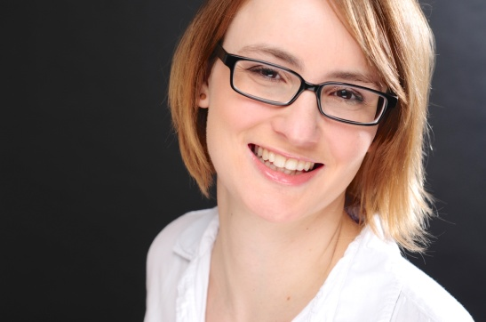I’m a digital and German native language-enthusiast.

I am experienced in digital communications and community management, particularly in the non-profit sector and with focus on the creative and writing side. I love spreading a message and getting in touch with people. I am also interested in and working on expanding my knowledge in web technology & analytics.

I am quick to learn new systems, programs and processes and eager to do so! I am also fluent in English.

**Education**

Oct 2009 - May 2014 **Master of Arts in Linguistics** **at** **Humboldt-University Berlin**

Grade: 2,3 (equivalent to 2:1)

Communication & language

Translation & interpreting, editing & proofreading

Logics, analytics and statistics

Introduction to media lawat the Career Centre

Sept 2010 - Jan 2011 **Erasmus Semester** **at King’s College London**

Sociolinguistics and research methods

Feb 2009 - June 2009 **Study Abroad Semester at** **the** **University of Auckland**, **New Zealand**

Overseas certificate for postgraduate courses in linguistics and translation

Oct 2006 - Feb 2009 **Bachelor of Arts in Linguistics** **at** **Heinrich-Heine-University Düsseldorf**

Grade 1,5 (equivalent to first)

English and Spanish

Oct 2005 - Mar 2006 One Semester of a Bachelor of Science in Biology at the University of Cologne

June 2005 **Abitur at Christian-Rohlfs-Gymnasium Hagen**

Equivalent to A-levels | overall grade: 2,3 (equivalent to 2:1)

English | Education sciences | Mathematics | Philosophy

**Professional Experience**

Apr 2016 and June 2016 **Copy Writer / Editor and Digital Marketing Assistant at Uniqlo Europe Ltd., London**

**Text** Writing | Translating | Editing | Proofreading

**Digital Marketing** Facebook Ads | Website | Campaigns

Dec 2015 - Apr 2016 **Community Manager and Translator**

**at incling Ltd., Mavens of London, AudienceNet and Kiosk, London (freelance, project-based)**

**Text** Translating | Writing

**Community Mgmt** Communicating | Coordinating | Moderating | Reporting

Nov 2015 and Feb 2016 **Proofreader at E.P.A. Language Services Ltd., London (project-based)**

**Text** Proofreading | Editing |Translating

Oct 2015 **German Language Consultant for Media Analysis at Ogilvy One, London (project-based)**

**Analysis** Media analysis | Social Media | German | Monitoring | Reporting

July 2014 - present **Freelance Subtitler at Ericsson (formerly TITELBILD Subtitling and Translation GmbH)**

(occasionally) **Subtitling** Movies | TV series | Inter-lingual | Intra-lingual

**Mgmt** Workload | Deadlines | Client contact

May 2011 - June 2015 **Volunteer at the charity Weitblick Berlin e.V.**

**Digital Communications** Newsletter | Website | Social Media | Community Mgmt

**Project Mgmt** Fundraising events | Educational events

June 2014 - Aug 2014 **German Language Teacher at GLS Language School, Berlin (summer school)**

**Teaching** German | Children (7-14 yrs) | All levels | Private tutoring experience

Apr 2012 - June 2014 **Research Assistant at ICWE GmbH, Berlin**

**Data** Research | Assessment of data | Updating and maintaining databases

**Events** Supporting logistics | On-site | Registration | International clients

Feb 2013 - Feb 2014 **Board Member at the charity Weitblick Berlin e.V.**

**Mgmt** Finances | Accounting | Strategic dev | Volunteer coordination

**Communications** Internal | External

**Liaising** NGOs | Partners | Sponsors

July 2010 - Jan 2012 **Freelance Writer at WebRichtUng GmbH**

**Writing** Producing content | SEO

Sept 2011 - Jan 2012 **Intern with successive freelance work** **at TITELBILD Subtitling and Translation GmbH, Berlin**

**Subtitling** Movies | TV series | Commercial and promo | Inter-lingual | Intra-lingual

**Text** Translating | Proofreading | Different types of documents

Feb 2011 - Apr 2011 **Intern** **in Administration at Berlin Metropolitan School**

Mar 2006 **Intern at local Newspaper ‘Westfalenpost’**

**Additional Skills & Experiences**

**Seminars ‘Civil Academy’ scholarship for young people and their social projects**

**and Workshops** Seminars and workshops on project management, financing, team building and pr

**Participation in extracurricular seminars:**

Talks and workshops on international development and NGO work

Talks and workshops on online marketing and SEO

**Language Skills German**: native speaker

**English**: proficient user, C2 (native speaker level); *UNIcert IV* exam, grade*:*1,7 (equivalent to 2:1)

**Spanish**: basic user, B1

**French**: basic user, A2

**Software Skills** High IT literacy and quick to learn new systems

Excellent knowledge of Social Media

Proficient user of Microsoft Office

Proficient user of EZTitles (subtitling software)

Experienced in usage of databases and CMS

Experienced in usage of various community mgmt platforms and software

Experienced user of Brandwatch (media monitoring tool)

Basic knowledge of HTML (in progress), image editing and design

**Interests**

***History*** *learning about different cultures through history is not only fascinating, but also teaches me to stay open-minded and curious*

***Photography*** *I have always loved photography as a means of capturing, expressing myself and being creative*

***Swimming*** *apart from keeping me fit, it gives me the opportunity to focus and to review events of the day and to develop new ideas*