
EXT: Multidomain Publishing
Extension Key: multidomain_publishing
Language: en
Version: 1.0.0
Keywords: forAdmins forDevelopers forAdvanced
Copyright 2006-2011, Thomas Hempel <hempel@work.de>, Martin Ficzel <ficzel@work.de>

This document is published under the Open Content License
available from http://www.opencontent.org/opl.shtml

The content of this document is related to TYPO3
- a GNU/GPL CMS/Framework available from www.typo3.org
Table of Contents
EXT: Multidomain Publishing 1
1 - Introduction 3
1.1 - What does it do? 3
1.2 - Screenshots 3
2 - Users manual 4
2.1 - Installing the extension 4
2.2 - Configuring of the domain-records 4
2.3 - Create TypoScript-Templates for the different Domains 5
2.4 - Create Content for Domains 6
2.5 - Preview Content 7
3 - Administration 8
4 - Configuration 9
5 - Extending 10
6 - ChangeLog 11

Introduction

What does it do?
The Extension extens TYPO3 for managing contents for multiple domains in a single pagetree. The major difference to standard TYPO3 multiple-pagetree or insert-record solutions is thar we manage the differences between the contens of the configured domains where the existing aproaches manage the similarities.
So multidomain_publishing is handy when you manage more than one domain from a single typo3 installation and the domains share 80 to 90 Percent of the contens.
Example usecases are:
- Mobile versions of a domain where you want to adjust the landing pages but leave the content as it is.
- White-label sites that show your content in the layout of your partnersite
- microsites
To achieve this multidomain publishing extends the acess-tab of backend records and adds the option to control the visibility across the configured domains.

Screenshots
Here you see what the extension does:
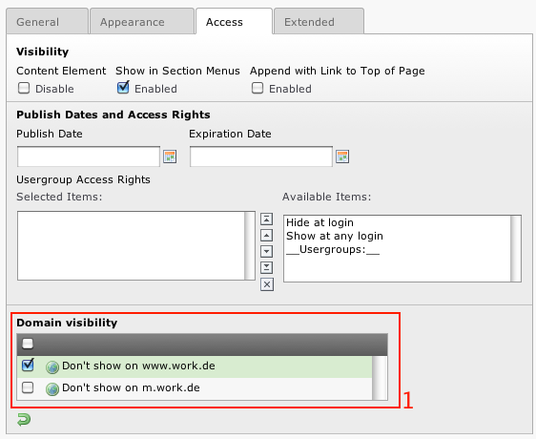

Users manual
Documentation of how to use the extension, how it works, how to apply it if it's a website plugin. A user manual.
Language should be non-technical, explaining, using small examples.
Examples: For the "News" plugin this would be a manual showing how to create the news-items, explaining the options etc.
Target group: Users, Administrators or Developers in that priority. Depends on the extension.

Installing the extension
The extension can be directly installed and needs no special configuration. If you are using a url-transformation extension you should install multidomain_publishing after the url-transformer.

Configuring of the domain-records

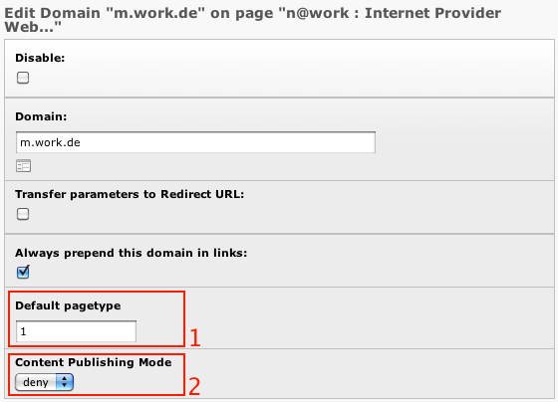
Create the domain records as usual. Multidomain Publishing adds the marked options.
 | Property: | Data type: | Description: | Default:
1 | Default pagetype | int | If this option is set TYPO3 will render the page with given typeNum if no typeNum is specified. This overrides the default rendering of the page with type=0 for this domain. | -
2 | Content Publishing Mode | allow / deny | This option configures wether on this domains contents have to be hidden or enabled. The setting works for all records that are configured to use multidomain_publishing. | deny

Create TypoScript-Templates for the different Domains
If you want to show different templates on your domains you can use the existing typeNum mechanism of TYPO3 to manage different Page Templates.
# default Page
page = PAGE
page.typeNum = 0
page.10 = TEMPLATE
page.10 …

# mobile Page
page_mobile = PAGE
page_mobile.typeNum = 1
page_mobile.10 = TEMPLATE
page_mobile.10 …
To configure the content rendering differently between domain use a TypoScript-condition for the type parameter.
# adjust conten rendering for mobile
[globalVar = GP:type = 1]
tt_content{
image.20.maxW >
image.20.maxW = 300
}
[global]

Now you should be able to see effect of the different templates on the domains.

Create Content for Domains

The content for all domains is created in single pagtree. To control the visibility of your contents across the domains you will find a new option on the access tab of pages and contend and all records that are configured for multidomain_publishing.
Based on the allow/deny mode of the domain record you can select wether the content should be hidden or shown on this domain.
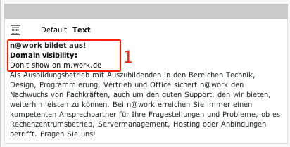
The Page Module shows the domain restrictions for the content-elements.

Preview Content
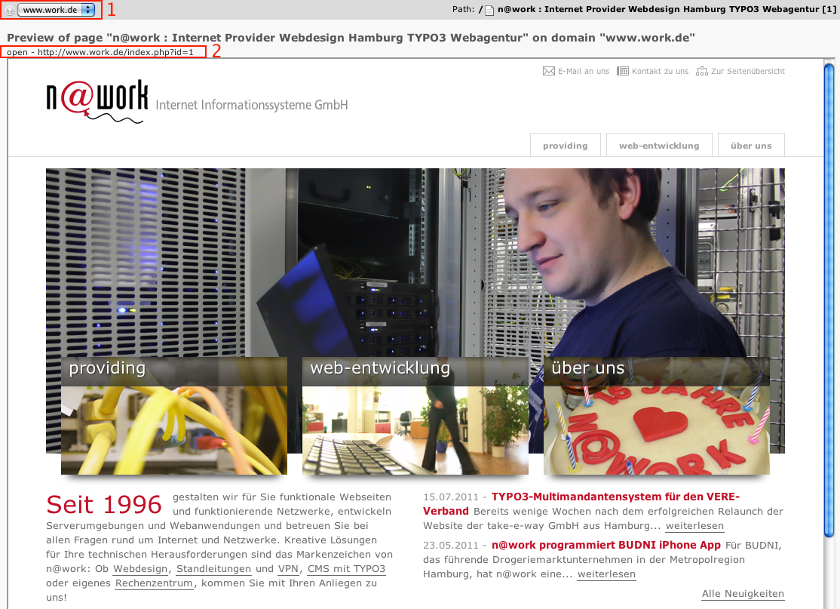
To get a fast Preview of your Work you can use the included “Domain View”- Module that allows to select the domain that is used for previewing (1) and also includes a preview-Link to open the page in a new window (2).

Administration
Describes how to manage the extension from an administrator’s point of view. That relates to Page/User TSconfig, permissions, configuration etc., which administrator level users have access to.
Language should be non/semi-technical, explaining, using small examples.
Target group: Administrators

Configuration
The Extension does'nt need special TypoScript configuration. You should read the TS-Ref documentation of Conditions and pagetypes/typeNum instead. You can read the section User-Manul instead.

Extending
The following 3 steps show how easy multidomain_publishing can be integratet into any extension-record. The example shows the code that adds multidomain options to the tt_content-table.
Step 1 – add the database field to the record in ext_tables.sql.
#
# Extend Table structure for table 'tt_content'
#
CREATE TABLE tt_content (
tx_multidomainpublishing_visibility varchar(100) DEFAULT '0' NOT NULL
);

Step 2 – extend TCA in ext_tables.php.
#
# Field definition for multidomain publishing
#
$tempColumns = array (
'tx_multidomainpublishing_visibility' => array (
'exclude' => 1,
'label' => 'LLL:EXT:multidomain_publishing/locallang_db.xml:pages.tx_multidomainpublishing_visibility',
'config' => array (
'type' => 'select',
'foreign_table' => 'sys_domain',
'itemsProcFunc' => 'tx_multidomainpublishing_tcaProcHelper->selectDomainRestrictionsProcFunction',
'size' => 5,
'minitems' => 0,
'maxitems' => 99,
'foreign_table_loadIcons' => 1,
'renderMode' => 'checkbox'
)
),
);

#
# add field to tt_content
#
t3lib_div::loadTCA('tt_content');
t3lib_extMgm::addTCAcolumns('tt_content', $tempColumns, 1);
t3lib_extMgm::addToAllTCAtypes('tt_content','tx_multidomainpublishing_visibility;;;;1-1-1' , '', 'after:fe_group');

#
# configure TCA-ctrl for multidomain publishing
#
$GLOBALS['TCA']['tt_content']['ctrl']['tx_multidomainpublishing_column'] = 'tx_multidomainpublishing_visibility';

Step 3 – use enableFields in your extension code.
Since multidomain_publishing implements a hook in the enable fields method all youzr extension that use enableFields properly are nor ready to go.

ChangeLog
Version: | Changes:
1.0.0 | Initial pubic release

