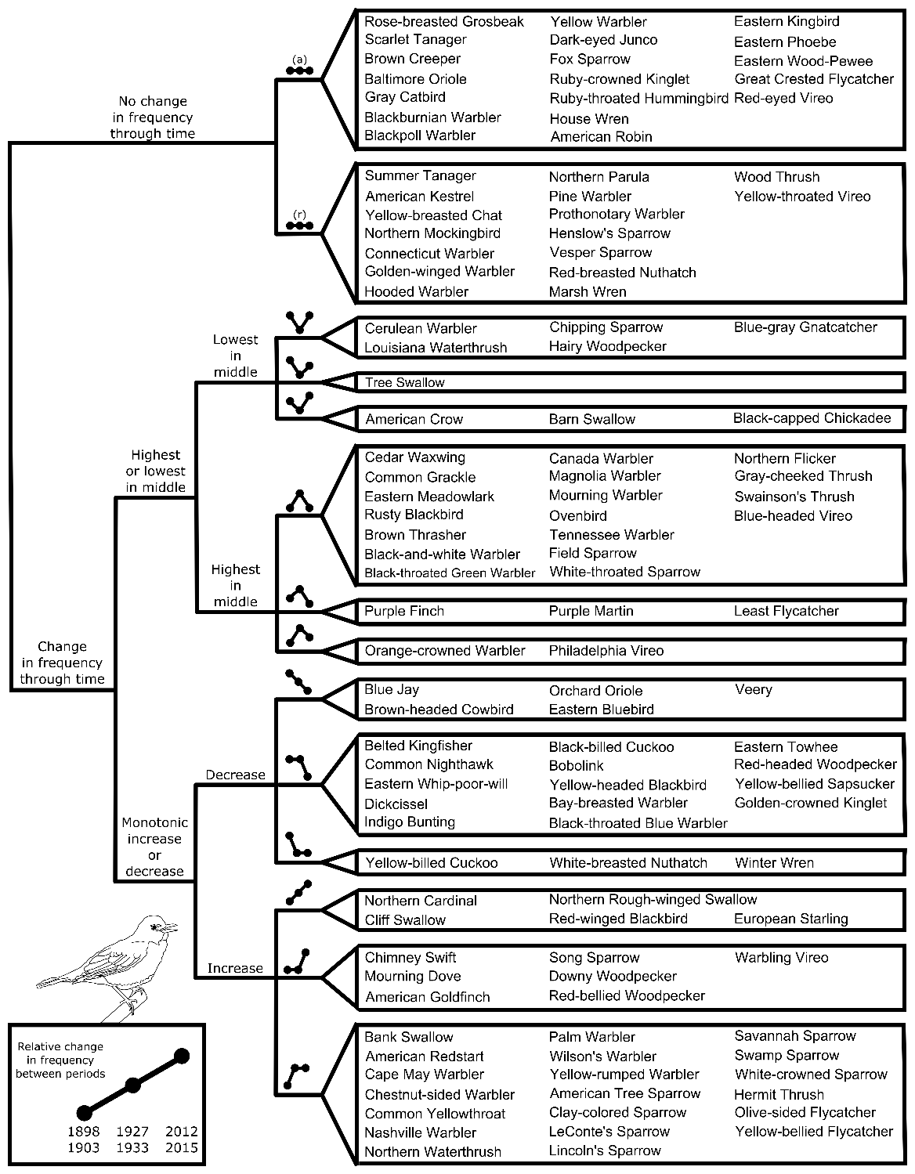

Figure 1. Trends observed in the number of days species were observed during the migratory season throughout Lincoln Park through time as supported by the GLM analysis. Trends are represented as ball-and-stick graphics which fall into 5 major categories: no change in frequency, frequency highest or lowest between 1927 – 1933, or monotonic increases or decreases across the three time periods birds were surveyed. Dots in the ball-and-stick graphics represent the three time periods bird counts were conducted while their relative vertical placement describe how frequency has or has not changed between periods, where higher relative placement indicates higher frequency for a given time period. Birds in which no change was detected are further classified into ‘abundant’ (a) or ‘rare’ (r), the latter being species who were detected on less than 5% of days each year. In each group species are sorted alphabetically by family and then common name.