

Supplementary Materials for

Landscape differences among cities alter species’ responses to urbanization

Mason Fidino, Travis Gallo, Elizabeth W. Lehrer, Maureen H. Murray, Cria Kay, Heather A. Sander, Brandon MacDougall, Carmen M. Salsbury, Travis J. Ryan, Julia L. Angstmann, J. Amy Belaire, Barbara Dugelby, Chris Schell, Theodore Stankowich, Max Amaya, David Drake, Sheryl H. Hursh, Adam A. Ahlers, Jacque Williamson, Laurel M. Hartley, Amanda J. Zellmer, Kelly Simon, Seth B. Magle

Correspondence to: [mfidino@lpzoo.org](mailto:mfidino@lpzoo.org)

**This PDF file includes:**

Materials and Methods

Figs. S1 to S2

Table S1 to S2

Materials and Methods

Cities

Ten UWIN cities provided data for this study: Austin, Texas; Chicago, Illinois; Denver, Colorado; Fort Collins, Colorado; Iowa City, Iowa; Indianapolis, Indiana; Manhattan, Kansas; Madison, Wisconsin; Orange County, California; and Wilmington, Delaware. The cities are spread across the entire contiguous United States and range from about 43° N (Madison, Wisconsin) to 30° N (Austin, Texas) and 118° W (Orange County, California) to 75° W (Wilmington, Delaware; Fig. S1).

Sites

All cities followed a standard protocol to select sampling locations along a gradient of urbanization (*8*). Sampling locations (hereafter ‘sites’) include an array of potential wildlife habitat such as parks, cemeteries, golf courses, natural areas, and backyards. Transects originated in an urban core of each city and extended outwards through suburban, exurban, and/or rural areas across gradients of impervious land cover and housing density. The average number of sites per city was 51 (min = 23, max = 104). All sites were separated by at least 1 km. This distance was selected because it exceeds the home range extent of most city dwelling mammals surveyed in this study, save for the coyote (*Canis latrans*) and red fox (*Vulpes vulpes*, *36*).

Biological sampling

The focus of UWIN to date has been on passive monitoring of medium to large-sized mammals with motion-triggered trail cameras (hereafter ‘camera traps’). One camera trap was placed at each site for at least 28 consecutive days in January, April, July, and October to capture seasonality in wildlife distributions (*8*). Camera traps were strapped to a tree, fence post, or other object and angled downward so that the camera’s field of view captured another tree or fence post 2.5 – 6 m away. To potentially increase species detectability, a synthetic fatty acid scent tablet (USDA Wildlife Services, Pocatello, Idaho) was placed in a mesh bag and attached roughly 30 cm from the ground to the object, towards which the camera trap was angled.

Photo data were uploaded and processed using a custom Microsoft Access database built for camera trapping research (*37*). A custom R package, ‘uwinr’, was used to check each city’s respective database for errors and to prepare data for analysis (*38*). We generated daily detection histories with these data for each site, species, and sampling season. A detection history took the value of 1 if a species was detected at a site on a given day, the value 0 if a species was not detected on that day, and the value NA if the camera malfunctioned (e.g., batteries ran out) or the camera was not deployed on a given day. For example, the detection history {0, 0, 1, NA} indicates that a species was not detected on the first two days, detected on the third, and then either the camera malfunctioned or was removed on the fourth day. Detection histories were generated with a two-week buffer around each sampling period to account for minor differences in deployment timings between cities.

Data

Most data for this analysis were collected during July 2017. However, two cities contributed data from July 2016 and six cities contributed data from July 2018 (Table S1).

Statistical analysis

We fit a Bayesian hierarchical single-season occupancy model to each species’ data to estimate if their average occupancy probability within a city changed due to among-city differences in greenspace availability and average housing density (*39*). We also quantified relative changes in the likelihood of occupancy along each city’s urbanization gradient (i.e., a species response to urbanization) as a function of among-city differences in greenspace availability and average housing density. Four candidate models were fit to each species’ data to determine the relative influence of our two among-city variables. We explain the global model below. The remaining three models are reduced versions of this global model.

To represent each city’s urbanization gradient, the global model included the housing density (1000 units/km2) within a 1-km buffer around each site. We also included two among-city covariates: overall greenspace availability and average housing density. To calculate overall greenspace availability we first extended the width of each transect in a city by its respective length. A straight 20-km transect, for example, became a square with 20 km-length sides wherein the transect line bisects the center of the square. This method was used to increase the sampled area in proportion to transect length and enabled us to apply a consistent definition of greenspace availability across cities with transects of different lengths. Overlapping squares resulting from multiple transects within a city were spatially dissolved to create a single sampling area. We then calculated the proportion of available greenspace in a city’s study area, following the U.S. EPA’s EnviroAtlas definition (*40*), by combining the forest, herbaceous, shrub & grass, and developed open space (e.g., ,golf courses, cemeteries, parks, etc.) land cover classes from the National Land Cover Database (*41*) and divided the summed area of those classes by the total sampled area for each city. We calculated the average housing density of each city as the mean housing density within a 1-km buffer of all sites in a city from the Silvis housing density data layer (*42*). To estimate if a species’ response to urbanization (i.e., the associated slope term to our ‘within-city’ covariate) changed due to structural differences among cities, we included statistical interactions between our two ‘among-city’ covariates (i.e., overall greenspace availability and average housing density of a city) and our single ‘within-city’ covariate (i.e., the housing density at each site). For a single-species the logit-linear predictor of the probability of occupancy (*Ψjs*) at *j* in 1,...,10 cities and *s* in 1,…,*Sj* sites was

|  |  |  |
| --- | --- | --- |
|  |  | Eq. S1 |

where

|  |  |  |
| --- | --- | --- |
|  |  | Eq. S2 |

and

|  |  |  |
| --- | --- | --- |
|  |  | Eq. S3 |

In Eq. S1, represents the average log-odds species *s* occupies an average site in city *j* and can be biologically interpreted as a species average occupancy probability within a city*.* It is derived from the intercept term and the effect of the two between-city covariates – overall greenspace availability () and the average housing density of a city () via Eq. S2. Among-city covariates were centered and scaled to have a mean of 0 and standard deviation of 1. is a slope-term that represents the relative log-odds change in occupancy at city *j* and site *s* given the within-city site-level housing density covariate, , and can be biologically interpreted as a species response to urbanization. Unlike the among-city covariates, is group-mean centered by subtracting the respective city average, , from each . This scaling eases model interpretation and ensures the slope terms in Eq. S2 and Eq. S3 (i.e., and represent among-city effects (*43*). As with , is allowed to vary in magnitude or direction via Eq. S3 as a function of the two among-city covariates. By algebraically inputting Eq. S2 and S3 into Eq. S1 it is evident that the parameters and are slope terms that vary by city while and are interaction terms between our among- and within-city covariates.

To account for additional among-city variation we included a city-specific random effect (; Eq. S1). We also accounted for multiple years of sampling with two indicator functions,and .The parameter is the log-odds difference in average occupancy at city *j* in 2016. If a city had 2016 data this term was estimated, otherwise it was 0. Conversely, is the log-odds difference in average occupancy at city *j* in 2018 if and only if city *j* had 2017 data. For the detection model we allowed the species-specific detection probability () to vary among cities such that the logit-linear predictor was whereis the average log-odds of detecting a species whileis a city level random-effect.

Model set, prior specification, and model selection

The four candidate models fit to each species’ data differed in the number of among-city variables (Eq. S2) and represented separate hypotheses about which differences in urban form among cities were correlated with the average occupancy of a species in a city (Eq. S2) or where a species was most likely to occur within a city (Eq. S3). The global model () described above contained both among-city variables, our greenspace model only included the proportion of greenspace in a city (), and our housing density model only included the average housing density of a city (). We also included a null model that contained no among-city variables (). All models included the site-level housing density covariate (; Eq. S1), which represents the urbanization gradient in each city, and used the same detection model. Cities that were outside the distributional range of a species were omitted from that species’ analysis, and models were only fit to a species’ data if they were detected at a minimum of five participating UWIN cities (50% of sampled cities).

We used a Bayesian framework to parameterize and evaluate our models. All logit-scale parameters, save for the random effect terms, were drawn from Logistic(0,1) distributions which represent a vague logit-scale prior. Random effects were drawn from N(0,σ) distributions where σ ~ Inv-gamma(0.001, 0.001). To compare the relative fit of each model we calculated the conditional predictive ordinate (CPO) of each data point at each MCMC step (*44*). Overall model performance was evaluated with the summary statistic for data point *k* and MCMC step *t* and the lowest value indicates the best relative fit (*45*). Models were fit in JAGS version 4.3.0 (*46*) via the R programming language version 3.5.3 (*47*). After a 60,000 step adaptation and 60,000 step burn-in, each model was sampled 1,250,000 times across 5 chains. Due to the computational intensity of tracking the CPO of each data point, chains were thinned by 10 for a total of 125,000 samples. To verify model convergence, we ensured that Gelman-Rubin diagnostics for each parameter were < 1.10 and examined trace plots of parameters from the MCMC chains to visually confirm proper mixing (*48*). While the number of parameters could differ for the best-fit model of each species, we referenced parameters as we did for the global model (i.e., Eq. S1 – S3) for consistency.

Quantifying species richness within and among cities

We used posterior simulations of species occurrences from each species’ best-fit model to derive 1) within-city species richness at sites surrounded by less than or more than a city’s average housing density and 2) the most likely wildlife community to occur at the estimated median species richness.

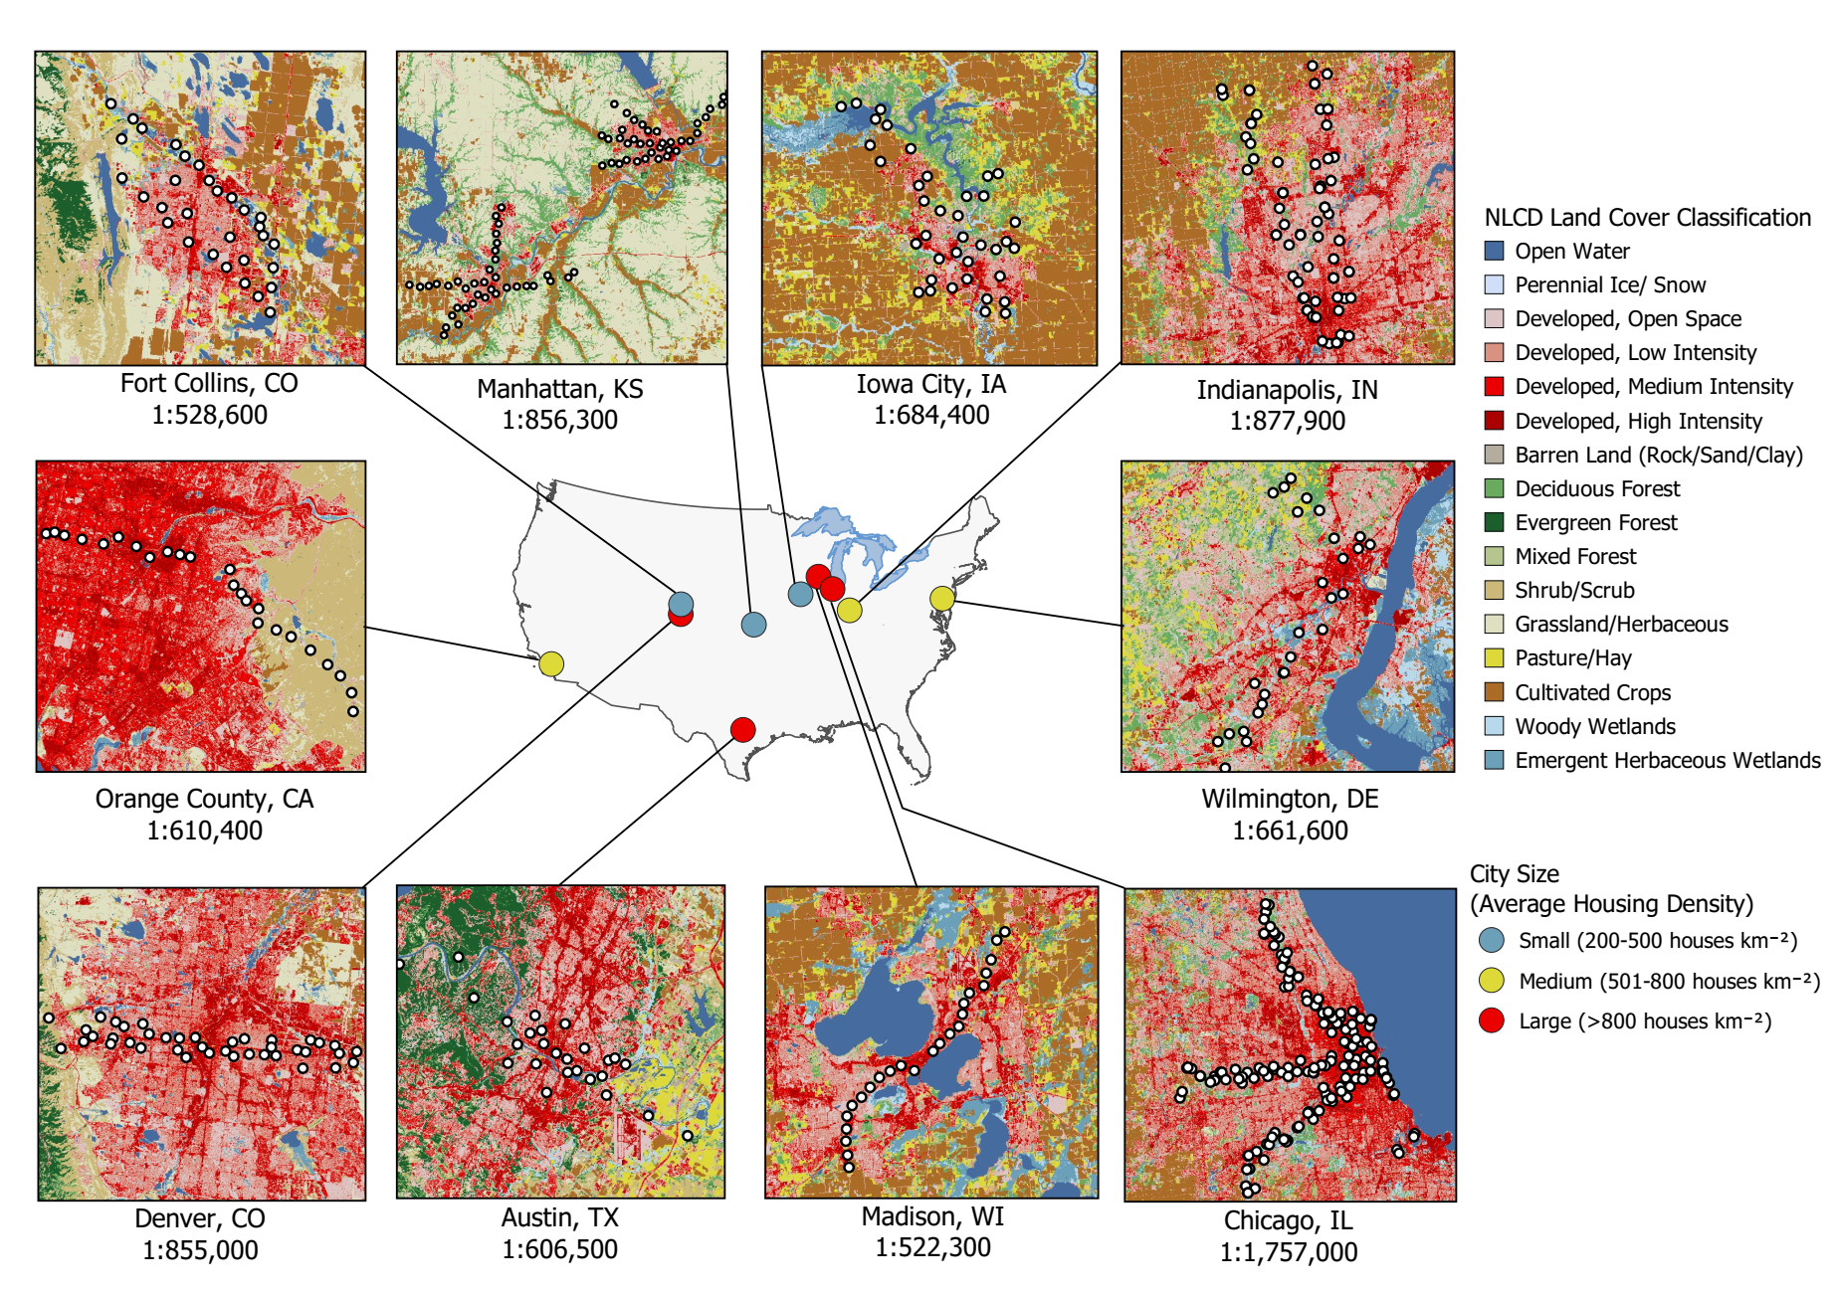

Fig. S1. Map of the ten cities sampled for this analysis. White dots within each subfigure represent camera trapping sites. Landcover images derived from the National Landcover Database.

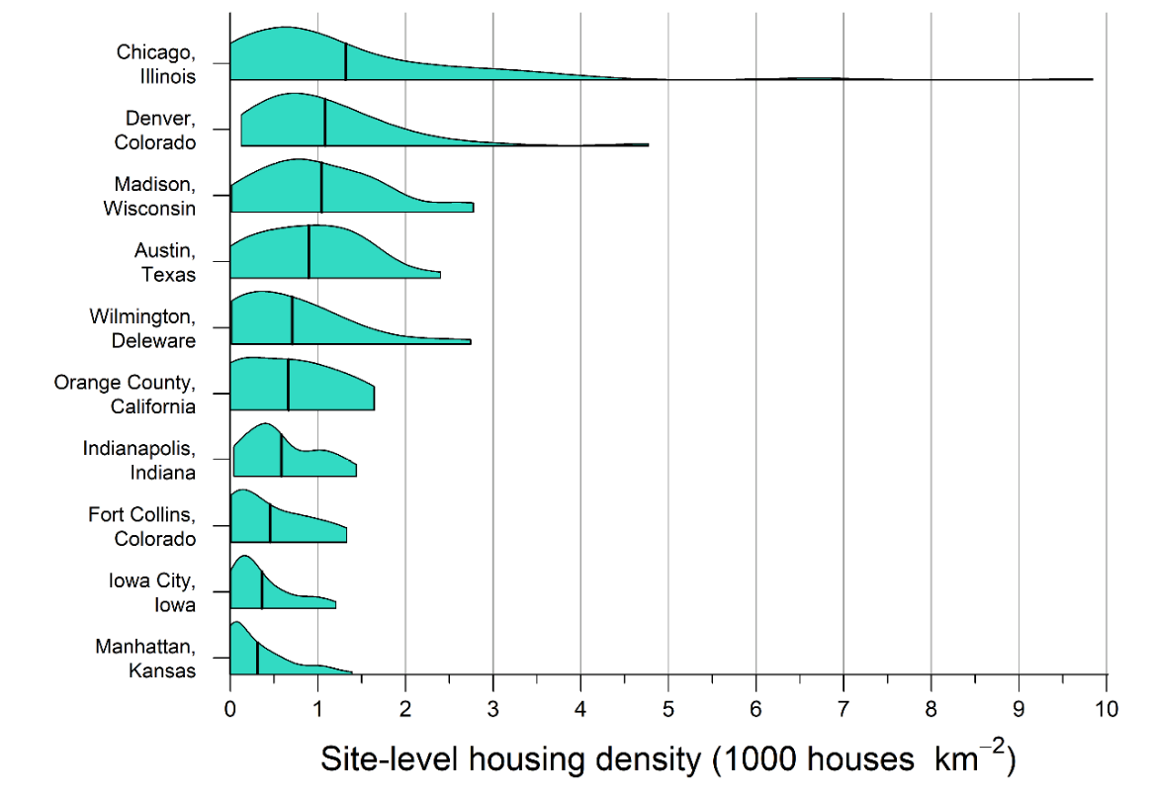

Fig. S2. The range and extent of within-city housing density measured at camera trap locations of 10 U.S. cities. Black vertical bars represent the mean housing density across all locations within a city. Housing density was calculated within a 1 km buffer of each camera trap location.

|  |  |  |  |
| --- | --- | --- | --- |
| **Table S1.** The number of functional sites with classified data per year and city. A dash indicates data were not available. | | | |
|  | Number of sites sampled | | |
| City | 2016 | 2017 | 2018 |
| Austin, Texas | - | 25 | - |
| Chicago, Illinois | 97 | 104 | 100 |
| Denver, Colorado | - | 40 | - |
| Fort Collins, Colorado | - | 31 | - |
| Iowa City, Iowa | - | 37 | 39 |
| Indianapolis, Indiana | - | 45 | 43 |
| Orange County, California | - | - | 24 |
| Manhattan, Kansas | 74 | 74 | - |
| Madison, Wisconsin | - | 23 | 24 |
| Wilmington, Delaware | - | - | 28 |

|  |  |  |
| --- | --- | --- |
| **Table S2**. The among-city covariates calculated for each of the 10 U.S. cities where camera trap data was collected. Cities are sorted by mean housing density. | | |
| City | Greenspace availability  (proportion) | Average housing density  (houses km-2) |
| Manhattan, Kansas | 0.63 | 310 |
| Iowa City, Iowa | 0.31 | 360 |
| Fort Collins, Colorado | 0.44 | 450 |
| Indianapolis, Indiana | 0.29 | 590 |
| Orange County, California | 0.42 | 660 |
| Wilmington, Delaware | 0.51 | 710 |
| Austin, Texas | 0.59 | 900 |
| Madison, Wisconsin | 0.24 | 1040 |
| Denver, Colorado | 0.39 | 1090 |
| Chicago, Illinois | 0.18 | 1320 |