What are Dungeness crab instars eating?

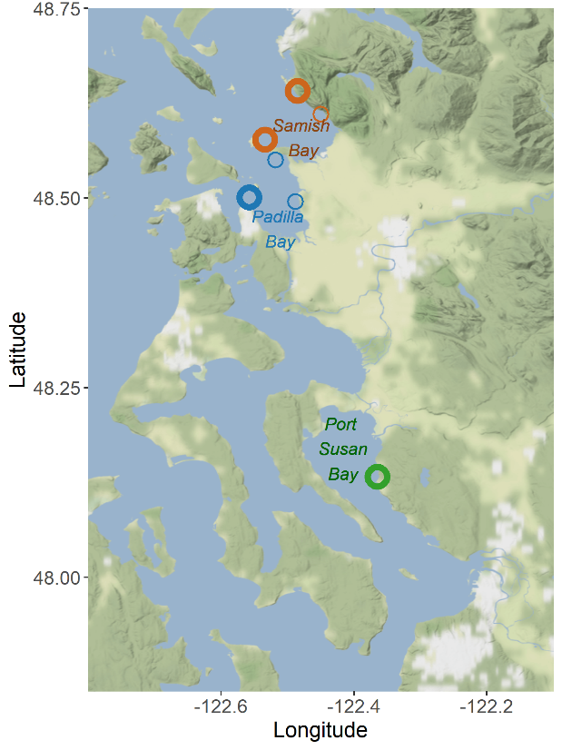High-resolution diet data can help us predict the indirect effects of land use and climate change associated with altered food webs. Yet there is very little diet information in the scientific literature for juvenile Dungeness crab at early instar stages. This is due in large part to the difficulty of visual stomach content identification for small organisms generally, and crabs in particular, which shred their prey while eating and possess a gastric mill to further grind down ingested material.

Sampling locations in Puget Sound

We used DNA-based diet analysis to determine what juvenile Dungeness crab consumed within the first few months of settlement. We collected 58 crabs (5-15mm carapace width; J1-4 instars) from three estuaries in northern Puget Sound in July and August 2021; we then extracted their stomach contents and conducted DNA metabarcoding of the cytochrome-oxidase I (COI) gene region. DNA metabarcoding uses high-throughput sequencing of a short DNA marker to simultaneously identify many taxa from a single sample.

## Results

**Dungeness crab instars are omnivorous, and are likely scavenging and/or consuming detritus.** The majority of taxa identified from crab stomach contents were arthropods (25%), followed by annelid worms (14%), diatoms (*Bacillariophyta*; 11%), and mollusks (11%).

**We identified 142 unique taxa present in 58 Dungeness crab stomachs**. 38 of these represented unicellular organisms, and 108 were multicellular taxa.

*Graph:* *Frequency of occurrence of taxa in crab stomachs (y axis), grouped by higher-level taxonomy (x axis).*

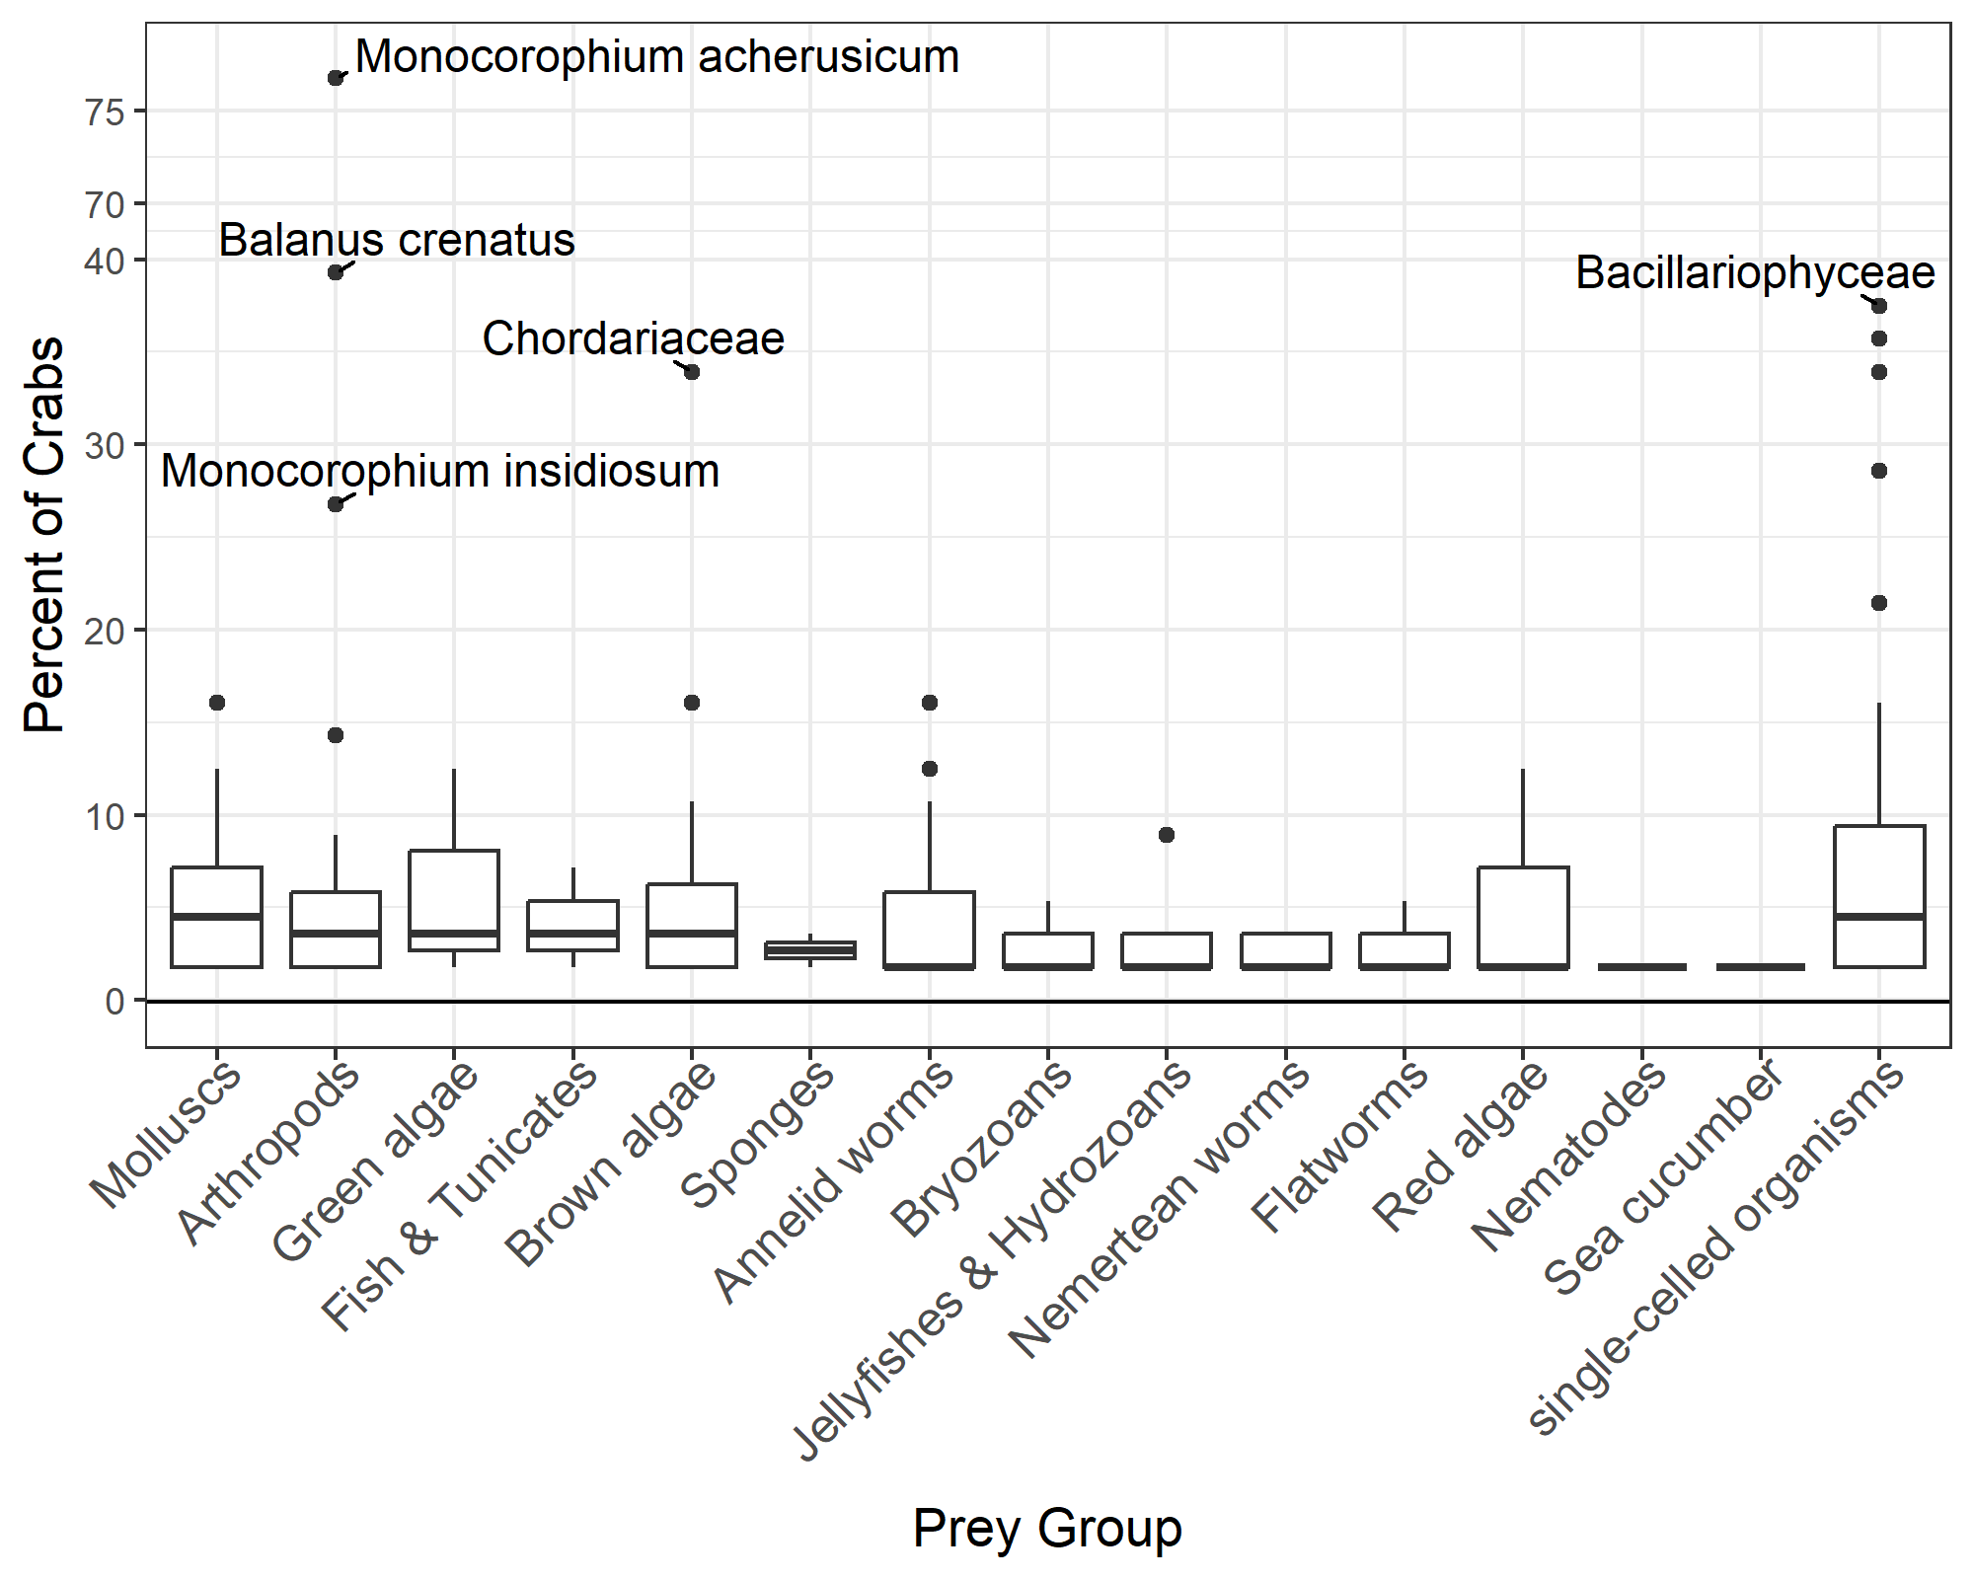

**We detected significant differences in crab stomach content composition between estuaries**, although there was also high variability between individuals collected in the same estuary. We found a weak but significant relationship between stomach content composition and crab size, such that crabs of similar carapace widths had more similar taxa in their stomach contents.

### Next Steps

(1) Test for a relationship between crab stomach content composition and habitat. (2) Calculate the risk to Dungeness crab instars from altered prey availability associated with ocean acidification.

Mary Fisher | [marfisher@ucdavis.edu](mailto:marfisher@ucdavis.edu)

*This research is in preparation for publication.* Co-authors: Ryan Kellya, Sarah Grossmanb, Claire Cookb, P. Sean McDonalda

(a) University of Washington (b) Swinomish Indian Tribal Community Fisheries Department

### Acknowledgements:

Crab collection was completed under WDFW Permit Fisher 21-190. Conceptualization of this project was based on research priorities identified by the Pacific Northwest Crab Research Group. Funding was provided by the American Fisheries Society’s Steven Berkeley Marine Conservation Fellowship. Field collection could not have been completed without the expertise and assistance of Beth Sanderson and Peter Kiffney at NOAA Fisheries, Karl Veggerby at the University of Washington, Emily Howe and Molly Bogeberg at The Nature Conservancy Washington, and Sylvia Yang at the Padilla Bay National Estuarine Research Reserve; additional thanks to Taylor Shellfish and homeowners of Samish Island for site access. Laura Nelson, Helena McMonagle, Audrey Malloy, Ben Bierle, Cameron Sokoloski, Jake Kuester, Morgan Arrington, and Polina Kritchko assisted with field collection. Eily Allen, Megan Shaffer, Maya Garber-Yonts, and Erin D’Agnese provided important feedback on laboratory methods and data analysis.