Requirements Specification

Solar Power Plant

Version | Change description | Person | Date
1.0 | Initial version | Carlos Martinez de la Riva | 27/09/2019
1.1 | Added some functions and pictures | Carlos Martinez de la Riva | 04/10/2019

Returned: _____________________
Checked: _____________________
Approved: _____________________

Table of Contents

1 Preword 3
2 General view 3
3 Functions 3
4 External interface 3
5 Other characteristics 4

Preword

The objective of this project is to design an easy-to-use user interface that allows you to monitor and control a solar power plant.

We have a 10-kW solar plant, which is ideally suited for smaller and decentralized installations. It is well suited for such purposes as rooftop installations.

This document will explain the components of the project, the software used in the development and the functions that the final product will have.

Special terms and abbreviations:

PV_Photovoltaic (PV Power, PV Cells...)
WRM 247+_Device used to remote management and control of the power station
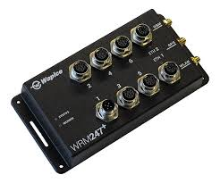

IoT-Ticket_Internet of Things application used for interface development

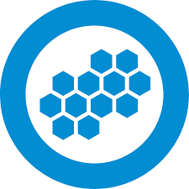

General view

The environment used is IoT-Ticket, which gives us the opportunity to present the station data to the user through widgets, in an easy and fast way. The platform supports remotely monitoring, control, automation and reporting functionalities.

Working together, is the WRM 247+ device, responsible for collecting the information remotely. Used as a part of Internet of Things platform, you can manage and control the target system from anywhere (via Ethernet).

The user will be able to watch real time parameters such as the energy produced, or the historical energy produced in the last month or year. This information will be shown in the dashboard, thanks to a dataflow editor that allows you to relate widgets and graphics with the information collected by WRM 247+ device.

That dataflow editor is based in block programming, by connecting blocks like timers, average blocks or mathematical operation blocks (sum, subtraction, square root, logarithm…).

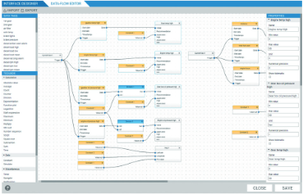

Functions
Each function shall be priorized from 1 (highest) to 5.

Reference | Description | Priorize
R1 | Daily Production (kWh) | 1
R2 | Current PV Power (an hour ago) | 1
R3 | Monthly Production (total) | 2
R4 | Annual Production (total) | 2
R5 | Annual Comparison | 4
R6 | Average Production | 4
R7 | Production Forecast (24h Following production) | 5
R8 | Co2 Avoided (kg)Average Production | 5

External interface

Below is shown an example of what could be seen on a display, in an easy and fast way. The user will be able to watch both current and historical information.

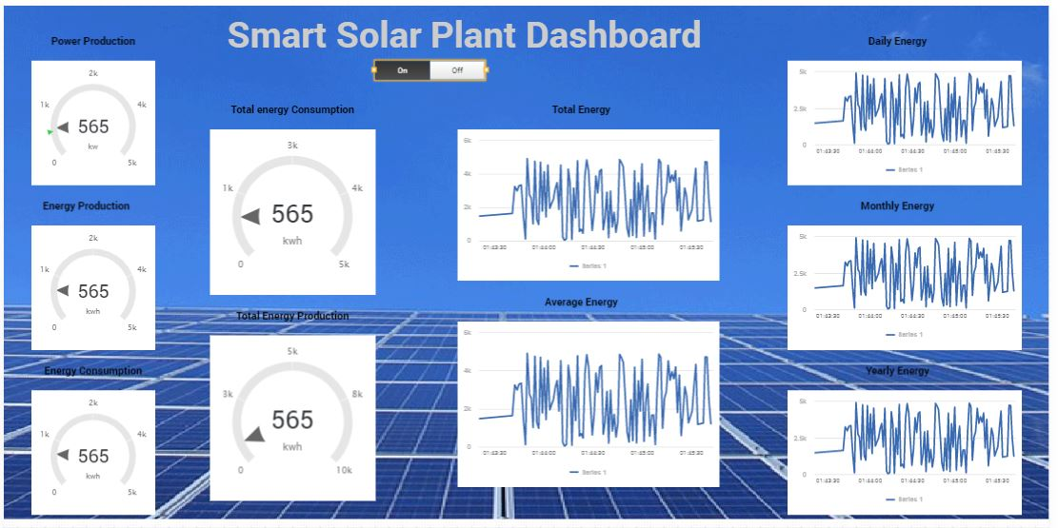
Dashboard designed with IoT-Ticket platform

Other characteristics
Non-functional requirements of the project
Characteristic | Describe
Connectivity | System should be monitored and controlled from anywhere with the application.
Availability | You must be able to access the system at any time.
Maintainability | The installation of the solar inverter is maintenance-free, but it´s recommended keeping clean the inverter.
Portability | WRM device is completely portable, but you must have the power source and an Ethernet cable. Highly recommended having the Wi-Fi antenna, weak connection instead.

