Technical specification
Table of contents
1 Technical specification
1.1 TABLE OF CONTENTS
1.2 INTRODUCTION
1.2.1 Purpose and scale
1.2.2 Definitions, notation and abbreviations
1.2.3 References
1.3 GENERAL DESCRIPTION OF THE SYSTEM
1.3.1 Description of application area
1.3.2 System interfaces to its environment
1.3.3 Hardware environment (description)
1.3.4 Software environment (description)
1.3.5 Agreements and standards
1.4 DESCRIPTION OF ARCHITECTURE
1.4.1 Hardware architecture
1.4.2 Software architecture, modules and processes
1.5 MODULE (HARDWARE PARTS) DESCRIPTIONS
1.5.1 Of each module (and process) the following is described:
1.5.1.1 General description
1.5.1.2 Interface
1.5.1.3 Implementation
1.5.1.4 Fault processing
1.6 REJECTED SOLUTIONS

Technical specification
Group: Solar Plant
Carlos Martínez de la Riva Valdaliso 20/10/19

TABLE OF CONTENTS

INTRODUCTION

Purpose and scope

The objective of this project is the creation of an application capable of monitoring and controlling a solar power station.

The application will be able to manage small stations, such as rooftop self-consumption plants (10-100 kW).

Definitions, notation and abbreviations

- PV_Photovoltaic (PV Power, PV Cells...)
- VACON 8000 SOLAR_ Solar inverters
- WRM 247+_Device designed by Wapice, works together with IoT-Ticket to control the solar plant.
- IoT-Ticket_Internet of Things application, used for interface development
- API_Application Programming Interface

References

- https://www.sunnyportal.com/Templates/Start.aspx?ReturnUrl=%2f
- https://omega.cc.puv.fi/redmine/projects/wiki-all-public-and-shared-documentation/wiki/IoT_Ticket_training
- https://www.youtube.com/playlist?list=PLkxzoaIdoqRwkknLyfYZRvrjAm8OtlXuA
- WRM247+_DataSheet
- VACON-8000-Solar-NXV0010 DataSheet
- VACON-8000-Solar-NXV0010 User Manual

GENERAL DESCRIPTION OF THE SYSTEM

Description of application area

The main application area is embedded and real-time systems.

Embedded systems connect a device with a computer, which interacts with a physical environment, and whose proper functioning does not depend on the actions of a human. One of the most important features is that the system must act quickly and with optimal use of resources.

On the other hand, real time application is a program that functions within a time frame that the user senses as immediate or current. The latency must be less than a defined value, usually measured in seconds.

System interfaces to its environment

The system will display in a simple, organized and concise manner a series of data related to the energy produced by the solar plant. From energy produced in real time, to graphs and charts with monthly and average production.
This is possible thanks to the IoT-Ticket software and the dashboard design, which will be explained in more detail in the section of Software environment

Hardware environment (description)

On the one hand, we have the solar inverters.
VACON 8000 SOLAR 10 kW series is a compact cabinet-assembled product line with integrated isolation transformers for maximum worldwide grid compatibility.
Solar inverters are a vital part of the configuration between solar panels and the general grid. The function of an inverter is simply to convert the captured photovoltaic power into AC, and feed it into the grid.

These solar inverters are ideally suited for smaller and decentralized installations, as rooftop installations.

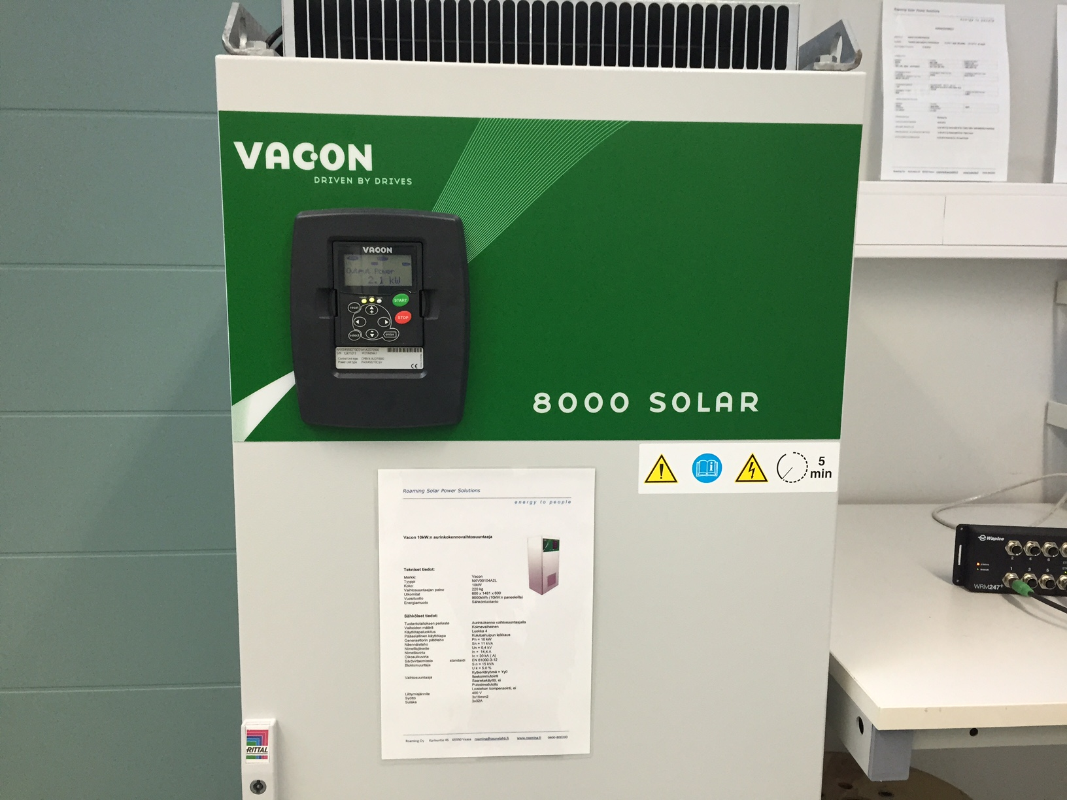
Inverter 8000 Module of Vacon Solar NXV0010

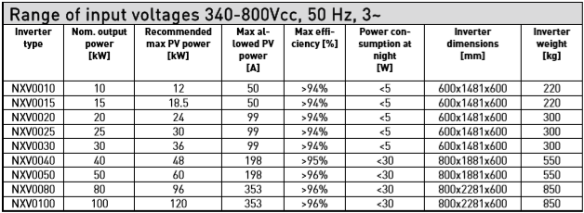
- Inverter ratings

- Keypad Buttons

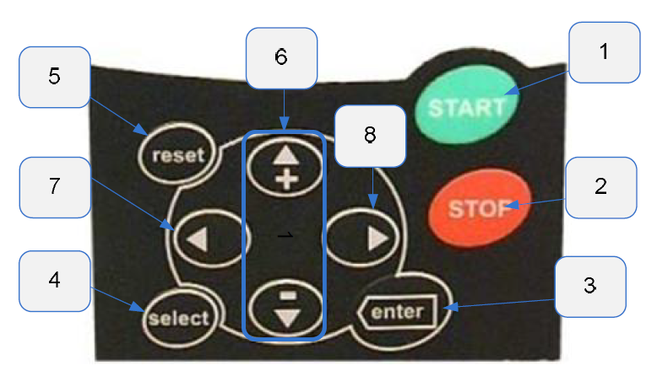

- Start Button

Pressing this button Unit goes to ready state in multi master system or if stand-alone configuration is used it goes ready state and if there is
enough DC voltage, it will try to run.

- Stop Button

Pressing this button stops the unit.

- Confirmation of selections/Fault history reset

- This button is used to switch between two latest displays. May be useful when you want to see how the changed new value influences some other value.

- This button is used to reset active faults.

- Browser button up and down. Browse the main menu and the pages of different submenus. Edit values.

- Menu button left. Move backward in menu. Move cursor left (in parameter menu). Exit edit mode.

- Menu button right. Move forward in menu. Move cursor right (in parameter menu). Enter edit mode.

On the other hand, we have WRM 247+ device. It is responsible of controlling, monitoring and managing our solar station. Created by Wapice, is used as a part of Internet of Things platform.

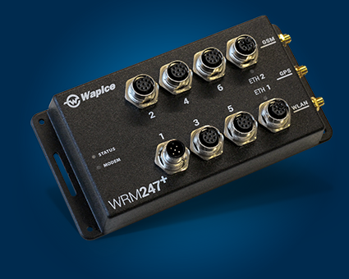
WRM247+ Device

Software environment (description)

We use rest API for fetching the data from different sources.

The main software tool used is IoT-Ticket.com, which is the platform for design and develops our interface.

IoT-Ticket Platform allows us to present user-friendly interfaces, through the design of dashboards. These dashboards are implemented by means of widgets provided by the platform, such as graphics, images, gauges, charts, tables or diagrams.

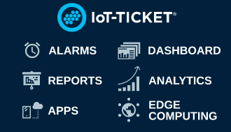

All those elements are connected to data with data tags and an extended dataflow editor, where you can use function blocks to implement logic and arithmetic operations.

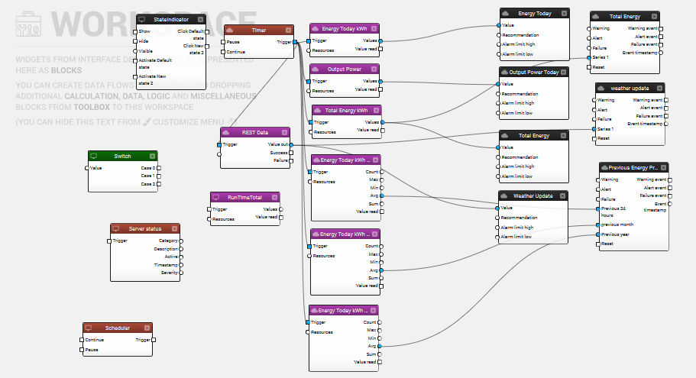
Data-flow editor
A user can interact securely with remote devices, check their status, view reports or get status updates on the current operational performance.

Agreements and standards
- EU Declaration of Conformity WRM 247+
https://www.wapice.com/services/electronics-design-and-embedded-systems/WRM247plus_EU_declaration_conformity_signed.pdf

- Grid Code Standards for Vacon 8000
-CGC/GF 001:2010
-G59
-GB/T 19964-2012
-NERC PRC-024-1
-IEEE 1547
-FERC 661A
-NT30

DESCRIPTION OF ARCHITECTURE

Hardware architecture

Basically, we use WRM247+ as a bridge between the solar inverters and our dashboard. It’s the data acquisition device, which collect the information of the plant for been showed in the dashboard.

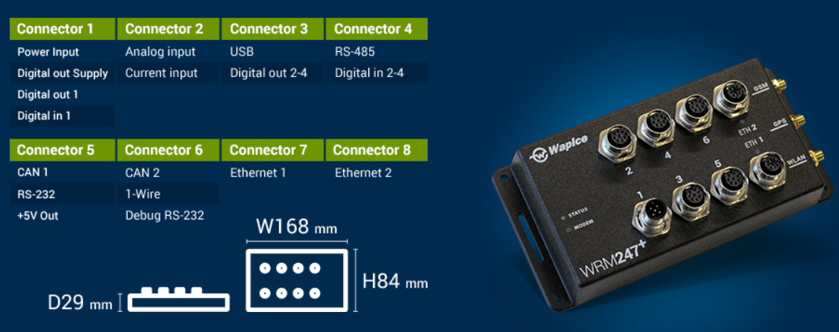

Software architecture, modules and processes

We are using IoT-ticket platform as a service or interphase for our system. Our WRM247+ module is going to sense the data from our Vacon 8000 Inverter and then, send the data into bigdata analytics server. By using those data from server, we can see those data in our created dashboard and then we can control and monitor those data.

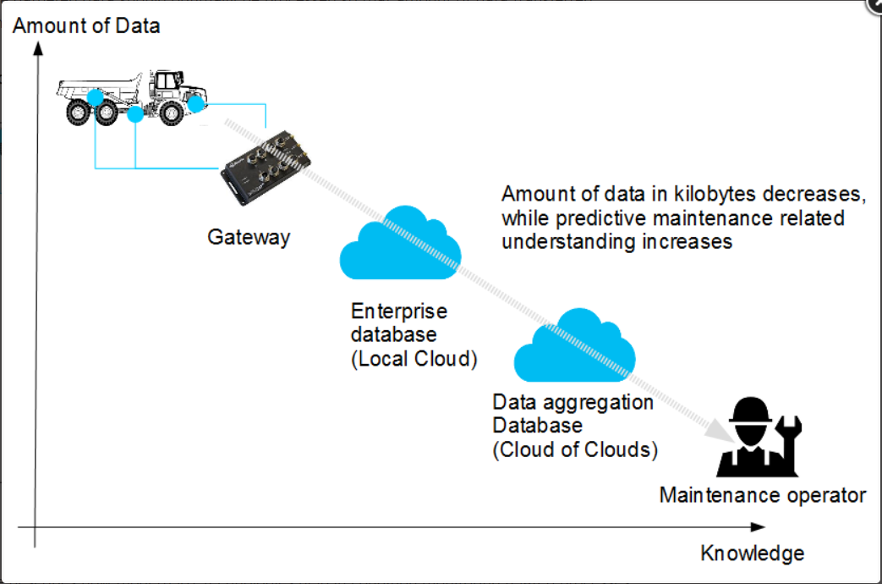

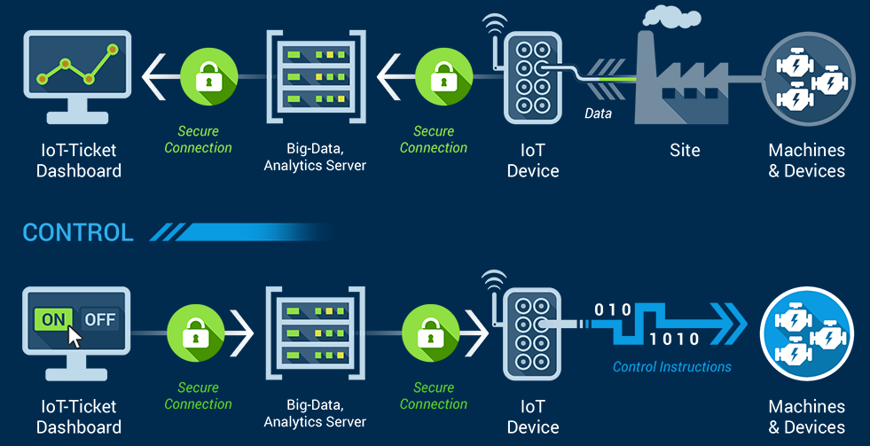

MODULE (AND SOFTWARE PARTS) DESCRIPTIONS

Of each module (and process) the following is described:

- General description
The architecture phase is the blueprint of our building process. First, we are going to analyze the requirements and functionalities. Then we are going to implement the task like design, coding, integration and testing.
- Interface
We are using iot-ticket.com interface for designing our dashboard.
- Implementation
For implementation we are using java rest client as our API.
- Fault processing
For processing software fault, we are going to use several testing methods and debugging method such as unit test.

REJECTED SOLUTIONS

No solution has been rejected.

