

Names of team members
NAME OF THE PROJECT
Project plan

Version history
Version | Change description | Person | Date

Returned: _____________________
Checked: _____________________
Approved: _____________________

Contents

1 INTRODUCTION 3
1.1 General Description of the Project 3
1.2 The Aim of the Project 3
1.3 Project Team 3
1.4 Right to the Deliverables of the Project 3
2 PHASES OF THE PROJECT 3
3 resource and time allocation plan 4
4 working methods and tools 5
4.1 Tools and Devices 5
4.2 Documentation Methods and Tools 5
4.3 Working Methods 5
4.4 Risk Management 5
4.5 Work Roles and Areas of Responsibility 6
4.6 Reference List 6
5 project control plan 6
5.1 Following the Status of the Project 6
5.2 Schedule 6

INTRODUCTION

General Description of the Project
<A short description of what is done during project and to whom>

The Aim of the Project
<Describe accurately what is delivered in this project>

Project Team
<Roles and contact information of all project members and the customer>
Role: (Manager, developer, controller ...)
Name:
Tel:
E-mail:
<Link to the common file area of the project>

Right to the Deliverables of the Project
<The system or parts of it can become financially important, so it is wise to make an agreement as early as possible, who will own the rights for the system software and HW design. >
<VAMK will hold all the rights for the system developed to be used as non-commercial ways, e.g. to be used for educational purposes without fees.>

PHASES OF THE PROJECT
<The oroject is divided into three phases, Prestudy, Prototype 1 and prototype 2>
<Each phase is divided into 10-50 tasks depending on the size of the project>
<The project plan is made into Redmine, which can be found on http://alpha.cc.puv.fi/dotproject/index.php>

<From Redmine the project schedule can be printed here>
Table 1. Project schedule
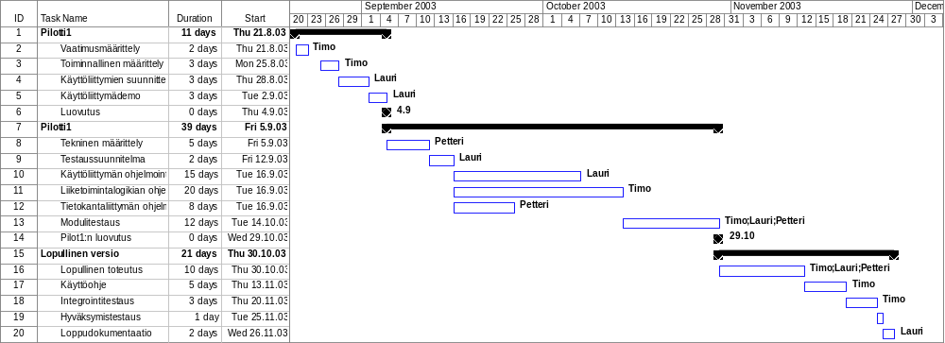

resource and time allocation plan
<The project resources are calculated for each person so that the workload is divided equally. The available allocated resource hours per people is calculated from the school time table by multiplying the scheduled hours by 2. For example, if students have 4 hours / week time for the course, then available hours are 2*4=8h/week>
Table 2. Resource and time allocation plan
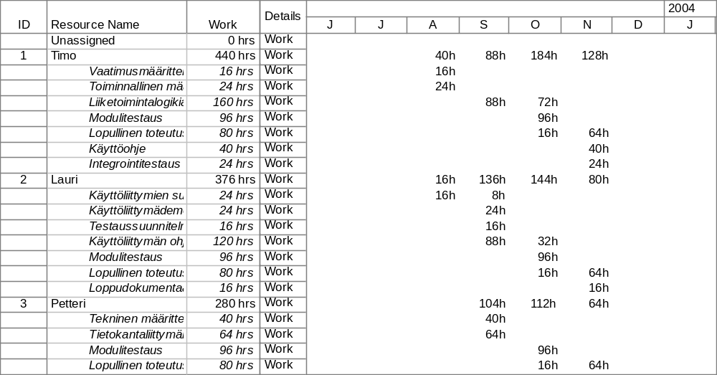

working methods and tools

Tools and Devices
<Needed devices and development tools, purchase plan and availability of them>
<Compilers, version control system, test equipment, development kits, etc. >

Documentation Methods and Tools
<The teacher of the course will deliver the Document templates>
<Document quality control methods>
<Documenting software and HW design>
<The ninutes of Review meetings and team meetings >
<Change control and reporting>

Working Methods
<Weekly team leader meetings, team meetings, phase reviews, etc.>

Risk Management
<How to do a risk analysis, risk plans, risk control>
<Use the following table to evaluate the risks in the project. Find at least 10 possible risks and estimate in scale 0-3 (3 is highest) the probability of the risk and impact of the risk. Multiply them and for each risk that will get a higher result than 3, some actions have to be planned to reduce the probability or impact.
Table 3. Risk analysis
Risk | Analysis | Action
Experience of persons making the estimation are weak | 2*2=4 | Create new estimates during project.
Major changes of requirements during project | 2*3=2.0 | Write down, priority and discuss with customer before project

Work Roles and Areas of Responsibility
<Define in detail the areas of responsibility for each member in the project environment. >

Reference List
<A compilation of used reference documents>

project control plan

Following the Status of the Project
<How to follow that the project is on time and all needed actions have been made. Following of the quality of the project deliverables, following of the resources allocation (not too much/little work for anyone)>

Schedule
<Milestones, deliverable delivery timetable, reviews, demonstration>
<Team biweekly control meetings>

