


Department of Electrical Engineering
Indian Institute of Technology Bombay
Mumbai 400076
April 16, 2018
TA: Romil Jain
Shubham Dhage
Faculty: Professor Shalabh Gupta
Theja Voora 150070052
Varun Bandaru 150070047
P.N.Aditya 150070044
IRNSS Receiver
Group BT 17

Abstract

The Indian Regional Navigation Satellite System(IRNSS) project was approved by the Indian Government in May 2006. This was done after the Indian military was denied access to the Global Positioning System(GPS) during the Kargil War in 1999. Seven satellites were subsequently launched which gave the capability of accurately determining location within India as well as in a region extending up to 1500 km from its boundary. However, receiver modules currently available in market are very expensive making them very unpopular. We aim to develop a cheaper alternative for the RF front end of the receiver circuit for the IRNSS L5 band centred at 1176.45 MHz.

Table Of Contents
Page Number
Abstract 2
1 Introduction 4
1.1 Block Diagram 5
2 Project Design 6
2.1 Subsystems 7
3 Project Implementation 8
3.1.1 L5 Band Antenna Design 8
3.1.2 LNA 9
3.1.3 SAW Filter 10
3.1.4 Mixer 10
3.1.5 PLL 11
3.1.6 GPS Chip 12
3.1.7 Power Board 13
3.2 PCB Design Strategies 13
3.3 Gain Calculation 14
4 Performance Evaluation 15
5 Conclusions and Future Work 21
6 Acknowledgements 22

Chapter 1
Introduction
The IRNSS, also popularly known as NAVIC (NAVigation with Indian Constellation), provides two levels of services namely, the 'standard positioning service' open for public use and a 'restricted service'(encrypted) for the military and other authorised users. The SPS signal is modulated by a 1 MHz BPSK signal, while the Precision service uses BOC(5,2). The satellites transmit dual NAVIC signals centred on the L5(1176.45 MHz) and S band (2492.08 MHz). Unlike GPS, the Indian model isn't affected by atmospheric disturbances and assesses the difference in delay of two frequencies. Hence it is more accurate than GPS.

Figure 1.1:
There are many applications of IRNSS, for example, Terrestrial, Aerial and Marine Navigation Disaster Management; Vehicle tracking and fleet management; Integration with mobile phones; Precise Timing; Mapping and Geodetic data capture; Terrestrial navigation aid for hikers and travellers; and Visual and voice navigation for drivers. IRNSS is also expected to play a major role in modernisation of Indian defence infrastructure, maritime security, transportation systems and implementation of smart city plans in India.

1.1 Block Diagram
The RF front-end has been designed with inspiration from the superheterodyne principle.
Figure 1.2: Block Diagram of IRNSS Receiver

The LNA (Low Noise Amplifier) amplifies the signals received from the antenna. The SAW (Surface Acoustic Wave) filter is necessary to suppress any out-of-band noise/interference. This L5 band signal is then translated to the L1 band by the mixer and a L1 band GPS chip is used for further processing, which includes translation to baseband and ADC. Moreover, IRNSS L5-band faces interference from GPS and Galileo signals which needs to be dealt with appropriately. This part is achieved by the software as the signals are “Code division multiplexed” and hence have unique “PRN” numbers associated with them.
Each subsystem is explained in detail in the further chapters.

Chapter 2
Project Design
2.1 Subsystems
- Antenna
For the Antenna to receive the IRNSS L5 band signals, it should meet the following specifications:
- Right Hand Circular Polarization (RHCP)
- Centre frequency at 1176.45 MHz
- 3 dB bandwidth of 24MHz around the centre frequency
- VSWR (Voltage Standing Wave Ratio) should be less than 2 and the axial ratio should be less than 3dB for the entire bandwidth for better reception of the signals.

- LNA
The low-noise amplifier(LNA), frequently found in radio systems, can amplify a very low-power signal (by around 20 dB) without significantly distorting the signal-to-noise-ratio(SNR). The significance of an LNA at the front-end of a RF receiver is justified by the Friis formula for noise. The LNA should be the first block placed after the antenna as its high gain helps reduce the noise figure of the complete chain to the following formula (higher terms will be negligible).
$$F_{receiver}=F_{LNA}+\frac{(F_{rest}-1)}{G_{LNA}}$$
The noise figure of the system can be improved by having a large gain in the LNA.

- SAW Filter
To improve the selectivity and the image frequency rejection of the system, a SAW front-end filter is placed between antenna and the receiver. Furthermore, the problem of receiver blocking and saturation in subsystems by powerful out-of-band interfering signals is prevented.

- Mixer and PLL
It is used for up converting the L5-band (1176.45 MHz) signal to the L1-band (1575.42 MHz) which is subsequently sent to the L1-band GPS chip. Since mixers are susceptible to image frequency ($2f_{IF}+ f_{RF})$, we opted to use 2751.87MHz LO frequency (high side injection) to avoid interference from GSM signals.

$$f_{LO}= f_{IF}+ f_{RF}$$

The PLL (Phase Locked Loop) generates the LO.

- GPS Chip
It consists of a quadrature mixer which down-converts the received L1 band signal to baseband I and Q components which are then sampled through an internal ADC and the raw bits thus obtained are sent for processing to a software through a serial interface.

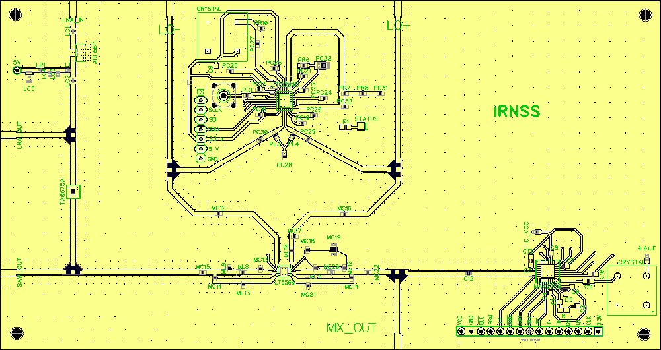
Figure 2.1: Our PCB layout

Chapter 3
Project Implementation
- L5-Band Antenna Design
A Microstrip Antenna (MSA) also known as patch antenna was designed to meet the above requirements. An MSA consists of a radiating patch on one side of a dielectric substrate and a ground plane on the other side. Radiation occurs due to the fringing fields between the periphery of the patch and the ground plane. MSAs generally have narrow bandwidth, allow both linear and circular polarization and are easily fabricated.

For an Electromagnetic wave to be circularly polarized, the Electric field must have two orthogonal components of equal magnitude and they must be 90º out of phase. A circularly polarized wave is said to have RHCP if the Electric field rotates in a right-hand sense with respect to the direction of propagation.

A circularly polarized MSA can be realized by exciting two orthogonal modes of equal magnitudes, which are in phase quadrature. The sign of the relative phase determines the sense of polarization (RHCP or LHCP). There are several designs to achieve circular polarized MSAs, a dual feed with a 3-dB two branch line coupler square MSA was designed and fabricated to receive the IRNSS L5 band signals.

A 3 dB two branch line coupler with Z₁=35Ω and Z₂=50Ω is used to provide equal amplitude with a 90º phase difference at the centre of the two adjacent edges of the square MSA. The coupler also provides isolation between the two feed points. The input impedance at the two adjacent edges (100 Ω) is transformed to 50Ω by using quarter wave transformers of
Z₀ = 70.7Ω. These are then connected to the two outputs of the coupler. By locating the feed point at either 1 or 2, LHCP or RHCP is obtained, respectively while terminating the other with a 50 Ω load.

The length of the square MSA was determined by using the formula
$$L=\frac{c}{{2f}_{c}\sqrt{E_{e}}}$$
Where c is the speed of light, f_{c} is the centre frequency and $E_{e}$ is the effective dielectric constant of the patch.
The value of $E_{e}$ is slightly less than $E_{r}$ because the fringing fields are not confined in the dielectric substrate but also spread in the air. It can be calculated from the thickness and dielectric constant ($E_{r}$) of the substrate.

ZELAND’s IE3D software was used for simulation of the antenna. After successive simulations, a square MSA with L = 62mm was used. The return loss (S₁₁) < -10 dB (corresponds to VSWR < 2 approximately) bandwidth of around 400MHz and axial ratio < 3dB bandwidth of 40MHz around the centre frequency (1176.45MHz) was obtained.
FR-4 substrate ($E_{r}$ = 4.4) of thickness 1.6mm was used for fabrication.

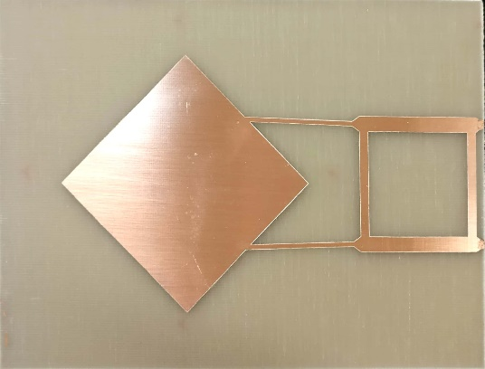
Figure 3.1: Antenna design (left) and the fabricated Antenna (right)

- LNA
The power of the signal received from the antenna is around –159 dBW. To efficiently extract our signal in the presence of a –130 dBW noise floor, it is essential not to degrade SNR (Signal to Noise Ratio) any further. We would need to obtain a gain of 100 dB from our front-end to get output power in the order of mW. As a general rule of thumb, a gain stage of atleast 10 dB above the Noise Figure of the mixer is required before the mixer. However, too much of gain can lead to saturation in the later stages and should be avoided.

We used ADL5611 in our design since it was available directly from the Communications Lab. It has a fixed gain of 22.2 dB and a decently low noise figure of around 2.1 dB. Also, its impedance is internally matched to 50 $Ω$ saving us the trouble.
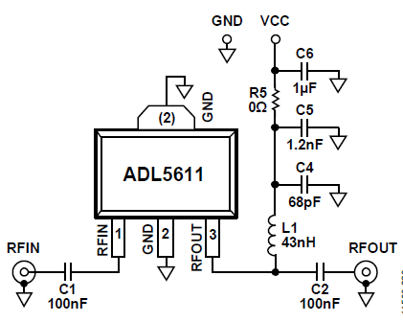
Figure 3.2: LNA Circuit Connections

- SAW
We used TA0675A in our design. It has a 3 dB bandwidth of 20 MHz with centre frequency at 1176.45 MHz. Since we are targeting only civilian applications, we only require 2 MHz bandwidth (the military service occupies 24 MHz of bandwidth). No impedance matching was required for the SAW filter too as both the source and load impedances were equal to 50 $Ω$.

Figure 3.3: SAW Filter Circuit Connections

- Mixer
One of the major selection criteria for our mixer was the frequency ranges of the input, output and LO ports. The LT5560 is a broadband active mixer (supports upto 4 GHz and has a small conversion gain of 1-2 dB) and is suited for both up and downconverting applications. It has a noise figure of around 9.3 dB.

For the mixer, we needed to use impedance matching circuits and used lumped element baluns to realize these networks.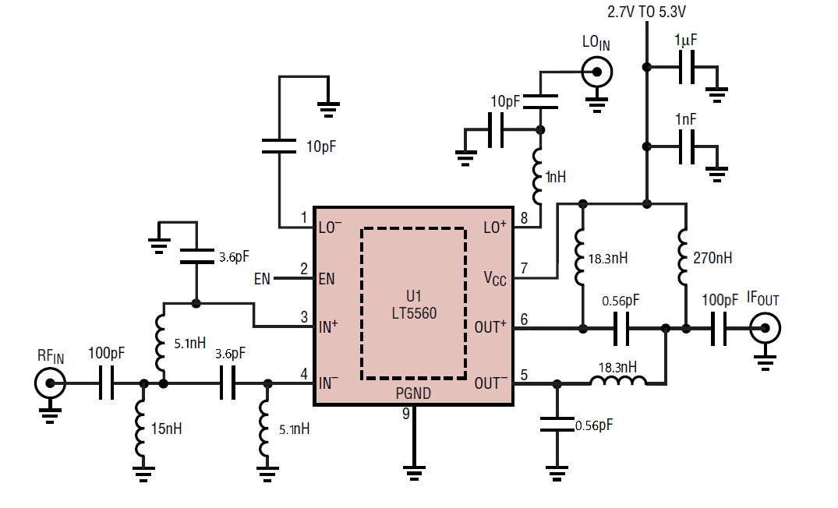
Figure 3.4: Mixer Circuit Connections

- PLL
We used the LTC6946 (the same is also used in the IQ modulator board).
$$f_{LO}=f_{REF}× \frac{N}{R}$$
Using a simple C code, we were able to determine the values for N, R for a LO frequency of 2751.87 MHz. The PLL IC is then to be programmed, via SPI communication, using the development board of the PIC18F2455 microcontroller. The components in the loop filter and impedance matching circuits were calculated based on the guidelines specified in the datasheet.
Figure 3.5: PLL Circuit Connections
- GPS Chip
We have used the MAX2769C GPS receiver chip which is custom made for L1 band based positioning system. However, once the desired signal has been translated to its domain, it is highly efficient in terms of the gain it provides(maximum of 96dB) as well as the space it takes. It has LNA, mixer, PLL and ADC , all integrated on it. Since we were already using external LNA, we bypassed its internal LNA and directly fed the signal to its quadrature mixer. This mixer down-converts the signal(centred around 1575.42 MHz) to baseband level. This baseband frequency can be programmed by setting certain registers inside it. For this down-conversion to take place, LO is needed, which is generated via a Fractional-N PLL. We wish to employ downside LO injection.
Thus,
f_{LO} = f_{RF} – f_{BB}
A reference frequency of 10 MHz is fed to the PLL via a crystal oscillator and the values of the registers corresponding to the numerator(MDR) and denominator(RDR) of the multiplying factor are set so that
10$×\frac{MDR}{RDR}$= f_{LO}
Following the mixer, it also consists of a bandpass filter whose passband too is programmable. After setting the ADC sampling rate as well as the quantisation (number of I and Q phase bits to be generated), we finally obtain the bits which are sent to a storage device via a serial interface. The software then computes the location and time using this data.
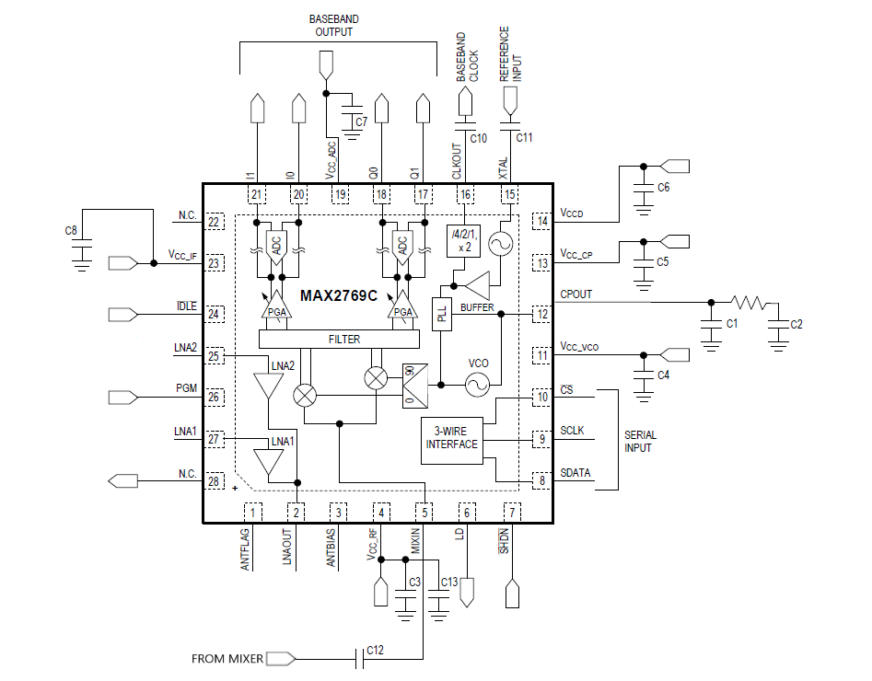

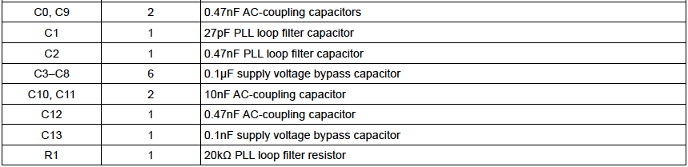

Figure 3.6: GPS chip circuit connections

- Power Board
We needed 5V, 3.3V and 3V supplies to power the board. We used LM7805, LM1117 and LM317 voltage regulator ICs respectively to obtain the specified voltages from a 12V power supply. LEDs are also placed for identification of any power supply related problems.
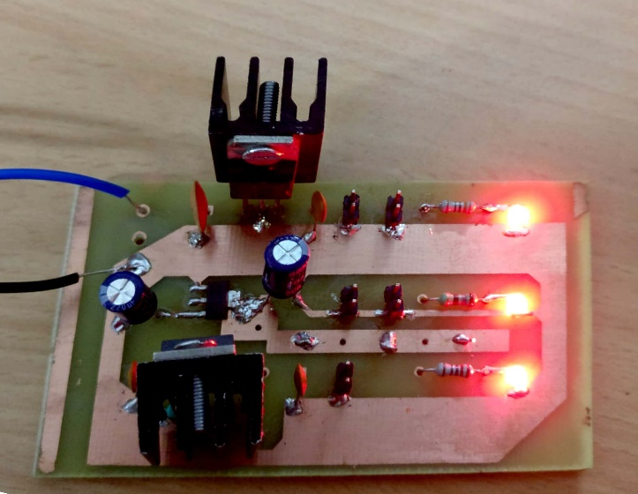
Figure 3.7: Power Board

PCB Design Strategies
RF PCB design isn’t very straightforward and requires some general guidelines to be followed.
- The routes behave as transmission lines and it is essential to maintain the impedance of the lines to 50 $Ω$ (standard) to prevent attenuation of signal. We used a coplanar waveguide impedance calculator to determine width of the transmission line and the separation from ground.
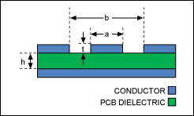
Figure 3.8: Coplanar waveguide with ground.
- It is recommended to liberally add lots of vias on both sides of the coplanar waveguide. This will ensure that the fringing fields from a trace are immediately drained to the ground before they can interfere with the neighbouring lines. Following a general rule of thumb, we maintained a separation of less than $\frac{λ}{10}$ between vias.
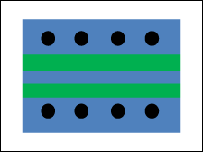
Figure 3.9: Via Fences
- Coppers pours were used to taper the line’s width down to meet a pin so that the impedance change is gradual.
- Making the design modular helps in testing of individual components. We placed some pads to be soldered for connecting subsystems.
We used a reflow oven (available in the Communications Lab) to solder the ICs.

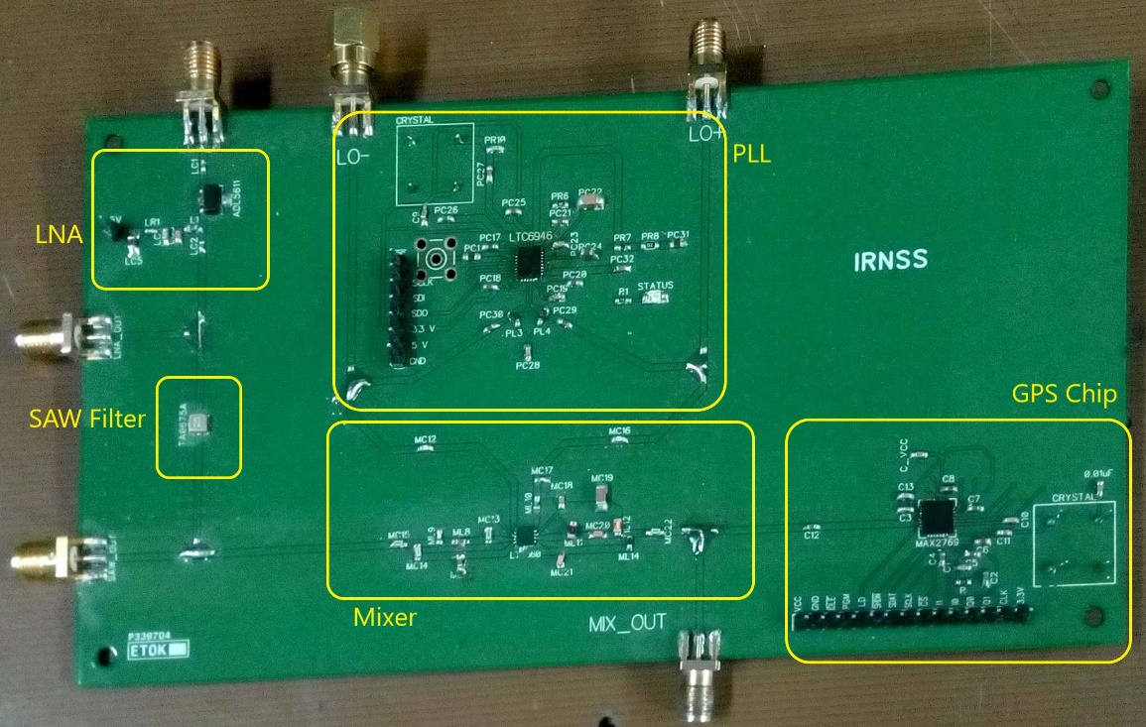
Figure 3.10: Fabricated PCB of our IRNSS receiver

Gain Calculations
Component | Gain(dB) | Noise Figure(dB)
LNA | 22 | 2.2
SAW Filter | -3 | 3.3
Mixer | ($≈)$0 | 10
GPS Chip | 96 | 10.3
Net | 115 | 2.33

Overall Noise Factor of the cascade (using Friis formula)
$$= {10}^{0.22}+\frac{{10}^{0.33}-1}{{10}^{2.2}}+\frac{10-1}{{10}^{2.2}*1}+\frac{{10}^{1.03}-1}{{10}^{2.2}*{10}^{9.6}} = 1.723 (Theoretically)$$
Therefore, Noise Figure = 2.33dB
Chapter 4
Performance Evaluation
- Antenna Testing
Testing of antenna was done in Communication lab and Antenna lab.
In communication lab, testing was done using Signal Hound Spectrum Analyzer and Tracking Generator on Spike software.

Measuring Return loss
- A directional coupler is used to make Return loss (S₁₁ parameter) measurements
- The Tracking generator is connected to the directional coupler’s OUT port.
- The Spectrum Analyzer is connected to the directional coupler’s COUPLED port.
- The IN port is used as the test port and is left open initially.
- By clicking Store Thru, the sweep is normalized to 0dB.
- Then the antenna is connected to the IN port and the Return loss is plotted.

The S₂₁ parameter was measured by connecting the Tracking generator to a source antenna and the Spectrum Analyzer to a test antenna. A difference of around 8dB in S₂₁ parameter between source co-polarization and source cross-polarization was observed. This ensures the RHCP of the MSA.

The radiation pattern was also observed by fixing the source antenna and slowing rotating the test antenna and noting down the measured S₂₁ parameter values at every 5º interval.

In antenna lab, the testing was done on a Vector Network Analyzer. The analyzer was initially calibrated before testing and the S₁₁ parameter, VSWR and Smith Chart were observed.
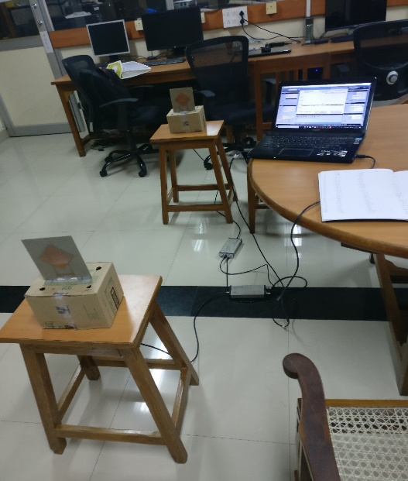
Figure 4.1: Antenna Testing Setup in Communications Lab
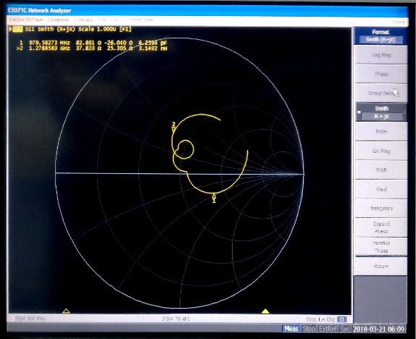
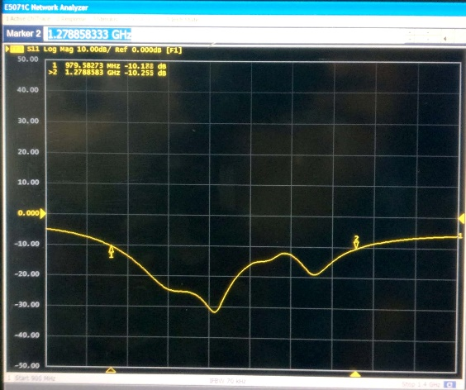
Figure 4.2: S₁₁ parameter Figure 4.3: Smith Chart
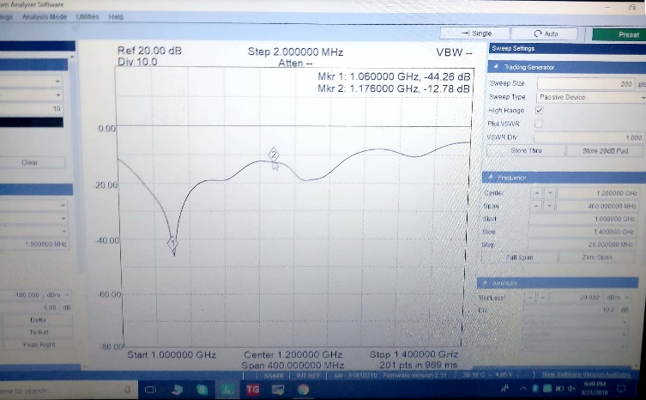
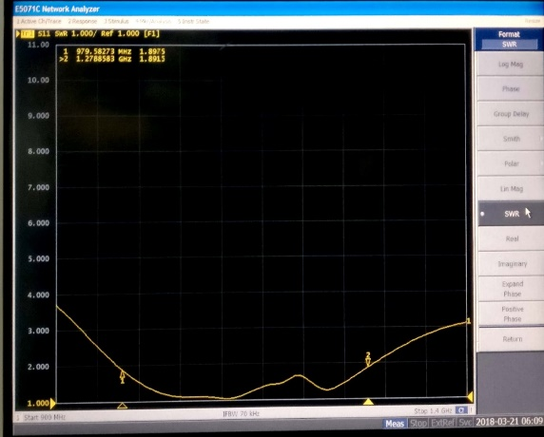

Figure 4.4: VSWR Figure 4.5: S₁₁ parameter

Figure 4.6: S₂₁ parameter
- LNA Testing
The LNA was tested using a VNA (Vector Network Analyser) in the
Communications Lab. We were able to obtain a gain of around 20.5 dB at our centre frequency 1176.45 MHz.

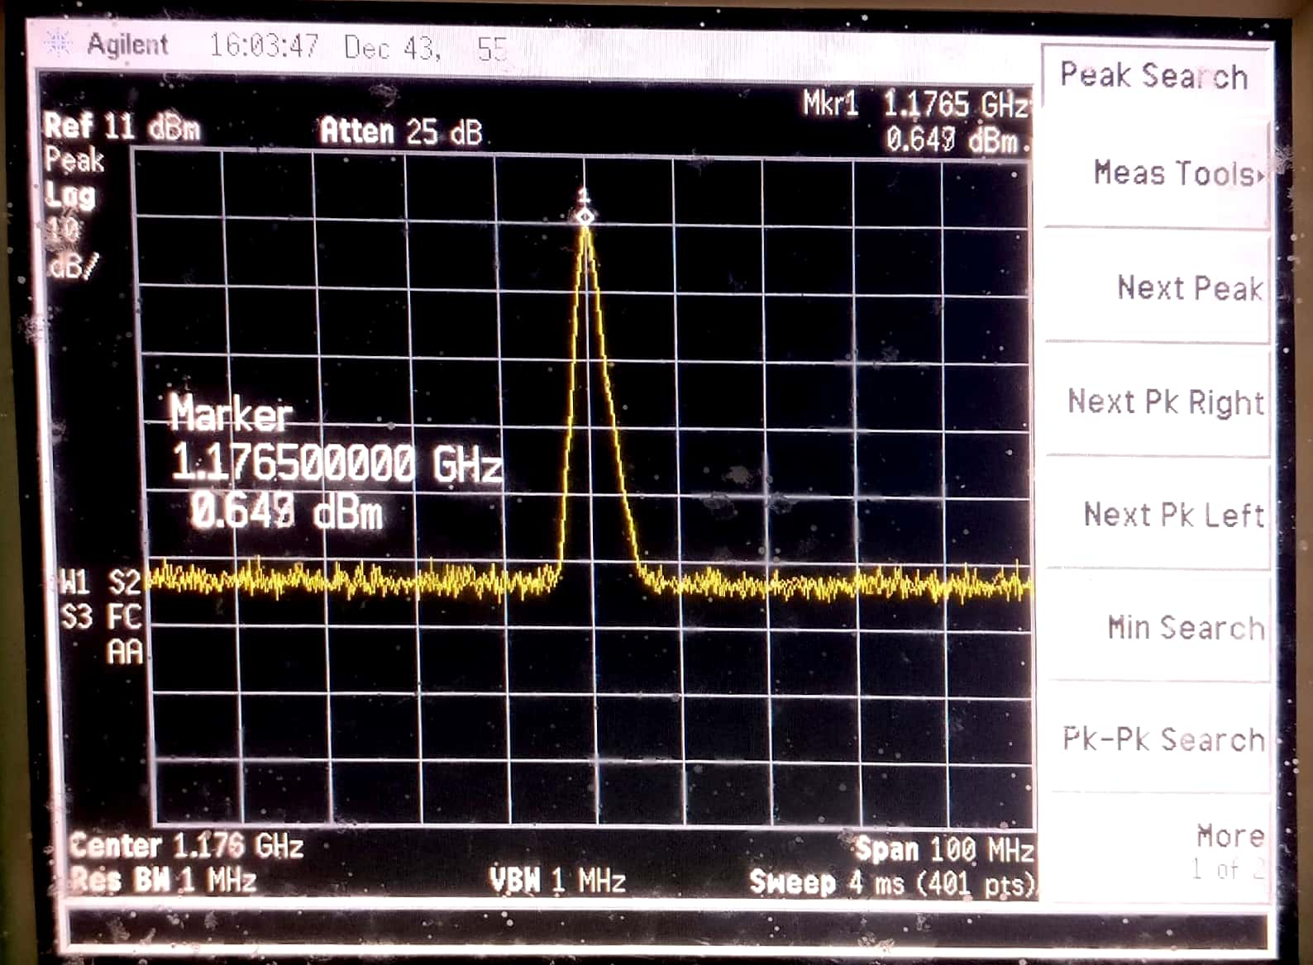
Figure 4.7: LNA Gain Testing

- SAW Filter Testing
We performed similar tests on the SAW filter at different frequencies and plotted its frequency response.

Figure 4.8: SAW Filter Testing

- PLL Testing
The STATUS LED indicates proper locking of PLL. For testing, one end of the PLL output was connected to a 50 $Ω$ terminator and the other end was connected to the Spectrum Analyser via a co-axial cable.

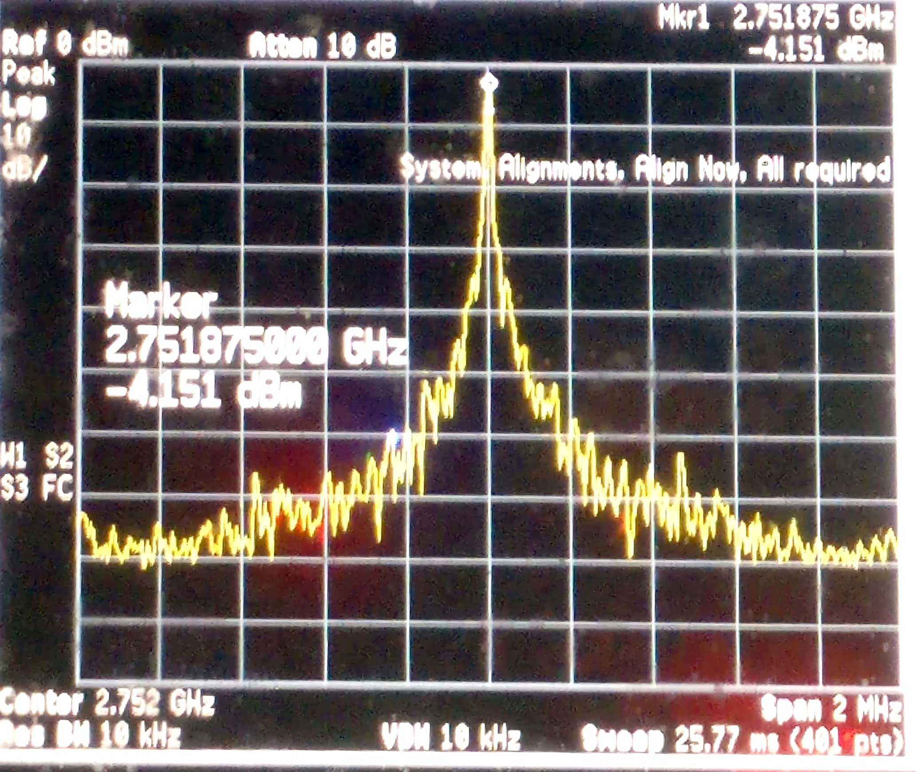
Figure 4.9: PLL Testing

- Mixer Testing
For the mixer, however, the dual-ended LO from the PLL was connected to the LO port of the mixer (We also tried supplying single-ended LO to the mixer. Better results, in terms of gain and leakage, were obtained for dual-ended LO).
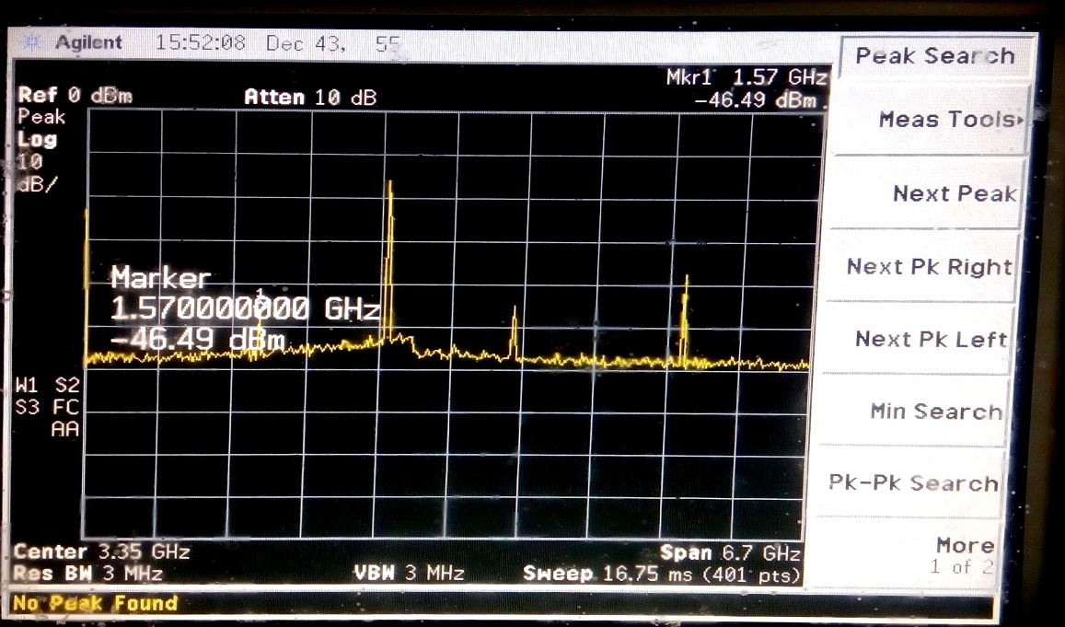
Figure 4.10: Mixer Testing
Although a peak in the output spectrum was observed at the L1 band (1575.42 MHz), there was a significant degradation in the conversion gain. -17 dB gain was observed as opposed to the 1-2 dB gain specified in the datasheet. The S₁₁ parameter for the input port of the mixer was observed to be around -5 dB, indicating a impedance mismatch. However, we believe that this loss in power of signal can be compensated by adding another gain block (LNA) before the mixer.
- GPS Testing
Unsuccessful.

Chapter 5
Conclusions and Future Work
Although we were unsuccessful in completely implementing the front-end receiver, we managed to implement majority of the subsystems. We drew some conclusions from our journey and observed significant scope for future work.
- We used reflow soldering for the ICs. In retrospect, this was a poor decision as most of them did not get properly soldered and we had to re-solder most of them. We wasted quite a lot of time in the process. However, other teams who used the reflow technique only for passive elements (R, L and C) found success.

- Although all our major subsystems (except for the antenna) are packaged on a single board, we had initially planned to implement the entire receiver on a single PCB. We used a separate power board and a development board for the micro-controller due to the shortage of time.

- We spent great attention to very small details in our PCB design. We picked up various rules of thumb from a lot of sources and ran multiple iterations to come up with our final design. During the testing process, we found out that most of these rules were not very significant and caused only minute losses if violated. We could have saved a lot of time had we stuck to the original PCB design guidelines provided by Prof. Shalabh.

Acknowledgements
This challenging project would have been very difficult to proceed with had it not been for the constant technical guidance and motivation of our instructor Prof. Shalabh Gupta. The WEL lab staff consisting of Maheshwar Sir, Shekhar Sir and Suraj Sir took a lot of pain to address all sorts of problems with regards to PCB order, components’ availability and soldering issues, posed by us. We would also like to thank Prof. Joseph John and the entire faculty team of the Electronic Design Lab, Spring 2018 for teaching us the importance of documentation and a proper work ethic. We are also grateful to Ms. Rinkee and Vinay Sir in the antenna lab for assisting us in antenna design and suggesting some important technical modifications to the PCB design. Finally, we would like to thank all Communication Lab RAs who assisted us in our project by helping us find some crucial components as well as giving us some important tips regarding RF circuit design and testing.

Voora Naga Sree Theja, Sai Varun Bandaru, P.N.Aditya
Indian Institute of Technology Bombay
16 April 2018

