1 Displacement Detection from GNSS Kinematic Positioning Using Bayesian

2 Inference for Deformation Monitoring

3 Nan Shena, Liang Chena,∗, Ruizhi Chena

4 *aState Key Laboratory of Information Engineering in Surveying, Mapping and Remote Sensing, Wuhan University, Wuhan 430000, PR China*

5 **Abstract**

Displacement is an important parameter in engineering analysis in structural mechanics and geomechanics. For decades, displacement detection based on the Global navigation satellite system (GNSS) has increasingly been im- portant for a wide range of applications, from landslide monitoring, subsidence survey, to industrial measurement. However, due to the influence of measurement noise, it is still a challenge to identify and extract displacement from GNSS kinematic positioning results. To resolve this, we propose a novel displacement detection approach with the purpose of identifying and extracting displacement from GNSS kinematic positioning. Specifically, we use the Bayesian inference model to obtain the displacement change time from the coordinate time series of GNSS kinematic positioning. By investigating the posterior distribution of the designed change point parameter, we can identify the change points. Furthermore, we derive the mean value from the posterior distribution of the mean parameter, and fur- ther obtain the displacement. Results from simulation and field experiments have demonstrated the effectiveness and flexibility of the proposed method. For significant displacement, it can be clearly identified; for small displacement, it can be identified by adding an interval constraint prior. The accuracy of up-displacement extraction from GNSS real-time kinematic positioning can reach within 2 mm in 15 minutes.

6 *Keywords:* GNSS, displacement detection, Bayesian inference, Markov Chain Monte Carlo, real-time kinematic

7 positioning

8 **1. Introduction**

9 In recent decades, the Global navigation satellite system (GNSS) has been widely used in surveying, civil avia-

10 tion, and autonomous vehicle as a positioning method[1, 2]. Besides, as a displacement detection method in defor-

11 mation monitoring, GNSS has been widely applied to engineering fields such as landslide monitoring[3], subsidence

12 survey[4], industrial measurement[5]. Displacement is an important parameter in engineering analysis in structural

13 mechanics and geomechanics[6, 7]. Compared with traditional displacement detection technology, GNSS-based dis-

14 placement detection has many advantages, such as real-time, high precision, and weather independence[8]. With the

15 development of the Internet of things (IoT), GNSS high-precision positioning technology, and GNSS enhanced infor-

16 mation transmission protocol, high-precision GNSS positioning results can be transmitted to the cloud in real-time.

17 There are many researches on displacement detection based on GNSS, which can be divided into two categories.

18 The first category is about the research of measurement technology in GNSS-based displacement detection. To

19 evaluate the performance of single base station real time kinematic(RTK) and network real time kinematic(NRTK) in

20 displacement detection, the data of different observation duration were compared[9]. The results showed that NRTK

21 has advantages in accuracy and robustness. A displacement monitoring system was designed to evaluate NRTK for

22 displacement detection[10]. The results showed that NRTK can achieve an accuracy of 4.7 mm and 7.9 mm in the

23 horizontal and vertical directions respectively. In [11] and [12], the feasibility of displacement detection for landslides

24 using precise point position(PPP) has been studied. The results showed that PPP can be capable of detecting large

∗Corresponding author

*Email address:* [l.chen@whu.edu.cn](mailto:l.chen@whu.edu.cn) (Liang Chen)

*Preprint submitted to Mechanical Systems and Signal Processing September 21, 2021*

25 landslides. Moschas et al.[13] studied the extraction of strong motion displacement waveform by PPP and evaluated

26 it through free vibration experiments. These results show that 10 Hz PPP-GPS is very useful for seismic engineering

27 and can be safely used to reconstruct the deflection waveforms of various points on the ground and structure during

28 strong motion. Zhang et al.[14] introduced Galileo augmenting GPS single-frequency single-epoch precise posi-

29 tioning method with baseline constrain for bridge dynamic monitoring, to improve the positioning availability and

30 reliability, as well as narrow the search space, and increase the success rate of ambiguity resolution and positioning.

31 Xue et al.[15] comprehensively evaluated multi-GNSS low-cost receivers for deformation monitoring and concluded

32 that the potential improvement of the precision of the low-cost receiver by using multi-GNSS measurements and a

33 GNSS base station with a geodetic antenna. There are also some studies using the time-differenced carrier phases

34 (TDCP) technique[16, 17] to obtain velocity estimates for displacement detection. This kind of method obtains dis-

35 placement by integrating velocity, which is mainly used in displacement detection and extraction of large earthquakes.

36 In general, the above research mainly focuses on how to improve the positioning accuracy, and the research on how

37 to identify and extract the displacement from the coordinate sequence obtained by GNSS is limited.

38 The other category is about displacement detection research based on GNSS. There are many studies on the use of

39 high-rate GNSS for structure displacement extraction and parameter identification. Psimoulis et al.[18, 19] studied the

40 feasibility of using GNSS for structural vibration detection. Experiments were carried out to evaluate the use of Global

41 positioning system (GPS) to determine the parameters of oscillation of major structures. Meng et al.[20] presented the

42 challenges faced by the design and implementation of a new monitoring system for large bridges. Damage detection

43 in SHM of long-span bridges is very challenging because there is no general damage definition, and damage is usually

44 unique and bridge-specific. Psimoulis et al.[21] presented an algorithm named RT-SHAKE to detect ground motions,

45 which aims to detect seismic motion more sensitively and robustly. There are also studies on the relationship between

46 receiver parameters and high-rate GNSS measurement[22, 23]. Ha¨berling et al.[22] argued that due to the large error of

47 dynamic GNSS measurement if high-rate GNSS is to be a valuable tool for seismic displacement measurement above

48 1 Hz, the baseband parameters of the GNSS receiver must be considered. Moschas et al.[23] studied the relationship

49 between the phase-locked loop(PLL) bandwidth and noise in 100 Hz GPS measurement. The results show that the

50 measurement correlation decreases with the increase of PLL bandwidth from low to high to 100 Hz. Shen et al.[24]

51 gave a more detailed review of dynamic structural health monitoring technology based on GNSS. There are also

52 studies on displacement detection such as landslide, and GNSS is usually used as a static positioning method. Gili

53 et al.[25] was one of the first landslide monitoring studies using GNSS technology, in which traditional measurement

54 data were used as a comparison. The results showed that the accuracy of the GPS measurement over a period of 26

55 months was 12 to 16 mm in the horizontal plane and 18 to 24 mm in the elevation. A prototype of a low-cost GNSS

56 has been developed for deep-seated landslide monitoring[26]. The results of a nine-month of field monitoring period

57 provided a detailed insight into the spatial and temporal pattern of deep-seated landslide surface movements, in which

58 the displacement was obtained by the direct difference between the coordinates of the start and end periods. Betti et

59 al.[27, 28] studied the use of the Bayesian approach to evaluating deformation from GPS time series, in which a test

60 procedure was constructed under the Bayesian framework. However, in this method, only specific epochs are tested,

61 and how to identify these epochs is not involved. There are also some studies on the significance analysis of the GNSS

62 control network based on the Bayesian test, and the control network processing results are generally based on repeated

63 static adjustment.

64 GNSS-based displacement detection is generally performed by the time-domain difference of GNSS positioning

65 results[29, 26]. The positioning results can be obtained from repeated GNSS static measurements, and the repetition

66 period is generally one day to several months. This kind of displacement detection is called long-term displacement

67 detection. In addition, real-time or near real-time detection can be obtained by using GNSS kinematic positioning

68 results, which is called short-term detection. At present, there are few studies on displacement identification and

69 extraction of GNSS kinematic positioning time series. In [30], a multiple Kalman filters model was proposed for de-

70 formation detection in the GPS real-time series. Different filters in the model represent different displacement models,

71 which need to be defined in advance. In addition, the index-based is also widely used, but it is easily affected by the

72 observation noise, so further measures need to be taken[31]. A modified real-time Chow test approach was proposed

73 for fast deformation monitoring[32]. This kind of method based on statistical index is easily affected by observa-

74 tion noise, and is not suitable for small displacement detection[33]. Besides, Dabove and Manzino[34] introduced a

75 cluster-based method for dynamic deformation analysis, but this method did not perform well on real data.

76 Previous studies provide important information for the application of displacement detection based on GNSS,

77 but most of them focus on the detection of long-term displacement. Few studies have explored the use of GNSS

78 kinematic positioning for short-term displacement detection. Although the displacement can be obtained directly by

79 the difference of GNSS positioning coordinates, the identification and extraction of displacement are still challenging

80 due to the influence of measurement errors. At present, most of the displacement detection methods based on GNSS

81 kinematic positioning are based on single epoch observations, which are easily affected by measurement noise and

82 gross error.

83 The primary aim of this paper is to explore using the context data of change point from GNSS kinematic posi-

84 tioning for displacement detection. This study utilized Bayesian inference to identify and extract displacement, and

85 the Markov Chain Monte Carlo (MCMC) technique is adopted to implement the Bayesian inference. Simulation and

86 field experiments were carried out to verify the feasibility of the proposed method. The posterior sample distribution

87 of parameters is used to analyze the reliability of displacement detection. The study presented here is one of the first

88 investigations to utilize Bayesian inference for displacement detection based on GNSS kinematic positioning. The re-

89 maining part is as follows. Section 2 shows the methodology used for this study, Section 3 presents the experimental

90 results, the discussion is given in Section 4, and finally, the conclusion is given in the last section.

91  **2. Methodology**

92 In this section, the Bayesian model of displacement detection and its implementation based on MCMC are pre-

93 sented first. Then the GNSS real-time kinematic positioning model is introduced.

94 *2.1. Bayesian Model for Displacement Detection*

95 The displacement time series is described as [*x*1*, x*2*,* · · · *xm*], and the corresponding time is denoted as [*t*1*, t*2*,* · · · *tm*],

96 where *m* is the number of coordinate. The displacement occurrence time is expressed as [*τ*1*, τ*2*,* · · · *τn*], which

97 is a subset of [*t*1*, t*2*,* · · · *tm*]. The time corresponding to the *n* change points satisfies the following relationship:

98 *τ*1 *< τ*2 *< τn*−1 *< τn*. The problem of displacement detection is to find out the time of displacement and estimate

· · ·

99 the displacement.

100 *2.1.1. Bayesian Inference*

101 Bayesian inference is one of the most important skills in statistics, and deduces the posterior probability as the

102 result of a priori probability and likelihood function[35]. Bayesian inference calculates the posterior probability

103 according to the Bayesian theorem[36, 37]

*P*(*θ* **x** ) *P*(*θ*)*P*(**x** |*θ* )

| =

*P*(**x**)

(1)

104 where *θ* is the parameter to be estimated and **x** is the observation; *P*(*θ* **x** ) denotes the posterior probability; *P*(*θ*)

|

105 represents a priori probability, which refers to the probability obtained from previous experience and analysis; *P*(**x** *θ* )

|

106 is the likelihood function, which represents the probability of *x* when a priori is established. *P*(**x**) is the total likelihood,

107 which is a constant value.

108 *2.1.2. Likelihood Function*

109 It is assumed that the displacement obtained by GNSS kinematic positioning obeys Gaussian normal distribution.

110 The displacement of each segment segmented by the change points obeys the Gaussian distribution of different mean

111 and same variance, which is expressed as follows

*x* ∼ 





*N*(*µ*0*, σ*)*, t < τ*1

*N*(*µ*1*, σ*)*, τ*1 ≤ *t < τ*2

*.*

*N*(*µn*−1*, σ*)*, τn*−1 ≤ *t < τn*

*N*(*µn, σ*)*, τn* ≤ *t*

(2)

112 where the *n* change points divide the time series into *n* + 1 segments, and the mean values of each segment are

113 *µ*0*, µ*1*, , µn*; *σ* is the standard deviation of each normal distribution; Then the likelihood probability is expressed as

· · ·

114 follows

*P*(**x** |*θ* ) = *P*(**x** |*µ*0*, µ*1*,* · · · *µn, τ*1*, τ*2*,* · · · *, τn, σ*) (3)

115 where *θ* = (*µ*0*, µ*1*, µn, τ*1*, τ*2*, , τn, σ*); Assuming that the displacement observations are independent of each

· · · · · ·

116 other, the likelihood probability can be expressed as

*n*−1

n n

*P*(**x** |*θ* ) = *P*(*x* |*µ*0*, σ* )

*i*=1 *τi* ≤*x<τi*+1

*x*≤*τ*1

n *P*(*x* |*µi, σ* ) n *P*(*x* |*µn, σ* )*.* (4)

*τn*≤*x*

117 Combine (2) and (4) to get the likelihood function as follows

1  1 I

 

2 *n*−1 I

2 I 2

118

*P*(**x** |*θ* ) = (2*πσ*2)*m/*2 exp −2*σ*2

*2.1.3. Prior Distribution*

*x<τ*1

(*x* − *µ*0) +

*i*=1 *τi* ≤*x<τi*+1

I

(*x* − *µi*) +

*τn*≤*x*

(*x* − *µn*) 

(5)

119 Assuming that the parameters *τ* = (*τ*1*, τ*2*,* · · · *, τn*), *µ* = (*µ*0*, µ*1*,* · · · *, µn*) and *σ* are independent of each other, then:

*P*(*θ*) = *P*(*τ, µ, σ*) = *P*(*τ*)*P*(*µ*)*P*(*σ*) (6)

120 The prior distribution consists of three parts, including the prior distribution of change point, mean value and standard

121 deviation. It is assumed that the standard deviation *σ* obeys the Gaussian normal distribution and is expressed as

122 follows

*σ* ∼ *N*(*µσ, σσ*) (7)

123 where *µσ* and *σσ* are determined according to the noise level of GNSS positioning. For the mean value of the segments

124 divided by the change point, it is assumed to obey the continuous uniform distribution, that is

*µi* ∼ *U*(*µl, µu*)(*i* = 0*,* 1*,* · · · *, n*) (8)

125 where *µl* and *µu* represent the lower limit and upper limit of the uniform distribution, which are determined by the

126 mean value of the coordinate time series and the possible range of variation. Assuming that the mean values of each

127 segment are independent of each other, then

*n*

n

*P*(*µ*) = *P*(*µi*) (9)

*i*=0

128 For the change point *τ*, we only know that it is a subset of the corresponding time series. It is assumed to obey the

129 discrete uniform distribution. However, it should be noted that the lower limit of the distribution of the *i*th change

130 point is determined by the (*i* − 1)th change point, that is

*P*(*τ τ* ) =|*i i*−1

131

*DiscreteU*(*t*1*, tm*)*, i* = 1

*DiscreteU*(*τi*−1*, tm*)*,* 1 *< i* ≤ *n*

The joint probability of all change points is expressed as

(10)

*P*(*τ*) = *P*(*τ*1*, τ*2*,* · · · *, τn*−1*, τn*) (11)

132 According to the conditional probability at the change point *τ*1, the joint probability is expanded as

*P*(*τ*) = *P*(*τn, τn*−1*,* · · · *, τ*2 |*τ*1 )*P*(*τ*1) (12)

133 Further conditionally expand at the change point *τ*2 to get

134

135

136

137

138

139

*P*(*τ*) = *P*(*τn, τn*−1*,* · · · *, τ*3 |*τ*2*, τ*1 )*P*( *τ*2| *τ*1)*P*(*τ*1) (13)

Since the conditional probability *P*(*τn, τn*−1*, , τ*3 *τ*2*, τ*1 ) is directly determined by *τ*2, it has no direct relationship with *τ*1. So the above formula is reduced to

· · · |

*P*(*τ*) = *P*(*τn, τn*−1*,* · · · *, τ*3 |*τ*2 )*P*( *τ*2| *τ*1)*P*(*τ*1) (14) Continue to expand in a similar way, and finally get

*P*(*τ*) = *P*(*τn* |*τn*−1 ) · · · *P*(*τ*3 |*τ*2 )*P*( *τ*2| *τ*1)*P*(*τ*1) (15)

Through (10) and (15), the joint probability of all change points can be determined. Finally, the prior distribution of parameter *θ* can be determined by formula (6), (7), (9), (15). After the Bayesian model of displacement detection is given, MCMC, one of the implementation methods of Bayesian inference, is introduced.

140 *2.1.4. Markov Chain Monte Carlo (MCMC)*

141 The posterior distribution of the parameters depends on the prior distribution and the likelihood function. Obtain-

142 ing the posterior probability of parameters by direct integration or sum requires a lot of operations, which is difficult

143 to achieve[38]. In this work, the Markov chain Monte Carlo technique is used to approximate the integral or sum

144 value. Two implementations of MCMC, the Metropolis-Hasting sampler[39] and the No-U-Turn sampler[40], are

145 used to sample discrete random variables and continuous random variables, respectively. Next, the data source of the

146 proposed method: GNSS real-time kinematic positioning is introduced.

147 *2.2. Relative Real-time Kinematic (RTK)*

148 There are many real-time kinematic positioning models, among which RTK is the most widely used model in

149 deformation monitoring. Therefore, in this work, RTK is adopted as the kinematic positioning model. RTK is im-

150 plemented by extended Kalman filtering, where the design matrix is derived from the double-difference observation

151 model, and the state transition matrix is the identity matrix. For the covariance matrix of process noise, the coordinate

152 covariance component is set to be large to capture dynamic features, while the ambiguity covariance component is set

153 to **0** to ensure the stability of positioning[41].

154 *2.3. Workflow of displacement detection*

155 In the previous paragraphs, the displacement detection model using Bayesian inference is proposed, and the kine-

156 matic positioning model is described. The workflow of the GNSS-based displacement detection using Bayesian

157 inference is shown in Fig. 1.

158 As shown in Fig. 1, to begin this process, the kinematic positioning is carried out to obtain the coordinates time

159 series to form the data source of Bayesian inference. Before the displacement detection, the posterior samples of

160 model parameters are obtained by Bayesian inference based on the MCMC sampling. After obtaining the posterior

161 sample distribution of the parameters, the displacement identification is achieved by the posterior sample distribution

162 of the change points. On getting the change points, the displacement is extracted by the posterior sample distribution

163 of the ’mean’ parameters. Finally, according to the analysis of the posterior samples, the original Bayesian model is

164 optimized as needed. The middle of Fig. 1 is a graphical description of the Bayesian model of displacement detection

165 and its implementation described above.

166  **3. Experiments and Results**

167 To verify the feasibility of the proposed method, we carried out a series of experiments, including simulation and

168 field experiments. In the simulation experiment, the data is composed of designed displacement and noise. In the field

169 experiment, the displacement is controlled manually by the the self-built displacement control platform. Moreover, the

170 results of some commonly used index-based abrupt detection methods including the Buishand U test(BUT), Pettitt’s

171 test (PETT), standard normal homogeneity test (SNHT), Z test(ZT), are given for comparison.

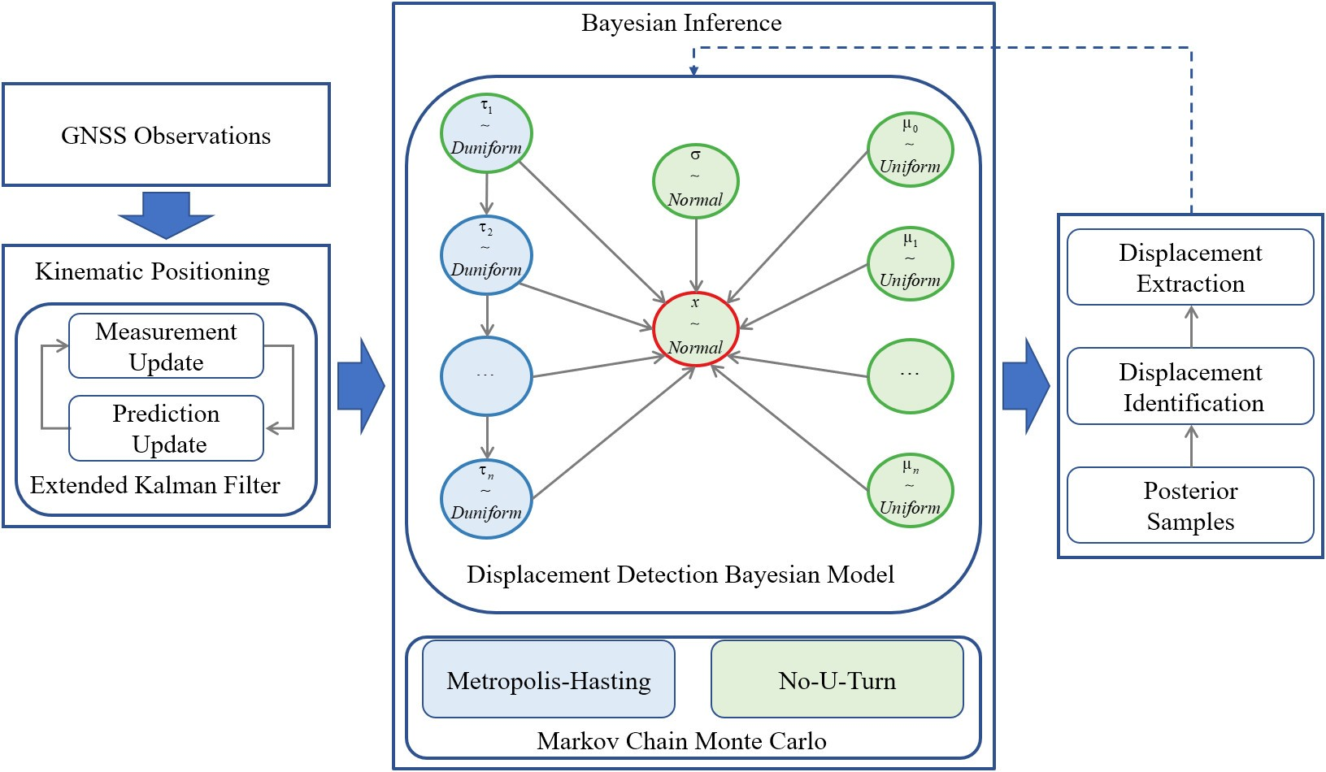

Figure 1: Bayesian model for displacement detection.

172 *3.1. Simulation Experiment*

173 In the experiment, we only simulate the up coordinate component, in which Gaussian white noise with the mean

174 of 0 mm and the standard deviation of 30 mm is added. At 1000 s, 2500 s, and 3200 s, the displacements of -50 mm,

175 -50 mm, and 100 mm are added, respectively. The simulation results are shown in Fig. 2.

10

999

0299

0 99

00 10

U p((m

0

10

00

10

000

0 100 000 100 0000 0100 0000 0100

Time s

Figure 2: Simulation data with multiple displacement change points.

176 As shown in Fig. 2, the whole time series is divided into four segments by three displacement change points.

177 Using the model designed above, Bayesian inference is implemented by the MCMC sampling. The posterior sample

178 distribution of *τ* is shown in Fig. 3.

179 As can be seen from Fig. 3, all the designed displacement change points are identified. *τ*3 is the easiest to be

180 identified, mainly due to the largest displacement amplitude. Since the displacement amplitude at *τ*2 is small and

181 there are fewer sample points on the right side, the estimated accuracy is worse than the other two change points. The

182 histogram of the posterior sample of *µ* is shown in Fig. 4.

183 The blue curve in Fig. 4 is the fitting result of Gaussian distribution of the histogram. Although we assume that

184 the prior distribution of *µ* in the model obeys a uniform distribution, the posterior sample approximately obeys normal

185 distribution. The vertical green dashed line in Fig. 4 represents the mean value of posterior samples, and the mean

2 x10

0 x10

x10

tCou

x10 x x10

1

0 x10

x10

tCou

x10 x x10

1

9 x10

9 x10

tCou

0 x10

x10

1

4x

44 440 449 449 x111 x11

4

041 04 049 044 21 212

4

x49 x49 x44 11 1x 1

# Time s

Figure 3: Posterior sample distribution of *τ* in the simulation experiment.

186 values of the four segments are 1.17 mm, -49.58 mm, -98.9 mm, and -3.65 mm. Among these means, *µ*2 has the

187 highest accuracy, and its corresponding posterior sample coverage is the narrowest. The estimation accuracy of *µ*4 is

188 the lowest, and the corresponding posterior sample coverage is the widest. These are mainly due to the fact that the

189 most observation samples are used for *µ*2 estimation, while the least observation samples are used for *µ*4 estimation.

190 As shown in Fig. 5, *σ* is also accurately estimated.

191 The index values of different index-based detection methods in the simulation experiment are shown in Fig. 6. It

192 can be seen that the numerical range of indicators used by different detection methods is not consistent, but all are

193 obvious at the designed abrupt point. However, to automatically identify these abrupt points based on these index

194 values, additional work is required, such as setting a certain threshold. In addition, these methods were originally de-

195 signed to detect abrupt points without involving displacement extraction. There are abrupt detection and displacement

196 extraction methods based on these indicators, but the implementation process is complex[31]. In contrast, the method

197 proposed in this work is a simple, straightforward, and easy-to-implement one-stop method.

198 *3.2. Field Experiments*

199 The experiments were carried out on the roof of a building on the campus of Wuhan University, and the equipment

200 deployment is shown in Fig. 7. A hard plank was pressed with large stones to ensure that the plank remains as fixed

201 as possible during moving the object hanging on the plank. One receiver antenna was fixed on the plank as a rover,

202 and the other receiver antenna was installed on a tripod beside it as the base station. Both antennas were connected to

203 BD992 OEM boards on the table, and the OEM boards were connected to the laptops for data collection. As shown

204 in subgraphs (c) and (d), the height of the antenna was measured with a tape before and after each movement of the

205 object hanging on the plank. The minimum scale of the tape is 1 mm, that is, the accuracy of the tape is 1 mm, and

206 the estimated reading is 0.1 mm. Take five readings for each measurement to ensure the accuracy and reliability of

207 the data. Besides, markers are made on the ground and on the antenna respectively to ensure that the same position

208 was referenced for each measurement. The sampling frequency of the GNSS receiver is set to 1 Hz. We did two

209 experiments, each lasting nearly 45 minutes. During the experiment, the object hanging on the board was manually

x -0x10 x 10x10

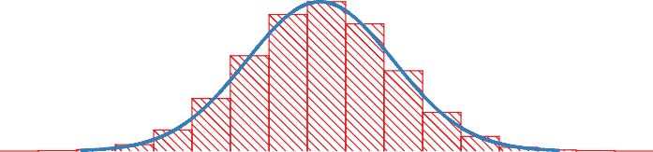

x x.

µ

1

tCoun

- 10x10

1 1

- 10x10 0 x 1 x 0 0 -



0- -9

µ

x

10x10 0 10x10

tCoun

1 1

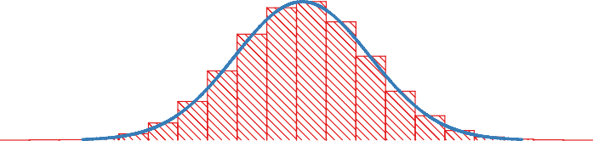

-9 -

µ

x 0x10 9 10x10

tCoun

0 10x10

1 1

- -x -1 0- 09 0.

x 0x10 x10 x1 x11 -9 0 -

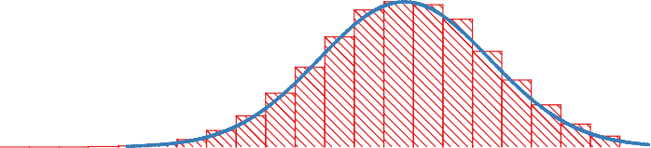

9 10x10

tCoun

0 10x10

- -0

µ0

1 1

x1 9 0 1

# µ ((m

Figure 4: Histogram of posterior estimation of *µ* in the simulation experiment.

x .0x.0

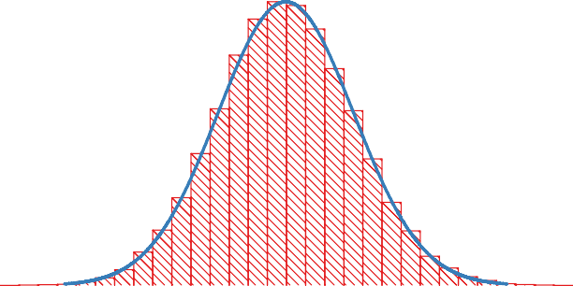

0.

.0x.0

.0x.0

Coun

0 .0x.0

.0x.0

. .

2 0. 0x

m

Figure 5: Histogram of posterior sample of *σ* in the simulation experiment.

0000

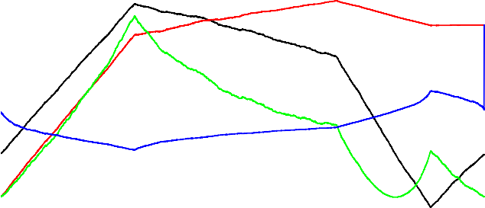

U TP TNH T

0000000

0000

000

00

0000000 00 0

0

0 0 000

00

00 0000 0 00 0000 0 00 0000 0 00

Time s

Figure 6: Index values of different index-based detection methods in simulation experiments.

210 moved several times. The displacement amplitude of the second experiment is smaller than that of the first experiment. The GNSS observation data collected above are processed by the open-source software RTKLIB[41].

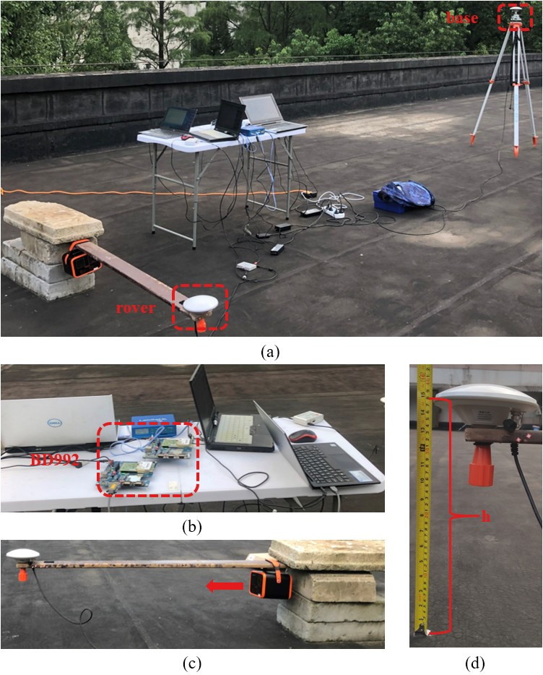

Figure 7: Filed experiment configuration. (a) Overview; (b) Working platform; (c) Displacement control platform; (d) Displacement measurement by tape.

211

212 *3.2.1. Field Experiment 1*

213 GNSS observations were processed epoch by epoch by using RTK mode, and the corresponding coordinate output

214 was the only input of the proposed displacement detection method. The results of RTK positioning are shown in Fig.

215 9. Only the vertical displacement was triggered in the experiment, so only the up coordinate component is displayed.

216 For such a short baseline, most of the errors can be eliminated by the double-difference observation. As can be

217 seen from Fig. 8, there are still some unmodeled errors, such as the multipath error that have not been eliminated. The

218 RTK positioning results are processed by the proposed method, and Bayesian inference is implemented by the MCMC

-100

-100

-110

-140

U p((m

-1 0

-100

-100

-110

-

- 8

0 100 -000 -100 0000 0100

Time s

Figure 8: The up component of coordinates obtained by RTK positioning in field experiment 1.

.0x.0 x .0x.0 x .0x.0

C oun

. .0x.0

. .

.0x.0

777 77.

4x

770 77 778 78

78.

0 .0x.0

C oun

.0x.0

. .

x78 x780

4

x78

# Time s

x787 x8.. x8.

Figure 9: Posterior sample distribution of *τ* in field experiment 1.

219 sampling. The histogram of the posterior sample of *τ* is shown in Fig. 9. From the posterior sample distribution of

220 *τ*2 in Fig. 9, one of the change points can be identified as 1897 s. According to the maximum value in the bar chart

221 of the posterior sample of *τ*1, the change point is identified as 781 s. However, as can be seen from Fig. 9, there are

222 two peaks in the posterior sample distribution of change point *τ*1. The main reason is that the displacement control

223 device is not completely controllable, and the plank floats up and down when moving the object. In addition, since

224 the antenna is close to the ground, the antenna vibration caused by breeze or touch causes an increase in the multipath

225 phase rate or fading frequency[42]. The index values of different index-based detection methods in field experiment

226 1 are shown in Fig. 10. At the abrupt point, each index value is no longer as clear as in the simulation experiment,

227 which puts forward higher requirements for additional analysis of these indexes. The posterior sample histogram of

228 the *µ* of each segment divided by the change point and the displacement measured by the tape are shown in Fig. 11 and Table 1, respectively.

0000000

0000

0 00 0

0000000

00

0000

00

00

00

0 0

0 00

0 00 0000 0 00 0000 0 00

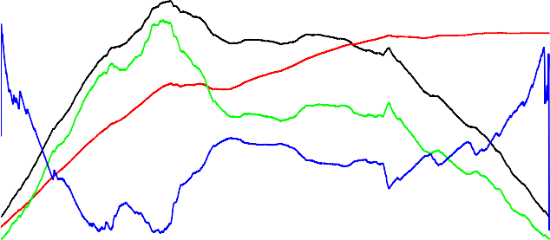

U TP TNH T

Time s

Figure 10: Index values of different index-based detection methods in field experiment 1.

Table 1: Measured height before and after each movement of the object hanging on the plank in field experiment 1, unit (mm).

|  |  |  |  |  |  |  |  |
| --- | --- | --- | --- | --- | --- | --- | --- |
|  |  | **1** | **2** | **3** | **4** | **5** | **mean** |
|  | *h*0 371.0 | 370.9 | 370.9 | 371.1 | 370.9 | 370.96 |
| Step 1 | *h*1 341.0 | 341.1 | 341.5 | 341.9 | 341.0 | 341.30 |
|  | ∆*h* -30.0 | -29.8 | -29.4 | -29.2 | -29.9 | -29.66 |
|  | *h*0 340.5 | 340.1 | 340.0 | 340.0 | 340.1 | 340.14 |
| Step 2 | *h*1 313.0 | 312.9 | 312.9 | 313.0 | 313.0 | 312.96 |
|  |  | ∆*h* -27.5 | -27.2 | -27.1 | -27.0 | -27.1 | -27.18 |
| 229 |  |  |  |  |  |  |  |

230 The *µ*0, *µ*1, and *µ*2 obtained by the mean of the posterior samples are -1446.03 mm, -1474.11 mm, and -1489.83

231 mm, respectively, and the two displacements obtained by the difference of these mean values are -28.08 mm, -15.72

232 mm, respectively. The two displacements measured by tape are -29.66 mm and -27.18 mm respectively. To our

233 surprise, the displacement difference between the two methods at the two change points is 1.58 mm and 11.46 mm,

234 respectively. The main reason is that the displacement control device is not fully controllable. As can be seen from

235 Fig. 8, the time series fluctuates obviously near the abrupt displacement. To explore the possible causes, the number

236 of satellites, geometric dilution of precision(GDOP), signal-to-noise ratio(SNR), and multipath are shown in Fig.

237 12. The number of satellites and GDOP changed when the displacement took place, which may be caused by the

238 shielding of the antenna during operation. The SNR and multipath have also changed when the displacement takes

239 place, possibly due to antenna vibration caused by touch or wind.

240 As shown in Fig. 13, the estimated value of *σ* is 12.58 mm through the posterior sample mean of *σ*. Different

- .- 1

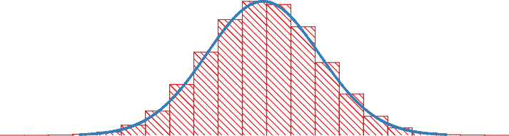

-114 0

µ

- .- 1

tC u

.- 0

- 4.- 1

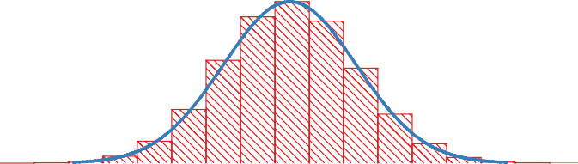

-141 --

µ-

- l.- 1

tC u

-114 -114 -114 -11 -111

4 .- 0

-144 -14 -141 -140

1

- .-

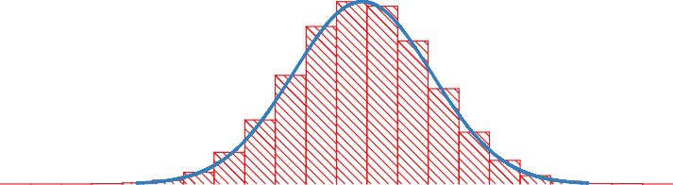

-144 40

µl

- .- 1

tC u

.- 0

-14l -14- -14

# µ ((m

-144 -144

Figure 11: Histogram of posterior sample of *µ* in field experiment 1.

uime s

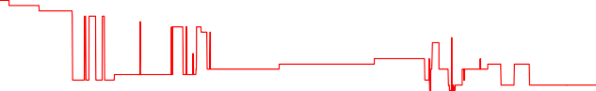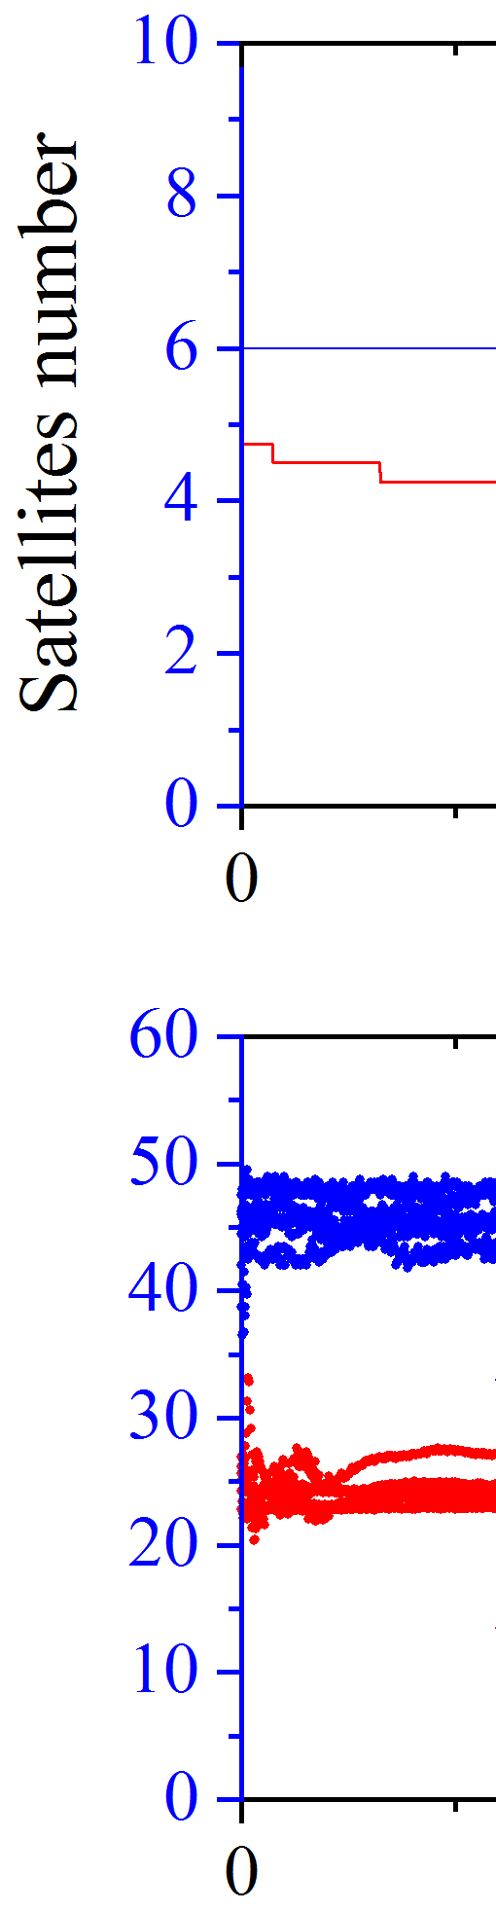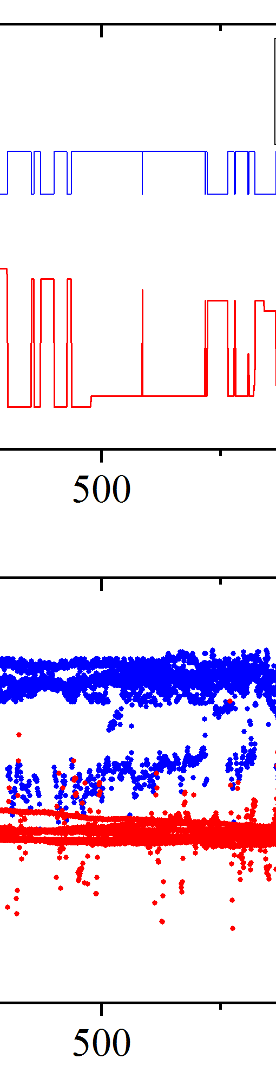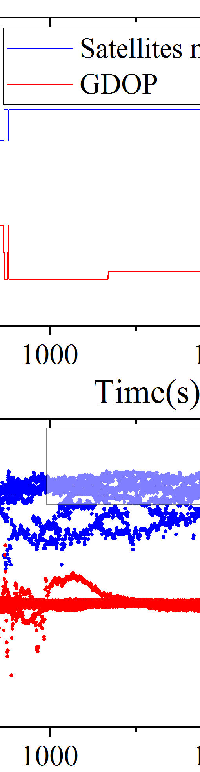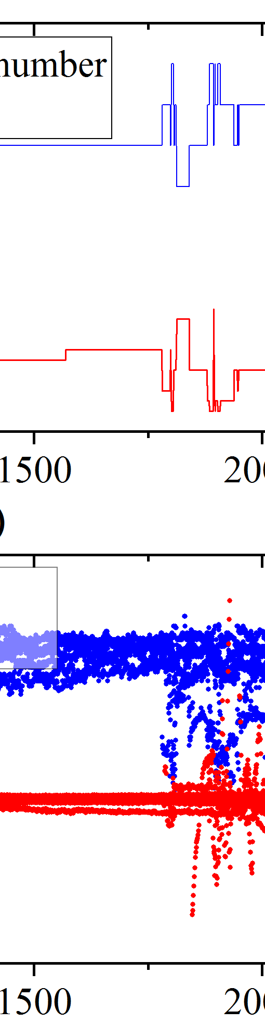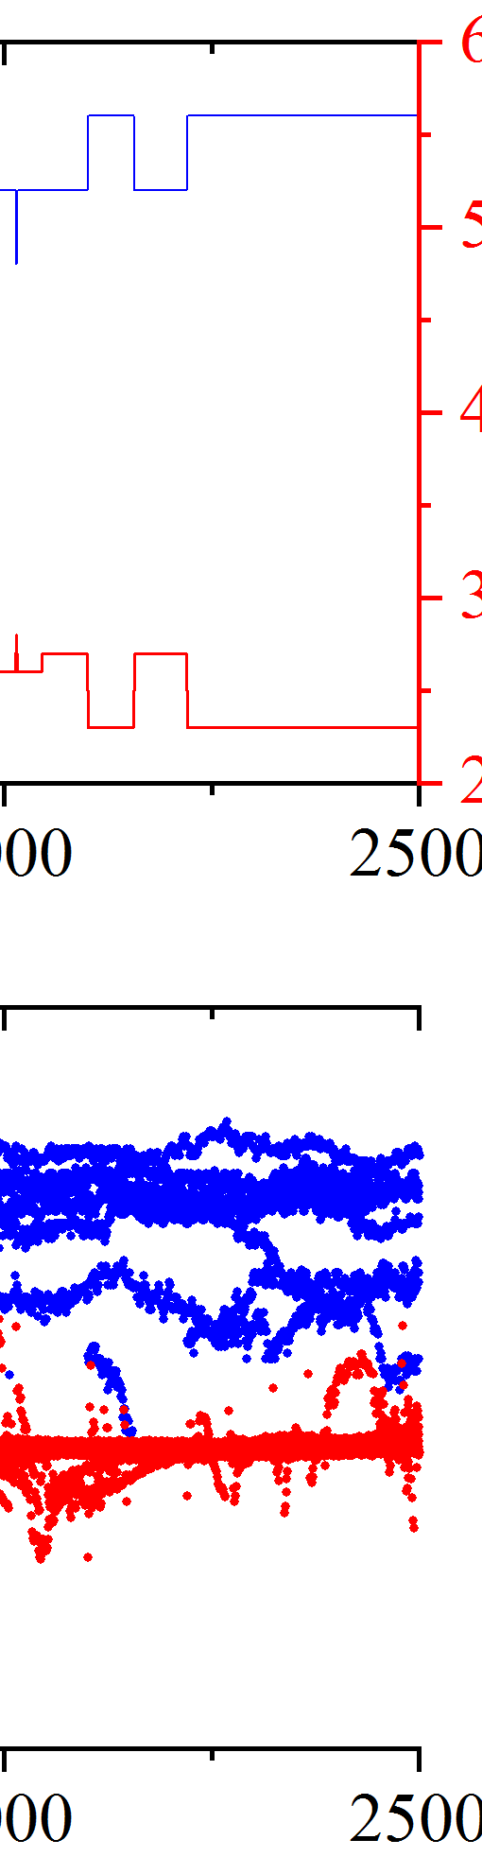

SN

M uti a

R 1

- 1

- 1 1 1

1 1

1 1

- 1

- 1

SN R(b H

M uti a (H

Figure 12: Number of satellites, GDOP, SNR, multipath of experiment 1.

1 .0x.0

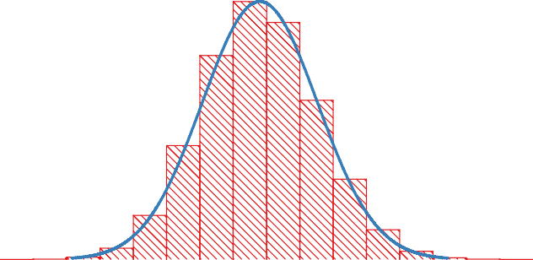

x1 .5

x 10x.0

x 10x.0

C ou

5 .0x.0

0 .0x.0

. .

x1 . x1 . x0 .

## m

Figure 13: Histogram of posterior sample of *σ* in field experiment 1.

241 from the posterior sample distribution of *τ*, there is only one peak value in the posterior sample distribution of *µ* and *σ*.

242 The main reason is that the interval of the two peaks is very close, which has little influence on the posterior mean and

243 standard deviation. In reality, multiple change points exist, such as multiple displacements in a short period of time

244 in the process of landslide or settlement. However, more attention is paid to the primary change points. By adding a

245 prior to the model to improve the identification of the primary change points, and weaken the influence of secondary

246 change points will be discussed later.

247 *3.2.2. Field Experiment 2*

248 This experiment is similar to the previous one except that the displacement amplitude is smaller. The coordinate

249 time series is obtained by RTKLIB with the same processing strategy as the previous experiment, and the up compo-

250 nent of the time series is shown in Fig. 14. In this experiment, the displacement measured by tape is shown in Table

251 2.

-1

1

-158

-14

-11

-14

tU ((m

-15

-1

-14

-11

1

- -1

Time s

4

Figure 14: The up component of coordinates obtained by RTK positioning in field experiment 2.

252 As can be seen from Fig. 14 and Table 2, the amplitude of the two displacements is smaller than that of the

253 previous experiment. The time series are processed by the proposed method, and Bayesian inference is implemented

254 by the MCMC sampling. The results are shown in Fig. 15, 16, and 17.

255 Due to the decrease of displacement amplitude, the results are not as good as the previous experimental results.

256 It can be seen from Fig. 15 that there are two peaks in the posterior sample distribution of *τ*1. Unlike Fig. 9 of the

257 previous experimental results, the two peaks are far away from each other, exceeding 500 s. Accordingly, there are

1 0

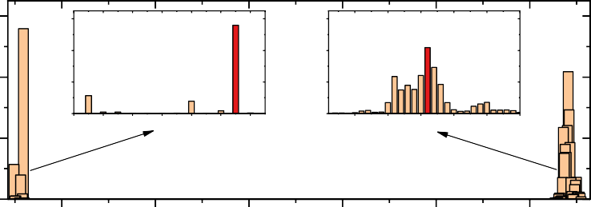

1 0

0

0

415

1 0

0

0

10

L

405 41 41 410 417 415 47

11 111 10 101 11 111

0

C oun

0

0 0

1 0

5 5 1

0

C oun

0

140 147

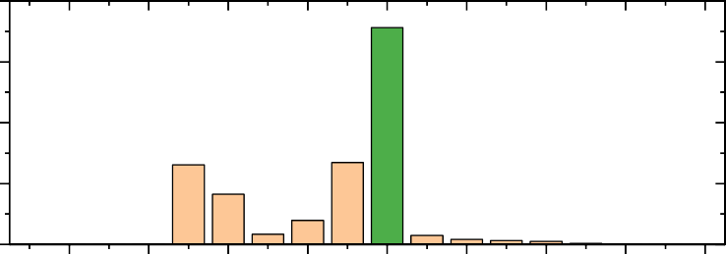

L

145 15

15 150 157 155 15

# Time s

Figure 15: Posterior sample distribution of *τ* in field experiment 2.

- 1

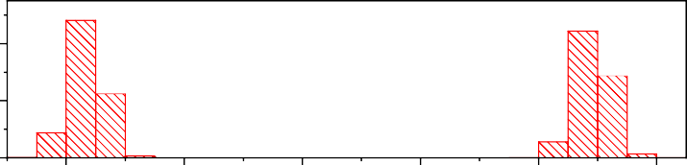

µ

tCoun

- - 1

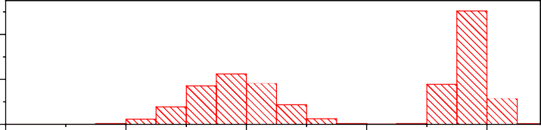

-14

-144

-144

-141

-14

-14

µ-

- 1

tCoun

- - 1

-10 -144

- 1

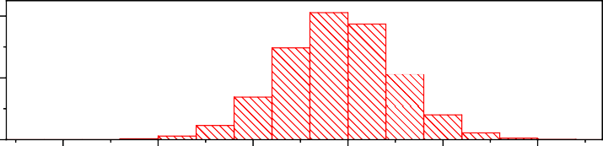

µ

-144

-141

-14

- - 1

tCoun

-1- 1 -1- -1 0 1

-1 0

-1 4 1 -1 4

# µ ((m

Figure 16: Histogram of posterior sample of *µ* in field experiment 2.

Table 2: Measured height before and after each movement of the object hanging on the plank in field experiment 2, unit (mm).

### 1 2 3 4 5 mean

*h*0 347.5 347.3 347.6 347.5 347.4 347.5

Step 1

Step 2

*h*1 326.1 326.3 326.1 326.0 326.1 326.1

∆*h* -21.4 -21.0 -21.5 -21.5 -21.3 -21.3

*h*0 325.0 325.1 324.9 325.0 325.2 325.0

*h*1 305.5 305.3 305.4 305.5 305.6 305.5

∆*h* -19.5 -19.8 -19.5 -19.5 -19.6 -19.6

.5x.0



.5x.0

x .5x.0

Coun

x .5x.0

. .5x.0

. .

.

.

5 . 5 . 5 . 5 .

a m

x. .

x. . xx .

Figure 17: Histogram of posterior sample of *σ* in field experiment 2.

258 two peaks in the posterior sample distribution of *µ*0, *µ*1 and *σ*. In addition, we found that the second peak of *τ*1 is very

259 close to the peak of *τ*2, which is not what we want because we do not want to get very short segments. In the next

260 section, we will discuss adding a prior to the model to improve the performance of Bayesian inference.

261  **4. Discussion**

262 In field experiment 1, there are two significant peaks in the posterior sample distribution at the same change point.

263 In addition, in field experiment 2, the posterior distribution interval of two different change points is close. Here, the

264 interval between adjacent change points is constrained by adding a prior. A random variable *dτ*, the distance between

265 continuous change points, is added, which obeys the discrete uniform distribution.

*P*(*dτi*) = *DiscreteU*(*τi* + *d, τi*+1) (16)

266 where *d* is the shortest time interval to be constrained. The new Bayesian probability model with the prior is shown

267 in Fig. 18.

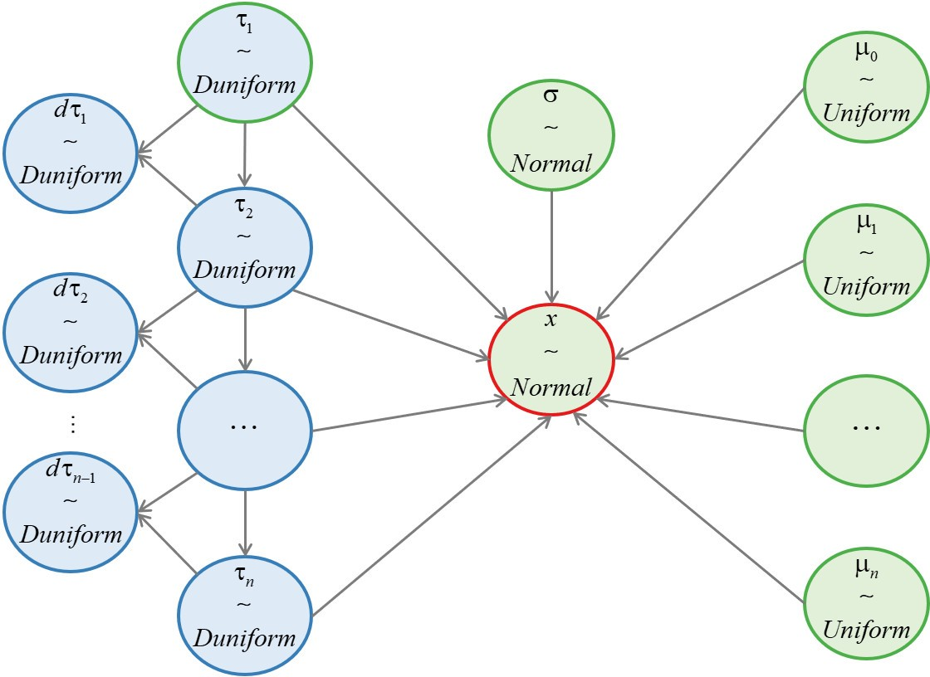

Figure 18: Bayesian model for displacement detection with an interval constraint prior.

268 As shown in (16) and Fig. 18, the prior distribution of newly added random variables depends on the change points

269 and the constraint interval. In the following data processing, the interval *d* is set to 300. The data in field experiment

270 1 is reprocessed with the new Bayesian model, and the posterior distribution of *τ* is shown in Fig. 19.

2x10

'x

2x10

C oun

x2x10

1

72x10

7

7 71

7 70 77 77 81 8 80

02x10

'

C oun

2x10

1

x78 x780

x787

# Time s

x787 x811 x81

Figure 19: Posterior sample distribution of *τ* in field experiment 1 with an interval constraint prior.

271 From the comparison between Fig. 19 and Fig. 9, it can be seen that the secondary peak of *τ*1 posterior distribution

272 in Fig. 9 is effectively suppressed, which is more conducive to the identification of the primary change point. There

273 is no significant change in the posterior distribution of *τ*2, *µ*, and *σ*. The data in field experiment 2 is also reprocessed

274 with the new Bayesian model, and the results are shown in Fig. 20, 21, 22, and 23.

275 Compared with the posterior sample distribution of *τ*1 in Fig. 15, the posterior sample distribution in Fig. 20

276 is more conducive to the identification of the change point. Although there are still some sampling points around

277 1200 seconds, most of the sample number is below 1000, which has little effect. The posterior distribution of *τ*2 has

0 0 0

0 0

C oun

0 0 0 0 0

0 0

400 000 0000

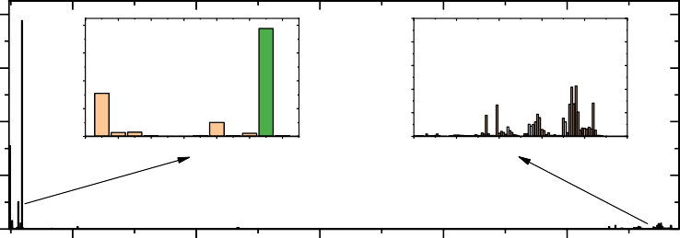

0 0 0

0 0

0 0 0 0 0

1 5

105 1 1 1 0 1 7 1 5 17

0

0

0 0 0 0 0 7 0 5 0

t0

0000 0100

0 0

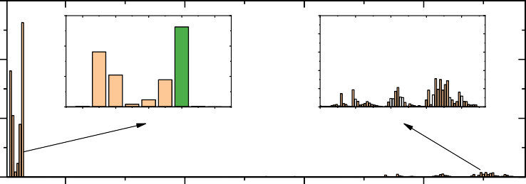

0 0

0 0 0 0 0

0 17 0 15 0 5 0 5 0 50

0 5

0

0

t

01 010 01 011 015

C oun

0 0 0

07 07 01 01

# Time s

Figure 20: Posterior sample distribution of *τ* in field experiment 2 with an interval constraint prior.

 000000

000000

0

000

100

0

000

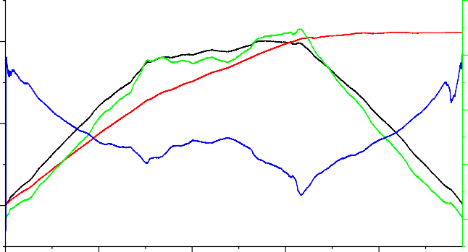 100

U TP TNH T

000

100

0

0

 10

00

0 100 000 100 000

Time s

Figure 21: Index values of different index-based detection methods in field experiment 2.

1 - 1

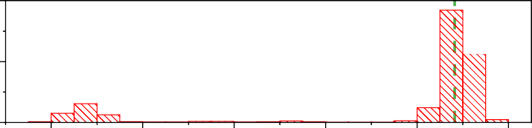

-14- -4

µ

- 1

tC u

1 - 1

tC u

-14 -144 -144 -141 -14

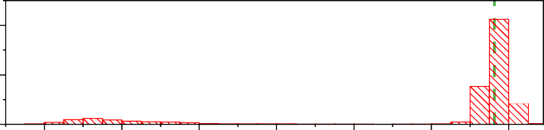

-14 84

µ-

-14

- 1

- 1

-141 -14 -14 -144 -144 -141

-14

- - 1

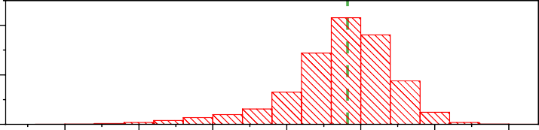

-1 4 4

µ

tC u

-1-- -1- 1 -1-

-1 4 1

# µ ((m

-1 4

-1 4 1 -1 4

Figure 22: Histogram of posterior sample of *µ* in field experiment 2 with an interval constraint prior.

04 10

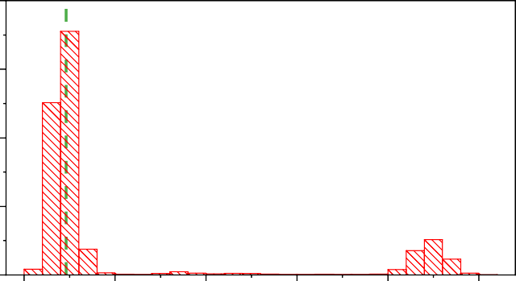

04

4 10

4 10

Coun

4 10

1

1

a m

Figure 23: Histogram of posterior sample of *σ* in field experiment 2 with an interval constraint prior.

278 slightly changed. There are a few sampling points around 1750 s, which are not enough to affect the identification

279 of change points. From the comparison between Fig. 16 and Fig. 22, it can be seen that the secondary peak of *µ*1

280 almost disappears. However, there are still some sample points which deviate from the main peak. In order to reduce

281 the influence of these sampling points, the median value of the sample is used as the final estimation of *µ*, and *µ*0, *µ*1

282 and *µ*2 are obtained as -1461.18 mm, -1482.37 mm and -1509.09 mm respectively. The two displacements obtained

283 by these means are -21.19 mm and -26.72 mm, respectively, and the displacements measured in Table 2 are -21.3 mm

284 and -19.6 mm respectively. The displacement difference between the two methods at the two change points is 0.11

285 mm and 7.12 mm, respectively. The larger displacement error at *τ*2 is mainly due to the incompletely controllable

286 experimental equipment. The number of satellites, GDOP, SNR, and multipath are shown in Fig. 24. The number of satellites and GDOP changed at *τ*2, which may be caused by the shielding of the antenna during operation. But on the

uime s

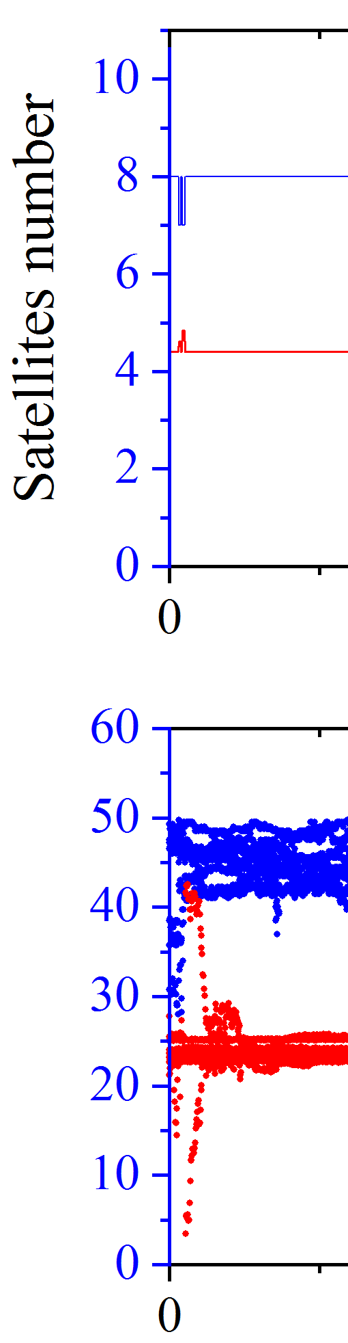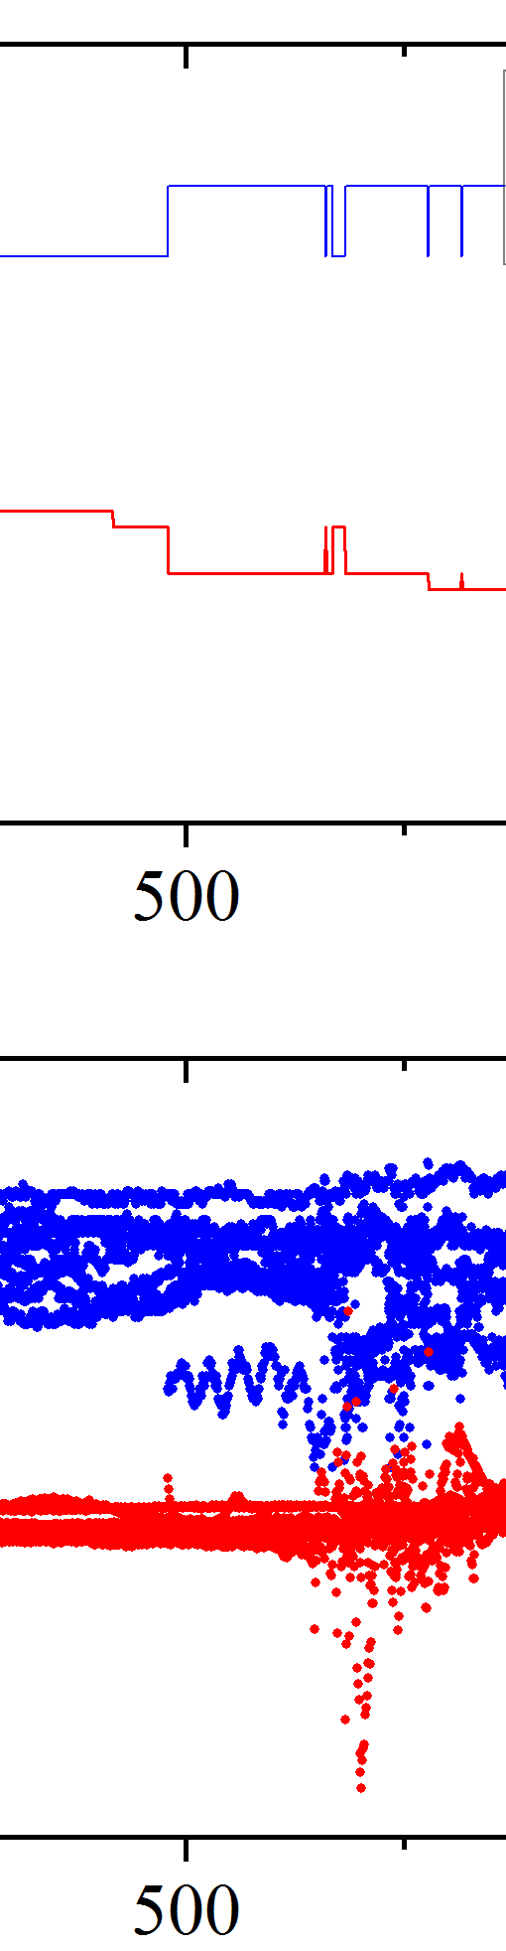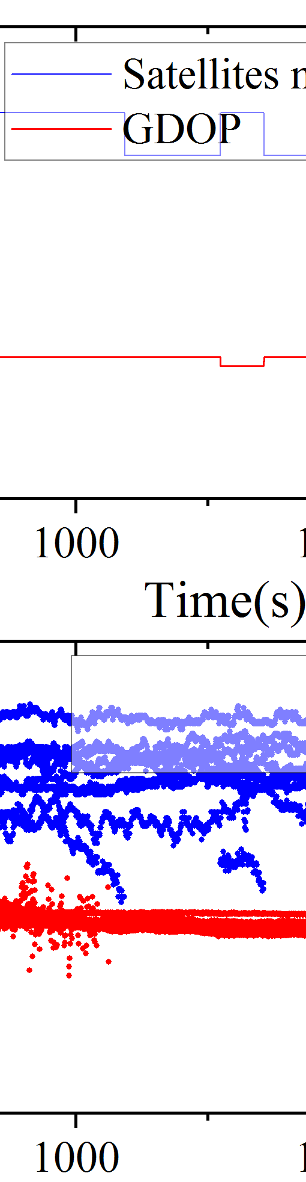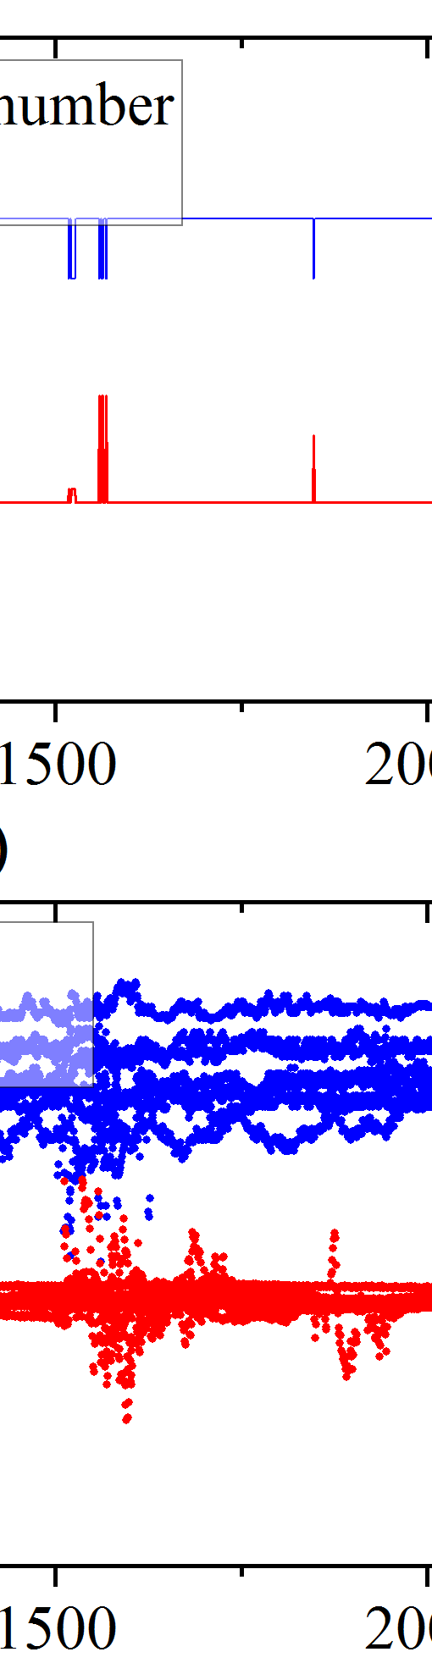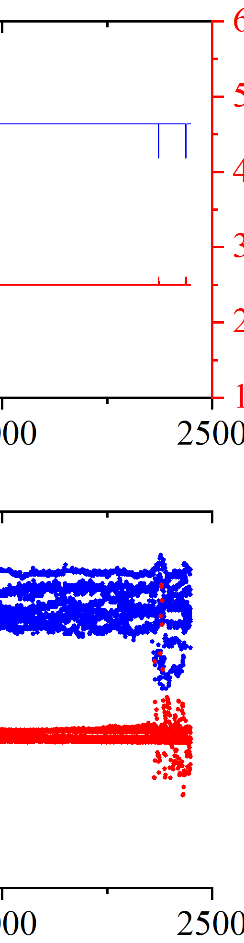

SN

M uti a

R 1

- 1

- 1 1 1

1 1

1 1

- 1

- 1

SN R(b H

M uti a (H

Figure 24: Number of satellites, GDOP, SNR, multipath of experiment 2.

287

288

289

290

291

292

293

294

295

296

297

whole, using the proposed method, the displacement extraction accuracy in the experiment can reach less than 2 mm. However, as mentioned in the simulation experiment, the accuracy of displacement extraction in practical application also depends on the number of available samples near the change point. It can be seen from Fig. 23 and Fig. 17 that the secondary peak of *σ* posterior distribution has been significantly weakened.

As can be seen from the above discussion that the interval constraint prior can effectively improve the identifiability of change points. This is the first time that Bayesian inference has been used for displacement detection based on GNSS kinematic positioning. Compared with indicator-based detection methods, this method has high robustness and flexibility. The method based on Bayesian inference uses multi-epoch observation data, which is more reliable. On the other hand, the Bayesian inference-based displacement detection method proposed in this paper is flexible enough to meet different analysis needs by adding a priori.

298 **5. Conclusions**

299 This study set out to develop a Bayesian model for displacement detection from GNSS kinematic positioning.

300 The description of multiple displacements is given, and the Bayesian model for multiple displacement detection is

301 proposed. The principle of Bayesian inference and its implementation based on MCMC sampling are presented. To

302 provide epoch by epoch coordinate time series for displacement detection, the principle of GNSS kinematic position-

303 ing mode RTK is introduced. The likelihood function of the observation and the prior distribution of the parameters

304 to be estimated are provided. Simulation and field experiments were carried out to verify the effectiveness of the

305 proposed method. These experiments confirmed the effectiveness of the method in displacement identification and

306 extraction.

307 Significant displacements can be effectively detected by the displacement Bayesian inference model. The dis-

308 placement is obtained by the difference of the mean of the coordinates before and after the change point, which can

309 be obtained by the mean of the posterior sample. The accuracy of the final displacement is determined by the number

310 of available samples before and after the change point. The more samples are, the higher the accuracy is.

311 When the amplitude of displacement is small, the posterior distribution of change points appears multiple peaks,

312 which is not conducive to the effective identification of change points. By adding an interval constraint prior, the

313 influence of secondary change points can be effectively weakened. To reduce the influence of the sample points of the

314 secondary change point on the displacement extraction, the coordinate mean before and after the change point can be

315 estimated by the median of the posterior sample.

316 The displacement detection based on Bayesian inference can meet different needs by adding a priori, and has

317 sufficient flexibility. In addition, the Bayesian inference implementation based on MCMC sampling used in this paper

318 provides posterior samples, which is more conducive to problem analysis. This study provides the first comprehensive

319 assessment of the Bayesian inference model for displacement identification and extraction from GNSS kinematic

320 positioning. Although the method is verified with GNSS kinematic data, the method is also suitable for long-term

321 displacement detection. The main difference is the error model and influencing factors considered, which will be

322 carried out in the follow-up work.

323 **Fundings**

324 This research was funded by the National Key Research and Development Programs 2018YFB0505400

325 **Conflict of interest**

326 The authors declare that they have no known competing financial interests or personal relationships that could

327 have appeared to influence the work reported in this paper.

328

329

330

331

332

333

334

335

336

337

338

339

340

341

342

343

344

345

346

347

348

349

350

351

352

353

### References References

1. F. Barry, B. Tom, Surveying principles and application ninth edition (2011).
2. V. Iatsouk, Development of standards for aeronautical satellite navigation system, Acta Astronautica 54 (11-12) (2004) 961–963.
3. J. L. Awange, Environmental monitoring using GNSS: Global navigation satellite systems, Springer Science & Business Media, 2012.
4. H.-f. Bian, S.-b. Zhang, Q.-z. Zhang, N.-s. Zheng, Monitoring large-area mining subsidence by gnss based on igs stations, Transactions of Nonferrous Metals Society of China 24 (2) (2014) 514–519.
5. M. Pavasovic´, M. Rezo, T. Basˇic´, The application of gnss vrs service in industrial survey, in: Proceedings of the 5th International Conference on Engineering Surveying INGEO 2011, 2011, p. 279.
6. A. Tasora, S. Benatti, D. Mangoni, R. Garziera, A geometrically exact isogeometric beam for large displacements and contacts, Computer Methods in Applied Mechanics and Engineering 358 (2020) 112635. doi:https://doi.org/10.1016/j.cma.2019.112635.
7. C. Bigoni, Z. Zhang, J. S. Hesthaven, Systematic sensor placement for structural anomaly detection in the absence of damaged states,

Computer Methods in Applied Mechanics and Engineering 371 (2020) 113315. doi:https://doi.org/10.1016/j.cma.2020.113315.

1. N. Shen, L. Chen, J. Liu, L. Wang, T. Tao, D. Wu, R. Chen, A review of global navigation satellite system (gnss)-based dynamic monitoring

technologies for structural health monitoring, Remote Sensing 11 (9) (2019) 1001.

1. G. Wang, Gps landslide monitoring: Single base vs. network solutions — a case study based on the puerto rico and virgin islands permanent gps network, Journal of Geodetic Science 1 (3) (2011) 191–203.
2. K. Gu¨mu¨s¸, M. O. Selbesog˘lu, Evaluation of nrtk gnss positioning methods for displacement detection by a newly designed displacement monitoring system, Measurement 142 (2019) 131 – 137. doi:https://doi.org/10.1016/j.measurement.2019.04.041.
3. ´I. S¸ anlıog˘lu, M. Zeybek, C. O¨ . Yig˘it, Landslide monitoring with gnss-ppp on steep-slope and forestry area: Tas¸kent landslide, in: International

Conference on Engineering and Natural Science (ICENS), 2016, pp. 12–16.

1. M. Lytvyn, C. Pollabauer, M. Troger, K. Landfahrer, L. Hormann, C. Steger, Real-time landslide monitoring using single-frequency ppp: Proof of concept, in: 2012 6th ESA Workshop on Satellite Navigation Technologies (Navitec 2012) & European Workshop on GNSS Signals and Signal Processing, 2012, pp. 1–6.
2. F. Moschas, A. Avallone, V. Saltogianni, S. Stiros, Strong motion displacement waveforms using 10-hz precise point positioning gps: An assessment based on free oscillation experiments, Earthquake Engineering & Structural Dynamics 43 (10 2014). [doi:10.1002/eqe.2426](https://doi.org/10.1002/eqe.2426).

354

355

356

357

358

359

360

361

362

363

364

365

366

367

368

369

370

371

372

373

374

375

376

377

378

379

380

381

382

383

384

385

386

387

388

389

390

391

392

393

394

395

396

397

398

399

400

401

402

403

404

405

406

407

408

409

410

411

412

413

414

1. Q. Zhang, C. Ma, X. Meng, Y. Xie, P. Psimoulis, L. Wu, Q. Yue, X. Dai, Galileo augmenting gps single-frequency single-epoch precise positioning with baseline constrain for bridge dynamic monitoring, Remote Sensing 11 (2019) 438. [doi:10.3390/rs11040438](https://doi.org/10.3390/rs11040438).
2. C. Xue, P. Psimoulis, Q. Zhang, X. Meng, [Analysis of the performance of closely spaced low-cost multi-gnss receivers](https://doi.org/10.1007/s12518-021-00361-8), Applied Geomatics

13 (3) (2021) 415–435. [doi:10.1007/s12518-021-00361-8](https://doi.org/10.1007/s12518-021-00361-8).

URL <https://doi.org/10.1007/s12518-021-00361-8>

1. P. Freda, A. Angrisano, S. Gaglione, S. Troisi, Time-differenced carrier phases technique for precise gnss velocity estimation, GPS Solutions

19 (2) (2015) 335–341.

1. G. Colosimo, M. Crespi, A. Mazzoni, Real-time gps seismology with a stand-alone receiver: A preliminary feasibility demonstration, Journal of Geophysical Research: Solid Earth 116 (B11) (2011).
2. P. Psimoulis, S. Pytharouli, D. Karambalis, S. Stiros, Potential of global positioning system (gps) to measure frequencies of oscillations of engineering structures, Journal of Sound and Vibration 318 (3) (2008) 606–623.
3. P. A. Psimoulis, S. C. Stiros, [Experimental assessment of the accuracy of gps and rts for the determination of the parameters of oscillation of](https://onlinelibrary.wiley.com/doi/abs/10.1111/j.1467-8667.2008.00547.x) [major structures](https://onlinelibrary.wiley.com/doi/abs/10.1111/j.1467-8667.2008.00547.x), Computer-Aided Civil and Infrastructure Engineering 23 (5) (2008) 389–403. arXiv:https://onlinelibrary.wiley. com/doi/pdf/10.1111/j.1467-8667.2008.00547.x, doi:https://doi.org/10.1111/j.1467-8667.2008.00547.x.

URL <https://onlinelibrary.wiley.com/doi/abs/10.1111/j.1467-8667.2008.00547.x>

1. X. Meng, D. T. Nguyen, Y. Xie, J. Owen, P. Psimoulis, S. Ince, Q. Chen, J. Ye, P. Bhatia, Design and implementation of a new system for large bridge monitoring—geoshm, Sensors 18 (03 2018). [doi:10.3390/s18030775](https://doi.org/10.3390/s18030775).
2. P. A. Psimoulis, N. Houlie´, M. Habboub, C. Michel, M. Rothacher, Detection of ground motions using high-rate gps time-series, Geophysical

Journal International 214 (2) (2018) 1237–1251.

1. S. Ha¨berling, M. Rothacher, Y. Zhang, J. F. Clinton, A. Geiger, [Assessment of high-rate gps using a single-axis shake table](https://doi.org/10.1007/s00190-015-0808-2), Journal of Geodesy 89 (7) (2015) 697–709. [doi:10.1007/s00190-015-0808-2](https://doi.org/10.1007/s00190-015-0808-2).

URL <https://doi.org/10.1007/s00190-015-0808-2>

1. F. Moschas, S. Stiros, [Pll bandwidth and noise in 100 hz gps measurements](https://doi.org/10.1007/s10291-014-0378-4), GPS Solutions 19 (2) (2015) 173–185. [doi:10.1007/](https://doi.org/10.1007/s10291-014-0378-4) [s10291-014-0378-4](https://doi.org/10.1007/s10291-014-0378-4).

URL <https://doi.org/10.1007/s10291-014-0378-4>

1. N. Shen, L. Chen, J. Liu, L. Wang, T. Tao, D. Wu, R. Chen, [A review of global navigation satellite system (gnss)-based dynamic monitoring](https://www.mdpi.com/2072-4292/11/9/1001) [technologies for structural health monitoring](https://www.mdpi.com/2072-4292/11/9/1001), Remote Sensing 11 (9) (2019). [doi:10.3390/rs11091001](https://doi.org/10.3390/rs11091001).

URL <https://www.mdpi.com/2072-4292/11/9/1001>

1. J. A. Gili, J. Corominas, J. Rius, Using global positioning system techniques in landslide monitoring, Engineering Geology 55 (3) (2000)

167–192.

1. E. Sˇegina, T. Peternel, T. Urbancˇicˇ, E. Realini, M. Zupan, J. Jezˇ, S. Caldera, A. Gatti, G. Tagliaferro, A. Consoli, J. R. Gonza´lez, M. J. Auflicˇ, Monitoring surface displacement of a deep-seated landslide by a low-cost and near real-time gnss system, Remote Sensing 12 (20) (2020). [doi:10.3390/rs12203375](https://doi.org/10.3390/rs12203375).
2. B. Betti, F. Sanso`, M. Crespi, Deformation detection according to a bayesian approach, in: IV Hotine-Marussi Symposium on Mathematical Geodesy, Springer, 2001, pp. 83–88.
3. B. Betti, N. E. Cazzaniga, V. Tornatore, Deformation assessment considering an a priori functional model in a bayesian framework, Journal of Surveying Engineering 137 (4) (2011) 113–119.
4. I. Abidin, H. Andreas, M. Gamal, M. H. Surono, On the use of gps survey method for studying land displacements on the landslide prone areas, FIG Working Week Athens, Greece (2004).
5. L. Li, H. Kuhlmann, Deformation detection in the gps real-time series by the multiple kalman filters model, Journal of Surveying Engineering- asce 136 (4) (2010) 157–164.
6. N. Shen, L. Chen, L. Wang, H. Hu, X. Lu, C. Qian, J. Liu, S. Jin, R. Chen, Short-term landslide displacement detection based on gnss real-time kinematic positioning, IEEE Transactions on Instrumentation and Measurement 70 (2021) 1–14. [doi:10.1109/TIM.2021.3055278](https://doi.org/10.1109/TIM.2021.3055278).
7. T. Bellone, P. Dabove, A. Manzino, C. Taglioretti, Real-time monitoring for fast deformations using gnss low-cost receivers, Geomatics,

Natural Hazards and Risk 7 (2) (2016) 458–470.

1. F. Pirotti, A. Guarnieri, A. Masiero, C. Gregoretti, M. Degetto, A. Vettore, Micro-scale landslide displacements detection using bayesian methods applied to gnss data, in: Modern Technologies for Landslide Monitoring and Prediction, Springer, 2015, pp. 123–138.
2. P. Dabove, A. M. Manzino, Fast displacements detection techniques considering mass-market gps l1 receivers, International Conference on Geographical Information Systems Theory, Applications and Management 741 (2016) 1–14.
3. C. Robert, Machine learning, a probabilistic perspective (2014).
4. L. Chen, H.-W. Cheng, L.-N. Wu, Modulation classification of mpsk signals based on nonparametric bayesian inference, Journal of Southeast University (English Edition) 25 (2) (2009) 171–174.
5. L. Chen, L. Pei, H. Kuusniemi, Y. Chen, T. Kro¨ger, R. Chen, Bayesian fusion for indoor positioning using bluetooth fingerprints, Wireless personal communications 70 (4) (2013) 1735–1745.
6. C. Robert, G. Casella, Monte Carlo statistical methods, Springer Science & Business Media, 2013.
7. S. Chib, E. Greenberg, Understanding the metropolis-hastings algorithm, The american statistician 49 (4) (1995) 327–335.
8. M. D. Hoffman, A. Gelman, The no-u-turn sampler: adaptively setting path lengths in hamiltonian monte carlo., J. Mach. Learn. Res. 15 (1) (2014) 1593–1623.
9. T. Takasu, Rtklib: An open source program package for gnss positioning, Tech. Rep., 2013. Software and documentation (2011).
10. J. M. Kelly, M. S. Braasch, M. F. DiBenedetto, Characterization of the effects of high multipath phase rates in gps, GPS Solutions 7 (1) (2003) 5–15.