**SNOWLeoSDR Open Source Project**

SNOWLeo SDR is a low-cost open source software defined radio platform based on Xilinx ZYNQ SoC and MYRIAD RF module. It include Giga Ethernet, USB OTG, HDMI, SDIO and USB-UART. SNOWLeo SDR is equipped an MYRIAD module that support 300MHz~3.8GHz, 28MHz BW application, such as WiFi, LTE or WiMax.

This Project provides the basic tools and APIs for developing open-source SDR application on ZYNQ SoC (FPGA+ARM architecture ) or x86 processor. The firmware supports SNOWLeo SDR to directly connect Matlab or GNU Radio on PC.

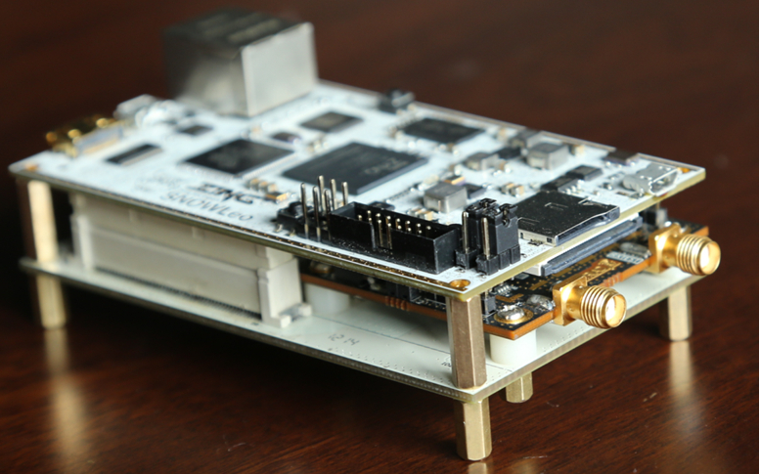

SNOWLeo SDR Platform Mounted with MYRIAD RF Moudule

**Device Specifications**

For information regarding specifications or purchase of completed units, please visit: [http://www.v3t.com.cn/english/product.asp?id=702.](http://www.v3t.com.cn/SNOWLeo/SNOWLeoSDR%20Brief.pdf.)

**Directory Description**

* **Docs**– contains hardware user guide and quick start guide about how to set up SNOWLeo SDR and program it.
* **Design**–contains high-level design documents and specifications for the SNOWLeoSDR, such as FPGA hdl and ARM system. This directory also includes cross-compiler tools provided by Xilinx for ARM linux..
* **Firmware**– contains embedded firmware for ZYNQ SoC. It include FPGA firmware and ARM Cortex-A9 processors firmware.
* **Hardware**– contains the hardware designs and other information needed to build and construct the SNOWLeoSDR module. It include SNOWLeo mainboard and SDR adapter board.
* **Host**– the host directory contains host processor programming guide for accessing the SNOWLeoSDR module via GigaE. Support is provided for both Matlab and GNU Radio development. It can also support embedded C/C++ programming on Windows, Linux or Mac.