**1/ Introduction about I2C:**

I2C is a serial protocol for two-wire interface to connect low-speed devices.

I2C bus is popular because it is simple to use, there can be more than one master, only upper bus speed is defined and only two wires with pull-up resistors are needed to connect almost unlimited number of I2C devices. I2C can use even slower microcontrollers with general-purpose I/O pins since they only need to generate correct Start and Stop conditions in addition to functions for reading and writing a byte.

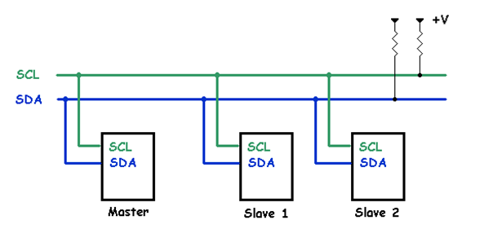

Each slave device has a unique address. Transfer from and to master device is serial and it is split into 8-bit packets. All these simple requirements make it very simple to implement I2C interface even with cheap microcontrollers that have no special I2C hardware controller. You only need 2 free I/O pins and few simple i2C routines to send and receive commands.

Some external devices have I2C interface such as microcontrollers, EFROM, A/D, D/A converter…

**2/ Specification:**

**a/ Interface**

I2C uses only two wires:

|  |  |
| --- | --- |
| Signal name | Function |
| SCL | Serial clock |
| SDA | Serial data |

Both need to be pulled up with a resistor to +Vdd. There are also I2C level shifters which can be used to connect to two I2C buses with different voltages.

**b/ Data structure**

With I2C, data is transferred in messages. Messages are broken up into frames of data. Each message has an address frame that contains the binary address of the slave, and one or more data frames that contain the data being transmitted. The message also includes start and stop conditions, read/write bits, and ACK/NACK bits between each data frame:

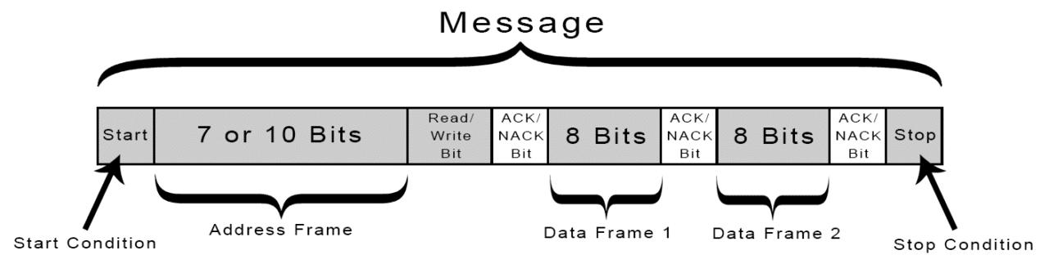

Start Condition: The SDA line switches from a high voltage level to a low voltage level before the SCL line switches from high to low.

Stop Condition: The SDA line switches from a low voltage level to a high voltage level after the SCL line switches from low to high.

Address Frame: A 7 or 10 bit sequence unique to each slave that identifies the slave when the master wants to talk to it.

Read/Write Bit: A single bit specifying whether the master is sending data to the slave (low voltage level) or requesting data from it (high voltage level).

ACK/NACK Bit: Each frame in a message is followed by an acknowledge/no-acknowledge bit. If an address frame or data frame was successfully received, an ACK bit is returned to the sender from the receiving device.

ADDRESSING

I2C doesn’t have slave select lines like SPI, so it needs another way to let the slave know that data is being sent to it, and not another slave. It does this by addressing. The address frame is always the first frame after the start bit in a new message.

The master sends the address of the slave it wants to communicate with to every slave connected to it. Each slave then compares the address sent from the master to its own address. If the address matches, it sends a low voltage ACK bit back to the master. If the address doesn’t match, the slave does nothing and the SDA line remains high.

READ/WRITE BIT

The address frame includes a single bit at the end that informs the slave whether the master wants to write data to it or receive data from it. If the master wants to send data to the slave, the read/write bit is a low voltage level. If the master is requesting data from the slave, the bit is a high voltage level.

THE DATA FRAME

After the master detects the ACK bit from the slave, the first data frame is ready to be sent.

The data frame is always 8 bits long, and sent with the most significant bit first. Each data frame is immediately followed by an ACK/NACK bit to verify that the frame has been received successfully. The ACK bit must be received by either the master or the slave (depending on who is sending the data) before the next data frame can be sent.

After all of the data frames have been sent, the master can send a stop condition to the slave to halt the transmission. The stop condition is a voltage transition from low to high on the SDA line after a low to high transition on the SCL line, with the SCL line remaining high.

c/ Waveform

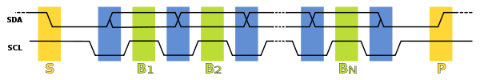

In normal state both lines (SCL and SDA) are high. The communication is initiated by the master device. It generates the Start condition (S) followed by the address of the slave device (B1). If the bit 0 of the address byte was set to 0 the master device will write to the slave device (B2). Otherwise, the next byte will be read from the slave device. Once all bytes are read or written (Bn) the master device generates Stop condition (P). This signals to other devices on the bus that the communication has ended and another device may use the bus.

Most I2C devices support repeated start condition. This means that before the communication ends with a stop condition, master device can repeat start condition with address byte and change the mode from writing to reading.

2/ RTL intention design

|  |  |
| --- | --- |
| Address | 10bit |
| Mode | 3 modes:  Standar :1 00 kbit/s  Fast-mode :400 kbit/s  High speed :3.4 Mbit/s |
| ACK/NACK | Support |
| User Application | DAC  ADC  Temprature |

