**https://lh5.googleusercontent.com/tQ-VzkTivR7YyM-1LDdG7OqF_Yx20RsN9fujh5_oYu6iFo7ifAfkqilsuQQenD2F34G0VfCQxcviVgA3dqPbCuO6wZgzj4rWKuzRCEDjzACDNdSFCR8Y2T0HluIO_6f_gi4kjKvG**

**University of Westminster**

**Programming Principles 1**

**4COSC006C.2**

**Coursework 3**

**REPORT**

**Module Leader:  Mr. Guganathan Poravi**

1. **Mohamed Fasehudeen Mohamed Afkar  - IIT NO : 2017350-UoW Number:16978065**
2. **Mohamed Mehaiza Iftikhar Wallin - IIT No: 2017375 -  UoW Number: 16985061**
3. **Name:Sachintha yapa Abeywardana-IIT number:2017489-  
   UOW number:16996724**
4. **Kalana Achintha-IIT No: 2017389 - UoW Number:16984486**
5. **Sanka Ravihara Peiris-IIT NO:2017490-UOW NUMBER:17016289 (BIS)**



[**INTRODUCTION    2**](https://docs.google.com/document/d/1PQAKvqnQAfXMV5gyJlFCXezyPupAJy-gJ4j3beVrkVM/edit#heading=h.yspy8tt3f0xe)

[Problem definition    2](https://docs.google.com/document/d/1PQAKvqnQAfXMV5gyJlFCXezyPupAJy-gJ4j3beVrkVM/edit#heading=h.uyuq5iiqtloo)

[**Why this problem is so important to solve:    2**](https://docs.google.com/document/d/1PQAKvqnQAfXMV5gyJlFCXezyPupAJy-gJ4j3beVrkVM/edit#heading=h.k1k1edgbv1bv)

[**Intended solution and technology to be used    3**](https://docs.google.com/document/d/1PQAKvqnQAfXMV5gyJlFCXezyPupAJy-gJ4j3beVrkVM/edit#heading=h.s5726qd6q3bw)

[**Architecture of the system:    5**](https://docs.google.com/document/d/1PQAKvqnQAfXMV5gyJlFCXezyPupAJy-gJ4j3beVrkVM/edit#heading=h.gry3wfr5dxh9)

[Cyber Model    5](https://docs.google.com/document/d/1PQAKvqnQAfXMV5gyJlFCXezyPupAJy-gJ4j3beVrkVM/edit#heading=h.hayzuihceh0u)

[Application    5](https://docs.google.com/document/d/1PQAKvqnQAfXMV5gyJlFCXezyPupAJy-gJ4j3beVrkVM/edit#heading=h.63ql1ocg2qp9)

[Analytics    5](https://docs.google.com/document/d/1PQAKvqnQAfXMV5gyJlFCXezyPupAJy-gJ4j3beVrkVM/edit#heading=h.fyows7f2luwg)

[**When and where you can apply/use your application (Conditions)    5**](https://docs.google.com/document/d/1PQAKvqnQAfXMV5gyJlFCXezyPupAJy-gJ4j3beVrkVM/edit#heading=h.wa95r0k3rvf5)

[System functionality    6](https://docs.google.com/document/d/1PQAKvqnQAfXMV5gyJlFCXezyPupAJy-gJ4j3beVrkVM/edit#heading=h.zerul21wbaqu)

[**Business perspective    7**](https://docs.google.com/document/d/1PQAKvqnQAfXMV5gyJlFCXezyPupAJy-gJ4j3beVrkVM/edit#heading=h.6btsg0c6kah4)

[**Flowchart    8**](https://docs.google.com/document/d/1PQAKvqnQAfXMV5gyJlFCXezyPupAJy-gJ4j3beVrkVM/edit#heading=h.sztwzqcyeoq2)

[**CONCLUSION    9**](https://docs.google.com/document/d/1PQAKvqnQAfXMV5gyJlFCXezyPupAJy-gJ4j3beVrkVM/edit#heading=h.xig6vrwzhzyt)

[**REFERENCES    9**](https://docs.google.com/document/d/1PQAKvqnQAfXMV5gyJlFCXezyPupAJy-gJ4j3beVrkVM/edit#heading=h.58s2isbcparm)

INTRODUCTION

Problem definition

The overall mission of our group is to mitigate problems during periods of crisis.

Particularly, for this project, we have focused on the problem of droughts and water shortages.

We have taken up such a problem in order to spread awareness of Climate Change and Global Warming which will gain the attention of local and international governing bodies to implement rules and regulations for the conservation of our precious resources.

Why this problem is so important to solve:

Water is the most essential chemical compound essential for all life forms.

When there is water, there is life.

Even Humanity's desire for space exploration was enhanced when renowned scientists informed the possibility of water being present in the planet of Mars.

Unfortunately, despite the Earth being covered in 71% of water, 96.5% of Earth’s water is in the oceans.

This leaves a small percentage of water fit for consumption.

Now we understand that water is a scarce resource and we intend to make the best out of it.

Several nations in the world are suffering from acute water shortages and droughts.

For example, much of India is suffering from constant heat waves and severe drought conditions that have destroyed crops, killed livestock and left approximately 330 million people without enough water for their daily needs.

Recently, over 60,000 farmers who feed the nation of India even committed suicide due to the harsh climate change.

This is but one country out of the 195 countries that is suffering as a result of Climate Change.  

Basically, storage of water (tank) has been a manual process where a person finds out that the tank of water has become low or empty once he or she checks the water flow by opening the tap. If the tank is empty not he or she must go and switch on the water pump in order to refill the tank again. So this has become a nuisance and we are going to solve this problems by introducing the automated water level indicator and controller.

Intended solution and technology to be used

We are trying to solve this problem by monitoring the scarce resource - water.

We have therefore implemented an Internet of Things (IoT) System to monitor water supply and demand in nations to verify the global water requirements, shortages and wastages.

To solve this problem by using the arduino board which is a microcontroller board based on the ATmega328P (datasheet). Microcontroller is a computer on a chip that is programmed to perform almost any control, sequencing, monitoring and display the function. Microcontroller is designed to be all of that in one. Its great advantage is no other external components are needed for its application because all necessary peripherals are already built into itself.

Arduino is an open-source electronic platform where user has the ability tell the board what to do by uploading a set of code to the microcontroller on the board. To do the user must use Arduino software IDE in Arduino programming language. The Arduino IDE is more user-friendly even for beginners and it is easy to understand the programming language.

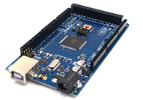

**Arduino board**

In this automated water level indicator and controller, we are measuring the content of water by using ultrasonic sensors. Basic principle of finding the distance using ultrasonic sensor is based on echo. When sound waves are transmitted   to the surrounding and return back to the origin just after the sound wave strike on any obstacle defines the phenomena echo. So we have to only to calculate its travelling time of both sounds waves are the time taken by out coming from the origin and incoming waves towards the origin. Considering the travelling time and speed of sound in air we can calculate the distance.

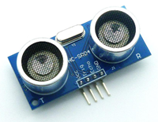

**Ultrasonic sensor**

Ultrasonic sensor has the ability to measure the distance in the range of 2 cm-400 cm with the accuracy of 3mm.this sensor is comprised with transmitter, receiver and control circuit. There are two speakers in the ultrasonic sensor, one of the speaker is called the transmitter and other one is receiver. The function of the transmitter is to send ultrasonic sound waves and receiver waits till it receive the ultrasonic sound waves just after getting knocked to obstacle.

By using a calculation we can get the distance from the sensor to the water surface, so now we need to calculate the water level. First of all we need to calculate the total length of tank. Since we are knowing the length of the water tank then we can get the water level by subtracting resulting distance coming from sensor from total length of the tank.so now we can convert the water level in percent of water, and can display it on LCD display.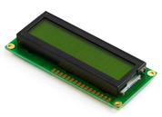

**LCD display**

Now we are going to convey about Water Controlling System which we are going to use in our project. We can control the water pump by connecting it with an output pin of microcontroller by means of a motor driver circuit. At the point when microcontroller sends a positive signal (+5v) or a ground signal (0v) to the motor driver circuit, at that point the water pump progress towards becoming on or off respectively. We additionally might want to utilize a manual switch on the motor driver circuit which should use for controlling it manually. It also makes this system more user friendly.

        User has the ability to see the water level in percent in a LCD display .Automatically when the tank get filled up to 100% supply of water is stopped from the  water pump. And system gives a reminder to the user when the level of water reached to least percent of water to refill the tank again and also when the tank is fully filled.

Architecture of the system:

The software defined product consists of the Cyber model, Application and Analytics.

Cyber Model

The Cyber Model is the physical representation of our system which incorporates real world data and its external systems.

Application

Application defines how the product works and its functionality. It’s also used for communication between internal (sensors) and external sources (cloud  technology).

Analytics

We believe that our project will help monitor water levels and address issues as soon as possible by governmental authorities. Therefore it will be totally worth it to upgrade the current methods to that similar to our project.

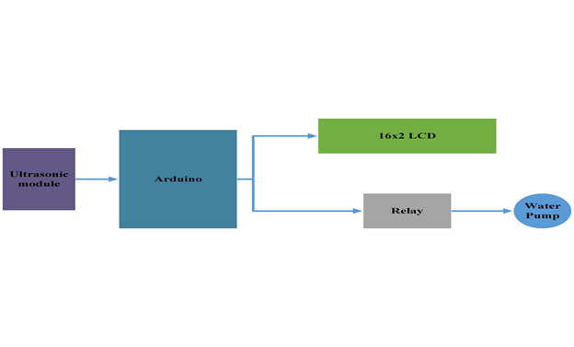

When and where you can apply/use your application (Conditions)

**APPLICATIONS:**• Automatic water pump control  
• Alarm devices for reducing water wastage  
• This technology can also be used to maintain industrial purpose smart monitoring system

When focusing on the country of Sri Lanka, we want the Ministry of City Planning and Water Supply, and the National Water Supply and Drainage Board to install  modernized measured water tanks with sensors and data transmission devices. This arrangement can be implemented for all the new customers, and the installation charges can be charged from them.

System functionality

1. The sensor will initially measure the depth of the measured water tank.
2. It will then signal the motor to fill the tank to the brim.
3. Once the water level is full the sensor will instruct the monitoring device which will in turn will switch off the motor (water pump).
4. When the water level is low, the sensor will once again repeat the process.
5. Each time the water is filled to brim of the tank, the monitoring device will log the total consumption on to the digital cloud which tracks the user consumption.
6. The cost of water will then be automatically calculated in the cloud.

By adopting this, the National Water Supply and Drainage Board will have a real time calculation of the total consumption and money owed by consumers.

As a result the  National Water Supply and Drainage Board will be well aware of the country’s water needs and will make sure that their reservoirs can supply the required water.

Consumers can also track their consumption by logging into their cloud accounts. In the event of a water leak they can inform the National Water Supply and Drainage Board to fix the damages, thus saving water.

This system can also be used to monitor the quantity of water in the reservoirs as follows:

1. The sensors will measure the total amount of collected water in the measured reservoir.
2. Using this data, the  National Water Supply and Drainage Board can verify whether there is sufficient water.
3. When water levels are low, an alert will be displayed by the monitoring system.
4. Then the National Water Supply and Drainage Board will contact the Department of Meteorology whether there is a drought.
5. If there is a drought, the necessary amount of water can be purchased by neighbouring countries according to the amount required by the consumer till the normal weather conditions resume.

In essence, our project will save the lives of millions of people using IoT, cloud and other technologies.

Business perspective

This is a very important equipment to factories, commercial complexes, apartments, hotels and even for individual residences. Using this they can manage their water usage daily and make it into an approximate equilibrium level  according to their demand and supply.

At an industrial level and individuals can can sort out their problems, errors using this system which will minimize their expenditure (Eg:-Inform water board easily in a failure,water board can detect the errors easily, minimize water overflowing instances) and using this they will be able to optimize their expenses and make it more profitable.Therefore this is a  compulsory object for macro-evolutionary users and micro-evolutionary users.

Flowchart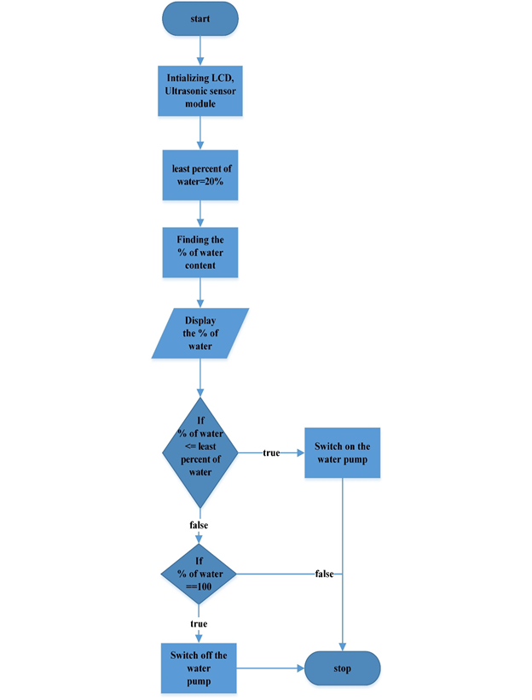

CONCLUSION

To fight against Climate Change and Global Warming political deniers and ensure that the entire planet has access to clean water for drinking and other purposes.

Therefore we have mentioned in this report an intelligent system that can be implemented using our prototype as the basis for design in local and regional levels.

REFERENCES

1. CNN. (2018). *India's drought crisis*. [online] Available at: https://edition.cnn.com/2016/05/04/asia/gallery/india-drought-crisis/index.html [Accessed 29 Apr. 2018].

2. Theguardian.com. (2018). [online] Available at: https://www.theguardian.com/environment/2017/jul/31/suicides-of-nearly-60000-indian-farmers-linked-to-climate-change-study-claims [Accessed 29 Apr. 2018].

3. Circuitdigest.com. (2018). Arduino based Automatic Water Level Indicator and Controller Project with Circuit Diagram & Code. [online] Available at: https://circuitdigest.com/microcontroller-projects/water-level-indicator-project-using-arduino [Accessed 29 Apr. 2018]

4. Arduino Project Hub. (2018). Automatic Water Level Controller. [online] Available at: https://create.arduino.cc/projecthub/karthickcj0083/automatic-water-level-controller-b2508d [Accessed 29 Apr. 2018].

5. Arduino.cc. (2018). Arduino - Introduction. [online] Available at: https://www.arduino.cc/en/Guide/Introduction [Accessed 29 Apr. 2018].

**Work Contribution**

**Pitch Video:**

**PLEASE MAKE SEPERATE VIDEOS WHICH WILL BE JOINED AFTERWARDS!**

**BIS student please include your own research and talk about it as well.**

**INTRODUCTION & Problem definition: Mohamed Afkar**

**Why this problem is so important to solve: Mohamed Afkar**

**Intended solution and technology to be used: Achintha**

**Architecture of the system (Cyber Model, Application , Analytics): Mehaiza Wallin**

**When and where you can apply/use your application (Conditions): Mehaiza Wallin**

**System functionality: Sachintha**

**Flowchart: Achintha**

**CONCLUSION: BIS student**

**Assignment 03** [**#CWK03**](https://www.facebook.com/hashtag/cwk03?source=feed_text) **is a group coursework consists of 4 SE students plus 1 BIS student which will consists of 5 students max may also have 4 student where 5th cannot be found. Students with 4 group MUST get my permission by meeting me personal by obtaining prior appointment.**

**You are suppose to come up with a proposal and submit the same by 30th of April 2018.**

**The proposal consists of two:**

**1) Written Proposal**

**2) Pitch Video uploaded to YouTube**

**1) Written Proposal**

**1.1) Problem definition - what’s the problem you are trying to solve**

**1.2) Why this problem is so important to solve - e.g. Magnitude of the problem with supporting evidence (Referencing must be given)**

**1.3) How are you trying to solve (Intended solution and technology to be used )**

**1.3.1) Give the architecture of the system**

**1.4) When and where you can apply/use your application (Conditions)**

**1.5) Draw a flowchart to show how your application will work**

**MUST not go beyond 10 pages**

**2) Pitch Video Guidelines:**

**Please read the link below to get an idea about how to make pitch video:**

[**https://blogs.msdn.microsoft.com/…/how-to-win-big-idea-pit…/**](https://blogs.msdn.microsoft.com/microsoftimagine/2015/09/16/how-to-win-big-idea-pitch/)

**1) Pitch video must not be more than 5 minutes MAX**

**2) All the members must appear but not compulsory every one does the presentation**

**3) Explain the problem visually**

**4) How do you intend to solve the issue**

**5) Technology to be used**

**6) How are you indent to take forward the project (What is the next step make it reality)**

**MUST to use the following technologies**

**1) IoT - look at all the possible devices and select the best one**

**2) Cloud**

**3) Android**

**Compulsory to use the above three to solve your problem**

**If you dont above technologies then know learn and do it...**

**<b>CWK03 Deadlines</b>**

**Proposal and pitch video - 01st of May 2018**

**Mid Term Review 15th of May 2018**

**Initial Prototype Submission 31st of May 2018**

**Final Prototype Submission only for the selected teams to CuttingEdge - 15th Jun 2018**