How code performs
How code is structured

- You will be writing algorithms to minimise various cost functions and will be designing mechanisms for inputting data and viewing data. You will be considering how to describe the quality of your resulting model and how to describe the limits on performance to a potential user (the recipient of your image).
- Your report is to focus on the technical aspects of the design of the algorithms you propose to use, and how you have tested and characterised their performance limitations. Imagine that your report is the technical white paper underpinning a business plan to launch a new App or Web-service - the final version may not even be implemented in Matlab.
- Your code will undoubtedly need a GUI to input data. The GUI will not be the main focus of your report but there should be an indication of how your program inputs data and the nature of the output.
- It is important that your code is well structured and designed. Comments should be informative and be consistent with the logical structure of your solution. Assumptions that you make about input parameters and return values that reflect the correctness of the code should be highlighted by your comments. Use comments to underpin the robustness of your code to improper input.
- Check eps.
- The entire project contains the test of the optimiser as an objective. We are only inputting simulated image data and we know the answer (we complete the K-matrix before we ‘estimate’ it). The percentage of outliers, the spacing of the grid, and the noise level in the estimation of the grid corners can all be varied to determine how the code’s performance varies as these key parameters are changed. You can also change the range of angles from which the grid is viewed to see how this affects the quality of estimation.
- Stopping criterion: the minimum is reached when the gradient is small. One possible measure of ‘small’ is the norm of the vector J’e divided by the number of measurements is small. But think about the units of each of the derivatives - the unscaled measurement is in pixels and the units used for the parameters are pixels, radians, and millimeters, so the derivatives are pixels per pixels, pixels per radian, and pixels per millimetre. You may wish to weight the elements of the derivative before computing the norm. Some discussion of the stopping criterion will be looked for in your report. This consideration is another advantage of scaling. Note that calculating the norm is very expensive.
- But in our case the Jacobian as a specific block structure can be used to speed up computation. The code is aimed at the task of estimating a K-matrix. I have also used a simple stopping criterion. Do you think the stopping criterion is appropriate? Why did I divide by the number of images? What is actually being tested here? Can you think of other termination conditions that might be better (how about the infinity norm - and how do you compute it?)

Report is to focus on optimisation , a potential GUI of the program, discussion of how it was programmed, commenting, input checks

This is a reminder about the B1 project administration. Please read the following information carefully as it includes important information and guidance.
Firstly, we want to remind you that you will no longer be able to get help with your code from the academics or demonstrators after the end of Michaelmas Term. Of course, if something is unclear in the project brief or similar, you can ask about this but no further help on your code will be available so it is important that your code is in good shape by the end of this week (Friday 2ndDecember).
Secondly, a reminder about the submission of your report. One copy of the B1 report must be submitted to the Chairman of the Examiners, Honour School of Engineering Science, c/o Clerk of the Schools, Examination Schools, High Street, Oxford, by noon on Wednesday of Week 1 in Hilary Term at the latest (Wednesday 18 January 2017). This is a strict deadline which must not be missed.
The project report must not exceed ten pages (including all diagrams, photographs, references and appendices). All pages must be numbered, have margins of not less than 20mm all round and typeface of Arial 11pt font with double-line spacing. The report must be the candidate’s own work and should include a signed statement to this effect. A declaration of authorship form must be completed for each student contributing to the report and a copy is available on WebLearn <https://weblearn.ox.ac.uk/x/jjAVnH> with all other B1 project documentation. The declaration must be submitted with the report but not attached or bound into the report to allow for easy removal prior to submission to the assessor. Neither the declaration or title page are included in the page count.

Any large coding project requires a structured approach, value checking, and proper commenting to be successful. This project was divided into four smaller, more managable steps: viewing an object with a camera model, estimating the homography, estimating the K-matrix, and optimising the K-matrix. The project was broken down further by writing a small piece of code and testing it with a harness script. For example, the first objective was to simulate a camera. This script was tested by plotting what a cube would look like viewed some angle and distance away, making it easy to verify the camera model.

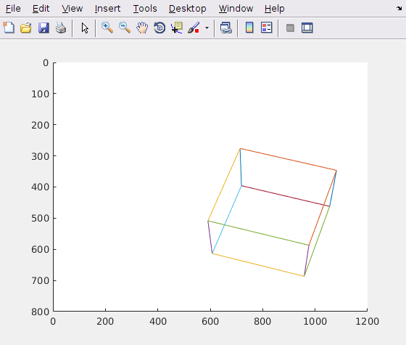
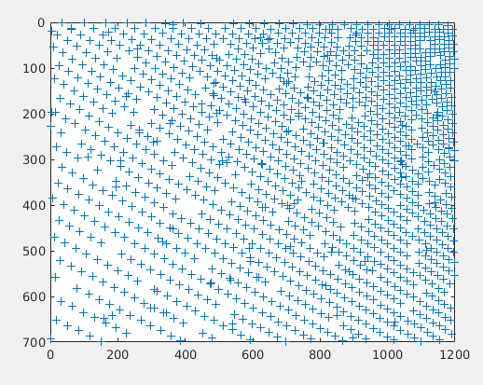
Fig I. Output from viewCamera and using viewCamera code to view a tile calibration grid with noise and outliers

Because the code builds on itself in each step, it is important to test each new addition to avoid bugs and unexpected outputs in the future. In this case, code from viewing the cube with a camera was later used to view a calibration grid with both noise and outliers. By using a piecewise approach, testing whether each component was working as expected and building on preexisting work was straightforward.
During the development process, the code was backed up and saved using a form of version control software called Github. Github allows users to push software changes to a repository along with version number and notes. The changes made are all tracked, making it easy to revert to an old program. Version control is an extremely important part of any large coding project. Projects are likely to have large teams tackling different aspects of the project at the same time. Team members can copy or ‘fork’ the main code to test new and experimental code and then merge changes together by combining branches of code.
Proper input and value checking statements in the code also ensured errors or inaccurate results were avoided. MATLAB’s calculation accuracy is limited because the minimum difference that its floating point arithmetic software can handle is given by eps, which has a value of approximately 2.22E-16. When normalising any values, a comparison between the denominator and eps was made. Checks to validate function inputs were also used, including matrix size and acceptable input value ranges.
Comments were also an important part of structuring the program. Comments were added to describe the structure, requirements, and limitations of the code. For example, when writing a new function, such as the calculateImageErrors function, commenting was used to lay out the steps the function took in the header, making information about function readily accessible without opening the function file. All newly initialised variables were also clearly defined and mathematical steps were explained throughout the code.

The aim of this project was to create a program that allows someone to measure distances in photos from a fixed focus camera reliably.

To achieve this, the program uses calibration images to calculate a K-matrix and then optimises the K-matrix. First the program creates a K-matrix and then creates a calibration grid with noise and outliers some distance and angle away. The program then uses six calibration images to estimate and optimise the K-matrix. The initial known K-matrix is used to assess the performance and accuracy of the K-matrix estimation and optimisation functions.

The calibration grid images are created by using the initial known K-matrix as a seed, so the performance and accuracy of the K-matrix estimation and optimisation functions can be assessed. To mimic a more realistic calibration process, both noise and outliers are added to the grid image. The noise is assumed to be white noise with a set variance. Because the calibration measurements would have been generated by a separate algorithm that may include unexpected points, outliers are added to account for these errors.
The camera is calibrated by using at least three differently oriented calibration grid images. This program uses six. For each image, a homography relating the grid coordinates to the unit camera plane can be found.
Outliers are rejected using Random Sample Consensus (RANSAC). Random Sample Consensus

The K-matrix is then optimised after it is estimated by searching a minimum in error magnitude. The optimisation algorithm used is the Levenberg-Marquardt, which is an iterative least-squares method that finds the local minimum and the error is quantified by taking the difference between the measured and predicted u and v points, squaring them, and then adding them.

Image error vectors are generated by the computeImageErrors function. The function takes inputs Kmatrix, RotAxis, Translation, Correspond, and BestConsensus. Kmatrix is the estimated K-matrix built from the calibration images, RotAxis is an angle-axis representation of the grid rotation in camera coordinates, and Translation is the origin of the grid in world space. Correspond is a set of [[u v]’ [x y]’] points and BestConsensus is a vector containing all the point numbers from Correspond that pass the error function. The difference between the respective u and x points in the consensus set are added to the error vector, followed by the v and y points.

The Jacobian for a single image is calculated by a

The code is limited by the noise and outliers in the image, the calibration image, as well as the time restraints on the code. A more accurate answer could always be found by inputting more images, increasing the number of calibration tiles in the grid, or changing the rejection in the code.

Because the units in the derivative of the jacobian ./ Error vector ? are different, the elements of the derivtive vector are scaled to properly represent the differences in value.

The stopping critereon used for the algorightm

