DIGIFIX
Project Progress Report
Car Parts Marketplace Platform

Prepared for: Digifix
Report Date: 27 June 2026
Status: Active Development — Core platform operational

1. Executive Summary
This document outlines the progress completed to date on the Digifix platform — an end-to-end online marketplace for automotive parts and accessories, complete with its own delivery network.
The platform is built as a connected ecosystem of four products that share a single backend:
- Customer Mobile App — where customers browse, search, and buy car parts.
- Seller / Salesman tools — for shops and salesmen to list products and manage sales.
- Rider (Delivery) Mobile App — for delivery partners to accept and complete jobs.
- Web Admin & Management Dashboard — for administrators and shop managers to oversee the operation.
All four are powered by a central backend API with a single secure database. The majority of the core features are now built and functioning, and the platform is in the testing-and-refinement stage.

2. Platform Architecture (Completed)
We have established the full technical foundation that everything else is built on.
Layer | Technology | Status
Customer & Rider Apps | React Native (Expo) — Android & iOS | Built
Web Dashboard | Next.js (React) | Built
Backend API | Node.js / Express | Built
Database | PostgreSQL (Supabase) | Built
Payments | Stripe + In-app Wallet | Built
Authentication | Email/Password + Google Sign-In | Built

Key achievements:
- A single shared backend serves all apps, so data stays consistent everywhere.
- Secure user accounts with multiple roles (Customer, Salesman, Shop Manager, Admin, Rider).
- Cloud-hosted database with proper indexing for fast search and scalability.

3. Customer Mobile App (Completed)
The customer-facing app allows shoppers to find and purchase car parts with a smooth, modern experience.
Completed features:
- Sign Up & Login — email/password and Google sign-in, plus password reset via OTP.
- Browse by Category — products and parts organised into categories.
- Product & Car Part Listings — images, prices, discounts, stock, and ratings.
- Vehicle Compatibility — parts matched to specific car makes, models, and years.
- Search — find products and parts quickly.
- Shopping Cart — add, update, and remove items.
- Wishlist — save items for later.
- Checkout — place orders with delivery address selection.
- Multiple Delivery Addresses — save and manage addresses.
- Order History & Tracking — view past orders and their current status.
- Reviews & Ratings — rate and review purchased products and sellers.
- Profile, Help & Support, About Us — in-app account and information pages.
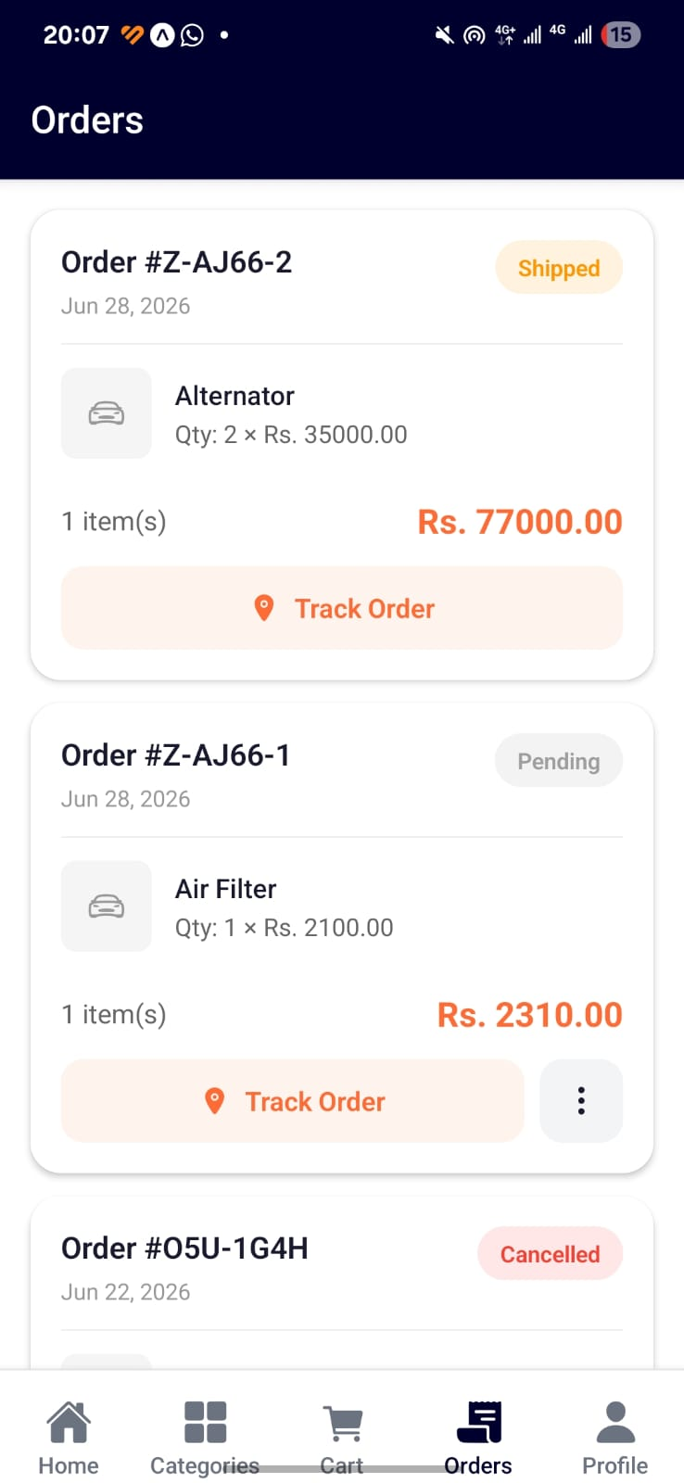
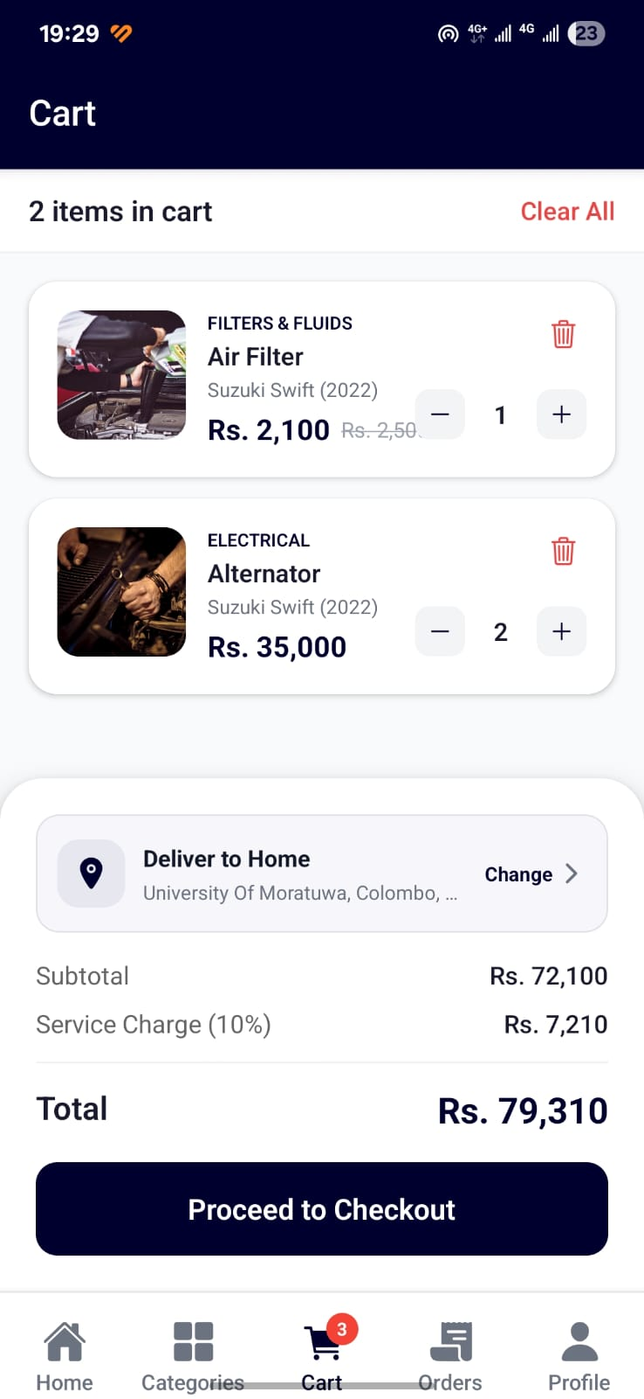
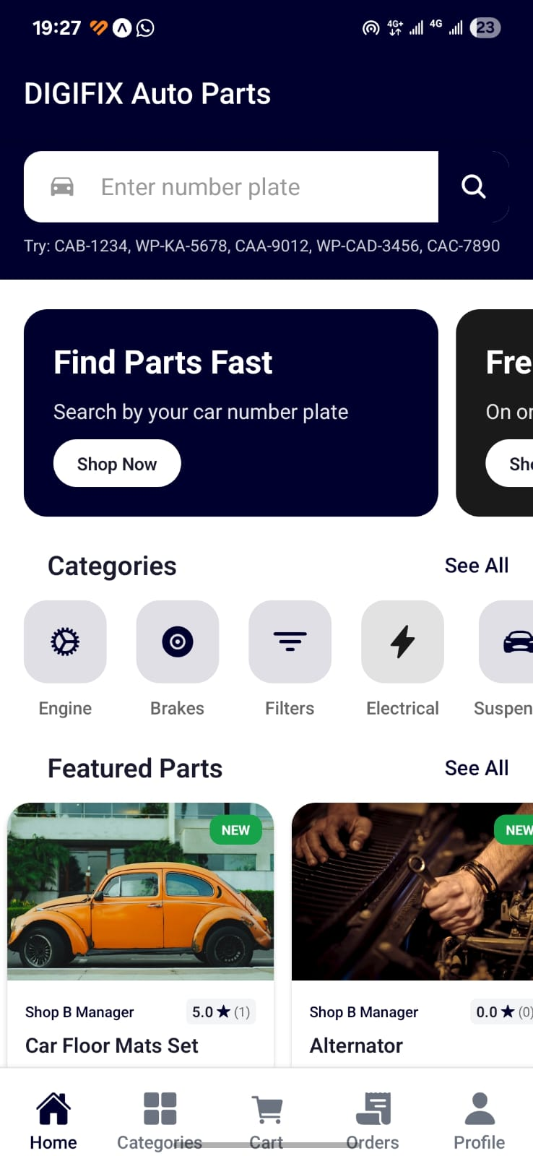

4. Seller / Salesman Tools (Completed)
Sellers and salesmen can run their store directly from the app.
Completed features:
- Add Products — create new product listings with images, pricing, and stock.
- Add Car Parts — list car parts linked to specific vehicles.
- Manage Listings — view and update existing products.
- Order Management — view and process incoming customer orders.
- Seller Wallet — track earnings from sales.
- Seller Profile & Store — manage store details.
- Review Replies — respond to customer reviews.
- Approval Workflow — new listings go through Pending → Approved / Rejected before going live.
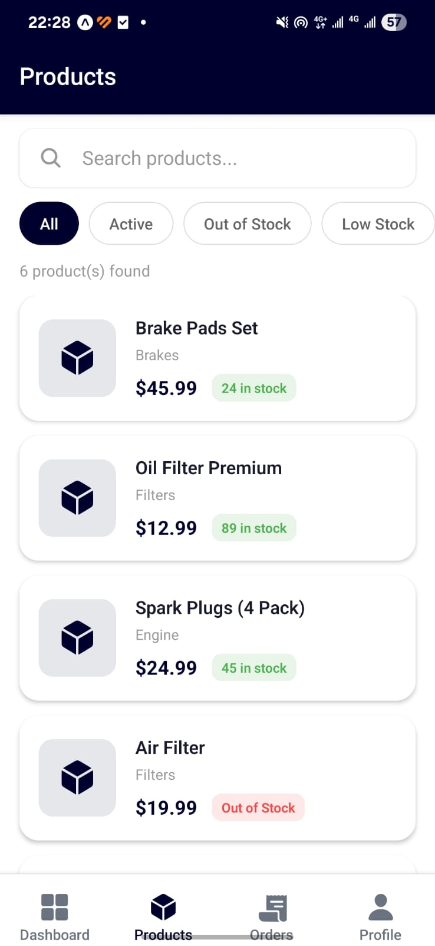
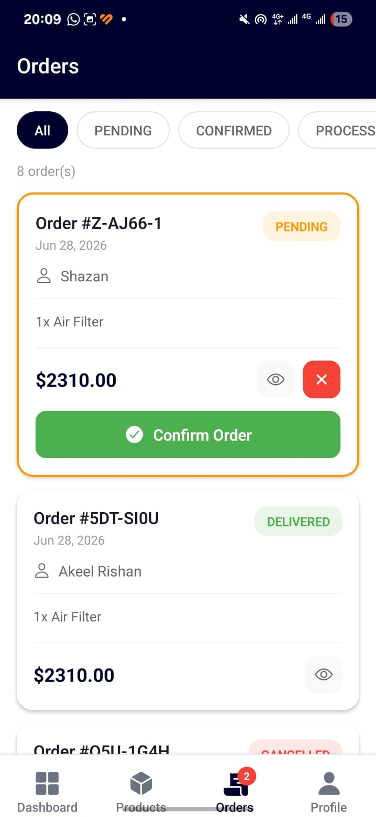
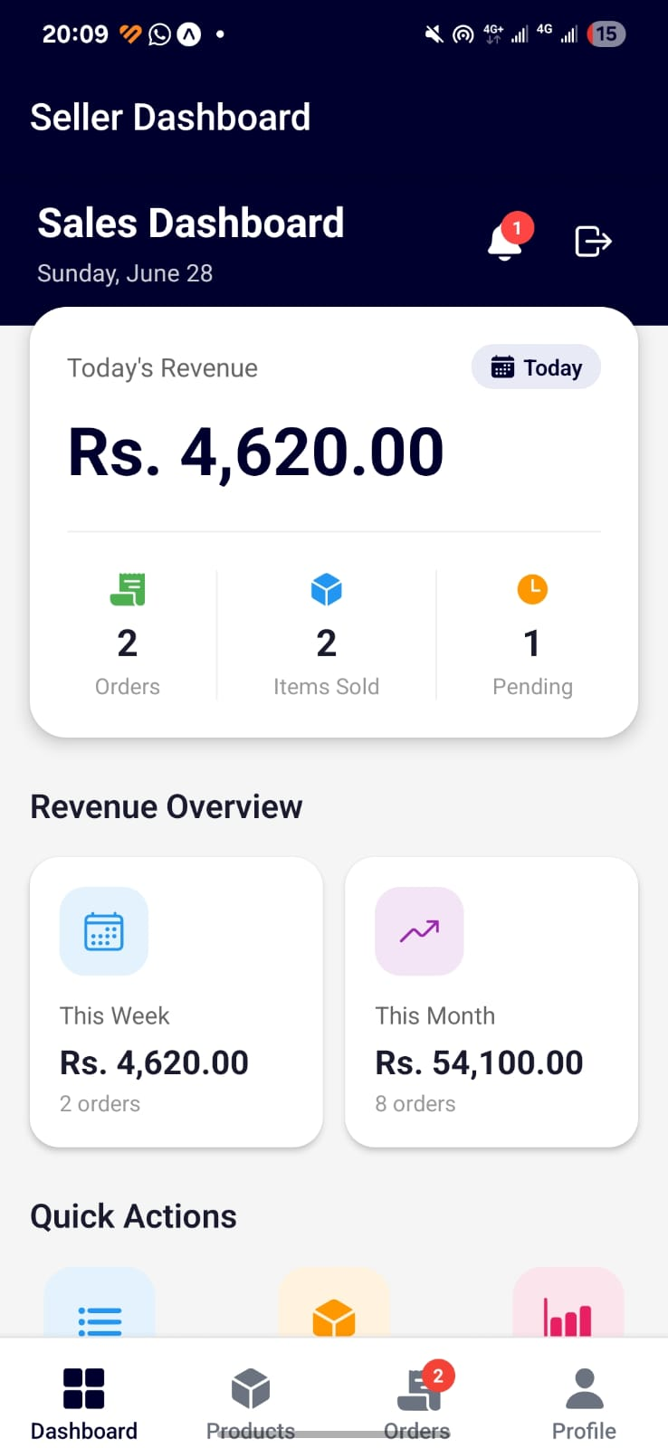

5. Rider (Delivery) Mobile App (Completed)
A dedicated app for delivery partners, fully integrated with the order system.
Completed features:
- Rider Sign Up & Login — with profile, vehicle details, and emergency contacts.
- Availability Toggle — riders go online/offline to receive jobs.
- Available Jobs — view nearby delivery jobs.
- Smart Dispatch — jobs auto-offered to the closest available riders in real time, with offer expiry.
- Accept / Reject Jobs — riders choose which deliveries to take.
- Active Delivery Flow — assigned → arrived at pickup → picked up → in transit → delivered.
- Live Location Tracking — rider location updates during delivery.
- Proof of Delivery — capture recipient name, signature, photo, and notes.
- Job History — completed deliveries record.
- Rider Wallet — track delivery earnings.
- Performance Dashboard — ratings, total deliveries, and statistics.

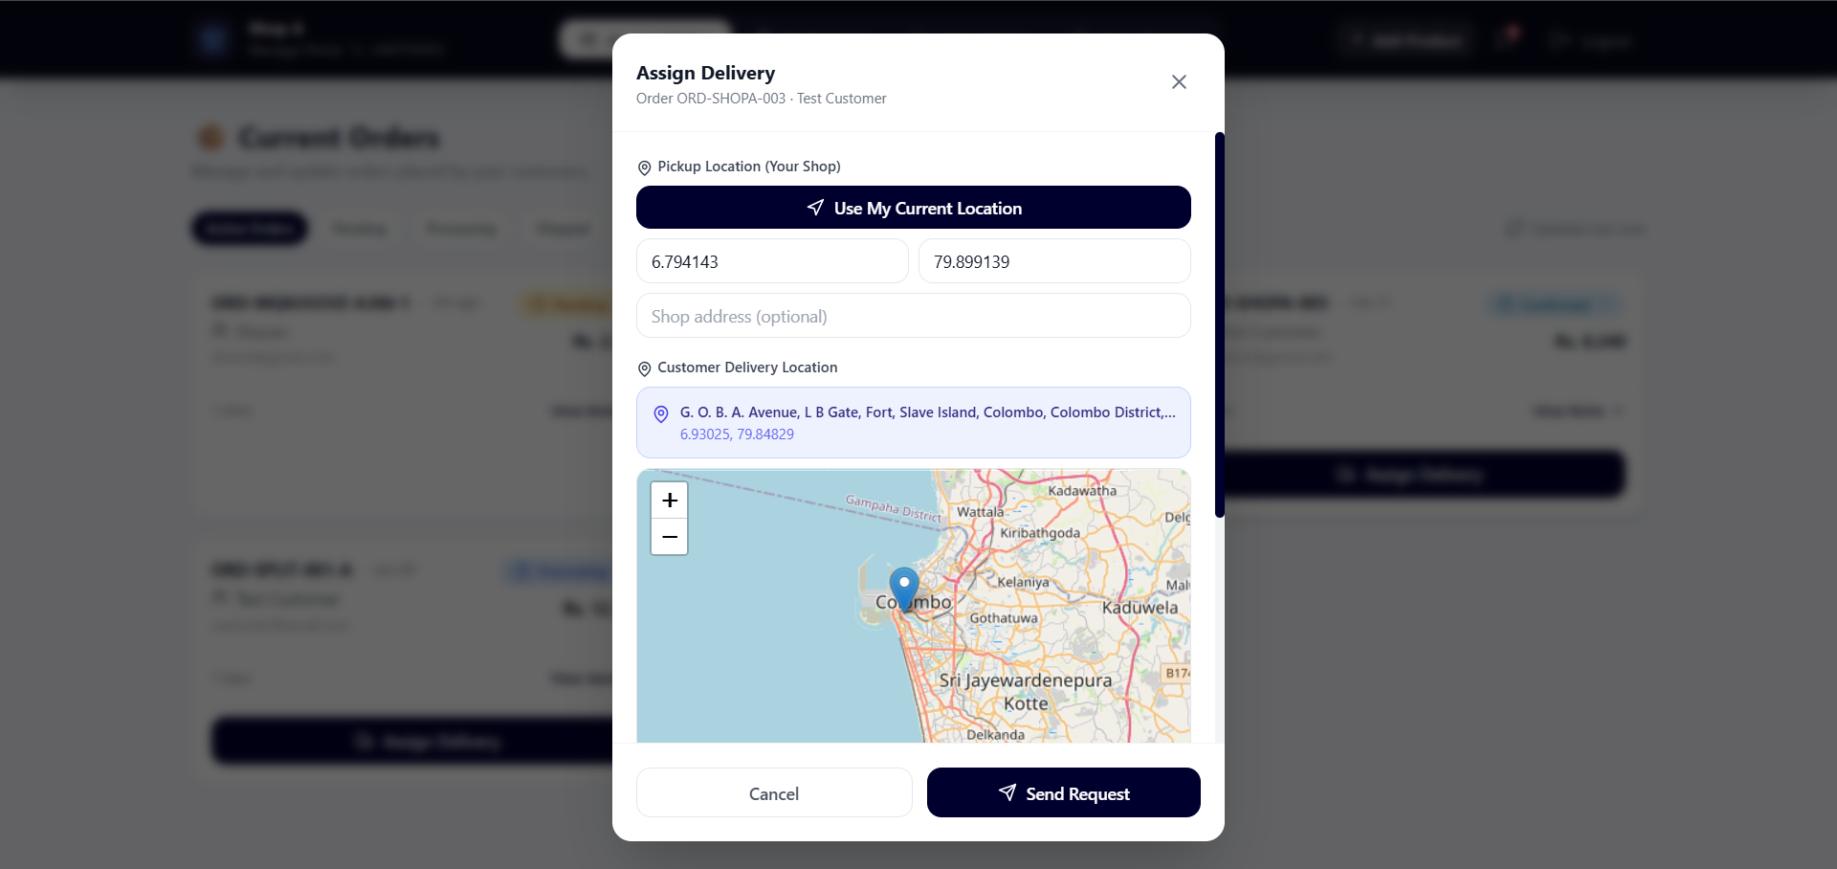

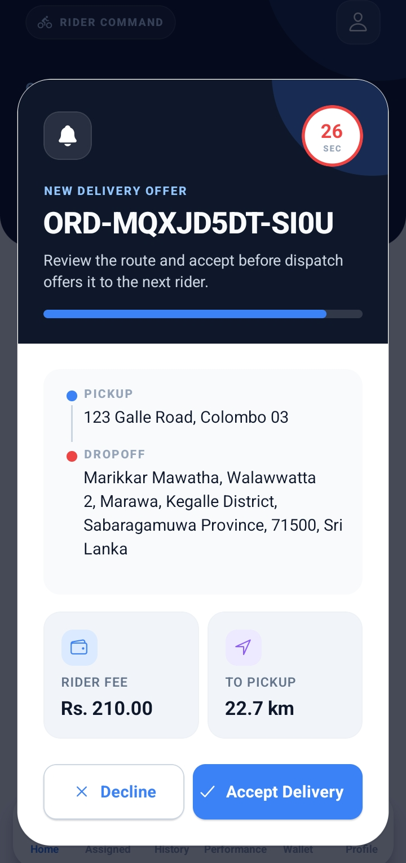
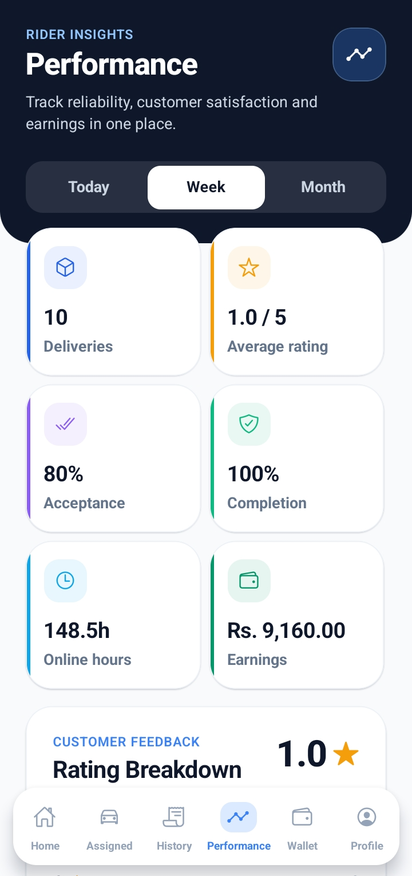
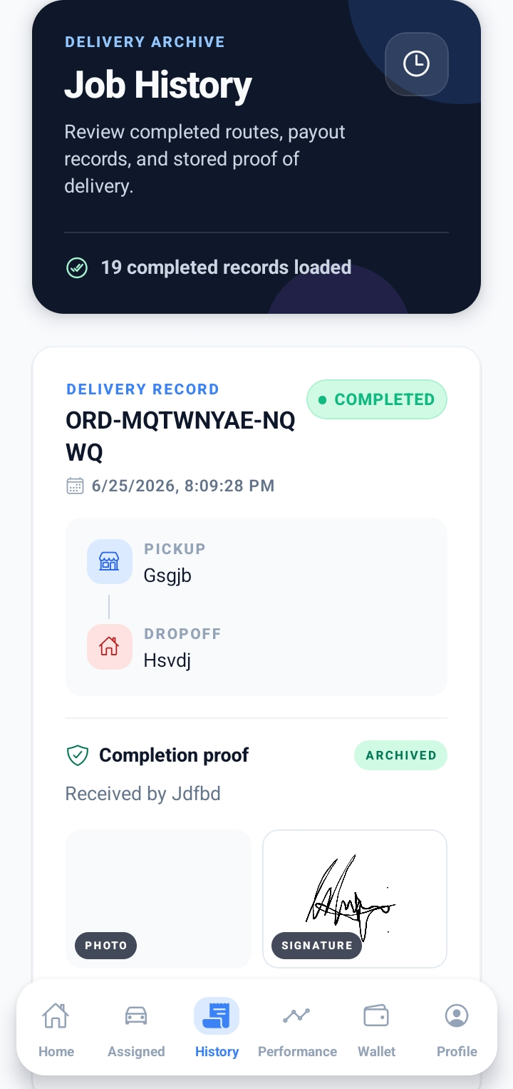
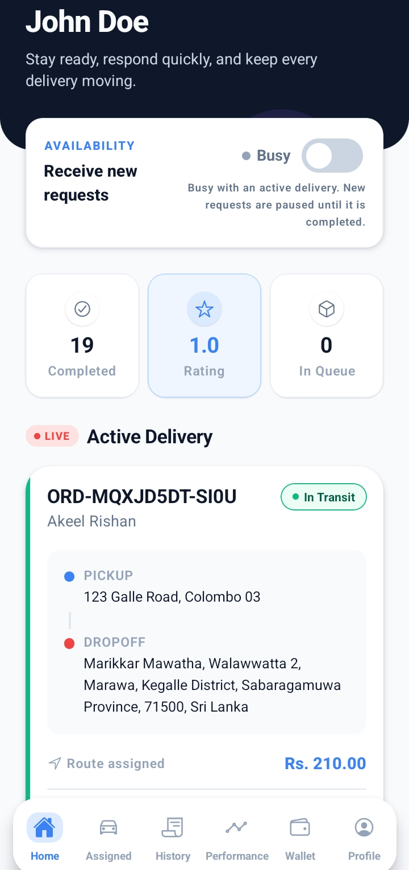
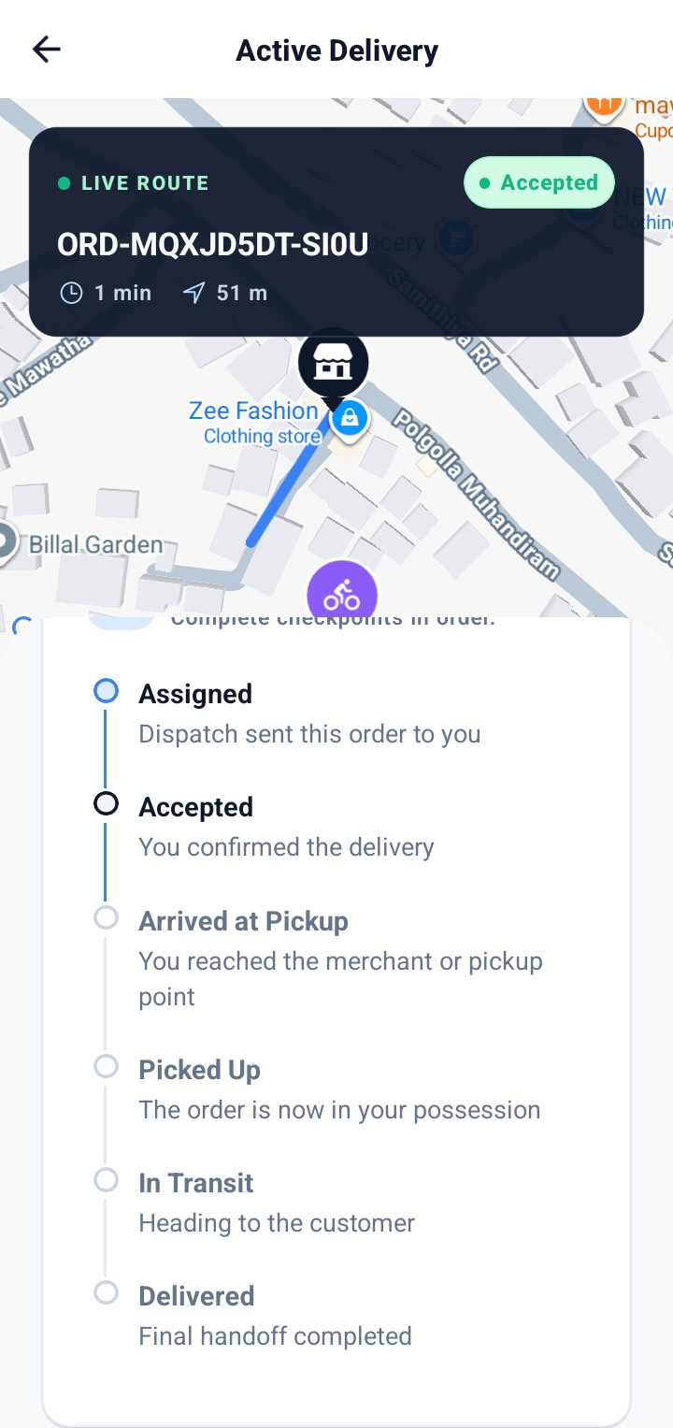
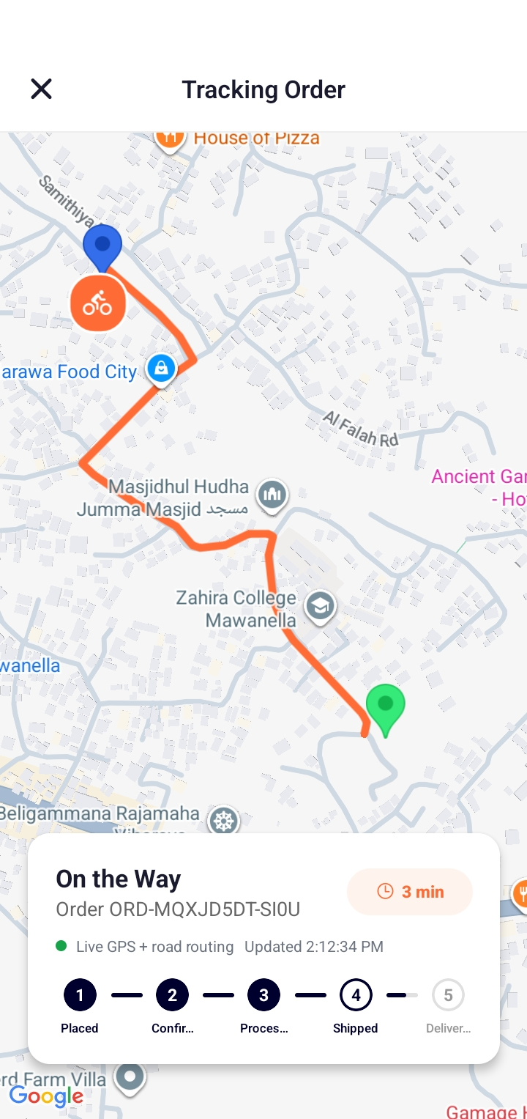

6. Web Admin & Management Dashboard (Completed)
A web portal for administrators and shop managers to oversee the entire platform.
Completed features:
- Admin Dashboard — full overview of users, products, orders, and platform activity.
- Shop Manager Dashboard — managers oversee their team of salesmen, shared catalog, and wallet.
- Salesman Web Access — salesmen can also operate from the web.
- Role Management — assign and manage user roles.
- Product / Listing Approvals — review and approve or reject seller listings.
- Review Moderation — low-rated reviews (below 3) are highlighted for attention.
- User Management — activate, deactivate, or suspend accounts.

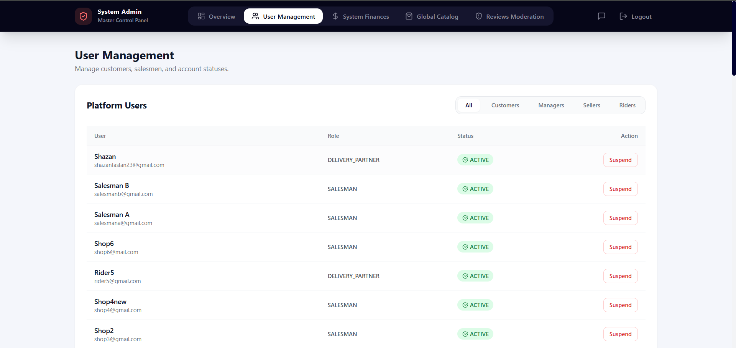
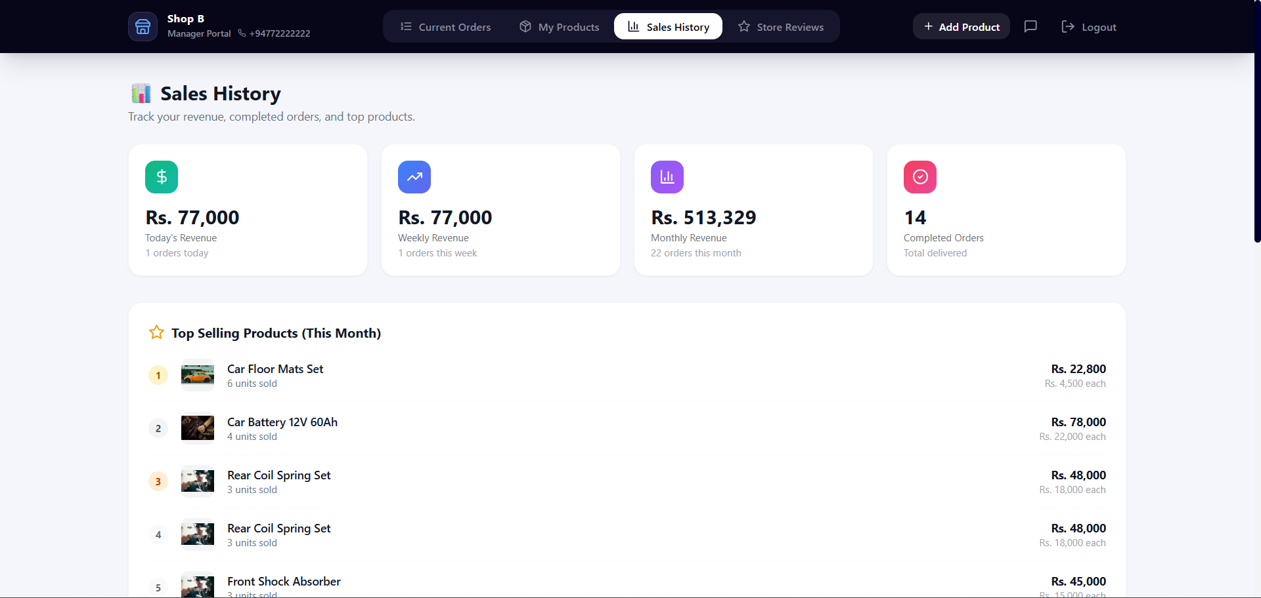
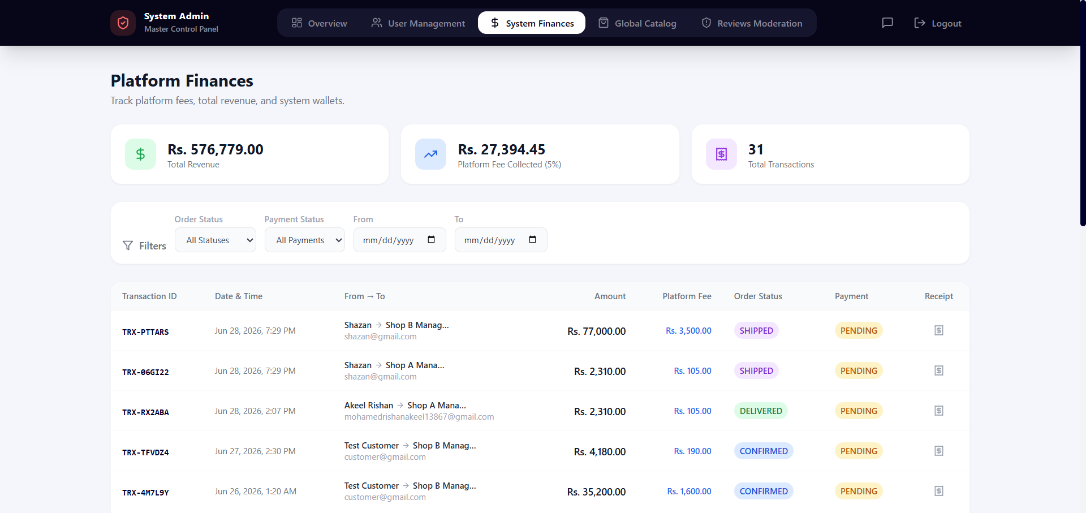
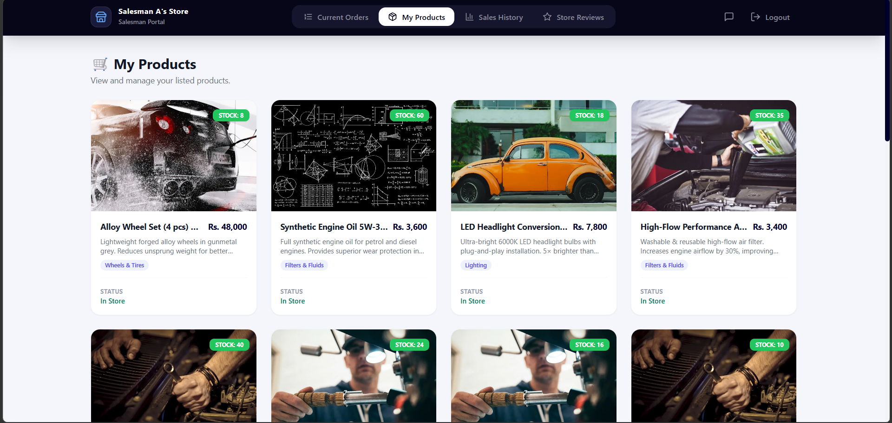

7. Payments & Wallet System (Completed)
A complete financial system underpins the marketplace.
Completed features:
- In-App Wallet — every user has a wallet with balance tracking.
- Stripe Integration — secure online card payments.
- Cash on Delivery (COD) — with a dedicated settlement-tracking system.
- Transaction Ledger — every payment, earning, fee, payout, and refund is recorded.
- Automated Splits — order payments distributed between sellers, riders, and the platform.
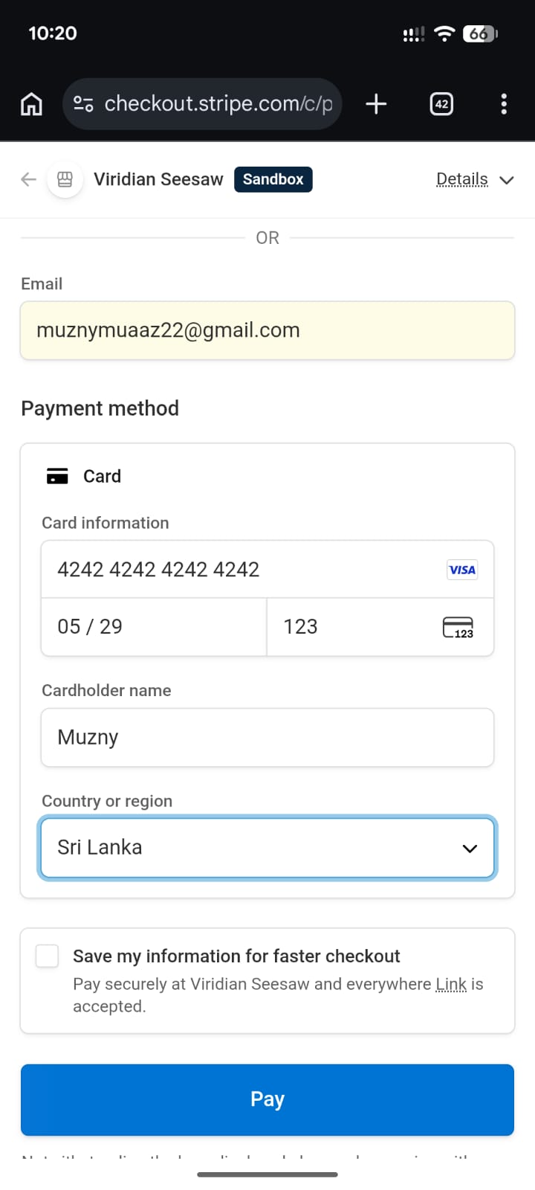
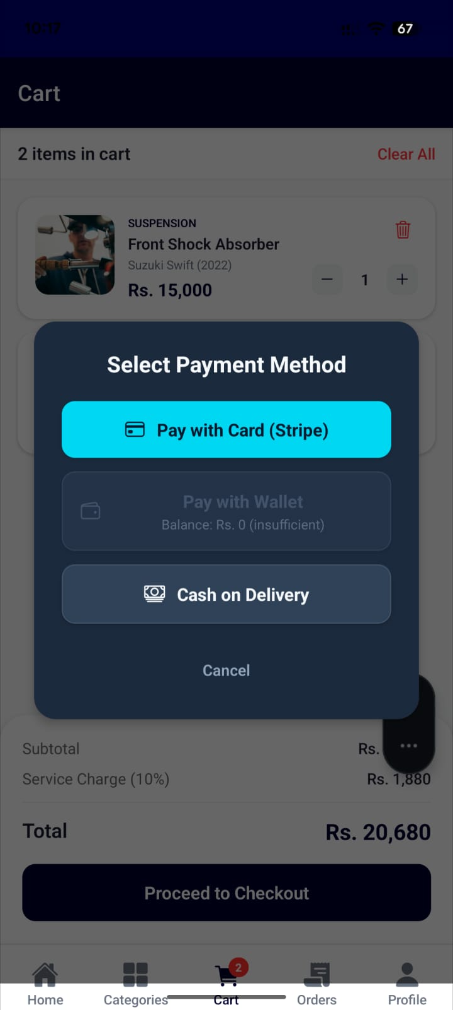
- Refunds — refund requests and settlement handling.

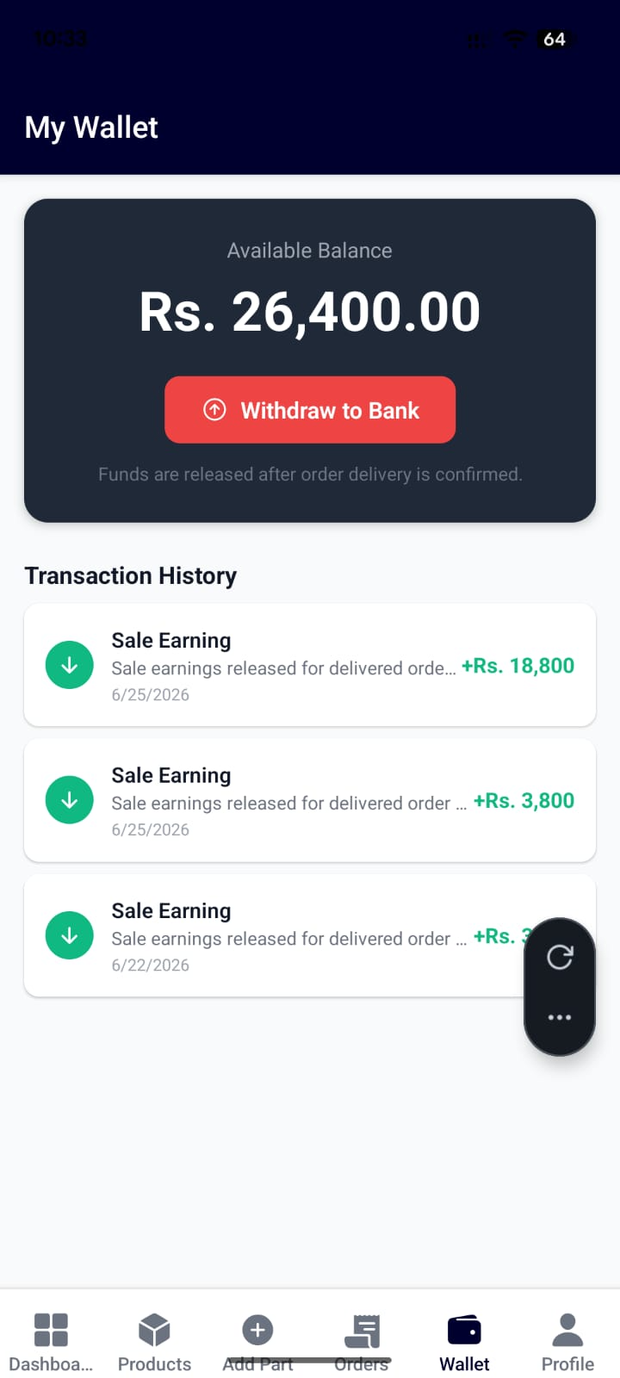

8. Order & Delivery Lifecycle (Completed)
Orders flow seamlessly from purchase to doorstep delivery. The complete journey now works end-to-end:
- Customer places an order and pays (online or COD).
- Seller receives and confirms the order.
- The order is automatically published as a delivery job.
- Nearby riders are offered the job in real time.
- A rider accepts, picks up, and delivers — with live tracking.
- Proof of delivery is captured and the order is marked complete.
- Earnings are settled to the seller and rider wallets.

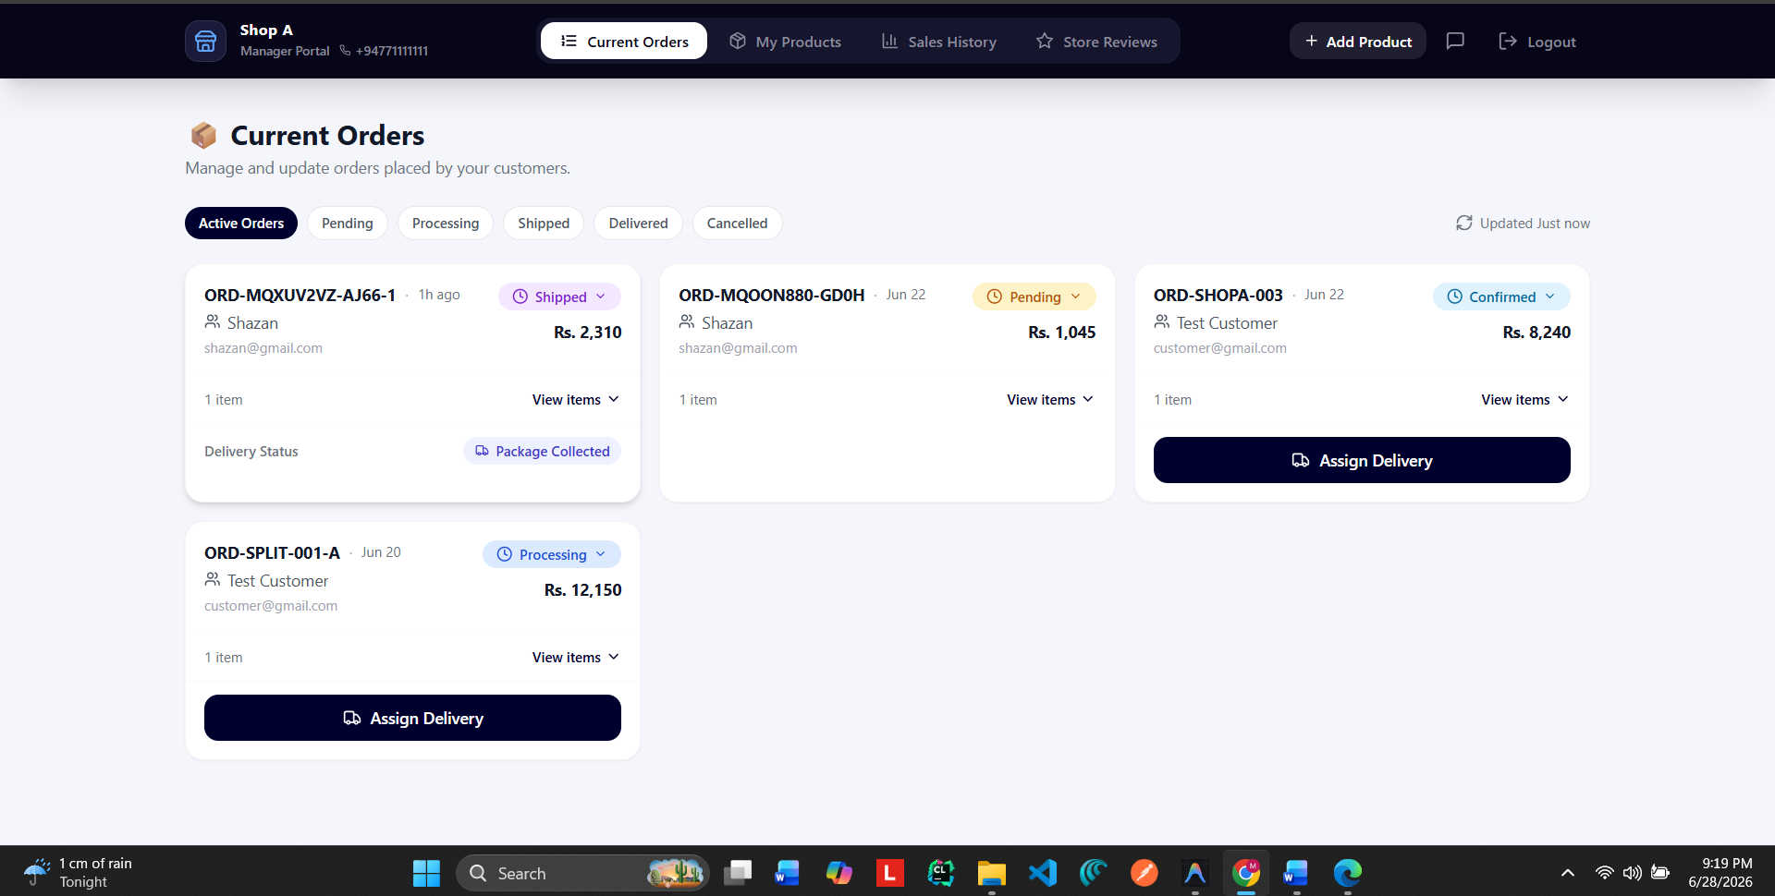

9. Reviews, Ratings & Quality Control (Completed)
- Customers can review products, sellers, and delivery partners.
- Sellers can reply to reviews.
- Ratings feed into seller, product, and rider scores automatically.
- Low ratings are flagged for management review to maintain quality.
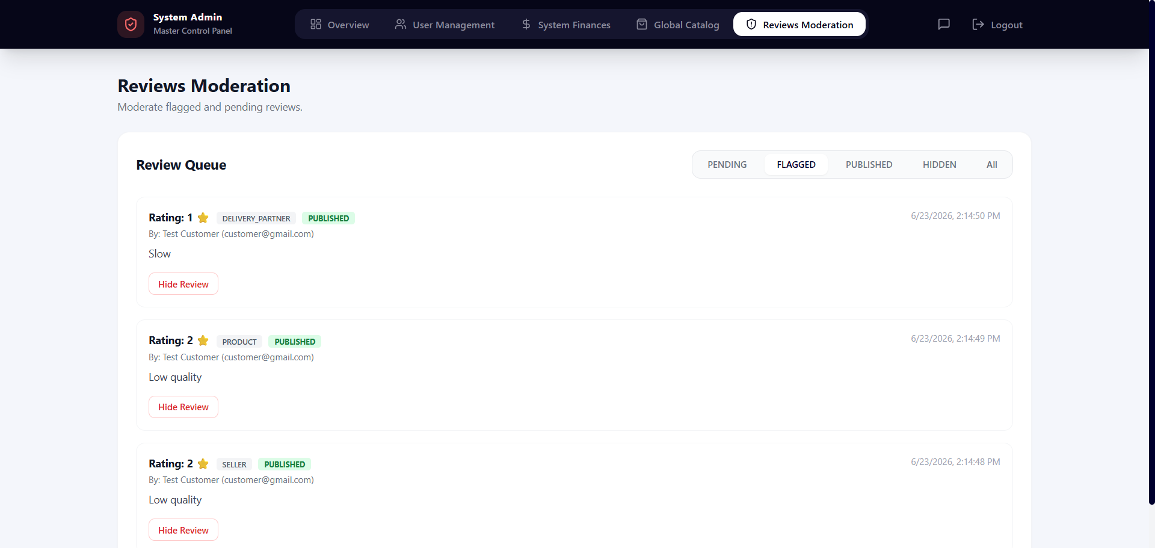

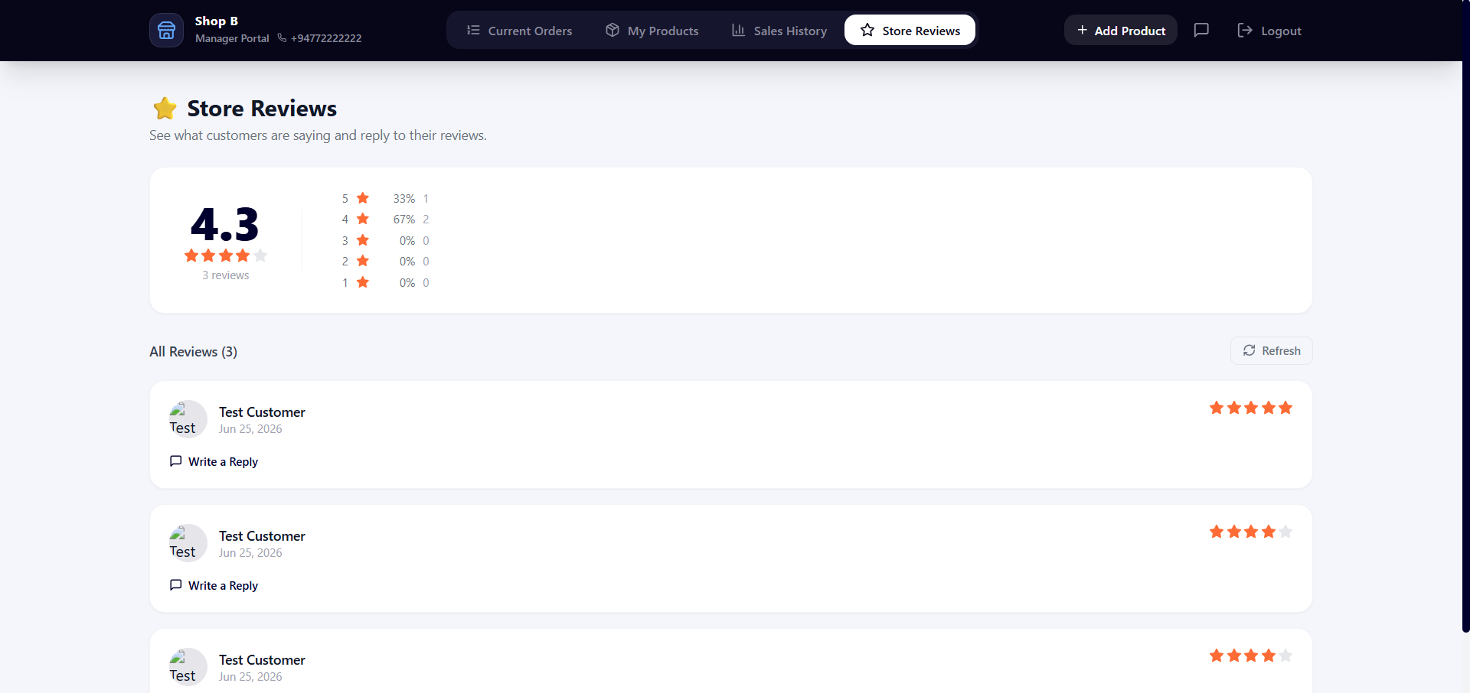
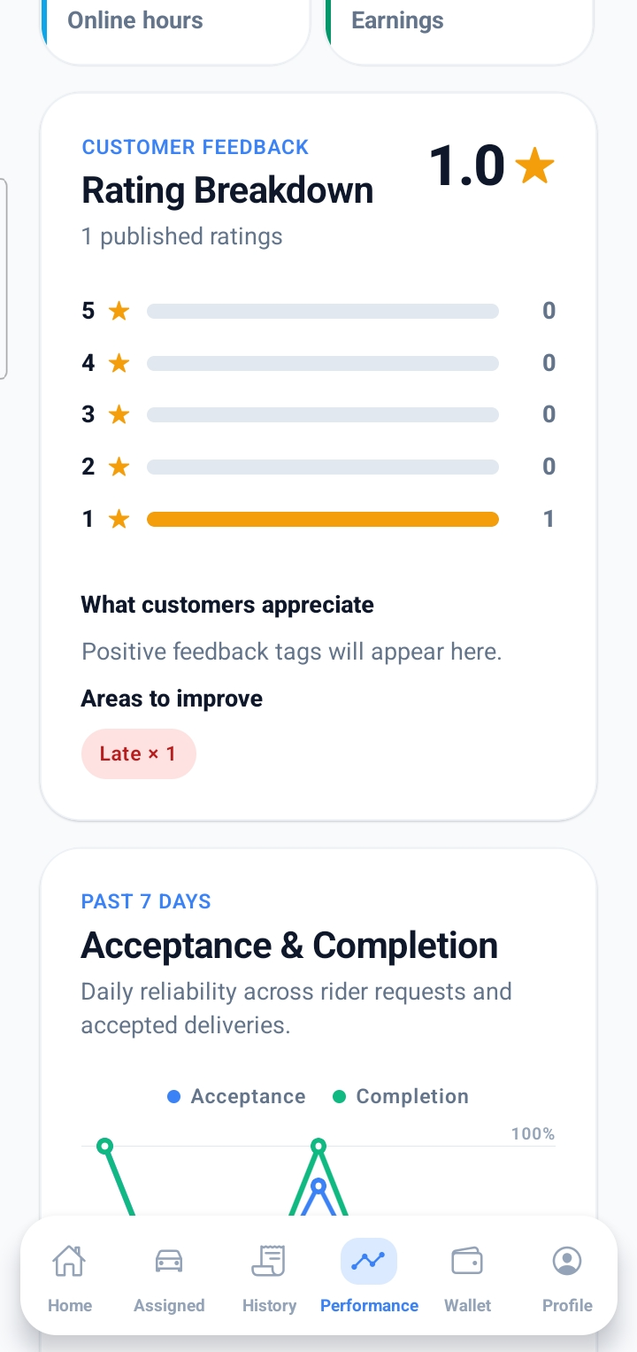
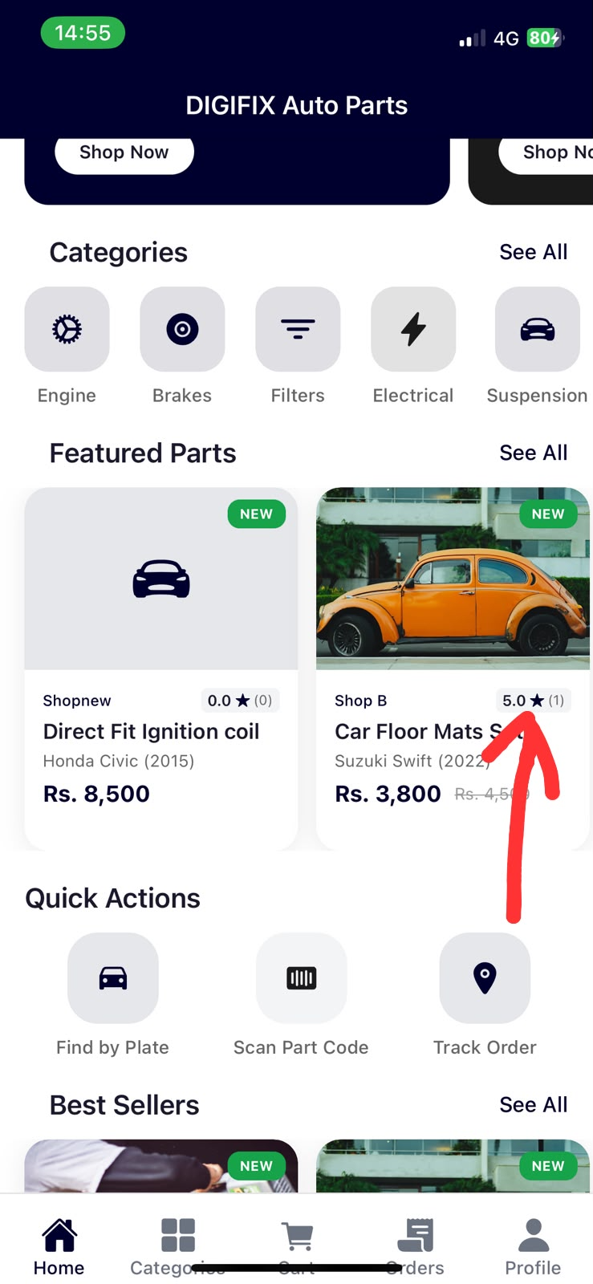

10. Summary of Completed Modules
# | Module | Status
1 | Platform architecture & database | Complete
2 | User accounts & multi-role system | Complete
3 | Customer mobile app | Complete
4 | Seller / salesman tools | Complete
5 | Rider delivery app | Complete
6 | Web admin & manager dashboard | Complete
7 | Payments, wallet & Stripe | Complete
8 | Order & delivery lifecycle | Complete
9 | Reviews, ratings & moderation | Complete
10 | Real-time rider dispatch & tracking | Complete

11. Next Steps
The core platform is operational. Upcoming work focuses on:
- Final end-to-end testing across all apps.
- Performance tuning and bug fixes from testing feedback.
- Polishing the user interface and experience.
- Preparing for production launch (app store submission and deployment).

This report reflects development progress as of 27 June 2026. Screenshots and images will be inserted at the marked placeholders.
— Project Development Team

