Release, Waiver of Liability, and Covenant
Not to Sue (Model Release)
For good and valuable consideration, the undersigned hereby grants the IEEE Robotics and Automation Society and the International Conference on Robotics and Automation (IEEE RAS/ICRA) the right and permission, in respect to the photographs, video tapes, motion pictures, recordings, or any other media (hereinafter collectively known as “Images”) that IEEE RAS/ICRA has taken of me or my property, or in which I may be included with others, to copyright the same to use, re-use, publish, re-publish, and allow other uses according to IEEE rules. I also allow my name in connection therewith if IEEE RAS/ICRA so chooses. I hereby waive any right to inspect or approve the Images or any finished version incorporating the same.

The undersigned does hereby release and forever discharge IEEE RAS/ICRA, their members individually, and their officers, agents, and employees of any kind from all claims, demands, rights, and causes of action of whatever kind or nature, arising from and by reason of any and all known and unknown, foreseen, and unforeseen injuries, damages, and the consequences thereof resulting from the use of the Images, including without limitation any and all claims for libel or invasion of privacy.

This authorization and release shall also inure to the benefit of the heirs, legal representatives, licensees, and assigns of IEEE RAS/ICRA. I hereby certify that I am suffering under no legal disabilities and that I have read the above carefully before signing. This release shall be binding upon me and my heirs, legal representatives, and assigns.

By signing below,

___I agree to the terms stated above and hereby certify that I am 18 years of age or older.

___14/02/2023_______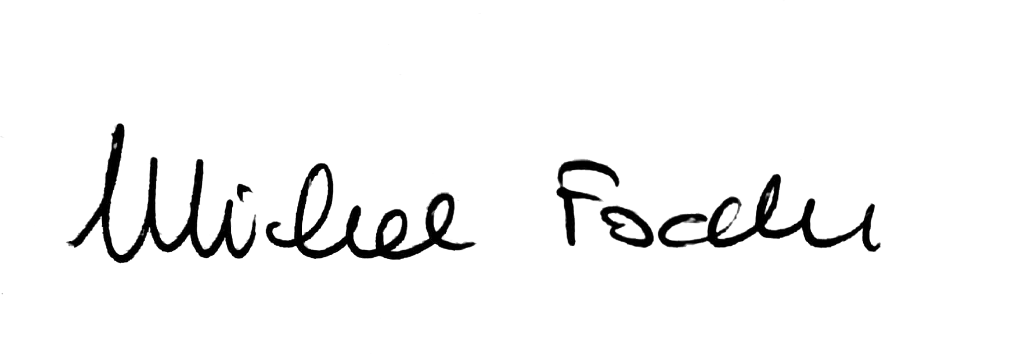
Signature/Date

Michele Focchi______________________________
Print Name

By signing below,

___I DO NOT agree to the terms stated above.

________________________________________________________________
Signature/Date

________________________________________________________________
Print Name

