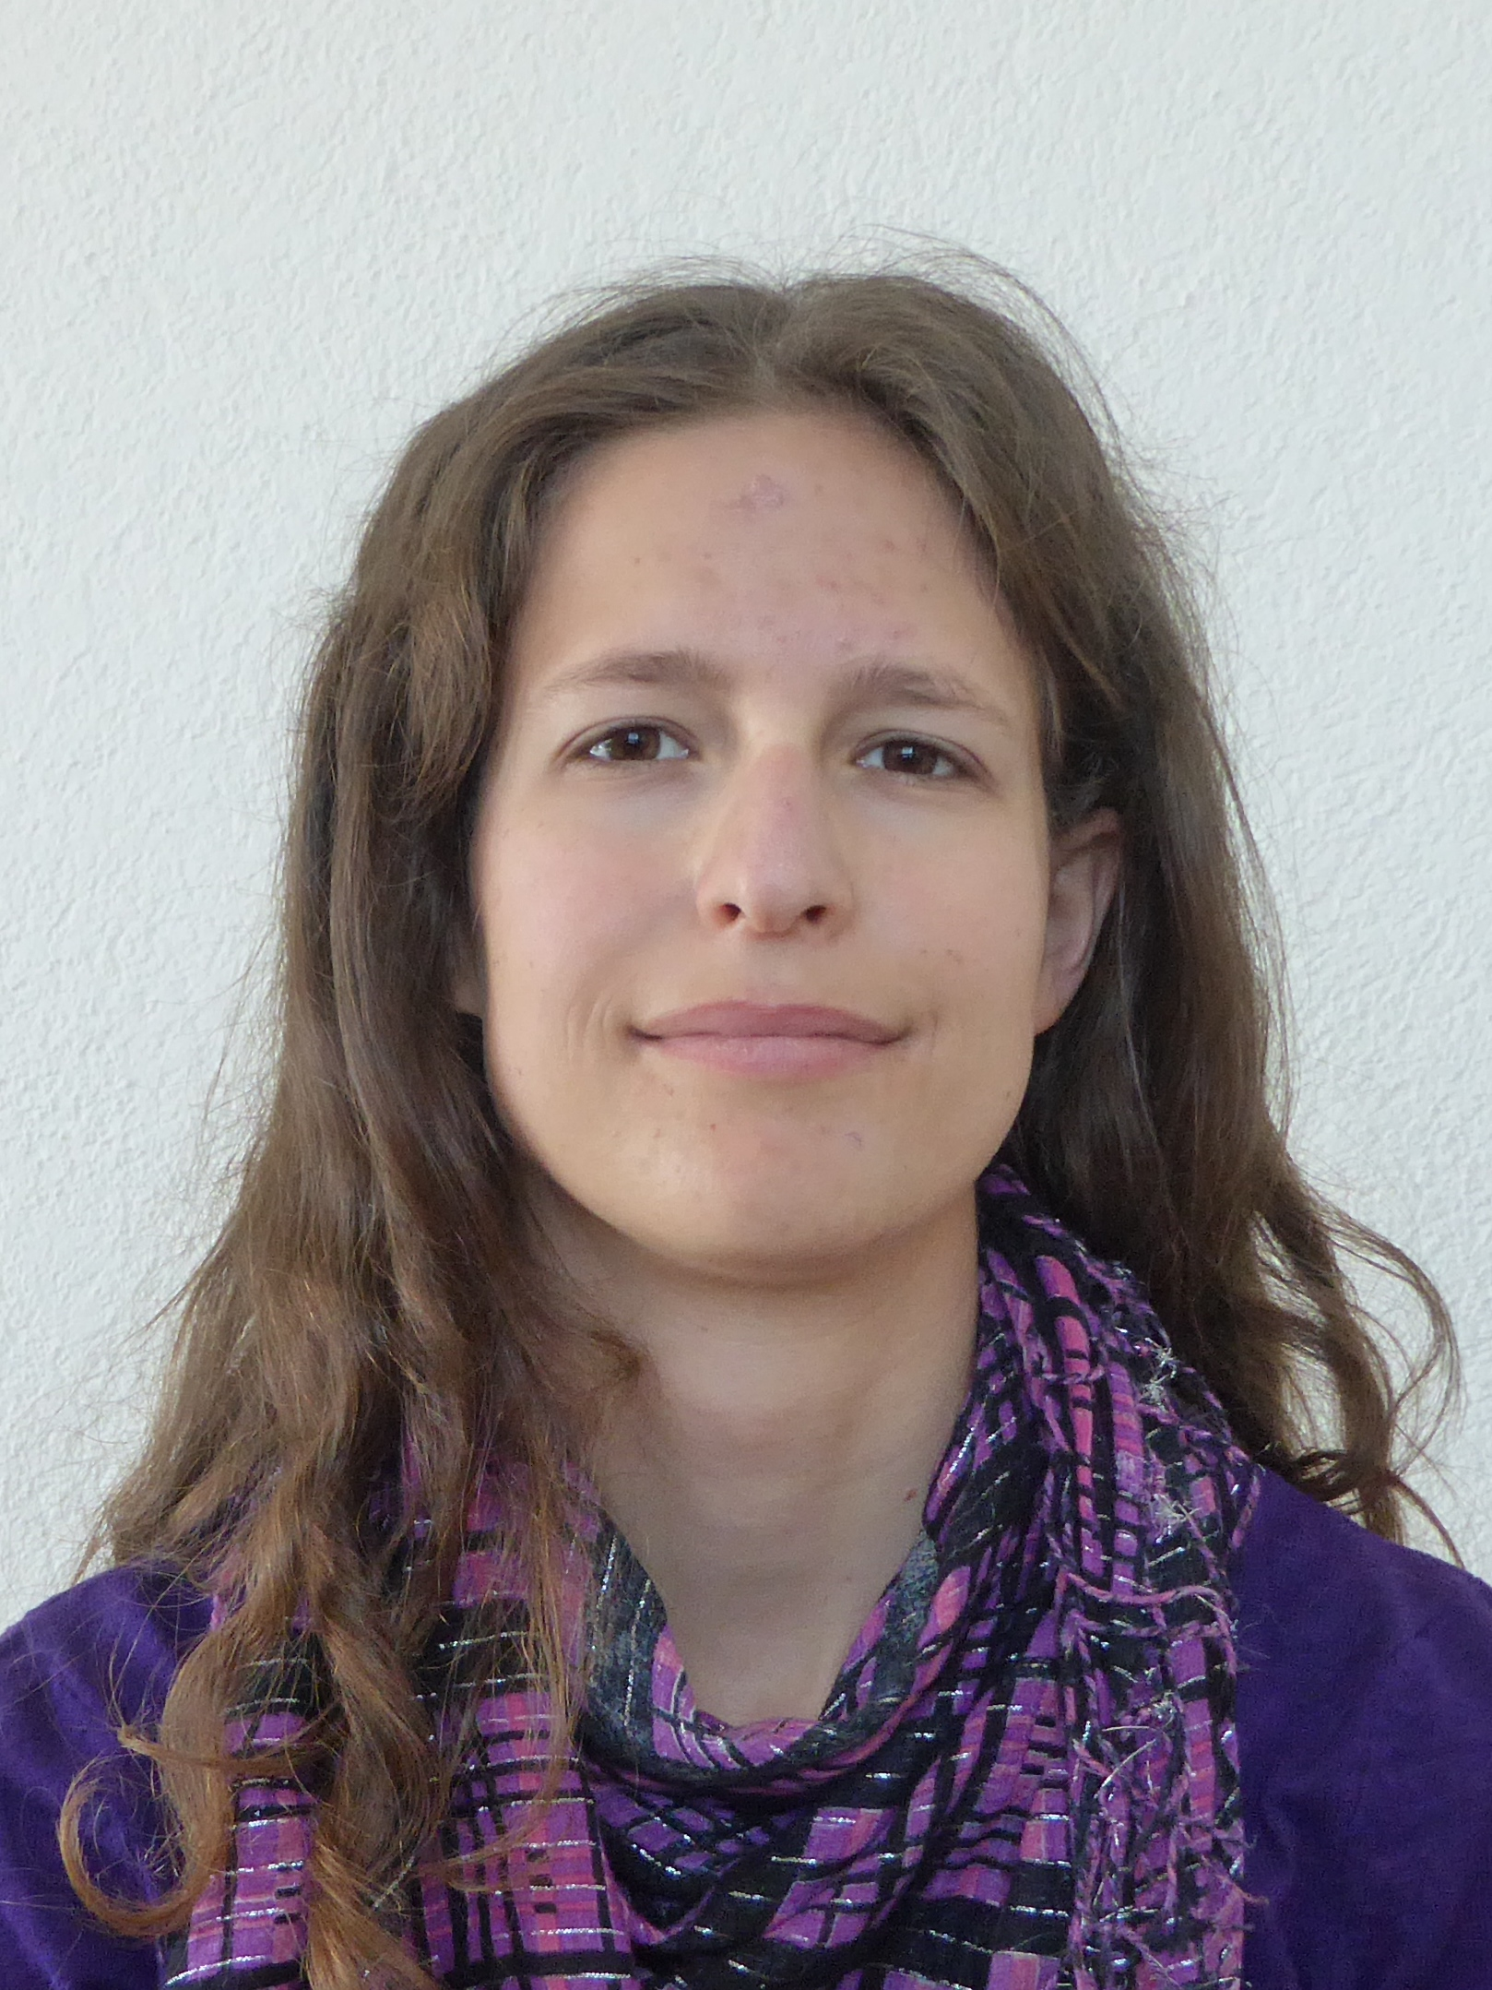
Curriculum Vitae

Name: Martina Föhn
Date of Birth: 4. February 1993
Place of Birth: Schwyz

Education
01.2018 – 12.2021 PhD in Physics, Physics Institute, Space Research and Planetary
Sciences Division, University of Bern, Switzerland
Thesis: NIM: The Neutral Gas and Ion Mass Spectrometer to Explore the Galilean Ice Worlds

01.2016 – 11.2017 MSc in Physics, Physics Institute, Space Research and Planetary
Sciences Division, University of Bern, Switzerland
Thesis: Application of Surface Physics for Instruments in Space Science

09.2011 – 01.2016 BSc. in Physics, Institute of Applied Physics, University of Bern, Switzerland
Thesis: Optical stimulation of the earthworm’s nerve cord

08.2007 – 07.2011 Gymnasium at Theresianum Ingenbohl with specialisation in Biology and Chemistry

Professional Experience
2012 – present Private tutor in Mathematics and Physics
2016 – present Teaching Assistant at the Physics Institute, University of Bern, Switzerland.

