**Software for Managing IT Projects**

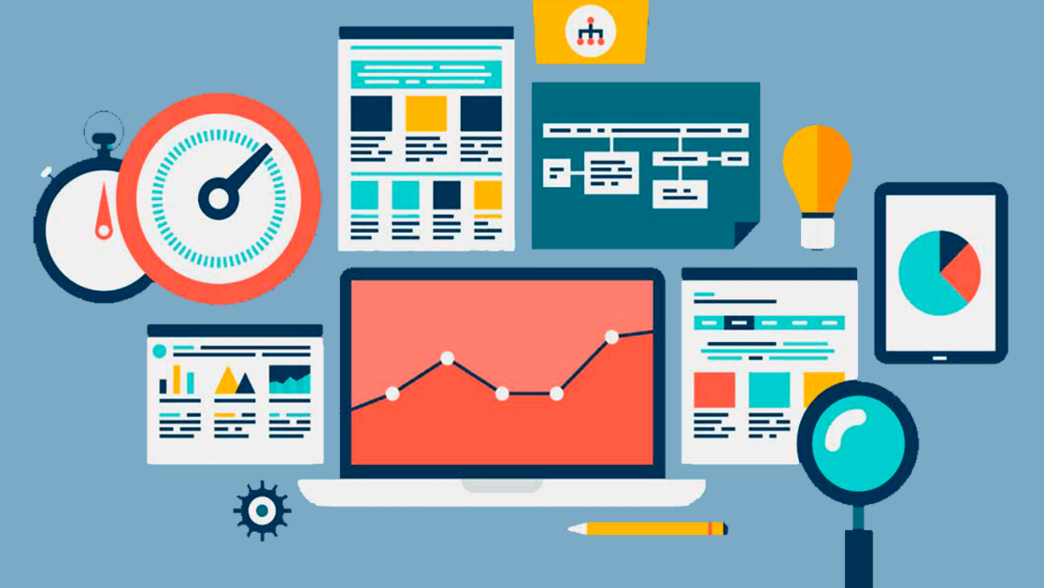

**Contents**

**1. Introduction: 3**

**2. Project Description: 3**

**3. Key Features: 3**

**3.1 Task Definition: 3**

**3.2 Schedule Management: 3**

**3.3 Cost Management: 3**

**3.4 Resource Management: 3**

**3.5 Follow-Up Reports: 4**

**4. Technical Specifications: 4**

**5. Interfaces: 4**

**6. Conclusion: 7**

# Introduction:

In today’s dynamic IT landscape, effective project management is crucial for the success of any endeavor. This report presents the design and functionality of a robust project management software tailored for IT projects. Leveraging the .NET framework for the user interface and MySQL as the database management system (DBMS), this software aims to streamline project planning, execution, and monitoring processes.

# Project Description:

The software serves as a centralized platform for managing IT projects, allowing users to define projects as sets of tasks, manage schedules, costs, resources, and generate follow-up reports. It caters to the specific needs of IT project teams, facilitating collaboration, transparency, and efficiency throughout the project lifecycle.

# Key Features:

## Task Definition:

* Users can define projects by breaking them down into granular tasks with detailed descriptions, start and end dates, priorities, and assigned resources.
* Tasks can be organized hierarchically to reflect project structures and dependencies.

## Schedule Management:

* The software offers intuitive tools for scheduling tasks, visualizing project timelines, and identifying critical path activities.
* Task dependencies are managed dynamically, ensuring that changes to schedules are accurately reflected across the project.

## Cost Management:

* Users can track costs associated with each task and monitor the overall project budget.
* The software provides features for estimating, allocating, and tracking expenses such as labor, materials, and overheads.

## Resource Management:

* Resources including human resources, equipment, and materials can be managed efficiently, ensuring optimal allocation and utilization.
* Resource assignments are synchronized with task schedules, preventing overallocation or underutilization of resources.

## Follow-Up Reports:

* Comprehensive follow-up reports are generated to provide stakeholders with insights into project progress, status, and performance.
* Reports include information on completed tasks, pending tasks, resource utilization, budget vs. actual costs, and any issues or risks identified.

# Technical Specifications:

* **Programming Language:** C# (.NET Framework)
* **User Interface:** Windows Forms for desktop application
* **Database Management System:** MySQL

# Interfaces:

The software provides a user-friendly interface with intuitive navigation and interactive features for managing projects..

1. **Dashboard**

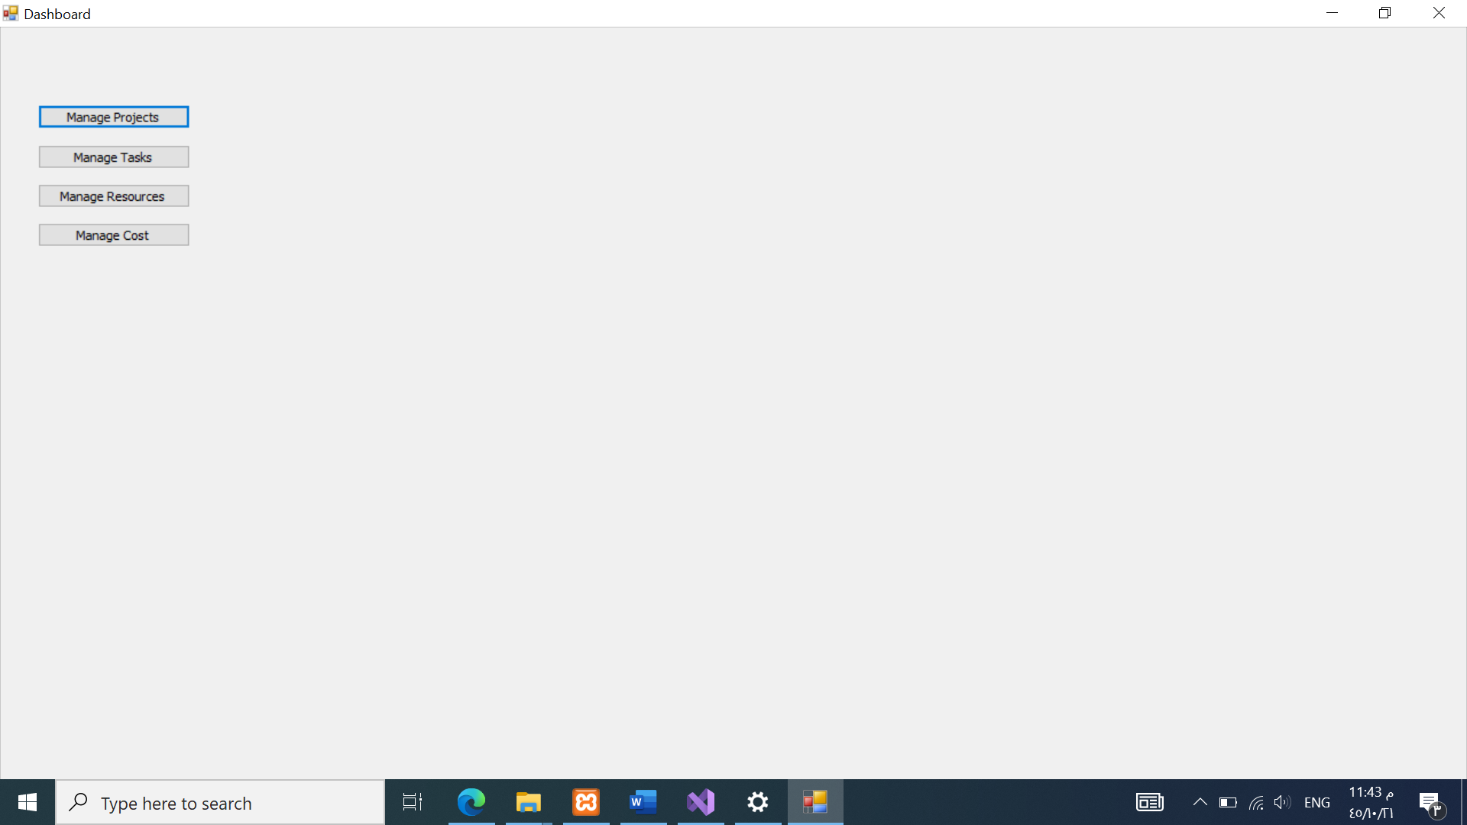

The Dashboard provides an at-a-glance view of the overall project status, including upcoming tasks, resource utilization, and project health indicators.

1. **Manage Projects**

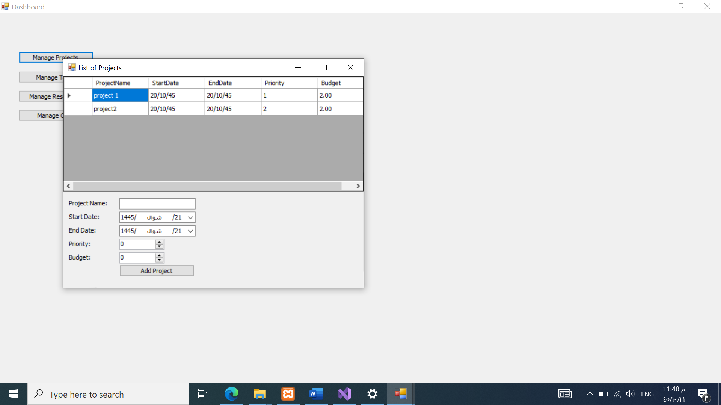

The Manage Projects interface allows users to create, edit, and view project details, such as project name, description, start and end dates.

1. **Manage Tasks**

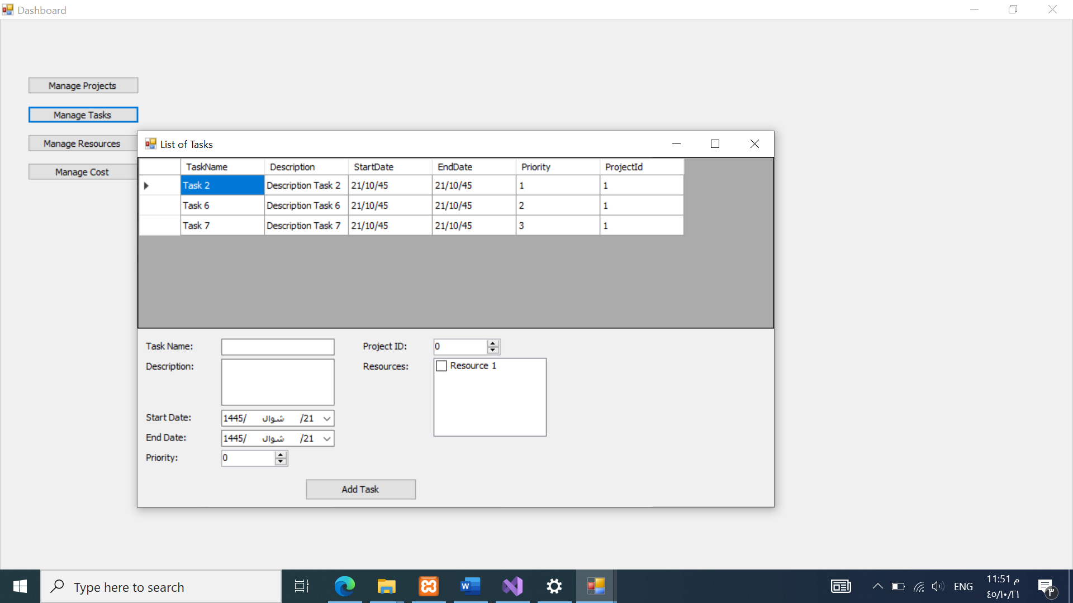

The Manage Tasks interface enables users to define and organize tasks within a project. Users can add task descriptions, set priorities, assign resources.

1. **Manage Resources**

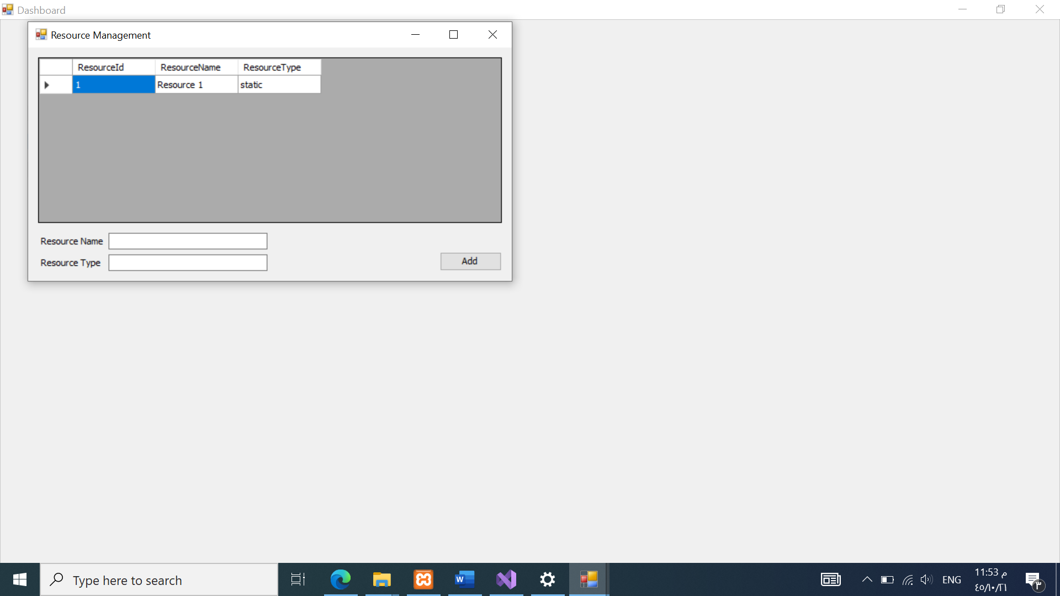

The Manage Resources interface provides a centralized view of all available resources, including human resources, equipment, and materials. Users can add, edit, and allocate resources to specific tasks or projects.

1. **Manage Cost**

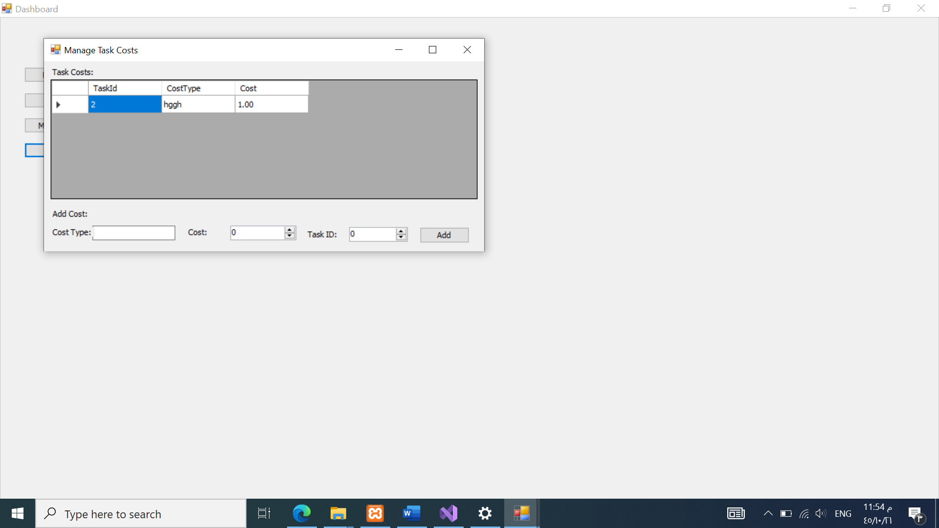

The Manage Cost interface allows users to track and monitor project costs. Users can estimate, allocate, and record expenses associated with tasks, such as labor costs, material costs, and overhead costs.

# Conclusion:

The project management software developed using .NET and MySQL offers a comprehensive solution for managing IT projects effectively. By integrating key features such as task definition, schedule management, cost tracking, resource allocation, and follow-up reporting, the software empowers project teams to plan, execute, and monitor projects with precision and agility. With its robust technical architecture and user-friendly interface, the software is poised to enhance productivity, collaboration, and decision-making across IT projects of varying complexities and scales.