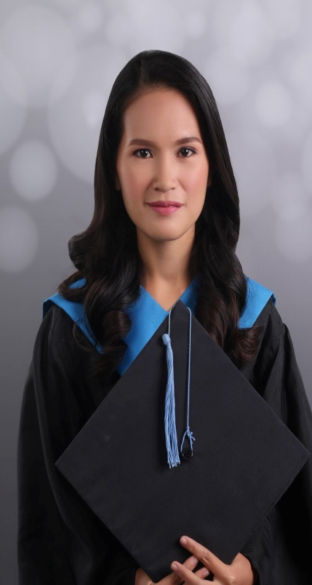**JENESEL A. MEDIO**

Mangabon, Lusaran, Cebu City

09109952231

mediojenesel@gmail.com

**Objective: To secure a teaching position at this school where I can utilize my skills and share my passion for the student’s quality education.**

**QUALIFICATIONS:**

* **Good at both written and spoken English**
* Patient
* **Hard working**
* **Strong work ethic**
* **Critical Thinker**
* **Computer Literate**
* **Willing to be trained to enhance my skills**

**EXPERIENCE:**

* **ESL Teacher Premier English College**
* **Student Teacher (Private School) University of Cebu-Banilad**
* **Student Teacher (Public School) Maguikay National High School**

**EDUCATIONAL ATTAINMENT:**

**University of Cebu-Banilad Mangabon Elementary School**

**Bachelor of Secondary education-English Mangabon, Lusaran, Cebu City**

**S.Y. 2017-2018 S.Y. 2009-2010**

**Lusaran National High School**

**Lusaran Cebu City**

**S.Y. 2013-2014**

**CHARACTER REFERENCE:**

**VICTORIA NGOA**

**Premier English College**

**Head Teacher**

**09239097763**