ATTACHMENT-BASED

PRACTICE WITH ADULTS:

Understanding strategies and promoting positive change

A 3-DAY COURSE facilitated by CLARK BAIM and LYDIA GUTHRIE

**10th – 12th October 2017**

Venue: Novotel, Broad Street, Birmingham B1 2HT, UK

This course is equal parts theory and practical applications. It is for professionals from a range of disciplines who work with adults whose behaviour may place themselves or others at risk of harm.

**What the course covers:**

* Understanding the key elements of contemporary attachment theory.
* Learning a model of attachment that is strengths-based, non-labelling and non-pathologising.

**Previous feedback:**

*“The training was probably the best I have ever been on. Brilliant, thought-provoking and a topic I will definitely continue to learn about!”*

* Improving interviewing skills by learning to focus your questions on specific memory systems.
* Identifying how attachment strategies are expressed in speech and behaviour.
* Understanding mental illness and personality disorder through the lens of attachment theory.
* How attachment theory helps our understanding of the long-term effects of trauma and loss.
* Using the LEARN Model for improving psychological integration.
* A six point model for case formulation, tracking progress, and programme evaluation.

The course is a mixture of presentation, audio and video clips, and small group tasks.

**Who is this course for?** This course is for professionals who work with parents or other adults who pose a risk to themselves or others. This includes those working in child welfare / child protection settings, safeguarding, adult mental health, social care or counselling services, criminal justice and multi-disciplinary contexts that cross adult and children’s services. This course is also relevant for professionals who supervise staff in the above areas.

**Please note: All delegates will receive a copy of *Attachment-based Practice with Adults*, by Clark Baim and Tony Morrison, published 2011 by Pavilion (retail price £115).**

**Clark Baim,** M.Ed., UKCP, is a Senior Trainer in Psychodrama Psychotherapy and Co-Director of the Birmingham Institute for Psychodrama. He and Lydia Guthrie are Co-Directors of Change Point Ltd., a training organisation focusing on the social care, mental health, voluntary and criminal justice sectors. In the 1980s, Clark was the founder and first Director of Geese Theatre UK, using applied drama in prisons and probation. In the 1990s, he worked as a group psychotherapist for five years at HM Prison Grendon, and from 2000 - 2012, he was a trainer for facilitators of the Probation Service’s Sexual Offending Groupwork Programmes. He has studied extensively in the Dynamic-Maturational Model of Attachment with Dr. Patricia Crittenden, and developed this 3-day course with Tony Morrison in 2002.

**Lydia Guthrie**, MA Hons, MSc, Dip SW has a long track record of work in the criminal justice and voluntary sectors. She qualified as a social worker in 1998 and worked for the Probation Service between 1998 and 2009. She has held a variety of roles including Treatment Manager of the Thames Valley Sexual Offending Groupwork Programme and Senior Probation Officer, supervising a team of probation officers in Oxford. This work focused on the risk assessment and management of high risk offenders, and on the delivery of programmes for sexual offending, domestic abuse and partners of offenders. Between 2007 and 2012, Lydia was a trainer for the Probation Service’s Sexual Offending Groupwork Programmes. She has an MSc in Attachment Theory from the University of Roehampton.

**Course fee:** £375 plus VAT. Course fee includes lunches but not accommodation. (There are many nearby hotels, and staying at the Novotel is also an option.) Payment in full is required to confirm your place. Confirmed places will not be eligible for a refund after 12th September 2017 unless we can reallocate the place. **Fee includes the course text, ‘Attachment Based Practice with Adults’** by Clark Baim and Tony Morrison (retail price: £115)

*“Very well organised, very informative, and highly knowledgeable trainers.* *It is honestly the best training I have EVER been on, and a must for all people involved in mental health.”*

**To book your place,** please contact Lydia Guthrie, c/o email: mailbox@changepointlearning.com. Or write to Lydia Guthrie c/o Change Point Ltd., 230 Oxford Rd., Kidlington, Oxon. OX5 1EB, UK. You can use the application form overleaf. Please provide your name and contact details, including email and telephone. Cheques can be made payable to ‘Change Point Ltd.’ If you need an invoice, please provide full details.

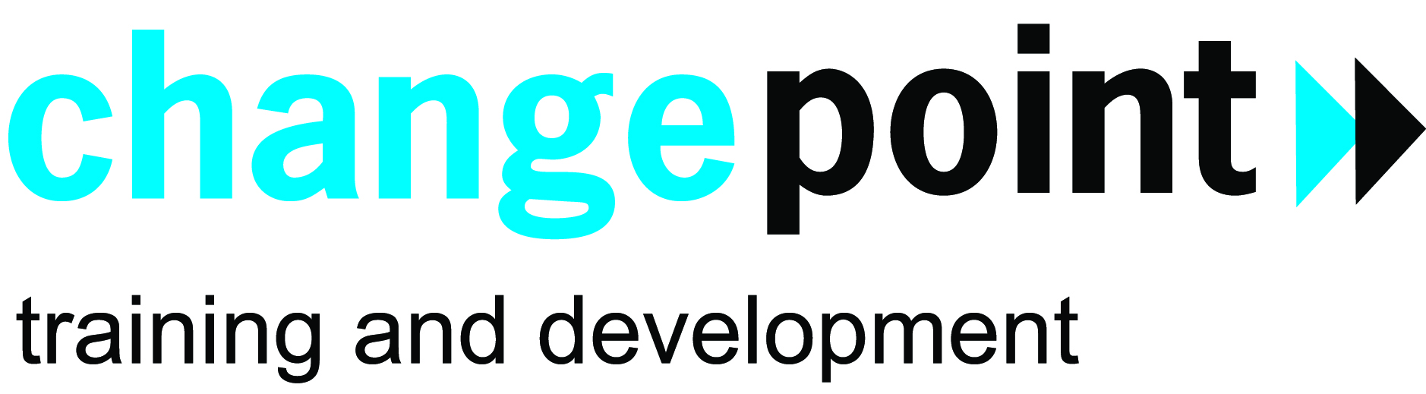

*Early booking is advised.*

Change Point Ltd. Registered in England and Wales.

Registered company number 6863016. VAT Registration No. 993 5155 84.

ATTACHMENT-BASED PRACTICE WITH ADULTS

**YOUR DETAILS (please complete one form per delegate)**

|  |  |  |  |
| --- | --- | --- | --- |
| NAME | |  | |
| OCCUPATION / POSITIONORGANISATION | | | |
| WORK ADDRESS | | | |
| POSTCODE | | | |
| WORK TELEPHONE | | **MOBILE** | |
| E-MAIL ADDRESS | | | |
| **HOME ADDRESS** (where work address is not being used) | | | |
| POST CODE | |  | |
| HOME TEL NO | | PERSONAL E-MAIL | |
| **BOOKING DETAILS - PLEASE BOOK ME A PLACE:** | | | |
| **ATTACHMENT- BASED PRACTICE WITH ADULTS,**  10th – 12th October 2017 | Tick | | **NON-RESIDENTIAL PLACE:** 3 days, including lunches & refreshments:  **£375 + VAT = £450.00** |
| **TOTAL:** | | | £_____ |
| **PAYMENT OPTIONS - PLEASE TICK:** | | | |

(**Payment in full is required to confirm your place.** Confirmed places will not be eligible for a refund after 12th September 2017, unless we can reallocate the place.)

Fee enclosed Please make cheques payable to 'Change Point Ltd.' No post-dated cheques, please.

I am paying via PayPal (please go to www.changepointlearning.com for the link to the PayPal payment window).

Invoice me at my home address

Invoice my work address - Please specify to whom the invoice should go:

|  |
| --- |
| Name and Title |
| Address (if different from above)including post code |
| Purchase order number, if relevant: |

**Please POST or E-mail to:**



Lydia Guthrie, Change Point Ltd.

230 Oxford Rd., Kidlington, Oxon. OX5 1EB, UK

E-mail: mailbox@changepointlearning.com

Mobile: + 44 (0) 7803 293223

Change Point Ltd. Registered in England and Wales. Registered company number 6863016. VAT Registration No. 993 5155 84